Official Statistics
18 March 2021

Introduction
This statistical release provides summary information on appeals, which represent the highest volume (in terms of number of cases) of the work of the Planning Inspectorate.

This release also provides a general overview of the impact of the Covid pandemic on the work of the Planning Inspectorate to enable everyone to see the effect of the restrictions on performance.

These statistics are produced each month and the focus is on timeliness, as that is an area in which stakeholders have an interest. Information on the decisions that we have made is also included; and on the number of Inspectors available to make those decisions.

These statistics have been published to ensure everyone has equal access to the information and to support the Planning Inspectorate’s commitment to release information where possible.

This statistical bulletin provides:
- An overview of the impact of Covid on the work of the Inspectorate
- Appeals decisions from March 2020 to February 2021
- The time taken to reach those decisions
- Number of open cases
- Number of Inspectors
- Number of virtual events.
The data in this release is only applicable to England.

The Planning Inspectorate
The Planning Inspectorate makes decision and provides recommendations and advice on a range of land use planning-related issues across England and Wales. We do this in a fair, open and timely way.

The Planning Inspectorate deals with planning appeals, national infrastructure planning applications, examinations of local plans and other planning-related and specialist casework in England and Wales.

The Planning Inspectorate is an executive agency, sponsored by the Ministry of Housing, Communities & Local Government and the Welsh Government.
Summary
The impact of COVID can be seen in The Planning Inspectorate data in three ways:
- The Inspectorate suspended all events during the Spring 2020 lockdown, but have since resumed activities, including holding events virtually and, where possible, carrying out site visits during the latest lockdown. The number of events held peaked in September 20 at over 2,000 but have been gradually reducing since. This is likely to be the impact of tiered restrictions and lockdowns, in November 20 and January 21 onwards.
- Following the Spring 2020 lockdown the timeliness measure increased, peaking at a median timeliness of almost 27 weeks in November 20, compared to pre pandemic levels of just over 21 weeks. In the last three months (Dec 20 – Feb 21) there has been a reduction in median timeliness.
- The number of open cases (cases received but not yet closed) increased to a high of around 11,000 in August 20. It was decreasing, as the Inspectorate closed more cases than were received on a monthly basis; but this trend has in the last three months started increasing (more being received than closed), with open cases now at almost 10,500.
Decisions
The Planning Inspectorate has made 16,956 appeal decisions in the last 12 months, an average of just over 1,400 per month. The 1,451 decisions for February 21 are marginally higher than January 21. However, February 21 had 22% fewer decisions than the same month in 2020.

Written representations decisions represent the highest volume and had recovered to pre-pandemic levels between September and December 20, but both January and February 21 were lower. Hearing decisions fell in February 21, and Inquiry decisions have been broadly similar since November 20. Both planning and enforcement decisions were lower in February 21 compared to recent previous months; Specialist casework had its highest number of decisions since Apr 20.

Performance
The mean average time to make a decision, across all cases in the last 12 months (Mar 20 to Feb 21), was 27 weeks. The median time is 23 weeks.

The median timeliness for February 21, at 21 weeks, was back to the level last seen in Apr 20. In the period between Apr 20 and Jan 21 performance was consistently above 22 weeks. Hearings and inquires take longer than written representations – with inquiries taking more than twice as long as written representations.

The median time for written representations over the 12 months to February 21 is 22 weeks. The median time for inquiries over the 12 months to January 21 is just over a year - 53 weeks. The median time for hearings is slightly less at 45 weeks.

The median time to decision for planning cases was lower than for other casework categories, apart from in May 2020. Across the whole year, the median time to decision for planning cases is 21 weeks. Enforcement decisions made in the last 12 months had a median decision time of 34 weeks. The median time to decision for specialist decisions is broadly the same as for enforcement decisions, and longer than the median for planning decisions.

The median time for inquiries under the Rosewell Process over the 12 months to February 21 is 32 weeks. The eight decisions in February 21 was a drop from the previous two months; Dec 20 and Jan 21 were comparable to pre-pandemic levels.

Open Cases
At the end of January 21, the Planning Inspectorate had ten thousand five hundred cases open. This is a small increase of 147 compared to the previous month.

Planning Inspectors
There were 345 Planning Inspectors employed by the Inspectorate in January 2021 – with a full-time equivalent of 308.1.

Virtual Events
The Inspectorate are continuing to carry out events ‘virtually’. There were 91 cases involving Virtual Events during February, with 86 estimated for March 2021. Please note that in the last release the period December 20 to February 21 indicated that no Local Plan events had been held virtually – this has been corrected to show 12, 5 and 7 plans having been held virtually in those respective months.

Impact of Covid

The impact of COVID can be seen in the Planning Inspectorate data in three ways:
- The Inspectorate suspended all events during the Spring 2020 lockdown, but have since resumed activities, including holding events virtually and, where possible, carrying out site visits during the latest lockdown. The number of events held peaked in September 20 at over 2,000 but have been gradually reducing since. This is likely to be the impact of tiered restrictions and lockdowns, in November 20 and January 21 onwards.
- Following the Spring 2020 lockdown the timeliness measure increased, peaking at a median timeliness of almost 27 weeks in November 20, compared to pre pandemic levels of just over 21 weeks. In the last three months (Dec 20 – Feb 21) there has been a reduction in median timeliness.
- The number of open cases (cases received but not yet closed) increased to a high of around 11,000 in August 20. It was decreasing, as the Inspectorate closed more cases than are received on a monthly basis; but this trend has in the last three months started increasing (more being received than closed), with open cases now at almost 10,500.

Figure 1: Number of events held, decisions issued and median time between valid date & decision date; Mar 20 to Feb 21
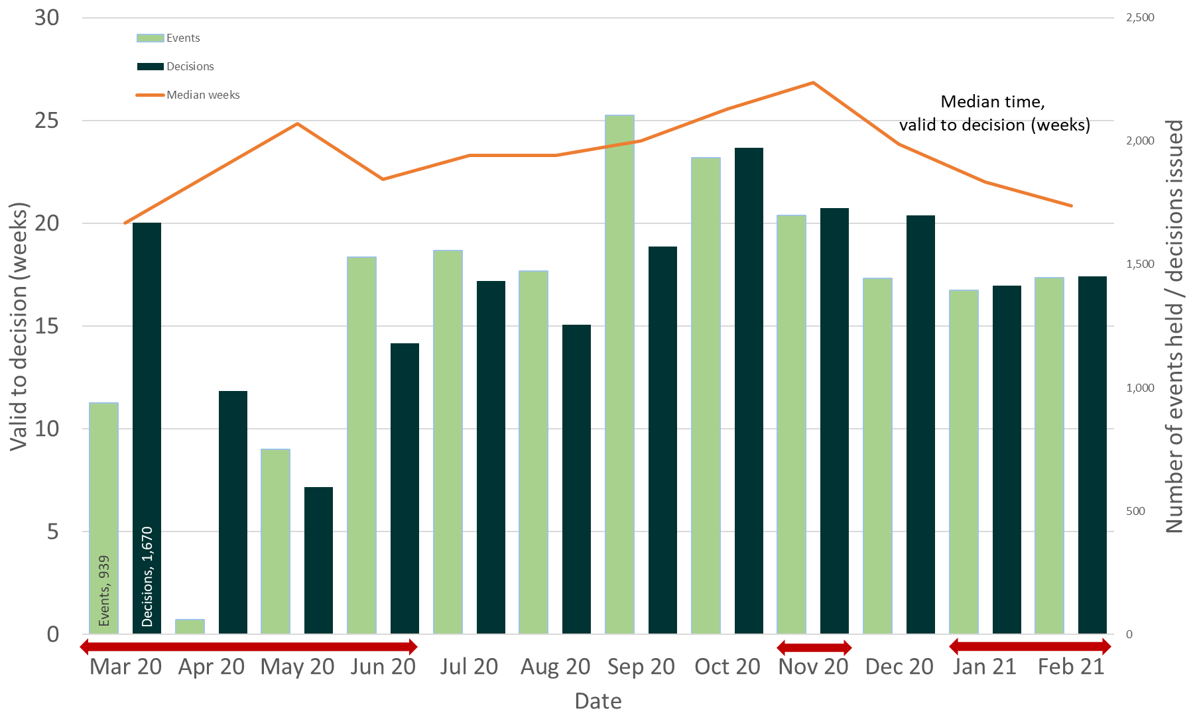
Source: Horizon, Picaso, Inspector Scheduling System
Note – Red arrows indicate periods when national lockdowns were in effect

Table 1: Number of events held, decisions issued and median time between valid date & decision date; Mar 20 to Feb 21
Month | Mar 20 | Apr 20 | May 20 | Jun 20 | Jul 20 | Aug 20 | Sep 20 | Oct 20 | Nov 20 | Dec 20 | Jan 21 | Feb 21 |  | Total
Events Held | 939 | 59 | 751 | 1,528 | 1,556 | 1,472 | 2,104 | 1,933r | 1,699r | 1,444r | 1,394r | 1,446 |  | 16,325
Decisions | 1,670 | 988 | 597 | 1,180 | 1,432 | 1,254 | 1,571 | 1,972 | 1,729 | 1,699 | 1,413r | 1,451 |  | 16,956
Median | 20.0 | 22.4 | 24.9 | 22.1 | 23.3 | 23.3 | 24.0 | 25.6 | 26.9 | 23.9 | 22.0 | 20.9 |  | 22.9
Source: Horizon, Picaso, Inspector Scheduling System. r denotes revision – a change of more than 5 cases since last month (see Background Quality Report for more information)

During the first lockdown The Planning Inspectorate were able to continue deciding cases where the site visit, hearing or inquiry had already occurred. The impact of pandemic meant that the Inspectorate did not carry out site visits, hearings and inquiries events during the lockdown period in Spring 2020. In contrast, site visits and virtual events were able to continue during the later lockdowns.

The Inspectorate needed to adapt to new ways of working and re-arrange those events that were cancelled during the Spring lockdown period and this also impacted on customers who appealed before (from as early as Dec 19), during and after the Spring 2020 lockdown.

Figure 2: Number of cases received, closed and open; Mar 20 to Feb 21
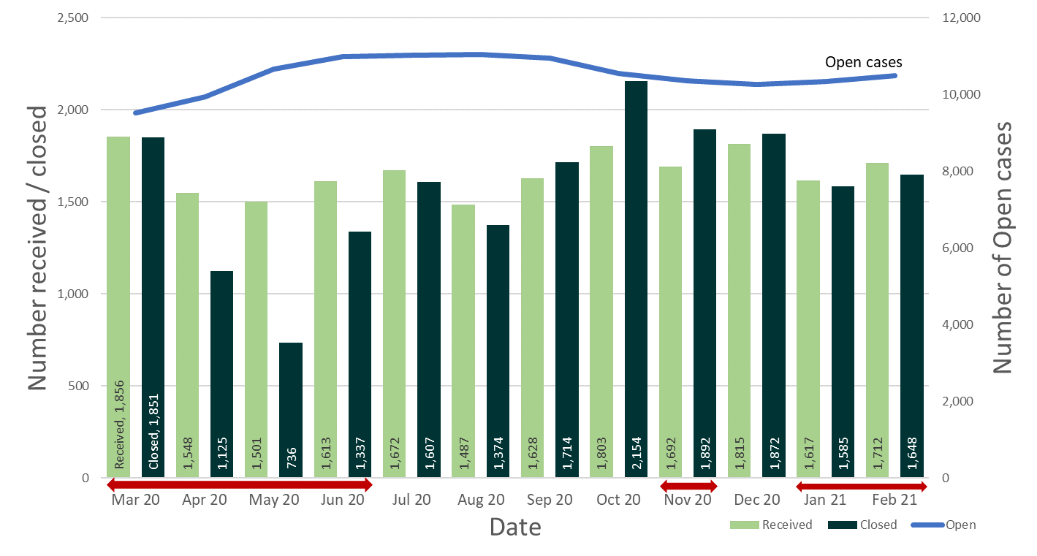
Source: Horizon and Picaso
Note – Red arrows indicate periods when national lockdowns were in effect

The number of open cases has increased slowly over the last two months, from 10,261 at the end of December 20 to 10,487 at the end of February 21. This contrasts with the period September to December 20, where once schools re-opened and full Inspectorate capacity had returned, the number of cases being closed noticeably exceeded the number received.

Table 2: Number of cases received, closed and open; Mar 20 to Feb 21
Month | Mar 20 | Apr 20 | May 20 | Jun 20 | Jul 20 | Aug 20 | Sep 20 | Oct 20 | Nov 20 | Dec 20 | Jan 21 | Feb 21 | Total
Received | 1,856 | 1,548 | 1,501 | 1,613 | 1,672 | 1,487 | 1,628 | 1,803 | 1,692 | 1,815r | 1,617r | 1,712 | 19,944
Closed | 1,851 | 1,125 | 736 | 1,337 | 1,607 | 1,374 | 1,714 | 2,154r | 1,892 | 1,872 | 1,585r | 1,648 | 18,895
Open | 9,513 | 9,933 | 10,665 | 10,987 | 11,023 | 11,050 | 10,951 | 10,541 | 10,350 | 10,261 | 10,342 | 10,487 | N/A
Source: Horizon and Picaso. r denotes revision – a change of more than 5 cases since last month (see Background Quality Report for more information)
The number of cases closed is considerably higher than the number of decisions, as it includes cases where an appeal is withdrawn, notice is withdrawn, or the appeal is turned away.

Number of Decisions
The Planning Inspectorate has made 16,956 appeal decisions in the last 12 months, an average of just over 1,400 per month. Table 3 below shows the monthly breakdown with fewer decisions from April to August 2020, and for the months of January and February 2021, than would have been expected, due to the impact of COVID-19. The same information is represented in Figure 3.
Table 3: Appeal Decisions; Mar 20 to Feb 21
Month | Mar 20 | Apr 20 | May 20 | Jun 20 | Jul 20 | Aug 20 | Sep 20 | Oct 20 | Nov 20 | Dec 20 | Jan 21 | Feb 21 | Total
Decisions | 1,670 | 988 | 597 | 1,180 | 1,432 | 1,254 | 1,571 | 1,972 | 1,729 | 1,699 | 1,413r | 1,451 | 16,956
Source: Horizon and Picaso. r denotes revision – a change of more than 5 cases since last month (see Background Quality Report for more information)
Figure 3 – Appeal Decisions; Mar 20 to Feb 21
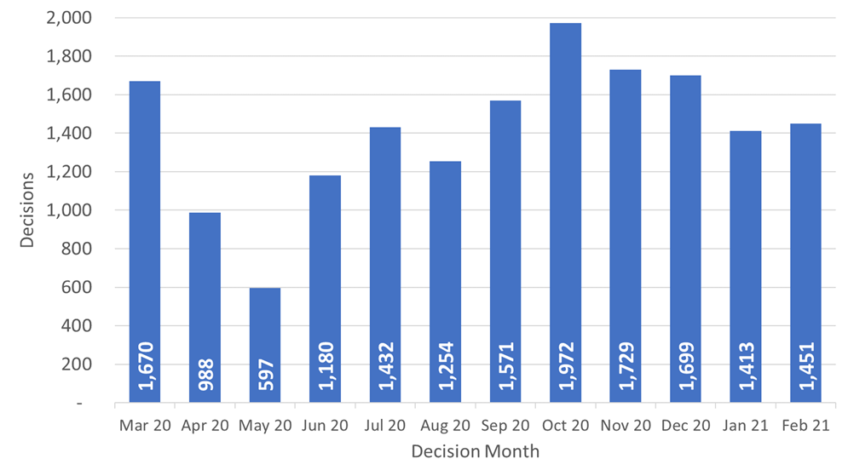
Source: Horizon and Picaso
As can be seen from the table, the fewest decisions were made in May 2020 – just under six hundred decisions. Since then the number of decisions each month showed an upward trend to October 20 (with a slight dip in August linked to annual leave). However, since October decisions decreased. The 1,451 decisions for February 21 are marginally higher than January 21. However, February 21 had 22% fewer decisions than the same month in 2020.

Decisions by procedure and case type
Planning Inspectors work on a broader range of work than the appeals featured in this Release. For example, they also work on examining Nationally Significant Infrastructure Project applications, Local Plans, Compulsory Purchase Order applications and many other specialist licencing/application types.

Table 4 below gives the numbers of appeal decisions made broken down by whether the case was dealt with by written representations, hearings, or inquiries.

The large majority of decisions (16,337) were made on written representations. This is about ninety five percent of all appeal decisions made. There were 429 decisions made on hearings; and 190 on inquiries. These totals are shown in Figure 4 below.

The large majority of cases were planning (13,992). This is about eighty-two per cent of all appeal decisions made. There were 2,361 enforcement decisions and 603 specialist decisions. These totals are also shown in Figure 4 below.

Table 4: Appeal Decisions by procedure and casework category; Mar 20 to Feb 21
Month | Mar 20 | Apr 20 | May 20 | Jun 20 | Jul 20 | Aug 20 | Sep 20 | Oct 20 | Nov 20 | Dec 20 | Jan 21 | Feb 21 | Total
Written Representations | 1,565 | 931 | 575 | 1,157 | 1,411 | 1,230 | 1,543 | 1,919 | 1,674 | 1,613 | 1,331r | 1,388 | 16,337
Hearings | 71 | 40 | 17 | 13 | 16 | 14 | 21 | 40 | 35 | 60 | 58 | 44 | 429
Inquiries | 34 | 17 | 5 | 10 | 5 | 10 | 7 | 13 | 20 | 26 | 24 | 19 | 190
Total | 1,670 | 988 | 597 | 1,180 | 1,432 | 1,254 | 1,571 | 1,972 | 1,729 | 1,699 | 1,413r | 1,451 | 16,956
Month | Mar 20 | Apr 20 | May 20 | Jun 20 | Jul 20 | Aug 20 | Sep 20 | Oct 20 | Nov 20 | Dec 20 | Jan 21 | Feb 21 | Total
Planning | 1,342 | 751 | 439 | 970 | 1,149 | 991 | 1,323 | 1,639 | 1,488 | 1,463 | 1,187r | 1,250 | 13,992
Enforcement | 272 | 144 | 146 | 178 | 239 | 227 | 215 | 281 | 195 | 187 | 165 | 112 | 2,361
Specialist | 56 | 93 | 12 | 32 | 44 | 36 | 33 | 52 | 46 | 49 | 61 | 89 | 603
Total | 1,670 | 988 | 597 | 1,180 | 1,432 | 1,254 | 1,571 | 1,972 | 1,729 | 1,699 | 1,413r | 1,451 | 16,956
Source: Horizon and Picaso. r denotes revision – a change of more than 5 cases since last month (see Background Quality Report for more information)

Table 4 shows that written representations decisions had recovered to pre-pandemic levels between September and December 20, but both January and February 21 are lower. Decisions for hearings in December 20 and January 21 increased to levels approaching pre-pandemic but fell lower in February 21. Inquiry decisions have been around 20, or more, for the last four months.

Trends for planning decisions show similar patterns to written representations. The number of enforcement decisions has been decreasing month on month since Oct 20. Specialist casework figures remain volatile; 89 decisions in February 21 being the highest monthly total since Apr 20.
Figure 4 – Appeal Decisions by Procedure and Casework Category; Mar 20 to Feb 21
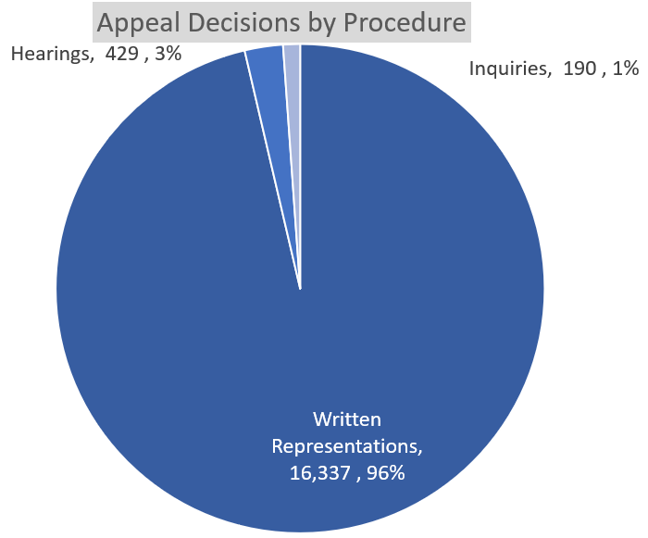 | 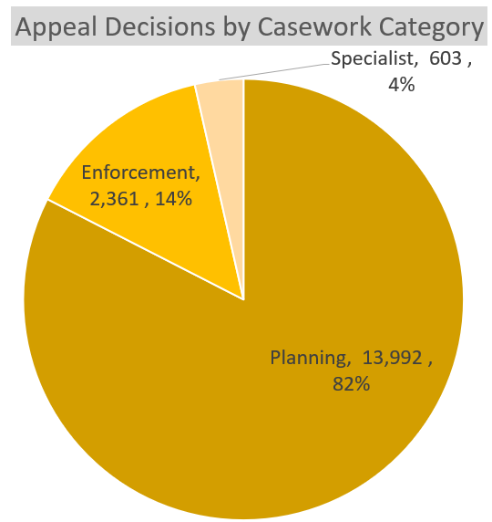
Source: Horizon and Picaso

Decision timeliness

It is important for people to know how long an appeal is going to take, so that they can make plans and decisions based on this information. This section covers the timeliness of decisions (i.e. how long it takes to make a decision) across our appeal casework. In addition to an overall measure, timeliness is analysed by procedure type and casework category, as timeliness varies a great deal depending on these characteristics.

Table 5 below shows that the mean average time to make a decision, across all cases in the last 12 months (Mar 20 to Feb 21), was 27 weeks. The table also shows the median time is 23 weeks. Each month the median is less than the mean; this is due to the larger impact on the mean of very long cases.

Also included in the table is the standard deviation of decision timeliness. A lower standard deviation would demonstrate greater consistency in the Planning Inspectorate’s decision timeliness. The data shows that the variability was getting less towards the end of 2020 – the standard deviation values are 15.6 or lower for June to December. Data for January and February 21 represent a slight increase, up to between 17 and 18 weeks.

What are mean, median, and standard deviation?
Measure | Definition
Mean | The total time taken divided by the number of cases. Also referred to as the ‘average’. A measure of how long each case would take, if the total time taken was spread evenly across all cases.
Median | This is the time taken by the ‘middle’ case if all cases were sorted from quickest to longest
Standard deviation | This is a measure of variability or spread. It is calculated by examining how much each value differs from the mean. A higher standard deviation means the individual decision times vary more widely around the mean.

Table 5: Mean, Median and Standard Deviation of Time to Decision; Mar 20 to Feb 21
Month | Mar 20 | Apr 20 | May 20 | Jun 20 | Jul 20 | Aug 20 | Sep 20 | Oct 20 | Nov 20 | Dec 20 | Jan 21 | Feb 21 | Total
Valid to Decision (mean weeks) | 24.2 | 28.1 | 29.1 | 26.1 | 26.0 | 25.9 | 26.1 | 28.4 | 28.6 | 27.8 | 27.7 | 26.7 | 26.8
Valid to Decision (median weeks) | 20.0 | 22.4 | 24.9 | 22.1 | 23.3 | 23.3 | 24.0 | 25.6 | 26.9 | 23.9 | 22.0 | 20.9 | 22.9
Standard Deviation (weeks) | 14.1 | 17.4 | 15.9 | 13.9 | 14.4 | 14.1 | 12.5 | 14.9 | 12.9 | 15.6 | 18.1 | 16.9 | 15.2
Source: Horizon and Picaso

The median timeliness increased in most months between Mar 20 to Nov 20, peaking at almost 27 weeks. The last three months, Dec 20 to Feb 21, have seen a reduction in the median time to decision.

Figure 5: Mean and Median time to decision; Mar 20 to Feb 21
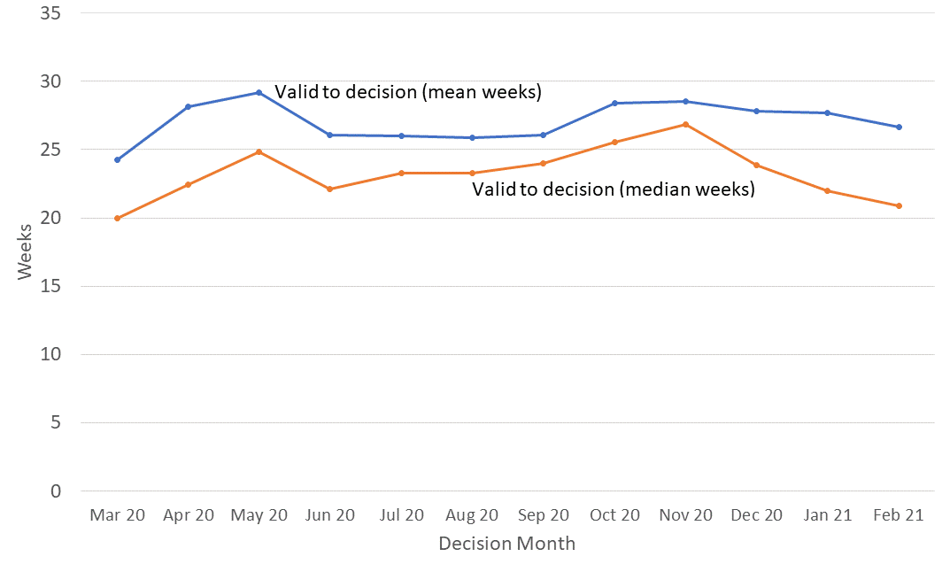
Source: Horizon and Picaso

The mean time to decide, shows a different pattern. The mean has often been above 25 weeks, dropping below this only in Mar 20 (to 24.2 weeks). The decrease in the mean between Oct 20 and Feb 21 is 1.9 weeks; the median measure has decreased by 4.7 weeks in the same period.

Procedure Type
Table 6 below shows decision timeliness broken down by the procedure type. Hearings and inquires take longer than written representations – with Inquiries taking more than twice as long as written representations. Because 19 of every 20 cases are by written representation, the timeliness measures for written representations is similar to the measure across all cases.

Where a small number of cases has been decided, the average timeliness (whether mean or median) is less meaningful as a measure than where there are many cases. Those areas shaded in the table below should be treated with caution as there are fewer than 20 cases decided.

The median time for written representations over the 12 months to February 21 is 22 weeks. The median time for inquiries over the 12 months to February 21 is just over a year - 53 weeks. The median time for hearings is slightly less at 45 weeks. For each of these procedure types, the mean is higher as it is more affected by the longest cases.

Table 6: Mean and Median Time to Decision, with standard deviation, by procedure; Mar 20 to Feb 21
Measure | Procedure | Mar 20 | Apr 20 | May 20 | Jun 20 | Jul 20 | Aug 20 | Sep 20 | Oct 20 | Nov 20 | Dec 20 | Jan 21 | Feb 21 | Total
Valid to Decision (mean weeks) | Written Representations | 22.8 | 26.4 | 28.1 | 25.3 | 25.6 | 25.4 | 25.6 | 27.9 | 28.0 | 26.6 | 25.8 | 25.3 | 25.8
 | Hearings | 45.5 | 48.0 | 50.4 | 63.8 | 56.0 | 44.5 | 50.5 | 49.8 | 37.6 | 49.6 | 59.8 | 47.5 | 49.3
 | Inquiries | 48.5 | 73.4 | 77.4 | 71.4 | 42.3 | 55.1 | 63.2 | 43.8 | 58.5 | 52.8 | 57.0 | 76.3 | 58.0
 | All Cases | 24.2 | 28.1 | 29.1 | 26.1 | 26.0 | 25.9 | 26.1 | 28.4 | 28.6 | 27.8 | 27.7 | 26.7 | 26.8
Valid to Decision (median weeks) | Written Representations | 19.4 | 22.1 | 24.1 | 22.0 | 23.1 | 23.0 | 23.9 | 25.1 | 26.6 | 23.1 | 21.3 | 20.4 | 22.4
 | Hearings | 44.0 | 43.9 | 47.1 | 52.6 | 39.6 | 47.6 | 40.3 | 40.1 | 37.3 | 43.9 | 51.5 | 49.0 | 45.0
 | Inquiries | 43.9 | 96.9 | 88.1 | 67.7 | 24.0 | 44.4 | 65.0 | 37.3 | 55.0 | 40.1 | 52.0 | 68.1 | 52.7
 | All Cases | 20.0 | 22.4 | 24.9 | 22.1 | 23.3 | 23.3 | 24.0 | 25.6 | 26.9 | 23.9 | 22.0 | 20.9 | 22.9
Standard Deviation (weeks) | Written Representations | 12.1 | 15.1 | 14.5 | 12.3 | 13.7 | 13.4 | 11.7 | 14.2 | 12.3 | 14.0 | 15.1 | 14.7 | 13.6
 | Hearings | 19.2 | 19.8 | 20.3 | 30.7 | 31.8 | 11.4 | 20.4 | 25.5 | 15.0 | 20.0 | 29.1 | 20.9 | 23.8
 | Inquiries | 24.3 | 32.8 | 18.5 | 13.2 | 24.0 | 34.0 | 18.5 | 17.4 | 14.0 | 31.0 | 29.8 | 36.9 | 28.6
 | All Cases | 14.1 | 17.4 | 15.9 | 13.9 | 14.4 | 14.1 | 12.5 | 14.9 | 12.9 | 15.6 | 18.1 | 16.9 | 15.2
Source: Horizon and Picaso. Cells shaded grey had fewer than 20 decisions.

The standard deviation information indicates that for all three procedures, there is considerable variation, meaning times are widely spread about the mean. For each type, the amount of variation is fairly stable through the year.

Casework Category
The nature of the cases the Planning Inspectorate deal with varies widely and several factors play a part in determining how long it takes to make a decision. One such factor is the casework type. Table 7 below shows the time taken to decide, in planning cases, in enforcement cases, and in specialist cases, as does Figure 6.

The median time to decision for planning cases (there are many more of these decisions than in the other categories) is lower than for other casework categories, apart from in May 2020. Table 7 and Figure 6 show the median time for planning cases was above 20 weeks from April 20 until Feb 21, when it dipped below 20 weeks. Across the whole year, the median time to decision is 21 weeks.

Annex B gives information on mean and median time to decision, with standard deviation, for these procedure types, split by planning, enforcement and specialist casework categories.

Table 7: Decisions, Mean, Median and Standard Deviation of Time to Decision – Planning, Enforcement, Specialist Cases; Mar 20 to Feb 21
Casework Category | Measure | Mar 20 | Apr 20 | May 20 | Jun 20 | Jul 20 | Aug 20 | Sep 20 | Oct 20 | Nov 20 | Dec 20 | Jan 21 | Feb 21 | Total
Planning Cases | Valid to Decision (mean wks) | 21.6 | 25.2 | 27.1 | 23.5 | 22.9 | 23.0 | 23.7 | 25.6 | 27.0 | 25.4 | 24.5 | 23.2 | 24.1
 | Valid to Decision (median wks) | 18.6 | 20.9 | 23.7 | 21.3 | 22.1 | 21.9 | 22.6 | 24.1 | 25.6 | 22.7 | 20.7 | 19.8 | 21.4
 | St. dev. of decision (weeks) | 11.6 | 15.0 | 14.4 | 10.0 | 9.6 | 11.4 | 9.8 | 11.3 | 11.3 | 12.3 | 12.3 | 11.6 | 11.7
Enforcement Cases | Valid to Decision (mean wks) | 34.1 | 39.6 | 34.9 | 37.5 | 38.0 | 36.8 | 37.5 | 42.8 | 37.7 | 42.1 | 43.7 | 42.8 | 38.9
 | Valid to Decision (median wks) | 29.3 | 35.2 | 29.4 | 29.0 | 33.0 | 33.3 | 33.6 | 38.4 | 34.6 | 36.9 | 37.6 | 34.9 | 33.6
 | St. dev. of decision (weeks) | 17.4 | 20.4 | 18.2 | 21.3 | 22.6 | 17.3 | 15.5 | 20.5 | 16.8 | 23.0 | 28.9 | 26.7 | 20.9
Specialist Cases | Valid to Decision (mean wks) | 39.9 | 33.8 | 32.3 | 40.6 | 42.3 | 37.6 | 47.0 | 38.8 | 39.4 | 44.3 | 46.1 | 54.7 | 41.2
 | Valid to Decision (median wks) | 36.5 | 26.1 | 19.9 | 37.1 | 40.9 | 37.3 | 48.7 | 35.5 | 41.1r | 44.0 | 52.9 | 54.0 | 38.0
 | St. dev. of decision (weeks) | 19.8 | 21.8 | 18.5 | 23.1 | 17.2 | 17.7 | 24.3 | 26.4 | 18.3 | 25.4 | 33.7 | 24.2 | 24.5
Source: Horizon and Picaso. Cells shaded grey had fewer than 20 decisions. r denotes revision – a change of more than 0.5 weeks since last month.
Figure 6 – Median time to decision by casework area; Mar 20 to Feb 21
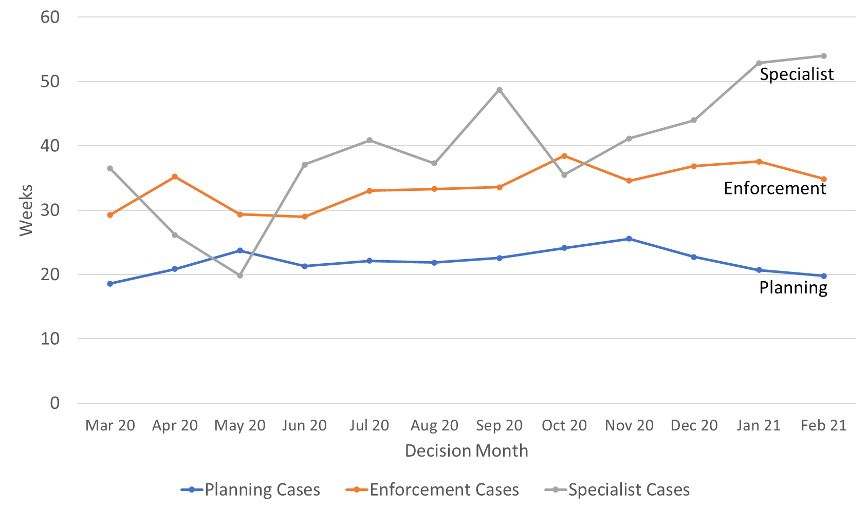
Source: Horizon and Picaso
The 2,361 enforcement decisions made in the last 12 months had a median decision time of 34 weeks. The median decision time increased between Jun 20 and Oct 20. For the last 12 months the median is 34 weeks. The median time for enforcement decisions is longer than the median decision time for planning cases.
There are considerably fewer specialist cases (603 for the year) which means results are more liable to be distorted by extreme values. Looking at the annual totals, the median and mean time to decision for specialist decisions are broadly the same as for enforcement decisions, and longer than the median for planning decisions. The median time for decisions in specialist cases since June 20 has been longer than for other case work areas. The mean and median figures for February 21 were the longest for the last 12 months, but the number decided was the second highest in the last 12 months; this could be due to working through a backlog of older cases.

Note that the Inspectorate publishes each month, information on the mean and median times from valid to decision, for selected appeal types. The information published also breaks down the time for each stage of the process. See Annex C for further details.

Planning Inquiry Decisions
For planning appeals decided by the inquiry process, The Planning Inspectorate has been implementing recommendations from the Rosewell review.

The median time for inquiries over the 12 months to February 21 is 32 weeks, with the mean being higher at almost 36 weeks. The eight decisions in February 21 was a drop from the previous two months; Dec 20 and Jan 21 were comparable to pre-pandemic levels.

Table 8: Decisions, Mean and Median Time to Decision, Planning Inquiry cases under Rosewell process; Mar 20 to Feb 21
Measure | Mar 20 | Apr 20 | May 20 | Jun 20 | Jul 20 | Aug 20 | Sep 20 | Oct 20 | Nov 20 | Dec 20 | Jan 21 | Feb 21 | Total
Decisions | 16 | 4 | 1 | - | 3 | 5 | 2 | 7 | 7 | 18 | 13 | 8 | 84
Mean (weeks) | 30.4 | 35.2 | 47.0 | - | 22.7 | 42.5 | 41.1 | 45.7 | 45.7 | 35.3 | 36.5 | 40.7 | 35.7
Median (weeks) | 23.7 | 34.4 | 47.0 | - | 23.4 | 45.6 | 41.1 | 32.6 | 50.9 | 39.4 | 40.3 | 40.7 | 31.9
St. Dev. (weeks) | 12.7 | 7.7 | - | - | 1.4 | 16.0 | 1.1 | 22.1 | 9.1 | 10.2 | 12.2 | 7.9 | 13.4
Source: Horizon
Most inquiry decisions now being issued are under the revised ‘Rosewell’ process, but we are still deciding those under the previous process.

Table 9: Decisions, Planning Inquiry cases under non-Rosewell process; Mar 20 to Feb 21
Month | Mar 20 | Apr 20 | May 20 | Jun 20 | Jul 20 | Aug 20 | Sep 20 | Oct 20 | Nov 20 | Dec 20 | Jan 21 | Feb 21 | Total
Decisions | 6 | 2 | 1 | 2 | 0 | 1 | 0 | 1 | 5 | 0 | 1 | 1 | 30
Source: Horizon
Figure 7 below shows the mean and median time to decision for planning inquiry cases under the Rosewell process. From Apr 20 there have been consistently fewer decisions being issued, although Dec 20 and Jan 21 levels were comparable to Mar 20.

Figure 7: Mean, Median Time to Decision, Rosewell Inquiry Process; Mar 20 to Feb 21
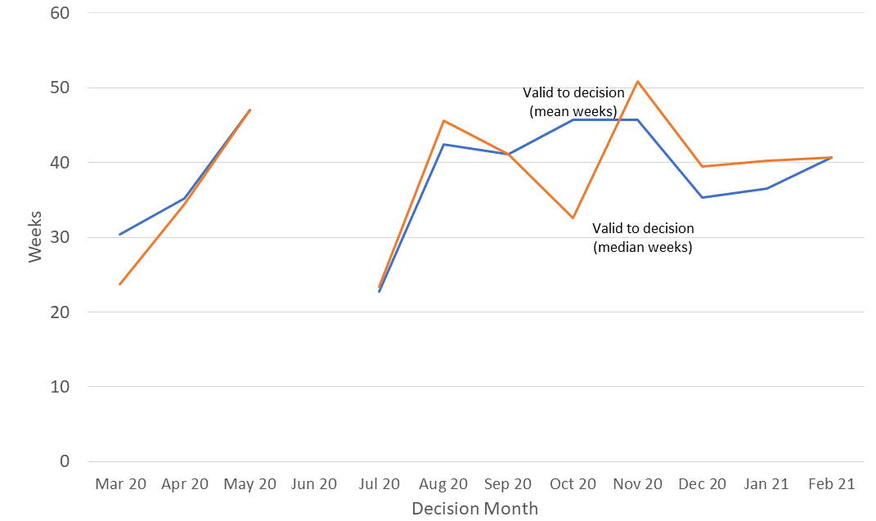
Source: Horizon
Note – no decisions were made during June 2020

Open Cases

At the end of February, the Planning Inspectorate had ten thousand five hundred cases open (10,487). This is an increase of 147 from the previous month. The open cases comprised 8,735 cases being handled through written representations; 1,041 through hearings; and 660 through inquiries. This is not the number of ‘live’ hearings and inquiries since it includes cases where the event (hearing or inquiry) has yet to start, as well as those where the event has finished but the decision has yet to be issued.

For each procedure type, there are more cases with an event scheduled but not yet started, than at any other stage in the process.

This information provides a ‘snapshot’ in time. As subsequent ‘snapshots’ are issued, more insight will be possible – including such issues as how the numbers and proportions change over time. Event refers to either a site visit, hearing or inquiry.

Table 10: Open cases by procedure and stage, as of end of February 2021
Procedure | Case received but yet to be deemed valid | Case deemed valid, event date yet to be set / in the future | Event complete but decision not yet issued |  | Total
Written Representations | 978 | 6167 | 1,590 |  | 8,735
Hearings | 75 | 853 | 113 |  | 1,041
Inquiries | 4 | 546 | 110 |  | 660
Total | 1,057 | 7,609 | 1,821 |  | 10,487
Source: Horizon and Picaso
Note there are 51 cases that have no procedure type recorded (see Background Quality Report for more detail)

Inspectors

Table 11 below shows the number of inspectors in the Planning Inspectorate in each month from March 20 and February 21. This includes headcount (i.e. the number of different individuals) and full-time equivalents (FTE) where those working part time are counted in proportion with their contracted hours. There were 345 Planning Inspectors employed by the Inspectorate in February 21 – with a full-time equivalent of just over 308.1.

By both measures (headcount and FTE) the maximum Inspector resource was in March 2020; and by both, the number at the end of Jan 21 was the lowest.

Table 11: Planning Inspectors – Headcount and FTE; Mar 20 to Feb 21 (at end of month)
Month | Mar 20 | Apr 20 | May 20 | Jun 20 | Jul 20 | Aug 20 | Sep 20 | Oct 20 | Nov 20 | Dec 20 | Jan 21 | Feb 21
Headcount | 361 | 357 | 356 | 356 | 355 | 352 | 352 | 347 | 345 | 345 | 343 | 345
FTE | 323.6 | 320.8 | 319.1 | 319.0 | 318.2 | 316.0 | 316.4 | 310.0 | 308.1 | 308.1 | 305.4 | 308.1
Source: SAP HR

As above, Planning Inspectors work on a broader range of work than the appeals featured in this Release. They also work on applications and examinations. Please note that data on Planning Inspectors is only applicable to salaried employees (it does not include fixed term contract Inspectors or non-salaried Inspectors).

Virtual Events

The Planning Inspectorate has continued moving casework forward during the pandemic by adapting the ways of working so that examinations, hearings and inquiries (which would previously have been held face-to-face) could take place virtually.

The Inspectorate are continuing to increase the number of events carried out ‘virtually’. The table and graph below give the number of virtual events that have occurred each month. Data for March 2021 is an estimate.

There were 91 cases involving Virtual Events during February, with 86 estimated for March 2021.

Data quality and corrections
There are concerns about the quality and accuracy of the data collection methods for virtual events data. For National Infrastructure, the number given in the table is the number of projects that have held virtual events. The number in brackets is the number of individual events but this is potentially misleading as multiple sessions on the same day (e.g. morning and afternoon sessions) have been counted as separate events.

Please note that in the last release the period December 20 to February 21 indicated that no Local Plan events had been held virtually – this has been corrected to show 12, 5 and 7 plans having been held virtually in those respective months.

Table 12: Virtual Events, Jun-20 to Mar-21^{P}
Case Type | Jun-20 | Jul-20 | Aug-20 | Sep-20 | Oct-20 | Nov-20 | Dec 20 | Jan 21 | Feb 21 | Mar 21
s78 Hearings | 8 | 11 | 18 | 36 | 41 | 43 | 35 | 33 | 23 | 26
s78 Inquiries | 4 | 6 | 4 | 11 | 11 | 17 | 16 | 15 | 15 | 16
Enforcement | 0 | 1 | 3 | 9 | 15 | 18 | 20 | 28 | 34 | 26
Local Plans | 1 | 2 | 3 | 7 | 14 | 12 | 12 | 5 | 7 | 5
National Infrastructure | 3  (3) | 1  (3) | 1  (2) | 2  (3) | 10  (30) | 3  (9) | 6  (18) | 3  (7) | 4  (8) | 2  (2)
Other | 0 | 1 | 0 | 0 | 4 | 16 | 6 | 13 | 8 | 11
Total | 16  (16) | 22  (24) | 29  (30) | 65  (66) | 95 (115) | 109 (115) | 95 (107) | 97 (101) | 91  (95) | 86  (86)
Source: Virtual Events Project Dashboard, data as at 11/03/21
Numbers in brackets show count of events but note concerns above over counting sessions on same day. Local Plans are counted as cases where at least one sitting day occurred in a month.
Other case type includes specialist casework like Environmental appeals, Transport examinations and Rights of Way cases
P – These numbers should be treated as provisional due to concerns about quality and accuracy.
Figure 8: Virtual Events; Jun 19 to Mar 21
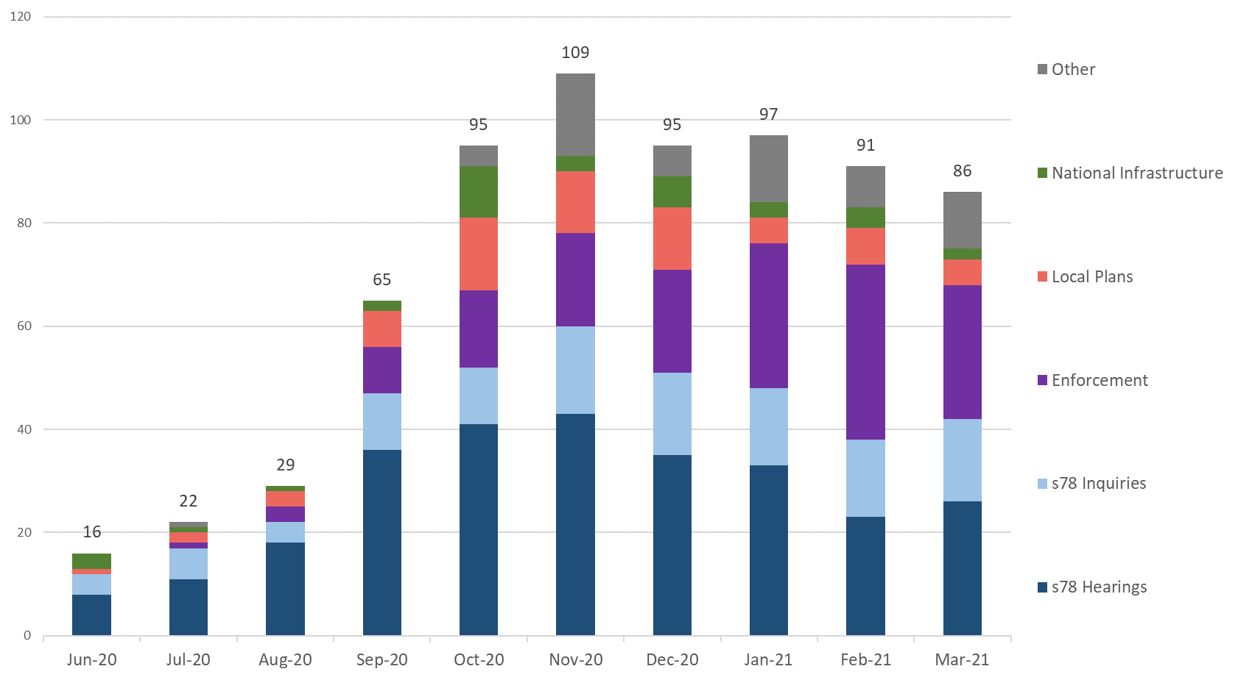
Source: Virtual Events Project Dashboard, data as at 11/03/21
P – These numbers should be treated as provisional.

Note – some cases can have multiple ‘events’ – for example an inquiry may sit over four to eight days but would only be counted as one ‘event’. On the other hand, casework like National Infrastructure may have multiple events for the same project. Local Plans are counted as cases where at least one sitting day occurred in a month.

Annex A – Content of ad-hoc Statistical Releases, 2020

Note: The Table below covers ad-hoc statistical releases. From November onwards, the content is fixed, so is the same as this publication.

Date | March 2020 | April 2020 | July 2020 | September 2020 | October 2020
Content | Appeals receipts and decisions in the last 12 and 24 months (1st March 2018 – 29th February 2020)  Number of section 78 Planning Appeals received / decided / within target that used the written representation method in the last 12 months (1st March 2019 – 29th February 2020)  Number of dwellings decided and number of dwellings allowed by appeal decisions between 1st January 2017 and 31st December 2019.  Number of Planning Inspectors employed by the Planning Inspectorate at the end of each quarter between 31st March 2017 and 31st December 2019. | Appeals receipts and decisions between 17th March 2020 and 22nd April 2020  Live appeals in the system as at 23rd April 2020  Number of appeals involving housing within the system as at 23rd April 2020  Virtual site visits | Appeals decisions between 17th March 2020 and 22nd June 2020  Number of open cases  Number of virtual events  Number of appeals  involving housing within the system as at 12th June 2020 | Appeals decisions between 17th March 2020 and 21st September 2020  Number of open cases  Number of virtual events | Appeals decisions from October 2019 to September 2020  Number of open cases  Number of virtual events
Scope | England only  Planning cases, Enforcement cases and Rights of Way orders | England only  Planning cases, Enforcement cases and Rights of Way orders | England only  Planning cases, Enforcement cases and Rights of Way orders | England only  Planning cases, Enforcement cases and Rights of Way orders | England only  Planning cases, Enforcement cases, Specialist cases: Common Land, Rights of Way orders, Tree Preservation Orders, High Hedges appeals and Hedgerow appeals

Annex B – Mean and median time to decision, with standard deviation, for planning, enforcement and specialist casework
Planning
Measure | Procedure | Mar 20 | Apr 20 | May 20 | Jun 20 | Jul 20 | Aug 20 | Sep 20 | Oct 20 | Nov 20 | Dec 20 | Jan 21 | Feb 21 | Total
Valid to decision (mean weeks) | Written Representations | 20.3 | 24.3 | 26.5 | 23.2 | 22.6 | 22.5 | 23.3 | 25.3 | 26.6 | 24.6 | 23.6 | 22.5 | 23.5
 | Hearings | 42.0 | 40.8 | 42.9 | 50.0 | 46.7 | 42.2 | 51.3 | 39.7 | 35.4 | 45.9 | 46.2 | 41.2 | 42.6
 | Inquiries | 40.3 | 56.2 | 69.4 | 62.0 | 22.7 | 60.0 | 41.1 | 44.6 | 54.9 | 35.3 | 40.4 | 50.6 | 45.2
 | All Cases | 21.6 | 25.2 | 27.1 | 23.5 | 22.9 | 23.0 | 23.7 | 25.6 | 27.0 | 25.4 | 24.5 | 23.2 | 24.1
Valid to decision (median weeks) | Written Representations | 18.0 | 20.3 | 23.3 | 21.3 | 22.0 | 21.7 | 22.3 | 23.9 | 25.4 | 22.0 | 20.4 | 19.4 | 21.0
 | Hearings | 42.9 | 36.1 | 42.0 | 42.4 | 34.4 | 45.1 | 43.1 | 34.0 | 36.1 | 43.0 | 46.6 | 46.4 | 40.3
 | Inquiries | 30.3 | 42.4 | 69.4 | 62.0 | 23.4 | 49.2 | 41.1 | 34.8 | 53.9 | 39.4 | 40.7 | 42.9 | 40.0
 | All Cases | 18.6 | 20.9 | 23.7 | 21.3 | 22.1 | 21.9 | 22.6 | 24.1 | 25.6 | 22.7 | 20.7 | 19.8 | 21.4
Standard Deviation (weeks) | Written Representations | 9.7 | 14.1 | 13.7 | 9.2 | 8.8 | 10.4 | 8.8 | 10.7 | 10.9 | 11.4 | 10.8 | 10.6 | 10.7
 | Hearings | 16.9 | 15.1 | 14.7 | 24.9 | 27.9 | 9.7 | 20.5 | 18.5 | 13.9 | 17.4 | 23.0 | 16.7 | 18.7
 | Inquiries | 21.0 | 30.4 | 22.4 | 1.6 | 1.4 | 41.8 | 1.1 | 20.8 | 13.1 | 10.2 | 18.4 | 29.0 | 23.5
 | All Cases | 11.6 | 15.0 | 14.4 | 10.0 | 9.6 | 11.4 | 9.8 | 11.3 | 11.3 | 12.3 | 12.3 | 11.6 | 11.7

Enforcement
Measure | Procedure | Mar 20 | Apr 20 | May 20 | Jun 20 | Jul 20 | Aug 20 | Sep 20 | Oct 20 | Nov 20 | Dec 20 | Jan 21 | Feb 21 | Total
Valid to decision (mean weeks) | Written Representations | 31.7 | 34.1 | 33.0 | 35.0 | 37.2 | 36.8 | 37.1 | 41.4 | 36.7 | 38.4 | 36.5 | 35.4 | 36.3
 | Hearings | 67.9 | 69.7 | 74.8 | 94.8 | 96.5 | 34.4 | 34.3 | 84.4 | 54.4 | 64.3 | 82.7 | 66.3 | 73.4
 | Inquiries | 72.7 | 88.5 | 91.6 | 85.6 | - | - | 84.6 | 43.9 | 62.5 | 102.9 | 94.7 | 108.7 | 83.4
 | All Cases | 34.1 | 39.6 | 34.9 | 37.5 | 38.0 | 36.8 | 37.5 | 42.8 | 37.7 | 42.1 | 43.7 | 42.8 | 38.9
Valid to decision (median weeks) | Written Representations | 27.9 | 32.1 | 28.5 | 28.9 | 32.6 | 33.3 | 33.6 | 36.9 | 33.9 | 35.3 | 31.1 | 28.1 | 32.3
 | Hearings | 72.0 | 70.4 | 76.5 | 93.4 | 100.1 | 34.4 | 34.3 | 89.0 | 56.0 | 68.5 | 78.8 | 68.8 | 71.4
 | Inquiries | 85.9 | 101.1 | 91.6 | 87.0 | - | - | 84.6 | 42.6 | 56.1 | 99.0 | 96.9 | 125.3 | 86.0
 | All Cases | 29.3 | 35.2 | 29.4 | 29.0 | 33.0 | 33.3 | 33.6 | 38.4 | 34.6 | 36.9 | 37.6 | 34.9 | 33.6
Standard Deviation (weeks) | Written Representations | 14.2 | 12.6 | 15.6 | 18.2 | 21.8 | 17.3 | 14.9 | 19.3 | 16.3 | 18.9 | 23.1 | 17.8 | 17.8
 | Hearings | 19.0 | 16.0 | 16.4 | 16.6 | 5.2 | 0.0 | 0.0 | 12.8 | 12.3 | 22.6 | 23.2 | 22.2 | 25.0
 | Inquiries | 22.3 | 25.8 | 3.5 | 7.6 | - | - | 0.0 | 10.1 | 10.1 | 19.2 | 21.0 | 23.2 | 25.0
 | All Cases | 17.4 | 20.4 | 18.2 | 21.3 | 22.6 | 17.3 | 15.5 | 20.5 | 16.8 | 23.0 | 28.9 | 26.7 | 20.9

Specialist
Measure | Procedure | Mar 20 | Apr 20 | May 20 | Jun 20 | Jul 20 | Aug 20 | Sep 20 | Oct 20 | Nov 20 | Dec 20 | Jan 21 | Feb 21 | Total
Valid to decision (mean weeks) | Written Representations | 39.1 | 32.6 | 29.4 | 37.4r | 40.9r | 34.6 | 45.2 | 38.9 | 37.5r | 43.6 | 42.7 | 53.8 | 0.0
 | Hearings | 58.7 | - | - | - | - | 62.1 | - | - | - | - | 89.8 | 65.0 | 70.8
 | Inquiries | 45.0 | 67.7 | 65.0 | 62.0 | 71.6 | 47.9 | 63.7 | 37.3 | 66.7 | 59.9 | 58.4 | 77.6 | 58.6
 | All Cases | 39.9 | 33.8 | 32.3 | 40.6 | 42.3 | 37.6 | 47.0 | 38.8 | 39.4 | 44.3 | 46.1 | 54.7 | 41.2
Valid to decision (median weeks) | Written Representations | 34.0 | 26.1 | 18.6 | 34.5 | 39.8 | 35.9 | 48.1 | 33.7 | 39.1 | 42.4 | 43.6 | 53.3 | 36.0
 | Hearings | 58.7 | - | - | - | - | 62.1 | - | - | - | - | 102.1 | 65.0 | 63.1
 | Inquiries | 41.5 | 45.4 | 65.0 | 63.5 | 71.6 | 43.1 | 65.0 | 37.3 | 60.4 | 59.9 | 64.0 | 81.9 | 54.7
 | All Cases | 36.5 | 26.1 | 19.9 | 37.1 | 40.9 | 37.3 | 48.7 | 35.5 | 41.1r | 44.0 | 52.9 | 54.0 | 38.0
Standard Deviation (weeks) | Written Representations | 20.4 | 20.1 | 16.3 | 22.6 | 16.4 | 17.0 | 24.5 | 26.6 | 16.7 | 25.6 | 33.3 | 24.0 | 24.0
 | Hearings | 0.0 | - | - | - | - | 0.0 | - | - | - | - | 18.1 | 0.0 | 22.5
 | Inquiries | 6.6 | 35.5 | 0.0 | 6.5 | 0.6 | 13.4 | 12.7 | 0.0 | 17.3 | 13.1 | 19.5 | 19.9 | 20.2
 | All Cases | 19.8 | 21.8 | 18.5 | 23.1 | 17.2 | 17.7 | 24.3 | 26.4 | 18.3 | 25.4 | 33.7 | 24.2 | 24.5
r denotes revision – a change of more than 0.5 weeks since last month.

Annex C – Detailed Information on timeliness (February)

The information below is published today on the number and length of decisions made in February 2021:
Casework Type | Procedure Type | Mean (weeks) | Median (weeks) | Decisions
s78 planning appeals | Written Representations | 23.8 | 20.6 | 811
 | Hearings | 41.2 | 46.4 | 33
 | Inquiries | 52.1 | 43.8 | 8
Householder appeals | Written Representations | 18.9 | 16.4 | 343
Enforcement appeals | Written Representations | 35.4 | 28.1 | 95
 | Hearings | 66.3 | 68.8 | 10
 | Inquiries | 108.7 | 125.3 | 7

The smaller the number of decisions, the less helpful the mean and median are as measures for summarising performance. Particular care should be taken when there are fewer than twenty decisions. These are shaded grey in the table but have been provided for completeness and transparency.

The information published below shows the time taken for different stages of the appeals process:
 | s78 planning appeals |  |  | Householder appeals
 | Written Representations | Hearings | Inquiries
Weeks between valid date & start date
Mean (average) | 9.2 | 19.0 | 5.5 | 4.9
Median (average) | 8.0 | 19.0 | 2.4 | 4.0
Cases that started in Feb 21 | 804 | 121 | 20 | 419
Weeks between start date & event date
Mean (average) | 12.4 | 30.1 | 32.3 | 6.3
Median (average) | 9.7 | 27.0 | 24.0 | 4.9
Cases where an event occurred during Feb 21 | 707 | 38 | 17 | 436
Weeks between event date & decision date
Mean (average) | 5.0 | 5.6 | 11.6 | 4.1
Median (average) | 3.3 | 4.3 | 12.1 | 2.3
Cases that have been decided in Feb 21 | 811 | 33 | 8 | 341

- Valid date – the date a case is deemed to have been validly received
- Start date – date when a case has started its documentation phase (requesting statements and additional information) and an Inspector resource has usually been identified to carry out the case
- Event date – the date of either a site visit, hearing or inquiry
- Decision date – the date the decision was issued by The Planning Inspectorate
Annex D – Casework types included in this release

Planning covers s78 planning appeals, Householder appeals, Commercial appeals, s20 Listed Building appeals, Advertisement appeals, s106 Planning Obligation appeals and Called In Planning Applications.

Enforcement covers s174 Enforcement appeals, s39 Enforcement Listed Building appeals and Lawful Development Certificate appeals.

Specialist casework includes Common Land, Rights of Way orders, Purchase orders, Tree Preservation Orders, High Hedges appeals and Hedgerow appeals.
Note that the data on Open Cases excludes Tree Preservation Orders and High Hedges and Hedgerow appeals.

Background notes

Data sources
Horizon / Picaso – The main casework management systems used for processing appeals casework.
SAP HR – The Human Resources system database used to store all information regarding members of staff.

Measure | Definition
Mean | The total time taken divided by the number of cases. Also referred to as the ‘average’. A measure of how long each case would take, if the total time taken was spread evenly across all cases.
Median | This is the time taken by the ‘middle’ case if all cases were sorted from quickest to longest
Standard deviation | This is a measure of variability or spread. It is calculated by examining how much each value differs from the mean. A higher standard deviation means the individual decision times vary more widely around the mean.

Compliance with the Code of Practice for Statistics
These statistics have been published in accordance with the Code of Practice for Statistics, which cover trustworthiness, quality and value. They have been pre-announced, and publication is overseen by the Head of Profession.

Technical Notes
A Background Quality Report is published alongside this Statistical Release. It provides more detail on the quality of statistics in this publication.

Data quality | Data on cases is taken from a live casework system, and details of cases can change for a number of reasons even after a decision has been made. We are seeking to get a better understanding of the nature and volume of these changes and will provide further information as it is available.  We carry out regular checks on the quality of our data and may undertake ad hoc data cleansing exercises. Therefore, all the data for the last 12 rolling months is published in provisional form.  We have indicated in this publication any data where a number of cases has changed by more than five cases in a month; or where a measure (mean, median or standard deviation) has changed by more than 0.5 weeks.
Virtual Events | Data is currently being sourced from an operational MS Excel workbook. It is therefore being constantly updated and refined and may result in data may changing between monthly publications.  There are concerns about the quality and accuracy of the data collection methods. Definitions of what constitutes an event are being refined, as this differs according to the type of casework. Whilst this work is in progress these numbers should be treated as provisional.  Data for Local Plans is now being sourced from information recorded by Inspectors on their timesheets.
Measuring weeks | Data are measured in days and then converted to weeks.  Note that not all decimal values are possible where converting days to weeks. 1 day is 1/7 of a week, or 0.14 weeks (to two decimal places). 2 days = 0.29; 3 days = 0.43; 4 days = 0.57; 5 days = 0.71; 6 days = 0.86.  When these are used to calculate averages, or displayed to one decimal place, the result will not equate to a full day which can be misleading: it may appear that we are measuring part days (e.g. 19.8 weeks) but we only measure in whole days.

Glossary
Term | Explanation
Appeals | The right to appeal a planning decision made by a local authority is a key feature of the planning system, as is appealing when an authority is taking too long.
Appeals decided | Number of appeals by the date the appeal was decided by The Planning Inspectorate.
Appeals received | Number of appeals by the date the appeal was received by The Planning Inspectorate.
Applications | Planning Inspectorate manage the application process for proposed Nationally Significant Infrastructure Projects (NSIPs) within England and Wales in line with the 2008 Planning Act.
Closed | The total number of appeals decided, withdrawn or turned away.
Decision | The outcome of the case e.g. appeal allowed or rejected. The date of the decision is taken as the date a decision letter is sent to the appellant.
Event | A site visit, hearing or inquiry (may be virtual)
Event Type | The different options of how an Inspector visits a site for a written representations appeal.
Examinations | The process of examining local plans is dealt with by the Planning Inspectorate. Every Local Planning Authority is required to have a local plan. This includes a vision for the future and plan to address housing needs in the area.  When a Local Planning Authority has finished preparing and consulting on a local plan it must be submitted to the Secretary of State who appoints an Inspector to carry out an independent examination.
FTE | Full Time Equivalent – a count of employees where those working part time are counted in proportion with their contracted hours.
Headcount | Total number of staff employed regardless of how many hours they work (i.e. the number of different individuals).
Hearings | A hearing involves the submission of written evidence by the main parties and a hearing once all the written submissions have been received.  This takes the form of a round-the-table discussion (in person or virtually) that will be led by the planning inspector. It allows for all parties to respond to any questions that the inspector might have, and to let everyone make their case known.  Source: Planning Portal
Inquiries | An inquiry is usually used for complex cases where legal issues may need to be considered. The main parties will usually have legal representatives to present their case and to cross-examine any witnesses. Prior to the inquiry date, the Planning Inspectorate will expect to have received various documents from all parties that will be taking part in the appeal. These may include statements of case and proofs of evidence from expert witnesses. Third parties may also take part. The inquiry will be led by the inspector and will follow a formal procedure.  At some point during or on conclusion of the inquiry the inspector and the main parties will undertake a site visit.  Source: Planning Portal
Live appeals | Number of live appeals in that have an appeal valid date but no end date (either decision date or a closed date, e.g. for appeals that have been withdrawn).
Open Cases | Number of cases that have been received but on which a decision has not yet been made/ issued. Will differ from Live Appeals as it includes those received but not yet verified.
Procedure Type | The method by which The Planning Inspectorate processes and decides appeals.
Written Representations | Most planning appeals are decided by the written representations’ procedure. With this procedure the Inspector considers written evidence from the appellant, the LPA and anyone else who has an interest in the appeal. The site is also likely to be visited.

Contact Us

The Planning Inspectorate welcome feedback on our statistical products. If you have any comments or questions about this publication or about our statistics in general, you can contact us as follows:
Media enquiries 0303 444 5004
email press.office@planninginspectorate.gov.uk

Public enquiries email statistics@planninginspectorate.gov.uk

Please note we are currently reviewing our statistics with a view to making them as clear and helpful as possible for users. We would be delighted if you could contact us via the address below with any views on this approach; particularly on what content would be most useful and why.

email statistics@planninginspectorate.gov.uk

If you require information which is not available within this or other available publications, you may wish to submit a Request for Information under the Freedom of Information Act 2000 to the Planning Inspectorate. For more information, see: https://www.gov.uk/make-a-freedom-of-information-request/the-freedom-of-information-act

See Annex A for breakdown of what has been included in recent releases.
The appeal types are the same as last month. They include planning & related appeals, Enforcement and Specialist casework (covering a range of casework types). Please note that some previous releases covered only Rights of Way orders within Specialist casework. Annex A details the scope of previous releases, Annex D the scope of this release and Background Notes has further information.
Although the Inspectorate suspended all site visits, hearings and inquiries, Table 1 indicates that 59 events occurred during April 2020. Analysis of this data shows that 38 cases have incorrect data recorded for the date of the event. A further 21 cases have an event date recorded for April 2020, as operational systems require, but involved cases where no physical event was required, as these cases were decided based on documentation only. See the Background Quality Report for further information.
The appeal types are the same as last month. They include planning & related appeals, Enforcement and Specialist casework (covering a range of casework types). Please note that some previous releases covered only Rights of Way orders within Specialist casework. Annex A details the scope of previous releases, Annex D the scope of this release and Background Notes has further information.
The time to make a decision is measured from the time we judge we have enough information for the case to proceed (i.e. it is deemed ’valid’) to the time a decision letter is issued. We estimate that most cases are ‘validated’ (the difference between receipt date and the validation process being completed) in a week or less.
The decisions made in a given month will include those that started many months before, and thus do not give an accurate indication of how decisions submitted, or deemed ‘valid’ in that month, will take.
Specialist cases comprise Common Land, Rights of Way orders, Tree Preservation Orders, High Hedges appeals and Hedgerow appeals
Data also published on gov.uk at https://www.gov.uk/guidance/appeals-average-timescales-for-arranging-inquiries-and-hearings
Open cases are any that have been received but on which a decision has not yet been made/ issued. Cases included comprise Planning, Enforcement, and the following Specialist cases: Common Land, Environment, Purchase Notice and Rights of Way. Tree Preservation Orders, Hedgerows and High Hedges cases are excluded.
Data as at the last day of the month.
Virtual Events data includes casework types not covered elsewhere in this release, including Local Plans and Nationally Significant Infrastructure Projects.
Also published on gov.uk here https://www.gov.uk/guidance/appeals-average-timescales-for-arranging-inquiries-and-hearings

