 | November 2020

Freedom of Information Act (FOIA) Request – 201015021

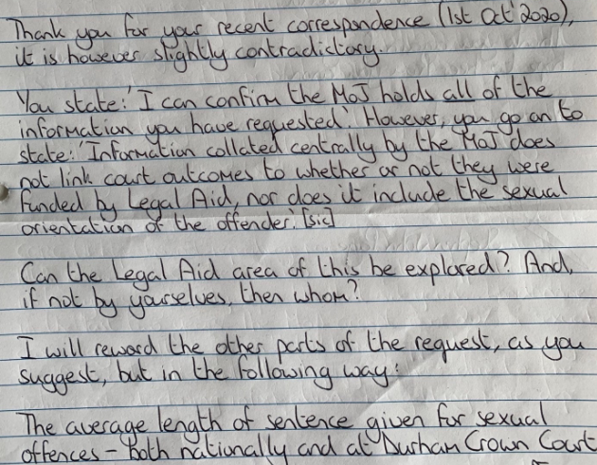
Thank you for your request in which you asked for the following information from the Ministry of Justice (MoJ):
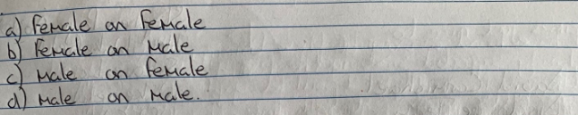

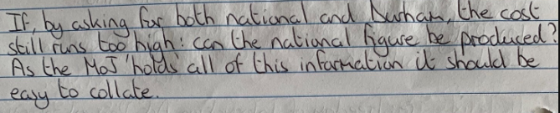

Your request has been handled under the FOIA.

I can confirm that the MoJ holds some of the recorded information that you have requested and I have provided it, covering the period from 2017 to 2019, in the Excel spreadsheet in the attached annex.

Care should be taken with average custodial sentence lengths where they are based on fewer than five cases.

Regarding the part of your FOIA request where you ask “Could the Legal Aid area of this be explored?” it is unclear exactly what you wish to be explored and what additional information, if any, you require? You may wish to submit a new request under the FOIA specifying the information you require. I am unable to answer this part of your request without further clarification. Section 1(3) of the FOIA does not oblige us to answer requests where we require further clarification to identify and locate the information requested.

So that I provide you with the right information, please can you explain what additional information you are requesting? On receipt of this information I will continue to process that part of your request.

