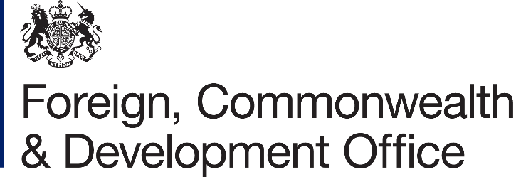

Information Rights Unit
WH 2.177
King Charles Street
London
SW1A 2AH
Email: information.rights@fcdo.gov.uk

3 March 2021

FREEDOM OF INFORMATION ACT 2000 - REQUEST REF: FOI2021/02711

Thank you for your email of 03/02/2021 asking for information under the Freedom of Information Act (FOIA) 2000. You asked:

I am doing a piece on the government’s progress towards its target of having 25% of its vehicle fleet be ULEVs by 2022 (excluding specialist vehicles). I see that FCDO Services have promoted their progress towards this target on their website and I was hoping you could provide me with an updated breakdown. i.e. the number of ULEVs and the total size of the fleet, excluding, where appropriate, specialist vehicles.

I am writing to confirm that we have now completed the search for the information which you requested.

I can confirm that the Foreign, Commonwealth & Development Office Services (FCDO Services) does hold information relevant to your request.

FCDO Services’ fleet of vehicles comprises 5 hybrid cars out of a fleet of 34 vehicles which includes 10 LGV/HGV lorries.

The article linked within your question refers to one of the services we provide to the Foreign, Commonwealth & Development Office (FCDO). This service includes the purchasing, outfitting and delivering of vehicles to overseas posts for the FCDO.

The vehicles referenced within the article are not a part of the FCDO Services fleet, but have been requested through this service by the FCDO. There could be additional vehicles purchased by the FCDO outside of the service we provide, we do not hold any information on those vehicles.

Since April 2019 we have placed 137 vehicle overseas for the FCDO, of which 63 were BEV’s, PHEV’s or MHEV’s. Please keep in mind this number includes both “flag cars” and “fleet cars”.

Once an FOI request is answered, it is considered to be in the public domain. To promote transparency, we may now publish the response and any material released on gov.uk in the FOI releases section. All personal information in the letter will be removed before publishing.

The copies of information being supplied to you continue to be protected by the Copyright, Designs and Patents Act 1988. You are free to use it for your own purposes, including any non-commercial research you are doing and for the purposes of news reporting. Any other re-use, for example commercial publication, would require the permission of the copyright holder. Most documents supplied by the FCDO will have been produced by government officials and will be protected by Crown Copyright. To re-use Crown Copyright documents please consult the Open Government Licence v3 on the National Archives website.

Information you receive which is not subject to Crown Copyright continues to be protected by the copyright of the person, or organisation, from which the information originated. You must ensure that you gain their permission before reproducing any third party (non-Crown Copyright) information.

If you wish to make a complaint or if you would like a review of our decision, please write to the Information Rights Unit, Foreign, Commonwealth & Development Office, Room WH 2.177, King Charles Street, London, SW1A 2AH. E-mail: information.rights@fcdo.gov.uk You have 40 working days to do so from the date of this letter.

If you are not content with the outcome of your complaint, you may then apply directly to the Information Commissioner for a decision. Generally, the Information Commissioner cannot make a decision unless you have exhausted the complaints procedure provided by the FCDO. The Information Commissioner can be contacted at: Information Commissioner's Office, Wycliffe House, Water Lane, Wilmslow, Cheshire SK9 5AF, or online at: https://ico.org.uk/make-a-complaint/

Yours sincerely,

FCDO Services

