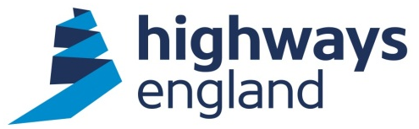

Our reference: EIR101745 | Senior Project Manager  Regional Investment Programme (South East)  Highways England  Bridge House  1 Walnut Tree Close  Guildford GU1 4LZ  19 February 2021
Dear

I am writing to confirm that we have now completed our search for the information, which you requested on 22 January 2021.

With regard to the Scheme Assessment Report for the Arundel bypass, published in October 2020, you asked ’Can you please tell me what this new and important information was?’

information you requested is available via;
https://www.gov.uk/government/news/arundel-bypass-further-consultation-next-spring. A copy of the relevant information is below.

This new information includes a redesign of the western end of the scheme where it re-joins the existing A27, updated traffic modelling results and updated data on and enhancements of the alternative Options 1 and 3.

If you are unhappy with the way we have handled your request you may ask for an internal review. Our internal review process is available at:
https://www.gov.uk/government/organisations/highways-england/about/complaints-procedure

If you require a print copy, please phone the Information Line on 0300 123 5000; or e-mail info@highwaysengland.co.uk. You should contact me if you wish to complain.

If you are not content with the outcome of the internal review, you have the right to apply directly to the Information Commissioner for a decision. The Information Commissioner can be contacted at:

Information Commissioner’s Office
Wycliffe House
Water Lane
Wilmslow
Cheshire
SK9 5AF

If you have any queries about this letter, please contact me. Please remember to quote reference number [EIR101745] in any future communications.

Yours sincerely

Senior Project Manger
Regional Investment Programme

We’d love to get your feedback about our reply to you today, simply click here to complete our short survey.

