Coronavirus vaccine (jab) consent form for adults

Coronavirus is an illness that lots of people are catching at the moment. Most people won’t get very poorly from coronavirus but some people have to go to hospital and some people might die from it.

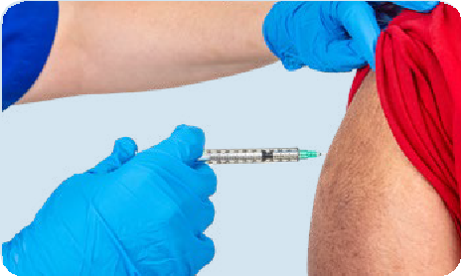
One way to help you stay safe is to get a coronavirus vaccine. The coronavirus
vaccine should stop you getting very poorly if you do catch coronavirus.

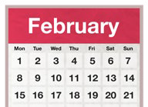It will take a few weeks for the vaccine to start working.
Month

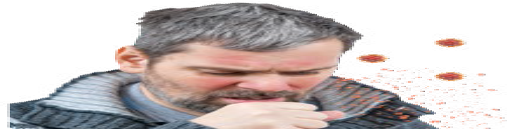There is a small chance that you can still catch coronavirus if you have had the vaccine.

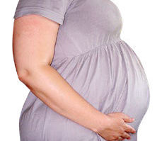If you are pregnant or might get pregnant, or if you are breastfeeding, it’s really important that you read all the information about the vaccine.

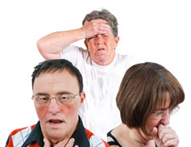
If you are not sure if it is safe to get the vaccine, talk to your doctor or nurse or someone else you trust.
You can’t catch coronavirus from having the vaccine.

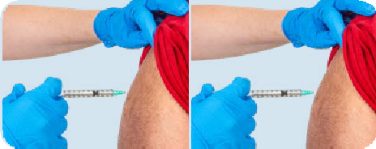You need to have two jabs for the vaccine to work as well as possible.

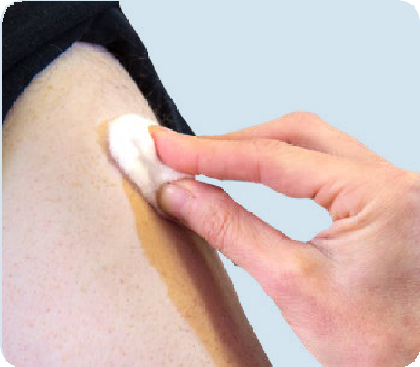
After your vaccine your arm might be a bit sore for a short time. You might also feel tired or have a headache.
This is called having side effects.
You can take painkillers like paracetamol for this.

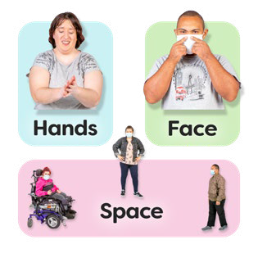You should carry on following the government’s rules to keep everyone safe even if you have had the coronavirus vaccine. This includes social distancing, wearing a face covering and washing your hands carefully and often.

About you

Full name (first name and surname):

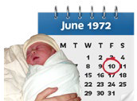
Date of birth:

Gender (tick as appropriate):
Male Female
Prefer not to say

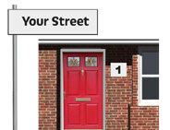
Home address:

NHS number (if you know it):

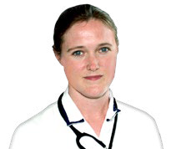
Care home address (if you live in a care home):
Doctor/GP name and address:

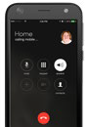
Your personal phone number:

Ethnicity (such as British, Irish, African, South Asian, Chinese, other):

I am a woman and I have read the leaflet on pregnancy and breastfeeding.

Consent to have the coronavirus vaccine
I want to receive the full course of coronavirus vaccine
Name:
Office use only

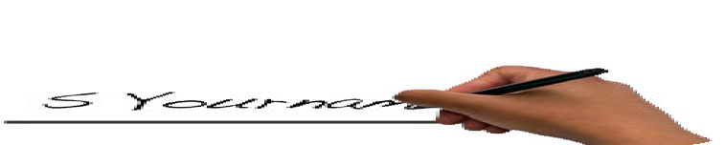
Signature:
Date:
Today
I don’t want to have the coronavirus vaccine
Name:

Signature:
Date:
Today
If you don’t want to have the vaccine can you tell us why?

Thank you for completing this form.
Please give the form back at your appointment.

Date of COVID-19 vaccination | Site of injection (please circle) |  | Batch number/ expiry date | Brand of Vaccine | Immuniser name and signature (please print) | Where administered (care home, home, GP etc)
First | L arm | R arm
Second | L arm | R arm

Public Health England gateway number 2020528. Product code: COV2020528 1P 10K FEB (APS) V1. FEB 2021. Other versions of these leaflets are available in braille, BSL, translated into many languages. Please visit Health Publications to order or download them: www.healthpublications.gov.uk/Login.html

