
Statistical Release
October to December 2020

Introduction

This statistical release presents statistics covering a range of casework dealt with by The Planning Inspectorate in England. This release should be read alongside the published tables on our gov.uk statistics pages.

Impact of COVID-19

The number of appeals received and decided in the first and second quarter of 2020/21 were affected by the COVID-19 outbreak.

The number of appeals received in the third quarter has returned to pre-outbreak levels. Compared to the corresponding quarter last year volumes were 1% higher for Section 78 (s78) planning appeals, down 1% for Householder appeals and 5% lower for Enforcement appeals. (see Tables 2.1, 2.6 & 3.1).

The number of appeals decided in the third quarter of 2020/21 has fallen for s78 planning appeals and Enforcement appeals but risen for Householder appeals, compared to the corresponding quarter last year. Volumes were 14% lower for s78 planning appeals, 11% lower for s174 Enforcement appeals and 34% higher for Householder appeals. (see Tables 2.4, 2.6 & 3.2).

At the beginning of the COVID-19 outbreak the Planning Inspectorate had to cancel most of the scheduled events due to concerns for the safety of both Inspectors and the public. During the pandemic Planning Inspectors have carried out many events, including Inquires and Hearings, virtually.

Section 78 planning appeals1

Overall volumes of s78 planning appeals received rose by 6% for the period October to December 2020 compared to July to September 2020 and are 1% higher than the same period in 2019/20 (see Table 2.1).

Decisions for s78 planning appeals were 27% higher than the previous quarter, returning broadly to pre-pandemic levels, and 14% lower in the third quarter of 2020/21 compared to the equivalent quarter in 2019/20 (see Table 2.4). The percentage of appeals allowed rose to 26% from the historic low of 22% in the first quarter of the year.

Figure 1 – s78 planning appeals received & decided

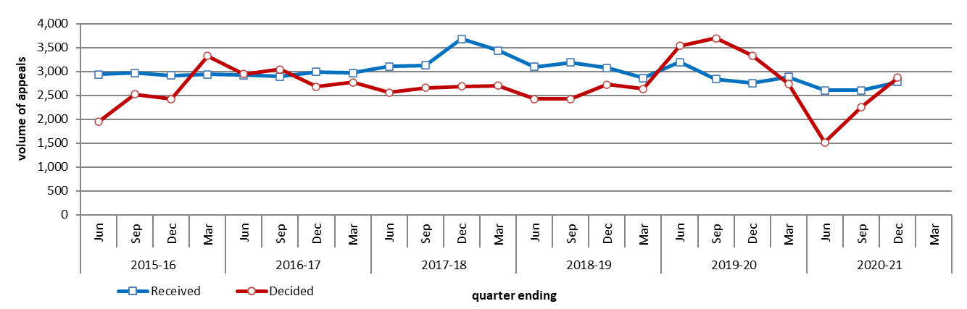

Note:- Approximately 5% of s78 planning appeals received are subsequently withdrawn or turned away.

Figure 2 – % of s78 planning appeals allowed
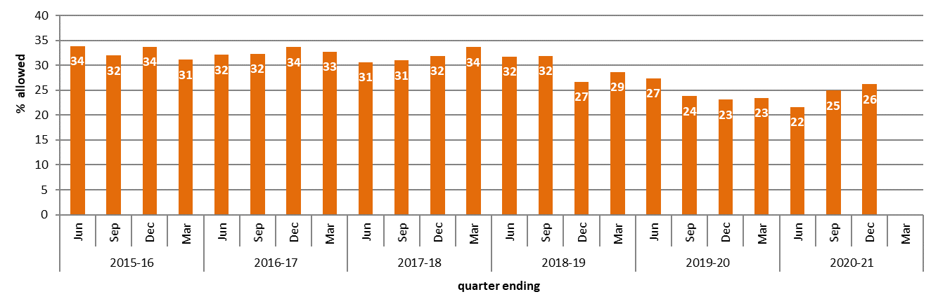

Householder appeals
The volume of householder appeals received in the third quarter of 2020/21 was broadly stable (down 1%) compared to the equivalent quarter in 2019/20 (see Table 2.6). The number of decisions in the third quarter of 2020/21 was 34% higher than the equivalent quarter in 2019/20. Both the number of householder appeal receipts and decisions have recovered to pre-pandemic levels. The percentage of householder appeals allowed has risen to 38%.

Figure 3 – Householder appeals received and decided

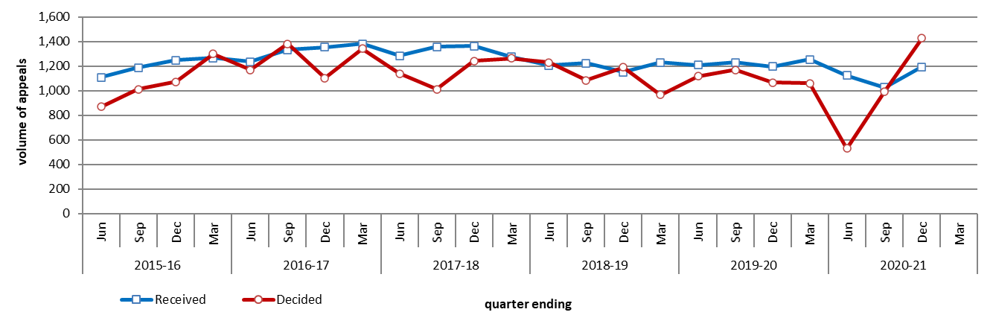
Section 174 Enforcement appeals1
The number of Section 174 (s174) enforcement appeals received rose by 32% in the period from October to December 2020 compared to July to September 2020 and are returning to levels seen before the pandemic The number of decisions was 15% lower than the previous quarter and 11% lower than the equivalent period in 2019/20 (see Table 3.2).

Figure 4 – s174 enforcement appeals received and decided

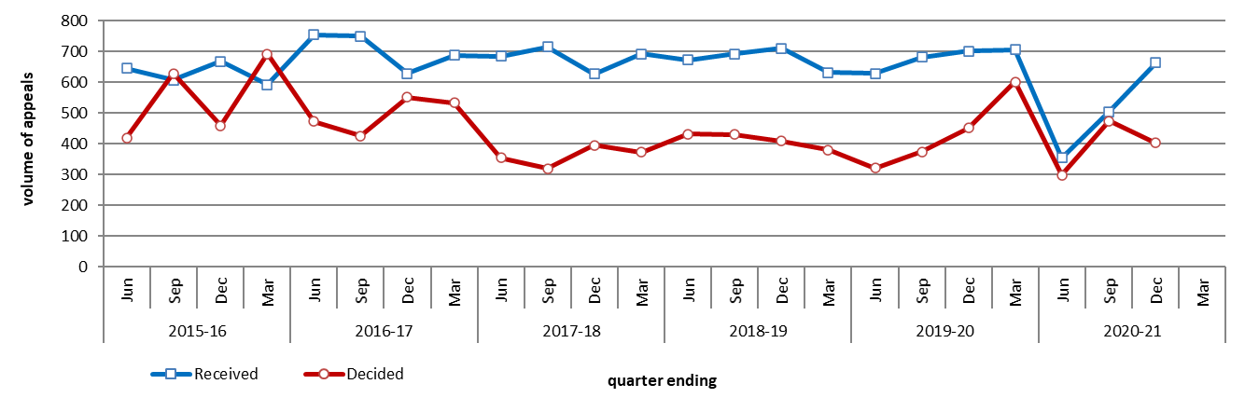

1 Section 78 and Section 174 refer to the Town and Country Planning Act 1990
Section 78 - appeals against refusal of planning permission; Section 174 – appeals against an Enforcement Notice
Future publication of this data

From May 2021 onwards, quarterly, and annual statistics published by The Planning Inspectorate will be published on the same day as we publish our monthly statistical release. Quarterly statistics will be published in the months of February, May, August and November. Annual statistics will be published in May each year. If you have any comments or concerns about this approach, please email the address below.

Technical Notes

Data collection | Data in this release has been extracted from The Planning Inspectorate’s main casework operational system.
Data quality | We carry out regular checks on the quality of our data and may undertake ad hoc data cleansing exercises. Therefore all the data for the last 12 rolling months is published in provisional form. Once this period has expired published data is only altered if a significant error is found.

Contact Us

Media enquiries | 0303 444 5004  email press.office@planninginspectorate.gov.uk
Public enquiries | email statistics@planninginspectorate.gov.uk

