Department for Environment, Food and Rural Affairs CSG 15
Research and Development

Final Project Report
(Not to be used for LINK projects)
Two hard copies of this form should be returned to:
Research Policy and International Division, Final Reports Unit
DEFRA, Area 301
Cromwell House, Dean Stanley Street, London, SW1P 3JH.
An electronic version should be e-mailed to resreports@defra.gsi.gov.uk

Project title | Prediction of Future Coastal Evolution for SMP Review

DEFRA project code | FD2002

Contractor organisation and location | Halcrow Group Ltd  Burderop Park  Swindon

Total DEFRA project costs | £ 1,139,352

Project start date | 01/10/00 |  | Project end date | 31/08/02

Executive summary (maximum 2 sides A4)

Background
Following the joint MAFF / Welsh Office publication of a flood and coastal defence strategy for England and Wales in 1993, coastal managers and decision makers were encouraged to work together in coastal groups to develop Shoreline Management Plans (SMPs). These non-statutory plans are considered to be a key part of sustainable coastal defence planning, identifying future policy that is technically and environmentally sustainable and economically viable. The first round of SMPs, covering the whole coastline of England and Wales, were completed between 1995 and 2000. It is expected that the SMPs will be regularly updated and revised on approximately a 5 year basis. Revisions are necessary to take account of changes that have taken place including progress with recommended studies and works in the original SMPs.

The first round SMPs represented a significant step forward in long-term strategic planning. Comparative reviews of some of the 49 SMPs have, however, indicated considerable inconsistencies in the consideration given to coastal processes, geomorphology and the prediction of future coastal evolution. Furthermore, there was often a lack of appreciation of long-term shoreline evolution and therefore insufficient use of such knowledge as a basis for identifying sustainable shoreline management policies. Some of the first generation SMPs have therefore been criticised for not making appropriate long-term decisions, partly due to the lack of data on long-term evolution. In order to improve the next round of SMPs there needs to be improved understanding of the processes acting along the shoreline and how the coast may evolve in the long term.

In order to help guide the next round of SMPs, which is due to start in 2002, the Department for Environment, Food and Rural Affairs (DEFRA) and the National Assembly for Wales have collaborated in the promotion of this coastal process and geomorphological study of the coastline, which has become known as Futurecoast. The study provides a sound, scientific and nationally-consistent basis for predicting coastal change in England and Wales over the next 100 years, with the aim to provide SMPs with a vision of coastal change in the longer term. This research will help enable coastal defence operating authorities to develop sustainable holistic plans with more confidence. The revised SMPs will, in turn, assist planners in developing policies that discourage inappropriate development in their statutory plans.

Overview of the Futurecoast Study
The Futurecoast study was commissioned by DEFRA and carried out by a team led by consultants Halcrow Group Ltd over a period of approximately 21 months. The study provides predictions of coastal evolutionary tendencies over the next century, which are to be considered in the updating of SMPs and other Strategic Plans targeted at determining broad scale future coastal defence policy throughout the open coast shorelines of England and Wales.

The study has considered fresh approaches to assessing shoreline evolution within such plans. The analysis of future shoreline evolution potential for each section of coast, which is the main component of the study, provides an improved understanding of the coastal systems and their behavioural characteristics. A framework to enable consistent reporting, assimilation and presentation of the study results has been developed.

The study has included a range of supporting studies, focussing upon maximising use of existing information and experience. A number of additional data sets have also been produced. The integration of leading expertise from different areas of coastal research to collectively consider this information has been the foundation for the study.

The output from the study includes reports, guidance, data and mapping at various scales. This is presented on a single interactive CD within an application that includes links between map views and report browsers, enabling easy and rapid access to specific information on any subject relating to the area of interest, together with an ability to compile maps and reports. This is supplemented by two further CDs, which contain oblique aerial photographs covering the entire open coast of England and Wales.

Outputs from the Study
The main outputs from this research are:

- Improved understanding of coastal behaviour – this has used and built upon the information contained within the first round of SMPs and other existing studies;
- Assessment of potential future shoreline behaviour for two scenarios: unconstrained (i.e. assuming no defences or management practices) and managed (i.e. assuming present management practices continue indefinitely);
- A ‘toolbox’ of supporting information and data that can be used in future assessments of shoreline behaviour – this includes (1) the background thematic studies produced for this project and (2) the additional data sets and information generated.

The key conclusions from the project are presented in a series of statements known as Shoreline Behaviour Statements. These statements describe both the current understanding of coastal behaviour and the predictions of future coastal evolution at both the large-scale and local-scale. This information has also been mapped.

In addition to these statements is a series of thematic reports, which were produced to assist in the development of the Shoreline Behaviour Statements. These reports, some of which are also accompanied by mapped data, cover the subjects of onshore and offshore geology, coastal processes, estuaries and climate change. These have provided useful background information during the study and may be useful for future projects, in addition to the next generation SMPs. Supplementing these reports are additional tools, including a reference manual on coastal geomorphology and a Futurecoast user guide.

There have also been a number of data sets generated as part of this research, which have been provided as output for potential further use and development. Much of this information has also been provided as mapped data or is linked to the maps. Included in these data sets are cliff behaviour assessments, analysis of historic shoreline movement, uncertainty classification and data on nearshore wave conditions and climate change impacts.

The CD-ROM
Following consultation with potential end-users and the client group, it was concluded that the most useful way to present the study results was via an interactive CD-ROM. This has many advantages in terms of the way data can be accessed and displayed, particularly for a project of this scale. Although this is a national project, many of the end-users will mainly be interested in specific areas and the CD-ROM is designed to make it easy to access the relevant data. The user can navigate through both the text and mapped data and there are links from the maps to the relevant sections of text. The user is also able to ‘design’ reports. Therefore no hard copies of reports have been produced, but users will be able to print from the CD-ROM and produce reports to their own specification.

The Aerial Photograph CDs
It was recognised at an early stage that it would be necessary to enable the study team to become quickly familiar with the section of coast that they were analysing. A key step was therefore the capture of the entire coastline of England and Wales as an oblique aerial digital video, shot from a helicopter in early 2001. Images have been extracted from the video and are provided to the end-users on two supplementary CDs. The aerial images are accessed via a digital interactive map-based viewing system, which enables easy location of coastal sections.

Use of Futurecoast Results
The study output is specifically targeted at the Coastal Groups and the consultants that will be assisting Coastal Groups in preparing revisions to SMPs. It will also feed into more detailed coastal defence strategy plans that are being developed.

User guidance is provided on the CD-ROM to inform end-users of the content of the Futurecoast study, how information can be accessed and how to navigate through the system. Guidance is also provided on how this information should be used in developing future assessments of coastal evolution, e.g. in the SMPs.

The results of the Futurecoast study will help to ensure that the second round of SMPs are better informed and are therefore able to make strategic coastal management decisions in a longer term and wider scale context. Futurecoast does not provide definitive predictions of future coastal evolution, because this is dependent upon the implementation and sustainability of the coastal management policies. It does, however, provide a knowledge base that can be used by coastal managers to help define sustainable policies, alongside other tools available to the developers of the second generation SMPs.

In addition to achieving the primary aims of this study, it is hoped that the Futurecoast project will have added another dimension to the way in which the coastal manager and the coastal engineer think about the nature of the environment within which they are working, when making decisions for the future of our shorelines.

Scientific report (maximum 20 sides A4)

INTRODUCTION
In England and Wales, coastal management has progressively moved away from the traditional re-active and parochial approach of providing localised hard-engineered coastal defence works to solve what was often perceived to be a local problem, with little consideration of wider effects. Unlike previous assessments of the UK coast, which have primarily focused upon contemporary hydrodynamic and sediment transport processes, the methodology adopted in this project is a geomorphology-based approach, which has focused upon providing an improved understanding of large-scale coastal behaviour. This approach involves the identification of different elements that make up the coastal structure and developing an understanding of how these elements interact and respond over different spatial and temporal scales. It is essentially a qualitative approach based upon conceptual understanding of the fundamental elements that make up the coastline of England and Wales and how these evolve.

PROJECT TEAM
To undertake this project, Halcrow recognised the need to bring together an expert team with the ability to integrate an understanding of geomorphology, sediment dynamics, and hydrodynamics, in a balanced way. The Core Team included Halcrow, who have been involved in all aspects of this study at both a technical level and in managing the project; British Geological Survey (BGS), who have provided the main contribution to the core data generation and mapping relating to geology and geomorphology of the coastline and offshore regions, as well as sourcing of information and the generation of thematic reports on these subjects; Risk & Policy Analysts (RPA), who have developed the methods and produced the tools to be used for assessing uncertainty and have also researched and developed the climate change scenarios; and ABPmer, who reviewed coastal processes and were involved in the analysis of the shoreline movement data. Other individuals, commissioned to contribute to the project at various stages of its development via workshops and to review the study output, complemented this team.

In developing the methodology for this project and to ensure high standards throughout the project, an Internal Panel was also appointed. This panel included Julian Orford (Queens University, Belfast), Ian Townend (ABPmer), Chris Fleming (Halcrow) and Keith Dyer. The remit of the panel has been to examine the approaches advocated and provide technical direction to the project.

An external Steering Group was also appointed by the client, which has had full input throughout the project. This comprised Jim Hutchison (Project Manager, DEFRA), Andy Parsons (DEFRA), Jane Rawson (Environment Agency), Tim Collins (English Nature) and Ron Eckersley (Lancaster City Council).

Castle Air Charters Ltd. were employed to undertake the aerial video survey of the coastline of England and Wales and RSK Orbital Ltd developed the digital interactive map-based viewing system for the aerial footage and provided the CD-based product. Walter Burrough was employed to develop the main interactive CD deliverable. This has involved the development of a system including creation of links and installation and integration of data (both map-based and text).

APPROACH
Development of the first round of Shoreline Management Plans (SMPs) was based upon littoral cell boundaries, which had previously been defined at zones of sediment convergence and divergence. The benefit of the cell approach was that it reflected regional processes on a basis that was easy to communicate and it was therefore quickly adopted. However, whilst the littoral cell concept is a valid approach, it is only one aspect of coastal system behaviour and other factors also need to be taken into account when assessing future shoreline evolution. Therefore, in terms of making large-scale or longer-term predictions of coastal evolution, the cell concept has a number of shortcomings. Unfortunately this point was not recognised by some of the first round of SMPs, which focused upon the littoral transport regime, often omitting to fully consider other factors.

Therefore for this research, a ‘behavioural systems’ approach has been explored, and ultimately adopted. This approach involves the identification of the different elements that make up the coastal structure and developing an understanding of how these elements interact on a range of both temporal and spatial scales. It has been recognised that the influences upon the coastal processes that drive change are not constrained to the shoreline, nor indeed are they necessarily adjacent to the feature that is affected. This approach concentrates upon the sensitivities and characteristic behaviour of geomorphological features in response to these processes and the phase in their development that these features have reached.

This approach has not sought to pre-define spatial or temporal boundaries, in recognition of the fact that such definitive boundaries rarely exist. Rather, it aims to change the way that people think about individual stretches of coastline and to understand that they sit within a much larger framework of influence and process.
The focus of this research has been to make fuller and appropriate use of existing information and combine this with an appreciation of the characteristic behaviour of geomorphological forms and their sensitivities to change, rather than undertake additional modelling or field data collection.

DEFINITION OF BEHAVIOURAL SYSTEMS
The identification of a behavioural system is an attempt to integrate geomorphological units that are spatially contiguous into a single entity. In this exercise it is the interaction between the units that is central to determining the behaviour. Feedback invariably plays an important role and changes in energy/sediment inputs that affect one unit can in turn affect other units, which themselves give rise to a change in the level of energy/sediment input.

Whilst the starting point for a behavioural system is the energy and sediment pathways, it is important to identify the causative mechanisms as a basis for building a robust means of predicting the response to change. This must take account of variations in sediment supply and forcing parameters, such as tide and wave energy. However, it is also important to look for situations where the system response is to switch to a different state, for example, the catastrophic failure of a spit, or the switching of channels as a consequence of episodic storm events.

To develop an understanding of shoreline behaviour, the characteristics and interactions of the elements that comprise and drive the systems have been considered at three different levels: Coastal Behaviour Systems, Shoreline Behaviour Units and Geomorphic Units. At the highest level, the Coastal Behavioural Systems (CBS) identify those areas that have similar characteristics or strong interactions, which provide either some commonality or inter-dependence in terms of behaviour and future evolution. CBS are generally defined by long-term regional evolution; the wider-scale interactions and drivers of change, over the longer-term and contemporary time-scales; and/or common characteristics of shoreline features. These factors have been considered for the wider coastal zone, extending offshore as well as along the shore, and it is at this level that the controls and linkages, influential upon shoreline behaviour, are identified.

Shoreline Behaviour Units (SBU) are sections of shoreline that exhibit coherent behavioural tendencies, with different elements combining to produce a particular response. An example of an SBU is a headland-controlled embayment, where the formation of the bay shape is a result of the influence of both the adjacent headlands upon the physical processes and the geology/ geomorphology. The evolution of the shoreline at this scale is therefore dependent upon its component parts, i.e. the geomorphological features. Such features, or Geomorphological Units (GU), reflect a combination of morphology, sediment and process with a discrete spatial extent. Dune, cliff, mudflat, saltmarsh, banks and shoals are all examples of GUs and they can overlap in space, particularly when examined in three dimensions. For SBUs and GUs, processes take place at a range of time scales and the form is a reflection of the response times to the various processes. It is important to recognise that a shoreline can change from one GU to another over time.

Often, the classification of one component of the coast (e.g. CBS, SBU or GU) depends upon the scale at which the coast is viewed. For example, a gravel barrier could arguably be defined as either a GU (sitting within a SBU) or as a SBU itself. Consequently, it has not been possible to be generically prescriptive about what constitutes a CBS, SBU or GU. Instead, in applying the methodological framework to the coastline of England and Wales, the concept of generic behaviour and the need to consider controls, influences and linkages at the large-scale, medium-scale and small-scale, has been used. The understanding of coastal behaviour, both past and present, has enabled assessments to be made of future evolution.

ANALYSIS
The coastline of England and Wales has been heavily modified over the centuries, in particular the estuary areas, and this has affected how the coastline has evolved. Therefore assuming a coastline position and form had defences never been constructed, would be unrealistic and of little value. The approach adopted has been to first consider an ‘unconstrained’ scenario, which assumes an instantaneous total removal and discontinuation of present anthropogenic intervention throughout the entire shoreline of England and Wales, using the present shoreline position as a starting point for assessment of future evolution. Whilst an unrealistic scenario in that all defences are never likely to be removed, this unconstrained scenario offers a baseline that can be used to appreciate the potential affect of coastal management, both current and future. A second scenario has then been considered, which assumes that present management practices continue indefinitely.

The first stage has been to understand how various influence factors, e.g. estuarine influences, hydrodynamics, nearshore and offshore sediment dynamics, geomorphology and geology (both onshore and offshore) interact to affect the coastal evolution over various timescales, i.e. determining the Coastal Behavioural System. Sections of coastline that exhibit characteristic behaviour tendencies have also been identified. This has been achieved through the review and interpretation of existing information and studies. The key controls and linkages have been identified and qualitative sediment audits developed, i.e. the identification of key potential sources, sinks and pathways. The past evolution of the shoreline has also been investigated to identify long-term controls, constraints and behaviour.

Appreciation of the likely evolutionary trends and the controls behind them provides a generic expression of how the coastline could develop if unconstrained and aids in understanding the influence of contemporary processes and the impact of human intervention. Evolution at the large-scale has been considered first, as this often drives the responses observed at the local-scale. Geomorphological interpretation of the critical elements, behaviour and sensitivity at this larger scale enabled identification of potential areas of increasing, decreasing, continuing, ceasing or commencing pressure caused by the forcing factors. Such pressure often relates to re-alignment of the coast, possibly influenced by:

- changes in geological controls (e.g. emergence of headlands within eroding cliffs; recession of existing headlands or exacerbation of embayment curvature due to immaturity of development);
- existing hydrodynamic forcing (e.g. wave diffraction processes around headlands);
- new hydrodynamic influences (e.g. interruption of littoral drift by newly created tidal inlets);
- sediment transport (e.g. natural changes in the rate or direction of sediment transport); and
- changes in sediment budget (e.g. shorelines switching from drift- to swash-alignment due to exhaustion of relict sediment sources).

Translation of these large-scale changes to the response at the local-scale involves consideration of the individual geomorphological units. Mapping of supra-tidal and inter-tidal morphology, together with an understanding of lithology and topography enabled the identification of these individual geomorphic features and combinations of these that could be considered together at the local-scale. Despite the complications associated with predicting shoreline response, there is a generic-level understanding of how various geomorphological features (such as dunes) may evolve and their sensitivity to change. Based upon this information, it is also possible to identify theoretical, or generic, responses of various coastal elements to changes in certain controlling parameters.

A key aspect of this stage of the analysis has been to consider the interactions and interdependence between adjacent shorelines, especially where these could influence the controls on the shoreline or alter the sediment regime. For example, the rapid and large-scale re-activation of cliff recession within one area could release significant quantities of beach-building sediment that could be transported to a downdrift area, possibly resulting in accumulation and progradation of the shoreline. The main link between these features is the foreshore, which acts as the primary conveyor of non-cohesive sediment transport within a system. Any changes in pressure to this conveyor may have implications both alongshore and between the shoreline and backshore features. An iterative approach was therefore adopted to review the cumulative impacts and knock-on effects of the predicted large-scale pressures and individual local-scale responses within a wider context (see Figure 1).

Through this approach a model of future shoreline evolution for the open coast of England and Wales has been developed for the ‘unconstrained’ scenario. Information about recent historic change has then enabled more specific conclusions to be made on the potential evolutionary tendency for specific lengths of shoreline.

Figure 1. Iterative approach to the prediction of potential shoreline evolution at the GU level.

In summary, to provide a prediction of future evolution for the unconstrained scenario, the following procedure has been applied:

- identification of the cross-shore and alongshore geomorphic elements which comprise the section of shoreline being considered (e.g. cliff fronted by shore platform) and how they inter-link;
- development of an understanding of past tendency and behaviour specific to that frontage and the reasons for such;
- consideration of typical generic behaviour for the features being assessed;
- consideration of the larger-scale pressures or behaviour tendency imposed on this section of the shoreline from the larger-scale evolutionary trends;
- identification of the links/interactions with other sections of the coast;
- interpretation of information derived from the above to draw conclusions concerning future tendencies and trends; and
- assessment of the impacts of this response on adjacent stretches of shoreline.

For the ‘managed’ scenario, the same procedure has been followed, but with the additional consideration of how existing defences and management practices affect the ‘natural behaviour’ both at the large-scale and the local-scale. The first step has been to establish whether any existing defence practices would add or alter a control upon shoreline change in the future; for example whether the practice produces a hard point on the coast, or whether it activates (or re-activates) a different geological control on the coast. It has also been necessary to establish whether the actions could potentially have an influence upon the sediment regime, such as preventing sediment from entering the system, or altering its natural transport mechanisms. As for the unconstrained scenario, impacts on adjacent shorelines have been considered.

RESULTS
The main outputs from this research are:

- A ‘toolbox’ of supporting information and data that can be used in future assessments of shoreline behaviour – this includes (1) the background thematic studies produced for this project and (2) the additional data sets and information generated (see Table 1);
- Improved understanding of coastal behaviour – this has used and built upon the information contained within the round one SMPs and other existing studies;
- Assessment of potential future shoreline behaviour for two scenarios: unconstrained (i.e. assuming no defences or management practices) and managed (i.e. assuming present management practices continue indefinitely).

Thematic Studies and Data
A series of thematic reports were produced to assist in the understanding of shoreline behaviour. Supplementing these reports are a number of data sets generated as part of this research, which have been provided as output for potential further use and development (see Table 1). Much of this information, and the information provided in the thematic reports, has also been provided as mapped data or is linked to maps.

Table 1. The ‘toolbox’ of supporting information and data provided by Futurecoast.
THEME | DESCRIPTION OF ANALYSIS
Macro-review of coastal processes | Integrated understanding of the modern large-scale hydrodynamic regime.
Macro-review of Holocene coastal change | Assessment of the long-term, large-scale evolution of the coastline around England and Wales and identification of the impact of sea level rise over the Holocene on the inherited morphology.
Shore geology and morphological elements | Review of the shoreline geology and classification of morphological elements of both the foreshore and backshore.
Cliff behaviour assessment | Assessment of cliff erodability, potential failure mechanisms and contribution to local sediment budgets.
Past shoreline evolution | Review of change in shoreline position and characteristics, both over the Holocene and recent history. Analysis of historical OS maps to provide a consistent assessment of shoreline positions since the First County Series (published 1846-1901).
Offshore morphology and evolution | Review of existing literature and data on historical development, bathymetry and physical regime, seabed sediments and offshore sediment transport trends.
Estuary influences | Definition of appropriate boundaries for predictions.  Classification of estuary type and assessment of estuarine influences and their role as a source or sink of sediment.
Coastal processes | Analysis of the forces exerting influences on water movement in the coastal zone e.g. waves, tides and currents, including a review of shoreline characteristics and internal constraints, external forcing, and nearshore sediment transport.
Nearshore wave analysis (including climate change impacts) | Analysis of transformed nearshore wave data for 68 representative locations.  Assessment of the possible impacts of 10 climate change scenarios on shoreline energy conditions, and thus sediment transport potential.
Climate change and sensitivity | Review of key climate change research applicable to the coastline of England and Wales and development of regional coastal climate change scenarios, considering natural variability, sea level rise, storm surges, wave climate and precipitation. Generic assessment of the sensitivity of different landforms to climate change and its impact upon future behaviour.
Uncertainty assessment | Assessment of the uncertainty of predictions, based upon the quantity and quality of existing information and the degree of understanding.

Shoreline Behaviour Statements
The key conclusions from the project are presented in a series of statements known as Shoreline Behaviour Statements. These statements describe both the current understanding of coastal behaviour and the predictions of future coastal evolution at both the large-scale and local-scale. This information has also been mapped. These have been written so as to ensure the user will gain an appreciation of the interactions within a system, at a range of both temporal and spatial scales, and thus the external influences upon behaviour. These statements include three key sections:

- Coastal Behaviour System;
- Assessment of Shoreline Behaviour;
- Local-scale Shoreline Response.

(1) Coastal Behaviour System:
These statements describe the broad characteristics of the coastal system(s) that presently exist, identifying the large-scale interactions and drivers of change over the longer-term, i.e. the Holocene, that have been influential upon the evolutionary behaviour of the shoreline. Generally these statements cover a much larger area than the specific length of coast covered by the Shoreline Behaviour Statement, and so provide the reader with an understanding of the wider influences that are acting upon this area.

(2) Assessment of Shoreline Behaviour:
This includes the following sections:
- Past Evolution – summarises the shoreline evolution over the centuries/millennia timescale, i.e. the origins of the shoreline that exists today. For many areas, especially those which exhibit the greatest rates of change, data exists in the published literature derived from observations and measurements made before the first reliable large-scale Ordnance Survey maps in the mid-19th century. Regional project workshops have also been a key source of information for identifying long-term evolution and in highlighting additional data sources.
- Controls and Linkages – identifies the key parameters influencing shoreline evolution over the century timescale, including geological and physical controls, sediment transport linkages and human intervention. It is these controls and linkages that are the main parameters for defining Shoreline Behaviour Units and therefore shoreline response over the next century.
- Future Unconstrained Shoreline Behaviour – identifies both large-scale evolution and assesses the influences of this upon the different geomorphological features that are present along the shoreline. This prediction of future evolutionary trends is based upon the scenario that all shoreline defences are removed and management practices cease immediately. These sections of the Shoreline Behaviour Statements provide the basic conceptual model for unconstrained shoreline evolution over the next century. This draws upon the knowledge of past evolution and the understanding of the controls and linkages, together with information on the local geomorphological character of the area, to identify large-scale realignment tendencies and the subsequent response of different elements of the coast.
- Uncertainty – an indication of the main uncertainties associated with understanding of coastal behaviour. This includes comment on any implications arising from future climate change scenarios, other than a continuation of natural variability – the assumption upon which the primary assessments of shoreline evolution are all based.

(3) Local-scale Shoreline Response Statements:
These describe shoreline behaviour at the local-scale and consider the following:
- Assessment of Characteristics and Behaviour – identification of the geomorphological elements, present management practices, historic trends and wider scale interactions (i.e. influence of and influence on this section of shoreline).
- Assessment of Future Geomorphic Evolution – predictions of potential future shoreline evolution over the next century assuming (a) all defence structures were removed and other coastal defence management interventions were to cease; and (b) all present defence management practices were to continue indefinitely. These predictions are derived from the larger-scale conceptual evolution presented in the ‘Future Unconstrained Shoreline Behaviour’ sections of the Shoreline Behaviour Statements. As such the conclusions reflect wider influences, which may not have been apparent had this length of shoreline been considered in isolation.

Predictions
Predictions/ estimates of future shoreline evolution have been made for both the unconstrained scenario (i.e. assuming all defence structures were removed and other coastal defence management interventions were to cease) and the management scenario, and include the following information:

- Trend of shoreline positional movement (e.g. landward, seaward, stationary);
- Likely foreshore change (e.g. intertidal narrowing, widening);
- Potential magnitude of shoreline positional change over next 100 years (provided as a band);
- Description of coastal geomorphological response and wider interactions, together with identification of any changes in geomorphological forms (including “hotspots” where a major change in shoreline morphology may occur);
- Level of uncertainty associated with the prediction (an assessment providing an indication of the present level of knowledge and understanding of coastal evolutionary processes at that location).
Baseline predictions of future tendencies for both scenarios have been made without considering the impacts of future climate change other than natural variability, due to the high levels of uncertainty associated with the nature of change that might take place. Therefore, the predictions of future tendency do assume continued sea level rise, but not any acceleration in that rate. The possible climate change scenarios and generic sensitivities have been dealt with separately; although the consequences for system behaviour at the regional level are identified where large-scale impacts may be observed (this has been reported, where relevant, within the uncertainty sections of the Shoreline Behaviour Statements).

Climate change
Future climate change scenarios have been examined on a broad, regional basis through review of key climate change research applicable to the coastline of England and Wales. A generic assessment has also been made of the sensitivities to changes in the forcing factors of the various coastal geomorphology elements around England and Wales, with specific examples to illustrate the potential impacts. This has been supplemented by analysis of sediment transport potential at over sixty locations around the coast, and the relative change in this, in response to altering patterns of wave or water level conditions.

The results of this analysis can be used by the SMPs as a reference “tool”, to be considered alongside the Futurecoast and/or other evolution predictions, to highlight the possible sensitivities to changes in future climate.

PROJECT OUTPUT
An interactive CD-ROM is the key deliverable from the Futurecoast project (see Figure 2). This format has many advantages in terms of the way data can be accessed and displayed, particularly for a project of this scale. Although this is a national project, many people will be interested in specific areas and the CD-ROM is designed to make it easy to access the relevant data. The user can navigate through both the text and mapped data and there are links from the maps to the relevant sections of text. Users are also able to print from the CD-ROM and produce reports to their own specification. There are also two supplementary CDs, which contain oblique aerial footage for the whole of the coastline of England and Wales. The aerial images are accessed via a digital interactive map-based viewing system, which enables easy location of coastal sections.

CD-ROM
There are three windows that are used in the application:

- the Document Browser;
- the Map Window; and
- the Shopping Basket.

The Document Browser is where reports can be viewed. The User can navigate through the reports using a Table of Contents. When a report section is selected in the Table of Contents, that section is displayed in the report window and highlighted. The Map Window is where the mapped data can be viewed. There are three map ‘libraries’, at which different data can be accessed: 1:500,000; 1:1:100,000; and 1:50,000. There is limited zoom functionality at each level. When different map libraries are accessed the map will be centred in the same place as the previous library. The user can select layers to be displayed and ‘activate’ layers, which can then be interrogated. When a layer is activated, relevant reports and additional information can be accessed, by clicking on a mapped feature. The Shopping Basket enables the user to design a report, using a set template, through selecting relevant documents via the Document Browser.

On the CD-ROM there are two main forms of output: the report documents and the mapped information.

There are four main Report Libraries:

REPORT LIBRARIES | REPORTS
- Framework reports: | - Executive summary  - Introduction and background  - Methodology  - Futurecoast User Guide
- Data and supporting information: | - Cliff behaviour assessment  - Shoreline movement assessment  - Nearshore wave analysis  - Uncertainty assessment  - Coastal geomorphology reference manual  - Supplementary bibliography  - Glossary
- Thematic studies: | - Onshore geology (including macro-review)  - Offshore geology  - Coastal processes (including macro-review)  - Estuaries  - Review of climate change and sensitivity
- Interpretative reports: | - Shoreline Behaviour Statements including Coastal System Statement and Local-scale Shoreline Response Statements.

There are three Map Libraries, which display at different scales:

MAP LIBRARY | DEFAULT SCALE | SCALE RANGE | DISPLAY LAYERS
1 | 1:500,000 | 1:750,000 - 250,000 | - Basemapping (communication, topography and coastline)  - Bathymetry  - Coverage of Coastal Systems and Shoreline Behaviour Statements  - Physical controls  - Tidal data  - Seabed sediment  - Seabed features  - Offshore sediment transport trends  - Inshore wave data  - Onshore geology (solid and drift)
2 | 1:100,000 | 1:150,000 - 75,000 | - Basemapping (communication, topography and coastline)  - Bathymetry  - Nearshore sediment transport  - Controls and linkages  - Backshore geomorphology  - Estuary limits  - EA indicative coastal flood plain mapping  - Coverage of Local-scale Shoreline Response Statements  - Future shoreline change (unconstrained)  - Hot spots
3 | 1:50,000 | 1:60,000 - 40,000 | - Basemapping (Communication, Topography and coastline)  - Backshore and intertidal geomorphology  - Coverage of Local-scale Shoreline Response Statements  - Built defences  - Historic shoreline movement  - Historic foreshore change  - Future shoreline change (unconstrained and defended scenarios)  - Future foreshore change (present defence scenario)  - Hot spots

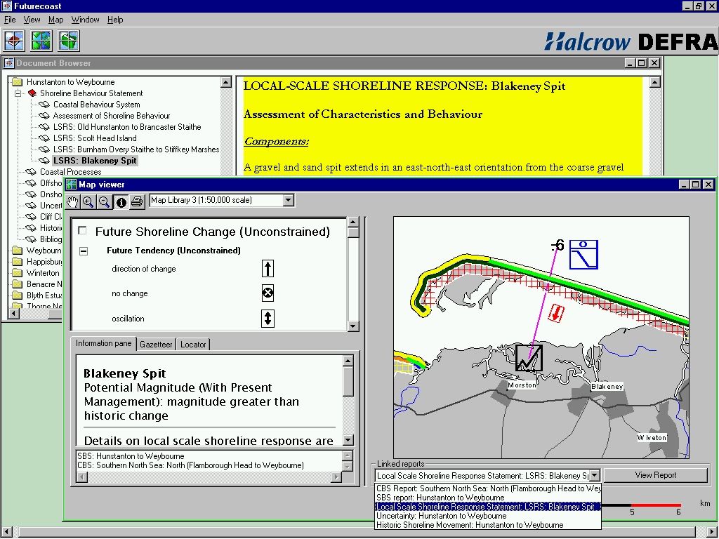
Figure 2: Screenshot from the Futurecoast application

Aerial Photograph CDs
A continuous digital aerial video of the coast was collected, in April 2001, to provide a baseline understanding of the current form of the coastline. This resulted in over 21 hours of digital video footage. In order to make this data set readily accessible, a map-based viewing system was used. Geo-referenced still images were extracted from the digital video at approximately 3-second intervals (ensuring an overlap between adjacent images), which were then linked to interactive mapping using SnapMap© software. The images can be accessed via overview and detailed mapping (as shown in Figure 3) and an animated sequence can be activated. This system allows ready viewing of any part of the England and Wales coastline, providing an invaluable tool for all coastal managers.

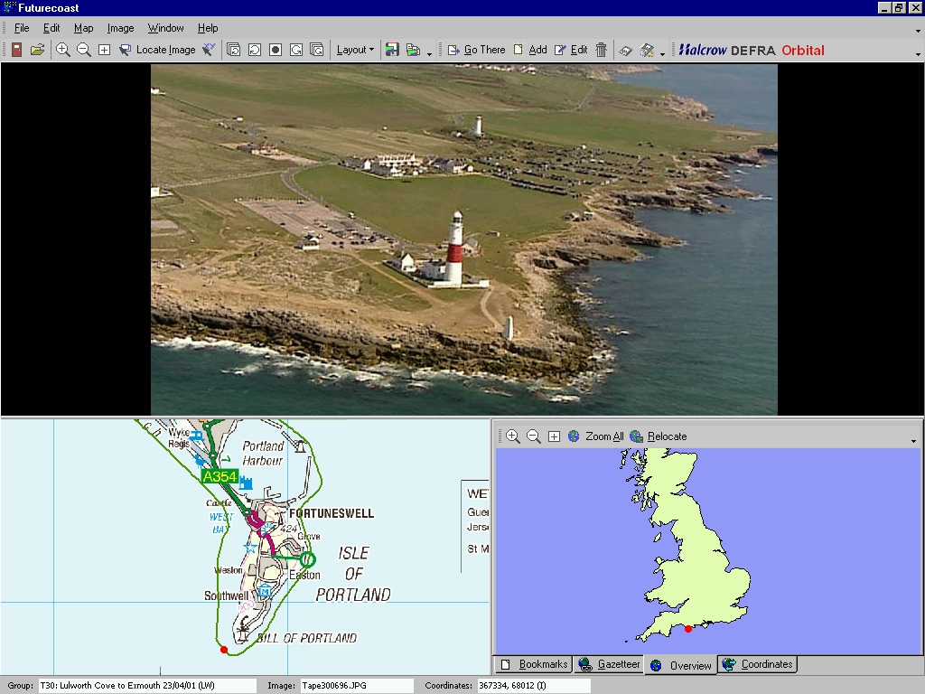
Figure 3. Screen shot from the Futurecoast aerial photograph viewer.

CONCLUSIONS
The main output from this research is the improved understanding of larger-scale coastal behaviour and geomorphological evolution of natural features on a consistent basis for the whole coast of England and Wales. It is hoped that this will assist in raising awareness of key geomorphological issues that are relevant beyond the time horizon of existing plans and the design life of existing coastal defence structures. Appreciation of these issues should help avoid tying future generations into inflexible and inappropriate coastal management decisions.

The results of the Futurecoast study will be applied to underpin strategic shoreline planning and thus contribute to future coastal management decisions. These will help to ensure that the second round of Shoreline Management Plans, and indeed all coastal management within England and Wales, are better informed, therefore enabling strategic coastal management decisions to be made in a longer-term and wider-scale context.

Futurecoast does not provide definitive predictions of future coastal evolution, because this is dependent upon a number of factors, not least of which is the implementation and sustainability of existing coastal management policies. It does, however, provide a knowledge base that can be used by all coastal managers to help define sustainable policies.

Whilst the research is targeted at future flood and coastal defence management, it is recognised that an appreciation of coastal processes and coastal evolution is an integral part of all aspects of management of the coast.

