ministry of agriculture, fisheries and food CSG 15
Research and Development

Final Project Report
(Not to be used for LINK projects)
Two hard copies of this form should be returned to:
Research Policy and International Division, Final Reports Unit
MAFF, Area 6/01
1A Page Street, London SW1P 4PQ
An electronic version should be e-mailed to c.csgfinrep@csg.maff.gsi.gov.uk

Project title | Beach Management and Design

MAFF project code | FD 0705

Contractor organisation and location | HR Wallingford Group Ltd  Howbery Park, Wallingford  Oxon, OX10 8BA

Total MAFF project costs | £ 515,000

Project start date | 01/04/96 |  | Project end date | 31/03/00

Executive summary (maximum 2 sides A4)

The Beach Management and Design programme has comprised four main research initiatives, plus two extensions.

Approach 1 (and extension Approach 6) comprised a four year collaborative research project involving HR Wallingford and the Universities of Portsmouth, Plymouth, Southampton and Brighton. The objectives were to improve understanding and develop predictive tools for short and long term shingle beach response. A substantial field measurement programme formed the foundation for the work, and successfully provided a database of information that is available to other researchers. A thorough review of existing transport formulae was undertaken and two new modelling approaches were developed, one looking at combined longshore and cross-shore transport within the swash zone, and the other modelling the effect of beach permeability on cross-shore, wave generated currents. The project has been discussed in a number of conference and journal papers and is fully reported in the Final Project Report TR 29 (B) (HR Wallingford, 2000). The work on the swash zone model is also written up as a PhD thesis (Van Wellen, 1999) while the permeable beach model has been incorporated into the ANEMONE suite and has been written up as TR 96 (HR Wallingford, 1999).

Approach 2 was an extension of earlier studies of the influence of beach slope on shoreline structures. Conclusions from this research have been used to guide the design of rock armour structures.

Approach 3 (and extension Approach 5) was an investigation of the impact of complex wave spectra (bi-modal wave conditions) on shingle beaches and sloping structures. Combinations of swell waves and wind sea were found to cause significantly different beach response compared to wave conditions of equal energy but with a single spectral peak.

These conditions are recommended to be considered as possible worst case scenarios during beach management operations in areas affected by swell waves. Bi-modal waves were also found to be influential in structure overtopping or rock stability situations, although the results were inconsistent. The project complements the development of the “Swell Atlas” produced as Report SR 409 (HR Wallingford, 1997).

Approach 4 investigated the erosion and failure of river banks and sea cliffs. Model Tests lead to a number of observations about bank and shoreline response, but physics based prediction methods were not derived.

Scientific report (maximum 20 sides A4)

Approach 1 – Collaborative Shingle Beach Project

INTRODUCTION

Effective shoreline management is dependent on understanding beach morpho-dynamics and an ability to predict both longshore and cross-shore sediment movements over time periods ranging from single storms to decades. Much of the existing scientific and engineering literature on littoral processes concentrates on sand beaches due to their international importance. Past research work has included laboratory model studies, large scale field experiments and the development of analytical/numerical models.

Around the UK coarse grained beaches are of equal importance to sand beaches, but the ability to predict responses has been less well developed. Past research has concentrated on the development of empirical profile models based on laboratory studies and verified against limited beach survey data. Longshore transport predictions have mainly relied on variations of sand transport formulae and on physical models, both being calibrated where possible against field measurements of long term changes to beach morphology.

More recent research has attempted to improve this situation through development of a physics based approach to transport modelling that gives specific consideration to coarse grained transport processes (Damgaard et al, 1996). Recognition of the weaknesses of this and earlier work provided the incentive for renewed effort.

The Shingle Beach Transport Project grew from the recognition that numerical model development should not proceed without a database of quality field measurements that confirmed fundamental processes and could provide verification of predictions. Although field data are available from a number of sources, the measurements are not co-ordinated or directed towards the specific requirements of model development. The potential for undertaking a significant project combining field research and numerical model development, integrated with studies of large scale, long term coastal morphology, was recognised by MAFF.

The Project was proposed with the stated aims of developing improved techniques for the prediction of beach transport and long term morphological development where coarse grained sediment forms a significant proportion of the beach material. The main objectives were:

- to process and analyse short term sediment transport data obtained from a co-ordinated series of field experiments, and to use this data to verify and/or develop existing or new transport models for shingle beaches

- to obtain, process and analyse data relating to long term, large scale morphological developments of a range of shingle beach situations, to compare this long term data with the short term data obtained from the field experiments and to develop predictive techniques for application by beach managers.

It is also intended that the field measurements collected should provide a quality data set for use by other coastal researchers in the future.

The Shingle Beach Transport Project was set up as a collaboration between several research groups, each with existing programmes of coastal research and each able to contribute unique expertise to the field experiments. The organisations and researchers included:

- HR Wallingford
- University of Portsmouth
- University of Brighton
- University of Plymouth
- University of Southampton

Figure 1 summarises the contributions and responsibilities of each organisation.

Figure 1 Responsibilities of collaborating partners
UNIVERSITY OF SOUTHAMPTON

Long shore processes and responses
Measurement and analysis of tracer movements
Contribution to other field studies
HR WALLINGFORD

Project Management
Continuous beach elevation monitoring
Development of cross-shore model
MAFF

ENVIRONMENT AGENCY
UNIVERSITY OF PORTSMOUTH
Scientific coordination
Large scale/long term processes
Beach surveying
Contribution to field measurement and analysis of tracer movements
Contribution to other field studies
UNIVERSITY OF PLYMOUTH

Measurement and analysis of offshore wave data and analysis of inshore wave data
Development of numerical transport model
Contribution to other field studies

UNIVERSITY OF BRIGHTON

Cross-shore processes and responses
Measurement of nearshore waves
Measurement of transport rates
Contribution to other field studies

The research programme was planned to make best use of the available time and resources through a division into three main stages. The first of the three years was given to planning and implementing field experiments on an open shingle beach site. Successful completion of this work led to the second year experiments on a recently recharged and groyned shingle beach. The final year was then devoted to analysis of the data and development of predictive techniques. Ongoing work throughout the project included critical analysis of existing numerical modelling and field measurement techniques, regular surveys of the field sites to determine seasonal development trends and preparation of progress reports for internal review.

FIELD STUDIES

The first year field programme was undertaken at West Beach, Shoreham (Figure 2) between 9 September and 13 November, 1996. The following objectives were defined:

- to co-ordinate and optimise a variety of monitoring and measurement techniques relying mainly on established methods, but including some evaluations of complementary new approaches
- to undertake offshore and beach face wave recording so as to estimate cross-shore distributions of wave energy and to validate existing wave transformation models
- to undertake electronic and aluminium tracing studies to obtain measurements of transport rates, the cross-shore and vertical distribution of transport and particle size dependency
- to undertake 3-d beach surveys covering: (i) the immediate field site and (ii) the whole of the West Beach, at a spatial resolution sufficient for production of digital ground models to record beach morphology changes and estimate transport volumes
- to undertake measurements at a variety of temporal resolutions ranging from one or two tides to semi-continuous samples over the full duration of the field programme
- to undertake measurements during a variety of wave states.

The field work at Shoreham focused on a 700m frontage around the centre of the 1500m length of open beach to the west of the harbour breakwater at the mouth of the River Adur. The beach comprises a massive shingle storm berm above a gently sloping sandy lower foreshore exposed at low water spring tides. The maximum tidal range is about 6m. The site is exposed to waves generated within the English Channel and to swell generated in the Atlantic; the predicted annual maximum offshore significant wave height is about 4m for waves approaching from the south and southwest quarter. As the beach is controlled by groynes to the west and the very large Shoreham breakwater to the east, then the 1500m of open beach is assumed to be an effectively closed sediment system over the time scale of the field programme.

Although the autumn programme ran on until 13 November 1996, the main elements ended after a major storm event between 28-29 October due to equipment damage. Despite the damage, the storm provided an opportunity to record waves and beach response under very severe conditions and was therefore considered to be extremely beneficial to the project.

The measurement programme was divided into core activities vital to the success of the project and trial activities likely to yield valuable information but using unproven techniques. Limitations on manpower and time required prioritisation of activities, with priority going to obtaining a high quality, high resolution data set of simultaneous core measurements under a range of wave conditions.

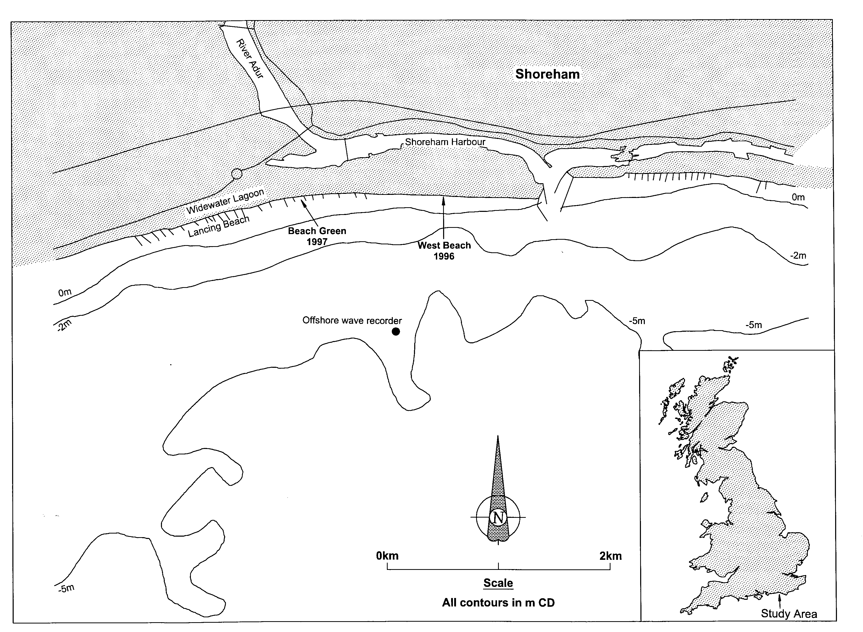

Figure 2 Field study locations

Figure 2 Shoreham site map

Core activities included:

- offshore wave recording (WRS)
- beach face wave recording (IWCM)
- electronic pebble tracing
- aluminium pebble tracing
- continuous beach elevation monitoring (Tell-Tail scour monitors)
- sediment sampling
- beach morphology surveys (GPS or total station)

Trial activities included:

- wave direction monitoring with X-band radar
- beach water table monitoring with pietzometers
- beach face wave induced current measurement with EM meters
- short duration sediment trapping with mobile rig.

The second year field programme was successfully undertaken near Beach Green, Lancing (Figure 2) between 3 September and 14 November 1997. The work involved measurement of waves, currents, shingle transport and beach morphodynamics on a newly replenished beach controlled by timber and rock groynes. The general aim was to build on the data base and understanding of beach process gained during the first field programme in 1996 and particularly to gain an understanding of the effects of groynes on beach processes.

The objectives defined were:

- to adapt and apply monitoring and measurement techniques successfully used during Autumn 1996, plus new approaches designed to tackle specific problems presented by the groynes
- to undertake offshore and beach face wave recording
- to measure wave and tide induced currents on the beach face
- to undertake tracing and trapping measurements of transport within and between groyne embayments (including overtopping and outflanking)
- to undertake topographic beach surveys covering: (i) the three embayments adjoining the specific groynes under study and (ii) the neighbouring areas comprising the remainder of the replenishment scheme, the depleted beach controlled by timber groynes to the west and part of the natural beach to the east
- to undertake measurements at temporal resolutions ranging from one or two tides (tracers, static traps, morphological surveys) to semi-continuous samples of instantaneous events (wave and current recording ,scour monitors, mobile traps)
- to undertake measurements during a variety of wave states, especially high energy conditions
- to obtain concurrent measurements of key parameters covering (i) specific wave events and (ii) simultaneous transport measurements at each study groyne.

Field work at the site also included ongoing profile and ground model surveys, intended to determine beach response to seasonal wave climate variations and to sequences of storm as part of the long term geomorphological aspects of the project.

The field study period was dominated by calm to moderate wave conditions with northerly and easterly winds. Several higher energy events occurred, with southwesterlies up to Force 8-9.

Work was undertaken within the Environment Agency (EA) Kings Walk rock groyne and recharge scheme. The foreshore comprises a recharged shingle (D₅₀ between2 and 50mm) upper beach, fronted by a sand platform below mid tide level. Monitoring focused on an embayment between a new rock groyne and a timber groyne. Beach morphology and tracer studies also included embayments to the east and west.

The field programme was set out with the aim of obtaining concurrent measurements during specific pre-determined periods, thereby removing the need for continuous staff involvement throughout the full 9 weeks. Work was separated into core and trial activities, with additional activities not directly supported by the project being undertaken as well. The priority was to obtain high quality, simultaneous core measurements at a high temporal resolution, with trial activities being fitted in as appropriate.

Core activities included:

- offshore wave recording (WRS)
- inshore wave recording (IWCM)
- beach elevation monitoring (Tell Tails)
- electronic pebble tracing, sediment sampling, depth of disturbance sampling (tracer columns)
- GPS surveying (full monitoring area)
- beach profiling (main field site only)
- current measurements (EMCM).

Trial activities included:

- mobile trapping within the swash and surf zone (NeSSIE)
- aluminium pebble tracing
- cross-groyne sediment trapping.

Additional work undertaken outside the direct support of the project included ground water (piezometers) and pressure monitoring (PM).

RESULTS

Discussion of all the results of this study is outside the scope of this short report. Full details are presented in the final Technical Report for the project (TR 29B, 1999 from HR Wallingford). The following provides an indication of some of the data.

Sample results from the inshore wave monitoring are set out in Figure 3. The figure clearly shows the wave energy spectral shape in terms of both direction and frequency for the storm event of 26-28 October, 1996. Simultaneous data is available from the offshore monitor. Of interest is the complex frequency spectra, including both long and short period waves. Earlier laboratory research (Hawkes et al., 1997) demonstrated the importance of complex storm wave spectra in the erosion of coarse grained beaches, and this was borne out by the field measurements of beach change at Shoreham.

Tracer and topographic survey results were used to define longshore transport over single tide durations, allowing comparison with prediction equations. Interpretation of the tracer results requires definition of the active beach (cross-shore width and depth below surface) over the period of each high tide. Definition of active depth was facilitated by the “Tell-Tail” scour monitors that monitored the change in beach elevation at discrete intervals along a profile line at 10 minute intervals throughout the two field programmes. Beach elevations were found to drop and rise again by as much as 1m during a single high tide, providing previously unrecorded evidence of the activity of shingle beaches.

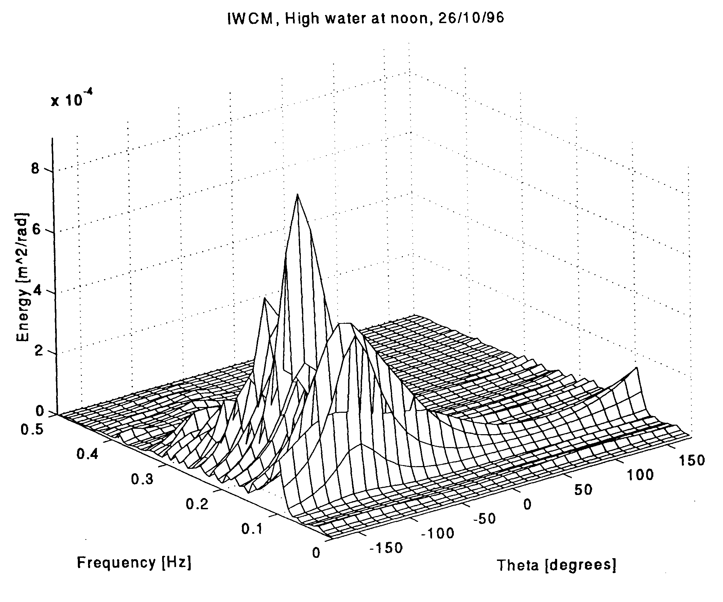

Figure 3 Sample wave energy spectrum (direction and frequency)

Figure 3 Sample results from the inshore wave monitoring

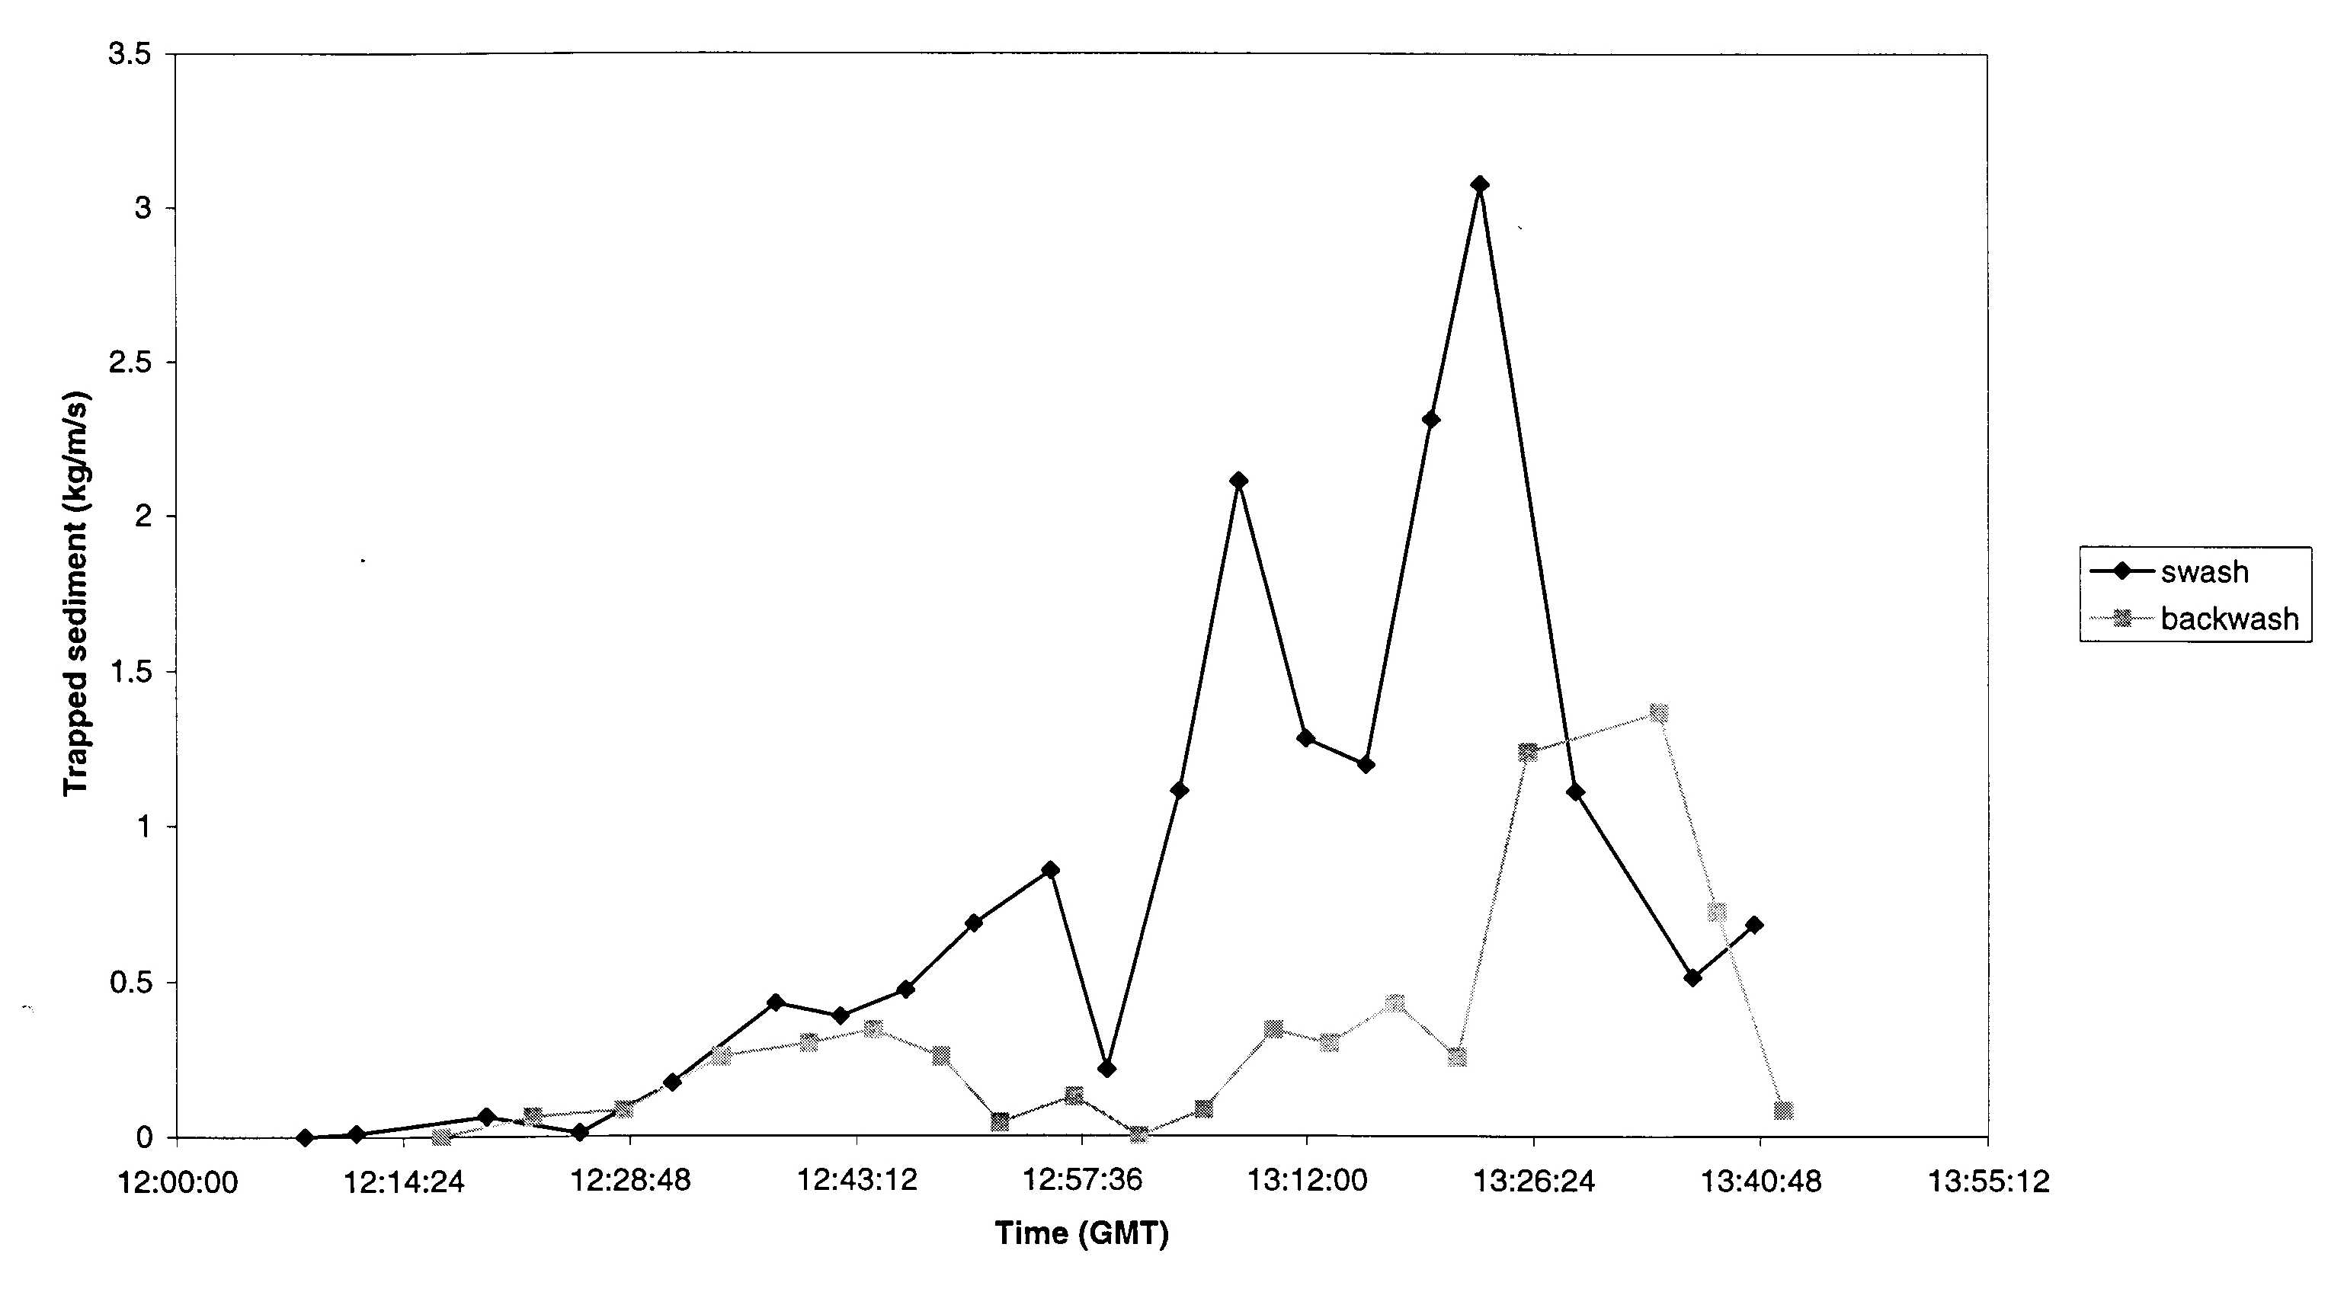

Figure 4 NeSSIE results: onshore-offshore shingle transport in the swash and breaker zone

Figure 4 Sample results of the NeSSIE mobile trapping system

Indications of the active beach width as the tide rose and fell over the shingle beach were provided in the second field programme by the NeSSIE mobile trapping system. Sample results are shown in Figure 4, indicating relative onshore and offshore sediment transport throughout the swash and breaking wave zone. Higher onshore transport indicates the importance of beach permeability and return flows within the beach face rather than over the surface.

Longshore transport during moderate wave conditions was found to be over the low level groynes, mainly as bedload, at points where the updrift beach built up to the groyne crest (whether rock or timber). There was no evidence for transport of shingle around the seaward tip of the groynes, even though the shingle beach extended to the tips or beyond. During stormier weather there was some evidence of shingle being transported over the groynes in temporary suspension, but the volumes were not quantified.

Other measurements provide indications of near-bed currents, hydraulic gradient and variations in the phreatic surface within the beachface.

All of the field data recorded is held in a database at HR Wallingford and discussed in detail in the final project report. Access to this database is open to other researchers interested in coarse grain beaches or nearshore wave transformations.

MODEL DEVELOPMENT

A thorough review of existing transport prediction methods was undertaken within the project. A number of interesting conclusions were drawn regarding the appropriateness of different methods for specific situations. Details of this work are presented in Van Wellen et al (1998), Van Wellen et al (1999), and Van Wellen (1999).

Figure 5 presents a sample of the results of this review, showing a comparison of various transport equations against long term average transport at Shoreham (Van Wellen et al., 1998). The grey bar defines the expected range of annual transport estimated from field evidence (map and photo analysis, recycling records). The CERC formula shows best agreement, but this is due to site specific calibration. Of the remaining non-calibrated equations the Damgaard and Soulsby (1996) methods, developed at HR Wallingford under MAFF funded research specifically for UK shingle beaches, not surprisingly show the best results. The remaining methods provide results that are up to five times greater than the field data suggests. Readers should refer to the referenced publications for full details of this comparison and the other work done under the review.

A further review of prediction methods for mixed grain beaches (Coates and Mason, 1998) suggests a number of weaknesses common to some or all of the existing prediction methods, as follows:

- swash zone processes and beach permeability are not included
- sediment definition is based on a single grain size (i.e. D₅₀) with no consideration of the influence of different grading ranges or variations across or along the beach, or over time
- threshold of motion is defined from a simple grain size definition, again with no consideration for the complexity of a real world beach
- cross-shore and long-shore transport are treated as separate processes, rather than integrated into total transport
- transport over, through or around structures tends to be accounted for with simplistic methods
- waves are defined by simple height and period parameters, with no consideration of the influence complex wave spectra.

From the results of these reviews the project team has begun the development of several new modelling methods. Plymouth University have developed a vector based total transport (longshore and cross-shore) model that includes swash zone processes (Van Wellen, 1999). HR Wallingford is developing an extension to the existing ANEMONE overtopping and run-up model suite (see Figure 6).

The new HR Wallingford approach includes beach porosity, and will include new friction and threshold of motion terms. Flow velocities generated at the beach face on a wave by wave basis will be influenced by flows into and out of the beach, allowing prediction of profile change, over-washing and flow through the beach crest to the backshore. Further work will develop this cross-shore approach into a quasi – 3D model and will take account of the influences of mixed sand –shingle sediment distributions. This work will be undertaken under the Mixed Beach programme up to 2003.
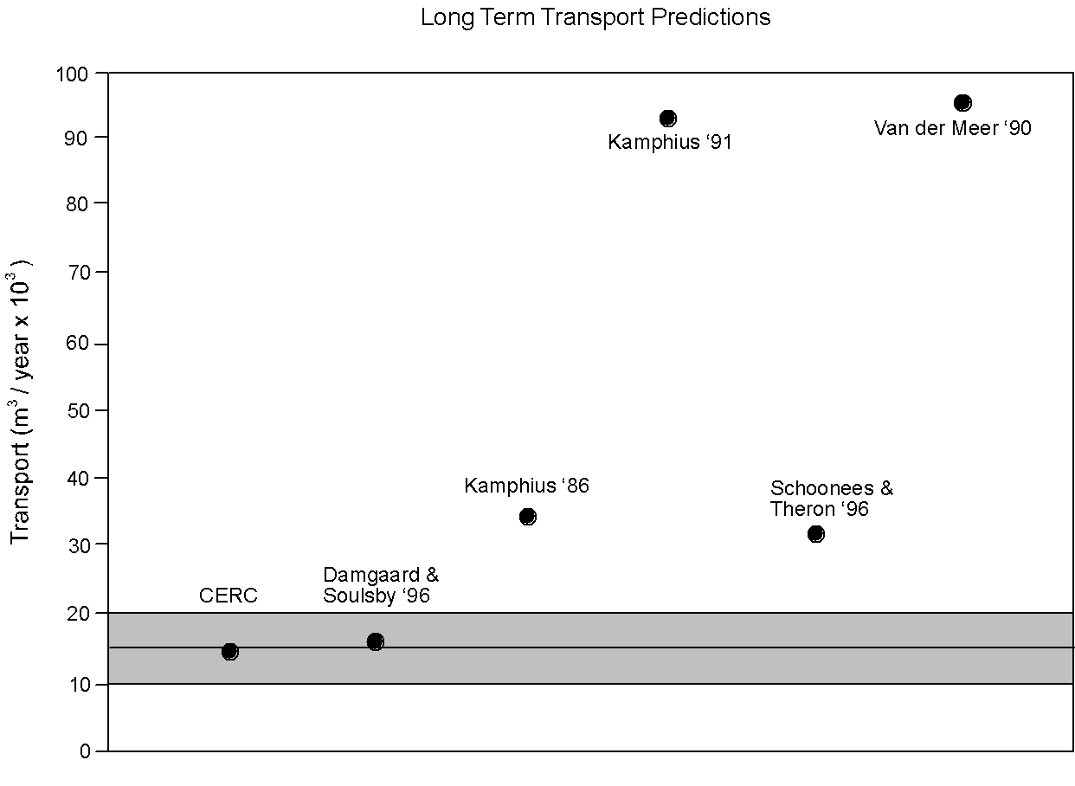

Figure 5 Prediction review for long term annual transport rates on Shoreham beach

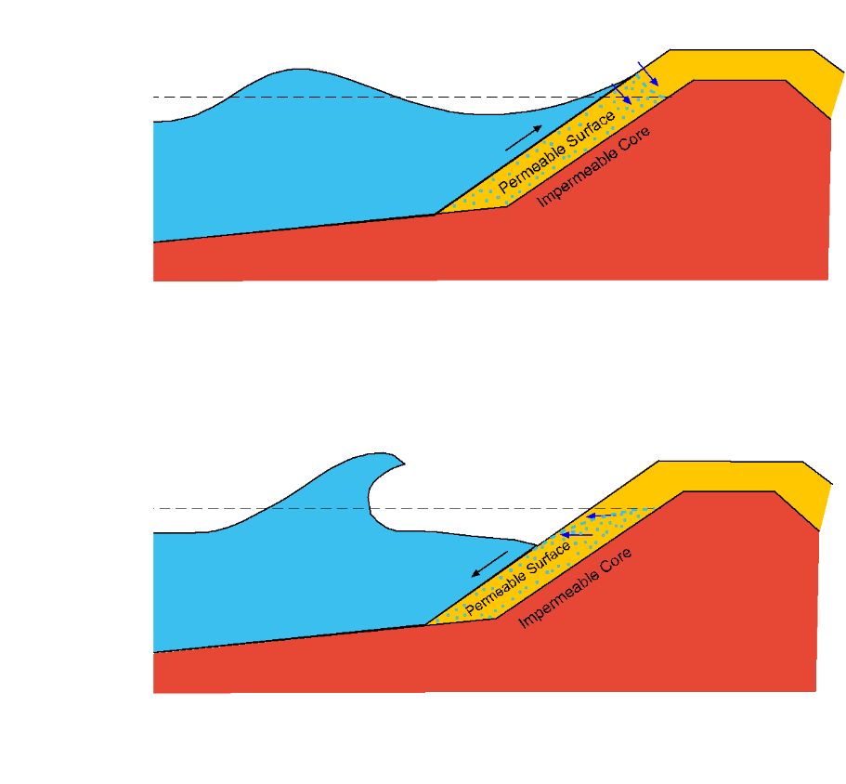

Figure 6 OTT-1d(p) – Cross – shore transport model schematic

Figure 6 ANEMONE overtopping and run-up model

CONCLUSIONS

The project has resulted in:

- an extensive database of field measurements, available to other research projects from HR Wallingford
- a comparison of existing equations used in numerical prediction models
- development of a new conceptual longshore transport model
- initial development of a physics based cross-shore model, including the effects of a permeable beach on wave run-up and an improved representation of bottom friction
- new guidance on the use of field equipment, including the use of GIS to form digital ground models for use in transport calculations
- guidance on the analysis or prediction of long term/large scale shoreline change.

Several conference papers were presented during the project and further conference and journal papers have been submitted (see References for details).

REFERENCES

Coates T. T. & Mason T. (1998). Development of predictive tools and design guidance for mixed beaches. Scoping study. HR Wallingford Ltd, Report TR 56

Coates T.T. & Hawkes P.J. (1997), What happens if your design conditions ignore swell?. Waves ’97 Conference. Virginia Beach, USA

Damgaard J. S. and Soulsby R. L., (1996), Longshore bed-load transport. Proc. 25th Int. Conf. on Coastal Eng., Orlando, ASCE. p. 3614-3627
Damgaard J. S., Stripling S. and Soulsby R. L., (1996), Numerical Modelling of Coastal Shingle Transport. Report TR4, HR Wallingford; p. 1-15
Kamphuis, J. W., (1991), Alongshore sediment transport rate. Journal of Waterway, Port, Coastal and Ocean Engineering, ASCE, 117, p. 624-640
Kamphuis J. W., Davies M. H., Nairn R. B. and Sayo O. J. (1986). Calculation of littoral sand transport rate. Coastal Eng., Vol. 10; p. 1-21
Komar P. D. and Inman D. L. (1970). Longshore sand transport on beaches. Journ. Geophys. Res., Vol. 75,(30); p. 5914-5927
Lee, M.W.E., Bray, M., Workman, M., Collins, M.B. and Pope, D., in press. Coastal Shingle Tracing: A Case Study Using the Electronic Pebble System and Geomorphological Applications. In: Tracers in the environment, Special Issue of Earth Surface Processes and Landforms, Foster, I. (Ed), BGRG

Lee, M.W.E., Sear, D.A., Atkinson, P., Workman, M., Collins, M.B. and Oakey, R., in prep. Requisite Tracer Population Size for Use on a Shingle Beach

Lee, M.W.E., in prep. Tracer Derived Measurements of Coarse Clastic Sediment Behaviour in the Littoral Zone. Unpublished PhD Thesis, School of Ocean and Earth Science, University of Southampton

Mason T., Van Wellen E. & Chadwick A.J. (1999), Application of Bailard’s energetics model for shingle sediment transport. In Kraus N.C. & McDougal W.G. eds. Proceedings of Coastal Sediments pp. 907-921
Schoonees, J. S. and Theron, A. K., (1996), Improvement of the most accurate longshore transport formula. Proceedings of the 25th International Conference on Coastal Engineering, Orlando, ASCE, p. 3652-3665
Sear, D.A., Lee, M.W.E., Oakey, R.J., Carling, P.A. and Collins, M.B., in press. Coarse Sediment Tracing Technology in Littoral and Fluvial Environments: A Review. In: Tracers in the environment, Special Issue of Earth Surface Processes and Landforms, Foster, I. (Ed), BGRG

Stapleton K.R., Mason T. & Coates T.T. (1999), Sub-tidal resolution of beach profiles on a macro-tidal shingle beach. In Kraus N.C. & McDougal W.G. eds. Proceedings of Coastal Sediments 99, pp. 885-893
van der Meer, J. W., (1990), Static and dynamic stability of loose material. Coastal Protection (Editor). Balkema, p. 157-195
Van Wellen E., Lee M. & Baily B. (1999), Longshore drift evaluation on a groyned shingle beach using field data. In Kraus N.C. & McDougal W.G. eds. Proceedings of Coastal Sediments 99, pp. 894-906
Van Wellen E., (1999), Sediment transport on coarse grained beaches, PhD Thesis, University of Plymouth, (in prep.)
Van Wellen E., Chadwick A. J. and Mason T., (1999), A review and assessment of longshore sediment transport equations for coarse-grained beaches, (Coastal Engineering, in review)
Van Wellen E., Chadwick A. J., Lee M., Baily B. and Morfett J., (1998), Evaluation of longshore sediment transport models on coarse grained beaches using field data: a preliminary investigation, Proc. 26th Int. Conf. on Coastal Eng., Copenhagen, ASCE, (in press)

Approach 2 – Structures on Steep Beaches

This work has been fully documented in HR Wallingford Report SR 511. For further information please contact Prof William Allsop at HR Wallingford.

Approach 3 – Impacts of Bi-modal wave conditions

This work has been fully documented in HR Wallingford Reports SR 507 and TR 24, and has been presented as conference papers at Waves’ 97 (Hawkes et al, 1997) and at ICCE (Coates et al., 1998). For further information please contact Dr Peter Hawkes or Mr Tom Coates at HR Wallingford.

Approach 4 – Erosion of dry areas

The aim of this project was to improve understanding of the physical processes involved in bank and cliff recession and to develop generic predictors for application in environments where receding dry areas are of interest.

Dry areas - such as river banks, dykes, coastal cliffs, reservoir side slopes and salt marsh banks - play an important role in flood defence. In heavily populated areas, their erosion can have an obvious and direct impact on the flood hazard. In rural areas, their loss can have major impacts on agriculture and on the economy which it supports. Additionally, sediment from eroding banks or cliffs plays an important part in the overall sediment budget.

Dry areas recede as a result of the interactions between two processes - erosion and failure. Erosion can be caused by fluid flows at the bank base, weathering or biological activity. In this study, research focused on areas with high recession rates and energetic fluid forcing. Commonly, fluid-induced erosion occurs at the toe of a bank, followed by bank failure as shear stresses inside the bank build up and exceed the shear strength of the soil. Part of the bank collapses and the resulting debris (sediment) acts as toe protection until it is itself eroded. Each cycle represents a recessionary impact. HR reviewed existing literature and then used physical models to study the erosion of dry areas in more detail.

The first set of experiments looked at the behaviour of river banks. Both cohesive (mud/sand) and noncohesive (sand) banks were studied. Observations showed that fluid-induced erosion at the bank toe caused undercutting of the bank. When the overhang reached a certain size, the bank failed. In physical terms, failure occurred when gravitational forces acting on the unsupported section of bank exceeded resistive forces (including friction and cohesion) acting between the main bank and the overhang. Bank failure was rapid and debris was carried away as bed load and suspended load. Overhangs from cohesive banks were generally greater than those along sandy banks and failure was characterised by a slow dragging of material down the bank face. Once it reached the water, the eroded mass rolled along the bank toe, gradually getting smaller as fine particles moved into suspension and coarser sand joined the bed load.

Graphical analysis showed that sandy banks eroded more rapidly than cohesive ones and average bank recession rates were positively correlated with shear stress. Time intervals between successive bank failures seemed to be correlated with hydrodynamic features of the adjacent flow (and possibly with cohesiveness). However, the actual size of a bank failure appeared to be independent of these factors.

A second series of model tests concentrated on the effects of erosion in coastal areas. A series of model cliffs were created using sand and, in one case, sand/clay mixtures. Each bank was subject to random wave attack at angles of between 0 and 30°. As waves moved into shallow water near the model cliffs, they broke and generated a longshore current.

Results showed that recession rates increased with wave height and period. There was also an association between recession rates and the angle of wave attack, but this seemed weaker than previously assumed. A further conclusion of the study was that cliff toe erosion depends on wave run-up as well as longshore currents.

This study has helped to clarify the physical processes operating when dry areas such as river banks and coastal cliffs recede. From experimental results and existing knowledge, a generic framework was developed for the prediction of erosion (or recession) of dry areas. Within the project, this framework was used to develop simple predictors for situations where ‘steady currents’ and ‘waves plus currents’ operate, effectively covering fluvial and coastal situations. This framework will aid engineers wishing to model the type of recession relevant to their area of work.

For further information please contact Jesper Damgaard at HR Wallingford. The project is fully reported in:

Towards Improved Modelling of Recession of Dry Areas: Development of a Predictive Model Framework
HR Wallingford Report SR 514, MAFF, 1999.

All HR Wallingford reports are available at www.hrwallingford.co.uk

Please press enter

