Statistical Release
26 November 2020

Introduction
This statistical release provides summary information on appeals, which represent the highest volume (in terms of number of cases) of the work of the Planning Inspectorate.

This Release also provides a general overview of the impact of the Covid pandemic on the work of the Planning Inspectorate to enable everyone to see the effect of the restrictions on performance.

These statistics will be produced each month to allow anyone to see how the Inspectorate is performing. The focus is on timeliness as that is an area in which stakeholders have an interest. Information on the decisions that we have made is also included; and on the number of Inspectors available to make those decisions.

These statistics have been published to ensure everyone has equal access to the information and to support the Planning Inspectorate’s commitment to release information where possible.

This statistical bulletin provides;
- An overview of the impact of Covid on the work of the Inspectorate
- Appeals decisions from November 2019 to October 2020
- The time taken to reach those decisions
- Number of open cases
- Number of Inspectors
- Number of virtual events.
The data in this release is only applicable to England.

The Planning Inspectorate
The Planning Inspectorate’s job is to make decisions and provide recommendations and advice on a range of land use planning-related issues across England and Wales. We do this in a fair, open and timely way.

The Planning Inspectorate deals with planning appeals, national infrastructure planning applications, examinations of local plans and other planning-related and specialist casework in England and Wales.

The Planning Inspectorate is an executive agency, sponsored by the Ministry of Housing, Communities & Local Government and the Welsh Government.
Summary
The impact of COVID can be seen in the Planning Inspectorate data in three ways:
- The Inspectorate suspended all events during the Spring lockdown, but have since resumed activities, including holding events virtually. The number of events held in September 20 were the highest recorded in the last 12 months at 2,112.
- In deciding cases that were impacted by the Spring lockdown, and aftereffects of the lockdown, the timeliness measure is starting to increase as the Inspectorate work through the backlog that was created. The median timeliness from April 20 onwards is consistently above 22 weeks, contrasting with the months of November 19 to March 20 where it is never above 21.3 weeks, and usually around 20 weeks.
- The number of open cases (cases received but not yet closed) increased to a high of around 11,000 in August 20 but is now decreasing, as the Inspectorate are now closing more cases than we receive on a monthly basis.

The Planning Inspectorate has made 17,802 appeal decisions in the last 12 months, an average of almost 1,500 per month. The 1,965 decisions in October are higher than the pre-pandemic levels and the highest in the last 12 months.

Written representations decisions have recovered to, and above, pre-pandemic levels. In contrast there remain fewer decisions from hearings and inquiries. Both planning and enforcement decisions have recovered to pre-pandemic levels; but there remain fewer specialist decisions.

The mean average time to make a decision, across all cases in the last 12 months (Nov 19 to Oct 20), was 26 weeks. The median time is 22 weeks.

The median timeliness from April 20 onwards is consistently above 22 weeks, contrasting with the months of November 19 to March 20 where it is never above 21.3 weeks, and usually around 20 weeks. Hearings and inquires take longer than written representations – with Hearings taking more than twice as long as written representations.

The median time for written representations over the 12 months to October 20 is 22 weeks. The median time for inquiries over the 12 months to October 20 is over a year - 59 weeks. The median time for hearings is slightly less at 42 weeks.

The median time to decision for planning cases is lower than for other casework categories, apart from in May 2020. Across the whole year, the median time to decision for planning cases is 20 weeks. Enforcement decisions made in the last 12 months had a median decision time of 35 weeks. The median time to decision for specialist decisions is broadly the same as for enforcement decisions, and longer (almost double) that for planning decisions.

The median time for Inquiries under the Rosewell Process over the 12 months to October 20 is 26 weeks. Since the COIVD outbreak there have been fewer such decisions and generally longer durations – noting that these inquiries began many weeks before the pandemic had its impact.

At the end of October, the Planning Inspectorate had ten thousand five hundred cases open. This is a reduction of about 400 from the previous month.

There were 347 Planning Inspectors employed by the Inspectorate in October 2020 – with a full-time equivalent of 310.

The Inspectorate are continuing to increase the number of events carried out ‘virtually’. There were 114 Virtual Events during October 2020, with 102 estimated for November.

Impact of Covid
The impact of COVID can be seen in the Planning Inspectorate data in three ways:
- The Inspectorate suspended all events during the Spring lockdown, but have since resumed activities, including holding events virtually. The number of events held in September 20 were the highest recorded in the last 12 months at 2,112.
- In deciding cases that were impacted by the Spring lockdown, and aftereffects of the lockdown, the timeliness measure is starting to increase as the Inspectorate work through the backlog that was created. The median timeliness from April 20 onwards is consistently above 22 weeks, contrasting with the months of November 19 to March 20 where it is never above 21.3 weeks, and usually around 20 weeks.
- The number of open cases (cases received but not yet closed) increased to a high of around 11,000 in August 20 but is now decreasing, as the Inspectorate are now closing more cases than we receive on a monthly basis.

Figure 1: Number of events held, decisions issued and median time between valid date & decision date, Nov-19 to Oct-20
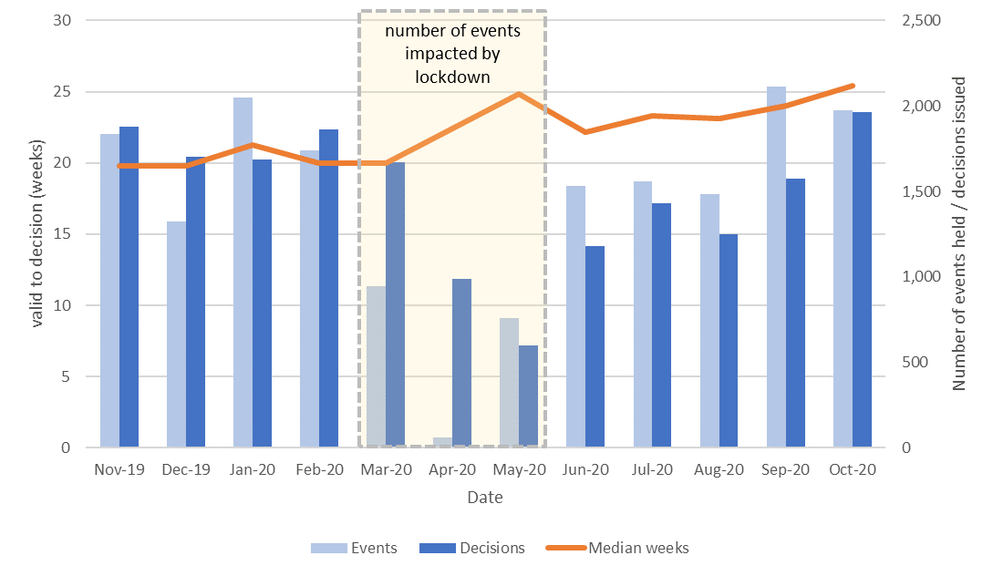
Table 1: Number of events held, decisions issued and median time between valid date & decision date, Nov-19 to Oct-20

Source: Horizon, Picaso, Inspector Scheduling System

The Planning Inspectorate were able to continue deciding cases where the site visit, hearing or inquiry had already occurred. However, the impact of pandemic meant that the Inspectorate did not carry out site visits, hearings and inquiries events during the lockdown period in Spring 2020.

The Inspectorate needed to adapt to new ways of working and re-arrange those events that were cancelled during the lockdown period and this also impacted on customers who appealed before (from as early as Dec 19), during and after lockdown.

The impact of Covid is starting to appear in the timeliness data, as cases delayed during and after the Spring 2020 lockdown are now being decided. Times for decisions are expected to lengthen further in the short term, as the Inspectorate make decisions on cases held up in a backlog, before reducing again leading up to Spring 2021.

Figure 2: Number of cases received, closed and open, Nov-19 to Oct-20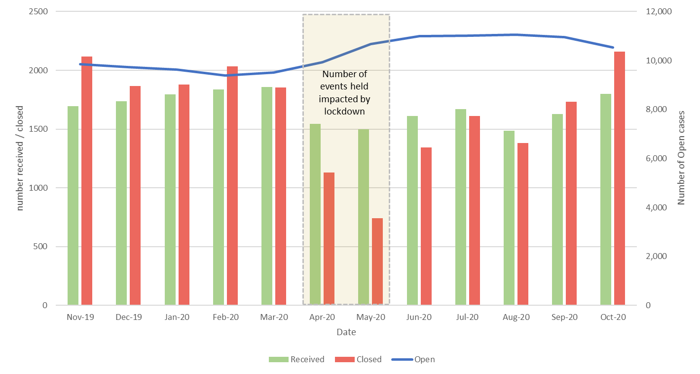
Table 2: Number of cases received, closed and open, Nov-19 to Oct-20

Source: Horizon and Picaso

The number of open cases increased, peaking at an increase of around 1,600 cases, or 16% (between the lowest and highest numbers of cases open). In the last two months the number of cases being closed has exceeded the number received (September & October 2020, once schools re-opened and full capacity returned), and the overall number of the open cases is starting to reduce as a result of this.

Number of Decisions

The Planning Inspectorate has made 17,802 appeal decisions in the last 12 months, an average of almost 1,500 per month. Table 3 below shows the monthly breakdown with fewer decisions from April to August 2020 than would have been expected, due to the impact of COVID-19. The same information is represented in Figure 3.

Table 3: Appeal Decisions, Nov 19 – Oct 20

Source: Horizon and Picaso

As can be seen from the table, the fewest decisions were made in May 2020 – just under six hundred decisions. Since then the number of decisions each month is showing a generally upward trend (with a slight dip in August linked to annual leave). The 1,965 decisions in October are higher than the pre-pandemic levels and the highest in the last 12 months.

Planning Inspectors work on a broader range of work than the appeals featured in this Release. For example they also work on examining Nationally Significant Infrastructure Project applications, Local Plans, Compulsory Purchase Order applications and many other specialist licencing/application types.

Figure 3 – Appeal Decisions, Nov 19 – Oct 20
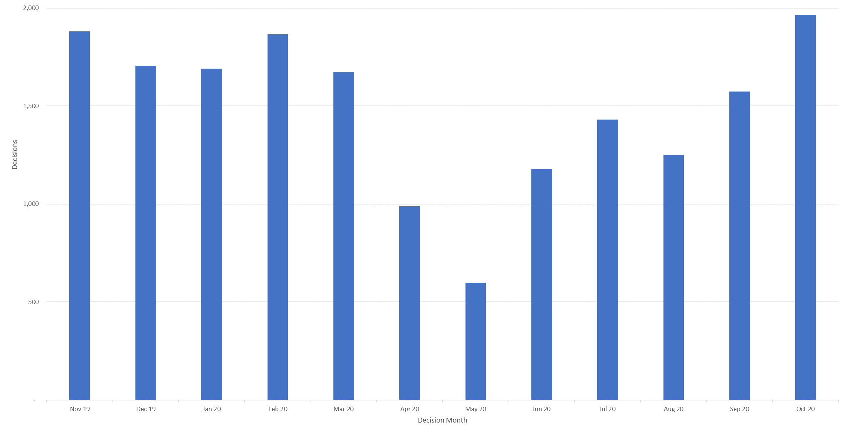
Source: Horizon and Picaso

Table 4 below gives the numbers of appeal decisions made broken down by whether the case was dealt with by written representations, hearings, or inquiries.

The large majority of decisions (16,954) were made on written representations. This is about ninety five percent of all appeal decisions made. There were 527 decisions made on hearings; and 321 on inquiries. These totals are shown in Figure 2 below.

The large majority of cases were planning (14,371). This is about eighty-one per cent of all appeal decisions made. There were 2,754 enforcement decisions and 677 specialist decisions. These totals are also shown in Figure 4 below.

Table 4: Appeal Decisions by procedure and casework category, Nov 19 – Oct 20

Source: Horizon and Picaso

Table 4 shows that written representations decisions have recovered to, and above, pre-pandemic levels. In contrast there remain fewer decisions from hearings and inquiries. It also shows that both planning and enforcement decisions have recovered to pre-pandemic levels; but that there remain fewer specialist decisions.

Figure 4 – Appeal Decisions by Procedure and Casework Category, Nov 19 – Oct 20
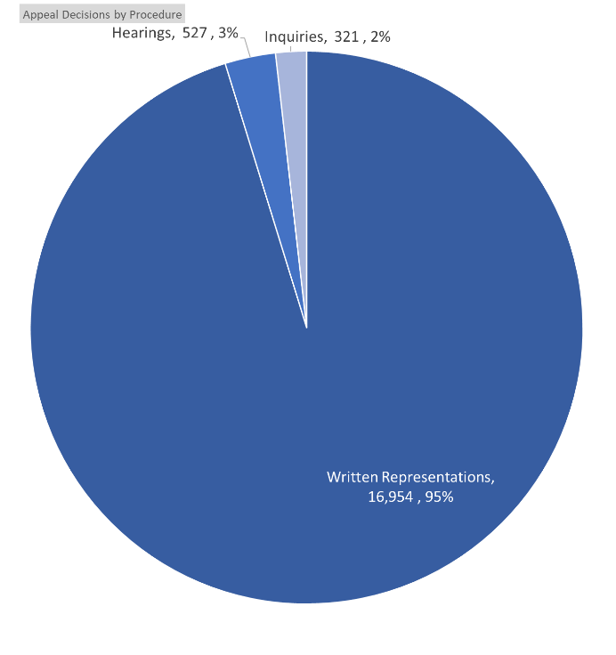 | 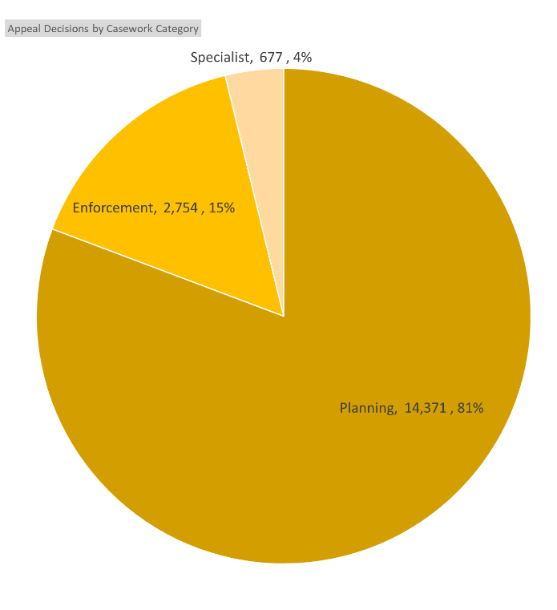
Source: Horizon and Picaso

Decision timeliness

It is important for people to know how long an appeal is going to take, so that they can make plans and decisions based on this information. This section covers the timeliness of decisions (i.e. how long it takes to make a decision) across our appeal casework. In addition to an overall measure, timeliness is analysed by procedure type and casework category, as timeliness varies a great deal depending on these characteristics.

Table 5 below shows that the mean average time to make a decision, across all cases in the last 12 months (Nov 19 to Oct 20), was 26 weeks. The table also shows the median time is 22 weeks. For each month the median is less than the mean, this is due to the larger impact on the mean of very long cases.

The mean and the median are two different representations of the centre of a data set, more detailed explanation can be found in the Background Notes section.

Also included in the table is the standard deviation of decision timeliness. A lower standard deviation would demonstrate greater consistency in the Planning Inspectorates decision timeliness. The data shows that the variability is getting less towards the end of the year – the standard deviation values are around 16 to 18 for much of November 19 to May 20; but 14.8 or lower for June to October.

Table 5: Mean, Median and Standard Deviation of Time to Decision, Nov 19 – Oct 20

Source: Horizon and Picaso
The median timeliness from April 20 onwards is consistently above 22 weeks, contrasting with the months of November 19 to March 20 where it is never above 21.3 weeks, and usually around 20 weeks.

Figure 5: Mean and Median time to decision, Nov 19 – Oct 20
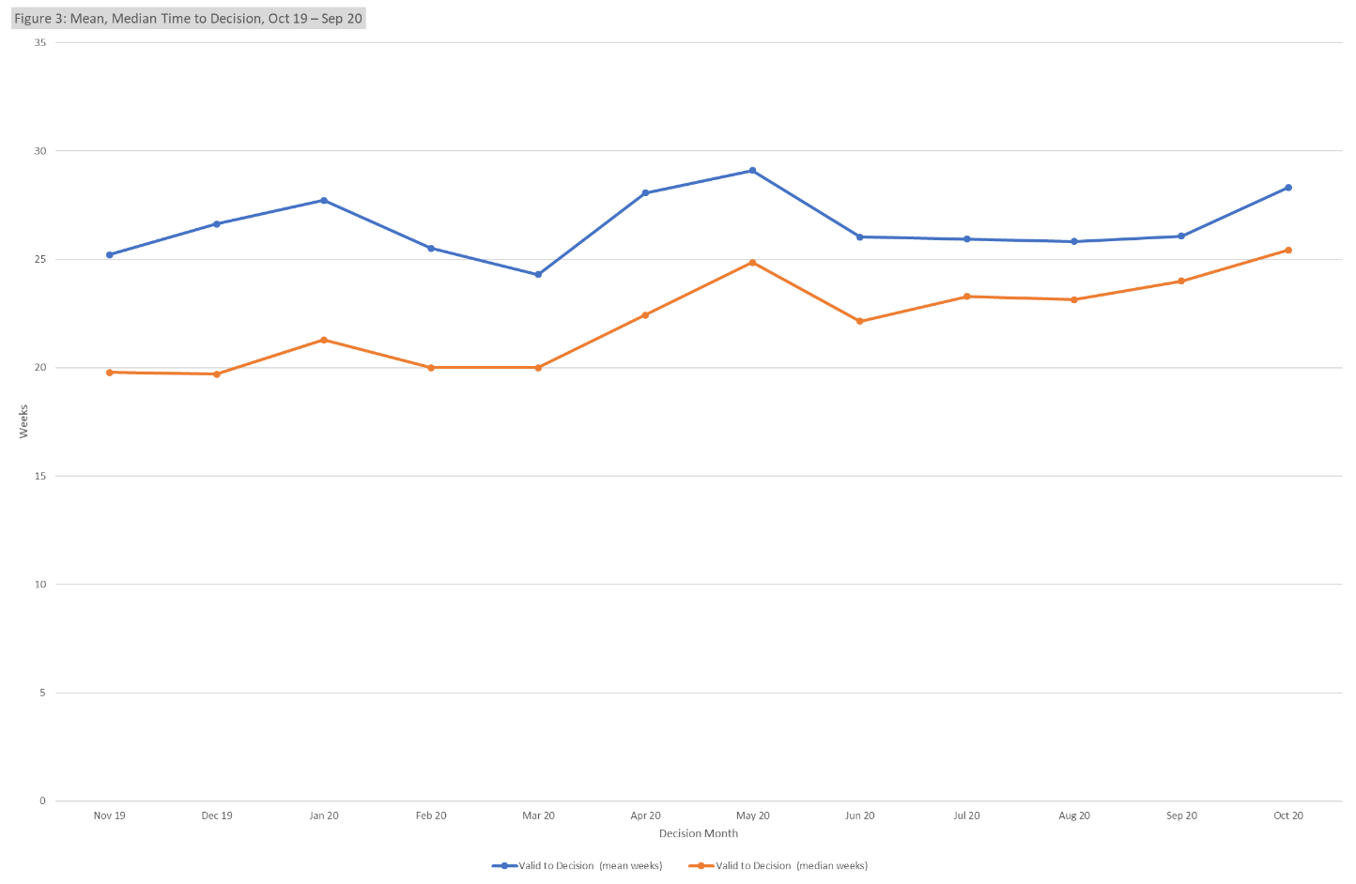
Source: Horizon and Picaso

The mean time to decide, shows a less clear pattern; it is often around 25 or 26 weeks, dropping below this only in March 20 (to 24.2 weeks). It is highest in May 20, at 29.1 weeks.

Procedure Type
Table 6 below shows decision timeliness broken down by the procedure type. Hearings and inquires take longer than written representations – with Hearings taking more than twice as long as written representations. Because 19 of every 20 cases are by written representation, the timeliness measures for written representations is similar to the measure across all cases.

Where a small number of cases has been decided, the average timeliness (whether mean or median) is less meaningful as a measure than where there are many cases. Those areas shaded in the table below should be treated with particular caution as there are fewer than 20 cases decided.

The median time for written representations over the 12 months to October 20 is 22 weeks.
The median time for inquiries over the 12 months to October 20 is over a year - 59 weeks. The median time for hearings is slightly less at 42 weeks. For each of these procedure types, the mean is higher as it is more affected by the longest cases.

Table 6: Mean and Median Time to Decision, with standard deviation, by procedure; Nov 19 – Oct 20

Source: Horizon and Picaso

The standard deviation information indicates that for all three procedures, there is considerable variation, meaning times are widely spread about the mean. For each type, the amount of variation is fairly stable through the year.

Annex B gives information on mean and median time to decision, with standard deviation, for these procedure types, split by planning, enforcement and specialist casework categories (see next section).

Casework Category
The nature of the cases the Planning Inspectorate deal with varies widely and a number of factors play a part in determining how long it takes to make a decision. One such factor is the casework type. Table 7 below shows the time taken to make a decision, in planning cases, in enforcement cases, and in specialist cases; as does Figure 6.

The median time to decision for planning cases (there are many more of these decisions than in the other categories) is lower than for other casework categories, apart from in May 2020. Table 7 and Figure 6 show an increase in median time for planning cases – they are consistently below 19 weeks up to March 2020; from April 2020 onwards they are above 20 weeks and in October 2020 rose to 25.5 weeks, higher than at any time in the last 12 months. Across the whole year, the median time to decision is 20 weeks.

The 2,757 enforcement decisions made in the last 12 months had a median decision time of 35 weeks. This has shown an improvement since the start of the 12-month period but has increased in the last month. The median time for enforcement decisions is longer than the median decision time for planning cases.

There are considerably fewer specialist cases (677 across the year) which means results are more liable to be distorted by extreme values. Looking at the annual totals, the median and mean time to decision for specialist decisions is broadly the same as for enforcement decisions, and longer (almost double) that for planning decisions. The median time for specialist decisions in specialist cases since June 2020 has been longer than for other case work areas.

Table 7: Decisions, Mean and Median Time to Decision – Planning, Enforcement, Specialist Cases; Nov 19 – Oct 20

Source: Horizon and Picaso

Figure 6 – Median time to decision by casework area, Nov 19 – Oct 20
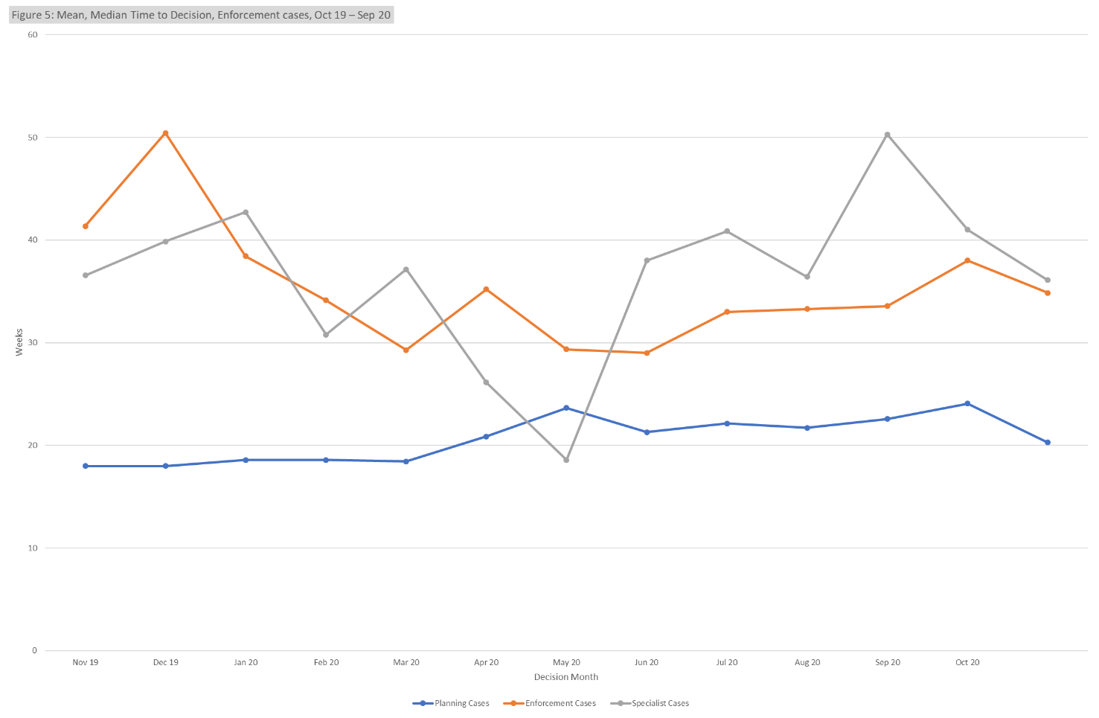

Note that we publish each month, information on the mean and median times from valid to decision, for selected appeal types – data for October 20 are published at the same time as this Release, and are given at Annex C. The information we publish also breaks down the time for each stage of the process, see “Open Cases” below.

Planning Inquiry Decisions
For planning appeals decided by the inquiry process, The Planning Inspectorate has been implementing recommendations from the Rosewell review.

Table 8: Decisions, Mean and Median Time to Decision, Planning Inquiry cases under Rosewell process; Nov 19 – Oct 20

Source: Horizon

The median time for Inquiries over the 12 months to October 20 is 26 weeks, with the mean being higher at 31 weeks.

Most inquiry decisions now being issued are under the revised ‘Rosewell’ process, but we are still deciding those under the previous process.

Table 9: Decisions, Planning Inquiry cases under non-Rosewell process; Nov 19 – Oct 20

Source: Horizon

Figure 7 below shows the mean and median time to decision for planning inquiry cases under the Rosewell process. Since the COIVD outbreak there have been fewer decisions (see table 8) and generally longer durations – noting that these inquiries began many weeks before the pandemic had its impact.

Figure 7: Mean, Median Time to Decision, Rosewell Inquiry Process, Nov 19 – Oct 20
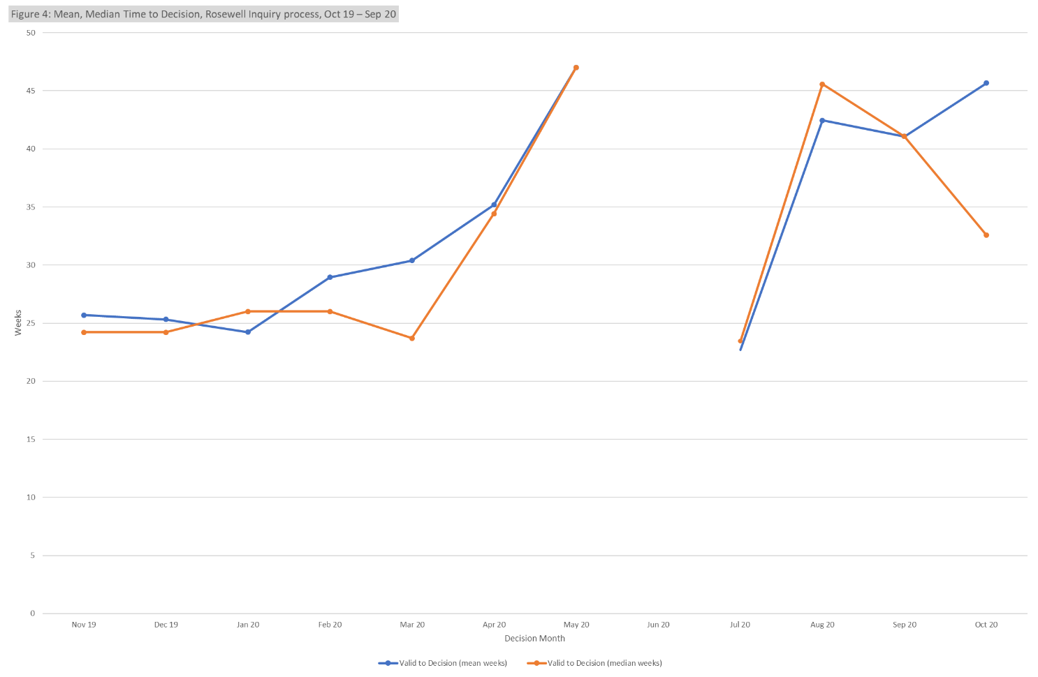
Note – no decisions were made during June 2020

Open Cases

At the end of October, the Planning Inspectorate had ten thousand five hundred cases open (10,543). This comprised 8,849 cases being handled through written representations; 1,025 through hearings; and 669 through inquiries. This is not the number of ‘live’ hearings and inquiries since it includes cases where the event (hearing or inquiry) has yet to start, as well as those where the event has finished but the decision has yet to be issued.

For each procedure type, there are more cases with an event scheduled but not yet started, than at any other stage in the process.

Table 10: Open cases by procedure and stage, as of end of October 2020

Source: Horizon and Picaso

This information provides a ‘snapshot’ in time. As subsequent ‘snapshots’ are issued, more insight will be possible – including such issues as how the numbers and proportions change over time. Event refers to either a site visit, hearing or inquiry.

Inspectors

Table 11 below shows the number of inspectors in the Planning Inspectorate in each month from November 2019 to October 2020. This include headcount (i.e. the number of different individuals) and full-time equivalents (FTE) where those working part time are counted in proportion with their contracted hours. There were 347 Planning Inspectors employed by the Inspectorate in October 2020 – with a full-time equivalent of 310.

By both measures (headcount and FTE) the maximum Inspector resource was in February 2020; and by both, the number at the start of the period was similar to the number at the end.

Table 11: Planning Inspectors – Headcount and FTE, Nov 19 to Oct 20
Source: SAP HR

As above, Planning Inspectors work on a broader range of work than the appeals featured in this Release. They also work on applications and examinations. Please note that data on Planning Inspectors is only applicable to salaried employees (it does not include fixed term contract Inspectors or non-salaried Inspectors).

Virtual Events

The Planning Inspectorate has continued moving casework forward during the pandemic by adapting the ways of working so that examinations, hearings and inquiries (which would previously have been held face-to-face) could take place virtually.

The Inspectorate are continuing to increase the number of events carried out ‘virtually’. The table and graph below the number of virtual events that have occurred each month. Data for November 2020 is an estimate.

Table 12: Virtual Events, Jun-20 to Oct-20P

Source: Virtual Events Project Dashboard, data as at 23/11/2020
P – These numbers should be treated as provisional.

Figure 8: Virtual Events, Jun-20 to Nov 20
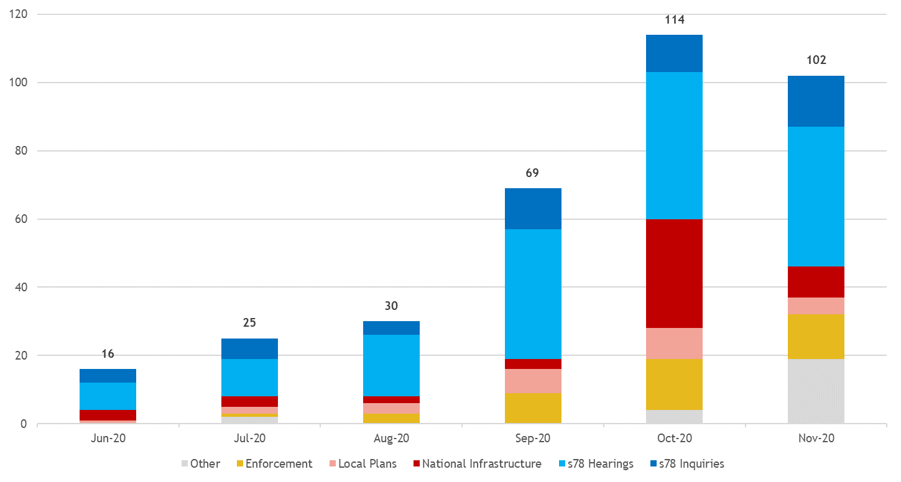
Note – some cases can have multiple ‘events’ – for example an inquiry may sit over four to eight days but would only be counted as one ‘event’. On the other hand, casework like National Infrastructure may have multiple events for the same project.

Annex A – Content of ad-hoc Statistical Releases, 2020

Date | March 2020 | April 2020 | July 2020 | September 2020 | October 2020
Content | Appeals receipts and decisions in the last 12 and 24 months (1st March 2018 – 29th February 2020)  Number of section 78 Planning Appeals received / decided / within target that used the written representation method in the last 12 months (1st March 2019 – 29th February 2020)  Number of dwellings decided and number of dwellings allowed by appeal decisions between 1st January 2017 and 31st December 2019.  Number of Planning Inspectors employed by the Planning Inspectorate at the end of each quarter between 31st March 2017 and 31st December 2019. | Appeals receipts and decisions between 17th March 2020 and 22nd April 2020  Live appeals in the system as at 23rd April 2020  Number of appeals involving housing within the system as at 23rd April 2020  Virtual site visits | Appeals decisions between 17th March 2020 and 22nd June 2020  Number of open cases  Number of virtual events  Number of appeals  involving housing within the system as at 12th June 2020 | Appeals decisions between 17th March 2020 and 21st September 2020  Number of open cases  Number of virtual events | Appeals decisions from October 2019 to September 2020  Number of open cases  Number of virtual events
Scope | England only  Planning cases, Enforcement cases and Rights of Way orders | England only  Planning cases, Enforcement cases and Rights of Way orders | England only  Planning cases, Enforcement cases and Rights of Way orders | England only  Planning cases, Enforcement cases and Rights of Way orders | England only  Planning cases, Enforcement cases, Specialist cases: Common Land, Rights of Way orders, Tree Preservation Orders, High Hedges appeals and Hedgerow appeals

Annex B – Mean and median time to decision, with standard deviation, for planning, enforcement and specialist casework
Planning

Enforcement

Specialist

Annex C – Detailed Information on timeliness (October)

The information below is published today on the number and length of decisions made in October:

The smaller the number of decisions, the less helpful the mean and median are as measures for summarising performance. Particular care should be taken when there are fewer than twenty decisions. These are represented with an * in the table but have been provided for completeness and transparency.

The information published below shows the time taken for different stages of the appeals process:

Valid date – the date a case is deemed to have been validly received

Start date – date when a case has started its documentation phase (requesting statements and additional information) and an Inspector resource has usually been identified to carry out the case

Event date – the date of either a site visit, hearing or inquiry

Decision date – the date the decision was issued by The Planning Inspectorate

Annex D – Casework types included in this release

Planning covers s78 planning appeals, Householder appeals, Commercial appeals, s20 Listed Building appeals, Advertisement appeals, s106 Planning Obligation appeals and Called In Planning Applications.

Enforcement covers s174 Enforcement appeals, s39 Enforcement Listed Building appeals and Lawful Development Certificate appeals.

Specialist casework includes Common Land, Rights of Way orders, Tree Preservation Orders, High Hedges appeals and Hedgerow appeals.

Background notes

Data sources
Horizon / Picaso – The main casework management systems used for processing appeals casework.
SAP HR – The Human Resources system database used to store all information regarding members of staff.

Measure | Definition
Mean | The total time taken divided by the number of cases. Also referred to as the ‘average’. A measure of how long each case would take, if the total time taken was spread evenly across all cases.
Median | This is the time taken by the ‘middle’ case if all cases were sorted from quickest to longest
Standard deviation | This is a measure of variability or spread. It is calculated by examining how much each value differs from the mean. A higher standard deviation means the individual decision times vary more widely around the mean.

Compliance with the Code of Practice for Statistics
These statistics have been published in accordance with the Code of Practice for Official Statistics, which cover trustworthiness, quality and value. They have been pre-announced, and publication is overseen by the Head of Profession.

Technical Notes
Data quality | Data on cases is taken from a live casework system, and details of cases can change for a number of reasons even after a decision has been made. We are seeking to get a better understanding of the nature and volume of these changes and will provide further information as it is available.  We carry out regular checks on the quality of our data and may undertake ad hoc data cleansing exercises. Therefore, all the data for the last 12 rolling months is published in provisional form. Once this period has expired published data is only altered if a significant error is found.
Virtual Events | Data is currently being sourced from an operational MS Excel workbook. It is therefore being constantly updated and refined and may result in data may changing between monthly publications. We are refining definitions of what constitutes an event, as this differs according to the type of casework. Whilst this work is in progress these numbers should be treated as provisional.
Measuring weeks | Data are measured in days and then converted to weeks.  Note that not all decimal values are possible where converting days to weeks. 1 day is 1/7 of a week, or 0.14 weeks (to two decimal places). 2 days = 0.29; 3 days = 0.43; 4 days = 0.57; 5 days = 0.71; 6 days = 0.86.  When these are used to calculate averages, or displayed to one decimal place, the result will not equate to a full day which can be misleading: it may appear that we are measuring part days (e.g. 19.8 weeks) but we only measure in whole days.

Glossary
Term | Explanation
Appeals | The right to appeal a planning decision made by a local authority is a key feature of the planning system, as is appealing when an authority is taking too long.
Appeals decided | Number of appeals by the date the appeal was decided by The Planning Inspectorate.
Appeals received | Number of appeals by the date the appeal was received by The Planning Inspectorate.
Applications | Planning Inspectorate manage the application process for proposed Nationally Significant Infrastructure Projects (NSIPs) within England and Wales in line with the 2008 Planning Act.
Closed | The total number of appeals decided, withdrawn or turned away.
Event Type | The different options of how an Inspector visits a site for a written representations appeal.
Examinations | The process of examining local plans is dealt with by the Planning Inspectorate. Every Local Planning Authority is required to have a local plan. This includes a vision for the future and plan to address housing needs in the area.  When a Local Planning Authority has finished preparing and consulting on a local plan it must be submitted to the Secretary of State who appoints an Inspector to carry out an independent examination.
FTE | Full Time Equivalent – a count of employees where those working part time are counted in proportion with their contracted hours.
Headcount | Total number of staff employed regardless of how many hours they work (i.e. the number of different individuals).
Hearings | A hearing involves the submission of written evidence by the main parties and a hearing once all the written submissions have been received.  This takes the form of a round-the-table discussion (in person or virtually) that will be led by the planning inspector. It allows for all parties to respond to any questions that the inspector might have, and to let everyone make their case known.  Source: Planning Portal
Inquiries | An inquiry is usually used for complex cases where legal issues may need to be considered. The main parties will usually have legal representatives to present their case and to cross-examine any witnesses. Prior to the inquiry date, the Planning Inspectorate will expect to have received various documents from all parties that will be taking part in the appeal. These may include statements of case and proofs of evidence from expert witnesses. Third parties may also take part. The inquiry will be led by the inspector and will follow a formal procedure.  At some point during or on conclusion of the inquiry the inspector and the main parties will undertake a site visit.  Source: Planning Portal
Live appeals | Number of live appeals in that have an appeal valid date but no end date (either decision date or a closed date, e.g. for appeals that have been withdrawn).
Open Cases | Number of cases that have been received but on which a decision has not yet been made/ issued. Will differ from Live Appeals as it includes those received but not yet verified.
Procedure Type | The method by which The Planning Inspectorate processes and decides appeals.
Written Representations | Most planning appeals are decided by the written representations’ procedure. With this procedure the Inspector considers written evidence from the appellant, the LPA and anyone else who has an interest in the appeal. The site is also likely to be visited.

Contact Us

The Planning Inspectorate welcome feedback on our statistical products. If you have any comments or questions about this publication or about our statistics in general, you can contact us as follows:
Media enquiries 0303 444 5004
email press.office@planninginspectorate.gov.uk

Public enquiries email statistics@planninginspectorate.gov.uk

Please note we are currently reviewing our statistics with a view to making them as clear and helpful as possible for users. We would be delighted if you could contact us via the address below with any views on this approach; particularly on what content would be most useful and why.

email statistics@planninginspectorate.gov.uk

If you require information which is not available within this or other available publications, you may wish to submit a Request for Information under the Freedom of Information Act 2000 to the Planning Inspectorate. For more information, see: https://www.gov.uk/make-a-freedom-of-information-request/the-freedom-of-information-act

See Annex A for breakdown of what has been included in recent releases.
The appeal types included are planning & related appeals, Enforcement and Specialist casework (covering a range of casework types). Please note that previous releases covered only Rights of Way orders within Specialist casework. Annex A details the scope of previous releases, Annex D the scope of this release and Background Notes has further information.
The time to make a decision is measured from the time we judge we have enough information for the case to proceed (i.e. it is deemed ’valid’) to the time a decision letter is issued. 50% of cases are deemed ‘valid’ in a week or less – see ‘Open Cases’ below for more information.
The decisions made in a given month will include those that started many months before, and thus do not give an accurate indication of how decisions submitted, or deemed ‘valid’ in that month, will take.
Note that the median case is the ‘middle’, so half the cases take this long or less; and half take this long or more.
Specialist cases comprise Common Land, Rights of Way orders, Tree Preservation Orders, High Hedges appeals and Hedgerow appeals
Open cases are any that have been received but on which a decision has not yet been made/ issued.
Note that, as of September 2020, the average time of cases to be deemed valid was 1.3 weeks. The median was 0 weeks. The time prior to validation is excluded from the timeliness figures above.
Virtual Events data includes casework types not covered elsewhere in this release, including Local Plans and Nationally Significant Infrastructure Projects.

