

Our Reference: 101599  Your Reference: None  By Email: | Safety Engineering and Standards  Official Correspondence Team  Highways England  Woodlands  Manton Lane  Bedford  MK41 7LW

22 January 2021

Dear Mr

Environmental Information Regulations 2004

Thank you for your request for information about Higham Lane Motorway Bridge dated
22 November 2020. We have dealt with your request under the terms of the
Environmental Information Regulations 2004. This is because the information requested concerns measures and activities affecting or likely to affect elements of the environment or affect factors such as noise, pollution discharges and other releases into the environment.

You asked us for:

1 | Summary of calculations proving that the Higham Lane / Higham Common Road motorway over-bridge has the capacity to handle the additional vehicular loadings expected over the next 30 years.
2 | A detailed summary of the latest inspection report for the motorway overbridge.
3 | Summary of calculations showing the expected safe operational life of the motorway-over-bridge.

Questions One and Three
Please note that some areas of the document have been redacted under Regulation 13 of the Environmental Information Regulations for personal information.

This structure is designated by Highways England as M1/278.40 Higham Common. It was built in 1968, and was designed to standards current at that time.

The bridge was structurally assessed by calculation in the 1990’s as part of a national programme to assess the effects of the introduction of heavier 40 tonne vehicles travelling onto the UK’s road network.

Highways England does not routinely hold detailed copies of calculations, but our structures asset database summarises the calculation results as a rated load
capacity. For this structure the capacity is recorded as 40t Assessment Live Load (ALL) + 45 units of HB loading. The ALL rating means the structure has been assessed as capable of carrying all legal heavy goods vehicles. The 45 units HB rating also covers most abnormal loads up to 150tonnes gross vehicle weight. This capacity is operationally equivalent to the majority of motorway carrying bridges built to the latest standards. Exceptionally for this structure we do have a copy of the original detailed calculation summary sheet that confirms our database recorded capacity which is attached.

Assessment calculations use theoretical load models which consider the worst effects from combinations of vehicles fully occupying all available carriageway space on the bridge deck. Therefore the maximum load on the bridge deck that needs to be assessed is not dependent on increased traffic flows that may occur over the next 30 years.

The structural assessment described confirms the structure is safe to carry all traffic loading for the foreseeable future.

Question Two
Highways England has a rigorous inspection regime ensuring the delivery of a safe and reliable motorway and trunk road network in England. We inspect all of our 22,000 bridges and other structures on the Strategic Road Network in line with the published guidance in the Design Manual for Roads and Bridges. This requires a visual General Inspection every two years, and a more detailed Principal Inspection every six years, which identifies and records defects in reinforced concrete, steelwork and other construction materials. Where necessary further investigations, which may include material tests, are undertaken to establish the extent, severity and specific causes of the defects. If maintenance works are required, they are prioritised and subject to funding and the availability of the roadspace, the necessary repairs are carried out.

The last Principal Inspection for Higham Common Bridge was carried out in March 2019. The summary section stated that:
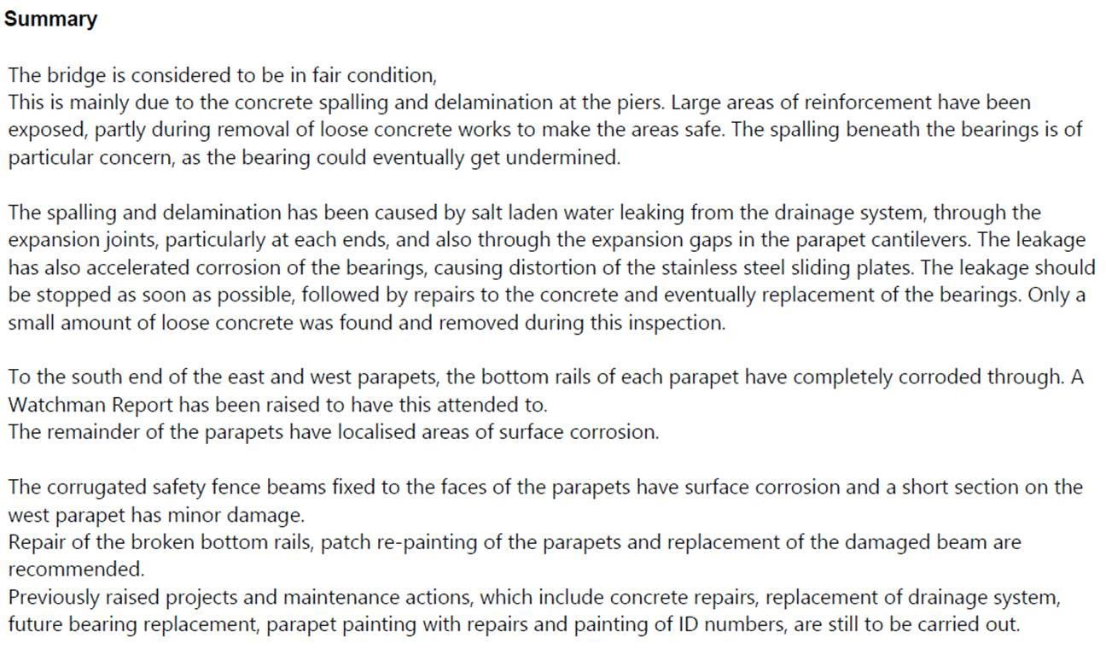

Highways England are currently considering what repairs will be required to this bridge, to ensure that it remains safe and serviceable, and taking account of its intended future usage. The need for concrete repairs has been assessed, but are not currently considered urgent and will be programmed in the future. However, repairs to the parapet are required and these are planned to be undertaken within the next month.

If you have any queries about this letter, please contact us by email:
info@highwaysengland.co.uk. Please kindly quote reference number 101616 in any future communications.

If you are unhappy with the way we have handled your request you may ask for an internal review. Our internal review process is available at:
https://www.gov.uk/government/organisations/highways-england/about/complaintsprocedure

If you require a print copy, please phone the Information Line on 0300 123 5000; or email info@highwaysengland.co.uk.

If you are not content with the outcome of the internal review, you have the right to apply directly to the Information Commissioner for a decision. The Information Commissioner can be contacted at:

Information Commissioner’s Office
Wycliffe House
Water Lane
Wilmslow
Cheshire SK9 5AF

Yours sincerely

Safety Engineering and Standards Official Correspondence Team

