
Transport and Technology:
Public Attitudes Tracker

Wave 6: Summary report

November 2020

Contents
1. Introduction 3
2. Electric vehicles: awareness and attitudes 5
3. Considerations for next vehicle purchase 11
4. Autonomous vehicles: awareness and attitudes 16
5. Attitudes towards electric scooters 20
Appendix A: Sample and survey methodology 23
Appendix B: Wave 6 CAWI questionnaire 27

- Introduction
  - Background to the survey
In 2017, the Department for Transport (DfT) commissioned Kantar’s Public Division to conduct six waves of research to track public attitudes and behaviours relevant to transport and transport technology in England. This report focuses on the results from Wave 6 of the survey conducted in August 2020.
The survey aims to fill gaps in knowledge on key areas and emerging topics such as public attitudes to autonomous vehicles and future modes of travel. Wave 6 of the survey was conducted on Kantar’s Public Voice panel. All previous waves had been conducted on Kantar’s face-to-face omnibus, however, due to COVID-19 and associated restrictions, it was not possible to conduct face-to-face fieldwork at Wave 6. The differences in sample composition and measurement mode make comparisons inadvisable and as such this report does not include any analysis comparing findings to previous waves.
DfT and Kantar jointly developed the core questionnaire content prior to Wave 1. This process included a review of relevant questions asked on other surveys and four focus groups to assist the development of new questions. All questions were tested through two rounds of cognitive testing. Further cognitive testing was conducted before Wave 6 to help develop new questions relevant to electric vehicles, hybrid vehicles and the government consultation on ending the sale of new petrol, diesel and hybrid cars and vans by 2035. Following fieldwork, a two-phased approach to ending the sale of these vehicles was announced on 18th November 2020. The sale of new petrol and diesel cars will now end in 2030, and for hybrids will end in 2035.
Overall, 3,543 adults in England were interviewed at Wave 6. The sample is representative of individuals aged 16 or over living in England. Data has been weighted to the profile of adults in England.
Wave 6 of the research took place in August and September 2020. This was pushed back from the initially planned date of June 2020 due to the impact of COVID-19.
More information on the sample and survey methodology is included in Appendix A.
  - Notes on findings
New questions on hybrid vehicles, electric vehicles and the government proposal to end the sale of new petrol, diesel and hybrid vehicles by 2035 were asked in August 2020 (Wave 6). The questionnaire for August 2020 (Wave 6) is included in Appendix B.
Due to the impact of COVID-19 and associated restrictions, the survey methodology moved from face-to-face to a mixed mode online and telephone survey. As such the report does not include any wave on wave analysis due to the differences in sample composition and measurement mode between waves.
Throughout the report differences are noted for the following key demographic sub-groups: gender, age, and urbanity. Other sub-group comparisons are also included where relevant, including region, car ownership, and educational attainment. At previous waves of the survey it was advised to interpret significant differences with caution, as the random location sampling method used strictly speaking should not be used to calculate significance. Significance was still marked as it could be assumed that the variance of an equally random location sample is similar to that of an equally specified probability sample. At Wave 6 the survey methodology used a random probability sampling method, and thus significance no longer needs to be interpreted with caution.
- Electric vehicles: awareness and attitudes
  - Awareness and knowledge of Electric Vehicles (EVs)
For the first time at Wave 6, people were asked how many people they knew who drove a plug in EV. Two-thirds of people (64%) knew no one with a plug in EV, leaving 36% who knew at least one person - this was more likely to be the case among those living in rural areas (43% versus 34% of urban dwellers) and among those with a degree level qualification (44% versus 34% with a non-degree qualification and 24% of those with no qualifications).
Fig 2.1 Number of people known to respondent who drive an EV
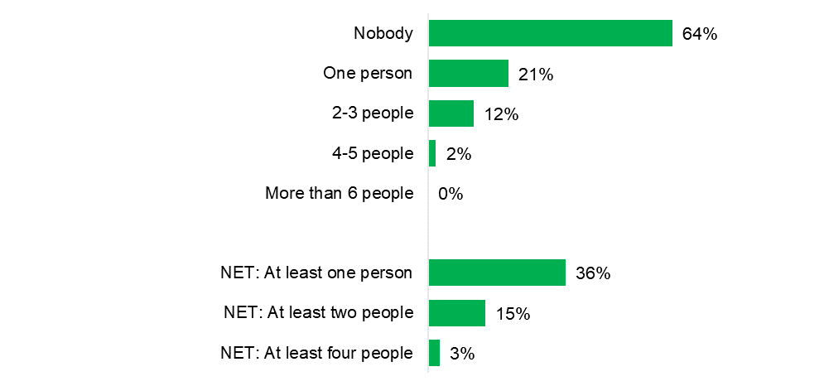

Source: Q93. How many of your friends, family and neighbours, if any, do you know who drive a plug-in electric vehicle of any kind?
Base: All respondents (Aug 2020: 3,543)

The overwhelming majority of people (98%) said that they had at least heard of EVs, while claimed knowledge (i.e. knowing at least a little about EVs) stood at 72%.

Fig 2.2 Claimed awareness and knowledge of electric vehicles, August 2020
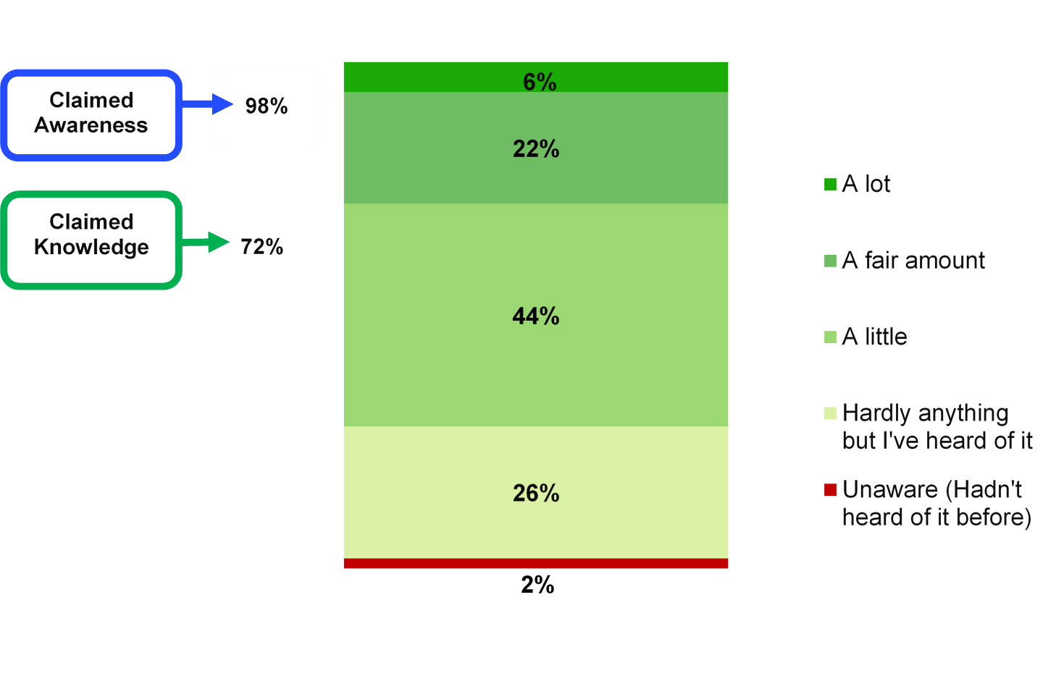

Note: Claimed knowledge = A lot, a fair amount, and a little; Claimed awareness = A lot, a fair amount, a little, and hardly anything but I’ve heard of it.
Source: Q25. How much, if anything, would you say you know about electric vehicles?
Base: All respondents (Aug 2020: 3,543)

Claimed knowledge of EVs was significantly higher among men (84% versus 62% of women); among those who held a degree level qualification (81% versus 71% with a non-degree qualification and 53% with no qualifications); and among those with at least one car in the household (72% or more compared with 60% for those with no car). In terms of age, 63% of those aged 75+ claimed at least a little knowledge of EVs and this was significantly lower than the levels of knowledge held by those aged 25-54.
Knowledge was significantly higher among those living in rural locations (78% versus 71% of urban dwellers), and while there were some differences in claimed knowledge by region, there was no clear pattern.
Notably, those who knew at least one person who drove an EV were more likely to claim some knowledge of these vehicles: 82% of people who had at least one contact who drove an EV claimed to know at least a little about EVs, compared with 67% of those who knew no one who drove an EV.

  - Perceived advantages of electric vehicles (EVs)
Figure 2.3 shows the perceived advantages of EVs. The categories represent unprompted, ‘top of mind’ responses where respondents were asked if they could think of any advantages of EVs over petrol or diesel vehicles. Overall, 88% of people could think of at least one advantage of EVs, and by far the most commonly cited advantage was their environmental benefit (77%), followed by lower running/maintenance costs (24%) and being quieter/less noisy (9%). When all mentions of advantages to do with cost were amalgamated, 28% of people made reference to at least one cost advantage of EVs.
Six per cent of people could think of no advantages of EVs, and this proportion tended to increase incrementally with age (for example, 0% of those aged 16-24 could think of no advantages of EVs, rising to 13% of those aged 75+). A similar proportion, 5%, said ‘don’t know’ and this was more likely among those with hardly any/no knowledge of EVs (11% versus 2% of those with at least a little knowledge).

Fig 2.3 Perceived advantages of electric vehicles, August 2020
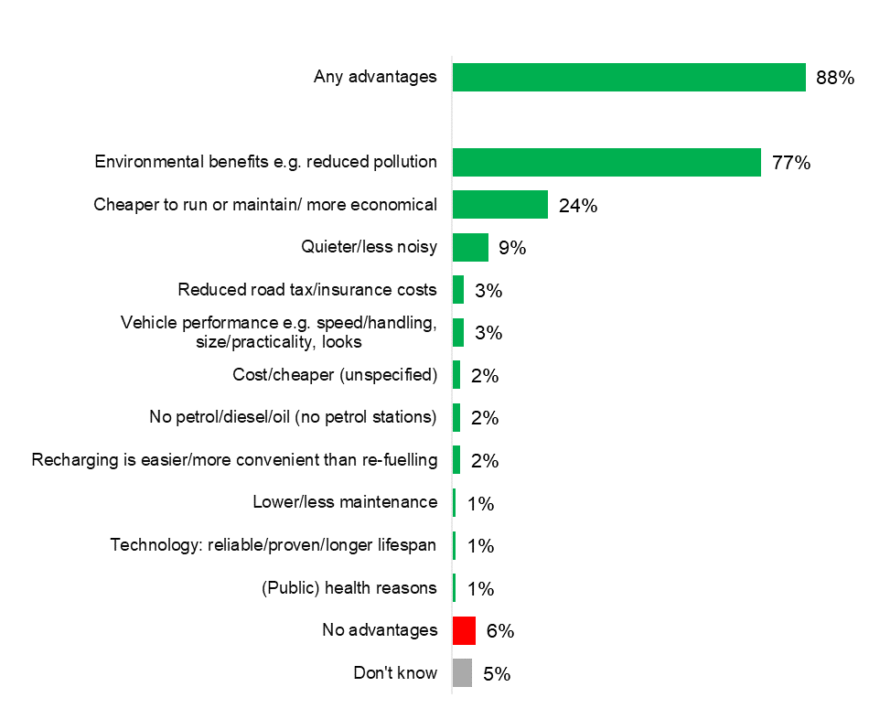
Source: Q26. What do you think are the advantages, if any, of electric over petrol or diesel vehicles?
Base: All respondents (Aug 2020: 3,543)
Further analysis showed that some groups were more likely than others to mention the environmental benefits of EVs, namely people with a degree level qualification (86% versus 76% with a non-degree qualification and 56% with no qualification), and those living in urban areas (78% versus 72% of those in rural areas).
Certain groups were also more likely than others to mention cost as an advantage of EVs (this included ‘Cheaper to run or maintain/more economical’; ‘Cheap(er) to buy’; ‘Cost/Cheaper (unspecified)’; ‘Reduced road tax/insurance costs’; and ‘Hold their value better (resale/residual)’):
- Men (35% versus 21% of women);
- Those with degree level qualifications (34% versus and 26% or less among those without degree level qualifications); and
- Car owners (30% versus 18% of non-car owners).
- Those aged 25-34 and 35-44 had the highest mentions of cost at 39% and 36% respectively, although the difference between the 35-44 and 45-54 age categories was not statistically significant (36% versus 31%).

  - Perceived disadvantages of electric vehicles
Figure 2.4 summarises the perceived disadvantages of EVs over petrol or diesel vehicles. Overall, 88% of people mentioned at least one disadvantage, and issues relating to battery life and recharging were the most common themes:
- 36% mentioned battery life/distance travelled;
- 22% mentioned a scarcity of charging points.
When responses were grouped together:
- 45% mentioned recharging concerns (this included ‘Recharging – where/how to charge’; ‘Not enough charging points’; ‘Time taken to recharge’; ‘Charging point(s) (unspecified)’; ‘Charging/the need to/having to recharge’; and ‘Constantly needing to charge/too frequent charging’);
- 39% mentioned battery concerns (this included: ‘Battery: distance travelled on charge’; ‘Disposal of batteries – impact on environment’; and ‘All other negative references to batteries’ (not charted)); and
- 22% mentioned a concern related to cost (this included: ‘Cost to run/maintain/fix faults’; ‘Cost to buy’; ‘Cost in general’; and ‘Value: resale/residual’ (not charted)).
A small minority (6%) could think of no disadvantages of EVs, and the same proportion said ‘don’t know’. Some groups were more likely than others to respond ‘don’t know’, namely women (8% versus 3% of men); non-car owners (10% versus 5% of car owners); and those with hardly any/no knowledge of EVs (12% versus 3% of those with a least a little knowledge).

Fig 2.4 Perceived disadvantages of electric vehicles, August 2020
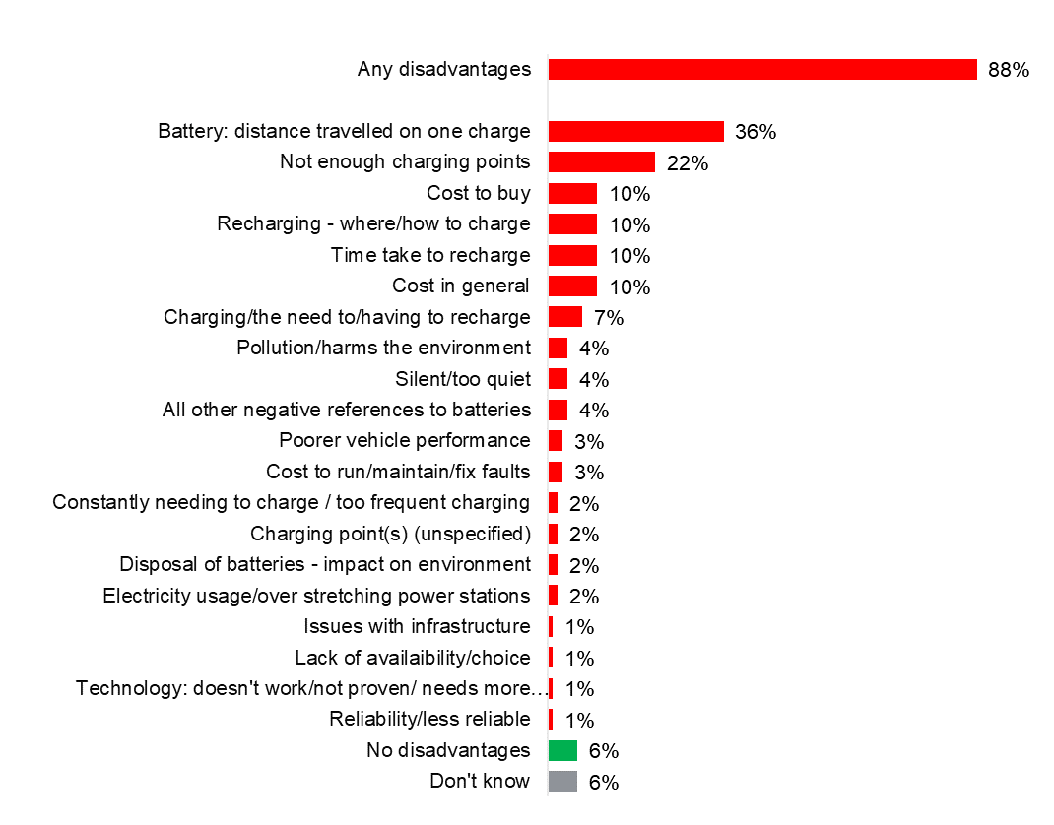
Source: Q27. What do you think are the disadvantages, if any, of electric over petrol or diesel cars?
Base: All respondents (Aug 2020: 3,543)

Further analysis of the broad categories of responses showed that recharging concerns were more likely to be held by those with degree-level qualifications (50% versus 44% or less among those without degree level qualifications). Battery concerns were more likely to be held by:
- Men (49% versus 29% of women)
- Those living in rural locations (45% versus 37% of urban dwellers)
- Car owners (41% versus 23% of non-car owners)
And cost concerns were more prevalent among:
- Men (25% versus 19% of women)
- Car owners (23% versus 15% of non-car owners)
- Those with degree or non-degree level qualifications (24% and 23% versus 12% of those with no qualifications)
- Considerations for next vehicle purchase
  - Timescale for buying/replacing vehicle
All those with a valid UK driving licence were asked when they planned to buy a vehicle, or replace their existing vehicle, either new or second hand. Figure 3.1 shows that in August 2020, 87% of people planned to buy or replace their vehicle at some point in the future, while 12% did not intend to do so. Of those with a valid driving licence:
- Nearly a fifth (18%) planned to buy/replace within the next year
- 18% in over 1 year but within 2 years
- 20% in over 2 years but within 3 years
- 19% in more than 3 years but within 5 years
- 13% planned to buy/replace their vehicle in more than 5 years’ time

Fig 3.1 Timescale of buying/replacing vehicle

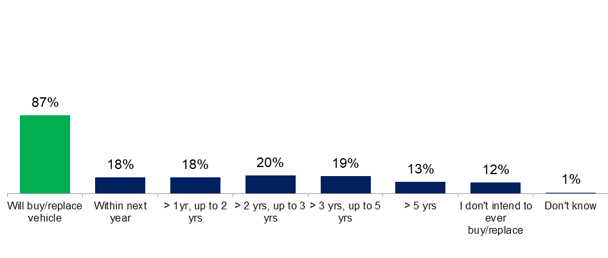Source: Q16 When, if at all, do you think you will next buy or replace a car or van, either new or second-hand?
Base: All with a valid UK driving licence (Aug 2020: 3,139)
Men were more likely than women to intend to purchase within the next year (21% versus 14% respectively), as were those with children in the household (25% versus 15% without children at home). In terms of those not intending to ever buy or replace a vehicle, this was more likely among those aged 65 or older (28% versus 9% or less in other age groups); those currently without a car (40% versus 9% of existing car owners) and those with no qualifications (25% versus 11% or less among those with qualifications).

  - Type of vehicle planning to buy/replace next time
Those who planned to buy or replace a vehicle were asked about their purchasing or leasing intentions. A majority planned to buy second-hand (74%), and this was particularly likely among non-car owners (86% versus 73% of existing car owners).
Figure 3.2 summarises the type of vehicle that people planned to buy or lease: 41% planned to buy a petrol vehicle, 18% diesel, 30% hybrid, and 9% fully electric (overall, 39% planned to buy or lease a hybrid or electric vehicle next time).

Fig 3.2 Future purchase/leasing intentions

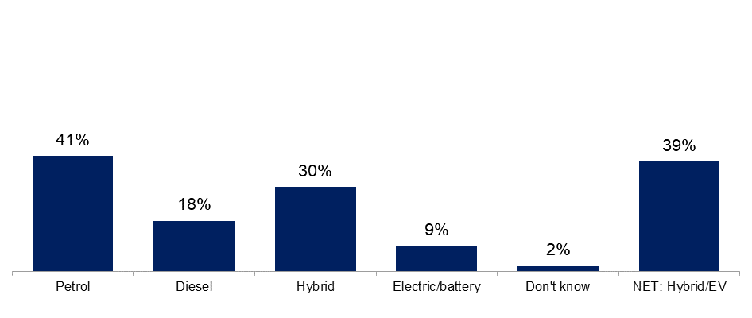Source: Q17. What type of car or van do you think you will most likely purchase or lease next time?
Base: All who will buy/replace their current car or van (Aug 2020: 2,810)
People with a degree level qualification were more likely to say that they planned to buy or lease an electric/battery driven vehicle than those with non-degree level qualifications and those with no qualifications (15% versus 6% and 5% respectively); this group were also more likely to say they would buy a hybrid vehicle (37% versus 26% or less among those without degree level qualifications).
Those living in rural areas were more likely than urban dwellers to say they intended to buy/lease a diesel vehicle next time (22% versus 17% respectively).
All those who planned to purchase or lease a hybrid vehicle next time were asked what type of vehicle this would be. Four in ten (43%) said this would be a non-plug in vehicle, 16% said they intended to buy/lease a plug-in model and 40% were undecided. Men were more likely than women to say their next purchase would be a plug-in model (22% versus 11% respectively).

  - Public reaction to government proposal to end the sale of new petrol/diesel/hybrid vehicles
The August 2020 survey explored public understanding of government proposals to end the sale of new petrol, diesel and hybrid vehicles by 2035 or earlier (N.B. A two-phased approach to ending the sale of these vehicles was announced on 18th November 2020, after fieldwork was conducted. The sale of petrol and diesel cars will now end in 2030, and for hybrids will end in 2035). Figure 3.3 shows that 73% of people had heard about this proposal, while 42% claimed to know at least a little about the proposal (i.e. they said they knew at least a little about it).
Fig 3.3 Claimed awareness and knowledge about plans to end sale of new petrol/diesel/hybrid vehicle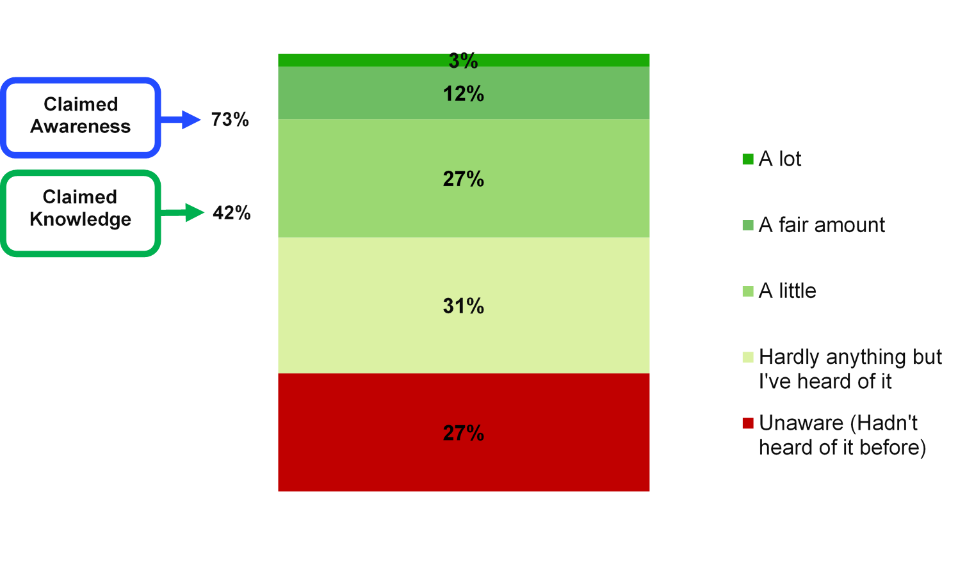
Note: Claimed knowledge = A lot, a fair amount, and a little; Claimed awareness = A lot, a fair amount, a little, and hardly anything but I’ve heard of it.
Source: Q94. How much, if anything, would you say you know about the proposal to end the sale of new petrol, diesel and hybrid vehicles?
Base: All respondents (Aug 2020: 3,543)

Further analysis showed that men were more likely than women to claim to know something about the proposal (53% versus 31%), as were those living in rural areas (48% versus 41% in urban areas), existing car owners (44% versus 32% of those without a car), and those with qualifications (47% with degree level and 41% with non-degree level versus 30% of those with no qualifications).
In terms of regional analysis, 37% of those living in London said that they hadn’t heard of the proposals and this proportion was significantly higher than that recorded in all other regions with the exception of the East Midlands (27%).
  - Impact of government proposal on purchasing decisions
People who were planning to buy/replace a vehicle in the future were asked whether the government’s proposal to end sales of new petrol, diesel and hybrid vehicles by 2035 or earlier might influence their decision-making (N.B. A two-phased approach to ending the sale of these vehicles was announced on 18th November 2020, after fieldwork was conducted. The sale of new petrol and diesel cars will now end in 2030, and for hybrids will end in 2035).
Figure 3.4 shows that three in ten (29%) people said that the government’s proposal would have no influence on any of their decisions concerning their next vehicle purchase/lease, while a quarter (25%) said that the proposals would have no impact on the timing of their purchase/lease and 11% said ‘it depends’. One in ten (11%) said that the proposals meant they were more likely to buy/lease an electric vehicle, and a similar proportion (10%) said they were more likely to buy/lease a plug-in hybrid vehicle. Seven per cent said that the proposals made it more likely that they would buy/lease a non-plug in hybrid and 6% said they were more likely to buy/lease a petrol/diesel vehicle.
Three per cent were less likely to buy/lease any vehicle and a further 3% said they would bring their purchase/lease decision forward.

Fig 3.4 Impact of government plans on purchase/leasing decisions
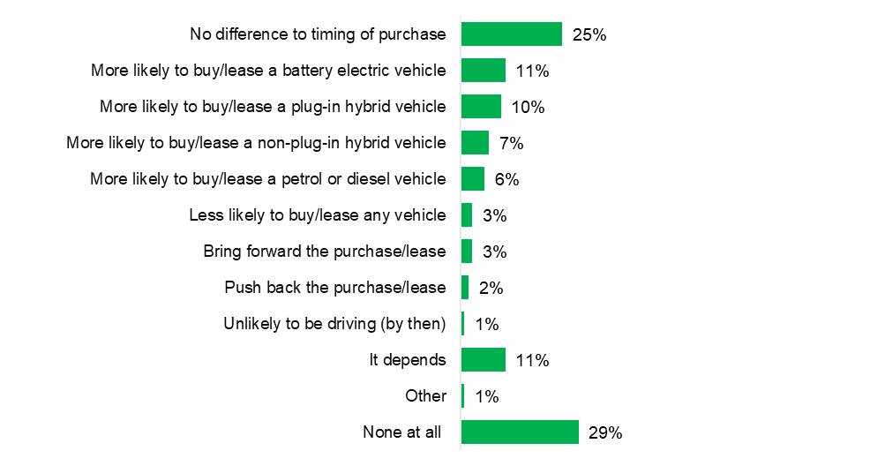
Source: Q95. Thinking about your next car or van purchase or lease, how, if at all, might the government’s proposal to end sales of new petrol, diesel and hybrid vehicles by 2035 or earlier influence your decision?
Base: All who will buy/replace car or van (Aug 2020: 2,810)

Further analysis revealed that certain groups were more likely to say they would buy/lease an electric vehicle, for example, 22% of those living in London gave this answer which was significantly higher than all other regions (with the exception of the West Midlands, 12%). Those who did not currently own a car were more likely than car owners to say they were more likely to buy/lease an electric vehicle given the government’s proposals (19% versus 11% respectively), as were those holding a degree-level qualification (17% versus 8% with a non-degree level and 9% with no qualifications). People claiming at least a little awareness of the proposals were also more likely than those with hardly any/no awareness to say they were now more likely to buy/purchase an electric vehicle (14% versus 9% respectively).
Focussing on those who said that the proposals would have no impact on their decision making, this view was more likely to be held by men (32% versus 25% of women), and those living in urban areas (30% versus 24% of people living in rural locations). This view was also more commonly held among those with lower awareness of the proposal: 31% of those who claimed to know hardly anything/nothing said the proposals would make no difference to their decision making, compared with 26% of those who knew at least a little about the proposal.
People who initially said that their next vehicle purchase/lease was likely to be a hybrid vehicle were more likely to say they would now buy or lease a battery/electric vehicle, given the government’s proposals (15% vs 5% of those who initially said they would buy or lease a petrol vehicle and 2% for diesel). Overall, 42% of people who initially said their next vehicle purchase/lease was likely to be an electric/battery vehicle said they would be more likely to buy or lease one now, as a result of the proposal.
- Autonomous vehicles: awareness and attitudes
  - Awareness and knowledge of autonomous vehicles (AVs)

Respondents were asked how much they knew about AVs (defined as fully driverless or self-driving cars) and almost all said that they had heard of these types of vehicle (94%), and six in ten (62%) claimed to know at least a little about them (Figure 4.1).
Fig 4.1 Claimed awareness and knowledge of autonomous vehicles, August 2020
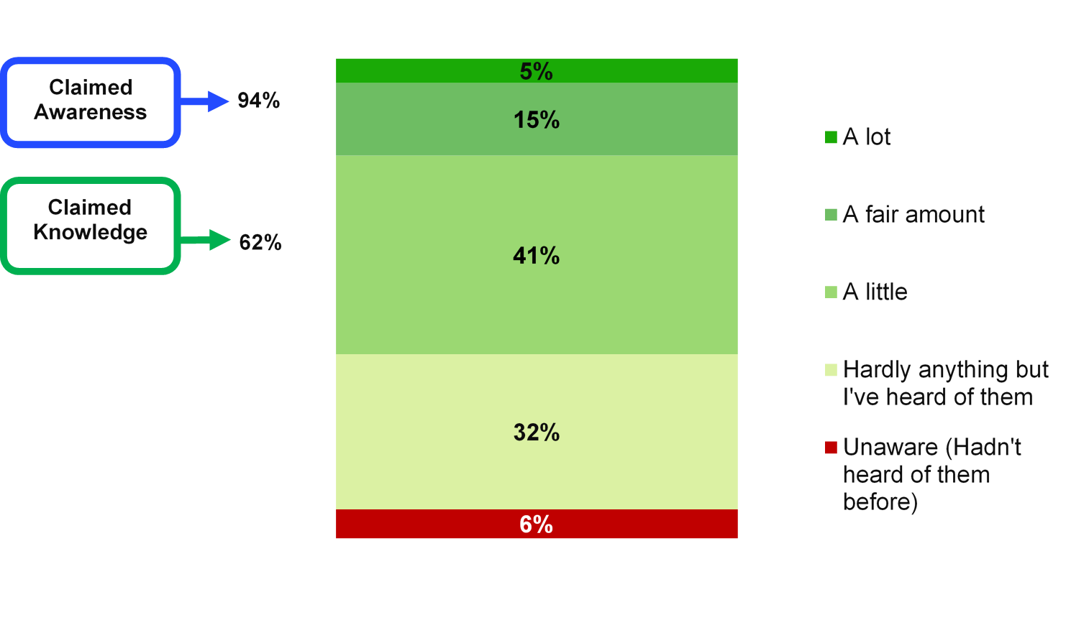
Note: Claimed knowledge = A lot, a fair amount, and a little; Claimed awareness = A lot, a fair amount, a little, and hardly anything but I’ve heard of it.
Due to rounding, the sum of all answer codes at this question do not equal 100%. This also applies to the ‘Claimed awareness’ and ‘Claimed knowledge’ figures.
Q28. Fully driverless or self-driving cars or vans are not yet available for everyday use. How much, if anything, would you say you know about these types of vehicle?
Base: All respondents (Aug 2020: 3,543)
Men were more likely to claim to know at least a little about AVs (77% versus 48% of women), as were those with qualifications (69% with degree-level and 61% with non-degree level qualifications versus 44% of those with no qualifications), and car owners (64% versus 53% of non-car owners). There were no significant differences in claimed knowledge by age.
People living in rural areas were more likely to claim at least a little knowledge of AVs (68% versus 61% of urban dwellers), and at a broad regional level, those living in the south were more likely than those in the north to claim at least a little knowledge (65% versus 58% respectively).

  - Perceived advantages of autonomous vehicles
Figure 4.2 shows the perceived advantages of AVs in August 2020. The categories represent unprompted, ‘top of mind’ responses where respondents were asked if they could think of any advantages of AVs. Six in ten people (59%) mentioned at least one advantage of AVs – in comparison, 85% mentioned at least one disadvantage (Figure 4.3).
By far the most commonly cited advantage related to safety (35%). Other advantages were mentioned by fewer than one in ten people, as shown in the chart (e.g. convenience 7%, lower fatigue 4%, less congestion 4%, no need for a licence 4%, better for elderly/disabled 4%, less stressful 4%).
A quarter of people (26%) could think of no advantages of AVs, while 14% said ‘don’t know’.

Fig 4.2 Perceived advantages of autonomous vehicles, August 2020
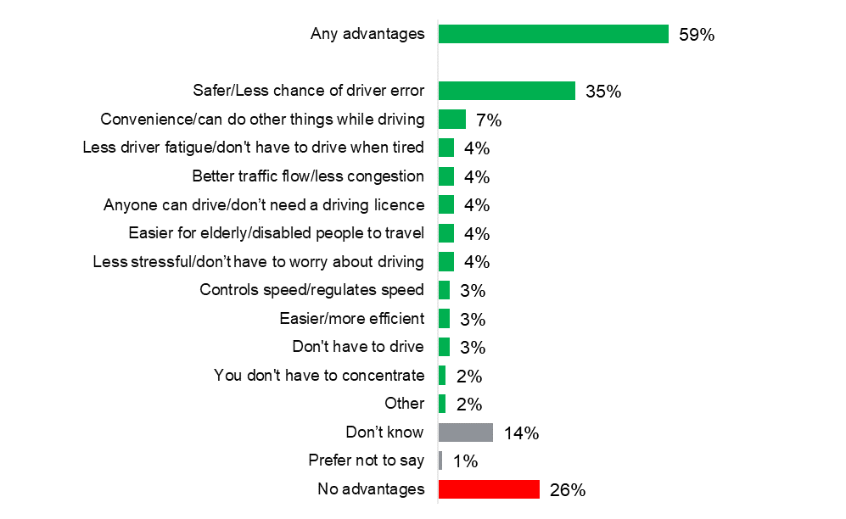Source: Q29. What do you think are the advantages, if any, of fully driverless or self-driving vehicles?
Base: All respondents (Aug 2020: 3,543)
Further analysis showed that certain groups were more likely than others to mention at least one advantage of AVs, including: men (66% versus 52% of women); younger people (68% or more among those aged 16-44 versus 56% or less in those aged 45 and older); and those with qualifications (71% of those with degree level and 57% of those with non-degree level qualifications versus 33% of those with no qualifications). In addition, people who claimed to know at least ‘a little’ about AVs were more likely than those who did not know anything to give at least one advantage (68% versus 33%).
Looking specifically at safety as an advantage, this was more likely to be mentioned by men (41% versus 28% of women) and those with qualifications (43% with degree level and 34% of those with non-degree level qualifications versus 16% of those without qualifications).

  - Perceived disadvantages of autonomous vehicles
Figure 4.3 summarises people’s perceived disadvantages of AVs. Eighty-five per cent of people mentioned at least one disadvantage, with general mentions of safety being the most commonly cited disadvantage (30%). When all the different mentions of safety were combined into one group, 47% of people mentioned at least one safety-related disadvantage (this included: ‘Equipment failure/system failure’; ‘Car fails to react to unexpected situations’; ‘Interacting with other human drivers’; ‘Interacting with pedestrians and cyclists’; and ‘Safety/dangerous/cause accidents (general mentions)’). Four per cent of people could think of no disadvantages and 10% said ‘don’t know’ (this was more likely among those who were unaware of AVs: 32% versus 8% of those with any awareness).
Fig 4.3 Perceived disadvantages of autonomous vehicles, August 2020
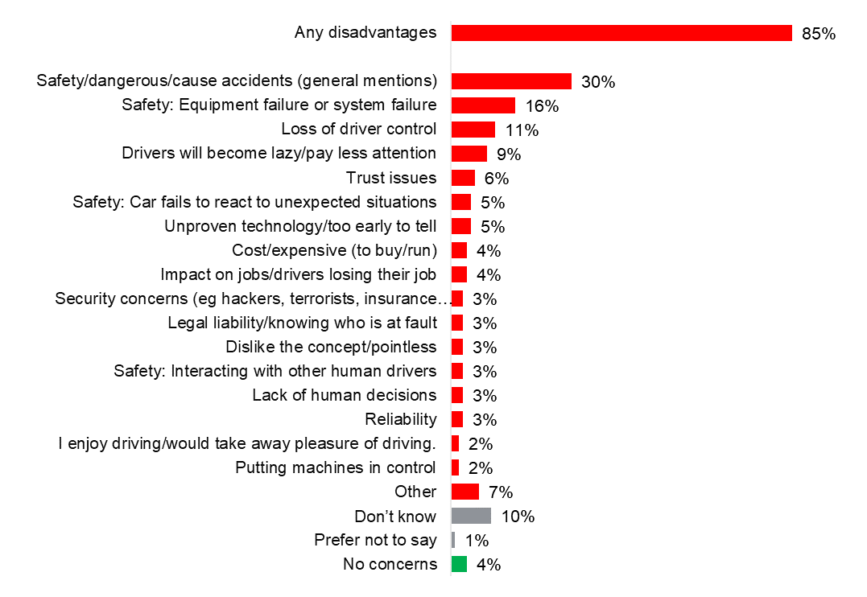
Source: Q30. What do you think are the disadvantages, if any, of fully driverless or self-driving vehicles?
Base: All respondents (Aug 2020: 3,543)
Demographic analysis revealed that some groups were more likely than others to cite at least one disadvantage, namely: car owners (86% versus 75% of those with no car) and those with qualifications (88% with degree level and 86% with non-degree level versus 71% with no qualifications). Awareness also played a role – those who claimed to know at least a little about AVs were more likely to cite at least one concern (89% versus 78% of those with hardly any or no knowledge).
Looking specifically at safety concerns as a whole, these were more likely to be cited by women (51% versus 42% of men), and those with qualifications (52% with degree level and 46% with non-degree level versus 36% of those with no qualifications).
- Attitudes towards electric scooters
  - Personal use of electric scooters

In August 2020, the vast majority of people (98%) did not make use of an electric scooter, while 2% did so regularly or just occasionally. An electric scooter was defined as a stand-up scooter with a small engine or electric motor. Those that completed the survey online were also able to see a picture of someone riding an electric scooter, at the first question on the topic.
Fig 5.1 Personal use of electric scooters, August 2020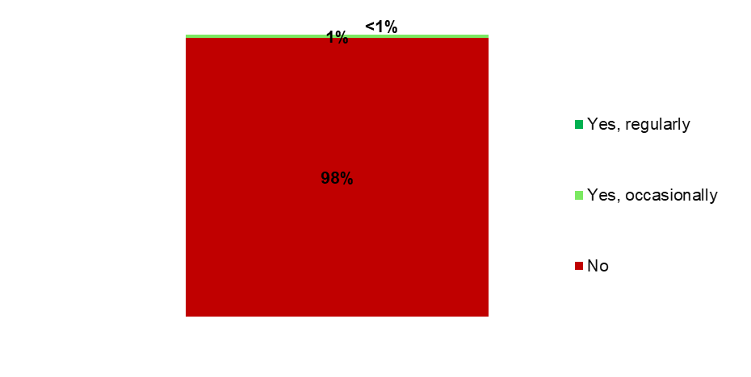
Source: Q88. Do you personally use an electric scooter in the UK?
Base: All respondents (Aug 2020: 3,543)

  - Perceived advantages of electric scooters
Figure 5.2 shows the perceived advantages of electric scooters; once again the categories represent unprompted, ‘top of mind’ responses where respondents were asked if they could think of any advantages of this type of vehicle. Seventy-five per cent of people mentioned at least one advantage and the most commonly cited advantage was environmental benefits (18%), followed by speed (14%), ease of use (12%) and cost (11%).
Overall, 36% of people mentioned something to do with convenience, and this was more commonly mentioned by younger people (for example, 44% of 16-24 year olds mentioned at least one advantage to do with convenience, compared with 23% of those aged 75+); those with degree level qualifications (42% versus 33% or less for those without); and those living in urban locations (37% versus 30% among those in rural areas). Responses related to convenience included: ‘Easy to use/learn/little effort required’; ‘Easier to use than standard scooters (can travel longer distances/easier going up hills)’; ‘Easy to store/secure/carry/small (compared to a bike)/foldable/portable’; ‘Easy/convenient for short journeys/to get from A to B’; ‘Convenience (unspecified)’; ‘Faster/easier than walking’; ‘Parking/easier to park/no parking required’; ‘Faster/easier/safer than cycling’.
Seventeen per cent of people could think of no advantages of electric scooters and this was more likely among men (19% versus 15% of women); those without degree level qualifications (19% or more versus 11% of those with); those living in rural areas (23% versus 15% among urban dwellers); people in the North (21% versus 15% in the Midlands and 16% in the South); and among those with restricted mobility (27% versus 15% of those with no mobility restrictions). In addition, the tendency to say there were no advantages increased with age (for example, 3% of 16-24 year olds gave this response, rising to a maximum of 34% among those aged 65-74).
Fig 5.2 Perceived advantages of electric scooters, August 2020
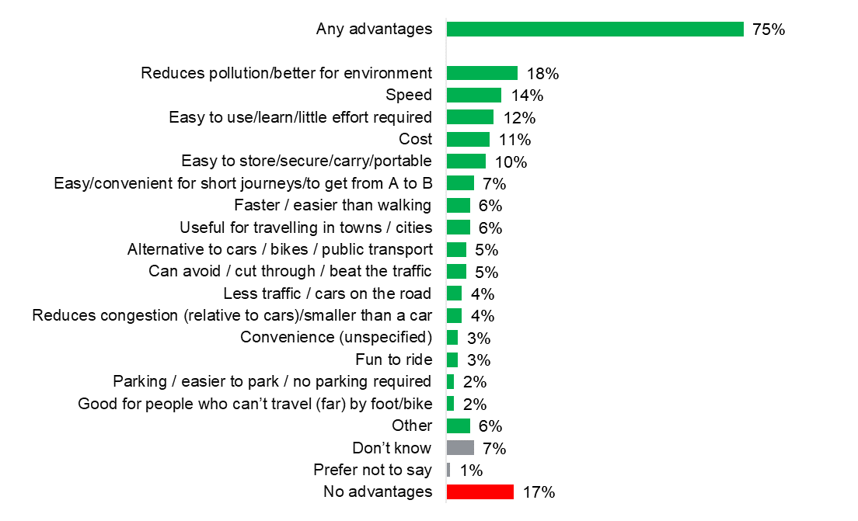
Source: Q81. What do you think are the advantages, if any, of electric scooters?
Base: All respondents (Aug 2020: 3,543)

  - Perceived disadvantages of electric scooters
Figure 5.3 summarises the perceived disadvantages of electric scooters: 85% mentioned at least one disadvantage, with general mentions of danger/safety/accidents being that most commonly cited disadvantage (27%), followed by a specific concern about the safety of using electric scooters on roads/ pavement/paths (20%) and the safety of pedestrians (13%).
Overall, 55% of people mentioned at least one safety concern, and this was more likely among older people (for example, 44% of 16-24 year olds mentioned a safety concern compared to a maximum of 64% among 65-74 year olds), and those with degree level qualifications (62% versus 53% or less among those without). People from London were more likely than all other regions, except the North East (54%), North West (59%) and South West (58%), to mention at least one safety concern (63% versus 54% or less in other regions). Responses related to safety included: ‘Rider safety’; ‘Helmet not worn/lack of safety equipment’; ‘Safety of pedestrians’; ‘Safety of others’; ‘Danger/safety/risk of accidents/injury (general mentions)’; ‘Not safe/dangers on busy roads/pavements/paths’; ‘Hard to control/(risk of) losing control’
Six per cent of people could think of no disadvantages (this was more likely to be the case among men than women: 8% versus 4% respectively), while 8% said ‘don’t know’ (more likely to be women than men: 10% versus 6%).
Fig 5.3 Perceived disadvantages of electric scooters, August 2020
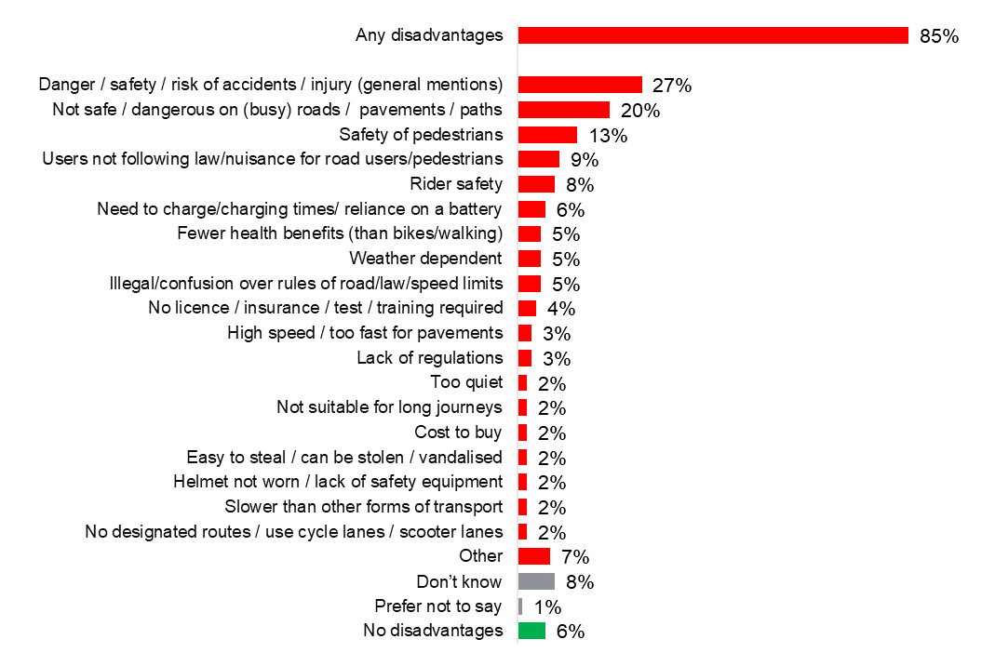
Source: Q82. What do you think are the disadvantages, if any, of electric scooters?
Base: All respondents (Aug 2020: 3,543)

Appendix A: Sample and survey methodology
Overview of survey methodology
Survey fieldwork for this wave was conducted on Kantar’s Public Voice panel. Public Voice is a high-quality survey panel, representative of the UK population aged 16+. Respondents were initially invited to carry out the survey online. The sample for the survey was created by systematically inviting half of the English panel on PV to take part. Online non-responders, and panel members who were ‘offline’ were then prompted to complete the survey over the telephone.
The Public Voice panel was built using random sampling methods so that inferences from the data it collects have design-based validity. The random nature of the Public Voice sample makes it much less reliant on models that adjust for the self-selected nature of typical panel samples. Recruitment for the panel was done using two recruitment protocols: (i) face-to-face interviewing (FTFI), and (ii) web/paper self-completion questionnaires using an adaptation of Kantar’s ‘ABOS’ method (standing for address-based online surveying).
For the panel surveys themselves, generally, these run every one to two months with three to four weeks set aside for fieldwork. The first two weeks are online only with the last week or two given over to telephone interviews (although the online version of the survey remains available throughout that time). All online non-responders for whom a telephone number is available - plus anyone not issued for online fieldwork (mainly offline panel members) - are issued for telephone fieldwork.
All available contact channels – emails, text messages, posted letters and telephone calls – are utilised to maximise the conversion rate.
Online fieldwork for Wave 6 was carried out between 19th August and 9th September 2020, whilst telephone fieldwork took place between 26th August and 9th September 2020. In total there were 3,543 complete interviews, with 3,142 carried out online, and 401 carried out over the telephone.
Overview of Questionnaire Development
Prior to Wave 1, DfT and Kantar Public jointly designed the questionnaire. This process involved multiple stages including:
- an initial qualitative research phase to test broad understanding of concepts to be covered in the questionnaire.
- a formal desk review of proposed questions using Kantar’s Questionnaire Appraisal Framework (QAF), to review questions asked on other surveys for relevance and applicability to this research and to inform the development of new questions.
- Cognitive testing of the draft questionnaire, which provided an in-depth test of the survey questions prior to main stage fieldwork.
Further cognitive testing was conducted before Wave 6 to help to develop new questions relevant to electric vehicles, hybrid vehicles, and the government proposal to end the sale of new petrol, diesel or hybrid vehicles by 2035 or earlier. In addition, existing questions were adapted slightly so they were suitable for online and telephone interviewing.
Achieved sample profile and weighting
Overall, 3,543 interviews with adults aged 16+ in England were achieved at Wave 6. The achieved sample was weighted to be representative of individuals aged 16 or over living in England. The weighting process has multiple stages.
The first stage is to identify differences between the respondent sample and the (itself weighted) recruitment survey sample. This inspection covers more than 100 variables, covering demographic, behavioural and attitudinal dimensions. A propensity score weight is generated to compensate for any substantial differences that are identified. In this case, the weight compensated for differences with respect to demographics (education level, ethnic group), technology and social media use (emails, games consoles and Twitter), news sources, political attitudes (toward immigration, business regulation and ‘British values’) and personality type.
The second stage is to calibrate the stage 1-weighted respondent sample to contemporary population statistics with respect to sex crossed by age group, region and highest educational level. The ONS Labour Force Survey from January-March 2020 was used as the data source (the last dataset available in which face-to-face interviews were used).
As noted in the table below, there is a relatively large difference between the unweighted and weighted sample profile for educational attainment. This survey was carried out when the panel was not fully built, meaning there was no scope to selectively sample from it. Now that it is fully built, it is possible to generate respondent samples up to c.3,500 that are educationally representative before weighting.
The achieved and weighted sample profiles are outlined in the following tables.
Fig A.1. Sample profile

Gender
Sub-category | Achieved sample | Unweighted % | Weighted % | Difference
Male | 1,647 | 46.5 | 49.0 | -2.5
Female | 1,885 | 53.2 | 50.7 | 2.5

Age
Sub-category | Achieved sample | Unweighted % | Weighted % | Difference
16-24 | 344 | 9.7 | 12.9 | -3.2
25-34 | 644 | 18.2 | 16.9 | 1.3
35-44 | 539 | 15.2 | 16.0 | -0.8
45-54 | 574 | 16.2 | 16.6 | -0.4
55-64 | 660 | 18.6 | 15.2 | 3.4
65-74 | 564 | 15.9 | 12.3 | 3.6
75+ | 218 | 6.2 | 10.1 | -3.9

Region (GOR)
Sub-category | Achieved sample | Unweighted % | Weighted % | Difference
North East | 179 | 5.1 | 4.8 | 0.3
North West | 479 | 13.5 | 13.0 | 0.5
Yorkshire and the Humber | 335 | 9.5 | 9.7 | -0.2
East Midlands | 339 | 9.6 | 8.6 | 1
West Midlands | 303 | 8.6 | 10.4 | -1.8
East of England | 393 | 11.1 | 11.1 | 0
London | 503 | 14.2 | 15.9 | -1.7
South East | 610 | 17.2 | 16.3 | 0.9
South West | 402 | 11.3 | 10.1 | 1.2

Urbanity (ONS classification)
Sub-category | Achieved sample | Unweighted % | Weighted % | Difference
Urban | 2785 | 78.6 | 79.8 | -1.2
Rural | 758 | 21.4 | 20.2 | 1.2

Working Status
Sub-category | Achieved sample | Unweighted % | Weighted % | Difference
In paid employment | 1,642 | 46.4 | 44.7 | 1.7
Self employed | 294 | 8.3 | 9.6 | -1.3
Unemployed | 157 | 4.4 | 4.2 | 0.2
Retired | 838 | 23.7 | 22.4 | 1.3
On maternity leave | 26 | 0.7 | 0.7 | 0
Looking after family or home | 121 | 3.4 | 3.1 | 0.3
Full time student | 186 | 5.3 | 6.1 | -0.8
Long-term sick or disabled | 78 | 2.2 | 2.8 | -0.6
On government training scheme | 2 | 0.1 | 0.1 | 0
Unpaid worker in family business | 6 | 0.2 | 0.2 | 0
Doing something else | 28 | 0.8 | 0.8 | 0
On furlough | 164 | 4.6 | 5.3 | 0.7

Ethnicity
Sub-category | Achieved sample | Unweighted % | Weighted % | Difference
White | 3,194 | 90.4 | 87.1 | 3.3
Minority ethnic | 341 | 9.6 | 12.9 | -3.3

Number of cars/vans in household
Sub-category | Achieved sample | Unweighted % | Weighted % | Difference
0 | 517 | 14.6 | 15.1 | -0.5
1 | 1,460 | 41.2 | 43.4 | -2.2
2 | 1,201 | 33.9 | 32 | 1.9
3+ | 362 | 10.2 | 9.4 | 0.8

Highest education
Sub-category | Achieved sample | Unweighted % | Weighted % | Difference
Degree level qualification(s) | 1,835 | 51.9 | 32.3 | 19.6
Non-degree level qualifications | 1,483 | 41.9 | 57.2 | -15.3
No academic or vocational qualifications | 220 | 6.2 | 10.6 | -4.4

Appendix B: Wave 6 CAWI questionnaire
Please be aware that the version of the questionnaire that is in this section was the version that respondents who completed online saw. There were two major differences for those that completed over the telephone. Firstly, for most questions answer codes were read out to them, and for some they were not presented any answer codes. Whereas, those that completed online were able to see answer codes for all questions on screen. Secondly, for the question on use of e-scooters, respondents who completed online were prompted with a photo of an e-scooter. Those that completed over the telephone were not able to see this photo and so only had the description of an e-scooter that was in the question text to go off.

Q098 – VBB:
The next set of questions are asked on behalf of the Department for Transport. The questions are about the different types of vehicle that you may use and your plans for the future.
Q004 - Licence:
Do you hold a valid UK driving licence?
Include international permits or other foreign licences valid in the UK
1 Yes, full licence for car
2 Yes, provisional licence for car
3 Currently disqualified
4 No
Scripter notes: Ask all adults 17+ in England
Q005 - Numcar:
How many cars or vans does your household own or have continuous use of at present?
Please include company cars if available for your private use. Please also include any broken down cars or vans which may be in use within the next month.
1 1 *Fixed
2 2 *Fixed
3 3 or more *Fixed
4 None *Fixed

Scripter notes: Ask all adults 16+ in England

Ask only if Q005 - Numcar,1,2,3
Q007 - CarOwn:
Just to check, do you personally own or have continuous use of a car or van?
Please include company cars if available for your private use. Please also include any broken down cars or vans which may be in use within the next month.

1 Yes
2 No

Ask only if Q004 - Licence,1,2,3
Q016 - CarWhen:
When, if at all, do you think you will next buy or replace a car or van, either new or second hand?
1 Within the next year *Fixed
2 In more than 1 year, but up to 2 years *Fixed
3 In more than 2 years, but up to 3 years *Fixed
4 In more than 3 years, but up to 5 years *Fixed
5 More than 5 years *Fixed
6 I don’t intend to ever buy or replace a car/van *Fixed
999 Don't know *Fixed *Exclusive

Ask only if Q016 - CarWhen,1,2,3,4,5
Q091 - NewSec:
Is the car or van more likely to be new or second hand?
1 New
2 Second hand
999 Don't know *Fixed *Exclusive

Ask only if Q016 - CarWhen,1,2,3,4,5
Q017 - CarNext:
What type of car or van do you think you will most likely purchase or lease next time?
If you would buy more than one type, please think about which one you would use for your main vehicle
1 Petrol
2 Diesel
3 Electric/battery only
4 Hybrid (petrol/electric)
5 Other *Open *Fixed
999 Don't know *Fixed *Exclusive

Ask only if Q017 - CarNext,4
Q092 - HybType:

What type of hybrid car or van do you think you will most likely purchase or lease next time?

1 A plug-in hybrid that plugs in to an external power source to recharge
2 A non-plug-in hybrid that recharges while driving and cannot be plugged in to an external power source
3 Undecided
999 Don't know *Fixed *Exclusive

Q096 - Infohelp:
Plug-in hybrid electric cars or vans can switch between running off electricity or petrol.
Battery electric cars or vans only run off electricity.
Both types of vehicles plug in to an external power source to recharge.
Non-plug-in hybrid electric cars or vans can switch between running off electricity or petrol but cannot plug in to an external power source to recharge.

Please have this text also available for Q93, Q94 and Q95 hidden behind an information button.
Q093 - ManyPlug:
How many people (friends, family, neighbours and colleagues), if any, do you know who drive a plug-in electric car or van?
1 Nobody *Fixed
2 One person *Fixed
3 2 - 3 people *Fixed
4 4 - 5 people *Fixed
5 6 - 10 people *Fixed
6 More than 10 people *Fixed
999 Don't know *Fixed *Exclusive

Q025 - EVknow:
How much, if anything, would you say you know about electric cars or vans?
1 Hadn't heard about them before now *Fixed
2 Hardly anything but I’ve heard of them *Fixed
3 A little *Fixed
4 A fair amount *Fixed
5 A lot *Fixed
999 Don't know *Fixed *Exclusive

Q026 - EvEnc:
What do you think are the advantages, if any, of electric over petrol or diesel cars or vans?
1 Write in *Open *Fixed
2 No advantages *Fixed
999 Don't know *Fixed *Exclusive

Q027 - EVProb:
What do you think are the disadvantages, if any, of electric vehicles over petrol or diesel cars?

1 Write in *Open *Fixed
2 No disadvantages *Fixed
999 Don't know *Fixed *Exclusive

Q094 - PropEnd:
While there is no plan to ban the use or sale of second hand petrol, diesel or hybrid vehicles, the government has proposed to bring about an end to the sale of new petrol, diesel and hybrid vehicles by 2035 or earlier.
How much, if anything, would you say you know about the proposal to end the sale of new petrol, diesel and hybrid vehicles?
1 Hadn't heard about it before now *Fixed
2 Hardly anything but I’ve heard of it *Fixed
3 A little *Fixed
4 A fair amount *Fixed
5 A lot *Fixed
999 Don't know *Fixed *Exclusive
Ask only if Q016 - CarWhen,1,2,3,4,5
Q095 - PropInf:
Thinking about your next car or van purchase or lease, how, if at all, might the government’s proposal to end sales of new petrol, diesel and hybrid vehicles by 2035 or earlier influence your decision?
Please select all that apply
1 Not at all
2 More likely to buy/lease a petrol or diesel vehicle
3 More likely to buy/lease a non-plug-in hybrid vehicle
4 More likely to buy/lease a plug-in hybrid vehicle
5 More likely to buy/lease a battery electric vehicle
6 Less likely to buy/lease any vehicle
7 Bring forward the purchase/lease
8 Push back the purchase/lease
9 No difference to timing *Fixed
10 It depends *Fixed
11 Other (specify) *Open
999 Don't know *Fixed *Exclusive

Q097 - Intro1:
Now a few questions about autonomous cars or vans, commonly referred to as driverless or self-driving cars or vans. By this we refer to cars or vans that can drive themselves on roads with little or no input from a human driver.

Q028 - AVKnow:
Fully driverless or self-driving cars or vans are not yet available for everyday use. How much, if anything, would you say you know about these types of vehicle?

1 Hadn't heard about them before now *Fixed
2 Hardly anything but I’ve heard of them *Fixed
3 A little *Fixed
4 A fair amount *Fixed
5 A lot *Fixed
999 Don't know *Fixed *Exclusive

Q029 - AVBen:
What do you think are the advantages, if any, of fully driverless or self-driving cars or vans?
1 Write in *Open *Fixed
2 No advantages *Fixed
999 Don't know *Fixed *Exclusive

Q030 - AVConcern:
And what do you think are the disadvantages, if any, of fully driverless or self-driving cars or vans?

1 Write in *Open *Fixed
2 No concerns *Fixed
999 Don't know *Fixed *Exclusive

Q088 - PersonalUseElectricScootersNEW:
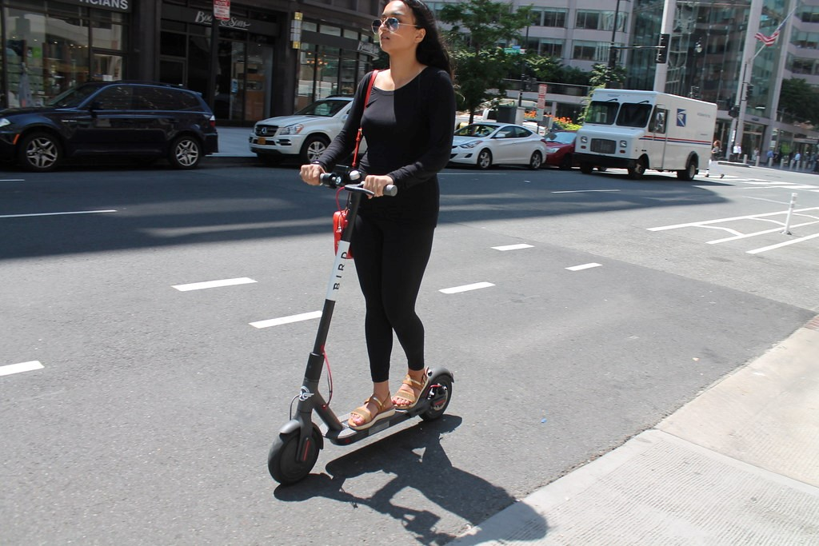An electric or motorized scooter is a stand-up scooter with a small engine or electric motor. Do you personally use an electric scooter in the UK?

1 Yes, regularly
2 Yes, occasionally
3 No
999 Don't know *Fixed *Exclusive
Q081 - AdvantagesEscooters:
What do you think are the advantages, if any, of electric scooters?
1 Write in *Open *Fixed
2 No advantages *Fixed
999 Don't know *Fixed *Exclusive

Q082 - DisadvantagesEscooters:
What do you think are the disadvantages, if any, of electric scooters?

1 Write in *Open *Fixed
2 No disadvantages *Fixed
999 Don't know *Fixed *Exclusive

Q050 - B2:
Do you have any disability or other long standing health problem that makes it difficult for you to do any of the following...
Select all that apply
1 Go out on foot
2 Use local buses
3 Get in or out of a car
4 None of these *Fixed *Exclusive

