Changes that the Government wants to make to a law called the Mental Health Act

Please tell us what you think of the changes

What is in this document

Page

About this document 3

The main changes that we want to make to the Mental Health Act: 6

1. Changing the Mental Health Act law 6

2. Changing mental health services to make them better and fairer for everyone 32

How to tell us what you think 35

About this document

We are the Government.

This document is about a law called the Mental Health Act.

It is about some changes we plan to make to the law.

The Mental Health Act is about people who need a lot of care for their mental health.

Some people who need mental health care might go to a mental health hospital.

We will call them hospitals in this document.
Some people who are very unwell can be kept in hospital even if they might not want to be there.

This is to give them the right care.

The Mental Health Act says when someone can be kept in hospital to get care even if they do not want to.

It says what their rights are and how they should be treated.

In 2017 we asked some people to look at the Mental Health Act and say how it could work better.

We looked at what the people said.

This document tells you the main changes we want to make to the Mental Health Act to make care better for people.
We want to know what people think of the changes first.

There are some questions you can answer in this document if you want to.

Some questions might be harder to answer.

You can answer them if you want. But you do not have to.

Please give us your answers by
21 April 2021.

You can find out how to give us your answers on page 35.

There is more information about the changes we want to make in this document:
https://www.gov.uk/government/consultations/reforming-the-mental-health-act
But it does not have easy words and pictures.

The main changes that we want to make to the Mental Health Act

Changing the Mental Health Act law

We want to change some things in the Mental Health Act.

We want the 4 things below to
be part of the Mental Health Act. And the rules for staff to follow.

- Mental health staff should listen to what people getting care think and the choices they make.

This should be a big part of people’s care.

- People should only be kept in hospital if they really need to be.
- Hospital care should help people to get better. This is so they can leave as soon as possible.

- Mental health staff should think about each person and what is right for them.
Everyone should be treated fairly.

Question:
Do you agree with the 4 things? Tick the answer you choose.

Yes No Not sure

Is there anything else you want to say about the 4 things? Or anything you want to change?

We want to change the rules about when someone can be kept in hospital.

Some people can be kept in hospital to find out what care they need or to get medical care.

They are not allowed to leave at that time.

We think people should only be kept in hospital like this if:

- They really need to be

- It is best for them and could help them get better

- There is a very big chance that they would hurt themselves or someone else

People should be told why they are going into hospital and being kept there.

Other people should also check the decision to make sure it is right.

Question:

Do you agree with the new rules about when people can be kept in hospital? Tick the answer you choose.

Yes No Not sure

Is there anything else you want to say about this? Or anything you want to change?

We want people to have more chances to leave hospital if they do not want to be there.

We want more checks to see if people still need to be kept in hospital.

Or if they could get other care instead.

For example, we want people getting medical care to have 3 checks to see if they can leave hospital in the first year.

At the moment it is only 2.

People being kept in hospital have the right to ask if they can leave hospital.

A decision might be made to keep the person in hospital even if they want to leave.

But this should only happen if there is
a good reason why the person should still be there.

Question:

Do you agree with the changes to give people more chances to leave hospital?

Tick the answer you choose.

Yes No Not sure

Is there anything else you want to say about this? Or anything you want to change?

We want people to have more say about their care.
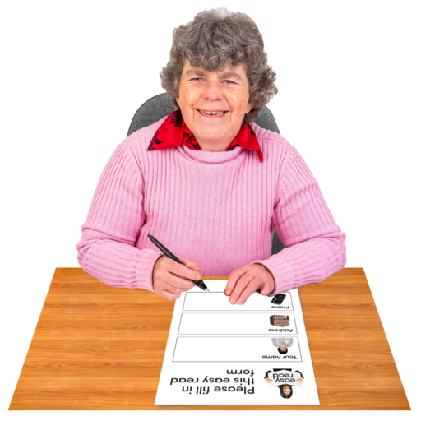

We want a document for people to fill in.

It would say what care the person does or does not want in hospital if they are too ill to decide in the future.

People should fill in the document when they are well enough to make their own choices.

Mental health staff would then have to follow the document where possible if the person got too ill to make their own choices.

Question:
Do you agree with the document idea?

Tick the answer you choose.
Yes No Not sure

Is there anything else you want to say about this? Or anything you want to change?

This includes your ideas for what should be in the document.

You can answer this question if you want to:

This is about the document people can make about the care they want in the future if they are too ill to decide then.
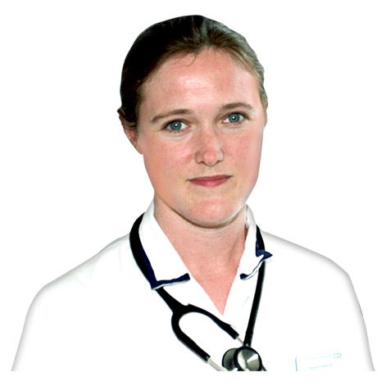

We want mental health staff to follow the document.

But do you think a doctor should agree that the person was well enough to make the choices in the document first?
Tick the answer you choose.
Yes No Not sure

We want everyone in hospital to have a plan about their care.

The plan should say things like:
- What care people will get and why

- How mental health staff have listened to what people want

- Plans for the person to leave hospital when they are well again
The plan should be made in the first 2 weeks that someone gets to hospital.

Question:

Do you agree with the care plan for everyone who is kept in hospital?

Tick the answer you choose.
Yes No Not sure

Is there anything else you want to say about the care plan?

Or anything you want to change or include in the plan?

We want people who are kept in hospital to have more rights to:
- Choose medical care
- Say no to some medical care
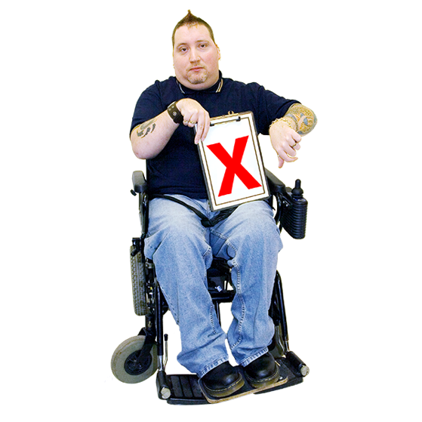
- Have their choices listened to

This is about people who have not agreed to their care.

We want to make it easier for another doctor to check decisions about the person’s care.

This is to see:

- If the care is right for that person

- If mental health staff have listened to what the person wants enough

We want people to be able to ask for decisions about their care to be looked at again.

For example, if mental health staff did not listen to what they want. But maybe they should have.

The person who looks at the decision would be from somewhere else. Not the hospital.

Question:

Do you agree with these new rights?
Tick the answer you choose.
Yes No Not sure

Is there anything else you want to say about this? Or anything you want to change?

You can answer these questions if you want to:

Some people might not agree to their medical care.

Should mental health staff do what the person wants if the person is well enough to make their own choices?

Should staff do this even if they think the person really needs the care to feel better?

Tick the answer you choose.

Yes No Not sure

If someone does not agree to their medical care, do you think their doctor should be told to change it?

Tick the answer you choose.

Yes No Not sure

We want people to choose someone to help make decisions about their care.

People who are kept in hospital have someone they know to help make decisions about their care.

This is usually someone from their family.

But we want the person getting care to choose who they want.

We want the person they choose to have some new rights.

For example, the right to have a say in the person’s care plan.

And the right to ask for decisions about the person’s care to be looked at again.

Only if the person cannot ask themselves.
Question:

Do you agree with these new rights? Tick the answer you choose.
Yes No Not sure

Is there anything else you want to say about this? Or anything you want to change?

You can answer this question if you want to:

Do you agree that children and young people should be able to choose someone to help make decisions about their care as well? Tick the answer you choose.
Yes No Not sure

We want better support for people who are kept in hospital.

The support helps people to know their rights and make decisions.

There are people who can give people in hospital this support.

We will call them mental health advocates.

We want people to get even more support from mental health advocates.

For example, mental health advocates could:

- Support people to make plans and documents about the care they want

- Help to make sure that mental health staff listen to people’s choices

Question:

Do you agree with these changes? Tick the answer you choose.

Yes No Not sure

Is there anything else you want to say about the support people should get if they are kept in hospital?

Or anything you want to change?

We want to make sure that people who need urgent care can be moved to the right
place quickly and safely.

Some people who go to A & E at their local hospital need urgent mental health care.

They might hurt themselves or someone else.

We want to change the law so that people like this can be kept in hospital for a short time.

This is to decide if they should go to a mental health hospital to get the right care.

Question:

Do you agree with this change? Tick the answer you choose.

Yes No Not sure

Is there anything else you want to say about this? Or anything you want to change?

We want better care for people who are in contact with the police, courts and prisons.

For example, if the police think they have done a crime.

Some people who are in contact with the police, courts and prisons might need urgent mental health care.

We want to make sure they get the right care at the right time.
We also want a quicker way to move people from prison to hospital if they need mental health care.

We want a new person in charge of how people are moved from prison to hospital.

We also want to make sure that people who are waiting to move to hospital get support to know their rights and make decisions.

Question:

Do you agree with these changes? Tick the answer you choose.

Yes No Not sure

Is there anything else you want to say about this? Or anything you want to change?

We want better care for people with a learning disability and autistic people.

Some people with a learning disability and autistic people might need mental health care in hospital.

We want this care to be good, safe and right for them.

But some people with a learning disability and autistic people might be kept in hospital when they do not need mental health care.

For example, they might need other support for their learning disability or autism instead.

They should get this support near where they live. Not in hospital.

Some people with a learning disability and autistic people might have done a crime.

Or they might be in contact with the police, courts and prisons.

If they need care we want them to be able to go to hospital instead of prison.

We want there to be enough support for people with a learning disability and autistic people near their homes.

This means people with a learning disability and autistic people should only be kept in hospital if they need mental health care.

We want health and care staff in local areas to work together to make sure there is enough support.

We want to make this the law.

Question:
Do you agree with these changes? Tick the answer you choose.
Yes No Not sure

Is there anything else you want to say
about support for people with a learning disability and autistic people? Or anything you want to change?

You can answer this question if you want to:

This question is about the plan we want everyone in hospital to have about their care.

We want the plan to include what people agree at meetings about their care.

The meetings are called Care and Treatment Reviews. Or Care, Education and Treatment Reviews for children.

The plan will help stop people from being in hospital.

Do you agree with this idea?
Tick the answer you choose.

Yes No Not sure

We want to make sure that all groups of people are treated fairly by mental health services.

For example, Black African and Caribbean people. And people from other communities.
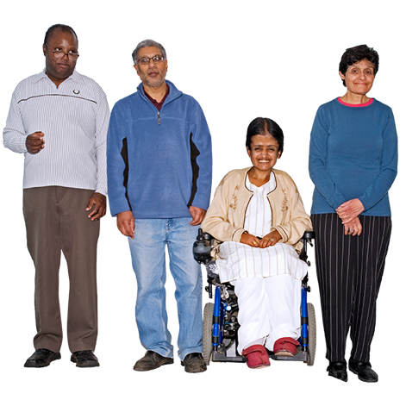

For example:

We want to make sure the changes to the law will make care better for people from different communities.

We want some groups of people to have better support to have their say and know their rights.

People called advocates can give this support.

We are working to get more mental health staff and managers from different communities.
Question:

Do you agree with these changes? Tick the answer you choose.

Yes No Not sure

Is there anything else you want to say about this? Or anything you want to change?

Changing mental health services to make them better for everyone

Our plans include:

- More mental health staff working in hospitals with people who are very ill

This is to help people get better more quickly.

- Making sure everyone can get urgent mental health support if they need it

People would phone NHS 111 to get this support.

- Giving people better support near where they live if they need a lot of care

This is to stop problems getting worse.
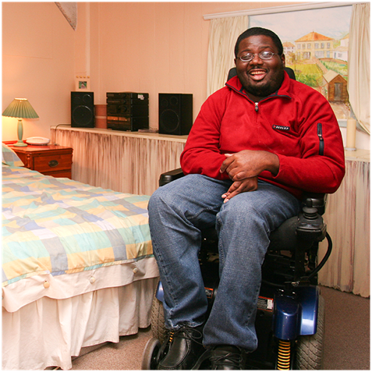
We will also make mental health hospitals better places for people getting care and staff.

For example, by making sure everyone in hospital has their own room.

Question:

Do you agree with these changes? Tick the answer you choose.

Yes No Not sure

Is there anything else you want to say about this? Or anything you want to change?

You can answer this question if you want to:

People called the CQC check mental health care to see if it is safe.

Do you think they should also check other things about mental health care in hospital, like:

- How people are treated

- What life is like for people in hospital

- How the care is helping people to get better?

Tick the answer you choose.

Yes No Not sure

How to tell us what you think

Please give us your answers by
21 April 2021.

Please do not include any personal details in your answers. For example, your name and the hospital you are in.

You can send us your answers
by email to:

MHAconsultation2021@dhsc.gov.uk

Thank you.

