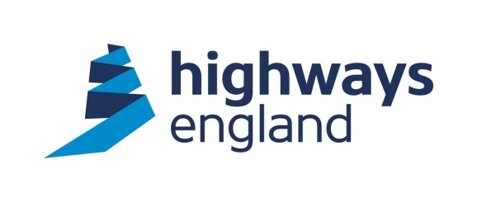  Our ref: 101522  Your ref:  Sent via Email | Historical Railways Estate  3rd Floor  37 Tanner Row  YORK  YO1 6WP  18th November 2020  http://highwaysengland.co.uk
Dear

Freedom of Information Request – Bridge infilling schemes

I am writing to confirm that we have now completed our search for the information,
which you requested on 21st October 2020.

Your Request - In relation to CVB 15m 33ch (Horse-Batch Bridge, Grid Ref ST528464), could you please provide me with a list of the repairs carried out since 1 January 2015, specifying the cost of each project, the specific works undertaken and the dates between which each project took place.

Our Response – The information that you requested is attached.

Your Request - In relation to overbridges AKC/95 (Alnwick Road bridge, Grid Ref NU157118) and AKC/99 (Rugley, Grid Ref NU169106) on the former Alnwick-Cornhill line, could you please provide me with -
* all visual inspection, detailed examination and structural assessment reports since 1 October 2013
* a list of repairs carried out to these structures since 1 January 2015, the cost of each project, the specific works undertaken and the dates between which each project took place.
Our Response – The information that you requested is attached. Please note that redactions have been made under Regulation 13 of the Environmental Information Regulations for personal information.

Your Request - In relation to Queensbury Tunnel (HQU/3D), could you please provide me with copies of the Compensation Event register and Risk/Early Warning register for the ongoing abandonment works, together with details of all costs not recorded in these registers since 1 August 2018, including the value, a description of the event and supporting documents.

Our Response – The information that you requested is attached. Please note that redactions have been made under Regulation 13 of the Environmental Information Regulations for personal information.

If you are unhappy with the way we have handled your request you may ask for an
internal review within 2 months of the date of this response for Freedom of Information
requests and within 40 days for Environmental Information Regulations requests.
Our internal review process is available at: https://www.gov.uk/government/organisations/highways-England/about/complaintsprocedure

If you require a print copy, please phone the Information Line on 0300 123 5000; or email info@highwaysengland.co.uk.

You should contact me if you wish to complain.

If you are not content with the outcome of the internal review, you have the right to
apply directly to the Information Commissioner for a decision. The Information Commissioner can be contacted at:

Information Commissioner’s Office
Wycliffe House
Water Lane
Wilmslow
Cheshire
SK9 5AF

If you have any queries about this letter, please contact me. Please remember to quote
reference number 101522 in any future communications.

Yours sincerely

Historical Railways Estate

