Appendix 1
Google Trends analysis
This appendix provides a very preliminary assessment of interest in the term “systems leadership” and ancillary concepts over time via Google Trends analyses. Numbers on the x-axis represent search interest relevant to the highest point on the chart for the given region and time. A value of 100 is the peak popularity for the term. A value of 50 means that the term is half as popular. A score of 0 means there was not enough data for this term.
Please note that this is not meant to be a rigorous review of the popularity of different terminology and that to undertake this would involve using a number of quantitative techniques which are beyond the scope of this review.
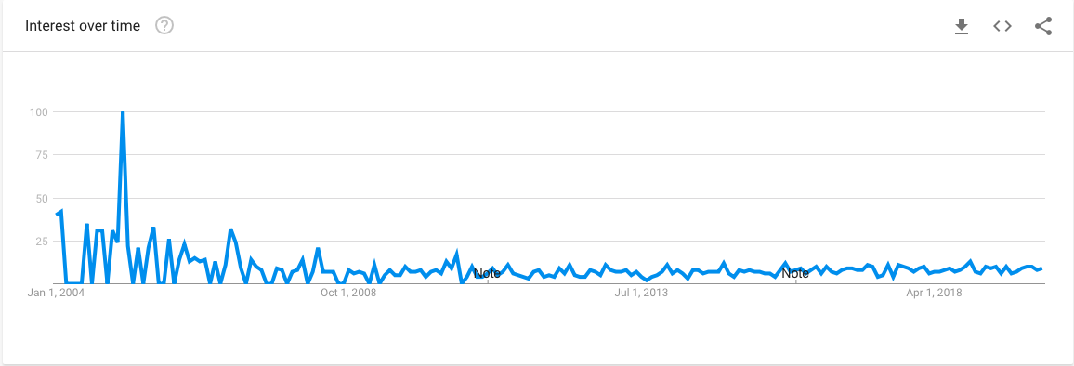
Figure 1: Search terms "systems leadership" in region United Kingdom
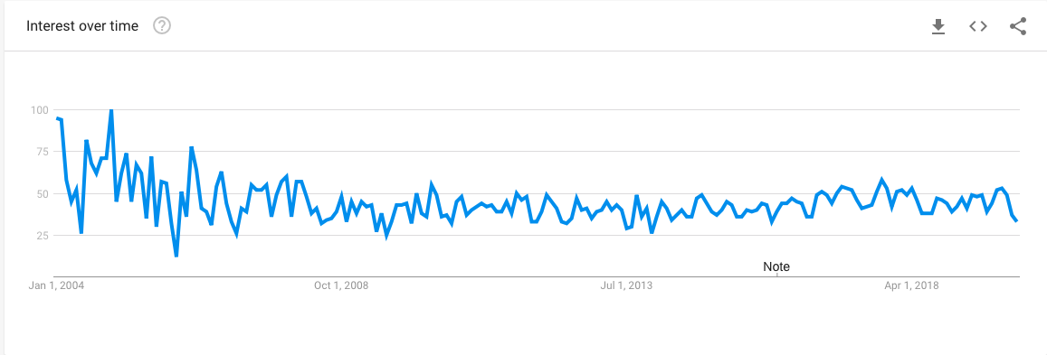
Figure 2: Search terms "systems leadership" in region "worldwide"

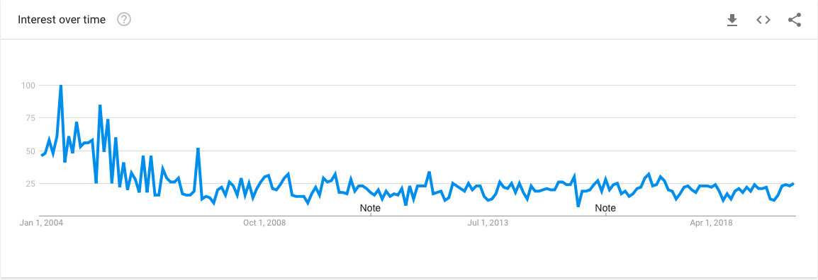
Figure 3: Search terms "complex system" in region United Kingdom
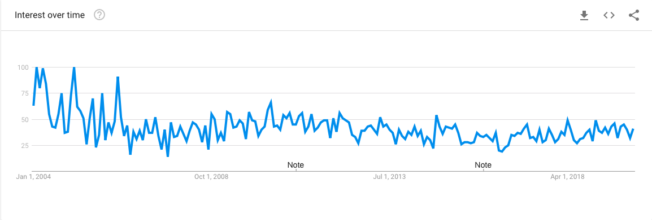
Figure 4: Search terms “systems thinking” in region United Kingdom
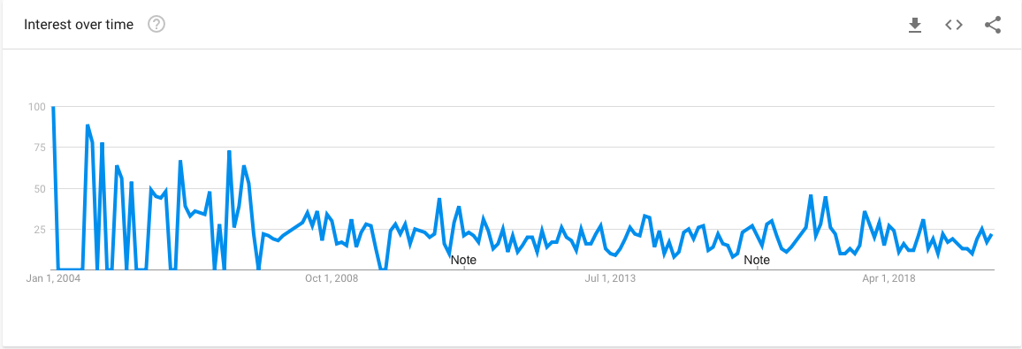
Figure 5: Search terms "distributed leadership " in region United Kingdom

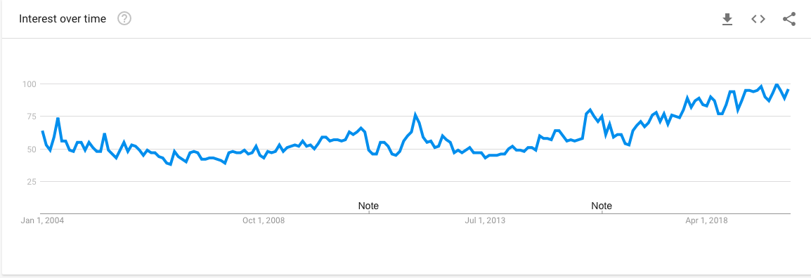
Figure 6: Search terms "AI" in region United Kingdom (for illustrative purposes)

