Coronavirus operational response survey results
November 2020 data

17 December 2020

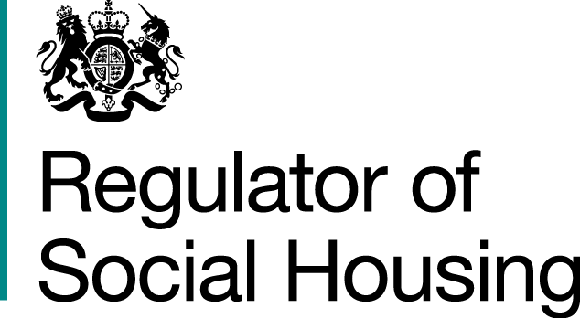

Results from the November survey
This is the summary from the eighth of our temporary monthly surveys about how providers are managing some of the challenges they face as a result of the coronavirus pandemic. Providers were asked to submit survey responses covering the period up to and including 30 November by 7 December. This includes the majority of the period under additional national restrictions, before the return to tiered restrictions in England. The response rate was 93% and we are grateful to all providers who responded.
The survey responses are shown below, and the survey questions are shown in full in Appendix 1.
The graph below shows the trends in survey responses since April where providers indicated that all or most checks were complete without a material backlog OR that they were maintaining safe staffing levels and essential service delivery in care and support settings, despite some pressure.
Trends in survey responses since April (as a % of total submissions)
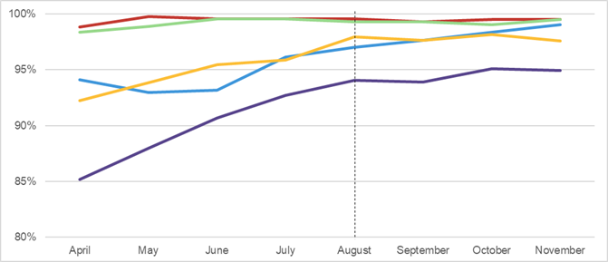
Headline operational impacts reported largely stable since August
Key
▬ Emergency repairs | ▬ Gas compliance checks | ▬ Fire compliance checks | ▬ Asbestos, electrical, legionella and lift checks | ▬ Care and support staffing levels
Despite the introduction of additional national restrictions, providers’ responses showed that the delivery of services remained stable in November.
The number of providers who had completed all or most gas safety, fire compliance, asbestos, electrical, legionella and lift checks was similar to the previous three months. Across the sector, gas safety compliance is reported to be broadly back to pre-coronavirus levels.
Almost all providers reported no material backlog in emergency repairs and the vast majority continued to deliver all responsive repairs in November. A minority reported that they had either paused non-emergency repairs during the additional national restrictions or that they have extended their target timescales for completing non-emergency repairs, reflecting current challenges.
Most care and support providers reported that staffing was at normal levels, but some continue to report pressures due to higher levels of staff absence. These care and support providers report they have contingency plans in place and are continuing to maintain safe staffing levels. During the additional national restrictions, some care and support providers report reverting to practices adopted for the first lockdown such as closing of communal areas or delivering some services remotely. Some care and support providers reported preparing for the Covid-19 vaccination programme, including for example ensuring they have the appropriate staff and tenant consents.
Many providers report anticipating increased constraints arising from a second wave of Covid-19 and further lockdowns. Some providers describe challenges with accessing the properties of a small minority of tenants, and their own and their contractors’ staffing capacity. Providers continue to express concern about Covid-19 compounding challenges usually faced over winter such as staffing capacity, staff wellbeing, and supplies of materials and personal protective equipment (PPE). But overall, providers report that they have appropriate systems and processes in place to manage the operational impact of continued restrictions.

Next steps
As we explained in last month’s report, from 2021 we will be reducing the frequency of survey returns to bi-monthly. We will review the future role of the Coronavirus operational response surveys (CORS) again in March 2021.
The submission dates for the next two CORS are shown in the table below.
Data up to and including | Submission by
31 January | 5 February
31 March | 9 April
CORS is not a regulatory return. If a provider believes tenant safety is threatened or viability is under strain, they should not wait for the survey but should speak to their key contact at the regulator, or contact our Referrals and Regulatory Enquiries team, via enquiries@rsh.gov.uk or 0300 124 5225. Providers with fewer than 1,000 homes should use our dedicated email address SmallProviders@rsh.gov.uk.

Appendix 1: About the coronavirus operational response survey and our analysis
We asked private registered providers with 1,000 or more homes, local authority social housing landlords and those providers with fewer than 1,000 homes which have a high proportion of supported accommodation to respond to the survey. The information in this report is based on our initial analysis of registered providers’ survey responses.
The survey asks providers to answer a single multiple-choice question on each of five key areas. For each area it also asks them to identify any key constraints, risks and mitigating actions and the scale of any backlog and how this has changed since the previous survey.
1. Emergency repairs
- All complete
- Most complete without a material backlog developing
- Some complete but a material backlog
- Few or no complete and a material backlog.

- Statutory gas safety checks
- All complete
- Most complete without a material backlog developing
- Some complete but a material backlog
- Few or no complete and a material backlog.

- Statutory fire safety checks
- All complete
- Most complete without a material backlog developing
- Some complete but a material backlog
- Few or no complete and a material backlog.

- Asbestos, electrical, legionella and lift checks
- All complete
- Most complete without a material backlog developing
- Some complete but a material backlog
- Few or no complete and a material backlog.

- Care and support staffing levels
- Maintaining safe staffing levels and essential service delivery
- Maintaining safe staffing levels and essential service delivery with some pressure
- Maintaining safe staffing levels and essential service delivery but at material risk of falling below safe levels
- Not maintaining safe staffing levels and essential service delivery.


© RSH copyright 2020
This publication is licensed under the terms of the Open Government Licence v3.0 except where otherwise stated. To view this licence, visit nationalarchives.gov.uk/doc/open-government-licence/version/3
Where we have identified any third party copyright information you will need to obtain permission from the copyright holders concerned.
This publication is available at: www.gov.uk/rsh
Any enquiries regarding this publication should be sent to us via enquiries@rsh.gov.uk
or call 0300 124 5225.
or write to:
Regulator of Social Housing
1st floor – Lateral
8 City Walk
Leeds LS11 9AT

RSH regulates private registered providers of social housing to promote a viable, efficient and well-governed social housing sector able to deliver homes that meet a range of needs.

