
BUSINESS IMPACT TARGET:
SUMMARY TEMPLATE
Non-qualifying Regulatory Provisions (NQRP) summary reporting template

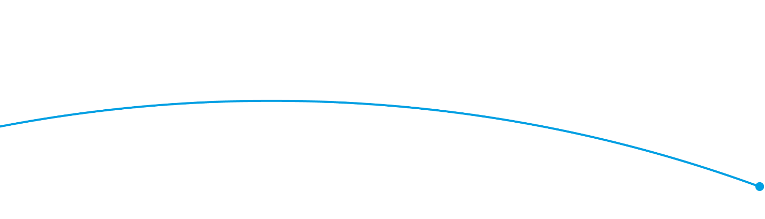

Regulator: Groceries Code Adjudicator
Business Impact Target Reporting Period Covered: 13 December 2019 – 16 December 2020
Excluded Category* | Summary of measure(s), including any impact data where available**
Measures certified as being below de minimis (measures with an EANDCB below +/- £5 million) | No activities/actions
EU Regulations, Decisions and Directives and other international obligations, including the implementation of the EU Withdrawal Bill and EU Withdrawal Agreement | No activities/actions
Measures certified as concerning EU Withdrawal Bill operability measures | No activities/actions
Pro-competition | No activities/actions
Systemic Financial Risk | No activities/actions
Civil Emergencies | No activities/actions
Fines and Penalties | No activities/actions
Misuse of Drugs | No activities/actions
Measures certified as relating to the safety of tenants, residents and occupants in response to the Grenfell tragedy | No activities/actions
Casework | No activities/actions
Education, communications and promotion | The GCA continues to publish general information and promotional material such as newsletters.
Activity related to policy development | No activities/actions
Changes to management of regulator | Mark White was appointed the UK’s second Groceries Code Adjudicator on 31 October 2020, after Christine Tacon stepped down on 30 October 2020.

* For full, legal definitions of these exclusion categories, please see https://www.parliament.uk/business/publications/written-questions-answers-statements/written-statement/Commons/2018-06-20/HCWS776/
** Complete the summary box as ‘Following consideration of the exclusion category there are no measures for the reporting period that qualify for the exclusion.’ where this is appropriate.

