Committee on Standards in Public Life

Room G07
1 Horse Guards Road
London
SW1A 2HQ

Email: public@public-standards.gov.uk

Rt Hon Ed Davey MP
Leader, Liberal Democrats
House of Commons
London SW1A 0AA
(by email)

10 December 2020

Dear Ed Davey,

Thank you for your letter of 9 December 2020 regarding tweets by Rt Hon Jacob Rees-Mogg MP, Lord President of the Council and Leader of the House of Commons, and Nadine Dorries MP, Minister of State, Department of Health and Social Care, on 2 December 2020.

The Nolan Principles are a matter of personal responsibility and the Committee is an advisory body, not a regulator; we have no remit to consider or rectify individual cases.

As you may be aware, I have spoken publicly in recent weeks about my concerns on some standards issues and the Committee has started a landscape review of the current standards arrangements, seeking evidence from the public and others with an interest in these issues.

We would very much welcome a submission from you about what works well in the standards systems we have and how any weaknesses might be strengthened.

We intend to report and make recommendations to the Prime Minister in 2021.

We will publish your letter and my reply on the Committee’s website.

Yours sincerely
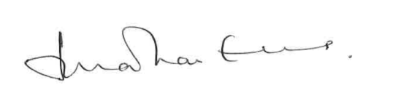
Lord Evans of Weardale KCB DL
Chair, Committee on Standards in Public Life

