Committee on Standards in Public Life

Room G07
1 Horse Guards Road
London
SW1A 2HQ

Email: public@public-standards.gov.uk

Tonia Antoniazzi MP
House of Commons
London SW1A 0AA
(by email)

30 November 2020

Dear Tonia Antoniazzi,

Thank you for your letter of 30 November 2020 requesting that the Committee on Standards in Public Life investigates reports that the Chancellor of the Exchequer failed to declare shareholdings and directorships related to his wife and her family in the register of ministers’ interests.

The Committee is an advisory body, not a regulator, so it is not within the remit of my Committee to investigate individual alleged breaches of the rules relating to the declaration of ministers’ interests.

There are specific rules for government ministers in relation to their private interests which form part of the Ministerial Code. Under the terms of the Code, ministers must ensure that no conflict arises, or could reasonably be perceived to arise, between their ministerial position and their private interests, financial or otherwise. The Prime Minister is owner of the Ministerial Code and the Cabinet Office is responsible for publishing the list of ministerial interests held by ministers or their close family members, which are additional to those already disclosed in the parliamentary registers.

We will publish this letter on the Committee’s website.

Yours sincerely
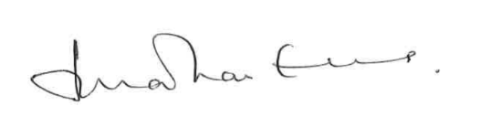
Lord Evans of Weardale KCB DL
Chair, Committee on Standards in Public Life

