Committee on Standards in Public Life

Room G07
1 Horse Guards Road
London
SW1A 2HQ

Email: public@public-standards.gov.uk

Jane Ramsey
Sent by email

29 October 2020
Dear Jane,

Thank you for your letter of 28 October 2020 letting me know that you are resigning from the Committee with immediate effect due to your taking up a new role that would present a clear conflict of interest.

I know I speak on behalf of all members when I say that we are indebted to you for the energy, passion and time you have committed to the Committee. The full range of our work has benefited from your thoughtfulness, intellect and insight, but I wanted to thank you particularly for leading the Committee’s important report into Intimidation in Public Life in 2017, including working with The Jo Cox Foundation to follow up our recommendations; and for taking such a close interest in and helping to drive the Committee’s close watching brief on bullying and harassment issues in Parliament.

You have helped the Committee accomplish a great deal since you joined in 2016. These things aren’t easy to measure, but you have undoubtedly helped the Committee make the case for high standards across public life during the past 4 years, a time of political turmoil and unprecedented economic and social crisis. Thank you again for that and for always exemplifying the Nolan Principles.

My very best wishes.

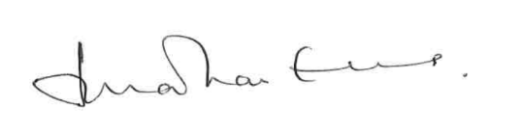

Lord Evans of Weardale KCB DL
Chair, Committee on Standards in Public Life

