Committee on Standards in Public Life

Room G07
I Horse Guards Road
London
SW1A 2HQ

Email: public@public-standards.gov.uk

Nick Thomas-Symonds MP
Shadow Secretary of State for the Home Department
House of Commons
London SW1A 0AA
(by email)

20 November 2020

Dear Mr Thomas-Symonds,

Thank you for your letter of 19 November 2020 requesting that the Committee on Standards in Public Life investigates the report into allegations that the Home Secretary breached the Ministerial Code. You referred to reports in the media that the Home Secretary will receive a written warning and expressed your concern about delays in action being taken on this case.

As you may be aware, I publicly expressed my own concerns when I spoke last week at the Institute of Business Ethics about the need for allegations of ministerial impropriety to be dealt with independently and transparently, to allow the public to have confidence in the way standards issues at the top of government are handled. But the Committee is an advisory body, not a regulator, so it is not within the remit of my Committee to investigate individual alleged breaches of the rules. In this case, it is a matter for the Prime Minister as owner of the Ministerial Code.

It is undoubtedly the case that the public expect those in all walks of public life to live up to the Nolan Principles. There are weaknesses and unfinished business in the current standards structures, which is why my Committee is starting a landscape review of the institutions, procedures and policies in place to uphold high standards of conduct. We would very much welcome your views, alongside the views of representatives of all the other political parties, as to how high standards can best be promoted and maintained in practice.

The Committee’s secretariat will be in touch shortly regarding the submission of evidence to our review.

We will publish this letter on the Committee’s website.

Yours sincerely
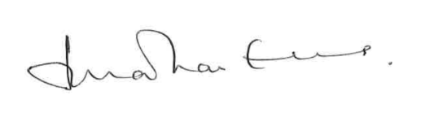
Lord Evans of Weardale KCB DL
Chair, Committee on Standards in Public Life

