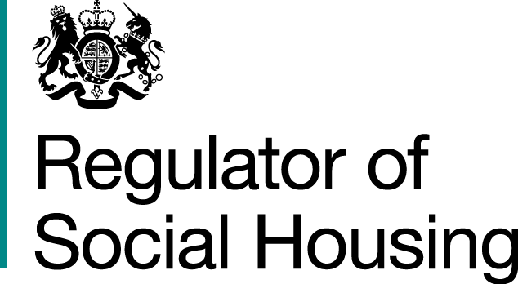
Coronavirus operational response survey results
October 2020 data

19 November 2020


Results from the October survey
This is the summary from the seventh of our temporary monthly surveys about how providers are managing some of the challenges they face as a result of the coronavirus pandemic. Providers were asked to submit survey responses covering the period up to and including 31 October by 6 November. This was before the introduction of the new national restrictions in England. The response rate was 94% and we are grateful to all providers who responded.
The survey responses are shown below, and the survey questions are shown in full in Appendix 1.
The graph below shows the trends in survey responses since April where providers indicated that all or most checks were complete without a material backlog OR that they were maintaining safe staffing levels and essential service delivery in care and support settings, despite some pressure.
Trends in survey responses since April (as a % of total submissions)
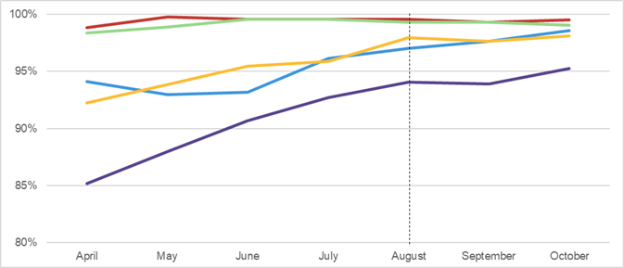
Headline operational impacts reported largely stable since August
Key
▬ Emergency repairs | ▬ Gas compliance checks | ▬ Fire compliance checks | ▬ Asbestos, electrical, legionella and lift checks | ▬ Care and support staffing levels

Despite increased infection rates and the introduction of tiered lockdowns in parts of England, providers’ responses showed that the delivery of services remained stable in October. The number of providers who had completed all or most gas safety, fire compliance, asbestos, electrical, legionella and lift checks was similar to the previous two months. Across the sector, gas safety compliance is reported to be broadly back to pre-coronavirus levels.
Most care and support providers reported that staffing was at normal levels, but some have started to report pressures due to higher levels of staff absence. These care and support providers report they have contingency plans in place and are continuing to maintain safe staffing levels. Some care and support providers are planning to revert back to practices adopted for the first lockdown such as the closure of communal areas or remote delivery of services where appropriate.
Providers’ returns more generally noted the additional pressures that staff absence or contractor capacity have had on delivery of repairs. However, they have not reported material backlogs and appear to have appropriate mitigations in place including procuring additional staffing resource.
Many providers had anticipated constraints arising from increased infection rates and further restrictions. The vast majority of providers reported that they are continuing to deliver all responsive repairs and have no intentions of reducing service delivery. Some are anticipating that planned works may be subject to delays due to residents self-isolating.
Access issues were a significant factor in operational challenges in the first lockdown. Providers continued to report small numbers of access issues where vulnerable tenants are shielding. They report that they are aware the second lockdown is likely to lead to renewed concerns among tenants about letting workers into their homes.
Overall, providers reported confidence that they have appropriate systems and processes in place to manage the operational impacts of a second national lockdown.

Next steps
During 2020, providers have responded effectively to the challenges presented by the pandemic and over the last three months their operational performance has been stable. We consider that we will still need to understand operational performance on a regular basis in early 2021, but that it would be proportionate to reduce the frequency of survey returns to bi-monthly. We will review the future role of the Coronavirus operational response surveys (CORS) again in March 2021.
The submission dates for the next three CORS are shown in the table below.
Data up to and including | Submission by
30 November | 7 December
31 January | 5 February
31 March | 7 April
CORS is not a regulatory return. If a provider believes tenant safety is threatened or viability is under strain, they should not wait for the survey but should speak to their key contact at the regulator, or our Referrals and Regulatory Enquiries team, via enquiries@rsh.gov.uk or 0300 124 5225. Providers with fewer than 1,000 homes should use our dedicated email address SmallProviders@rsh.gov.uk.

Appendix 1: About the coronavirus operational response survey and our analysis
We asked private registered providers with 1,000 or more homes, local authority social housing landlords and those providers with fewer than 1,000 homes which have a high proportion of supported accommodation to respond to the survey. The information in this report is based on our initial analysis of registered providers’ survey responses.
The survey asks providers to answer a single multiple-choice question on each of five key areas. For each area it also asks them to identify any key constraints, risks and mitigating actions and the scale of any backlog and how this has changed since the previous survey.
1. Emergency repairs
- All complete
- Most complete without a material backlog developing
- Some complete but a material backlog
- Few or no complete and a material backlog.

- Statutory gas safety checks
- All complete
- Most complete without a material backlog developing
- Some complete but a material backlog
- Few or no complete and a material backlog.

- Statutory fire safety checks
- All complete
- Most complete without a material backlog developing
- Some complete but a material backlog
- Few or no complete and a material backlog.

- Asbestos, electrical, legionella and lift checks
- All complete
- Most complete without a material backlog developing
- Some complete but a material backlog
- Few or no complete and a material backlog.

- Care and support staffing levels
- Maintaining safe staffing levels and essential service delivery
- Maintaining safe staffing levels and essential service delivery with some pressure
- Maintaining safe staffing levels and essential service delivery but at material risk of falling below safe levels
- Not maintaining safe staffing levels and essential service delivery.


© RSH copyright 2020
This publication is licensed under the terms of the Open Government Licence v3.0 except where otherwise stated. To view this licence, visit nationalarchives.gov.uk/doc/open-government-licence/version/3
Where we have identified any third party copyright information you will need to obtain permission from the copyright holders concerned.
This publication is available at: www.gov.uk/rsh
Any enquiries regarding this publication should be sent to us via enquiries@rsh.gov.uk
or call 0300 124 5225.
or write to:
Regulator of Social Housing
1st floor – Lateral
8 City Walk
Leeds LS11 9AT

RSH regulates private registered providers of social housing to promote a viable, efficient and well-governed social housing sector able to deliver homes that meet a range of needs.

