

The Planning Inspectorate
Annual Report and Accounts 2019/20

HC 738

The Planning Inspectorate
Annual Report and Accounts 2019/20

Presented to the House of Commons pursuant to Section 7 of the Government Resources and Accounts Act 2000

Ordered by the House of Commons to be printed on 10 September 2020

HC 738
The Planning Inspectorate
Temple Quay House
2 The Square
Temple Quay
Bristol
BS1 6PN

Tel: 0303 444 5000

Email: enquiries@planninginspectorate.gov.uk

This publication is available in Welsh, please contact the Inspectorate’s Cardiff office, and in large print, please contact the Inspectorate’s Bristol Office.

The Planning Inspectorate
Cathays Park
Cardiff
CF10 3NQ
Tel: 0303 444 5940
Email: wales@planninginspectorate.gov.uk
Mae’r cyhoeddiad hwn hefyd ar gael yn Saesneg trwy gysylltu â Swyddfa’r Arolygiaeth yng Nghaerdydd, ac mewn print bras trwy gysylltu â Swyddfa’r Arolygiaeth ym Mryste.



© Crown copyright 2020

This publication is licensed under the terms of the Open Government Licence v3.0 except where otherwise stated. To view this licence, visit nationalarchives.gov.uk/doc/open-government-licence/version/3.
Where we have identified any third party copyright information you will need to obtain permission from the copyright holders concerned.

This publication is available at www.gov.uk/official-documents.

Any enquiries regarding this publication should be sent to us at the Planning Inspectorate Press Office, Temple Quay House, 2 The Square, Bristol, BS1 6PN or by email to press.office@planninginspectorate.gov.uk

ISBN 978-1-5286-2103-8
CCS CS01209294746 09/20
Printed on paper containing 75% recycled fibre content minimum

Printed in the UK by the APS Group on behalf of the Controller of Her Majesty’s Stationery Office
Contents |  | Page
Performance report
 | Chief Executive’s statement | 9
 | Board Chair’s statement | 13
Performance summary
 | - Statement of purpose and activities | 16
 | - Performance highlights | 16
 | - Strategic risks | 18
Performance analysis
 | - Excellent customer service | 23
 | - Improved efficiency and effectiveness | 25
 | - Increased staff engagement | 27
 | - Innovate approaches and services | 28
 | - Community and environmental impact | 30
 | - Detailed performance analysis – England | 35
 | - Detailed performance analysis – Wales | 54
 | - Detailed quality analysis – England and Wales | 56
Accountability report
Corporate governance report
 | - The Directors’ report | 58
 | - Statement of the Accounting Officer’s responsibilities | 60
 | - The governance statement | 61
Remuneration and staff report
 | - Remuneration report | 80
 | - Staff report | 84
Parliamentary accountability and audit report
 | - Budget allocations and outturn | 92
 | - Creditor payments | 94
 | - Fees and charges | 95
 | - Regularity of expenditure | 96
 | - Remote contingent liabilities | 97
The Certificate and Report of the Comptroller and Auditor General to the House of Commons |  | 98
Financial Statements for the year ended 31 March 2020
 | - Statement of comprehensive net expenditure | 103
 | - Statement of financial position | 104
 | - Statement of cash flows | 105
 | - Statement of changes in taxpayers’ equity | 106
 | - Notes to the accounts | 107
Annexes
 | Annexe A - Performance against ministerial targets | 127
 | Annex B - Customer services and contact points | 132

Performance report

OVERVIEW:
This performance summary provides information on the purpose of the Planning Inspectorate, our main activities, performance highlights and key risks.
The performance analysis section provides detail of our work towards our strategic priorities as well as our results against key performance indicators, including in relation to quality. It also sets out our community and environmental impact and provides the data required in relation to sustainability.

Chief Executive’s statement


Continuing the journey of planned improvements
The year from April 2019 to March 2020 was a year of real progress and substantial change for the Planning Inspectorate. At the time of writing this statement, this all feels somewhat in the past as the last months have been about responding to the impact of the pandemic.
To ensure the Planning Inspectorate is on track to meet its performance targets for determining all appeals, one of our key delivery priorities for 2019/20 was the successful rollout of our performance recovery programme. With this programme in place, we have significantly improved our casework performance throughout the year, both in planning appeal cases and our enforcement appeal work. We have also made substantial progress with implementing the recommendations of the Rosewell review and the average time taken to decide appeal inquiries has nearly halved.
It was expected, prior to the pandemic, that we would see continued progress in improving the planning appeal decision speed; further improve the timescales for our enforcement appeal work; and as a priority, to increase the consistency of our casework timeframes into the summer of 2020 and beyond.
The good progress we had made was affected by the COVID-19 pandemic towards the end of the financial year. Nonetheless, we responded to this challenge quickly and effectively in many areas, including expediting our work around introducing virtual hearings and inquiries.
Another key priority for the year was our organisational transformation, aiming to improve outcomes for customers. To achieve this we created new directorates, new teams and closer ways of working between our inspectors and case working teams. The project was split into two phases.
The first phase set out our operating model in three directorates and allowed us to establish a new senior leadership structure. Phase two involved working closely with each of the new directorates to create organisational designs for our staff including inspectors and those below grade 7.
This new structure was successfully implemented on 1 April 2020. But as a result of the COVID-19 pandemic, it was decided to delay the changes to the line management arrangements for the Inspectors until July 2020.
With our foundations now in place, the design work will shift to the development of our people and culture. This focuses on our commitment to be a more cohesive organisation, improving our accountability, adaptability and flexibility.
Our digital change project, Organisational Delivery Transformation, progressed to a new phase in August 2019, with 27 Local Planning Authorities across the south east using the new portal. The project has released various updated since and added a range of extra functionalities.
By delivering the organisational design and development programmes, and making good progress with digital change, we will greatly improve our customers’ experience, directly addressing three of our four organisational strategic priorities:
- excellent customer service;
- innovation and new approaches; and
- improving efficiency and effectiveness.
Addressing our fourth strategic priority, ‘increasing staff engagement’, we successfully held our third all-staff event, OnePINS, in March 2020. This was held alongside the long-running annual training event for inspectors. Both events were judged successful with increased engagement and much positive feedback. Indeed, despite working through a significant period of change in the organisation, our engagement score in the 2019 People Survey increased to 63%, a two percentage points improvement from 2018.
It was disappointing to have an underspend at the end of the financial year. A couple of factors contributed to this, namely the volatility of income and carrying vacancies for longer than expected. Our budgeting and forecasting is an area identified for improvement, which should be addressed through strengthening our finance team with the introduction of new posts.
Our decisions on pay have ensured that we have addressed equal pay issues, but I remain concerned that our gender pay gap (the comparison of the average of all male salaries to all female salaries) remains stubbornly wide. The causes are complex but well understood and I am committed to finding ways to narrow the gap. Encouragingly, the latest People Survey results in relation to the theme of inclusion and fair treatment were both extremely positive.

Impact of the outbreak of COVID-19
The necessary response to the COVID-19 pandemic significantly altered our approach to casework progression, and naturally impacted on sustaining our performance recovery. Protecting our people, as well as providing customer service and supporting frontline operations, are clear priorities for us. Over 30 of our Inspectors volunteered to support the Ministry of Housing, Communities and Local Government, and at the peak of the pandemic the Ministry did require up to 21 of our Inspectors to help out.
As a result of the substantial investment we made in 2018/19 in our digital kit, our staff were able to shift to home working across the organisation almost seamlessly. The priority was to keep staff safe and casework moving. As lockdown restrictions eased to enable site visits to take place, getting these underway quickly was also prioritised. The move to virtual hearings and inquiries has been notable.

Looking forward
In 2020/21 we will work to deliver key priorities set by the Ministry of Housing, Communities and Local Government, including a continuing response to the COVID-19 situation; preparedness for the latest Spending Review and enabling the changes that are implemented following the consultation on the planning system reform. We will do this alongside completing our Operational Delivery Transformation project, working to ensure workforce equality, managing our resources and productivity to focus on recovering performance.
We will also work closely with the Welsh Government to ensure a seamless transition as it establishes its own dedicated Planning Inspectorate in 2021.
The successful delivery of our Operational Delivery Transformation digital project is a critical underpinning to our ability to successfully deliver sustainable improved performance and meet the needs of our users and customers. It will be an absolute focus and priority for the Inspectorate in the coming year.
The response from our staff to the challenges of the pandemic is just one example of the way in which all staff have contributed to the progress made through the last year. I am immensely proud of their commitment to the organisation and our work.
I am equally proud of the way in which Planning Inspectorate staff are supportive and generous, exemplified in the prioritisation of wellbeing, and in the willingness to volunteer to assist other organisations and colleagues.
Finally, I am grateful for the leadership of my Executive Team, and I am confident we will continue to improve performance and change the way we operate, while retaining our supportive and customer-focused culture.

Sarah Richards
28 August 2020

Board Chair’s statement

Historically, the Planning Inspectorate has been known for its fairness and impartiality, to which we should now add adaptability. The way the organisation has responded to the challenge of the COVID-19 pandemic has been impressive in both its approach and results.
The organisation prioritised the wellbeing of its people, progressed its casework and delivered innovation, all while enabling staff to volunteer and support the Ministry of Housing, Community and Local Government and the Welsh Government in their crisis response teams.
It re-engineered its operational processes and engaged with stakeholders in testing how the new ways of working might impact service users and other people affected by its decisions.
The Inspectorate has greatly benefited from what it learned in implementing Bridget Rosewell’s recommendations last year. It has also drawn from the experience of its home-based inspectors to support other colleagues in switching to home working, all with the constructive support from trade union colleagues.
The pandemic came towards the end of a financial year which had seen many notable achievements. There is no doubt improvements made over the year – in the organisation’s timeliness, technology, customer experience, innovation, staff wellbeing and engagement – all helped its ability to respond effectively.
The Board currently meets virtually, and in March reflected on these achievements and its performance recovery. It acknowledged the collective effort to get to this position and was encouraged by the prospect of further, sustainable, gains.
Performance will inevitably have been disrupted by the conditions in which we now find ourselves, but the business continued to progress cases and issue decisions without interruption. Decisions it has taken will have contributed to the country’s recovery and its preparations for future recovery are vitally important.
The organisation’s response to the pandemic in shifting to virtual and new ways of working has accelerated – and in doing so increased the potential to engage with a wider range of customers and stakeholders, as well as support our efforts in equality and diversity.
The Inspectorate’s drive to speed up decision making will continue, and it will contribute to delivering the UK government’s Project Speed initiative. With both its in-depth understanding of the planning system and its ambition to find new ways of working, the Inspectorate will play its part in the implementation of the English planning reform.
The work the Inspectorate does remains at the heart of the planning system: from locally and nationally significant infrastructure, helping to support the economy through the examination of local plans and proposals for homes, to environmental heritage, and a cultural and social responsibility to help create flourishing communities.
The Planning Inspectorate is acutely aware its service users are facing a challenging time. Whether it is local authorities supporting their communities and the vulnerable while exploring new ways of operating (such as virtual planning committees), or private sector and third-sector organisations balancing decisions to both survive and thrive. By enforcing planning rules fairly, the Inspectorate helps to protect the things communities’ value.
This year saw a change in my fellow non-executive directors. I would like to thank the outgoing non-executive directors David Holt, Susan Johnson and Jayne Erskine for their contribution to the organisation. I welcome Rebecca Driver, Sally Dixon and Stephen Tetlow who have made a significant contribution already. I also want to personally thank Sarah Richards and her Executive Team for their commitment to making sure their people stay safe and well, and to thank colleagues from across the organisation for their tenacity in ensuring the Inspectorate continues to fulfil its purpose.
Together, we can continue to improve our performance, while remaining true to the organisational values of fairness, openness, impartiality and putting the customer first. In so doing, the organisation will continue to play its part in helping England and Wales deliver against the United Nations sustainable development goals.

Trudi Elliott
28 August 2020

Performance summary

1. Statement of purpose and activities
The Planning Inspectorate is a joint executive agency of the Ministry of Housing, Communities and Local Government (MHCLG) and the Welsh Government. It is led by a Chief Executive, Sarah Richards, who is supported by a team of executive directors, It is made up of mainly homebased salaried and non-salaried Inspectors and support colleagues working in our Bristol and Cardiff offices.
The Inspectorate operates in a plan led system defined legally by several primary legislations:
- the Planning and Compulsory Purchase Act 2004 covers the Local Plans system;
- the Planning Act 2008 (as amended) covers the consenting regime for National Infrastructure projects;
- the Planning (Wales) Act 2015 covers Developments of National Significance in Wales;
- the Town and Country Planning Act 1990 (as amended) covers the appeals system; and
- frameworks established by related legislation cover other areas of work such as Environmental appeals and Rights of Way casework.

A fair planning system The right to appeal a planning decision made by a local authority is a key feature of the planning system, as is appealing when an authority is taking too long. While there will always be those who agree with planning inspectors’ decisions and those who do not, we always operate fairly.
Helping meet future infrastructure needs Further economic growth will be underpinned by sustainable development across a number of sectors, particularly energy and transport. We implement government policy and consider the interests of developers, local citizens and other interested parties in recommending to Ministers which projects should be built.
Supporting communities shape where they live We implement the government’s aims of sustainable development and through shaping positive local planning. Through the local plan process, communities and developers can prepare accordingly for the future.

2. Performance highlights - Shown as a 2 page graphic in the PDF document

Strategic priorities in 2019/20: ‘Delivering excellent customer service’ and ‘Improve efficiency and effectiveness’
Strategic Priority: Deliver excellent customer service
Number of appeal and specialist casework decisions issued in 2019/20 (England): 22,635
Increased by 21% from previous year 434 issued in Wales
Valid to decision time for appeal and specialist casework(median averages): 21 Weeks Down from 24 weeks in previous year (in England)
The ‘Rosewell’ effect:24 Weeks£17.6M The median average time taken to decide cases from validation. Counting 66 planning appeals that proceeded by public inquiry under the ‘Rosewell Review’ improvement programme.
Our Values: Fair, Open, Impartial, Customer Focused
8 in 10 believe we uphold our values*
* based on data from our 2019 customer survey

Strategic Priority: Improve efficiency and effectiveness
Gross spend on:
£30M Inspectors, non-salaried inspectors and appeals planning officers.
£20.8M Support related costs.
£10.6M Casework related costs.
Income generated:
Actual spend vs. budget (net of income): £2.3M underspend £43.7M actuals £46.1M budget
Targets met by Planning Inspectorate Wales: 100%
All quality and performance targets in Wales were met or exceeded in the year. There was a slight increase in incoming casework (1.06%) and outgoing casework was down on the previous year (-16.7%).
Inspector Headcount
394 Salaried Inspectors
Increase of 64 salaried Inspectors from previous year (contributed to 14% of all decisions).
79 Non-Salaried Inspectors

Strategic priorities in 2019/20: ‘Increase staff engagement’ and ‘Identify and trial new approaches’
Strategic Priority: Increase Staff Engagement
Engagement index score (Civil Service People Survey 2019): 63%
Increase of 2 percentage points from previous year.
4 percentage points below civil service top performers.
Findings from Civil Service People Survey 2019:
Nearly 8 in 10 staff members agree they “work together to find ways to improve the service we provide”.
Over 7 in 10 staff members believe their managers “actively role model the behaviours set out in the Civil Service Leadership Statement”.
Outcome of organisational redesign
(Non-Inspector workforce): 377 permanent posts
30 fixed term posts
76% of establishment in place at 1 April 2020
Professions established at the Planning Inspectorate:
Commercial, Communications, Digital, Finance, Human Resources, Knowledge and Information Management, Operational Delivery, Planning Inspectors, Project Delivery, Statistics

Strategic Priority: Identify and trial new approaches
Automation - Trialling of test automation tools to accelerate testing of the Inspectorate’s new case work system, PICASO
Local plan report template - Use of a report template by Inspectors has helped drive efficiency in writing local plan recommendations
Virtual staff briefings- Using Microsoft’s Teams Live Events, we have successfully driven better staff engagement through live question and answer sessions. Use of the technology has helped prepare us for virtual casework events in 2020/21

3. Strategic risks
Our performance against our strategic objectives, particularly our performance in dealing with casework, is subject to risk.
The table below shows the risks that were being monitored at the end of the 2019/20 year and the most significant mitigating actions for each.
Strategic risks
Area of risk | Risk description | Mitigating actions
Capability and capacity | Cause: The failure to proactively assess our resource needs and embed flexible processes which allow us to have the right people, when and where we need them.  Event: Will result in the lack of business-critical staff.  Consequence: We will not have the capability and/or capacity to meet the future needs of our customers and stakeholders. We will be a reactive organisation. | - Develop strategic workforce planning.  - Develop a talent strategy.  - Review of the Organisational Design implementation.
Horizon scanning and resource planning | Cause: We do not effectively utilise our knowledge about upcoming changes affecting the Inspectorate to proactively manage our resources.  Event: Insufficient resource to service casework, not prepared for changes to policy. Systems cannot meet changing requirements.  Consequence: Inconsistent decision making, errors and extended timescales in determining appeals. Cost and reputational damage. | - Work with relevant Departments to identify impact of future policy changes.  - Manage emerging risks at operational level through separate register, escalating as necessary.  - Embed Organisational Design changes (building capability within the Strategy Directorate).
Transformation agenda and savings | Cause: Lack of capability and/or capacity means projects don't deliver the expected benefits.  Event: Failure to successfully deliver on the transformation agenda.  Consequence: The Inspectorate fails to meet performance targets and deliver required savings. | - Review and update regularly the anticipated benefits.  - Monitor load on change resources and organisational capacity.
Operational performance | Cause: Mismatch between demand for services and capacity and skills to deliver.  Event: Failing to sustain the level of performance required by Ministers and customers.  Consequence: Significant effect on employee morale and the Inspectorate's reputation and credibility with Ministers and customers. | - Develop improved management information capability (reviews of resource modelling, recruitment and training plans).  - Build strategic workforce planning capability.  - Trial new approaches to delivery.
Cultural resistance to change | Cause: A significant proportion of staff have worked in the organisation for 10 years and more during which time they have been doing the same work in very similar ways.  Event: Fear of failure associated with moving from the status quo dominates, rather than an appetite and enthusiasm for working in new ways and making improvements.  Consequence: Cultural resistance to change makes achieving improved performance unlikely. | - Involve staff in change projects and trials.  - Model desired culture at staff event.  - Articulate and share compelling reasons for change.
Impact of Heathrow Airport project being submitted | Cause: The combination of the scale, complexity and profile of the Heathrow Airport project will bring significant new challenges to the organisation.  Event: The failure to adequately plan and forecast the levels of Inspector’s input, or to identify all forms of costs. Or procedural failure in our work.  Consequence: Could result in costs falling outside MHCLG funding. Late requests for additional inspector resources directly impacts on performance. Costs of high court challenge. Considerable reputational damage to MHCLG and the Planning Inspectorate. | - Set up a dedicated funding and project team.  - Include National Infrastructure in Operational Delivery Transformation portal development.
Data protection | Cause: The lack of an embedded and mature culture of data governance. Limited understanding of policies and processes needed to ensure compliance with the General Data Protection Regulation (GDPR).  Event: The inspectorate fails to comply with its regulatory obligations leading to a data breach.  Consequence: The reputation of the Inspectorate is damaged; individuals are harmed or distressed; the Inspectorate is subject to monetary sanctions from the Information Commissioners Office. | - Set up a project team to identify the work required.  - Deliver improvement programme.  - Roll out bespoke GDPR training across the organisation.  - Appoint and train Information Asset Owners and Information Asset Experts.
Implementation of Operational Delivery Transformation | Cause: Failure to deliver the required technology and new processes, and train staff to use them.  Event: The operational capability and effectiveness of the Inspectorate and its reputation to deliver impartial, fair and transparent decisions could be negatively impacted.  Consequence: Inspectors take longer to find and work through the material they require to make decisions resulting in delayed decisions. | - Implement a dedicated workstream to ensure the delivery of the new casework system overseen by a member of senior management.  - Undertake independent assurance reviews on key areas.
Failure to manage stakeholders | Cause: Customer and stakeholder relationships are neglected, promises are broken or there is a gross error/incompetence made within the Inspectorate that is handled poorly.  Event: The Inspectorate fails to manage stakeholder relationships/communications.  Consequence: The Inspectorate suffers reputational damage and customers and stakeholders lose faith in the organisation. | - Monitor customer feedback on an ongoing basis through a variety of means and take prompt action to address issues.  - Develop and actively manage a stakeholder management tool to understand stakeholder attitudes and interests.  - Improve customer experience by dealing with issues promptly.  - Deliver adequate training to all staff in all relevant areas.

There are no dedicated resources for dealing with the impact of Brexit. A working group was established in previous financial year. The group have met twice in the 2019/20 year to discuss impacts on our people, digital services, operational services, and policy. The working group had previously identified commercial risks related to supply of goods and services, and relating to the accessibility of data, and identified appropriate mitigations. Much of the mitigations had been put in place and the commercial risks largely mitigated. The policy risk remains, mitigated by our increased capability to engage with horizon scanning and us working closely with key government departments e.g. Department for Business, Energy and Industrial Strategy , Department for Transport, Department for Environment, Food and Rural Affairs.
The COVID-19 pandemic has impacted on the majority of our strategic risks, particularly on capability and capacity risks and operational performance risks. Mitigations have included the establishment of a dedicated project group to plan both an immediate and a longer-term response to its effects.
To mitigate the impact on operational performance the Inspectorate has implemented new ways of working at pace. While trialling new ways of working, we must make sure we continue to be fair, open and transparent making sure all groups are able to engage. Complaints and concerns in relation to new ways of working remain low at present, but consideration needs to be given to the complexity of casework and the diversity of parties involved.
Since first responding to the pandemic through to the point of signing off this report, the Inspectorate prioritised employee wellbeing, progression of its casework, engagement with key stakeholders/customers and supporting MHCLG in its response to the crisis. The Inspectorate was able to continue to progress its digital change project, including the Operational Delivery Transformation, its implementation of its organisational re-design, and issue circa 3000 decisions (between 1 April and 30 June 2020). It is anticipated that we will reach a ‘break-even’ position (matching the levels of incoming work to outgoing work) by August 2020 and we remain committed to improving performance further. The Inspectorate is developing a long-term performance recovery plan and diverting resources from supporting functions to frontline casework progression in the short-term to reduce the impact of the pandemic on performance.
More information about our risk management process can be found in the Governance Statement in this document.

Performance analysis
Our strategic priorities in 2019/20 were:
- Excellent customer service.
- Efficient and effective.
- Increase staff engagement.
- Innovate approaches and services.

4. Excellent customer service
The Inspectorate interacts with a diverse range of customers. These include local authorities, appellants, agents, infrastructure developers, ministers, subject matter experts and interested parties.
We are committed to ensuring that all our casework is handled professionally, taking all submissions from various parties into account, within the context of relevant local and national planning policy, and applicable legislation, such as the Human Rights Act.
Our strategic objectives for the year under this priority were:
- improve performance to meet targets and embed a performance-focused culture; and
- design end-to-end processes and systems that have users’ needs at heart.

Improve performance to meet targets and embed a performance-focused culture
As the end of the financial year approached, before the outbreak of COVID-19 in England and Wales, our operational performance had improved significantly.
Progress included:
- Appeal and specialist casework - valid to decision time improved from a median of 24 weeks to 21 weeks. The following categories have improved significantly:
  - Planning appeals by written representations – receipt to decision times significantly improved from a median of close to 30 weeks to 19 weeks.
  - Planning appeals by inquiry - successfully implementing most of the Rosewell review recommendations, with decision times halved to a median of 24 weeks.
We made significant progress in reducing the number of cases being considered across all workstreams from around 13,000 to around 9,500. This affects the overall performance against targets as older cases being cleared impacted the overall percentage of cases meeting the target timescale. We continued to prioritise national infrastructure, local plans and housing inquiries work and built a firm foundation for significant and sustained improvements in planning appeals, enforcement and specialist casework during 2020/21.
We were supported in this by MHCLG providing £13m of funding for a two-year performance recovery programme (2018/19 - 2019/20). At the heart of this programme was recruiting new salaried Inspectors and implementing a new decision-making model using Appeals Planning Officers. New management information systems were developed to underpin effective decision making.
Central to our progress this year was recruiting, inducting, training and supporting new Inspectors and training existing Inspectors to undertake different areas of work. The progress was an organisation-wide effort, engaging staff across all parts of the Inspectorate. Support also came in the form of our Non-Salaried Inspectors. However, the need for this resource reduced towards the end of the year. This was due to the recruitment of new Band 2 salaried Inspectors who, during their initial training period, honed their skills on casework usually undertaken by Non-Salaried Inspectors.
The Rosewell review into the planning appeals inquiry process made 22 recommendations ranging from a more proactive approach to managing the inquiry process by appointing Inspectors earlier, through to more active case management and better technology solutions, including a new online portal. Implementing these recommendations was integral to us achieving consistently quicker decisions for planning inquiries while maintaining the quality of those decisions.
The Inspectorate invested in analysing its current approach to customer engagement and understanding what is required to improve customer service. As part of the Organisational Design programme, a decision was taken to create a single customer point of contact by merging the customer service and the customer quality teams. The customer service function reports to a newly created post: Head of Innovation and Improvement, and a customer strategy is under development.
A small working group has also been analysing and identifying customer-oriented productivity measures. This will support work planned for 2020/21 to improve the way we measure organisational performance so that it relates to what customers value most.
Feedback from the customers who use our service the most, predominantly planning agents and Local Planning Authorities, was collected. It continued to show that they highly rated our quality and rigor in deciding cases but still felt progress was too slow. Even though our timeliness has significantly improved. Improving customers’ perceptions of our consistency, for both processing and decision making, remains a challenge for us.
We are proud of the progress we had made, but have been clear with our customers, other stakeholders and within the organisation that we have significant further progress to make.

Design end-to-end processes and systems that have users’ needs at heart
The organisation piloted and rolled out changes recommended by the Rosewell review. This included:
- Inspectors consistently taking a much more directive approach to case management;
- fixing early inquiry dates; and
- changing guidance to influence behaviour.
These new approaches played a significant part in speeding up processes. Following implementation of a new process taking the above into account, decisions were determined in 24 weeks (median value). This is approximately half the time they would have taken under the former process.
The Operational Delivery Transformation programme aims to transform our end-to-end delivery processes by:
- making it easier for customers to do business with us;
- supporting staff to work as efficiently and effectively as possible;
- maximising the use of digital opportunities; and
- providing excellent value for money for taxpayers.
The processes start at the ‘front door’ of the Inspectorate (when a customer considers submitting a case) and finish when a decision/report has been made, recorded and communicated (or where we handle a complaint or further contact regarding a case).
In August the Operational Delivery Transformation programme reached a critical stage of delivery in releasing the first prototype of the new customer-facing portal and office case management system, named PICASO. This was launched to 27 Local Planning Authorities across three regions in the South East of England.
The prototype is still being used, we have made regular improvement updates following user feedback and more than 250 applications have been submitted through the prototype.
Over the last quarter of the financial year, concerns around the Organisational Delivery Transformation technical solution arose related to system requirements. The governance statement details about how the programme is being controlled in order to ensure the required outcomes are delivered.

5. Improved efficiency and effectiveness
Our strategic objectives for the year under this priority were:
- better access to, and use of, digital solutions and management information;
- deploy our resources in the most effective way; and
- become financially stronger.

Better access to, and use of, digital solutions and management information
The contract with Fujitsu, our IT supplier, came to an end in March 2019. Together with MHCLG, we worked as part of the Information Technology Modernisation Programme to replace the services provided by Fujitsu.
Our new laptops and tablets utilise wireless connectivity. They have provided greater portability, the ability to work from anywhere with faster, and secure access to the Inspectorate’s systems. Support desk functionality has been provided by LittleFish.
Microsoft 365 has enabled a wider range of communication methods between colleagues, contributing to improved time management. It has supported our staff to have a more flexible work/life balance, improved wellbeing, and our ambition to have a more diverse workforce. It also supported us hugely in our ability to respond to the COVID-19 pandemic, allowing all of our office-based staff to start working from home.
Our business information tool MiPINS has been instrumental in improving how the Inspectorate uses data. It presents business intelligence in a simple, easy to understand way, and can be customised to meet the needs of users throughout the organisation. It has supported effective decision making by giving managers the tools to take the initiative and is providing a key capability for the future to give early warning of performance risks.
The tool can pull information from many different areas of the business, enabling simple and rapid business analysis. An example of this was analysis undertaken on Householder appeal times (S78 Written Representations). The tool was used to break the end-to-end time down into its component parts and analyse them for weaknesses. The performance reporting showed there were delays occurring in the latter stages of the work, known as the ‘reading’ stage. A rapid tactical solution was put in place to fix this, and a strategic solution (known as ‘Checkmark’) was built within MiPINS to solve the problem in the future.

Deploy our resources in the most effective way
In order to implement the recommendations of the Rosewell review, the Inspectorate needed to both increase our resources and change the way they are used.
The Inspectorate modelled likely and possible demand for inquiry Inspectors to deliver sustainable performance in line with the Rosewell review. We increased our capacity within Band 2 and 3 Inspectors and we increased our flexibility through ‘multi-training’ of the majority of Band 2 and 3 Inspectors. This will allow us to improve our performance for inquiries, but also in Nationally Significant Infrastructure Projects and Local Plans.
We analysed trends in historic data to consider a range of future scenarios across different case types in order to improve programming and reduce delays.
At the same time, the Inspectorate planned for a re-organisation of our resources in terms of structure and management through the Organisation Design programme. The new Organisation Design will bring together all those involved in operational delivery across Inspectors and operational staff for the first time.
The new structure will support decisions being made as close to the front line as possible. It introduces accountability for performance for those delivering our services. It also brings a greatly improved focus on managing and supporting our people, especially Inspectors. Professional Leads will have an advisory role, ensuring training and that technical support is in place and effective.

Become financially stronger
As part of the Organisational Design programme the finance team has been restructured and recruited to senior leadership levels and included an additional role of Financial Controller. The new structure will be fully recruited during 2020/21 alongside further enhancements to Corporate Systems and financial management tools. The new structure also includes two Finance Business Partners and a Financial Planner that will support the business and budget holders as we transition into Finance Business Partnering alongside Management Accounting and Financial Reporting. Once fully implemented this additional capacity will enable the Inspectorate to significantly improve its financial management and put in place long-term financial plans.
A permanent Risk and Operational Governance Manager was recruited in February 2020 to develop an integrated approach to risk management. The role includes oversight of compliance with the Cabinet Office Counter Fraud Functional Standards that will improve the Inspectorate’s awareness of, and controls over, anti-corruption. See the Governance Statement for more information on fraud, bribery and whistleblowing.

6. Increased staff engagement
Our strategic objectives for the year under this priority were:
- ensure we have the right number of people with the right skills and the right values; and
- engage staff in defining our culture and ways to improve how we work.

Ensure we have the right number of people with the right skills and the right values
We started a journey in 2018/19 to change how we organise ourselves to better deliver for our customers, progress against our strategic goals and support our people in their careers in the Inspectorate. We started by developing a new target operating model that allowed us to shape and prioritise the work, paint a picture of the future for staff and identify critical capability gaps.
We decided to tackle this change in two phases and developed a senior structure that:
- provided clear accountability for our operational performance;
- enabled movement of resources to the highest priority work;
- removed silos between our lines of work to enable better communications; and
- created more structured opportunities for career progression and development.
The first phase of the Organisational Design programme was completed in 2019/20 and the second phase progressed well with the new structure designed and ready for phased implementation from 1 April 2020.
The Organisational Design programme put in place the necessary structure to enable more efficient and effective working across the Inspectorate and greater accountability for delivery. This is part of a wider cultural change aimed at strengthening the performance culture of the Inspectorate.
The People Strategy was launched in October 2019. This strategy underpins the Strategic Plan and focuses on three pillars of work: developing our leadership and management skills, developing the professional expertise of our people and increasing our focus on inclusion, diversity and wellbeing.
We have trained line managers to have more constructive management conversations and to help them become more inspiring, confident and empowering. Quality conversations take place regularly (typically monthly) and managers understand their responsibility for ensuring the welfare of their teams as well as managing performance. We invested in continuing professional development and started setting up professional frameworks across the Inspectorate. Those frameworks aim at ensuring that everyone is seen as a member of a profession and is respected for their expertise.

Engage staff in defining our culture and ways to improve how we work
Many staff were involved in assessing current approaches, roles and structures to contribute to a design for the new operating model. Front line staff have additionally been involved in the designs of the new customer portal and the related back office system.
The Inspectorate has invested in the development of line managers and senior leaders. Improving leadership, performance management and building strong working relationships is central to increasing staff engagement.
In March 2020, the third ‘OnePINS’ event was held to bring together all our office-based staff and remote workers for a day. A guest speaker specialising in positive psychology presented on the ‘Science of Happiness’, the aims of which included increasing engagement and productivity. The event received positive feedback and will be an annual event preceding the Inspectors’ annual training event.
Additionally, towards the end of the 2019/20 year, a Continuous Improvement Strategy was under development for agreement in early 2020/21.

7. Innovate approaches and services
Reflecting the 2019/24 Strategic Plan, much of the work on this priority in year one (2019/20) was focused on structuring the Inspectorate and developing the capability to deliver against the objectives under this priority in future years. Our strategic objectives for the year under this priority were:
- trial new approaches;
- develop our environmental policy and review our carbon footprint; and
- understand our impact on sustainable development as a consequence of our decisions and recommendations.

Trial new approaches
The Inspectorate has historically continually improved how it delivers its functions and services, both internally and externally. However, prioritising innovation within our Strategic Plan 2019/24 reflects our ambition to proactively challenge the way we operate and look for innovative solutions to improve our services.
The rapid rise of technology in everyday life means that our customers are seeking and expecting different approaches to the way we provide our services. Putting customers at the heart of what we do, we want to continually innovate and improve to deliver the best services our customers can reasonably expect, ensuring we make good use of public sector money.
Through the Organisational Design programme, the Inspectorate identified a need for a senior leadership post and we have recruited a Head of Innovation and Improvement. Over the next year, they will establish a plan to develop systems, processes and a culture that encourage and nurture innovative ideas as well as support their implementation. We expect all leaders and staff to see this as a priority, alongside and as part of establishing the culture of performance.
As a result of the need to work differently following the outbreak of COVID-19, we have accelerated the pace of our work on new approaches and are moving more quickly towards implementation of new approaches and services, an objective set for later years of our Strategic Plan.

Develop our environmental policy and review our carbon footprint
We have proposed to develop and implement an Inspectorate wide and fully accredited Environmental Management System (EMS). This will provide a useful first phase in facilitating achievement of this objective. We are implementing a business case to obtain specialist support to enable a strategic review and gap analysis of our existing business processes. This will enable us to develop an organisational environmental policy, action plan and route map for transitioning to a fully accredited EMS. With the system in place, we will more accurately baseline the Inspectorate’s current environmental performance and determine where and how to implement improvement measures in a controlled and continued way. The EMS will enable a holistic review of the Inspectorate impacts on the environment and will support the implementation of measures to reduce our environmental footprint, including a better understanding of our resource impact and carbon footprint.

Understand our impact on sustainable development as a consequence of our decisions and recommendations
Sustainable development is at the heart of all UK Government policy and directly influences the work of our Inspectors and the decisions they take. Every Inspector is aware of their duty to ensure the planning system contributes to the achievement of sustainable development and the overarching objectives. Inspectors routinely undertake examinations, inquiries and hearings within the areas affected by their decision and, as necessary, conduct site visits to ensure they fully understand the impact their decisions have on relevant economic, social and environmental receptors. We are considering ways in which the Inspectorate can more accurately report on the effect of decisions on sustainable development and the achievement of UN sustainable development goals (see Figure 7.1). Three are particularly relevant to the Inspectorate’s role: 8 - economic growth, 9 – infrastructure and 11 – sustainable cities and communities. We consider that the development and implementation of an accredited Environmental Management System (EMS) for the organisation will provide the framework and steppingstone for future progress against this strategic objective.


Figure 7.1 UN Sustainable development Goals

8. Community and environmental impact

Community and environmental impact – our organisation
We recognise how our work impacts on the environment, especially our organisational model and our operational delivery. With the implementation of the Environmental Management System we anticipate being able to implement stronger environmental controls in this regard and will consider improvements/enhancements to further reduce our environmental impact.

Our office space
The Inspectorate is a workforce is split between home-based Inspectors, and support teams based in offices in Bristol and Cardiff. Inspectors will, where required, attend our offices but do so by exception and are facilitated through our flexible workspace arrangements. Our office-based teams have been encouraged to work flexibly between the offices and home working. Improvements to the information technology we use have allowed this flexibility and reduced the pressure on centralised office resource.
Alongside these arrangements we encourage the use of public transport. We also support the cycle-to-work scheme and provide facilities for those using this mode of transport to commute to work.

Recycling
We provide recycling facilities in our offices – for plastic, aluminium cans, glass, cardboard, paper and waste food.

Equipment disposal
In 2019/20 we were unable to dispose of any equipment due to the supplier used by both MHCLG and the Inspectorate ceasing trading on the 3 April 2019. While another contract was obtained, there was no Data Protection Impact Assessment in place, and we were unable to use this disposal arrangement. All equipment has been safely stored and once all safeguards are in place, disposal will resume.

Our staff
Volunteering is encouraged across the civil service. An allowance of up to six days a year of special leave can be used to spend time helping our communities. In 2019/20, 62 people volunteered, 118 days of their time.
Staff raised a total of £14,114.59 from organising and being involved with internal and external fundraising events. The money raised went to hospitals, Great Western Hospital Ambulance Service, cancer charities (Brain Tumour, Breast Cancer Care, MacMillan), the Lung Foundation, the Royal National Lifeboat Institution and the British Heart Foundation.

Sustainability report
The Government Property Agency is leading on creating a new regional Government hub at Temple Quay House where our Bristol office is based. This project has been delayed due to other Government priorities and the COVID-19 pandemic. We are working with the Government Property Agency to agree our space and facilities requirements when the programme resumes.

Government Greening Commitment
As a tenant of Temple Quay House we contributed to the Government Greening Commitment targets for sustainability, reporting figures along with all Government Departments and arm’s length bodies.
With the advancement in electronic working and communications we were able to reduce the amount of paper we used from 844 boxes in 2018/19 to 694 in 2019/20. We expect to continue to reduce this further in the future. All the paper we used was 100% recycled.
The figures in the following tables reflect the percentage of space in Temple Quay House that we paid for (unless otherwise stated) and do not include home workers or Cathays Park, which is included in the Welsh Government’s report. In 2016/17 and 2017/18 this was 34%, decreasing to 22.25% from 1 March 2019. This reduction has resulted from an increase in flexible working, with office-based staff encouraged to work from home where appropriate. We have also reduced desk sizes and created more collaborative working spaces. Scope 3 includes all indirect emissions from business travel.
Greenhouse Gas Emissions |  | 2017/18 (34% occupancy) | 2018/19 (34% occupancy) | 2019/20 (22% occupancy)
Non-Financial Indicators (tCO2e) | Gross emissions for Scopes 1 and 2 | 289.51 | 172.37 | 83.53
Non-Financial Indicators (tCO2e) | Total net emissions for Scopes 1 and 2 | 0 | 0 | 0
Non-Financial Indicators (tCO2e) | Gross emissions for Scope 3 Official business travel | 467 | 459 | 453
Non-Financial Indicators (tCO2e) | Gross emissions for Scope 3 Official business travel | (Actuals for the Inspectorate)
Non-Financial Indicators (tCO2e) | Other Scope 3 emissions | 0 | 0 | 0
Related Energy Consumption (KWh) | Electricity: Green tariff | 623,087 | 383,382 | 216,863
Related Energy Consumption (KWh) | Gas | 271,294 | 135,647 | 116,681
Related Energy Consumption (KWh) | Liquid Petroleum Gas | 0 | 0 | 0
Related Energy Consumption (KWh) | Other | 0 | 0 | 0
Financial Indicators (£k) | Expenditure on Energy | 82.55 | 136.93 | 78.86
Financial Indicators (£k) | Carbon Reduction Commitment (CRC) Licence Expenditure | 0 | 0 | 0
Financial Indicators (£k) | CRC income from Recycling Payments | 0 | 0 | 0
Financial Indicators (£k) | Expenditure on official business travel | 846.3 | 887.6 | 1.026
Financial Indicators (£k) | Expenditure on official business travel | (Actuals for the Inspectorate)

Waste |  |  | 2017/18 (34% occupancy) | 2018/19 (34% occupancy) | 2019/20 (22% occupancy)
Non-Financial Indicators (t) | Total waste |  | 29.76 | 42.74 | 48.92
Non-Financial Indicators (t) | Hazardous waste |  | 0 | 0 | 0
Non-Financial Indicators (t) | Non-hazardous waste | Landfill | 2.80 | 1.41 | 0.66
Non-Financial Indicators (t) | Non-hazardous waste | Reused/Recycled | 13.52 | 34.05 | 48.23
Non-Financial Indicators (t) | Non-hazardous waste | Incinerated/energy from waste | 13.44 | 7.28 | 0
Financial Indicators (£k) | Total disposal cost |  | 10.65 | 5.65 | 0.1
Financial Indicators (£k) | Hazardous waste disposal cost |  | 0 | 0 | 0
Financial Indicators (£k) | Non-hazardous waste | Landfill | 0.34 | 0.66 | 0.035
Financial Indicators (£k) | Non-hazardous waste | Reused/Recycled | 1.60 | 1.18 | 0.063
Financial Indicators (£k) | Non-hazardous waste | Incinerated/energy from waste | 8.72 | 3.80 | 0

Finite Resource Consumption - Water |  |  | 2017/18 (34% occupancy) | 2018/19 (34% occupancy) | 2019/20 (22% occupancy)
Non-Financial Indicators (m3) | Water Consumption | Supplied | 1,992 | 1,243.38 | 911.24
Non-Financial Indicators (m3) | Water Consumption | Abstracted | 0 | 0 | 0
Financial Indicators (£k) | Water Supply Costs |  | 6.63 | 4.22* | 3.46
*Estimate based on 2017/18 cost uprated by 2%.

Performance commentary
The costs for gas were not available in 2019/20 when requested. This is being investigated. To produce the figure, we have calculated the unit cost price based on the actual costs from 2018/19 and multiplied it by the consumed gas for 2019/20.

Controllable impacts commentary
None. The building was managed centrally by the Government Property Agency.

Overview of influenced impacts
None. The building was managed centrally by the Government Property Agency.

Transparency commitments as part of the Government Greening Commitment Reporting Requirements

Climate change adaptation
Our office is located within easy reach of good bus and rail links that reduce the use of private transport. Our computer technology supports:
- increased home working so our staff are better able to balance their work and personal lives, while keeping in touch easily with colleagues in the office or elsewhere;
- reduction of travel to meetings (e.g. in London) through increased use of video calling; and
- our contingency plans for working at home in the event of disruptions caused by adverse weather and transport problems.

Biodiversity and the natural environment
Apart from our Inspectors, who are home-based, our operation is office-based in Bristol and Cardiff. The Inspectorate is largely office or home based and as a result, we are less likely to directly impact biodiversity and natural environmental receptors. However, we recognise that our organisational decisions, including operation and procurement, can indirectly affect such receptors. With the implementation of the Environmental Management System we anticipate being able to understand these impacts in greater detail and consider what improvements/enhancements we can implement to reduce our impact.

Procurement of food and catering services
The facilities management contract for the Bristol headquarters includes an element for meeting our catering requirements.

Sustainable construction
None. The Inspectorate does not commission new construction.

9. Detailed performance analysis – England
This section details how we have performed, the scale of demands we have received and decisions we have issued during 2019/20, in comparison to previous years.
Each of the figures below is headed by the following information: the type of casework it represents, the status of that casework, any additional sub-categories, the range, the value (number, median or proportion) and the period it spans.
- The work that we carry out is varied. Projects like power stations and extensions to motorways (Nationally Significant Infrastructure Projects) are big in scale and complexity but we only deal with few each year.
- Our largest area of work is planning appeals. Most of those appeals follow our most straightforward decision-making methods but they can vary widely in complexity. We also handle other types of casework, where the volumes we receive are lower and the work very specific, for example rights of way orders involving changes to a public footpath route or authorising work on common land.
- One of other key areas is the work we do with Local Planning Authorities to help them achieve sound local plans.

Nationally Significant Infrastructure projects
Our purpose | We are responsible for operating the planning process for Nationally Significant Infrastructure Projects, large scale projects in six sectors: energy, transport, water, waste water, waste and business and commercial. Examples include power stations; railways and major roads; reservoirs; harbours; airports; offshore wind farms and sewage treatment works - in other words, the kinds of large-scale facilities that support the everyday life of the country.
Key numbers for 2019/20 | Project reports submitted to Secretary of State | Projects submitted to Planning Inspectorate
Key numbers for 2019/20 | 20 | 14
Key performance measures/ Ministerial agreed targets | To decide 100% of acceptance of all applications within 28 days |  | Met
Key performance measures/ Ministerial agreed targets | Complete 100% of all examinations within six months |  | Met
Key performance measures/ Ministerial agreed targets | Submit 100% of all recommendations to the relevant Secretary of State within three months |  | Met
Our impact | The Planning Inspectorate team brings its skills and professionalism as the Examining Authority to examine complex applications within the statutorily defined timescales.  Our role as Examining Authority involves looking at the National Policy Statement (if designated), the views of the local authorities and other parties of the likely impact of the proposal and anything else that is important and relevant. We recommend to the relevant Secretary of State whether the project should go ahead.

Key trends
The number of project reports issued by the Planning Inspectorate was the highest number in a year since the process was created.
Fourteen projects were submitted to the Planning Inspectorate in 2019/20, which is fewer than the previous year (Figure 9.1). Most of the projects submitted are in the energy and transport sectors (Figure 9.2).

Figure 9.1: Nationally Significant Infrastructure Projects submitted, and reports submitted to Secretary of State, by financial year, Number
2015/16 to 2019/20
Source: The Planning Inspectorate
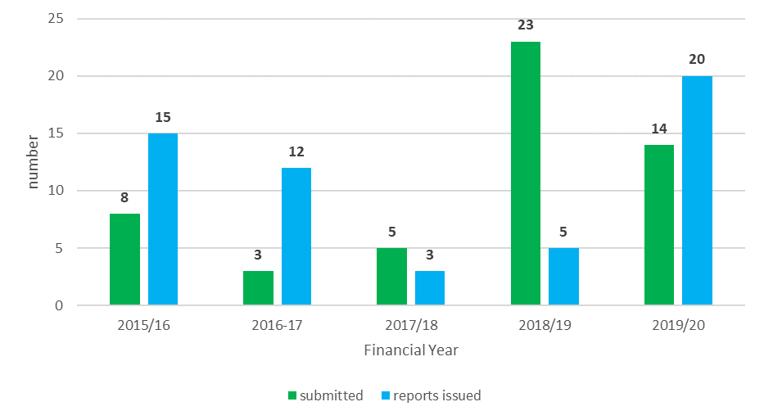
Figure 9.2: Nationally Significant Infrastructure, reports submitted to Secretary of State, by sector, by financial year, Number
2015/16 to 2019/20
Source: The Planning Inspectorate
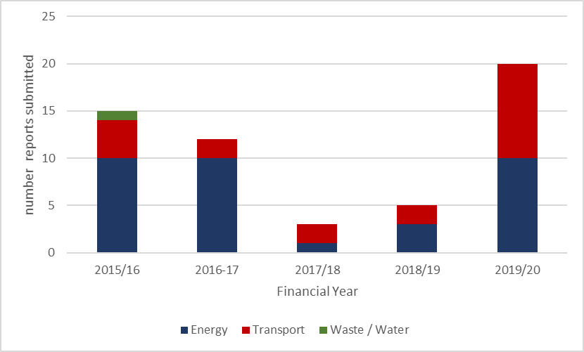

Environmental impact assessments
Our purpose | The Planning Inspectorate carries out Environmental Impact Assessments (EIA) which aim to protect the environment. Those assessments ensure that Local Planning Authorities make planning decisions based on the full knowledge of the likely significant environmental effects of projects applying for planning permission.
Key numbers for 2019/20 | EIA scoping requests received | EIA scoping requests issued | EIA screening requests received,
Key numbers for 2019/20 | 9 | 12 | 0
Key performance measures/ Ministerial agreed targets | Issue 100% of all EIAscoping opinions within 42 days of receipt |  |  | Met
Key performance measures/ Ministerial agreed targets | Issue 100% of all EIA screening opinions within 21 days of receipt |  |  | N/A
Our impact | The Planning Inspectorate undertakes its delegated responsibility for the EIA and Habitats Regulations Assessment (HRA) processes with care, supporting all applications and appeals as required. The work we do aims to ensure appropriate robustness and encourage proportionality towards the information produced for the EIA and HRA processes.

Public examination of local plans
Our purpose | Local plans set out the long-term development strategy of an area and are where the big decisions on planning for the future of communities and land are made. Once the Local Planning Authority has finished preparing and consulting on a local plan it must be submitted to the Secretary of State who will appoint an Inspector to carry out an independent examination. This process is dealt with by the Planning Inspectorate.
Key numbers for 2019/20 | Reports issued | Reports assessed as sound | Plans submitted to the Planning Inspectorate
Key numbers for 2019/20 | 59 | 58 | 39
Key performance measures/ Ministerial agreed targets | Complete Development Plan (Local Plan) examinations within the timetable agreed with the Local Planning Authorities |  |  | Met
Our impact | The 59 reports issued all included recommended changes that were necessary to allow the plan to be adopted, also known as Main Modifications, demonstrating how our Inspectors are working pragmatically and constructively with Local Planning Authorities to help them achieve a sound plan where possible. The modifications can vary from amending policy wording to removing unjustified housing allocations or introducing new ones and changing the housing requirement.

Key trends
The number of local plan reports that we issued was comparable to previous years. The significant change has been the reduction in demand, with 40% fewer plans being submitted in 2019/20 to 2018/19 (Figure 9.3). During 2019/20 two local plans were withdrawn before Inspectors submitted a report. In the first instance the Inspector had paused the examination to allow the Local Planning Authority to undertake a Green Belt Review and to carry out work on its housing land supply. Subsequently, following a change in political control the council withdrew the plan. In the other instance the Inspector concluded that the duty to cooperate with neighbouring authorities had not been complied with and the Local Planning Authority subsequently withdrew the plan. Similarly to previous years, the types of plans most often submitted by Local Planning Authorities were strategic plans, site allocation plans and mineral/waste plans (Figure 9.4).

Figure 9.3: Local plans examination reports submitted and reports issued, by financial year, Number 2015/16 to 2019/20
Source: The Planning Inspectorate
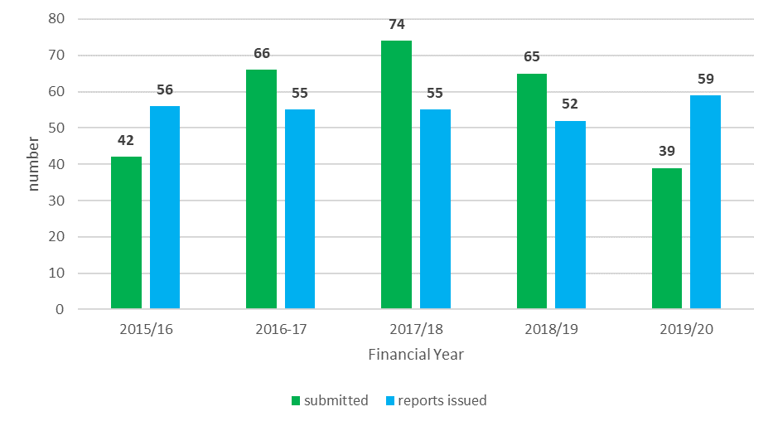
Figure 9.4: Local plans examination reports submitted, by type of plan, by financial year, Number
2015/16 to 2019/20
Source: The Planning Inspectorate

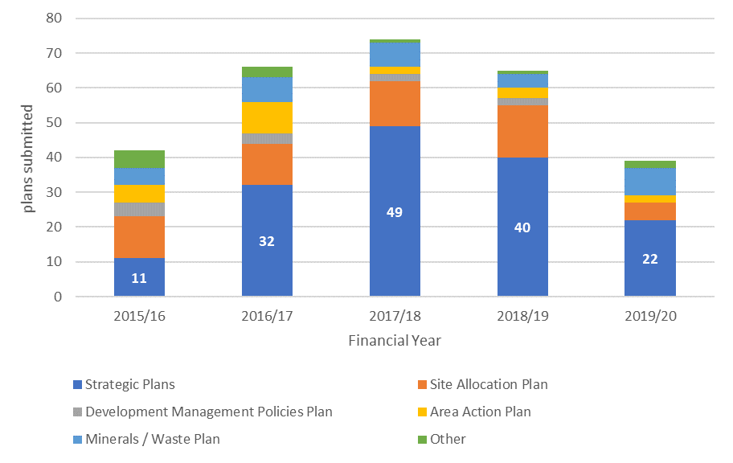

Community Infrastructure Levy schedules
Our purpose | The Community Infrastructure Levy is a levy that Local Authorities in England and Wales can choose to charge on new developments in their area. The charging authority produces a document called a charging schedule which sets out the rate for their levy. It must undergo a public examination by an independent person before the charging authority can formally approve it.
Key numbers for 2019/20 | Reports issued | Charging schedules submitted
Key numbers for 2019/20 | 4 | 3
Key performance measures/ Ministerial agreed targets | Complete Community Infrastructure Levy examinations within the timetable agreed with the Local Planning Authority |  | Met
Our impact | We continue to support this process, assessing that the charging schedules of Local Authorities are reasonable and providing certainty to Local Authorities about the ability to implement charging schedules. The volumes of inputs and outputs reflect a process that is mature within the wider planning world and that Local Planning Authorities can choose alternative providers to assess their Community Infrastructure Levy charging schedule.

Key trend
The number of charging schedule reports issued and submitted in 2019/20 are comparable to the previous year; four reports issued compared to five in 2018/19, and three schedules submitted compared to seven in 2018/19.

Planning and related appeals

Our purpose | If an application for planning permission is refused by the Local Planning Authority, or if it is granted with conditions, an appeal can be made to the Secretary of State against the decision, or the conditions, under Section 78 of the Town and Country Planning Act 1990. This appeal comes into the Planning Inspectorate, who acts on behalf of the Secretary of State.
Key numbers for 2019/20 | Appeals received | Change from previous year | Appeals decided | Change from previous year
Key numbers for 2019/20 | 11,690 | 5% less | 13,325 | 30% higher
Key performance measures | Aspiration for the median of written representations to be 18 weeks, from appeal valid date to decision date. This is equivalent to 50% of cases decided in 18 weeks. |  |  | The median performance in March 2020 was 19 weeks.
Key performance measures | Aspiration for the median of hearings to be 31 weeks, from appeal valid date to decision date. This is equivalent to 50% of hearings decided in 31 weeks. |  |  | The median performance in March 2020 was 36 weeks.
Ministerial targets | Note: Our Ministerial Targets no longer reflect the core measures operated by the Planning Inspectorate and replacement measures are to be agreed with MHCLG in autumn 2020
Ministerial targets | To determine 80% of written representations in 14 weeks of the start date |  |  | Not met
Ministerial targets | To determine 80% of hearings in 14 weeks of the start date |  |  | Not met
Ministerial targets | To determine 80% of inquiries (non-bespoke) in 22 weeks of the start date |  |  | Met
Ministerial targets | To determine 100% of inquiries (bespoke) according to the agreed timetable |  |  | Met
Ministerial targets | To determine 90% of inquiries under the Rosewell review in 24 weeks |  |  | 82.5% in target
Ministerial targets | To determine 100% of inquiries under the Rosewell review in 26 weeks |  |  | 98.75% in target
Our impact | Our Inspectors are independent of the Local Planning Authority and the applicant. They look again at the case and provide an open, fair and impartial way to either agree with, or overturn, the Local Planning Authority’s decision. The number of cases decided each year demonstrates the importance of this as part of the overall planning system. During 2019/20 we decided planning appeals involving over 60,000 homes, allowing over 38% of them.

Key trends | receipts & decisions
During 2019/20 we saw demand levels return to those seen prior to 2017/18 (figure 9.5). The increases in demand during 2017/18 and early 2018/19 were mostly associated with appeals for telephone kiosks following legislative changes. It’s only with the removal of permitted developments rules that we started to see a significant reduction in appeals being received, starting in May 2019.
The number of cases decided increased in 2019/20. This can be linked to the recruitment of Inspectors, as part of our Performance Recovery Programme. The amount of appeals we decided was 3,000 more than the previous year, 30% higher, and the highest in at least the last ten years (data published starts from 2010/11) (figure 9.5).
Figure 9.5: Planning appeal receipts and decisions by financial year, Number
2015/16 to 2019/20
Source: The Planning Inspectorate
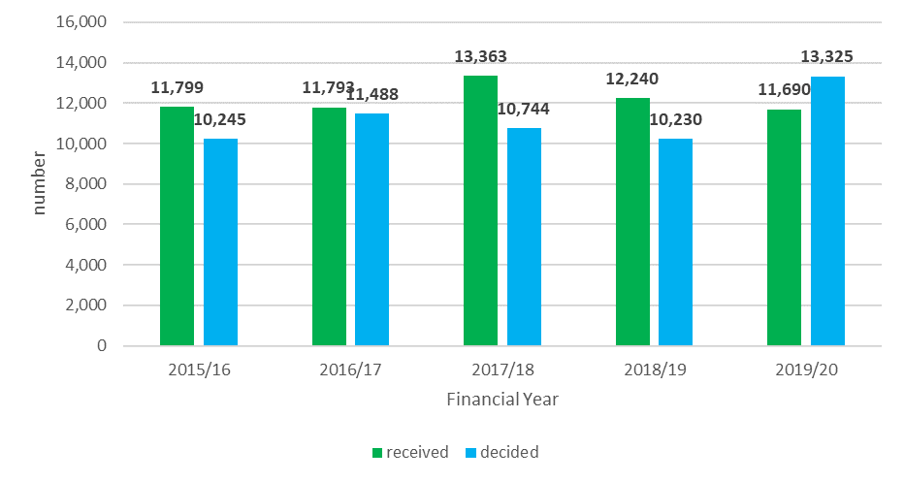

Key trends | Performance
Appeals decided through written representations
Most appeals are determined by written representations. During 2019/20 we set ourselves two main challenges; to improve our performance to customers and reducing the amount of appeals in the system.
We have been successful in reducing the median measure, from 26 weeks in April 2019 to 19 weeks by October 2019. This performance level was then maintained for the remainder of the financial year (Figure 9.6).
Figure 9.6: Planning appeal written representation decisions by month, Median
2019/20
Source: The Planning Inspectorate
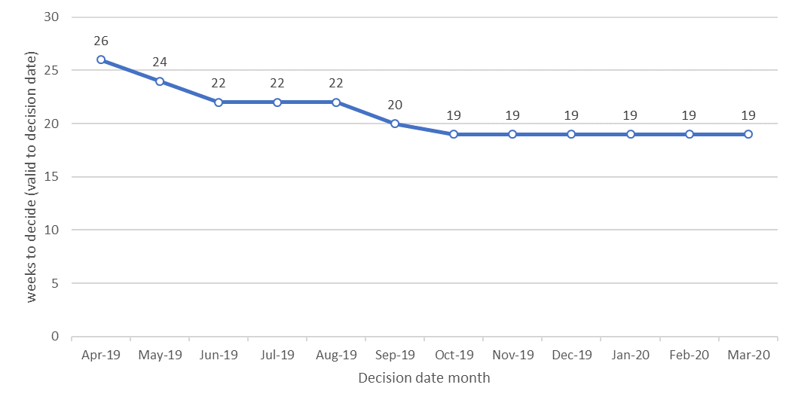
Figure 9.7: Planning appeal written representations, number of open appeals at the end of each month, by month, Number
2019/20
Source: The Planning Inspectorate
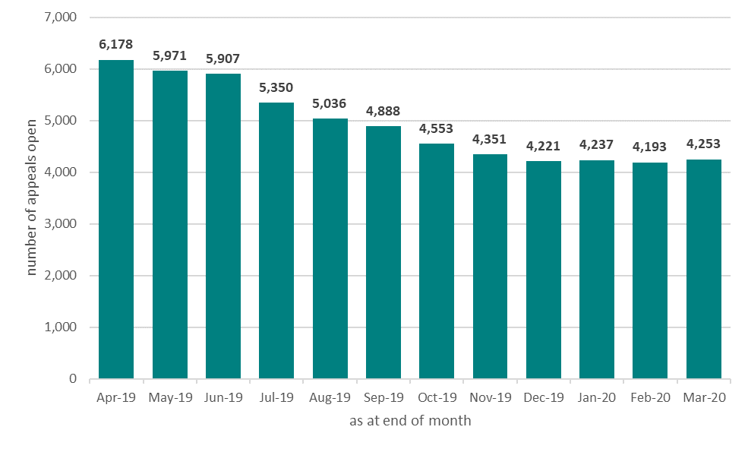
We brought the number of these appeals in the system down from over 6,000 in April 2019 to just over 4,000 in March 2020 (Figure 9.7).

Figure 9.8: Planning appeal written representation decisions by month and length of time (from valid to decision), Proportions
April 2018 to March 2020
Source: The Planning Inspectorate
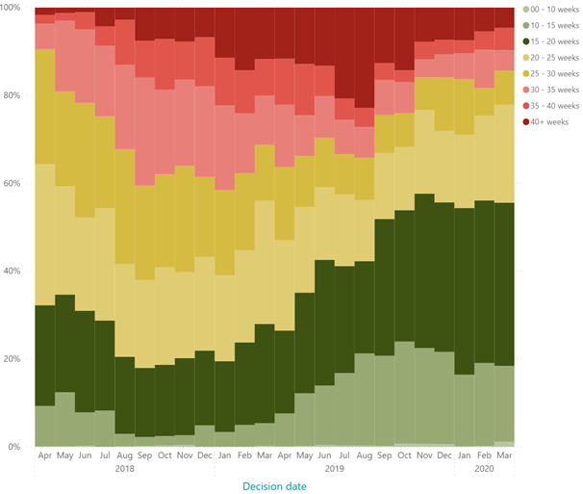
Ongoing work that we have been doing ongoing work to clear the backlog of older cases that has impacted on our Ministerial target this year (see the red/pink sections in Figure 9.8)
A higher percentage of appeals are being decided more quickly over the financial year (see the green sections in Figure 9.8)
Appeals decided through hearings
During 2019/20 the Planning Inspectorate decided over 600 planning appeal hearing decisions.
Figure 9.9: Planning appeal (s78) hearing decisions by month, Median
2019/20
Source: The Planning Inspectorate
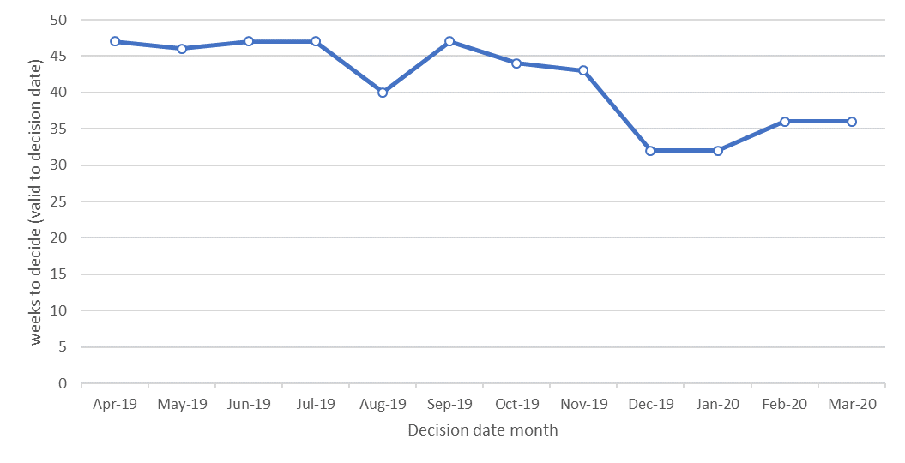
During the latter half of 2019/20 we concentrated more inspectors on hearings but due to the inherited performance time lags, progress has been less apparent in performance to our customers.
For planning appeal hearings decided in March 2020 the median length of time of appeal was 36 weeks. This has reduced from 47 weeks in April 2019 (Figure 9.9)

Appeals decided through inquiries
During 2019/20 the Planning Inspectorate started to implement the recommendations of the Rosewell review. The main impact on performance has been to shorten the time taken to decide inquiry appeals. The process change implemented more transparent and rigid timescales for all participants. As Figure 9.11 below shows, the new process is substantially faster than the previous process, but during 2019/20 we were still deciding a significant number of inquiries under the previous process.
Figure 9.10: Planning appeal inquiry decisions, by decision date month, Number
2019/20
Source: The Planning Inspectorate
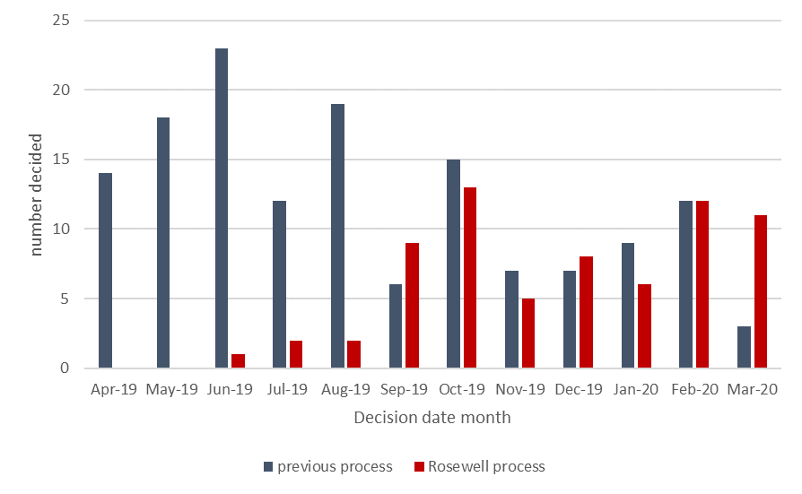
Figure 9.10 shows how volumes of inquiry appeals proceeding under the Rosewell process have increased during 2019/20, while we have also been deciding appeals under the previous process.
Figure 9.11: Planning appeal inquiry decisions, weeks to decide (valid date to decision date), Median
2019/20
Source: The Planning Inspectorate
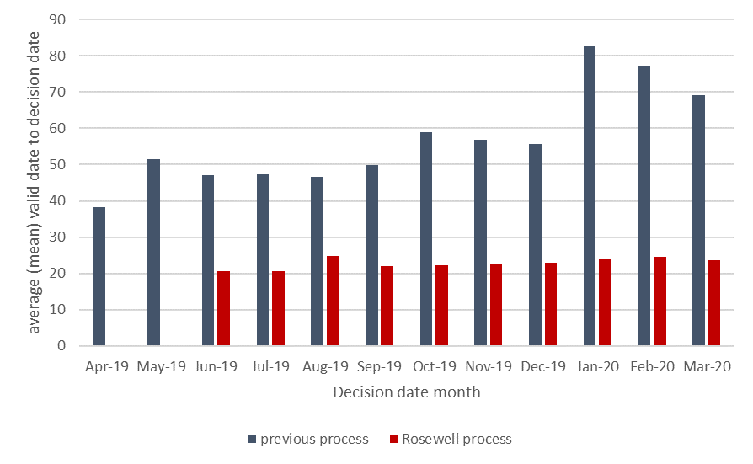
The Rosewell process is significantly faster with a median over the year of 24 weeks from valid date to decision date (Figure 9.11).

Major planning applications
During 2019/20 we did not receive or decide any major planning applications. Provision exists under Section 62A of the Town and Country Planning Act 1990 (as amended by the Growth and Infrastructure Act 2013) for an application for planning permission and reserved matters approval to be made directly to the Secretary of State. This is in cases where they involve major and non-major development, and the relevant Local Planning Authority has been designated by the Secretary of State. Any applications would be handled by the Inspectorate on behalf of the Secretary of State.

Householder appeals

Our purpose | Householder planning appeals cover small projects like extensions and loft conversions. If an application for planning permission is refused by the Local Planning Authority, or if it is granted with conditions, an appeal can be made to the Secretary of State against the decision, or the conditions, under Section 78 of the Town and Country Planning Act 1990. This appeal comes into the Planning Inspectorate who act on behalf of the Secretary of State.
Key numbers | Appeals received | Change from previous year | Appeals decided |  | Change from previous year
Key numbers | 4,896 | 2% higher | 4,417 |  | 1% less
Key performance measures | Aspiration for the median of written representations to be 12 weeks, from appeal valid date to decision date. This is equivalent to 50% of cases decided in 12 weeks. |  |  | The median performance for the whole of 2019/20 was 14 weeks and in March 2020 was 16 weeks.
Ministerial target | Note: Our Ministerial Target no longer reflects the core measure operated by the Planning Inspectorate and replacement measures are to be agreed with MHCLG in autumn 2020
Ministerial target | To determine 80% of householder appeals in 8 weeks of the start date |  |  |  | Not met
Our impact | Our Inspectors are independent of the Local Planning Authority and the applicant. They look again at the case and provide an open, fair and impartial way to either agree with or overturn the Local Planning Authority’s decision. The number of cases that are decided each year demonstrate the importance of this as part of the overall planning system.

Figure 9.12: Householder appeal receipts and decisions by financial year, Number
2015/16 to 2019/20
Source: The Planning Inspectorate
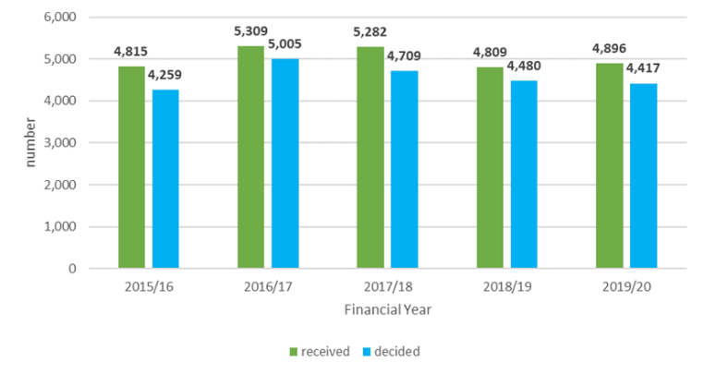
The number of appeals received and decided for Householder appeals during 2019/20 was comparable to the previous year (Figure 9.12).
Figure 9.13: Householder appeal decisions by month, Median
2019/20
Source: The Planning Inspectorate
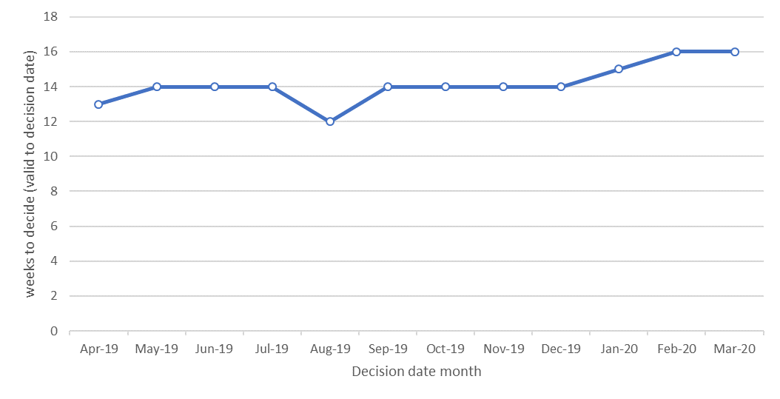
The median performance for the whole of 2019/20 was 14 weeks. Monthly performance against the median saw some variation and slight decline in performance in the last quarter of 2019/20 (Figure 9.13).

Other planning related appeals
Our purpose | The Planning Inspectorate also handles other planning related appeals, including:  - Commercial appeals: Local Planning Authorities make decisions on applications about minor commercial developments, for example, ground floor alterations like shop fronts and security shutters. Appeals against these decisions can be made through the Planning Inspectorate.  - Advertisement appeals: Local Planning Authorities make decisions about displaying an advertisement or sign on houses or buildings. Appeals against these decisions can be made through the Planning Inspectorate.  - Listed building consent appeals: If a property is a listed building and the Local Planning Authority has refused listed building consent then this decision can be appealed. An appeal can also be made if there are conditions on a consent that the applicant considers to be unreasonable.
Key numbers | Appeals received | Change from previous year | Appeals decided | Change from previous year
Key numbers | 1,024 | 36% less | 1,418 | 42% higher
Key performance measures/Ministerial targets | There are no set aspirations for performance for these casework types. There are no Ministerial Targets for these casework types.
Our impact | Our Inspectors are independent of the Local Planning Authority and the applicant. They look again at the case and provide an open, fair and impartial way to either agree with or overturn the Local Planning Authority’s decision.

Key trends | Demand & Performance
Volumes of appeals received and decided were significantly skewed by demand associated with telephone kiosks (see also planning appeals). We received substantial numbers of advertisement appeals that were linked to telephone kiosks during 2018/19 and then made decision about them during 2019/20. We also decided almost 40% more listed building consent appeals during 2019/20, when demand was comparable to previous years.
Performance for our commercial appeals customers was a median of 19 weeks for 2019/20. Advertisement appeals took longer, with a median of 44 weeks for 2019/20, although this was skewed by many appeals being linked to telephone kiosks. Customers of listed building consent appeals received an appeal decision in a median of 31 weeks for 2019/20.

Enforcement appeals
Enforcement covers enforcement notice appeals, listed building enforcement notice appeals and lawful development certificate appeals.
Our purpose | An enforcement notice will usually be served on the owner of a property when the Local Planning Authority considers there has been a breach of planning control and consider it expedient to take action to remedy the breach.  The notice will usually require you to stop doing something, such as removing a building or structure, or alter it to make it acceptable. The Planning Inspectorate offers the opportunity to make an appeal in respect of the notice issued by the Local Planning Authority.
Key numbers | Appeals received | Change from previous year |  | Appeals decided | Change from previous year
Key numbers | 3,389 | 2% higher |  | 2,413 | 11% higher
Key performance measures | Aspiration for the median of written representations to be 36 weeks, from appeal valid date to decision date. This is equivalent to 50% of cases decided in 36 weeks. |  | The median performance in March 2020 was 28 weeks compared to 40 weeks in April 2019. The average over the whole financial year was 38 weeks.
Key performance measures | Aspiration for the median of hearings to be 37 weeks, from appeal valid date to decision date. This is equivalent to 50% of cases decided in 37 weeks. |  | The median performance in 2019/20 was 62 weeks.
Key performance measures | Aspiration for the median of inquiries to be 47 weeks, from appeal valid date to decision date. This is equivalent to 50% of cases decided in 47 weeks. |  | The median performance in 2019/20 was 76 weeks.
Ministerial target | Note: Our Ministerial Targets no longer reflects the core measures operated by the Planning Inspectorate and replacement measures are to be agreed with MHCLG in autumn 2020.
Ministerial target | To determine 80% of written representations in 32 weeks of the start date |  |  |  | Met
Ministerial target | To determine 80% of hearings in 33 weeks of the start date |  |  |  | Not met
Ministerial target | To determine 80% of inquiries in 43 weeks of the start date |  |  |  | Not met
Our impact | Our Inspectors are independent of the Local Planning Authority and those enforced against. They look again at the case and provide an open, fair and impartial way to either agree with or overturn the Local Planning Authority’s decision.

Key trends | Demand & Performance
The number of enforcement appeals received has been comparable with previous years. However, during 2019/20, we dedicated more resource to carrying out enforcement appeals. The data shown below does not provide a long enough time series to confirm that performance has consistently shown an improvement. It does show early evidence of the impact of allocating more resource to this casework type.
Figure 9.14: Enforcement appeal receipts and decisions by financial year, Number
2015/16 to 2019/20
Source: The Planning Inspectorate
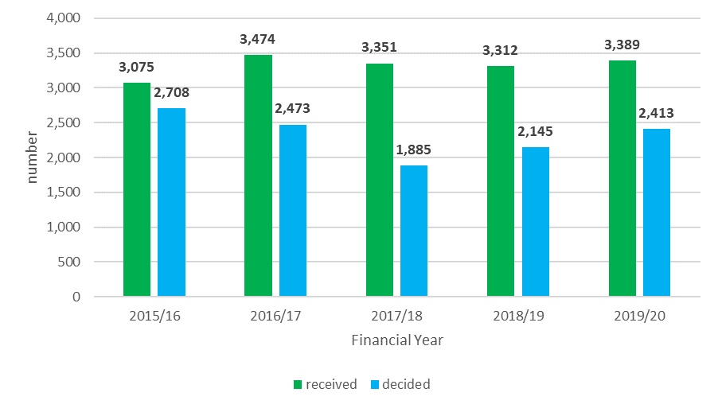
The number of enforcement appeals received during 2019/20 was comparable with previous years. Decisions volumes were up when comparing 2019/20 against the previous year (Figure 9.14).
Figure 9.15: Enforcement appeal decisions by month, Number
2019/20
Source: The Planning Inspectorate
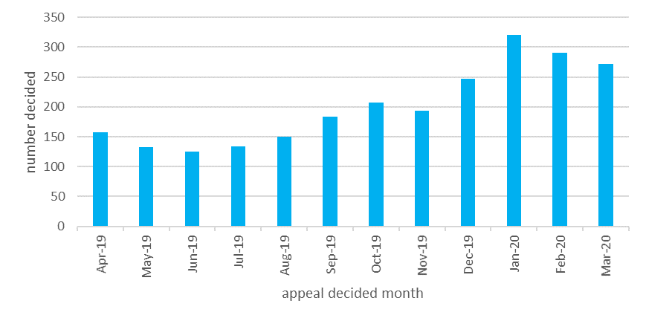
Towards the end of 2019/20 the Planning Inspectorate allocated more resource to enforcement appeals and this was shown by an increase in appeals decided between January and March 2020 (Figure 9.15).

Figure 9.16: Enforcement appeal written representation decisions by month, Median
2019/20
Source: The Planning Inspectorate
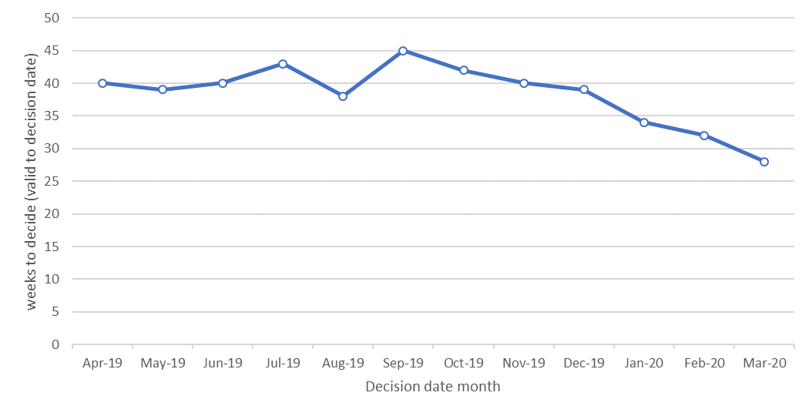
Performance during 2019/20 has started to improve for our customers, with the median at 28 weeks in March 2020, compared to 40 weeks in April 2019 (Figure 9.16).
The median value over the whole financial year was 38 weeks.
Figure 9.17: Enforcement appeal hearing & inquiry decisions by month, Median
2019/20
Source: The Planning Inspectorate
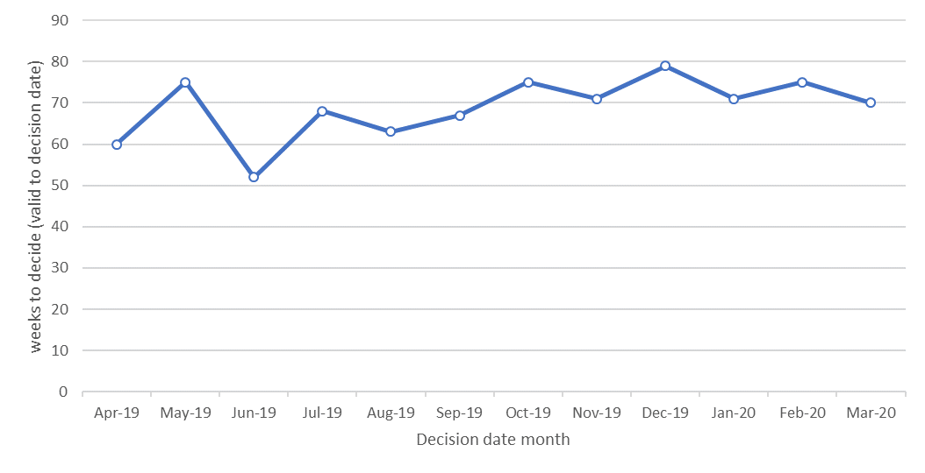
There has not been an improvement in performance for hearings and inquiries during 2019/20 (Figure 9.17).

Specialist casework

Our purpose | There are other decisions that are made by Local Planning Authorities and councils, appeals can be made to the Secretary of State against the decision, or the conditions. These appeals come into the Planning Inspectorate, which acts on behalf of the Secretary of State.
Key numbers | Received | Change from previous year | Decided / reports submitted | Change from previous year
Key numbers | 1,003 | 11% less | 854 | 0.1% less
Key performance measures/Ministerial targets | Note: Our Ministerial Targets no longer reflect the core measures operated by the Planning Inspectorate and replacement measures are to be agreed with MHCLG and other Government departments in autumn 2020.
Key performance measures/Ministerial targets | Rights of Way, Public Path Orders
Key performance measures/Ministerial targets | To determine 80% of written representations in 37 weeks of the valid date (2018/19 - 27 weeks of the start date) |  |  | Not Met
Key performance measures/Ministerial targets | To determine 80% of hearings in 39 weeks of the valid date (2018/19 - 29 weeks of the start date) |  |  | Not Met
Key performance measures/Ministerial targets | To determine 80% of inquiries in 45 weeks of the valid date (2018/19 - 35 weeks of the start date) |  |  | Not Met
Key performance measures/Ministerial targets | Rights of Way, Wildlife and Countryside
Key performance measures/Ministerial targets | To determine 80% of written representations in 37 weeks of the valid date (2018/19 - 27 weeks of the start date) |  |  | Not Met
Key performance measures/Ministerial targets | To determine 80% of hearings in 39 weeks of the valid date (2018/19 - 29 weeks of the start date) |  |  | Not Met
Key performance measures/Ministerial targets | To determine 80% of inquiries in 45 weeks of the valid date (2018/19- 35 weeks of the start date) |  |  | Not Met
Key performance measures/Ministerial targets | Schedule 14
Key performance measures/Ministerial targets | To determine 80% of directions in 21 weeks of the valid date (2018/19 -17 weeks of the start date) |  |  | Met
Key performance measures/Ministerial targets | To determine 80% of appeals in 30 weeks of the valid date (2018/19 - 26 weeks of the start date) |  |  | Not Met
Key performance measures/Ministerial targets | Environmental appeals
Key performance measures/Ministerial targets | To determine all types of appeal in 28 weeks of the start date |  |  | Not Met
Key performance measures/Ministerial targets | Tree Preservation Orders
Key performance measures/Ministerial targets | To determine 80% of written representations in 14 weeks of the start date |  |  | Met
Key performance measures/Ministerial targets | To determine 80% of hearings/inquiries in 26 weeks of the start date. |  |  | Met
Key performance measures/Ministerial targets | High Hedges
Key performance measures/Ministerial targets | To determine 80% of written representations in 24 weeks of the start date |  |  | Met
Key performance measures/Ministerial targets | Hedgerows
Key performance measures/Ministerial targets | To determine 80% of all appeal types in 28 weeks of the start date |  |  | Met
Key performance measures/Ministerial targets | Common Land
Key performance measures/Ministerial targets | To determine 80% of no objections in 18 weeks of the start date  (2018/19 - 12 weeks of the start date) |  |  | Met
Key performance measures/Ministerial targets | To determine 80% of those objected in 26 weeks of the start date |  |  | Met
Key performance measures/Ministerial targets | To determine 80% of those objected (Inspector) in 40 weeks of the start  (2018/19 - 52 weeks of the start date) |  |  | Met
Key performance measures/Ministerial targets | Cost applications
Key performance measures/Ministerial targets | To determine 50% of all appeal types in 10 weeks of the start date |  |  | Met
Our impact | Our Inspectors are independent of the original decision maker and look again at the case. They provide an open, fair and impartial way to either agree with or overturn the original decision maker’s decision.

Key trends | Demand & Performance
Figure 9.18 below shows the number of cases received in 2019/20 by casework type that we categorise as ‘specialist’. The largest categories are tree preservation orders, rights of way, commons and high hedge appeals. The next phase of the Performance Recovery Programme was due to focus on making improvements to our performance in this area during 2020/21. However the impact of COVID-19 pandemic may prevent us from making significant performance improvements.
Figure 9.18: Specialist casework receipts, Number
2019/20
Source: The Planning Inspectorate
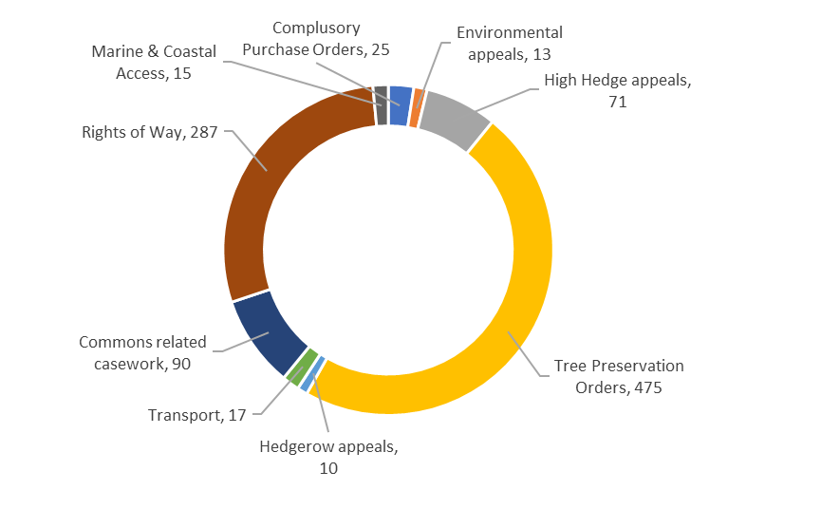

10. Detailed performance analysis – Wales
Planning Inspectorate Wales undertakes all planning, environmental and associated casework in Wales, apart from the largest national infrastructure projects, for which the responsibility for processing and determination has not been devolved to Welsh Government. Planning Inspectorate Wales deals with some types of casework that are specific to Wales and not dealt with by the wider Inspectorate, such as non-validation appeals, sustainable drainage appeals, reviews against listing, joint housing land availability studies and maintenance of land appeals (S125).
Planning Inspectorate Wales has a vital role in supporting the Welsh Government’s aims and objectives of delivering a Wales which is:
- prosperous and secure;
- healthy and active;
- ambitious and learning; and
- united and connected.
In May 2019, Julie James, the Minister for Housing and Local Government, made a written statement to the Senedd, setting out Welsh Government’s intention to establish a separate, dedicated planning service for Wales. Setting up a new organisation will be a challenge and a significant piece of work which will divert people and resources. Nevertheless, Planning Inspectorate Wales is committed to maintaining the same level of excellent performance during the transition to independence. Colleagues in the Welsh Government and the Planning Inspectorate England are working to ensure that the new organisation is in place by April 2021.
We have established an aligned casework team, ensuring a mobile resource able to be deployed, where needed, when needed. This has improved the continuity of service for appellant’s Local Planning Authorities, communities and other stakeholders. The expansion and development of knowledge, expertise and experience in the team, continues to be driven forward.
In the summer of 2019, the Minister for Environment, Energy and Rural Affairs issued her decision on the Wales Rod and Line (Salmon and Sea Trout) and Wales Net Fishing (Salmon and Sea Trout) Byelaws 2017. This decision followed the submission of our Inspectors’ report and recommendation. The Inspector who held the inquiry to hear objections into the confirmation of the byelaws received a letter of thanks from the Minister. The Minister commended the open, impartial and fair way the inquiry was run, identifying in particular, his professionalism and expertise.
Two reports on Developments of National Significance were submitted for decision by Welsh Ministers. The first one about the installation of a stand-by energy generating station with a capacity of approximately 40MW at land North of Felindre Road, Pencoed. The second on a solar park at Wauntysswg Farm, Abertysswg, Rhymney. Eight reports were also submitted to the Department for Business, Energy and Industrial Strategy in relation to Wayleave applications under the Electricity Act. An application for an off-shore tidal array for a maximum capacity of 240MW has been submitted, the first of its kind to be considered, following power to determine these applications being devolved to Welsh Ministers. Similarly, an application for a Harbour Revision Order has been received.
Events were held designed to introduce Community Council’s to the work of the Planning Inspectorate and explore how Community Councils can effectively engage with the planning system. We explained our approach to decision making, in appeals, local plan examinations and Developments of National Significance applications, and the matters that are and aren’t relevant. Working with Planning Aid Wales, we then facilitated workshop sessions to discuss how Community Councils can use their resources to get the best for their communities.
The Head of Planning Inspectorate in Wales presented to local authority committee members on their role in the planning system and evidence-based decision making. We also led sessions at the Royal Town Planning Institute Cymru summer and autumn conferences. One session covered 'A day in the life of an Inspector' providing insight into the day to day role of an Inspector. Another covered good practices when dealing with enforcement notice appeals, specifically, the drafting of an enforcement notice.
At the invitation of the Royal Town Planning Institute and Department of Infrastructure in Northern Ireland, we spoke at events in Belfast designed to help them prepare for their first local development plan examinations.
We have also worked with Welsh Government Planning Directorate and the Well Being and Welsh Language Commissioners on improving the planning system in Wales.
Sustaining a high level of performance against ministerial targets, we decided well over 90% of cases within required timeframes, against a target of 85%. This is, in no small part, a result of a flexible efficient team. Planning Inspectorate Wales are a bespoke team based in Cardiff, independent from Welsh Government, but funded by them. The team comprises 20 home-based Inspectors and 26 office based professional administrative staff who provide support to Inspectors. There are currently four Welsh speakers across the team and any recruitment exercise actively seeks to strengthen this number.
We have carried out several activities to ensure communication and understanding of individual roles within the team is fostered. Inspectors sit alongside case officers to familiarise themselves with case officers’ duties and to gain a case officers’ perspective. Office staff have accompanied Inspectors on site visits and have attended events to better understand role of Inspectors. Inspectors have taken case officers through their decision-making process. Office staff and Inspectors share lunch at quarterly sub-group meetings, an opportunity to get to know each other. A team away day at an Escape Rooms was received well by all involved, the measure of success being the tangible improved communication between those usually at home and those usually in the office.
Planning Inspectorate Wales takes promoting the use of the Welsh language very seriously. We have Welsh language speakers in the team, as well as those who are independently learning to speak Welsh, ensuring a basic level of skill throughout the whole team. We are committed to promoting the language and improving the service we provide to our Welsh speaking customers. To this end, a Welsh Language taster session for the team, run by the University of South Wales, was undertaken as part of the team away day and was well received.

11. Detailed quality analysis – England and Wales
Maintaining the quality of our output is essential. Complaints on individual cases are all investigated, and we review any case where our decision is challenged in the High Court.
The Professional Steering Group regularly reviews the outcomes of complaints and successful legal challenges. This allows us to capture lessons and then disseminate knowledge to Inspectors through a combination of training material and updates to guidance.
The Planning Inspectorate was included in the Parliamentary and Health Service Ombudsman’s statistics for 2017/18. This is the latest data set available. The document was published in December 2018 and is available on their website.

 | England | Wales
High Court Challenges | 160 | 4
High Court Outcomes | 144 | 4
Successful Challenges | 44 | 1

We handled 251 Freedom of Information requests, and answered 87% of those within 20 working days, and kept the requesting party informed where we needed extra time to respond.
Parties put to unnecessary expense as a direct result of an error made by the Inspectorate could claim recompense through our ex gratia scheme. In 2019/20, we made cash payments in relation to 14 claims, totalling under £335,000.
At the end of 2019, we conducted our fifth annual reputation survey, receiving almost 300 responses.
Over 80% of our customers told us we uphold our values of being impartial, fair and open. A large majority also agreed we listen, we are professional, and trustworthy. While there was a slight improvement on last year’s survey, our customers remain less confident in our consistency and more than half of the respondents expressed concern with our speed of decisions.

Sarah Richards
Chief Executive of the Planning Inspectorate
28 August 2020

Accountability report

Introduction:
The accountability report records details of the executive and non-executive directors and sets the context for the way the Inspectorate was managed and controlled. It also accounts for use of resources – both staff and money.

Corporate governance report

12. The Directors’ report
The Inspectorate is overseen by an Executive Team made up of the Chief Executive and its Directors. They met every two weeks to consider, plan and review the organisational strategic direction, financial and non-financial performance and manage risks and issues, taking decisions as appropriate.
It is supported by an advisory Board, which is overseen by an independent non-executive chair. The Board also comprised three non-executive directors; the Chief Executive, executive directors and representatives from MHCLG. There is an open invitation to a representative of the Welsh Government to attend Board meetings.

Our Executive Team
 | Sarah Richards  Chief Executive  Attended 7 of 8 Board meetings |  |  |  | Paul McGuinness  Interim Director of Corporate Services  From March 2020  Attended 1 of 1 Board meetings
 | Navees Rahman  Director of Corporate Services (Parental leave from March 2020)  Attended 6 of 8 Board meetings |  |  |  | Graham Stallwood  Director of Operations  From June 2019  Attended 7 of 8 Board meetings
 | Chris Thorby  Director of Strategy  Attended 4 of 6 Board meetings

Previous Executive Directors
Phil Hammond  Director of Volume Casework until July 2019  Did not attend Board meetings | Tim Guy  Director of Transformation until March 2020  Attended 4 of 5 Board meetings

Our Non-Executive Directors
 | Trudi Elliott  Chair of the Planning Inspectorate Board  Attended 8 of 8 Board Meetings |  | Sally Dixon  Non-Executive Director  From July 2019  Attended 5 of 5 Board Meetings
 | Dr Rebecca Driver  Non-Executive Director  From December 2019  Attended 2 of 2 Board Meetings |  | Stephen Tetlow  Non-Executive Director  From July 2019  Attended 3 of 5 Board Meetings

External Representatives
Simon Gallagher  Director of Planning MHCLG  Attended 6 of 8 Board meetings | Neil Hemington  Chief Planner, Welsh Government  Attended 3 of 8 Board meetings

Previous Non-Executive Directors
David Holt  Attended 3 of 6  meetings | Susan Johnson  Attended 1 of 1  meetings | Jayne Erskine  Attended 1 of 1  meetings

13. Statement of the Accounting Officer’s responsibilities
Under Section 7(2) of the Government Resources and Accounts Act 2000, HM Treasury has directed the Planning Inspectorate to prepare for each financial year a statement of accounts in the form and on the basis set out in the Accounts Direction. The accounts are prepared on an accruals basis and must give a true and fair view of the state of affairs of the Inspectorate, its income and expenditure, Statement of Financial Position and cash flows for the financial year.
In preparing the accounts, I, as the Accounting Officer am required to comply with the requirements of the Government Financial Reporting Manual and in particular to:
- observe the Accounts Direction issued by HM Treasury, including the relevant accounting and disclosure requirements, and apply suitable accounting policies on a consistent basis;
- make judgements and estimates on a reasonable basis;
- state whether applicable accounting standards as set out in the Government Financial Reporting Manual have been followed, and disclose and explain any material departures in the financial statements;
- prepare the financial statements on a going concern basis; and
- confirm that the Annual Report and Accounts as a whole is fair, balanced and understandable and take personal responsibility for the Annual Report and Accounts and the judgements required for determining that it is fair, balanced and understandable.
The Departmental Accounting Officer at MHCLG has appointed the Chief Executive as Accounting Officer of the Planning Inspectorate. The responsibilities of an Accounting Officer, including responsibility for the propriety and regularity of the public finances for which the Accounting Officer is answerable, for keeping proper records and for safeguarding the Inspectorate’s assets, are set out in Managing Public Money published by the HM Treasury.
As the Accounting Officer, I have taken all the steps that I ought to have taken to make myself aware of any relevant audit information and to establish that the Inspectorate’s auditors are aware of that information. So far as I am aware, there is no relevant audit information of which the auditors are unaware.

Sarah Richards
Chief Executive and Accounting Officer
28 August 2020

14. The governance statement

Introduction
This governance statement covers the period from 1 April 2019 to 31 March 2020. It includes any matters from after the year-end that are pertinent.
MHCLG also publishes a governance statement that covers the central Department and refers to its arm’s length bodies (of which we are one), acknowledging they maintain their own governance structures and processes, appropriate to their business and scale. Therefore, there is no duplication of information contained in this Statement.

Scope of responsibility
I am the Inspectorate’s Chief Executive and Accounting Officer. My responsibility is to ensure that the system of governance in the organisation supports the achievement of our policies, aims and objectives, while ensuring accountability, value for money, probity and regularity of finances, and safeguarding public funds and assets as set out in Managing Public Money.
I was designated as Accounting Officer by the Permanent Secretary and Accounting Officer for MHCLG in March 2016, with a summary of responsibilities in my letter of designation. That letter set out my responsibility to the Minister for the organisation’s use of resources to carry out its functions, and my liability to be called to appear before the Public Accounts Committee to give evidence on the handling of my Accounting Officer responsibilities. I remain personally responsible for the effective management of the organisation in accordance with our Agency Framework Document and in accordance with the normal Civil Service rules on propriety and securing value for money. This responsibility takes account of the delegation to the Welsh Government of headcount and budget controls.
During the period covered by this Statement, I have not sought any written directions to continue with a call from a Minister to take responsibility for an aim, priority or action that I believed to be contrary to the principles of Managing Public Money.
I am satisfied that I have the necessary level of assurance for the period of this Statement based on discussions over the course of the year, and information received from:
- the Non-Executive Chair of the Planning Inspectorate’s Board;
- the other Non-Executive Directors on the Board, particularly the Chair of the Audit and Risk Assurance Committee;
- internal and external audit; and
- the Executive Directors.

Impact of COVID-19 on governance
The COVID-19 pandemic has impacted on all aspects of people’s lives and the workings of businesses and institutions. The Planning Inspectorate have continued to work through the implications to our casework and our workforce in response to the developing pandemic.
A project was initiated ahead of lockdown to respond to the pandemic, setting four priorities for our response:
- Well-being – To continue to ensure staff are safe and well.
- Casework – To continue to progress and decide casework (as long as this remains practical and safe).
- Engagement – To keep staff, customers and other key stakeholders informed and engaged.
- Support MHCLG – To provide support to MHCLG.
The project team’s response was in three phases:
- crisis response;
- resume operations and recovery; and
- review learnings and build into future plans.
This unprecedented situation led to a number of changes to the governance structure to ensure the organisation was able to adapt quickly to the changing situation and Government advice. The organisation was able to adapt quickly with Inspectors already being based from home and office staff normally based in Bristol and Cardiff having the technology available to transfer to working from home overnight. A reminder on data security and the General Data Protection Regulation was issued to staff.
As an organisation, it was agreed to amend the governance structure in the short term. This meant the Executive Team met on a daily basis to ensure strategic oversight and developments were quickly addressed. A project team, led by the Director of Corporate Services was initiated. This included staff from across all Directorates. This team met on a daily basis to review the impact of the pandemic on our risks and procedures which needed temporary/permanent changes (e.g. home working, special paid leave, site visits etc.).
A COVID-19 specific dashboard was created which tracked performance, availability and absences. It was used to make decisions by the project team and the Executive Team. Reviews of contractors and access to payments were also evaluated to ensure resilience of service. An emergency budget allocation was set aside to enable the organisation to respond quickly to needs – such as personal protection equipment for Inspectors returning to site visits, information technology solutions, and health and safety kit being sent to staff working from home.
The pandemic has led to an acceleration of the timetable to hold digital events. This work is now moving forward at pace and has been adopted to be delivered as part of the Change Portfolio budget. A number of Inspectors supported MHCLG and the wider Government response as it moves towards a business as usual, recovery period of response. The review of learning and impact on future plans is now underway.

Governance framework
Our Governance framework is made up of the structures, systems, processes, cultures and values that together are used to direct and control the organisation and its activities. The system of internal control is an ongoing and integral part of the framework, and regular management information is used to support decision-making. A formal risk management system and processes are in place to manage risk to a level considered acceptable.
The Governance framework includes:
- the Planning Inspectorate Board;
- the Audit and Risk Assurance Committee;
- the Strategic Assurance Panels (new from February 2020);
- the Executive Team, groups with delegated authority from the Executive Team and Senior Leadership Group;
- portfolio, programme, and project boards;
- business planning and performance reporting;
- legal controls including delegations from decision-making departments on National Infrastructure casework to ensure we operated within the scope provided by legislation; and
- financial regulation and administrative procedures including management supervision, formally recorded financial and contractual delegations and accountability, segregation of duties, procurement and spend controls, fixed asset controls, recruitment controls and controls relating to contracts for services.
Reflecting on the findings of an effectiveness review on the Board and Committees (reported to Board in January 2019), and taking the opportunity of new Non-Executive contracts and newly established Executive Team, we gave some thought to some changes to the governance framework.
It was agreed by the Executive Team and the Non-Executive Directors that the People Committee and Customer Quality and Professional Standards Committee (formerly part of the governance framework and in operation until January 2020 and May 2019 respectively) should be replaced by Strategic Assurance Panels. The purpose of the panels is to focus on delivery of our strategic priorities (excellent customer service, efficient and effective, increase staff engagement, and innovate approaches and services). Each Directorate has been paired with a Non-Executive Director to lead on assurance against a priority. MHCLG representation at the panels has been invited.
Establishing the panels enables the Directors to lead, with insight and challenge from the non-executives, the assurance of strategic delivery. It increased accountability. It also created the opportunity to identify and treat risks to delivery through a greater analytical focus of the executive and non-executives time, with increased scrutiny of strategic impact.
The changes are compliant with the framework agreement between ourselves, MHCLG and Welsh Government, and were brought into effect in early 2020. The last Committee (People) was held in January 2020, and the first strategic assurance panel was held in February 2020.
The Audit and Risk Assurance Committee and Board remained in place, with a change to the Board’s Terms of Reference to bring Executives to the meeting as full members rather than attending for specific agenda items. The Terms of Reference documentation was brought for formal sign off to the Board in July 2020. Amendments were requested and the terms of reference were agreed virtually, outside of the formal Board meeting in August 2020.
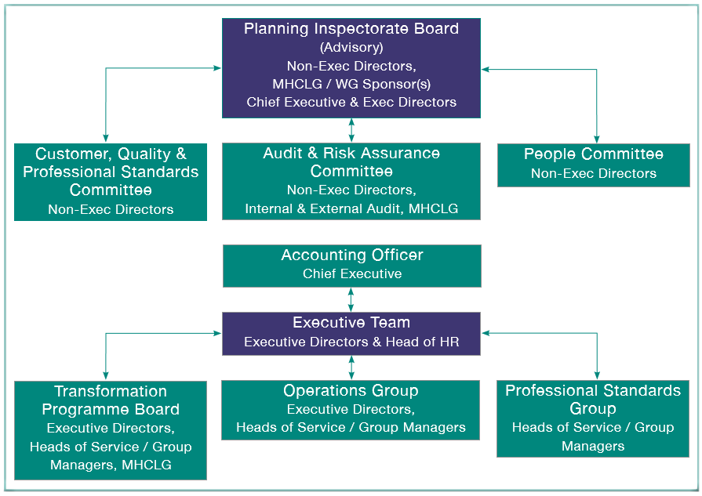
Figure 14.1 - Historic governance structure in place at 1 April 2019

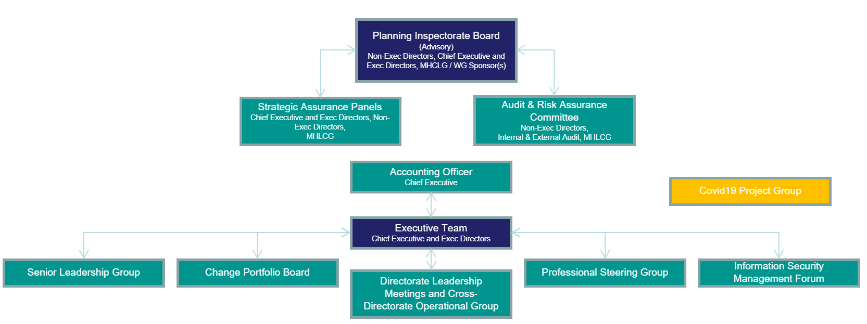
Figure 14.2 - Current governance structure in place at 31 March 2020

The Board
I am supported by an advisory Board appointed in accordance with our Agency Framework Document and the rules for Public Appointments. Board attendance can be found in Section 12 of this Annual Report The Directors’ Report.
The Board comprised:
- the Inspectorate’s Non-Executive Chair;
- three Non-Executive Directors (NEDs);
- myself as Chief Executive, supported by Executive Directors;
- a representative from MHCLG; and
- there was an open invitation to a representative of the Welsh Government to attend Board meetings.
Three new contracts for Non-Executive Directors were issued during the financial year to replace outgoing incumbents:
Name | Start Date | End Date
Jayne Erskine | N/A | 31 May 2019
Susan Johnson | N/A | 31 May 2019
David Holt | N/A | 30 December 2019
Sally Dixon | 22 July 2019 | N/A
Stephen Tetlow | 22 July 2019 | N/A
Rebecca Driver | 31 December 2019 | N/A
The role of the Non-Executives is to use their knowledge and background in matters such as business planning, policy, strategy, performance, customer experience, resources, risk and governance, and to contribute to collective Board scrutiny of the executive’s plans and operations. Our non-executives furthered their understanding of the organisation through meetings with individuals as well as teams and attending stakeholder events and Inspector training sessions.
The Board met every two months with additional short meetings convened as appropriate: for example in June 2019 to sign off the Annual Report and Accounts and in February 2020 to sign off the 2020/21 Business Plan.
During the period, the Board:
- reviewed and signed off the Annual Report and Accounts;
- reviewed and signed off the Strategic Plan for 2019/24 and the Business Plan for 2020/21;
- reviewed regular dashboards of management information (financial and non-financial) to identify issues and risks, and ensure they were appropriately managed;
- reviewed and commented on a developing customer strategy and customer-centric performance measures;
- had oversight of the key change programmes, offering advice and challenge on the delivery timelines, receiving and reviewing progress updates on organisational development transformation, organisational design and performance recovery programme;
- considered strategic risks, reviewing the assessment (appetite applied to categorisations and individual risks) and the proposed mitigations;
- considered the preparedness of the organisation for the impact of Brexit on operations;
- reviewed proposals for changes to governance arrangements; and
- had oversight of the Inspectorate’s response to the COVID-19 pandemic.
Examples of how members of the Board offered insight and challenge:
- The dashboard data reviewed by the Board reflected the data used by the Executive Team to manage the business. The organisation has been developing new management information technology (MiPINS), offering a more sophisticated approach through the provision of business analytic capability. The initial development phase has focussed on developing insight into operational performance, and the Board was asked for views on the data presented and what else might be useful to build into the system.
- A deep dive assurance of our Organisational Delivery Transformation programme by an Inspectorate Non-Executive Director took place in November 2019.

The Audit and Risk Assurance Committee
The Audit and Risk Assurance Committee is a sub-committee of the Board, supporting it in matters relating to risk, control and governance. The Committee met on a quarterly basis and kept under review the reliability and integrity of assurance provided by the executive to the Board and the Accounting Officer.
Formal membership of the Committee is restricted to the Non-Executive Directors, supported by a Head of Service as the Committee’s professional lead, with other participants attending by invitation. David Holt chaired the Committee throughout 2019. Rebecca Driver assumed responsibility for the Committee from 31 December 2019 onwards, attending in September and December 2019 as an observer and chairing it in March 2020.
During the period, the Committee:
- reviewed the final Annual Report and Accounts for 2018/19, prior to recommending sign-off by the Board;
- provided assurance to the Accounting Officer (Chief Executive) on propriety issues, based on reviews of the strategic risks and audit reports;
- provided oversight and advice on the Board’s responsibilities for risk management, including reviewing the strategic risk register (with a specific focus on the Heathrow project risk) and the maturity of risk management within the organisation;
- reviewed an assurance dashboard, focused on compliance against the governance framework in place between MHCLG, the Welsh Government and the Inspectorate;
- reviewed internal audit reports;
- received updates about reviews of fraud, bribery and whistleblowing procedures;
- reviewed and provided insight and challenge into findings around data compliance;
- monitored progress against the internal audit plan for 2018/19 and approved the draft programme for 2019/20; and
- received, reviewed and cleared a ‘standing items’ report at each meeting.

The Customer, Quality and Professional Standards Committee and the People Committee
The Customer, Quality and Professional Standards Committee was a sub-committee of the Board, supporting it in matters relating to customer service, quality and maintaining professional standards.
The People Committee was similarly a sub-committee of the Board, supporting it in matters relating to the key people elements of organisational effectiveness.
The Committees, chaired by Non-Executives, provided opportunities for them to comment, challenge and make recommendations, operating in a meeting style.
Formal membership of the Committee was restricted to the Non-Executive Directors, supported by a Head of Service as the Committee’s professional lead, with other participants attending by invitation.
The Committees had historically been convened on a quarterly basis.
During the period, the Committees:
- reviewed overall operational performance, focusing on those elements which matter most to customers (including timeliness and consistency), and provided insight and challenge to Directors and Heads of Service;
- received updates from the Professional Steering group;
- provided advice and challenge on the organisational strategies (for example the People Strategy);
- reviewed the Organisational Design programme progress including a plan for Phase 2 of the programme;
- reviewed the plans for the OnePins event;
- reviewed the results of the People Survey; and
- reviewed the Inspectorate’s pay remit including the gender pay gap.

Strategic Assurance Panels
The move to Strategic Assurance Panels has offered assurance focusing on delivery against strategic priorities. The Panels, scoped for thematic workshops, are intended to offer the Executive Team and Non-Executive Directors a greater depth of analysis for assurance purposes.
The table below sets out the panels held in the 2019/20 year and to the point of signing the accounts.

Priority | Date held | Insight
All (launch of panel approach) | 20 February 2020 | - Challenge of the business plan 2020/21 - product and process.
Customer Excellence | 20 February 2020 | - Organisational Design phase two design for one customer team, customer strategy;  - plan to benchmark customer service provision with Institute of Customer Service membership, and  - progress on development of customer-oriented productivity measures.
Innovation | 23 April 2020 | - Organisational approach for innovation and continuous improvement;  - plans for trials; and  - view of relationship with organisational culture towards innovation and change.
Customer Excellence | 21 May 2020 | - Response to the COVID-19 pandemic to maintain delivery of excellent customer service.
Customer Excellence and Innovation | 23 July 2020 | - Follow up from previous sessions to update on progress.

Review of board and committee effectiveness
A review of Board and Committee effectiveness took place towards the end of 2018, resulting in the changes described above. A follow-up review is scheduled for September 2020.

Executive Team
The role of the Executive Team is to set direction and ensure delivery of the strategic objectives of the organisation within the context set by MHCLG and Welsh Government as joint sponsors. The Executive Team oversees the day-to-day operational management of the organisation and make associated decisions. They provide collective strategic leadership and direction for the organisation while supporting the Chief Executive’s role as Accounting Officer. They act in accordance with the Agency’s Framework Document, upheld the Principles of Public Life set out in the Civil Service Code and role model the Civil Service Leadership Statement.
They met every two weeks to consider, plan, and review the organisational strategic direction, financial and non-financial performance and manage risks and issues, taking decisions as appropriate.

Change portfolio and transformation programme
The Inspectorate established a Change Portfolio for its significant change activities in 2019/20. This expanded the focus of change delivery governance to all change within the organisation rather than solely the Transformation Programme. The Change Portfolio is made up of those activities which are key to the delivery of our strategic objectives and require additional governance, due usually to their significant cost, impact and risk.
The Change Portfolio for the 2019/20 year was defined and directed by a Change Portfolio Board, made up of the Inspectorate’s Executive Team and MHCLG’s Director of Planning as Senior Sponsor. MHCLG provided funding for aspects of the programme following approval of relevant business cases. Over the year, the following key projects were undertaken:
- Organisation Design: Continuing from Stage One in 2018/19, Stage Two expanded the definition and delivery of a new structure for the organisation across all areas and roles to be in place from the start of April 2020.
- Operational Delivery Transformation: Ongoing work, from the design stages to a Beta stage with a selection of Local Planning Authorities, providing a streamlined experience, new processes and modern technology.
- Performance Recovery Programme: Ongoing from 2018/19, significant investment to fully resource the operational delivery of casework through the recruitment and training of Inspectors and Casework teams, and the introduction of improved management information and monitoring.
- As part of the Transformation Programme, the Digital Workstream and People workstream were completed and closed.
- Projects to deliver Planning Inspectorate Wales separation, data governance improvements and compliance and corporate system replacement were commenced.
The Organisational Design work impacted on all people within the organisation, and significant work was undertaken to ensure the impact of change on individuals was carefully balanced. This resulted in the slowing and postponement of some other planned work, to ensure that the desired outcomes were achieved.
At the end of March 2020, the approved Change Portfolio consisted of the following programmes and projects:
- Performance Recovery Programme;
- Planning Inspectorate Wales Separation;
- Data Governance;
- Corporate Systems; and
- Transformation Programme:
  - Organisational Design (to be Organisational Development from 1 April 2020);
  - Operational Delivery Transformation; and
  - Customer.

The Transformation Programme received a yellow rating, with no issues raised, from an internal audit in 2018/19. A follow-up internal audit in 2019/20 was deferred for a year, while the new organisation structure was implemented, and any resulting changes and improvements to the already audited processes were defined. There has, however, been a range of assurance throughout the financial year. Those included internal reviews by the Chief Executive, the Director of Transformation , the Programme Management Office, and external parties, including critical friends, both at a programme and project level. A deep dive assurance of our Organisational Delivery Transformation programme by a Non-Executive Director took place in November 2019.
Over the last quarter of the financial year, concerns around the Organisational Delivery Transformation technical solution began to surface. These were linked to the delivery of additional system requirements identified and the reusability of components detailed in the original procurement. A formal contractual pause was invoked.
Digital Services undertook an internal review and found a number of concerns which would impact and limit the future resilience of the system, delivery timescales, supplier costs and the ability to continue to support the solution. For these reasons, the technical solution was terminated and a constructive loss recorded.
A review of the governance of the project has taken place with several recommendations implemented in relation to digital, commercial and financial oversight to mitigate the risk of this project not delivering the outcomes required. Roles and responsibilities are clearly defined within the Organisational Delivery Transformation Board and risks reviewed on a monthly basis.
The Transformation Programme was due to complete at the end of March 2020. Operational Delivery Transformation and Customer remain ongoing. Both have changed in scope since originally being defined, and both are now being managed individually within the Change Portfolio. A formal closure of the Transformation Programme will take place in 2020/21.

Sponsorship arrangements: England
The MHCLG Senior Sponsor, the Director of Planning, continued as lead senior contact within the Department, coordinating engagement with the Inspectorate on policy, strategy and performance matters. The Central Portfolio Office led on oversight of corporate governance, financial management and assurance activities. The team managed the process for Accounting Officer meetings between the Planning Inspectorate’s Chief Executive and the Permanent Secretary of MHCLG. These meetings were held to review and challenge the Inspectorate’s performance and compliance with the Agency Framework Document, and to provide an opportunity to raise risks and issues with MHCLG. Given the Government’s focus on planning, particularly housing, two-way dialogue between MHCLG policy officials and the Inspectorate team remained key.

Sponsorship arrangements: Wales
Separate arrangements apply in Wales, where the sponsorship team was kept informed through both formal meetings with our Head of Planning Inspectorate Wales, and more frequent, less formal, contact where required.

Internal audit programme
The Government Internal Audit Agency carried out audits of specific aspects of controls and processes across our business. Details are given in the table below.

Internal Audit Programme | Report date | Assurance level | Actions
Internal Audit Programme | Report date | Assurance level | H | M | L
Governance Statement and Risk management framework | May 2019 | Substantial | - | - | -
Procurement | September 2019 | Moderate | - | 3 | -
Financial Key Controls | February 2020 | Moderate | - | 2 | -
Human Resources Key Controls | May 2020 | Limited | - | 4 | -
Transformation Programme | Deferred into 2020/21 |  | - | - | -
General Data Protection Requirements | May 2020 | Limited | 2 | 7 | 1
Health and Safety | May 2020 | Limited | - | 4 | -

Each audit with identified actions resulted in an agreed Action Plan designed to address weaknesses and increase the level of assurance. Each audit was allocated a sponsor Director and Head of Service, who co-ordinated activity with the Auditor, and managed the agreed Action Plan. There were two high priority actions identified in 2019/20 in relation to the General Data Protection Regulation (GDPR). These are being addressed as part of the GDPR programme managed by the Data and Performance Head of Service. Progress with Action Plans has been collated by the Government Internal Audit Agency and regularly reviewed by the Audit and Risk Assurance Committee.
The outcomes of the individual audits, and the work undertaken on the associated Action Plans, contributed to the Government Internal Audit Agency’s consideration of the overall adequacy and effectiveness of the arrangements for risk management, control and governance, enabling it to provide an independent opinion at year-end. This was provided to the Audit and Risk Assurance Committee in June 2020, and gave an overall opinion of ‘Moderate’. The Government Internal Audit Agency assured us that the opinion was not a cause for concern.
We are working to develop a risk-based approach to determining the Audit Plan for 2020/21, and therefore would anticipate a trend of increasing reports with more management actions and lower levels of assurance. This is to focus on improving policies/processes and compliance in the long-term and improving overall business controls.

Risk management process
The Governance Framework includes the Risk Management Framework that provides the means of capturing and mitigating the impact of uncertain matters and events that could impact on achievement of the organisation’s aims, objectives and performance. Our Risk Management Framework has been updated and was presented at the June 2020 Audit and Risk Assurance Committee. The Framework and the Strategic Risk Register are published on our intranet. An owner is identified for each risk on the Register, and on other registers used across the organisation, including for the Transformation Programme and associated projects. The Operational Governance Team reviews and challenges the registers regularly, with a review of strategic risks tabled monthly for Executive Team meetings. Our Strategic Risks for 2019/20 can be found in Section 3 of this Annual Report on Strategic Risks.

Fraud, bribery and whistleblowing
Our policies relating to fraud, bribery and whistleblowing are available to all staff through our intranet. We continue to use the independent ‘See, Hear, Speak up’ service to support our whistleblowing process. We have our own procedure, aligned to the Civil Service-wide policy. Our Nominated Officer, who had received formal training, left the organisation in July 2019. Their replacement has been appointed as the Nominated Officer and has undertaken a formal induction which included awareness training. They have familiarised themselves with their responsibilities and the support provided by the ‘See, Hear, Speak up’ service and has registered the need to train further. They can call on a network of other Nominated Officers within MHCLG and across the civil service should the need arise.
In the reporting period, there were no instances of whistleblowing. In the autumn, action was taken to raise awareness internally of our policies with intranet articles released during October and November 2019 on whistleblowing and fraud.
For adherence to the Cabinet Office Fraud Functional standards, a Fraud Maturity Assessment was conducted in October. The results of which were used to inform a Counter Fraud strategy and action plan which was formally reviewed by the Audit and Risk Assurance Committee. Fraud risk assessments were conducted between November 2019 and January 2020 across key areas of the organisation by the Risk Manager who is also the Counter Fraud Champion. Fraud Functional standards submission for Planning Inspectorate have been sent to the Cabinet Office in April 2020.
There have been no instances of reported fraud during the reporting period.
There was one instance of reported attempted bribery in the reporting period, and this was addressed in accordance with organisational procedures.

Health and safety
A Health and Safety Committee exists to support the Executive Team. They met three times in May, September and December 2019. Their responsibilities include:
- supporting the statutory responsibilities of the Inspectorate’s Health and Safety representatives;
- ensuring a positive and proactive safety culture where workplace risks are identified and reduced; and
- encouraging a consistent approach to improving the health, safety and welfare of staff.
During the year, a total of 17 accidents and two near misses were recorded. Accidents and near-misses were reported to the local Health and Safety Committee. All accidents were fully investigated, though none were reported formally to the Health and Safety Executive. Provision for workstation assessments was made through an online self-assessment tool. Health and safety training was provided to all new staff. We have run several sessions during the year on mental health, driver awareness and lone working issues.
Earlier in the year, it was recommended by a Director that health and safety responsibilities and accountabilities needed to be refreshed and clear. In recognition of the need to maintain a culture, supported by systems, where health and safety and wellbeing are prioritised within the organisation and physical and mental harm risks are appropriately managed, the organisation has sought to appoint to a dedicated Health and Safety and Wellbeing Officer position.

The Information Commissioner Office, data protection and information security
Correct handling of data, whether personal data or otherwise, is essential for maintaining public trust and ensuring our statutory obligations are met.
During the reporting period, the Information Commissioner Office did not inform us of any Data Protection Act, Freedom of Information or Environmental Information Regulations complaints being accepted by them for investigation.
During this period, the First Tier Tribunal decided one Environmental Information Regulations case and agreed with the Information Commissioner Office (ICO) response. It was an appeal of an ICO’s decision upholding the Inspectorate’s response that it had provided the requester with all information held. We are still awaiting the decision from the ICO on the one remaining case with them, a Data Protection Act complaint concerning the publication of name and address information of a party affected by a National Infrastructure proposal.
During the reporting period of this statement 23 data breaches were reported to the Information Commissioner. Since the implementation of the General Data Protection Regulation (GDPR) on the 25 May 2018, the Inspectorate is reviewing and transitioning the GDPR Project recommendations into business as usual activities. Those recommendations are being worked through and implemented in conjunction with the Commissioner’s Guide and other tools that are available on the Information Commissioner Office website.
Specific data protection training for Planning Inspectorate office-based staff has been created and partially rolled out prior to COVID-19. Inspectors’ training is being created and adapted to an online training course that will be completed during 2020/21. Further bespoke data protection training for business areas and specific roles will also be created and delivered next year.
See the table below for types of data breaches sent to the Information Commissioner Office.

Summary of breach/complaint | Information Commissioner Office Finding
Published copies of objections from application stage containing special category data. | No further action required.
Names and addresses published that should not have been. | No further action required.
Unredacted information published containing special category data including references to other third parties. | No further action required.
Published and exchanged representations containing special category data alongside identifying information. | No further action required.

Digital Services follow the principles of ISO27001, the international standards for information security management. The Information Security Management Forum met five times to monitor, develop and improve the Information Security Management System. Serious cyber security incidents (such as a serious infection of malware) would have been reported to the Board, though there were no such breaches in the period. We are Cyber Essentials certified under the National Cyber Security Centres scheme.
The Digital Architecture Review board governs the adherence to Digital Services principles, policies and standards for all new systems and applications ensuring they are applied when making decisions about solutions and technology investments. They align with the Government Digital Service policies, standards and guidance which are applicable across all of Government.

Analytical modelling
Our use of analytical models was limited to those that helped us to forecast demand for our services, associated resourcing needs and related impact on performance. They were regularly reviewed, refined and updated. The Director of Corporate Services is currently the Senior Responsible Owner for our models.
If we develop models that have the potential or possibility to directly inform government policy, we will ensure that they are subject to robust internal and external quality assurance.

Recruitment controls
The Civil Service Commission compliance balanced score card rated the Inspectorate as ‘fair’ for the 2019/20 year. It assigned an ‘at risk’ trajectory for 2020/21 as a result of one identified breach of controls. The breach was identified and corrected by the Inspectorate, it was the result from an error made by a third party provider acting on our behalf.
Our 2019/20 public sector target for apprenticeships was 16. The Inspectorate was unable to meet this target, and this can be attributed to the demands on leaders and the human resources function to carry out the change programme of Organisational Design. The organisation has been unable to convert current staff posts into apprenticeships as the new structure was not due to be fully implemented until 1 April 2020. Planned recruitment for apprenticeship posts has also had to pause in several areas.

Apprenticeships
 | 2019/20 | 2018/19
Public Sector Target | 16 | 14
Apprentices in total | 5 | 13

Commercial activity and supplier management
The Inspectorate’s commercial function has continued to provide a central hub to deliver a professional service to the organisation and its supply chain. This was fundamental in the realisation of change projects plus business as usual activity and focussed on delivery against the Inspectorate’s strategic objectives. Highlights included:
- procurement of Tree Preservation Order and Heritage specialist Non-Salaried Inspectors to undertake planning appeals on a case-by-case basis, supporting performance through the utilisation of a flexible supplier resource;
- contract management of key service delivery contracts including travel, off-site storage, estates and statutory advertising;
- ensuring that change projects and business as usual activity was adequately resourced through robust and commercially sound contracts with external expertise providers; and
- the commencement of work to move to a Category Management commercial model.
Figure 14.3 below summarises our procurement activity in 2019/20 (based on invoices paid).
- £15.5m spend through external suppliers
- 30% spend with public bodies for contracts provided through them
- 43% proportion of spend paid directly to small and medium enterprises
- £8.4m spend channelled through Crown Commercial Service Frameworks
- 99 new contracts awarded, excluding renewals, extensions & call-off arrangements. In total, 390 purchase orders were raised
- 185 suppliers to the Planning Inspectorate.
6 of these are classified as strategic suppliers to Government
The Inspectorate managed its suppliers through a range of techniques dependent on value, criticality and contract type. Wherever possible and as appropriate, we took a collaborative approach to deliver best value for money, increase innovation and transfer of skills to staff within the organisation. Early supplier engagement in a controlled manner was encouraged and the procurement strategy encompassed the entire life of the contract through to vendor rating.
Many of the Inspectorate’s services were supplied through other Government Departments including, but not limited to:
- MHCLG for the supply of digital and telephony services;
- Government Legal Department for the supply of legal services; and
- Government Property Agency for the supply of Estates services.
To ensure these provisions were proactively managed, agreements remain in place in the form of Service Level Agreements and Memorandum of Understandings. A new Memorandum of Terms of Occupation was agreed with the Government Property Agency when the lease for our Bristol office transferred to them from the Ministry of Justice.
Activity has continued to ensure that we fully understand the impact of Brexit on our supply chain and risks mitigated wherever possible.
We hold ourselves and our supply chain to the highest standards, including, but not limited to, ensuring sustainability, tackling modern slavery, working smartly and supporting economic growth.

Conflict of interests
Our long-standing Conflict of Interest policy requires all staff and our Non-Executive Directors to declare any potential conflicts as they arise. In addition, Inspectors are precluded from taking casework in Local Planning Authority areas where they have recent or ongoing connections. Interests are declared on or after appointment and updated as necessary. Organisations such as the Royal Town Planning Institute, Royal Institution of Chartered Surveyors and Royal Institute of British Architects have their own codes of ethics and professional standards, and any staff belonging to professional organisations will be expected to adhere to them as well.
Everyone is expected to proactively report any potential conflict, and our Inspectors will excuse themselves from cases on this basis. Our Conflict of Interest policy is deemed proportionate to the perceived risk to our impartiality.
All Directors, and Non-Executive Directors, were required to complete a declaration of any related party transactions as part of the Annual Accounts process.
A standing agenda item for Boards, Committees, Executive Groups and Planning Inspectors’ meetings makes provision for attendees to declare any such interests.
Our Register of Board Member Interests was published on the GOV.UK website and has been updated since to reflect changes to the membership of the Board, and at Executive Director level. The Register can be found at: https://www.gov.uk/government/publications/register-of-planning-inspectorate-board-member-interests.

Value for money
As Accounting Officer, I was responsible for ensuring that our activities were regularly assessed to provide confidence about their suitability, effectiveness, prudence, quality, good value and avoidance of error and other waste. Regular reports were provided to the Audit and Risk Assurance Committee on aspects of our system of internal control.
I was supported by Directors who provided me with assurances that their business areas achieved the optimum mix of quality and effectiveness for the least outlay, including through the use of shared service contracts covering off-site file storage, hotel booking and travel.

Compliance with the corporate governance for central government departments: code of good practice
We complied with the principles of good corporate governance set out in the corporate governance for central government departments: code of good practice in all material aspects, proportionate to the size and complexity of the organisation. In the interests of transparency, and in order to protect our reputation for impartiality, Directors and Non-Executive Directors were obliged to declare any business or other interests or any personal connections which could have been misconstrued or caused embarrassment to the Inspectorate, MHCLG or the Welsh Government (see Conflict of Interests above).

Sarah Richards
Chief Executive of the Planning Inspectorate
28 August 2020

Remuneration and staff report

This section contains details of the monies paid to senior members of the executive and the Non-Executive Directors. It also provides information in relation to staff numbers, trade unions and other information including required disclosures on consultancy expenditure and exit packages.

15. Remuneration report

Remuneration policy
The remuneration report summarises our remuneration policy and disclosures on directors’ remuneration as required by Section 421 of the Companies Act 2006 adapted for the public sector context.

Directors’ remuneration policy
The remuneration arrangements and performance appraisal that apply at director level and above are those which apply to the Senior Civil Service generally. The main features of these arrangements are specified centrally by the Cabinet Office. In line with Senior Civil Service pay guidance as part of the work and recommendations of the Senior Salaries Review Body, annual salary is determined on an individual basis by the Chief Executive, with oversight from MHCLG.

Remuneration and pension entitlements (including Cash Equivalent Transfer Values (CETV) disclosures) for directors and board members
This section of this document has been subject to audit.
The single total figures of remuneration for directors for the year ended 31 March 2020 were as follows (comparative figures for 2018/19 are shown in brackets):
 | Salary and fees paid  £k in bands of £5k | Bonus  £k in bands of £5k | Taxable benefits  £ to the nearest £100 | Pension related benefits  £ to the nearest £1,000 | Total for  2019/20  (2018/19)  £k in bands of £5k
Accounting Officer
Sarah Richards  Chief Executive | 140-145  (140-145) | -  (-) | -  (-) | 55,000  (55,000) | 195-200  (195-200)
Executive Directors
Tim Guy  Director of Transformation (to March 2020) | 100-105  105-110  full-time equivalent  (105-110) | -  (-) | -  (-) | 41,000  (42,000) | 145-150  (145-150)
Paul McGuiness  Director of Corporate Services (from March 2020) | 0-5  75-80 full-time equivalent  (-) | -  (-) | -  (-) | 1,000  (-) | 0-5  (-)
Navees Rahman  Director of Corporate Services (to March 2020) | 85-90  (75-80) | -  (-) | -  (-) | 51,000  (31,000) | 135-140  (105-110)
Graham Stallwood  Director of Operations (from May 2019) | 90-95  100-105 full-time equivalent  (-) | -  (-) | -  (-) | 36,000  (-) | 125-130  (-)
Christine Thorby  Director of Strategy (from April 2019) | 110-115  (-) | -  (-) | -  (-) | 309,000  (-) | 415-420  (-)
Phil Hammond  Director of Volume Casework (to July 2019) | 120-125  75-80 full-time equivalent  (75-80) | -  (-) | -  (-) | -  (39,000) | 120-125  (115-120)
Steve Hudson  Director of Corporate Services (from January 2018 to November 2018) | -  (40-45)  (65-70 full-time equivalent) | -  (-) | -  (-) | -  (26,000) | -  (70-75)
Ben Linscott  Director of Inspectors (to August 2018) | -  (20-25)  (85-90 full-time equivalent) | -  (-) | -  (-) | -  (1,000) | -  (20-25)
Mark Southgate  Director of Major Casework (to November 2018) | -  (50-55)  (85-90 full-time equivalent) | -  (-) | -  (-) | -  (20,000) | -  (70-75)
Tony Thickett  Director of Wales (to March 2019) | -  (95-100) | -  (-) | -  (-) | -  (17,000) | -  (115-120)
Non-Executive Directors
Trudi Elliott  Chair, Non-Executive (from April 2018) | 20-25  (20-25) | -  (-) | -  (-) | -  (-) | 20-25  (20-25)
Sally Dixon  Director, Non-Executive (from July 2019) | 5-10  10-15 full-time equivalent  (-) | -  (-) | -  (-) | -  (-) | 5-10  (-)
Dr Rebecca Driver  Director, Non-Executive (from December 2019) | 0-5  10-15 full-time equivalent  (-) | -  (-) | -  (-) | -  (-) | 0-5  (-)
Stephen Tetlow  Director, Non-Executive (from July 2019) | 5-10  10-15 full-time equivalent  (-) | -  (-) | -  (-) | -  (-) | 5-10  (-)
Jayne Erskine  Director, Non-Executive (to May 2019) | 0-5  10-15 full-time equivalent  (10-15) | -  (-) | -  (-) | -  (-) | 0-5  (10-15)
David Holt  Director, Non-Executive (to December 2019) | 5-10  10-15 full-time equivalent  (15-20) | -  (-) | -  (-) | -  (-) | 5-10  (15-20)
Susan Johnson  Director, Non-Executive (to July 2019) | 0-5  10-15 full-time equivalent  (15-20) | -  (-) | -  (-) | -  (-) | 0-5  (15-20)

All Directors are required to give at least three months’ notice.

Directors’ pension disclosure
This section of this document has been subject to audit.
 | Real increase in pension and related lump sum at pension age  £k in bands of 2.5k | Total accrued pension at pension age at 31/3/20 and related lump sum  £k in bands of 5k | Cash Equivalent Transfer Value (CETV) in £k to the nearest £1,000
 |  |  | As at 31/3/19 | As at 31/03/20 | Real Increase
Sarah Richards  Chief Executive | 2.5-5 | 10-15 | 169 | 234 | 45
Tim Guy  Director of Transformation (to March 2020) | 0-2.5 | 25-30 | 334 | 380 | 24
Phil Hammond  Director of Volume Casework (to July 2019) | 0-2.5 plus a lump sum of 0 | 35-40 plus a lump sum of 85-90 | 687 | 708 | (2)
Paul McGuiness  Director of Corporate Services (from March 2020) | 0-2.5 | 10-15 | 120 | 120 | 1
Navees Rahman  Director of Corporate Services (to March 2020) | 2.5-5 | 20-25 | 214 | 253 | 24
Graham Stallwood  Director of Operations (from May 2019) | 0-2.5 | 0-5 | 0 | 22 | 15
Christine Thorby  Director of Strategy (from April 2019) | 15-17.5 | 50-55 | 698 | 1,048 | 312

Cash Equivalent Transfer Values
A Cash Equivalent Transfer Value (CETV) is the actuarially assessed capitalised value of the pension scheme benefits accrued by a member at a particular point in time. The benefits valued are the member’s accrued benefits and any contingent spouse’s pension payable from the scheme. A CETV is a payment made by a pension scheme or arrangement to secure pension benefits in another pension scheme or arrangement when the member leaves a scheme and chooses to transfer the benefits accrued in their former scheme. The pension figures shown relate to the benefits that the individual has accrued as a consequence of their total membership of the pension scheme, not just their service in a senior capacity to which disclosure applies. The figures include the value of any pension benefit in another scheme or arrangement, which the member has transferred to the Civil Service pension arrangements. They also include any additional pension benefit accrued to the member as a result of their buying additional pension benefits at their own cost. CETVs are worked out in accordance with The Occupational Pension Schemes (Transfer Values) (Amendment) Regulations 2008 and do not take account of any actual or potential reduction to benefits resulting from Lifetime Allowance Tax which may be due when pension benefits are taken.

Real increase in Cash Equivalent Transfer Values
This reflects the increase in Cash Equivalent Transfer Values (CETV) that is funded by the Exchequer. It does not include the increase in accrued pension due to inflation, contributions paid by the employee (including the value of any benefits transferred from another pension scheme or arrangement) and uses common market valuation factors for the start and end of the period.

Compensation on early retirement or loss of office
This section of this document has been subject to audit.
A payment was made to an outgoing Director as disclosed in the Exit Packages section.

Payments to past directors
This section of this document has been subject to audit.
Directors do not have any entitlements to pay after their departure date.

Fair pay disclosure
This section of this document has been subject to audit.
Reporting bodies are required to disclose the relationship between the remuneration of the highest paid director in their organisation and the median remuneration of the organisation’s workforce. The calculation is based on the full-time equivalent staff at the reporting period-end date on an annualised basis.
 | 2019/20 | 2018/19
Band of Highest Paid Director’s Total Remuneration (£’000) | 140-145 | 140-145
Median Total – Inspector | 58,837 | 56,484
Remuneration Ratio - Inspector | 2.4 | 2.5
Median Total - Support | 27,221 | 25,157
Remuneration Ratio - Support | 5.2 | 5.7
The banded remuneration of the highest paid director in the financial year 2019/20 was £140,000 - £145,000 (2018/19: £140,000 - £145,000). This was 5.2 times (support); 2.4 times (Inspectors) (2018/19: 5.7 (support); 2.5 (Inspectors)) the median remuneration of the workforce, which was £27,221 (support); £58,837 (Inspector) (2018/19: £25,157 (support); £56,484 (Inspector)).
We conducted an equal pay review based on employee’s average earnings in 2018/19 to establish whether the salaries paid are appropriate for the work done, and do not pose any equal pay challenges. This work will inform our ongoing pay strategy.
Information on the gender pay gap for the Planning Inspectorate was published on GOV.UK at https://www.gov.uk/government/publications/mhclg-gender-pay-gap-report-and-data-2019.
In 2019/20, nil employees received remuneration in excess of the highest paid director (2018/19: nil). Remuneration ranged from £110,762 to £10,500 (2018/19 £107,248 to £13,477) excluding the highest paid director. Total remuneration includes salary, non-consolidated performance-related pay and benefits-in-kind. It does not include severance payments, employer pension contributions and the cash equivalent transfer value of pensions.

16. Staff report

Staff numbers
This section of this document has been subject to audit.
For the financial year 2019/20, we employed (average, full-time equivalent) 725 staff (see the table below). This total was made up of 358 women and 454 men (average, whole-time equivalent: 314 women; 411 men) which included two women and three men at Senior Civil Servant level. Staff numbers include a mixture of full and part-time employees, home-based salaried Inspectors and office-based staff in the Cardiff and Bristol offices. We also used the services of 94 Non-Salaried Inspectors (2018/19: 85) on a fee-paid contractual basis to allow flexible resourcing and value for money.
Number of full-time equivalent persons permanently employed by us (including senior management) during the year was as follows:
 |  | Permanent (average)
 |  | 2019/20 | 2018/19
Senior Civil Service Pay Band 2 |  | 1 | 1
Senior Civil Service Pay Band 1 |  | 4 | 6
Grade 6-7 (Senior staff) |  | 32 | 25
Salaried Inspector |  | 331 | 270
Support |  | 97 | 93
Caseworkers |  | 260 | 241
Total |  | 725 | 636
Less Secondments |  | - | (1)
Add Agency |  | 11 | 15
Total Employed |  | 736 | 650

We used the services of, on average, five seconded-in staff during the year. These services were used at management levels, for longer than six months, to support us whilst undertaking organisational design work. At 31 March 2020, 75 staff (80 as at 31 March 2019) were on contracts for a fixed term duration. Staff were not seconded outside of The Planning Inspectorate during 2019/20.

Staff policies

Recruitment
All recruitment is carried out on the basis of fair and open competition, and selection is made on merit. Recruitment processes are fair and are regularly reviewed to take account of any changes to employment legislation.

Equality and diversity
As part of our commitment to fairness and promoting equality, we work closely with colleagues in MHCLG to embed diversity into our business functions and service delivery and to ensure compliance with equality legislation, promoting best practice in an environment of openness, fairness, and equality of opportunity.
Following a programme of awareness and learning the Inspectorate made further improvements for all inclusion and fair questions in the 2019 People Survey resulting in a 2% increase in overall satisfaction levels which are above the average for the Civil Service Building on already strong results; more than 86% of respondents believed they are treated fairly, 91% believed they are treated with respect at work and 77% believed that individual differences were also respected.
The proportion of staff that consider themselves to have a disability remains low at 9%, though this figure is a slight decrease on 2018/19. When recruiting staff, we continue to guarantee an interview to disabled candidates who meet the core requirements of the job description and person specification under the Disability Confident scheme.

Trade unions
The organisation formally recognises two unions: Public and Commercial Services (PCS), representing office-based staff, and Prospect, representing Inspectors. Formal consultation with the unions took place largely through the Whitley meetings held in June, September and December 2019, and in March 2020. We also work with the unions and employees, both formally and informally, on management proposals that have a direct bearing on how staff work, ensuring that there is a common understanding of the impact on individuals. Information on relevant employment policies and changes is available to all staff through the intranet.
We are required to publish information in the following tables in accordance with the Trade Union (Facility Time Publication Requirements) Regulations 2017.
Trade Union representation
Employees who were relevant union officials during the period | Full-time equivalent employees
20 | 17.92

% of time spent on facility time
Percentage of time | Number of employees
0% | 9
1-50% | 11
51-99% | 0
100% | 0

% of pay bill spent on facility time
Total cost of facility time | £58,643.69
Total pay bill | £43,218,356.40
Facility time cost as percentage of pay bill | 0.14%

Paid Trade Union activities
Time spent on paid Trade Union activities as a percentage of total paid facility time hours | 100%

Attendance management
The average working days lost through sickness absence in 2019/20 was 5.5 days. This is below the Civil Service Average of 6.8 days for the same period. Some of the absence is due to complex disability related issues. We are working closely with the line managers to ensure that appropriate support is provided to individuals by the use of reasonable adjustments, regular return to work interviews and use of Employee Assistance Programme.

Staff costs
This section of this document has been subject to audit.
The table below includes the Total staff costs for the 2019/20 financial year, as shown in the Financial Statements.

 |  |  | 2019/20 |  | 2018/19
 |  |  | £’000 |  | £’000
Wages and salaries |  |  | 31,223 |  | 25,878
Social security costs |  |  | 3,439 |  | 2,851
Other pension costs |  |  | 8,457 |  | 5,497
Sub Total |  |  | 43,119 |  | 34,226
Agency staff |  |  | 528 |  | 589
Total net staff costs |  |  | 43,647 |  | 34,815

Pension benefits
Pension benefits are provided through the Civil Service pension arrangements. Principal Civil Service Pension Scheme (PCSPS) and Civil Servants and Others Pension Scheme (CSOPS) – known as ‘Alpha’ are unfunded multi-employer defined benefit schemes in which we are unable to identify our share of the underlying assets and liabilities. The last full actuarial valuation was carried out as at 31 March 2016.
Details can be found in the resource accounts of the Cabinet Office: Civil Superannuation (http://www.civilservicepensionscheme.org.uk/about-us/resource-accounts/).
For 2019/20, employers’ contributions of £8,338,082 were payable to the PCSPS (2018/19: £5,482,057) as one of four rates in the range 26.6% to 30.3% (2018/19: 20% to 24.5%) of pensionable pay, based on salary bands. The Scheme Actuary reviews employer contributions usually every four years following a full scheme valuation. The contribution rates are set to meet the cost of the benefits accruing during 2019/20 to be paid when the member retires and not the benefits paid during this period to existing pensioners.
Employees can opt to open a partnership pension account, a stakeholder pension with an employer contribution. Employer contributions of £30,197 (2018/19: £15,220) were paid to one or more of the panel of three appointed stakeholder pension providers. Employer contributions are age-related and range from 8% to 14.75% of pensionable earnings. Employers also match employee contributions up to 3% of pensionable earnings. In addition, employer contributions of £93 (0.5% of pensionable pay for those employees) were payable to the PCSPS to cover the cost of the future provision of lump-sum benefits on death in service or ill-health retirement of these employees.
Contributions due to the partnership pension providers at 31 March 2020 were £2,550 (2018/19: £1,249). Contributions prepaid at that date were £nil (2018/19: £nil).
Nil persons (2019/20: nil persons) retired early on ill-health grounds; the total additional accrued pension liabilities in the year amounted to £nil (2018/19: £nil).

Expenditure on consultancy
In 2019/20, the Planning Inspectorate incurred less than £106,000 (2018/19: £60,000) on contracts which were categorised as consultancy. However, none of these required Cabinet Office approval, as they were out of scope of the Cabinet Office spend controls.

Off-payroll engagements
We engaged in a number of off-payroll contracts (see the following tables for further analysis). Over 60% of these engagements were for the services of Non-Salaried Inspectors (on a fee-paid contractual basis), to provide necessary flexibility in the Inspector workforce. The remainder of the off-payroll engagements were to support a specific need in the organisation whilst transforming the organisational design.

All off-payroll engagements as of 31 March 2020, for more than £245 per day and that last for longer than six months | As at March 2020
No. of existing engagements. | 133
Of which…
No. that have existed for less than one year at time of reporting. | 45
No. that have existed for between one and two years at time of reporting. | 87
No. that have existed for between two and three years at time of reporting. | 1
No. that have existed for between three and four years at time of reporting. | -
No. that have existed for four or more years at time of reporting. | -

All existing off-payroll engagements, outlined above, have at some point been subject to a risk-based assessment as to whether assurance is required that the individual is paying the right amount of tax under Inland Revenue legislation 35 (IR35) and, where necessary, that assurance has been sought.

All new off-payroll engagements, or those that reached six months in duration, between 1 April 2019 and 31 March 2020, for more than £245 per day and that last for longer than six months | As at March 2020
No. of new engagements, or those that reached six months in duration, between 1 April 2019 and 31 March 2020. | 149
Of which…
No. assessed as caught by IR35. | -
No. assessed as not caught by IR35. | 149
No. engaged directly (via Public Service Companies (PSC) contracted to agency) and are on the agency payroll. | -
No. of engagements reassessed for consistency/assurance purposes during the year. | 116
No. of engagements that saw a change to IR35 status following the consistency review. | -

Any off-payroll engagements of Board members, and/or, senior officials with significant financial responsibility, between 1 April 2019 and 31 March 2020 | As at March 2020
No. of off-payroll engagements of board members, and/or senior officials with significant financial responsibility, during the financial year. | -
Total no. of individuals on payroll and off-payroll that have been deemed ‘board members, and/or senior officials with significant financial responsibility’, during the financial year. This figure should include both on-payroll and off-payroll engagements. | 14

Exit packages
This section of this document has been subject to audit.
Exit costs are accounted for in full either in the year of departure or, where a binding commitment is made to leave in the subsequent year, costs are accrued. Ill-health retirement costs are met by the pension scheme.
There were no compulsory redundancy departures in 2019/20. Other departure costs for 2019/20 were as a result of the Organisational Design project.
One of the departures reported in 2019/20 was for Phil Hammond, the former Director of Operations. Phil Hammond was employed by the Planning Inspectorate from May 1985 and was a Senior Civil Servant from June 2013. He left the Planning Inspectorate in July 2019. Phil Hammond left the Planning Inspectorate through a Voluntary Early Release Scheme and received compensation as part of the scheme of between £90,000 and £95,000.

 | 2019/20 | 2018/19
 | Number of other departures agreed | Number of other departures agreed
 | £'000 | £'000
<10,000 | 1 | -
£10,000-25,000 | - | -
£25,001-£50,000 | 1 | -
£50,001-£100,000 | 1 | -
 |  | -
Total number of exit packages | 3 | -
Total Resource cost (£) | 128,401 | -

Parliamentary Accountability and Audit Report

This section provides the detailed disclosures we are required to make and is supported by the detail in the Financial Statements starting at Section 22 of this Annual Report Statement of comprehensive net expenditure.

17. Budget Allocations and Out-turn
The Planning Inspectorate is funded through MHCLG and Welsh Government. Initial indicative allocations are agreed as part of HM Treasury Spending Review exercises and are then refined on an annual basis as necessary through the MHCLG business planning round. During 2019/20 MHCLG transferred funding from administrative to programme budgets. Since 1 April 2020, we are fully funded from MHCLG programme budgets and this classification of our funding is reviewed annually.
The detailed accounts for the 2019/20 financial year are included in the ‘Financial Statements’ part of this publication. A brief summary of our performance against budget is provided in the table below.
During the year we managed our financial performance against budget across three main headings: staff and related costs; non-pay running costs; and income. The agreed net revenue budget at the start of the year was £47.2m (2018/19 £36.1m) and the capital budget was £2.2m. The approved budget from MHCLG was uplifted by £10m in 2019/20 to support on-going performance recovery. After a hand back of £1.5m at Supplementary Estimates in October 2019, we ended the year with a further underspend against revised budget of £2.4m being:

2019/20 | Original budget  £000 | Revised budget (October 2019)  £000 | Out-turn  £000 | Underspend  £000
Staff & related costs | 42,046 | 43,893 | 43,647 | 246
Non-pay running costs | 21,840 | 18,485 | 16,698 | 1,787
Receipts | (17,761) | (17,620) | (17,566) | (54)
Net costs | 46,125 | 44,758 | 42,779 | 1,979
Ring-fenced costs | 1,000 | 1,300 | 958 | 342
Total programme costs | 47,125 | 46,058 | 43,737 | 2,321
Non-cash costs (Annually Managed Expenditure - AME) | 161 | 161 | 125 | 36
Total operating expenditure | 47,286 | 46,219 | 43,862 | 2,357
Capital expenditure | 2,200 | 4,150 | 3,445 | 705

The underspend of £1.8m on non-pay running costs related to Non-Salaried Inspector budgets not being fully utilised in the final quarter. This budget is a flexible resource that was not required due to salaried staff being allocated to work priorities.
The capital expenditure underspend related to a £455,000 write off on previously capitalised digital development work and £250,000 on printers that were unable to be delivered before 31 March 2020 due to COVID-19.
The table below shows the current provisional allocations and working assumptions for the budget. The Planning Inspectorate received an indicative budget for 2020/21 financial year, which will be confirmed in a formal budget delegation. The figures are subject to change.

 |  | 2020/21
 |  | £’000
Net costs |  | 46,839
Ring-fenced costs |  | 2,550
Total programme costs |  | 49,389
Annually managed expenditure |  | 161
Total operating expenditure |  | 49,550
Capital expenditure |  | 5,041

18. Creditor payments
The Government announced in November 2008 that all government organisations should aim to pay invoices, particularly from small and medium-sized enterprises, within ten days. The Budget 2010 announcement revised this target to payment of 80% of all undisputed invoices within five days for all central government departments. It is our policy to pay all bills not in dispute within five days of receipt of a valid invoice or within the agreed contractual terms if otherwise specified.
In 2019/20, we paid 82% of 4543 invoices received within five days. This compares with the previous year’s performance of 81% of 3,241 invoices. In November 1998, the Late Payment of Commercial Debts (Interest) Act came into force, providing small businesses with a statutory right to claim interest from large businesses (and all public sector bodies) on payments that are more than 30 days overdue. Amended legislation (the Late Payment of Commercial Debts Regulations 2002) came into force on 7 August 2002 providing all businesses, irrespective of size, with the right to claim statutory interest for the late payment of commercial debts. No claims were received during 2019/20 (no claims in 2018/19).

19. Fees and charges
This section of this document has been subject to audit.
We have complied with the cost allocation and charging requirements set out in HM Treasury and Office of Public Sector Information guidance for fees and charges. Casework for which total fees exceed £1m are analysed below. During the year we have reviewed the accuracy of how costs are allocated across National Infrastructure and as a result restated the 2018/19 figures for a more accurate comparison.
 |  |  | 2019/20 |  |  |  | RESTATED 2018/19
 |  |  | Cost | Income | Net |  | Cost | Income | Net
 |  |  | £'000 | £'000 | £'000 |  | £'000 | £'000 | £'000
National Infrastructure |  |  | 9,103 | (8,456) | 647 |  | 6,157 | (6,334) | (177)
Local Plans |  |  | 6,807 | (4,576) | 2,231 |  | 5,188 | (4,976) | 212
Other Major Specialist Casework |  |  | 4,540 | (1,277) | 3,263 |  | 4,305 | (1,621) | 2,684
Totals |  |  | 20,450 | (14,309) | 6,141 |  | 15,650 | (12,931) | 2,719

20. Regularity of expenditure
This section of this document has been subject to audit.
Expenditure on losses and special payments, as defined in Chapter 4 and Annexes 4.10 to 4.13 of Managing Public Money, is reported to HM Treasury through the parent Department. The number and value of cases that exceed £300,000 are detailed below.
 | 2019/20 |  |  | 2018/19
 | Number of cases | £'000 |  | Number of cases | £'000
Constructive loss | 1 | 455 |  | - | -
Special Payments | 36 | 347 |  | 27 | 156

Special payments include: ex gratia payments; and damage to hire cars.
Details of cases over £300,000:
There was one reportable case in 2019/20 of £455,000, for a constructive loss (no reportable cases in 2018/19) which related to an agile digital project, the Operational Delivery Transformation. Following an in-depth project review, it was determined that the requirements for the software architecture solution, being developed and implemented by an external third-party supplier, no longer provided an effective platform for ongoing maintenance and change. This would have impacted the Inspectorate’s ability to respond to new business or customer requirements in a timely manner, compromising future improvement.

21. Remote contingent liabilities
This section of this document has been subject to audit.
Ex gratia costs are non-statutory payments, generally made as a result of an acknowledged error causing unnecessary expenditure for the claimant. This can include cases where maladministration is found by the Parliamentary Ombudsman. Based on previous years, it is a remote possibility that we could have significant costs claims which relate to work completed prior to 31 March 2020 where the case has yet to be raised. Given the remote classification, it is not possible to estimate a value but, if required, we would seek additional funding from MHCLG as part of our normal spending review submissions.
On 29 March 2017, the UK Government submitted its notification to leave the European Union (EU) in accordance with Article 50. The triggering of Article 50 started a two-year negotiation process between the UK and the EU. On 31 October 2019 the UK left the EU and entered into an initial transition phase. At present there are no material changes in legislation, regulation and funding arrangements as a result of the outcome of the negotiations to exit. The Inspectorate is not directly funded by the EU, however, due to the potential impact from changes in legislation and regulation, an unquantifiable remote contingent liability is disclosed.
We are monitoring the impact of COVID-19 on our key suppliers and contractors and at the time of writing there is nothing quantifiable to disclose.

Sarah Richards
Chief Executive of the Planning Inspectorate
19 August 2020

The Certificate and Report of the Comptroller and Auditor General to the House of Commons.
Opinion on financial statements
I certify that I have audited the financial statements of the Planning Inspectorate for the year ended 31 March 2020 under the Government Resources and Accounts Act 2000. The financial statements comprise: the Statements of Comprehensive Net Expenditure, Financial Position, Cash Flows, Changes in Taxpayers’ Equity; and the related notes, including the significant accounting policies. These financial statements have been prepared under the accounting policies set out within them. I have also audited the information in the Accountability Report that is described in that report as having been audited.
In my opinion:
- the financial statements give a true and fair view of the state of the Planning Inspectorate’s affairs as at 31 March 2020 and of the net expenditure for the year then ended; and
- the financial statements have been properly prepared in accordance with the Government Resources and Accounts Act 2000 and HM Treasury directions issued thereunder.

Opinion on regularity
In my opinion, in all material respects the income and expenditure recorded in the financial statements have been applied to the purposes intended by Parliament and the financial transactions recorded in the financial statements conform to the authorities which govern them.

Basis of opinions
I conducted my audit in accordance with International Standards on Auditing (ISAs) (UK) and Practice Note 10 ‘Audit of Financial Statements of Public Sector Entities in the United Kingdom’. My responsibilities under those standards are further described in the Auditor’s responsibilities for the audit of the financial statements section of my certificate. Those standards require me and my staff to comply with the Financial Reporting Council’s Revised Ethical Standard 2016. I am independent of the Planning Inspectorate in accordance with the ethical requirements that are relevant to my audit and the financial statements in the UK. My staff and I have fulfilled our other ethical responsibilities in accordance with these requirements. I believe that the audit evidence I have obtained is sufficient and appropriate to provide a basis for my opinion.

Conclusions relating to going concern
I have nothing to report in respect of the following matters in relation to which the ISAs (UK) require me to report to you where:
- the Planning Inspectorate’s use of the going concern basis of accounting in the preparation of the financial statements is not appropriate; or
- the Planning Inspectorate have not disclosed in the financial statements any identified material uncertainties that may cast significant doubt about the Planning Inspectorate’s ability to continue to adopt the going concern basis of accounting for a period of at least twelve months from the date when the financial statements are authorised for issue.

Responsibilities of the Accounting Officer for the financial statements
As explained more fully in the Statement of the Accounting Officer’s Responsibilities, the Chief Executive as Accounting Officer is responsible for the preparation of the financial statements and for being satisfied that they give a true and fair view.

Auditor’s responsibilities for the audit of the financial statements
My responsibility is to audit, certify and report on the financial statements in accordance with the Government Resources and Accounts Act 2000.
An audit involves obtaining evidence about the amounts and disclosures in the financial statements sufficient to give reasonable assurance that the financial statements are free from material misstatement, whether caused by fraud or error. Reasonable assurance is a high level of assurance, but is not a guarantee that an audit conducted in accordance with ISAs (UK) will always detect a material misstatement when it exists. Misstatements can arise from fraud or error and are considered material if, individually or in the aggregate, they could reasonably be expected to influence the economic decisions of users taken on the basis of these financial statements.
As part of an audit in accordance with ISAs (UK), I exercise professional judgement and maintain professional scepticism throughout the audit. I also:
- identify and assess the risks of material misstatement of the financial statements, whether due to fraud or error, design and perform audit procedures responsive to those risks, and obtain audit evidence that is sufficient and appropriate to provide a basis for my opinion. The risk of not detecting a material misstatement resulting from fraud is higher than for one resulting from error, as fraud may involve collusion, forgery, intentional omissions, misrepresentations, or the override of internal control;
- obtain an understanding of internal control relevant to the audit in order to design audit procedures that are appropriate in the circumstances, but not for the purpose of expressing an opinion on the effectiveness of the Planning Inspectorate’s internal control;
- evaluate the appropriateness of accounting policies used and the reasonableness of accounting estimates and related disclosures made by management;
- evaluate the overall presentation, structure and content of the financial statements, including the disclosures, and whether the financial statements represent the underlying transactions and events in a manner that achieves fair presentation; and
- conclude on the appropriateness of the Planning Inspectorate’s use of the going concern basis of accounting and, based on the audit evidence obtained, whether a material uncertainty exists related to events or conditions that may cast significant doubt on the Planning Inspectorate’s ability to continue as a going concern. If I conclude that a material uncertainty exists, I am required to draw attention in my report to the related disclosures in the financial statements or, if such disclosures are inadequate, to modify my opinion. My conclusions are based on the audit evidence obtained up to the date of my report. However, future events or conditions may cause the Planning Inspectorate to cease to continue as a going concern.
I communicate with those charged with governance regarding, among other matters, the planned scope and timing of the audit and significant audit findings, including any significant deficiencies in internal control that I identify during my audit.
I am required to obtain evidence sufficient to give reasonable assurance that the expenditure and income recorded in the financial statements have been applied to the purposes intended by Parliament and the financial transactions recorded in the financial statements conform to the authorities which govern them.

Other Information
The Chief Executive as Accounting Officer is responsible for the other information. The other information comprises information included in the annual report, but does not include the parts of the Accountability Report described in that report as having been audited, the financial statements and my auditor’s report thereon. My opinion on the financial statements does not cover the other information and I do not express any form of assurance conclusion thereon. In connection with my audit of the financial statements, my responsibility is to read the other information and, in doing so, consider whether the other information is materially inconsistent with the financial statements or my knowledge obtained in the audit or otherwise appears to be materially misstated. If, based on the work I have performed, I conclude that there is a material misstatement of this other information, I am required to report that fact. I have nothing to report in this regard.

Opinion on other matters
In my opinion:
- the parts of the Accountability Report to be audited have been properly prepared in accordance with HM Treasury directions made under the Government Resources and Accounts Act 2000;
- in the light of the knowledge and understanding of the entity and its environment obtained in the course of the audit, I have not identified any material misstatements in the Performance Report and Accountability Report; and
- the information given in the Performance Report and Accountability Report for the financial year for which the financial statements are prepared is consistent with the financial statements and have been prepared in accordance with the applicable legal requirements.

Matters on which I report by exception
I have nothing to report in respect of the following matters which I report to you if, in my opinion:
- adequate accounting records have not been kept or returns adequate for my audit have not been received from branches not visited by my staff; or
- the financial statements and the parts of the Accountability Report to be audited are not in agreement with the accounting records and returns; or
- I have not received all of the information and explanations I require for my audit; or
- the Governance Statement does not reflect compliance with HM Treasury’s guidance.

Report
I have no observations to make on these financial statements.

Gareth Davies
Comptroller and Auditor General
National Audit Office
157-197 Buckingham Palace Road
Victoria
London, SW1W 9SP
1st September 2020

Financial Statements for the year ended 31 March 2020

The format and content of the financial statements in this section are in accordance with relevant Treasury/Cabinet Office guidance.

22. Statement of comprehensive net expenditure (SOCNE)
 |  | 2019/20 |  | 2018/19
 |  | £'000 |  | £'000
 | Note
Income from sale of goods and services |  | (2,584) |  | (2,518)
Other operating income |  | (14,982) |  | (13,729)
Operating income | 4 | (17,566) |  | (16,247)
Staff costs | 3a | 43,647 |  | 34,815
Other administrative costs | 3b | 21,041 |  | 19,546
Total operating expenditure |  | 64,688 |  | 54,361
Net expenditure for the year |  | 47,122 |  | 38,114

All income and expenditure is derived from continuing operations.
The Notes in Section 26 form part of these accounts.

23. Statement of financial position
 |  | 31 March 2020 |  |  | 31 March 2019
 |  | £'000 |  |  | £'000
 | Note
Non-current assets
Property, plant and equipment | 5 | 1,585 |  |  | 2,235
Intangible assets | 6 | 126 |  |  | 252
Prepayments greater than one year | 8 | 10 |  |  | -
Total non-current assets |  |  | 1,721 |  |  | 2,487
Current assets
Trade and other receivables | 8 | 6,383 |  |  | 8,658
Cash and cash equivalents | 9 | 1,263 |  |  | 2,477
Total current assets |  |  | 7,646 |  |  | 11,135
Total assets |  |  | 9,367 |  |  | 13,622
Current liabilities
Trade and other payables | 10 | (7,238) |  |  | (8,820)
Provisions | 11 | (138) |  |  | (13)
Total current liabilities |  |  | (7,376) |  |  | (8,833)
Assets less liabilities |  |  | 1,991 |  |  | 4,789
Taxpayers’ equity
General fund |  |  | 1,991 |  |  | 4,789
Total taxpayers’ equity |  |  | 1,991 |  |  | 4,789
The accounts on pages 109 to 129 were approved by the Inspectorate’s Board on 12 August 2020 and signed on its behalf by:

Sarah Richards
Chief Executive
28 August 2020
The Notes in Section 26 form part of these accounts.

24. Statement of cash flows
 |  |  |  |  | 2019/20 |  |  |  |  | 2018/19
 |  |  |  |  | £'000 |  |  |  |  | £'000
 | Note

Cash flows from operating activities
Net operating expenditure |  |  |  |  | (47,122) |  |  |  |  | (38,114)
Adjustments for non-cash transactions | 3b,4 |  |  |  | 1,238 |  |  |  |  | 1,609
(Increase)/Decrease in trade and other receivables | 8 |  |  |  | 2,265 |  |  |  |  | (3,034)
Less movement in bad debt provision | 3b |  |  |  | 30 |  |  |  |  | 47
Increase/(Decrease) in trade payables | 10 |  |  |  | (1,582) |  |  |  |  | 843
Less movements in payables relating to items not passing through the SOCNE | 5,6 |  |  |  | 1,159 |  |  |  |  | (1,154)
Use of provisions | 11 |  |  |  | (8) |  |  |  |  | -
Net cash outflow from operating activities |  |  |  |  | (44,020) |  |  |  |  | (39,803)

Cash flows from investing activities
Purchase of property, plant and equipment | 5 | (1,344) |  |  |  |  |  |  | (1,277)
Purchase of intangible assets | 6 |  |  | - |  |  |  |  |  |  | (4)
Net cash outflow from investing activities |  |  |  | (1,344) |  |  |  |  |  |  | (1,281)
Cash flows from financing activities |  |  |  |  | 44,150 |  |  |  |  |  | 39,786
Net (decrease)/increase in cash and cash equivalents in the period | 9 |  |  |  | (1,214) |  |  |  |  |  | (1,298)
Cash and cash equivalents at the beginning of the period | 9 |  |  |  | 2,477 |  |  |  |  |  | 3,775
Cash and cash equivalents at the end of the period | 9 |  |  |  | 1,263 |  |  |  |  |  | 2,477
The Notes in Section 26 form part of these accounts.

25. Statement of changes in taxpayers’ equity

 | Note | General fund
 | Note | £'000
Balance at 31 March 2018 |  | 2,945
Changes in Taxpayers’ Equity for 2018/19
Total comprehensive expenditure |  | (38,114)
Non-cash charges – auditor’s remuneration | 3b | 57
Notional charges | 3b | 115
Funding from MHCLG |  | 39,786
Balance at 31 March 2019 |  | 4,789
Changes in Taxpayers’ Equity for 2019/20
Total comprehensive expenditure |  | (47,122)
Non-cash charges – auditor’s remuneration | 3b | 60
Notional charges | 3b | 114
Funding from MHCLG |  | 44,150
Balance at 31 March 2020 |  | 1,991
The Notes in Section 26 form part of these accounts.

26. Notes to the Accounts

Note 1. Statement of accounting policies and estimates

Note 1.1 Accounting policies
The financial statements have been prepared in accordance with the 2019/20 Government Financial Reporting Manual (FReM) issued by HM Treasury.
The accounting policies contained in the FReM apply International Financial Reporting Standards (IFRS) as adapted or interpreted for the public sector context. Where the FReM permits a choice of accounting policy, the accounting policy which is judged to be most appropriate to the particular circumstances of the Inspectorate for the purpose of giving a true and fair view has been selected. The particular policies we adopted are described below. They have been applied consistently in dealing with items considered material in relation to the accounts.

Note 1.1a Accounting convention
These accounts have been prepared under the historical cost convention modified to account for the revaluation of property, plant and equipment.

Note 1.1b Accounting estimates and judgements
The preparation of financial information in conformity with the International Financial Reporting Standards requires the use of certain accounting estimates. It also requires management to exercise its judgement in the process of applying the accounting policies. The key accounting estimates and judgements are accruals (see Note 10), provisions (see Note 11) and contingent liabilities (see Note 12). Estimates are based on known information within the business and past trends.

Note 1.1c Value added tax
Most of the Planning Inspectorate’s activities were outside the scope of VAT and in general output tax does not apply and input tax on purchases is not recoverable, other than under the terms of the Treasury Direction under section 41(3) Value Added Tax Act (VATA) 1994. Irrecoverable VAT is charged to the relevant expenditure category or included in the capitalised purchase cost of fixed assets. Where output tax is charged, or input VAT is recoverable the amounts are stated net of VAT.
We are not separately registered for VAT but operate under the MHCLG VAT registration.

Note 1.1d Operating income
Income is recognised when a performance obligation is satisfied e.g. by providing a service to a customer. The provision of services is by reference to time spent on casework. For casework, such as Local Plan inquiries, which can span financial years, income is calculated on the work completed to the end of the financial year and accrued.
The main services offered can be seen within the segmental analysis in Note 2 of the Financial Statements which describes the service areas and income received.

Note 1.1e Operating leases
Leases other than finance leases are classified as operating leases. Operating leases are charged to the Statement of Comprehensive Net Expenditure on a straight-line basis over the term of the lease, taking account of any lease incentives in accordance with the terms of International Accounting Standards (IAS) 17 – Disclosures and treatment of finance leases as separate from operating leases.

Note 1.1f Notional costs
In accordance with Managing Public Money, notional costs at the appropriate rate are included for audit fees and for services provided by MHCLG.

Note 1.1g Property, plant and equipment
Property, plant and equipment are stated at fair value using depreciated historic cost. On initial recognition they are measured at cost including any costs, such as installation, directly attributable to bringing them into working condition. Property, plant and equipment is not revalued, as using indices published by the Office for National Statistics appropriate to the category of asset, the value would be immaterial. The minimum level for capitalisation of property, plant and equipment is £5,000, or £5,000 for aggregated items. Items falling below this value are charged as an expense and shown in the Statement of Comprehensive Net Expenditure.

Note 1.1h Depreciation
Property, plant and equipment are depreciated at rates calculated to write off the assets over their estimated useful lives on a straight-line basis, as follows:
Information Technology (Strategic IT) 3 years

Note 1.1i Intangible assets
Intangible assets comprise the capitalised value of systems developed in-house or bought-in software, software licences and systems under development. Intangible assets are valued at cost less amortisation and impairment. Intangible assets are not revalued; the organisation considers the amortised replacement cost basis of valuation is not materially different from fair value.

Note 1.1j Amortisation and impairment
Intangible assets are amortised at rates calculated to write off the assets over their estimated useful lives on a straight-line basis, as follows:
Internally-generated software 8 years
Assets in the course of construction are amortised from the point at which the asset is brought into use. Amortisation is charged as an expense and shown in the Statement of Comprehensive Net Expenditure.

Note 1.1k Finance leases
The terms of all the Planning Inspectorate leases are reviewed and, where the risks and rewards of ownership rest with the Planning Inspectorate, leases are treated as finance leases.
The Planning Inspectorate also reviewed all service contracts (e.g. contracts for the supply of Information Technology services) to determine whether the contracts include an embedded finance lease, under the terms of IAS 17 as interpreted by International Financial Reporting Interpretations Committee (IFRIC) 4 - Determining Whether an Arrangement Contains a Lease.

Note 1.1l Provisions
The Planning Inspectorate provides for legal or constructive obligations which are of uncertain timing or amount at the Statement of Financial Position date on the basis of the best estimate of the expenditure required to settle the obligation (see Note 11).

Note 1.1m Segmental reporting
The Planning Inspectorate, as an Executive Agency of MHCLG, reports under only one operating segment: Localism. It is therefore felt more appropriate to base the segmental analysis on major areas of casework, based on the internal reporting structure. The assets and liabilities have not been included in the segmental analysis as these are not apportioned but used across the organisation (see Note 2).

Note 1.1n Financial instruments
As our cash requirements are met through the Estimate process, financial instruments play a more limited role in creating and managing risk than would apply to a non-public sector body. Financial instruments relate to contracts to buy non-financial items in line with our expected purchase and usage requirements and we are therefore exposed to little credit, liquidity or market risk.

Note 1.1o Accounting standards and interpretations not yet adopted
The following standards, amendments and interpretations have been issued but are not yet effective:
Change published | Published by IASB | Financial year for which the change first applies
IFRS 16 Leases | January 2016 | Effective from 2020/21
IFRS 17 Insurance Contracts | May 2017 | Effective from 2021/22
The impact of IFRS 16 implementation had it been effective from 1 April 2019 would have been to capitalise the lease commitment of £1,904,000 and amortise it over two years. This would result in an amortisation charge of £952,000 and interest of £12,000. We will review the lease commitments during 20/21 and apply IFRS 16 to any commitments as appropriate.
The impact of IFRS 17 is still to be determined and is dependent upon any FReM interpretations or adaptations applied. Any such interpretations or adaptations are currently being determined, and the outcome of this work is not yet known. However, we do not expect any major adjustments as a result of the new standards.

Note 1.1p Going concern
In common with other Government organisations, the future financing of our liabilities is to be met by resources approved annually by Parliament. Approval for amounts required for 2020/21 was given before the Parliamentary Recess and there is no reason to believe that future approvals to support business as usual activities will not be made. It has accordingly been considered appropriate to adopt a going concern basis throughout this report and for the preparation of the 2019/20 Financial Statements.

Note 2. Statement of operating costs by segment
We report based the segmental analysis on major areas of casework.
The assets and liabilities have not been included in the segmental analysis as they are used across the organisation and are not apportioned or reported in this way to senior leadership.
The Planning Inspectorate receives most of its funding from MHCLG but approximately 27% of its costs in 2019/20 have been recovered by charging a mixture of other central government departments, local government bodies or private individuals and businesses.
The process by which costs are apportioned to income streams was reviewed during 2019/20 and the table below reflects the restated 2018/19 cost apportionment. The impact of the restatement is that National Infrastructure costs more accurately reflect a reallocation of total organisational costs (2018/19 published £4,849,000 of National Infrastructure costs compared to the restated value of £6,157,000). The overall net position of £38,114,000 remains the same for 2018/19.
 |  |  | 2019/20 |  |  |  | 2018/19
 |  |  |  |  |  |  | RESTATED |  | RESTATED
 |  |  | Cost | Income | Net |  | Cost | Income | Net
 |  |  | £'000 | £'000 | £'000 |  | £'000 | £'000 | £'000
Planning appeals |  |  | 30,480 | - | 30,480 |  | 26,196 | - | 26,196
National Infrastructure |  |  | 9,103 | (8,456) | 647 |  | 6,157 | (6,334) | (177)
Local Plans |  |  | 6,807 | (4,576) | 2,231 |  | 5,188 | (4,976) | 212
Enforcement appeals |  |  | 5,066 | - | 5,066 |  | 5,209 | - | 5,209
Rights of Way |  |  | 1,658 | - | 1,658 |  | 1,185 | - | 1,185
Listed Building Planning appeals |  |  | 261 | - | 261 |  | 508 | - | 508
Compulsory Purchase Orders |  |  | 441 | (213) | 228 |  | 259 | (111) | 148
Other Major Specialist Casework |  |  | 4,540 | (1,277) | 3,263 |  | 4,305 | (1,621) | 2,684
Income from Welsh Government |  |  | - | (2,584) | (2,584) |  | - | (2,518) | (2,518)
Transformation Programme |  |  | 5,242 | - | 5,242 |  | 4,236 | - | 4,236
Other |  |  | 1,090 | (460) | 630 |  | 1,118 | (687) | 431
Totals |  |  | 64,688 | (17,566) | 47,122 |  | 54,361 | (16,247) | 38,114

Description of segments
Planning appeals: This covers the usual planning appeals affecting householders, advertisement and minor commercial appeals.
National Infrastructure: This relates to work undertaken on large-scale proposals that support the economy, and vital public services, including railways, energy generation stations, harbours and airports. These costs include an element of pre-application work which occurs before the point of income recognition, so costs and associated income can span different financial years.
Local Plans: This covers work undertaken in relation to examination of Local Planning Authorities’ Local Plans.
Enforcement appeals: This is where an appeal is made against enforcement notices when a development is carried out without planning permission or not in accordance with an approved planning application.
Rights of Way: This is work undertaken in reviewing orders regarding rights of way.
Listed Building Planning appeals: This covers appeals in relation to work being undertaken with respect to listed buildings.
Compulsory Purchase Orders: This is work undertaken in respect of objections received in relation to a Compulsory Purchase Order.
Other Major Specialist Casework: This covers work undertaken on behalf of other government departments. These costs are only partially recovered from the work we undertake on behalf of other government departments.
Transformation Programme: This is a large change programme which strives to deliver three strategic priorities: excellent customer service; improved efficiency and effectiveness; and increased staff engagement. For the purposes of segmental analysis, the costs are derived from elements which are funded by: Transformation; Performance recovery; capital; and business as usual budgets.
Other: This covers all other work not listed above and includes making cost decisions arising mainly from withdrawn appeals/enforcement notices and making decisions on Purchase Notice appeals. Such work can include subjects such as tree preservation orders and transport.

Note 3. Operating expenditure

Note 3a. Staff costs
Remuneration for directors
Remuneration for directors is included in Staff costs but further detail can be found in Section 15 of this Annual Report Remuneration Report.
Staff costs
Staff costs comprise:

 | 2019/20 |  | 2018/19
 | £'000 |  | £'000
Wages and salaries | 31,223 |  | 25,878
Social security costs | 3,439 |  | 2,851
Other pension costs | 8,457 |  | 5,497
Sub Total | 43,119 |  | 34,226
Agency staff | 528 |  | 589
Total net staff costs | 43,647 |  | 34,815

Note 3b. Other administrative costs

 |  |  |  |  |  | 2019/20 |  |  |  | 2018/19
 |  |  |  |  | Note | £'000 |  |  |  | £'000
Rentals under operating leases:
 |  | Hire of plant and machinery |  |  |  |  | 250 |  |  |  | 152
 |  | Other operating leases |  |  |  |  | 1,024 |  |  |  | 1,417
 |  |  |  |  |  |  | 1,274 |  |  |  | 1,569
Non-cash items:
 |  | Depreciation |  |  | 5 |  | 832 |  |  |  | 209
 |  | Amortisation |  |  | 6 |  | 126 |  |  |  | 338
 |  | Impairment of assets |  |  |  |  | - |  |  |  | 924
 |  | Loss on disposal of asset |  |  |  |  | 3 |  |  |  | -
 |  | Provision for doubtful debt |  |  |  |  | (30) |  |  |  | (47)
 |  | Auditor’s remuneration |  |  |  |  | 60 |  |  |  | 57
 |  | MHCLG recharges |  |  |  |  | 114 |  |  |  | 115
 |  | Apprenticeship Levy Training Services |  |  |  |  | 13 |  |  |  | 19
 |  | In-year increase in provision |  |  |  |  | 138 |  |  |  | 13
 |  | Write-back of provisions |  |  |  |  | (5) |  |  |  | -
 |  |  |  |  |  |  | 1,251 |  |  |  | 1,628
Other expenditure:
 |  | Fees to Non-Salaried Inspectors |  |  |  |  | 1,222 |  |  |  | 2,239
 |  | Travel, subsistence and hospitality |  |  |  |  | 2,316 |  |  |  | 2,009
 |  | Accommodation costs |  |  |  |  | 569 |  |  |  | 760
 |  | Legal and professional services |  |  |  |  | 1,897 |  |  |  | 1,678
 |  | Support Services |  |  |  |  | 3,613 |  |  |  | 2,466
 |  | Research and Development |  |  |  |  | 3,260 |  |  |  | 2,017
 |  | Information Technology |  |  |  |  | 2,696 |  |  |  | 2,608
 |  | Ex gratia costs |  |  |  |  | 405 |  |  |  | 136
 |  | Adverse costs |  |  |  |  | 325 |  |  |  | 333
 |  | Bad debts and write offs |  |  |  |  | 496 |  |  |  | 130
 |  | Telecoms |  |  |  |  | 130 |  |  |  | 182
 |  | Training and conferences |  |  |  |  | 532 |  |  |  | 835
 |  | Postal services |  |  |  |  | 175 |  |  |  | 157
 |  | Office supplies |  |  |  |  | 150 |  |  |  | 196
 |  | Redundancy and other departure costs |  |  |  |  | 128 |  |  |  | 1
 |  | Other administration costs |  |  |  |  | 602 |  |  |  | 602
 |  |  |  |  |  |  | 18,516 |  |  |  | 16,349
Total |  |  |  |  |  |  | 21,041 |  |  |  | 19,546

Note 4. Operating income

 |  |  |  | 2019/20 |  |  | 2018/19
 |  |  |  |  | £’000 |  |  | £’000
Fees and charges
 |  |  | Local Plans | 4,576 |  |  | 4,976
 |  |  | National Infrastructure | 8,456 |  |  | 6,334
 |  |  | Compulsory Purchase Orders | 213 |  |  | 111
 |  |  | Other Major specialist casework | 1,277 |  |  | 1,621
Total Fees and charges |  |  |  |  | 14,522 |  |  | 13,042
Goods and services
 |  | Income from Welsh Government |  | 2,584 |  |  | 2,518
Total Goods and services |  |  |  |  | 2,584 |  |  | 2,518
Miscellaneous income
 |  | Recovery of adverse costs |  | 440 |  |  | 650
 |  | Other |  | 7 |  |  | 18
Total Miscellaneous income |  |  |  |  | 447 |  |  | 668
Total Miscellaneous notional income |  |  |  |  | 13 |  |  | 19
Total Operating income |  |  |  |  | 17,566 |  |  | 16,247

Note 5. Property, plant and equipment

 | Information Technology
 | £’000
Cost or valuation
At 1 April 2019 | 2,490
Additions | 185
Disposals | (59)
At 31 March 2020 | 2,616
Depreciation
At 1 April 2019 | 255
Charged in year | 832
Disposals | (56)
At 31 March 2020 | 1,031
Net book value at 31 March 2020 | 1,585
At 31 March 2019 | 2,235
Asset financing
Owned at 31 March 2020 | 1,585
 | Information Technology
 | £’000
Cost or valuation
At 1 April 2018 | 55
Additions | 2,435
At 31 March 2019 | 2,490
Depreciation
At 1 April 2018 | 46
Charged in year | 209
At 31 March 2019 | 255
Net book value at 31 March 2019 | 2,235
At 31 March 2018 | 9
Asset financing
Owned at 31 March 2019 | 2,235

Note 6. Intangible assets

Internally Generated
Information Technology
 |  | £’000
Cost or valuation
At 1 April 2019 |  | 3,473
Additions |  | -
At 31 March 2020 |  | 3,473
Amortisation
At 1 April 2019 |  | 3,221
Charged in year |  | 126
At 31 March 2020 |  | 3,347
Net book value at 31 March 2020 |  | 126
At 31 March 2019 |  | 252
Asset financing
Owned at 31 March 2020 |  | 126
Internally Generated
Information Technology
 |  | £’000
Cost or valuation
At 1 April 2018 |  | 4,397
Impairment |  | (924)
At 31 March 2019 |  | 3,473
Amortisation
At 1 April 2018 |  | 2,883
Charged in year |  | 338
At 31 March 2019 |  | 3,221
Net book value at 31 March 2019 |  | 252
At 31 March 2018 |  | 1,514
Asset financing
Owned at 31 March 2019 |  | 252

Note 7. Financial Instruments
As our cash requirements are met through the Estimate process, financial instruments play a more limited role in creating and managing risk than would apply to a non-public sector body. The majority of financial instruments relate to contracts to buy non-financial items in line with our expected purchase and usage requirements and we are therefore exposed to little credit, liquidity or market risk.

Note 8. Trade receivables and other current assets
 |  | 2019/20 |  | 2018/19
 |  | £’000 |  | £’000
Amounts falling due within one year
 | Trade receivables | 825 |  | 2,043
 | Other receivables:
 | VAT | 361 |  | 122
 | Other | 289 |  | 228
 | Prepayments and accrued income | 4,908 |  | 6,265
Total |  | 6,383 |  | 8,658
 | Prepayments falling due after one year | 10 |  | -
Total |  | 6,393 |  | 8,658

Note 9. Cash and cash equivalents
 | 2019/20 |  | 2018/19
 | £’000 |  | £’000
Balance at 1 April | 2,477 |  | 3,775
Net change in cash and cash equivalent balances | (1,214) |  | (1,298)
Balance at 31 March | 1,263 |  | 2,477
All cash balances are held in the Government Banking Service.

Note 10. Trade payables and other current liabilities
 | 2019/20 |  | 2018/19
 | £’000 |  | £’000
Amounts falling due within one year
Trade payables | 23 |  | 25
Other payables:
VAT, taxation and social security | 927 |  | 760
Other | 1,108 |  | 1,000
Accruals and deferred income | 5,180 |  | 7,035
Total payables at 31 March | 7,238 |  | 8,820

Note 11. Provisions
 |  | Ex gratia | Adverse costs | Total
 |  | £’000 | £’000 | £'000
Balance at 1 April 2019 |  | - | 13 | 13
Provided in the year |  | 138 | - | 138
Utilised in the year |  | - | (8) | (8)
Written back in the year |  | - | (5) | (5)
Balance at 31 March 2020 |  | 138 | - | 138
 |  | Ex gratia | Adverse costs | Total
 |  | £’000 | £’000 | £’000
Balance at 1 April 2018 |  | - | - | -
Provided in the year |  | - | 13 | 13
Balance at 31 March 2019 |  | - | 13 | 13

Analysis of expected timing of discounted flows
 | 2019/20 |  | 2018/19
 | £’000 |  | £'000
Not later than one year | 138 |  | 13

Ex gratia
Ex gratia payments are non-statutory payments, generally made as a result of an acknowledged error causing unnecessary expenditure for the claimant. This can include cases where maladministration is found by the Parliamentary Ombudsman. The provision is the best estimate based on the available information.

Adverse costs
Adverse costs are litigation costs which may possibly be incurred following unsuccessful attempts to resist a High Court challenge to an inspector's decision. The provision is the best estimate based on the available information.

Note 12. Contingent liabilities disclosed under IAS 37
There were two types of contingent liability which existed at 31 March 2020, and have not been provided for in the accounts. These were:
- Ex gratia payments which may possibly be made to appellants or other appeal parties as a result of an acknowledged error causing unnecessary expenditure for the claimant. The timing and value of these payments are very difficult to predict but a best estimate of the contingent liability is £5,000 (2018/19 £467,000);
- Litigation costs which may possibly be incurred following unsuccessful attempts to resist a High Court challenge to an inspector's decision. The timing and value of such awards are difficult to predict. We have reviewed evidence from previous years on the number of cases which resulted in payment and, applying this trend to the cases in the current year, estimated a contingent liability of £88,000 (2018/19: £110,000).

Note 13. Commitments under leases
Two properties are occupied and used for operational activities which are leased from government departments (England and Wales) on cancellable contracts. We are required to give 12 months notice on the lease. For Temple Quay House in Bristol, should the lease be cancelled before the end of the lease term the Planning Inspectorate would be liable for the costs of the lease until the space was re-let (up to a maximum of the next 12 months lease term of £952,000 up to 31 March 2021).

Note 14. Other financial commitments
MHCLG manages a significant contract for technology services on our behalf and the commitment is reflected in full in MHCLG’s Annual Report and Accounts.
The payments to which we are committed, mainly for technology and telephony services, are as follows:
 | 2019/20 |  | 2018/19
 | £’000 |  | £'000
Not later than one year | 551 |  | 1,119
Later than one year and not more than five years | - |  | 152

Note 15. Related-party transactions
MHCLG is the controlling related party and the ultimate controlling party.
Welsh Government is regarded as a related party, with which the Planning Inspectorate has had a significant number of material transactions during the year.
In addition, the Inspectorate has had a significant number of material transactions with other government departments, central government bodies and local government organisations, in relation to the usual course of business. The Departments with which the Inspectorate has the most significant transactions are: Department for Environment, Food and Rural Affairs; Department for Transport; Government Legal Department; Department for Education; and Ministry of Justice.
Non-Executive and Executive Board members must declare any personal or business interest which may, or may be perceived to, influence their judgement as a Board member. During the year no Board member, or other related parties, have undertaken any material transactions with us.
The remuneration of senior managers/Board members is set out in the Remuneration Report (see Section 15 of this Annual Report).

Note 16. Events after the reporting period
The Planning Inspectorate’s financial statements are laid before the Houses of Parliament by the Secretary of State of MHCLG. IAS 10 – Events After the Reporting Period requires us to disclose the date on which the accounts are authorised for issue. This is the date on which the certified accounts are despatched by the Planning Inspectorate’s management to the Secretary of State of MHCLG.
The financial statements are authorised for issue on the same date that the Comptroller and Auditor General signs the Certificate and Report of the Comptroller and Auditor General.

Annexes

Annex A - Performance against ministerial targets

Annex A not subject to audit

England
The 2020/21 Business Plan includes work to replace these targets with a new set of measures agreed by MHCLG from April 2021. They no longer reflect the core measures used by the Planning Inspectorate.
For appeals, information about our speed of decision making that we provided to customers through the year and used in the main Annual Report and Accounts generally focused on the timeframe between us receiving a valid appeal and the decision made. This is more helpful to customers than the timeframe between the start date of the appeal and the decision used in these indicators.
Section 9 of this Annual Report Detailed Performance Analysis describes our performance through the year.

Key | Target met | Target not met |  | * Results show percentage in target followed by total number of cases in brackets.  ** Results show percentage in target followed by number of cases decided in target in brackets.
Nationally Significant Infrastructure Projects * |  |  |  |  |  | 2019/20 |  | 2018/19
Issue 100% of all EIA scoping opinions within 42 days of receipt |  |  |  |  |  | 100% |  | 100%
Issue 100% of all EIA screening opinions within 21 days of receipt |  |  |  |  |  | N/A |  | N/A
To decide a 100% of acceptance of all applications within 28 days |  |  |  |  |  | 100% |  | 100%
Complete 100% of all examinations within six months |  |  |  |  |  | 100% |  | 100%
Submit 100% of all recommendations to the relevant Secretary of State within three months |  |  |  |  |  | 100% |  | 100%
Planning Appeals * |  |  |  |  |  | 2019/20 |  | 2018/19
To determine 80% of written representations in 14 weeks of the start date |  |  |  |  |  | 50%  (12,439) |  | 58.8%  (9,318)
To determine 80% of hearings in 14 weeks of the start date |  |  |  |  |  | 20%  (615) |  | 23.6%  (453)
To determine 80% of inquiries (non-bespoke) in 22 weeks of the start date |  |  |  |  |  | -  (-) |  | 0.0%  (3)
To determine 100% of inquiries (bespoke) according to the agreed timetable |  |  |  |  |  | 95%  (127) |  | 99.4%  (176)
To determine 90% of inquiries under the Rosewell review in 24 weeks |  |  |  |  |  | 83%  (66) |  | N/A
To determine 100% of inquiries under the Rosewell review in 26 weeks |  |  |  |  |  | 99%  (66) |  | N/A
To determine 80% of householder appeals in 8 weeks of the start date |  |  |  |  |  | 58%  (4,417) |  | 75.9%  (4,453)
To determine 80% of commercial appeals in 8 weeks of the start date |  |  |  |  |  | 40%  (598) |  | 62.9%  (402)
Enforcement Appeals (S174, S39 and Lawful Development Certificates) * |  |  |  |  |  | 2019/20 |  | 2018/19
To determine 80% of written representations in 32 weeks of the start date |  |  |  |  |  | 94%  (2,076) |  | 88.7%  (1,868)
To determine 80% of hearings in 33 weeks of the start date |  |  |  |  |  | 64%  (145) |  | 83.2%  (167)
To determine 80% of inquiries in 43 weeks of the start date |  |  |  |  |  | 42%  (192) |  | 62.1%  (195)
Rights of Way, Public Path Orders ** |  |  |  |  |  | 2019/20 |  | 2018/19
To determine 80% of written representations in 37 weeks of the valid date (2018/19 - 27 weeks of the start date) |  |  |  |  |  | 67.7%  (21) |  | 81.25%  (39)
To determine 80% of hearings in 39 weeks of the valid date  (2018/19 - 29 weeks of the start date) |  |  |  |  |  | 12.5%  (1) |  | 33.3%  (1)
To determine 80% of inquires in 45 weeks of the valid date  (2018/19 - 35 weeks of the start date) |  |  |  |  |  | 57.1%  (8) |  | 77.5%  (4)
Rights of Way, Wildlife and Countryside ** |  |  |  |  |  | 2019/20 |  | 2018/19
To determine 80% of written representations in 37 weeks of the valid date  (2018/19 - 27 weeks of the start date) |  |  |  |  |  | 42.1%  (16) |  | 73.5%  (25)
To determine 80% of hearings in 39 weeks of the valid date  (2018/19 - 29 weeks of the start date) |  |  |  |  |  | 33.3%  (1) |  | 83.3%  (5)
To determine 80% of inquiries in 45 weeks of the valid date  (2018/19 - 35 weeks of the start date) |  |  |  |  |  | 48.8%  (20) |  | 77.5%  (45)
Schedule 14 ** |  |  |  |  |  | 2019/20 |  | 2018/19
To determine 80% of directions in 21 weeks of the valid date  (2018/19 - 17 weeks of the start date) |  |  |  |  |  | 88.7%  (87) |  | 46.2%  (56)
To determine 80% of appeals in 30 weeks of the valid date  (2018/19 - 26 weeks of the start date) |  |  |  |  |  | 30.2%  (13) |  | 45.83%  (11)
Common Land ** |  |  |  |  |  | 2019/20 |  | 2018/19
To determine 80% of no objections in 18 weeks of the start date  (2018/19 - 12 weeks of the start date) |  |  |  |  |  | 100%  (30) |  | 89%  (33)
To determine 80% of those objected in 26 weeks of the start date |  |  |  |  |  | 93%  (27) |  | 92%  (22)
To determine 80% of those objected (Inspector) in 40 weeks of the start  (2018/19 - 52 weeks of the start date) |  |  |  |  |  | 87%  (20) |  | 84%  (15)
Environmental Appeals * |  |  |  |  |  | 2019/20 |  | 2018/19
To determine all types of appeal in 28 weeks of the start date |  |  |  |  |  | 50%  (6) |  | 33%  (6)
Tree Preservation Orders * |  |  |  |  |  | 2019/20 |  | 2018/19
To determine 80% of written representations in 14 weeks of the start date |  |  |  |  |  | 92%  (399) |  | 1%  (292)
To determine 80% of hearings/inquiries in 26 weeks of the start date |  |  |  |  |  | 85%  (39) |  | 13%  (54)
High Hedges * |  |  |  |  |  | 2019/20 |  | 2018/19
To determine 80% of written representations in 24 weeks of the start date |  |  |  |  |  | 87%  (52) |  | 1.7%  (56)
Hedgerows * |  |  |  |  |  | 2019/20 |  | 2018/19
To determine 80% of all appeal types in 28 weeks of the start date |  |  |  |  |  | 100%  (4) |  | 0%  (4)
Cost applications * |  |  |  |  |  | 2019/20 |  | 2018/19
To determine 50% of all appeal types in 10 weeks of the start date |  |  |  |  |  | 63%  (121) |  | 55%  (139)
Development plans * |  |  |  |  |  | 2019/20 |  | 2018/19
Complete Development Plan (Local Plan) examinations within the timetable agreed with the Local Planning Authority |  |  |  |  |  | 100%  (59) |  | 100%  (52)
Complete Community Infrastructure Levy examinations within the timetable agreed with the Local Planning Authority |  |  |  |  |  | 100%  (3) |  | 100%  (5)
Customer satisfaction |  |  |  |  |  | 2019/20 |  | 2018/19
To ensure that 80% of parties surveyed are satisfied or very satisfied with the appeal process/procedures |  |  |  |  |  | 55%  (116) |  | 74%  (249)

Wales
Timeliness * |  | 2019/20 |  | 2018/19
To determine 90% of all planning appeals decided by written representations (part 1 and part 3 of 2017 Regulations) in 8 weeks |  | 97.35% (114) |  | 98.8%  (116)
To determine 85% of all planning appeals decided by written representations (part 4) in 14 weeks |  | 95.95% (303) |  | 92.5%  (256)
To determine 85% of all planning appeals decided by hearings in 21 weeks |  | 93.75%  (17) |  | 93.5%  (34)
To determine 85% of all planning appeals decided by inquiries in 29 weeks |  | N/A |  | 0%  (1)
To determine 85% of all enforcement appeals decided by written representations in 27 weeks |  | 100%  (54) |  | 92.3%  (13)
To determine 85% of all enforcement appeals decided by hearings and inquiries in 41 weeks |  | 87.50%  (8) |  | 100%  (9)
To meet the timetable set by Welsh Government in respect of recommendations provided by the Inspectorate on recovered appeals and called in applications |  | 100%  (4) |  | 100%  (5)
To submit recommendations on Developments of National Significance within 36 weeks |  | 100%  (2) |  | 100%  (3)
To provide an Inspector for Development Plan examinations in all cases on the date requested by the Local Planning Authority |  | N/A |  | 100%  (2)
To deliver Inspectors’ reports on Development Plan examinations according to agreed timescales |  | 100%  (1) |  | 50%  (2)
England jointly with Wales
Quality |  | 2019/20 |  | 2018/19
99% of Inspector decisions are free from upheld complaint or successful legal challenge |  | 99.6% |  | 99.6%  (Wales 99.7%)

Annex B - Customer services and contact points

We welcome all comments, feedback and questions you may have about this Annual Report and Accounts. You can contact us at strategicsupport@planninginspectorate.gov.uk. For Press enquiries, please contact: press.office@planninginspectorate.gov.uk.

Customer Services England

The Planning Inspectorate
Customer Services Team
Area 3
Temple Quay House
2 The Square
Temple Quay
Bristol BS1 6PN
Tel: 0303 444 5000
Email: enquiries@planninginspectorate.gov.uk
General Enquiries Wales


The Planning Inspectorate
Crown Buildings
Cathays Park
Cardiff CF10 3NQ
Tel: 0303 444 5940
Email: wales@planninginspectorate.gov.uk
Press Office

The Planning Inspectorate
Press Office
Area 3Q
Temple Quay House
2 The Square
Temple Quay
Bristol BS1 6PN
Tel: 0303 444 5004 / 0303 444 5005
Email: press.office@planninginspectorate.gov.uk
Twitter: @PINSgov
Corporate sites
England: https://www.gov.uk/government/organisations/planning-inspectorate
Wales: https://gov.wales/planning-inspectorate
Appeals Casework Portal: https://acp.planninginspectorate.gov.uk/
Parliamentary and Health Service Ombudsman: https://www.ombudsman.org.uk
Public Services Ombudsman for Wales: https://www.ombudsman.wales

CCS CS01209294746
978-1-5286-2103-8

Median: the middle value when the data is arranged in order from smallest to largest.
Based on cost unit price from 2018/19.
An Environmental Impact Assessments (EIA) scoping request involves the applicant asking the Local Planning Authority for its opinion on what information needs to be included. This determines the extent of issues to be considered in the EIA and reported in the Environmental Statement.
An EIA Screening request determines whether a proposed project falls within the remit of the Regulations and, whether it is likely to have a significant effect on the environment, therefore requiring an assessment.
We did not issue any screening requests in 2019/20.
Median: the middle value when the data is arranged in order from smallest to largest.
At time of publishing this is still the planned date and has not been affected by the COVID-19 pandemic.
https://www.ombudsman.org.uk/publications/reports-about-government
Less than 1% of total casework, for the tenth year.
Following challenge at the court of appeal.
https://www.gov.uk/government/publications/managing-public-money
https://www.gov.uk/government/publications/the-planning-inspectorate-framework-document
https://www.gov.uk/government/publications/civil-service-code/the-civil-service-code
https://www.gov.uk/government/publications/civil-service-leadership-statement/civil-service-leadership-statement
https://www.gov.uk/government/publications/corporate-governance-code-for-central-government-departments-2017
Her Majesty Revenue and Customs have considered the payment of expenses for Non-Executive Directors and concluded that all travel/accommodation expenses incurred in the normal course of business are not considered to be taxable (in the 2018/19 Annual Report and Accounts these were included in the ‘salary and fees paid’ column).
Phil Hammond left the Planning Inspectorate through a Voluntary Early Release Scheme on July 2019. He received compensation as part of the early release scheme of between £90,000-£95,000 that was not pensionable. His whole year equivalent pay, excluding early release was between £75,000 and £80,000.
The total pay bill figure is representative of salary payments, whereas the Staff costs include accounting adjustments necessary for the financial statements.
Costs include an element of pre-application work which occurs before the point of income recognition, so costs and associated income can span different financial years.
The costs of Other Major Specialist Casework are only partially recovered from the work we undertake on behalf of other government departments.
Represents the notional audit fee in respect of the Comptroller and Auditor General’s annual certification of the Planning Inspectorate’s financial statements. There was no remuneration due for non-audit work.
MHCLG recharges are for the supply of accounting and Human Resources services.
Other administration costs include professional fees, publications, furniture/fittings and translation services.
The additions recorded in the Statement of Cash Flows do not include the movement in asset accruals for which there have been no cash flows.
In 2018/19, a replacement document management system was being developed resulting in the existing system being impaired to reflect the reduced value in use. The majority of the remaining value is in relation to our document management system.
Other includes balances due from organisations and other government departments which are not in relation to regular fee-based work and various payroll advances and recoveries.
Other includes payroll deductions
We have used a different methodology for counting the number of inquiry cases. Inquiry cases can start as a different procedure type and then change during the life of the case.
Data supplied for 2019/20 is based on survey respondents answer to satisfaction with our handling of their appeal. Due to sample size it is not considered statistically valid. Nor is it directly comparable with previous years’ results. We have identified a need to significantly improve how we measure customer satisfaction during 2020/21.

