Summary of the MCA disabled passenger satisfaction survey
Contents:
Background summary
High level summary
Detailed analysis
Next steps

1. Background Summary

- It was agreed that the Maritime and Coastguard Agency (MCA) would carry out an annual survey to find out from disabled passengers and those of reduced mobility, their experience of transport using ships and how effective the provision of assistance has been when using ferries or cruise ships, as required by regulation EU1177/2010.
- The MCA will monitor how well port terminal and vessel operators are complying with regulation EU1177/2010.
- The disabled passenger survey ran for three months between 1st August 2019 to 31st October 2019. This is the second year the survey has been carried out.
- The MCA received 173 returns, of these 62 had only travelled on a cruise, 86 only on a ferry, while 25 had travelled on both a cruise and a ferry in the last 12 months. Only passengers that have travelled in the last 12 months have been included in the analysis of the survey in order to track year on year changes.
- Year on year changes are referred to in this summary. However, where the number of observations is less than 30, changes are not quoted due to lower estimating powers of small samples, therefore potentially providing misleading changes. Year on year changes where the number of observations is greater than 30 are quoted. However, all changes should be interpreted with caution due to low response rate for the survey and short time series. The number of observations for each question are shown in parentheses in each figure in the detailed analysis section below.
- Caveats – Not all questions are applicable to all respondents based on previous questions the respondent has answered. Not applicable (N/A) responses have been excluded from the analysis. For this reason, there are varying response rates to each question in this survey, and responses may not add up to the total number of respondents surveyed. Percentages quoted may not add to 100 due to rounding.
- Due to the current COVID-19 situation it has been decide by DfT and the MCA that a 2020 Disabled Passenger Satisfaction Survey will not take place as few people have travelled. The next Disabled Passenger Satisfaction Survey will be in 2021 but will be confirmed later in the year. (Repeated in 4.j)

2. High Level Summary
For a more detailed summary and charts, please see Section 3.
On average, 55% of disabled passengers who travelled on a cruise and/or ferry in 2019 were either very satisfied or satisfied. Largely due to satisfaction during booking falling by 10 percentage points from 61% in 2018, to 51% in 2019.
Passengers who travelled only by ferry in 2019 showed lower levels of satisfaction compared with passengers only travelling by cruise, again largely driven by falls in satisfaction during booking.

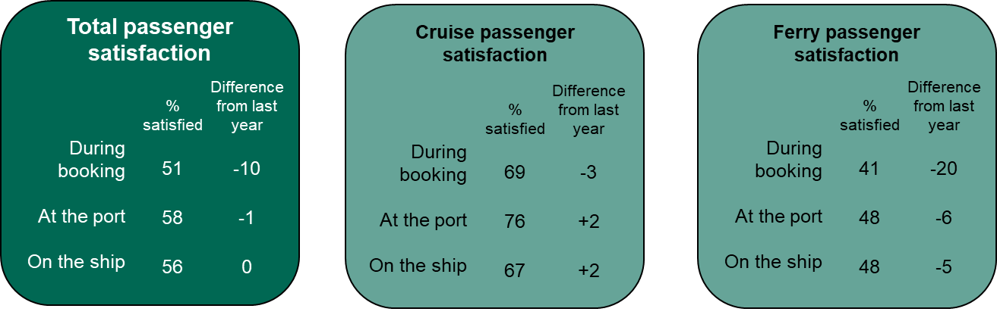

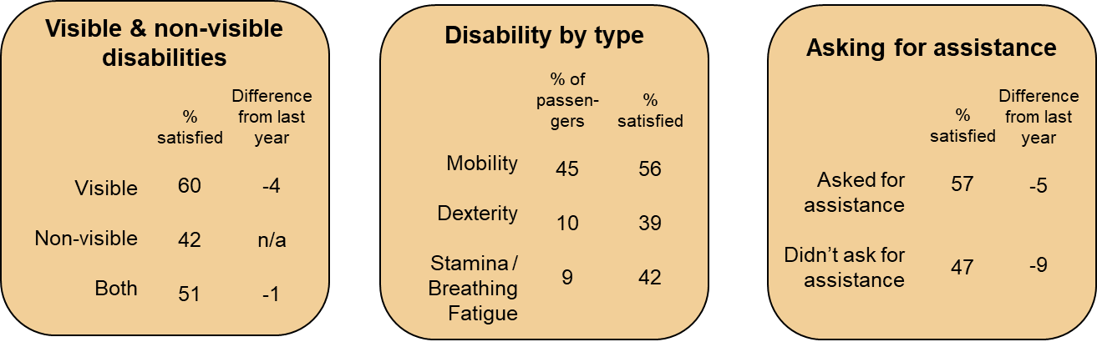

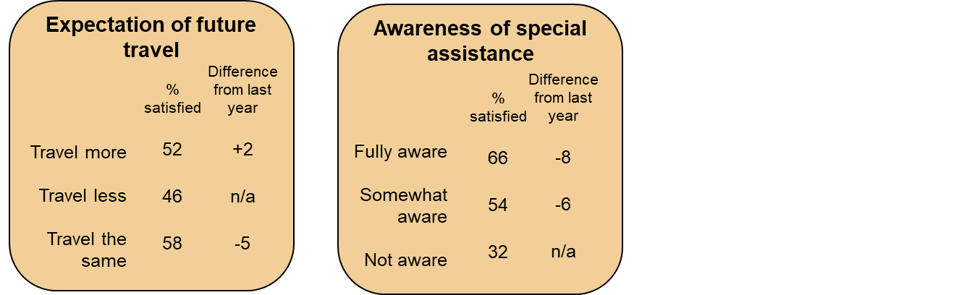
3. Detailed Analysis
3.1 Comparing satisfaction of those who travelled by cruise and ferry
Overall (across the three measures: during booking, at the port & on the ship) – On average, 55% of disabled passengers who travelled on a cruise and/or ferry in 2019 were either very satisfied or satisfied. This was around four percentage points lower than 2018, mostly due to satisfaction during booking falling by 10 percentage points from 61% in 2018, to 51% in 2019. While satisfaction levels at the port and on the ship remained relatively stable compared to the previous year.
In 2019, like 2018, disabled passengers that travelled on a cruise expressed the highest levels of satisfaction – on average 71% were either very satisfied or satisfied with their experience during booking, at the port & on the ship. Those who travelled only by ferry in 2019 showed lower levels of satisfaction, averaging 46% in 2019, around 10 percentage points down from 2018, again largely driven by falls in satisfaction during booking. Individuals travelling on both a ferry and a cruise in the last 12 months expressed similar satisfaction levels to those travelling by ferry only – average of 42%.

Chart 1: Total cruise and ferry (Number of observations for each question in parentheses)
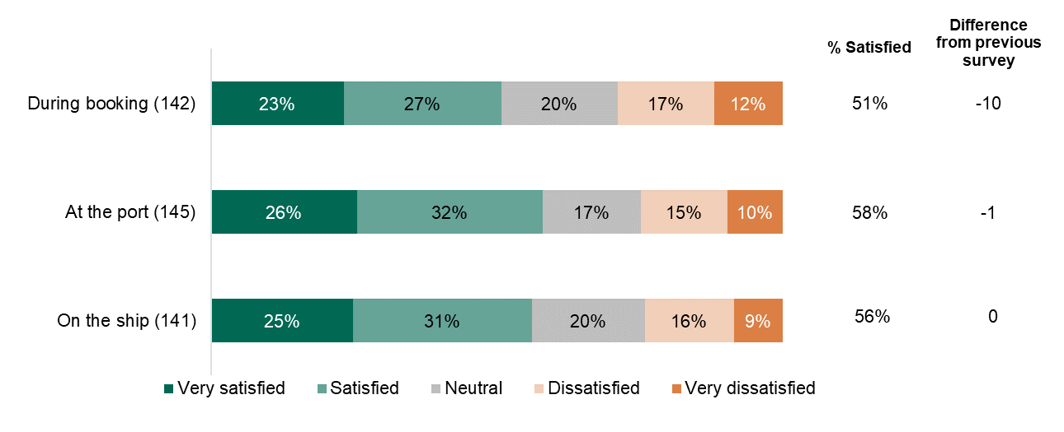

Chart 2: Cruise only (Number of observations for each question in parentheses)
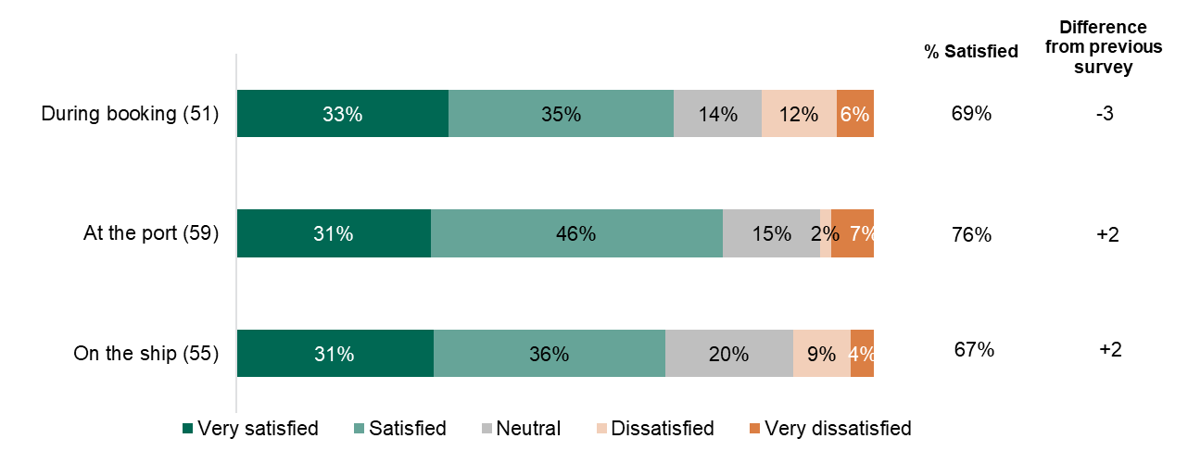
Chart 3: Ferry only (Number of observations for each question in parentheses)
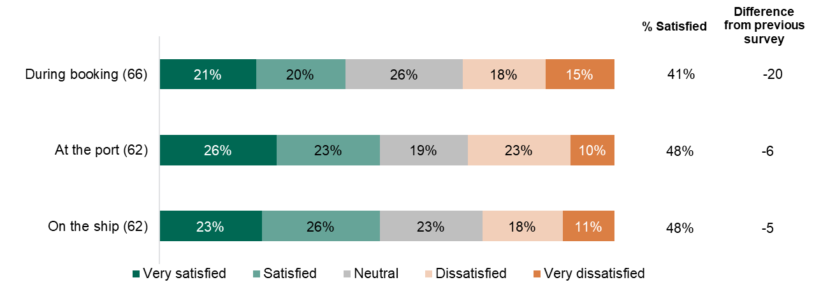
Chart 4: Both cruise and ferry (Number of observations for each question in parentheses)
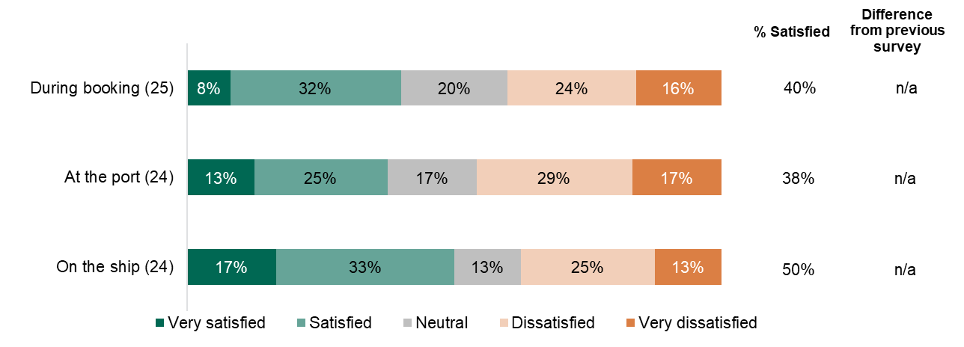

3.2 Comparing satisfaction of those with visible and non-visible disabilities
Overall – Passengers with a visible disability were the most satisfied with 60%, on average, being either satisfied or very satisfied: during booking (57%), at the port (63%) and on the ship (62%). This satisfaction level is however four percentage points down from 2018.
Passengers with a non-visible disability had a lower average rating of satisfaction at 42% in 2019. Breaking down the satisfaction levels across all three measures: 38% during booking, 43% at the port, and 45% on the ship.
Passengers with both a visible and a non-visible disability expressed an average satisfaction of 51% in 2019, similar to the 52% expressed in 2018. This was broken down in satisfaction levels of: 48% during booking, 57% at the port, and 49% on the ship.

Overall visible and non-visible disability trends:
Chart 5: During booking (Number of observations for each question in parentheses)
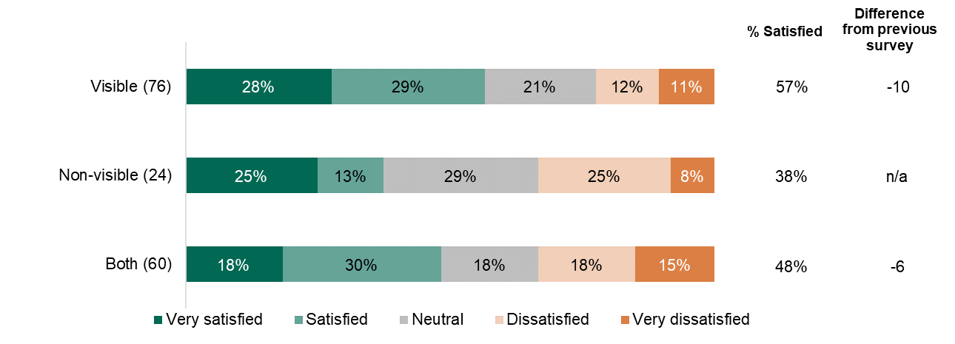
Chart 6: At the port (Number of observations for each question in parentheses)
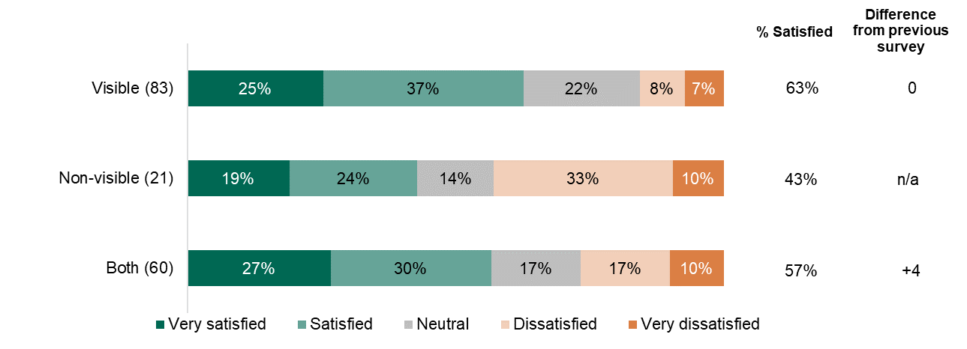

Chart 7: On the ship (Number of observations for each question in parentheses)
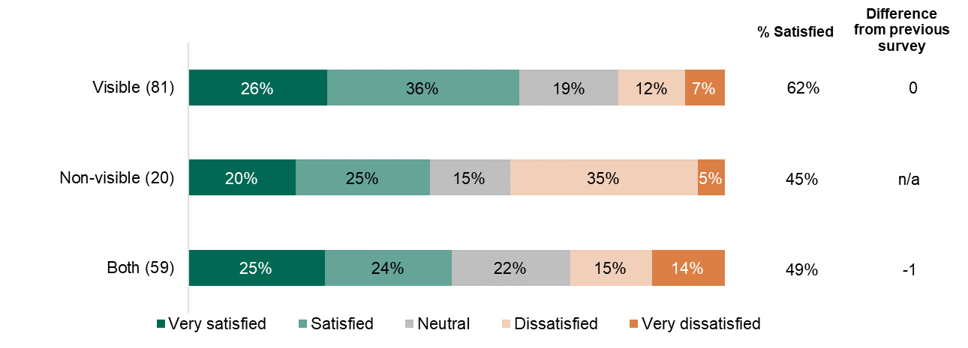

3.3 Comparing satisfaction levels between different disabilities
Overall – on average, satisfaction levels for passengers with different disabilities ranged from 20 to 66% in 2019. The highest satisfaction levels across the three criteria were for individuals with hearing disability (66%), followed by mobility and vision disabilities, at 56% and 54% satisfaction levels respectively. The lowest satisfaction levels were seen among passengers with social & behavioural disabilities (20%), followed by passengers with learning disabilities (24%).
Passengers with a mobility disability were by far the largest group to take the survey. For this group 60% were either very satisfied or satisfied with their experience at the port, up three percentage points from 2018; 58% were satisfied on the ship, the same as in 2018. Meanwhile 52% were satisfied during booking, representing a nine percentage point fall compared with 2018.

Overall trends of satisfaction level by different disabilities:
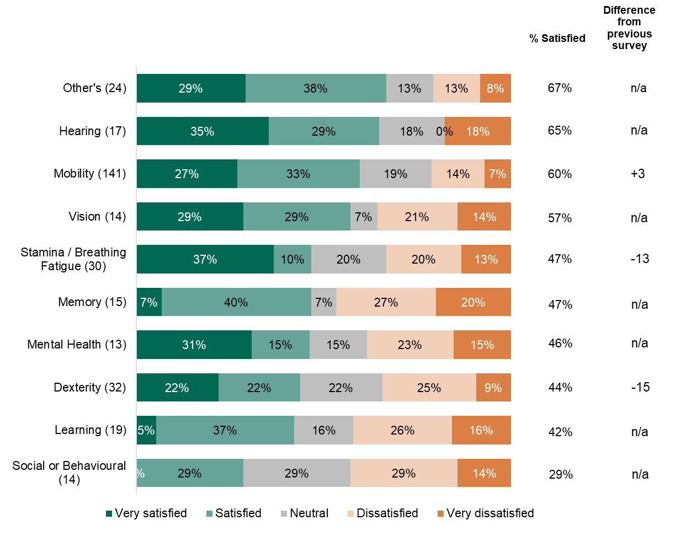
Chart 8: During booking (Number of observations for each question in parentheses)

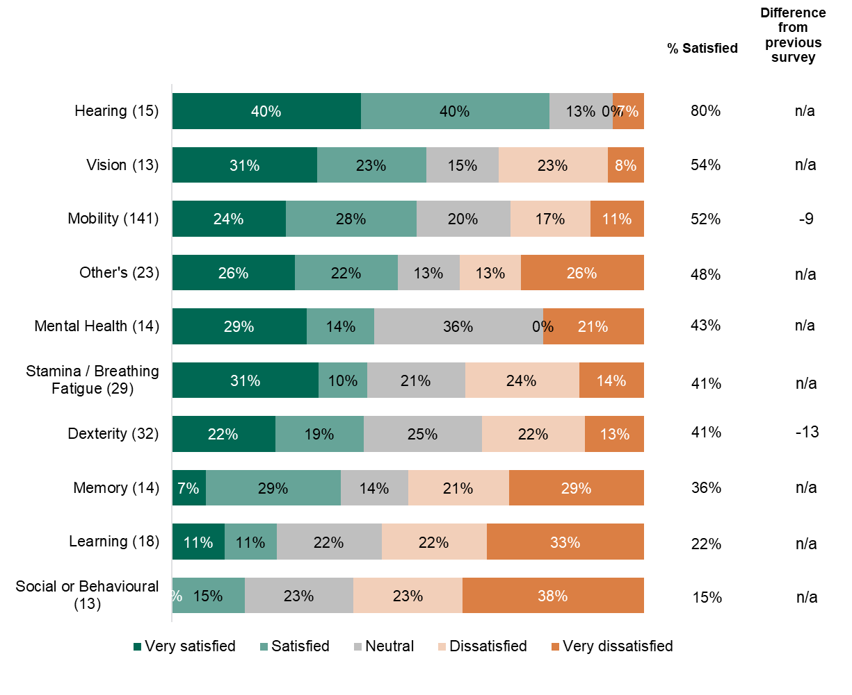
Chart 9: At the port (Number of observations for each question in parentheses)

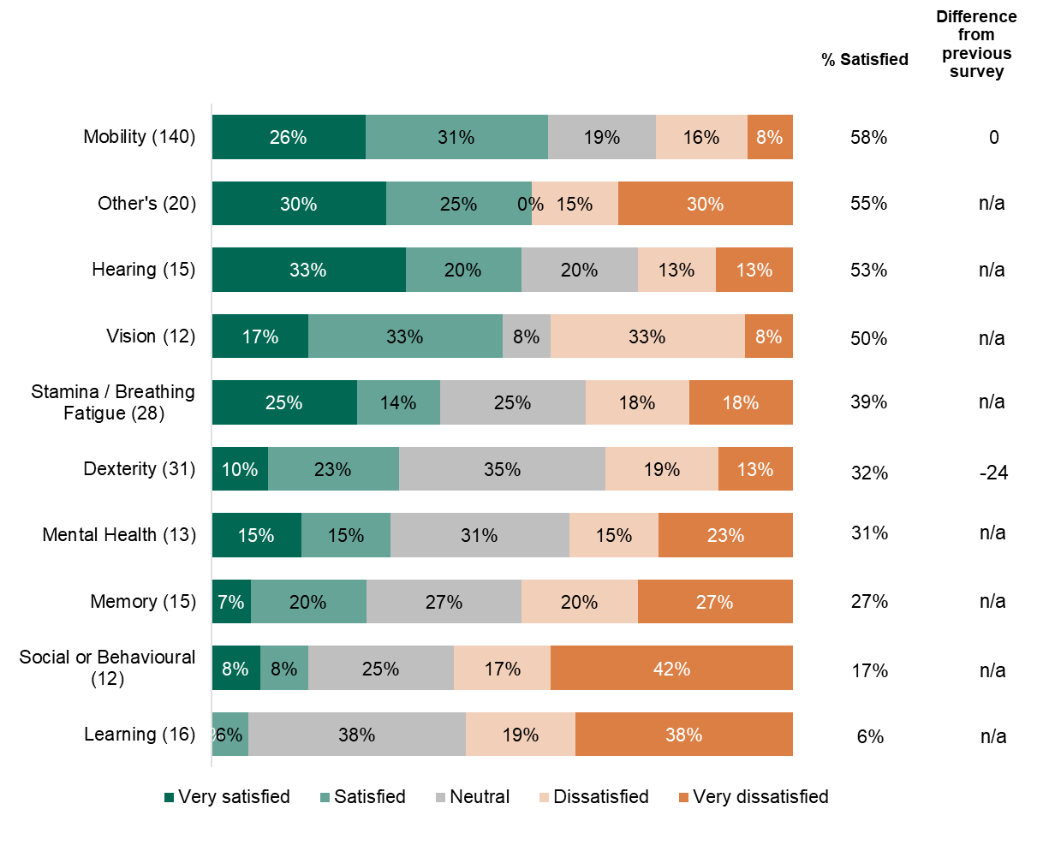
Chart 10: On the ship (Number of observations for each question in parentheses)

3.4 Comparing satisfaction of those who asked for assistance and those who didn’t
Overall – on average 57% of passengers who requested assistance were either very satisfied or satisfied during the three criteria tested in 2019. The average satisfaction levels were lower, at 47%, for those who didn’t request assistance. However, for those who requested assistance there was a five percentage point fall in satisfaction compared to 2018.
Passengers who had requested assistance during booking were about as satisfied as those who did not ask for assistance, at 50% and 51% satisfaction levels respectively. However, of these, 28% of those requesting assistance reported they were very satisfied, while this represented only 10% of passengers who didn’t request assistance. When comparing passenger satisfaction levels with 2018, there was a 13 percentage point fall in 2019.
Meanwhile, passengers who had requested assistance at the port and on the ship were generally more satisfied with their experience, with 60% expressing being either very satisfied or satisfied in both cases. This is similar to satisfaction levels in 2018. However, passengers who had not requested assistance on the ship showed the lowest satisfaction levels at 38%.

Overall trends of satisfaction level by passengers who requested assistance compared to who did not:
Chart 11: During booking (Number of observations for each question in parentheses)
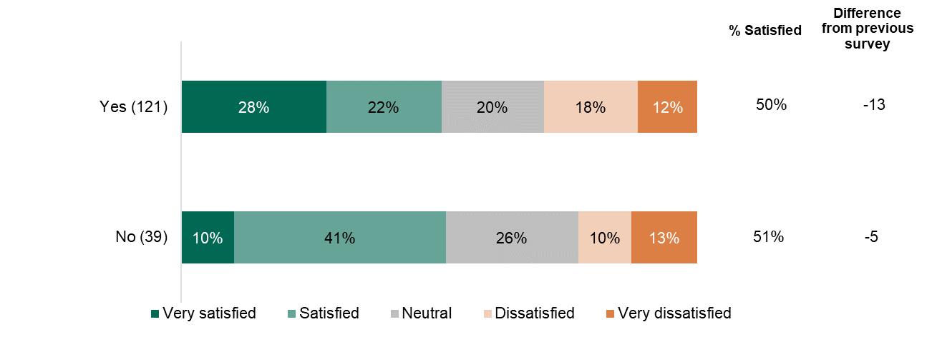

Chart 12: At the port (Number of observations for each question in parentheses)
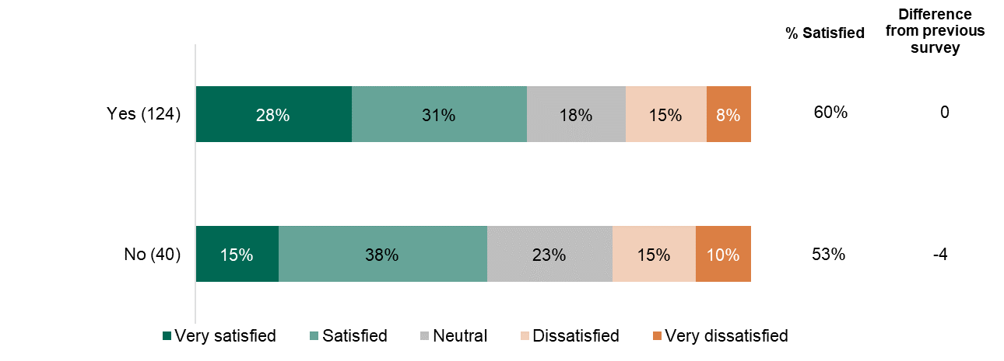

Chart 13: On the ship (Number of observations for each question in parentheses)
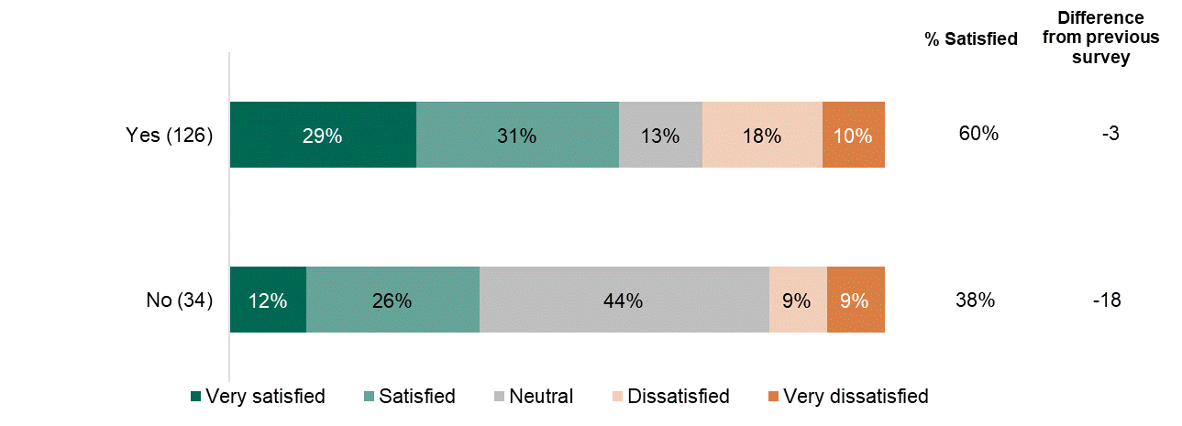

3.5 Satisfaction bearings on passengers’ expectation of future travel (i.e. the next 12 months)
Overall – on average, disabled passengers who expected to travel the same amount in the next 12 months expressed the highest satisfaction level of 58% in 2019, this compared with 52% satisfaction for those expecting to travel more, and 46% for those expecting to travel less. Following the high-level trend, the overall satisfaction level for passengers travelling the same amount was down five percentage points since 2018.
The group expecting to travel the same over the next 12 months expressed their highest satisfaction at the port (62%), almost identical to 2018, while 59% were satisfied on the ship, down three percentage points since 2018, and 54% satisfied during booking, down 11 percentage points.
For passengers expecting to travel more during the next 12 months, satisfaction levels were broadly similar across the three categories, expressing satisfaction levels of: 51% during booking, 53% at the port, and 50% on the ship.
For passengers expecting to travel less during the next 12 months, satisfaction levels were broadly similar to those expecting to travel more when at the port (50%), and on the ship (48%). However, during booking showed lower levels of satisfaction at 39%. Therefore, the decision to travel less may be related to the lower satisfaction levels during booking.

Overall trends of satisfaction bearings on passenger’s expectation of future travel:
Chart 14: During booking (Number of observations for each question in parentheses)
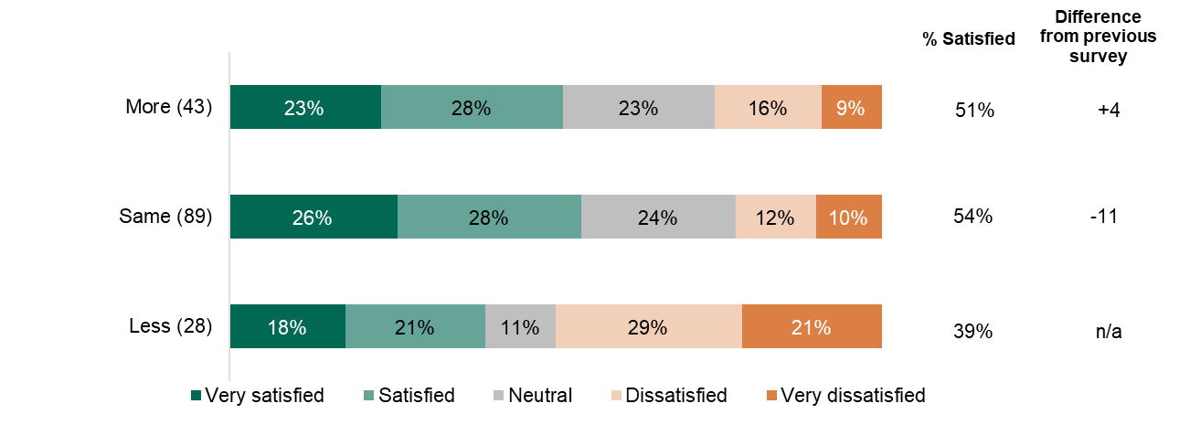

Chart 15: At the port (Number of observations for each question in parentheses)
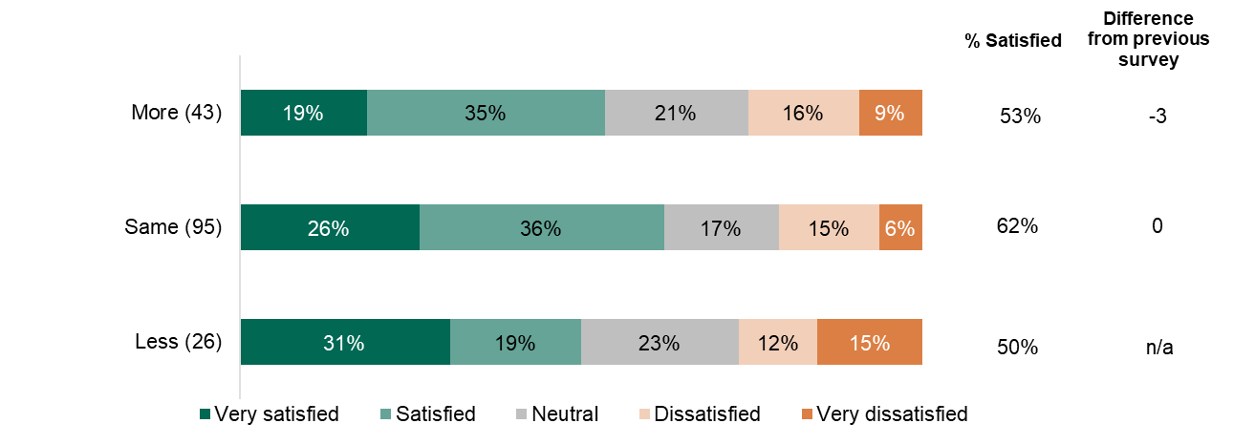
Chart 16: On the ship (Number of observations for each question in parentheses)
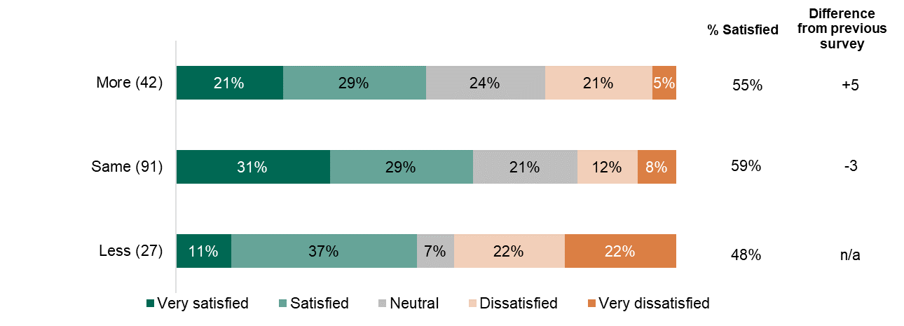

3.6 Passenger awareness of specialist assistance available to disabled and reduced mobility passengers in ports and on-board ships
Overall – on average, disabled passengers who were fully aware specialist assistance were the most satisfied with their experience, with 66% expressing being very satisfied or satisfied. This compares with 54% satisfaction for those who were somewhat aware, and 32% satisfaction for those who were not at all aware of the specialist assistance available.
For those who were fully aware of the specialist assistance available, their highest satisfaction was at the port (76%), followed by on the ship (68%). However, their satisfaction during booking was lower, at 53%, which is similar to the satisfaction of the group which were somewhat aware of the assistance (52%).
In contrast, for those who were not at all aware of the assistance available, they were consistently less satisfied compared with other groups, expressing satisfaction levels of: 36% during booking and at the port, and 25% on the ship. Passengers who were not sure about specialist assistance available reported 64% satisfaction, however only 15 passengers responded this answer, making the percentage more susceptible to skew from a few individuals.

Overall trends of satisfaction by passenger’s awareness of specialist assistance availability:
Chart 17: During booking (Number of observations for each question in parentheses)
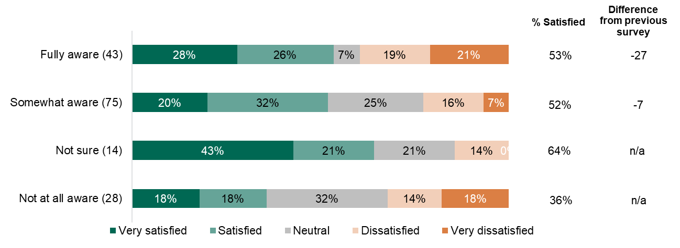

Chart 18: At the port (Number of observations for each question in parentheses)
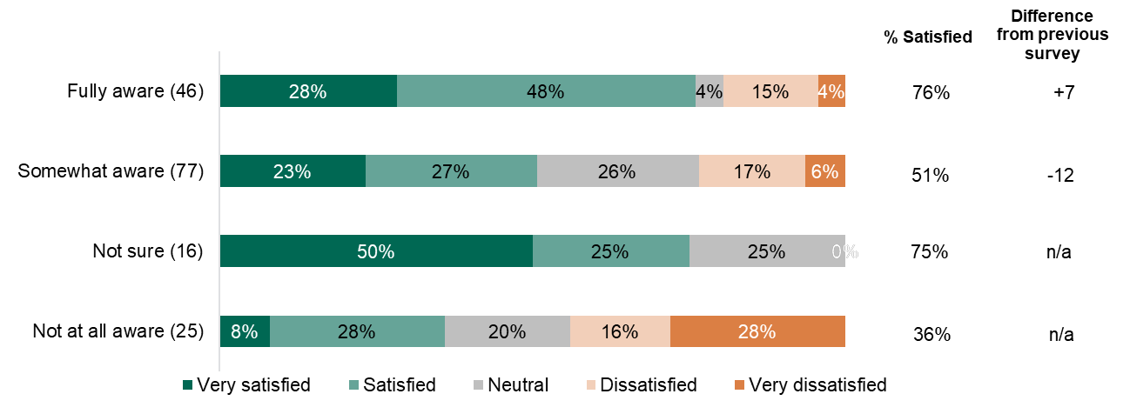

Chart 19: On the ship (Number of observations for each question in parentheses)
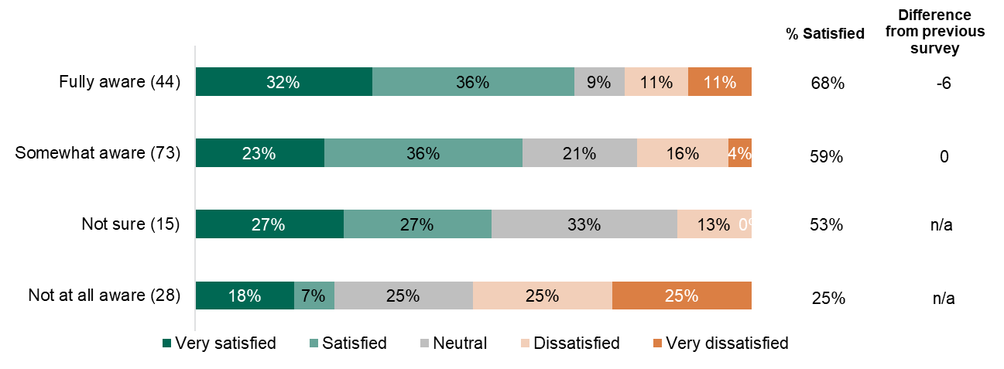

4. Next steps

- It has been agreed between DfT and the MCA to run the Disabled Passenger Satisfaction Survey annually, this will enable us to plan and target future port and vessel inspections to help us understand good and bad experiences faced by passengers.
- Identified areas of concerns from the survey will be targeted during futures passenger rights inspections.
- It has been decided that the same questions will be used year on year to ensure consistency. Additional questions may be added to improve the information gathered. Identify improvements in passenger satisfaction. Identify continual areas of dissatisfaction. Use survey results to plan, inform and target future inspections.
- The MCA plan to participate in Passenger Rights inspections of the top 10 ferry routes and ports every year; however due to the current COVID-19 situation it has not been possible in 2020. This will resume in 2021.
- We will look to target ferry passengers ahead of cruise passengers due to levels of satisfaction identified, but we will maintain awareness of any cruise operator issues,
- We will continue to raise awareness of hidden disabilities with operators, encourage promotion of accessibility information and the publishing passenger rights information on operator websites.
- We need to identify ways to increase passenger awareness of assistance available. We do this by working closely with operators and discussing the need to publish and inform passengers of what assistance is available.
- We will arrange passenger experience visits with disability support groups. This will enable the MCA to identify concerns and issues faced by passengers with a disability.
- Analysis of survey identifies more needs to be done to raise awareness of passenger rights, the MCA will work with DfT Accessibility team to promote passenger rights and how to raise concerns/complaints.
- Due to the current COVID-19 situation it has been decide by DfT and the MCA that a 2020 Disabled Passenger Satisfaction Survey will not take place as few people have travelled. The next Disabled Passenger Satisfaction Survey will be in 2021 but will be confirmed later in the year.

