Rt Hon Oliver Dowden CBE MP
Secretary of State for Digital, Culture, Media and Sport
4th Floor
100 Parliament Street
London SW1A 2BQ
www.gov.uk/dcms
enquiries@dcms.gov.uk
INT2020/19838/DC
22 September 2020
Dear Colleagues,

RE: HM GOVERNMENT POSITION ON CONTESTED HERITAGE

You will recall my earlier letter setting out Government policy regarding contested heritage and the removal of historical objects. I am grateful to those of you who have been in touch with me and my officials since. This clearly remains a live issue, so I wanted to take the opportunity to provide further support by way of restating the Government’s position and inviting you to engage with DCMS on what this means in the context of your organisation.

Government Position

History is ridden with moral complexity. Statues and other historical objects were created by generations with different perspectives and understandings of right and wrong. Some represent figures who have said or done things which we may find deeply offensive and would not defend today. But though we may now disagree with those who created them or who they represent, they play an important role in teaching us about our past, with all its faults.

It is for this reason that the Government does not support the removal of statues or other similar objects. Historic England, as the Government’s adviser on the historic environment, have said that removing difficult and contentious parts of it risks harming our understanding of our collective past. Rather than erasing these objects, we should seek to contextualise or reinterpret them in a way that enables the public to learn about them in their entirety, however challenging this may be. Our aim should be to use them to educate people about all aspects of Britain’s complex past, both good and bad.

As set out in your Management Agreements, I would expect Arm’s Length Bodies’ approach to issues of contested heritage to be consistent with the Government’s position. Further, as publicly funded bodies, you should not be taking actions motivated by
activism or politics. The significant support that you receive from the taxpayer is an acknowledgement of the important cultural role you play for the entire country. It is imperative that you continue to act impartially, in line with your publicly funded status, and not in a way that brings this into question. This is especially important as we enter a challenging Comprehensive Spending Review, in which all government spending will rightly be scrutinised.

Next Steps

I recognise that this is a difficult subject, and one that can attract a great deal of intense feeling - from a variety of perspectives - among employees of your organisations, stakeholders and the public at large. We want to help. As such, I will shortly be inviting you to an online roundtable, which will provide an opportunity for an open discussion about the government position, the practical implications in your context, and how we can best collaborate going forward.

In the meantime, DCMS would like to develop a more complete understanding of the work you are undertaking, or considering, in this space. To that end, your Sponsors will be in touch with a short questionnaire designed to help inform our overview of this policy issue. This is in addition to the existing request that you continue to notify the department in advance of any actions or public statements in relation to contested heritage or histories.

Thank you once again for your engagement on this important matter; I look forward to hearing from you.

Yours sincerely,
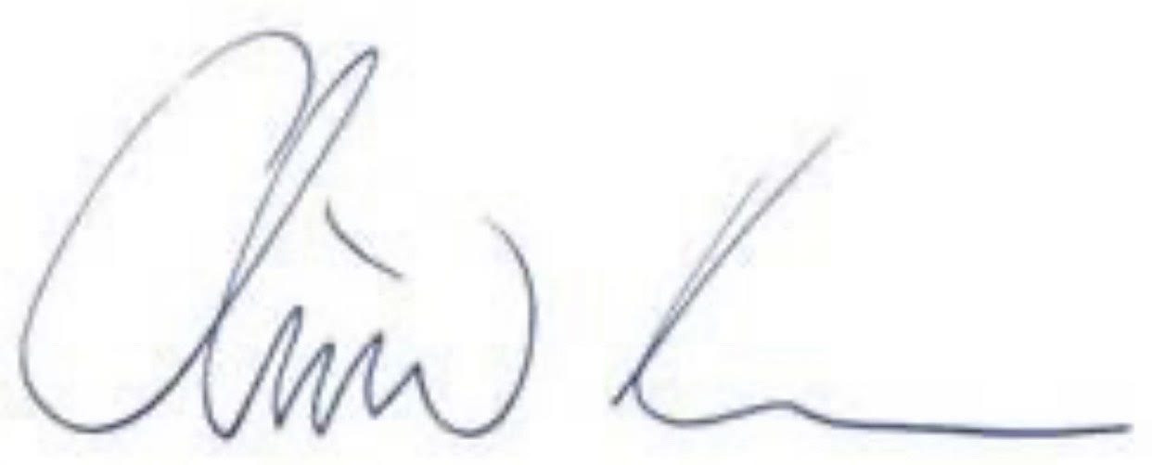
Rt Hon Oliver Dowden CBE MP
Secretary of State for Digital, Culture, Media and Sport

