Social Value in Government Procurement: Consultation Response Paper
A summary of responses to the consultation on how Government should take account of social value in the award of central Government contracts
A consultation response paper produced by the Cabinet Office
This consultation opened on 11 March and closed on 10 June 2019
It is also available at www.gov.uk/Government/publications

© Crown copyright 2020  This publication is licensed under the terms of the Open Government Licence v3.0 except where otherwise stated.  To view this licence, visit nationalarchives.gov.uk/doc/open-Government-licence/version/3 or write to the Information Policy Team, The National Archives, Kew, London TW9 4DU, or email: psi@nationalarchives.gsi.gov.uk.  Where we have identified any third party copyright information you will need to obtain permission from the copyright holders concerned. |  | Any enquiries regarding this publication should be sent to us at Domestic-policy-queries@cabinetoffice.gov.uk.  This publication is available at www.gov.uk/Government/publications  Printed on paper containing 75% recycled fibre content minimum.

Introduction
The Public Services (Social Value) Act 2012 already places a requirement on relevant contracting authorities to consider, in respect of procurement for services (a) how the economic, environmental and social well-being of the relevant area may be improved by what is being procured and (b) how, in conducting the procurement, they might act with a view to securing that improvement. Contracting authorities must also consider whether to consult the market on these issues before the procurement process starts.

On 11 March 2019, the Cabinet Office published a consultation on the Government’s proposed model for evaluating and reporting social value in the award of central Government contracts. This new approach would require central Government departments to take account of social impact as part of the award criteria, where the social impact is linked to the subject-matter of the contract and proportionate to what is being procured. Procuring authorities would have the freedom to choose which of the themes and policy outcomes they apply in each procurement.

The consultation closed on 10 June. During this period, Ministers and officials from the Cabinet Office and the Department for Digital, Culture, Media and Sport (DCMS) held a series of discussions with stakeholders on the proposals. 245 submissions to the consultation were received from a range of respondents (see Figure 1 below). Publication of the Government’s response to the consultation and implementation of the new approach has been delayed by the coronavirus (COVID-19) outbreak.

The Government is committed to using its purchasing power to help communities and businesses recover from COVID-19. Central Government will, in future, take better account of the additional social benefits that can be achieved in the delivery of its contracts. This will level the playing field for all types of businesses including small businesses, voluntary and community sector organisations and social enterprises, encouraging employment opportunities, developing skills, tackling inequality and improving supply chain resilience.
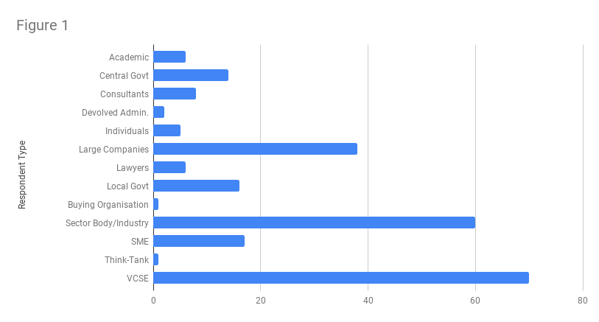

Analysis of submissions and Government response
Question 1: Do you agree with the proposed policy metrics in the model in the attached annex? Do you have examples of such metrics being successfully used in public procurement?

77% of respondents were supportive of the policy metrics in the model.

Themes arising from the feedback from respondents can be summarised as follows: -
  - further clarify needed on how qualitative criteria will be used for evaluation of the metrics within the model; there were also requests for additional detail around some of the metrics, and for definitions to be provided where terminology may not be widely known or understood;
  - highlighted the importance of training for commercial teams to ensure successful implementation of the model, and that effective pre-market engagement and contract management will both be fundamental to the successful implementation of the new approach.
  - suggested the proposed metrics could be more outcomes-based, i.e. focussed on on the delivery of outcomes rather than outputs, and suggested some examples of how this might be achieved;
  - suggested the model could be clearer on the treatment of inherent social value (i.e. where the outcome is core to the delivery of the contract) versus added social value (i.e. created in addition to the core requirements of the contract);
  - suggested the model did not adequately distinguish between social value and corporate social responsibility and went beyond the Social Value Act concept of social value by including wider policy objectives.

15% of respondents did not support the proposed metrics:
  - the approach lacked ambition and the metrics were too restrictive; bidders should be able to offer their own outputs in tenders rather than a specific list;
  - the use of financial proxies in addition or instead of the proposed qualitative methodology
  - they preferred another model to be used, for example the National TOMs Framework.

8% of respondents did not provide an answer to this question.

Government response

Given the majority support for the proposed metrics, Government has further developed the model on the basis of these metrics but to also reflect the Government’s priorities following the COVID-19 outbreak. In setting out how the model will operate in practice, Government will provide further guidance on:
- how the evaluation methodology should operate, with responses being scored on qualitative social value criteria with standard scoring methodologies (in the same way that other ‘quality’ questions are treated in a tender);
- more detail on each metric; examples of when they would be relevant and how they should be used by departments to performance manage suppliers in delivery of social value throughout the contract;
- how to differentiate between inherent social value (i.e. where the outcome is core to the delivery of the contract) versus added social value (i.e. created in addition to the core requirements of the contract).

The Government does not intend to implement a financial metrics-based approach to the evaluation of social value. Government will, however, continue to engage with providers of social value measurement and consider the outcomes of pilots being conducted by the National Social Value Task Force and others.

Government agrees that training for commercial teams, effective pre-market engagement and contract management will be critical to ensure successful implementation of the model and further details are set out later.

Question 2: Do you agree that the proposed minimum 10% weighting for evaluating social value in the bid is appropriate?

62% of respondents were supportive or broadly supportive of the proposed minimum 10% weighting.

22% did not agree that the proposed minimum 10% weighting was appropriate:
- a 10% weighting would not give sufficient importance to social value in the overall evaluation and therefore would not incentivise bidders to provide good quality responses
- the weighting should be flexible, (i.e. that it should be permissible to fall above or below 10%) dependent on the subject matter of the contract and market maturity and conditions.

16% of respondents did not provide an answer to this question.

Government response

Given that that the majority of respondents were broadly in favour of the proposed minimum 10% weighting, Government intends to adopt this in the guidance.

Government will make clear through guidance:
- when it might be appropriate to use a higher weighting for the social value element of a bid and how to determine the upper limit;
- the difference that may be achieved by social value being treated as a standalone aspect of the overall score, or by social value being part of the quality score;
- when it might be appropriate to set a minimum requirement for social value such that failure to achieve that score results in a “fail”.
- How social value weightings may be applied under framework agreements, i.e. at procurement of the framework agreement and then at call-off stage.

Question 3: Does the proposed approach risk creating any barriers to particular sizes or types of bidders, including SMEs or VCSEs? How might these risks be mitigated?

28% of respondents were supportive of the proposed approach.

46% of respondents (10% of whom were SMEs or VCSEs) highlighted risks including:
- capacity to manage, measure and report on social value;
- wider concerns around the ability to bid for Government contracts.

A number of respondents suggested potential ways to mitigate these risks:
- effective pre-procurement engagement with the market;
- effective contract management;
- guidance on consortia bidding and how to engage with mutuals and charities.

26% of respondents did not provide an answer to this question.

Government response

Encouraging more diverse supply chains, including SMEs and VCSEs, is a fundamental driver of the Government’s approach to social value and is reflected in the Government’s recently published update to the Outsourcing Playbook. The Government has worked closely with representatives of the SME and VCSE communities to develop the qualitative approach to evaluation reflected in the new model. However, the Government recognises the concerns of respondents from these communities.

Therefore the Government will mitigate these risks through a comprehensive training programme and publishing guidance on:
- ensuring a consistent approach is taken throughout central Government procurement;
- evaluating the qualitative nature of social value responses, rather than evaluating purely on volume or quantity.
- ensuring metrics are clearly linked to bidders’ proposals for the particular contract rather than general corporate policies.
- structuring procurements to enable consortia bidding and how to engage with mutuals and charities.

Question 4: How can we ensure Government’s existing procurement policy mandates (for example on levelling the playing field for SMEs) take precedence in designing the procurement?

Of the 49% who responded to this question, a significant number believed that by driving social value in procurement, the Government would in fact be better able to meet existing procurement policy mandates. Respondents also suggested that effective pre-procurement engagement and clear guidance for commissioners and suppliers would support the alignment of relevant policy priorities through the procurement.

51% of respondents did not provide an answer to this question.

Government response

The Government recognises that good quality pre-procurement engagement and planning will lead to more effective alignment and delivery of policy priorities and will make this clear in the guidance and training programme.

Next steps
Cabinet Office and DCMS officials are working with the Crown Representatives for VCSEs and Small Business to review implementation plans and the Government has already taken action to address the issues identified during the consultation, including:

- publishing guidance for VCSEs looking to contract with central and local Government;
- piloting the proposed social value model across a range of central Government procurements and departments;
- developing material to support the supply market to bid for Government contracts, in conjunction with a range of sector bodies;
- enhanced opportunities to deliver social value through the commercial agreements for common goods and services provided by the Crown Commercial Service.

Government recognises that many of the consultation submissions argued that effective training and guidance would be critical to successful implementation of the new model. Officials are developing a capability programme that will include:

- e-learning training for 4,000 commercial buyers on the new approach to raise awareness of social value and to introduce the new model;
- training for departments, delivered via workshops and webinars, to work through the practical application of the model, using case studies;
- publishing guidance for commercial teams, aligned with the updated Outsourcing Playbook, which will be made available on GOV.UK;
- publishing guidance for suppliers and a programme of engagement with sector bodies on supplier readiness, with material they can use to train their members;
- publishing case studies to share lessons-learned, drive best practice and support continuous improvement;
- continuing to engage on social value evaluation and reporting with the devolved administrations, local government and the National Social Value Task Force.

Whilst the overarching objective for the Government’s commercial activities will remain achieving the best commercial outcome, it is right that Government applies its commissioning to supporting key social outcomes. The public sector must maximise social value effectively and comprehensively through its procurement. It cannot afford not to; a missed opportunity to deliver social value is a cost that has to be absorbed elsewhere in public services.

The new model will apply tests that all bidders, irrespective of their size and type, should be capable of meeting. Our proposed approach will further level the playing field for the UK’s small businesses, voluntary and community sector organisations and social enterprises - they are closest to our communities and will often be well placed to deliver social value through the contract.

