Redundancy Payments Service ‘RP14 & RP14A Upload Instructions’ (using insolvency practitioner software)

Contents
1. An overview of the process for submitting RP14 and RP14A information to the Redundancy Payments Service (RPS) Case Management System (CMS) using an insolvency practitioners (IP) internal case management system (where the capability exists).
2. Uploading the XML file through the insolvency practitioner (IP) upload service.
3. Troubleshooting.

Context
- these instructions are for uploading forms RP14 & RP14A through the IP case management system
- these instructions do not cover uploading of forms RP14 and RP14A using the official RP14 / RP14A templates
- there are separate instructions and guidance regarding the uploading of forms RP14 & RP14A using the official templates

Process Overview
Submitting RP14 & RP14A forms electronically via IP software is a 3 step process.
1. Enter the data in to your case management system.
2. Export the data into XML format.
3. Upload the exported XML file to the RPS using the online portal.
Uploading an RP14 / RP14A XML file to the RPS through the new upload portal
- go to the new IP upload service web site:
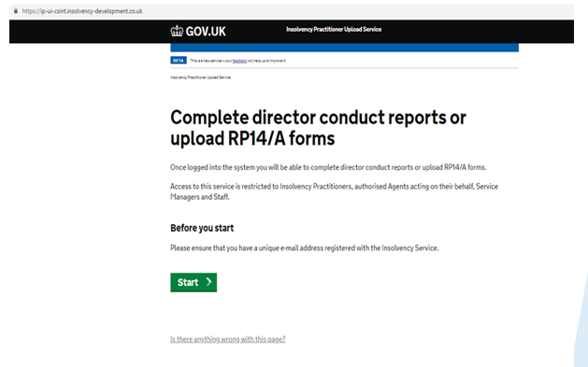

- log on to the IP upload service

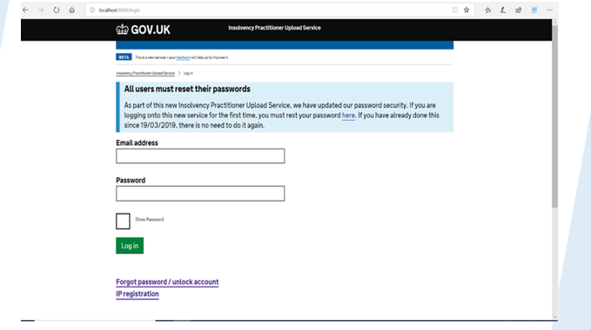
- all current users of the Director Conduct Reporting Service (DCRS) - IP’s, their service managers and staff - will have to reset their passwords when attempting to log onto the new IP upload service for the first time
- agents of IP’s appointed to deal with employment matters, including RPS claim submissions will be set up and provided with log on credentials by the RPS
- all users, including IP’s, service managers and staff will be able to upload RP14 / RP14A’s
- IP’s and service managers can add new users to upload RP14 / RP14A’s, in the same way as on the DCRS service
- agents who require set up please email RPS

User permissions
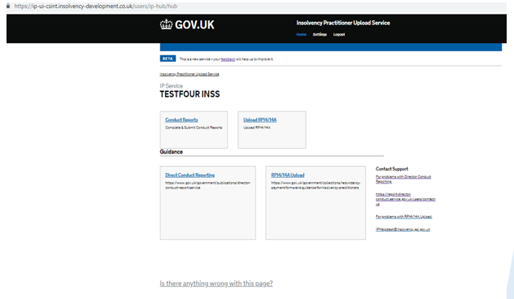

- all users will be able to see both the ‘DCRS’ and ‘Upload RP14 / RP14A’ options
- all users will be able to upload RP14 / RP14A’s
- only IP’s, their service managers and their allocated staff will be able to see any content on the DCRS function
- The DCRS service will continue to operate as usual

Uploading an XML file to the RPS
- to proceed to upload an RP14 / RP14A XML file, you will need to accept the declaration
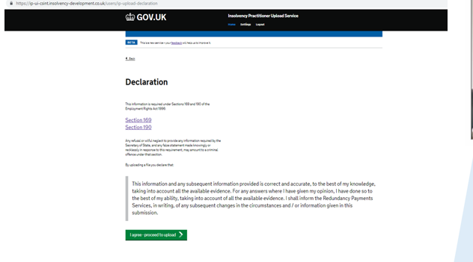
- you will move to the upload page. Click on choose file and select the file you wish to upload
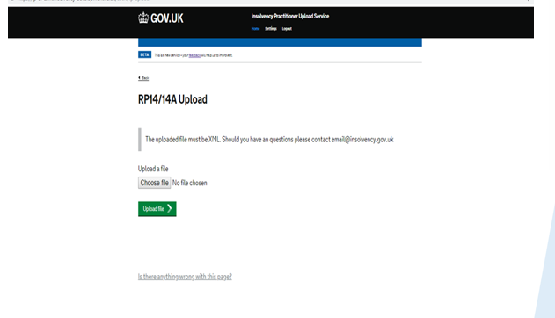
- when you have successfully uploaded the XML, you will see a message saying, ‘upload complete’

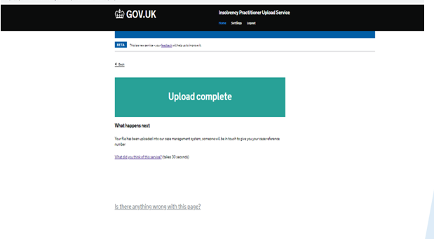
- if your upload was unsuccessful, you will see an error message
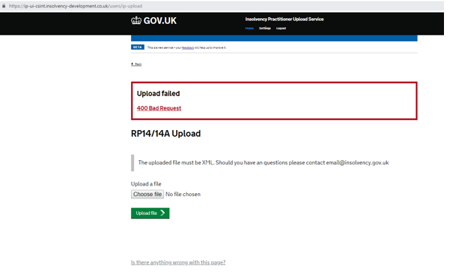

When uploading an RP14 XML, you must include:
- the name of the business
- the pay records contact
- the IP contact details
Failure to do so will mean your XML will NOT upload.
The e-mail address you provide for the IP contact details will be used to issue copies of the redacted RP1’s.
The provided e-mail address can be for a generic inbox.
Uploading an XML file to the RPS (entering the National Insurance number)
When uploading an RP14A XML, you must include:
- a validly formatted National Insurance number
- the RPS ‘CN’ case reference number
Do NOT include more than two decimal points in any entry.
Failure to do so will mean your XML will NOT upload.
- you can find guidance on how to input National Insurance Number formats
- you can find further information about why the XML has failed to upload and the types of error messages in our FAQ’s
- if you have any queries about the RP14 / RP14A upload, please email RPS

