virus operational response survey results
July 2020 data

6 August 2020
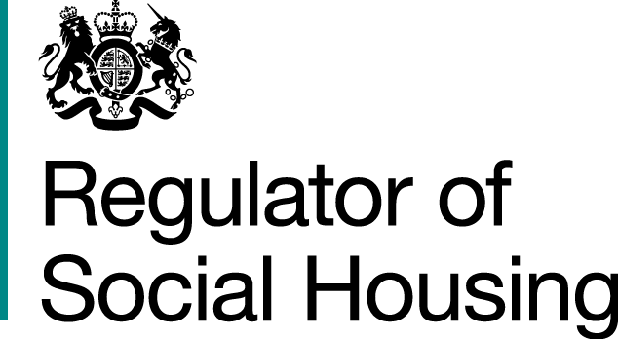


Results from the July survey
This is the summary from the fourth of our temporary monthly surveys to establish up-to-date information about how providers are coping with some of the current challenges they face as a result of the coronavirus pandemic.
These surveys are not regulatory returns. If a provider believes tenant safety is threatened or viability is under strain, they should not wait for the survey but should speak to their key contact at the regulator, or our Referrals and Regulatory Enquiries team, via enquiries@rsh.gov.uk or 0300 124 5225. Providers with fewer than 1,000 homes should use our dedicated email address SmallProviders@rsh.gov.uk.
The survey responses are shown below, and the survey questions are shown in full in Appendix 1.
Survey responses for June and July (as a % of total submissions)
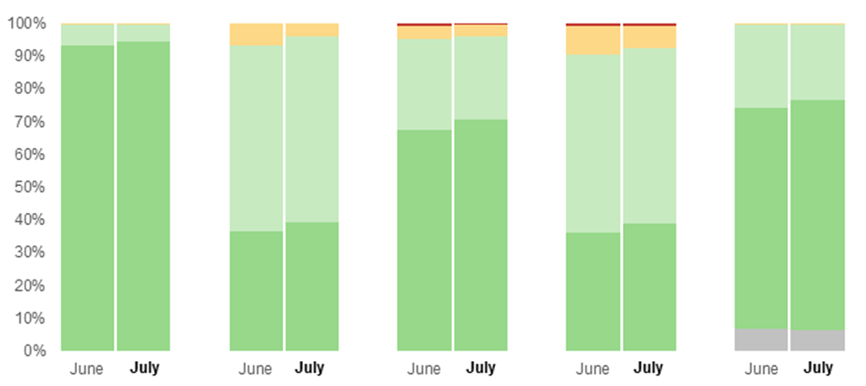
 | Emergency repairs | Gas compliance checks | Fire compliance checks | Asbestos, electrical, legionella and lift checks | Care and support staffing levels
Key
■  All complete OR maintaining safe staffing levels and essential service delivery |  | ■  Most complete without a material backlog developing OR maintaining safe staffing levels and essential service delivery  with some pressure | ■  Some complete  but a material backlog OR maintaining safe staffing levels and essential service delivery but at material risk of falling below safe levels | ■  Few or no complete and a material backlog OR not maintaining safe staffing levels and essential service delivery | ■  Not applicable - no care, supported or other accommodation for vulnerable people

The survey is hosted on our data collection portal NROSH+, for all private registered providers with 1,000 or more homes, local authority registered providers and some registered providers with fewer than 1,000 homes to complete. Providers were asked to submit survey responses covering the period up to and including 17 July, by Friday 24 July.
Providers’ written responses show that the delivery of services is stable, and that work towards addressing backlogs has started. The vast majority of providers are working through backlogs of non-emergency repairs in line with latest government guidance and generally report that backlogs are decreasing.
Most providers confirm that tenants’ repairs reporting is almost back to pre-Covid levels and that they are working through backlogs; some having resourced additional contractor services and supplies. Under current projections, providers widely anticipate that backlogs of non-emergency repairs will be addressed by the end of 2020 – for some providers by as early as September.
More providers have been able to complete all statutory gas safety checks in July than in June. Providers continue to report some challenges accessing properties, but the number of tenants refusing access is falling sharply. This is driving an improvement in gas safety check compliance.
On care and support, most providers are reporting no issues with staffing. Face-to-face support services are resuming, and communal areas are being reopened.
A small number of providers have reported impacts of localised lockdowns and others are reporting they are preparing for a potential second wave or for future local lockdowns, for example by increasing stocks of personal protective equipment (PPE) and other materials or carrying out health and safety checks (electrical, gas, fire risk assessments) earlier than scheduled.

Next steps
We will repeat this survey every month until at least December 2020, and we will publish our analysis of the responses shortly afterwards. The CORS survey will be launched in NROSH+ on the last Friday of each month, and the dates for submission are shown in the table below.
Data up to and including | Submission by
31 August | 7 September
30 September | 7 October
31 October | 6 November
30 November | 7 December

If providers believe tenant safety is threatened or viability is under strain, they should not wait for the survey but should speak to their key contact at the regulator, or our Referrals and Regulatory Enquiries team, via enquiries@rsh.gov.uk or 0300 124 5225. Providers with fewer than 1,000 homes should use our dedicated email address SmallProviders@rsh.gov.uk.

Appendix 1: About the coronavirus operational response survey and our analysis
We asked private registered providers with 1,000 or more homes, local authority social landlords and those providers with fewer than 1,000 homes which have a high proportion of supported accommodation to respond to the survey. The response rate was good (98%) and we are grateful to all the providers that responded. The information in this report is based on our initial analysis of registered providers’ survey responses.
The survey asks providers to answer a single multiple-choice question on each of five key areas. For each area it also asks them to identify any key constraints, risks and mitigating actions and the scale of any backlog and how this has changed since the previous survey.
1. Emergency repairs
- All complete
- Most complete without a material backlog developing
- Some complete but a material backlog
- Few or no complete and a material backlog.

- Statutory gas safety checks
- All complete
- Most complete without a material backlog developing
- Some complete but a material backlog
- Few or no complete and a material backlog.

- Statutory fire safety checks
- All complete
- Most complete without a material backlog developing
- Some complete but a material backlog
- Few or no complete and a material backlog.

- Asbestos, electrical, legionella and lift checks
- All complete
- Most complete without a material backlog developing
- Some complete but a material backlog
- Few or no complete and a material backlog.

- Care and support staffing levels
- Maintaining safe staffing levels and essential service delivery
- Maintaining safe staffing levels and essential service delivery with some pressure
- Maintaining safe staffing levels and essential service delivery but at material risk of falling below safe levels
- Not maintaining safe staffing levels and essential service delivery.


© RSH copyright 2020
This publication is licensed under the terms of the Open Government Licence v3.0 except where otherwise stated. To view this licence, visit nationalarchives.gov.uk/doc/open-government-licence/version/3
Where we have identified any third party copyright information you will need to obtain permission from the copyright holders concerned.
This publication is available at: www.gov.uk/rsh
Any enquiries regarding this publication should be sent to us via enquiries@rsh.gov.uk
or call 0300 124 5225.
or write to:
Regulator of Social Housing
1st floor – Lateral
8 City Walk
Leeds LS11 9AT

RSH regulates private registered providers of social housing to promote a viable, efficient and well-governed social housing sector able to deliver homes that meet a range of needs.

https://nroshplus.regulatorofsocialhousing.org.uk/

