Room G.07

Committee on Standards in Public Life

Committee on Standards in Public Life

Chair:
1 Horse Guards Road
London
SW1A 2HQ

Tel: 020 7271 2948

Email: public@public-standards.gov.uk

Rt Hon Robert Jenrick MP
Secretary of State
Ministry of Housing, Communities and Local Government
2 Marsham Street
London SW1P 4DF

6 July 2020

Dear Secretary of State,

The Committee on Standards in Public Life published in January 2019 its report on Local Government Ethical Standards. I wrote to Luke Hall MP, Minister for Local Government and Homelessness, in October last year asking when we might receive the government’s formal response (a copy of that letter is attached for ease of reference.) We have not received a reply to that letter to date.

I do of course understand the urgent priorities that local government is facing at the moment, and I don’t wish to put any additional burden on the Ministry. But, at this time of crisis, demonstrable high standards are as important as ever to help maintain trust between government and the public. With that in mind, it would be very helpful to know when we might receive the government's response to our report.

Yours sincerely

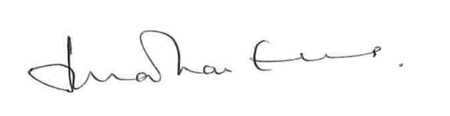

Lord (Jonathan) Evans, KCB, DL
Chairman, Committee on Standards in Public Life

