

**National Citizen Service 2018**

**Evaluation**

**Main report**

**Kantar: Bethany Dokal, Alice McGee, Emma McKay, Alice Fitzpatrick, Eleanor Hodgson, Peter Matthews, Thomas Nickson, Jodie Bates**

**London Economics: Joscelyn Miller, Gavan Conlon**

July 2020

Table of Contents

1. Executive Summary 3

2. Introduction and background 8

3. Methodology 11

4. Social cohesion 19

5. Social mobility 30

6. Social engagement 41

7. Wellbeing and loneliness 56

8. Participant experience 63

9. Value-for-money 72

10. Bibliography 88

Appendix 1: Full impact results 2018 91

Appendix 2: Distributions of 2018 mean score data 108

Appendix 3: Theory of change 120

Appendix 4: Methodological limitations 121

1. Executive Summary

**Introduction**

The National Citizen Service (NCS) is a government-backed initiative that brings together young people from different backgrounds, aged 16-17, to engage in a programme of activities encouraging personal, social and civic development. Over 100,000 young people took part in the programme during 2018.

NCS has an ambition to improve outcomes for young people; specifically related to **social mobility, engagement and cohesion.** This evaluation aims to measure the impacts on participants related to these key social outcomes outlined in the programme’s theory of change;[1] specifically, in relation to its summer and standard autumn programmes.[2]

The evaluation data was collected by Kantar through a **baseline and follow-up survey** with NCS participants, and a comparison group of young people. Using a comparison group enables better attribution of impact to the programme through an analysis approach called difference-in-difference (DiD)[3].

Separately, London Economics carried out a **value-for-money assessment** of the programme, to understand the social value of NCS in relation to those programme attributes to which a monetary value can be assigned. This involved two approaches; the first which looked at leadership, volunteering and higher education aspiration, and the second which looked at wellbeing.

The rest of this executive summary sets out the key insights from these impact and value for money analyses, structured according to NCS’s core ambitions. It also includes highlights from the self-reported questions about their own programme experience which were asked of participants in the follow-up survey.

**Social cohesion**

When it comes to social cohesion, there is a mixed picture with regards to the impact of the programme on the measures examined. The summer NCS programme has some positive impacts, but there is no statistically significant impact identified for autumn.

* The summer NCS programme has an impact of **+9pp** on participants **agreeing that their local area is a place where people from different backgrounds get on well together**.[4]
* Summer participants’ **comfort with a friend or relative going out with someone who is different to them,** or from a minority group**,** is impacted positively, for one measure, going out with someone who is disabled (**+0.4**).[5] There was no positive impact detected for autumn participants. These small or non-impacts may be explained by social desirability bias or the already high positive attitudes already recorded at the baseline among participants.
* Neither the summer nor autumn NCS programmes have significant impacts on participants’ **trust in others, their experiences (whether positive or negative) with people from the same or different ethnic backgrounds to them, or on the ethnic diversity of their friendship groups.** It is worth noting friendship groups of both participant and comparison groups have low levels of homogeneity from the outset and, existing literature suggests that over time everyday engagement with different groups may positively influence people’s trust in those around them.[6]
* The participant experience section of the survey suggests that the programme is helping to improve tolerance towards others. Over three quarters of summer (78%) and autumn (76%) NCS participants agree that following their NCS experience *‘I now feel more positive towards people from different backgrounds to myself’.*

**Social mobility**

When it comes to social mobility, NCS has a positive impact across almost all of the measures examined for summer, and several autumn ones too.

* **Making the most of opportunities:** The largest social mobility impacts relate to self-confidence. The summer NCS programme has a significant positive impact on all self-confidence measures, and the autumn NCS programme on nearly all (five out of the seven measures), including confidence in being the leader of a team (+18pp summer and +13pp autumn).
* The areas of **problem solving and decision-making and emotional regulation** and resilience are also positively impacted by both programmes. For instance, the summer NCS programme has a positive impact on all four problem-solving and decision-making measurements, but the autumn NCS programme has an impact on only one: participants’ enjoyment of finding new ways to do things (+6pp autumn and +10pp summer).
* **Broader social networks**: The summer NCS programme has a positive impact on most measures (four out of six) of team-working and social networking, including participants’ agreement that if they needed help there are people who would be there for them (+9pp). The autumn NCS programme has an impact on only one of six team-working and social networking measures: participants’ agreement that they get along with people easily (+7pp).
* **Awareness of and aspirations to future opportunities**: The summer NCS programme has a positive impact on two of three measures of participants’ future outlook: how positive they feel about getting a job in future (+8pp) and their confidence in having the skills and experience to get a job in the future (**+6pp**). However, the autumn NCS programme has no significant impacts on participants’ positivity towards the future.
* The participant experience findings show a positive picture regarding social mobility, with the majority of participants agreeing that NCS helps develop skills for the future (87% both summer and autumn) and almost four in five (**78%**) summer and autumn participants agree that they now ‘feel better prepared for challenges that life might bring me.’ (See participants experience chapter for more detail).

**Social engagement**

NCS has a positive impact across many of the social engagement measures for both summer and autumn.

* **Awareness of challenges faced by communities and sense of social responsibility:** Both summer and autumn programmes have a positive impact on participants’ agreement that they can have an impact on the world around them (summer **+15pp**; autumn **+17pp**) and that they would know how to deal with a problem in their local area (summer **+20pp**; autumn **+13pp**).
* **Involvement in activities that benefit others:** The social action element of the programmes is intended to encourage further volunteering among participants. The summer NCS programme has a positive impact on the action young people take in their community after attending the programme – for example, taking part in extracurricular activities (**+9pp**), formal volunteering (**+10pp**) and informal volunteering (**+9pp**). There is less evidence of impact for autumn, where NCS only has a positive impact on participants taking part in informal volunteering (**+12pp**).
* Related to the above, both the summer and autumn programmes had an impact on **time spent volunteering** in a typical four-week period after the programme. Summer NCS participants spent an additional **8 hours** volunteering on average than the comparison group, whilst autumn NCS participants spent an additional **5 hours** volunteering on average than the comparison group.
* **Involvement in political processes and public debates:** Both summer and autumn NCS programmes help to promote democratic engagement, with a positive impact on participants’ intention of voting (**+0.6** for both programmes).

**Wellbeing and loneliness**

Overall, the evaluation finds that the NCS summer programme has a positive impact on participants’ wellbeing, but not on loneliness. The autumn programme has no impact on either.

* **Wellbeing: The summer NCS programme has positive impacts on all four ONS wellbeing measures**: a) life satisfaction (**+0.4**); b) the extent to which they feel the things they do in their life are ‘worthwhile’ (**+0.5**);c) happiness (**+0.4**); and d) anxiety (**-0.5**)[7]. However, the autumn NCS programme does not have a significant impact on any of these same wellbeing measures.

**Participant experience**

**Overall enjoyment**: NCS provides an enjoyable experience for the young people attending. Participants on both the summer and autumn NCS programmes report having positive experiences, with most agreeing they would recommend NCS to other young people **(summer 95%, autumn 96%)** and would like to stay in touch with NCS in the future **(summer 87%, autumn 86%)**.

**Perceptions of staff:** Overall, NCS participants think the course is well run by staff. Seven in ten (**71%**) summer participants agree that NCS staff are supportive and **65%** of summer participants agree ‘they encouraged me to fully take part in the programme.’ A similar proportion of autumn participants agree that staff are supportive (**68%)** and encourage them to fully take part in the programme (**66%**). One area where the evaluation found room for improvement was around staff’s knowledge, with only half of participants agreeing that staff are knowledgeable about the course **(summer 49%, autumn 50%)**.

**Views on personal development**: The majority of summer and autumn NCS participants feel the programme has had a positive impact on their personal development, with **87%** of both summer and autumn participants agreeing that NCS has helped develop their skills for the future. Participants also say the programme has improved their self-understanding and pride: **89**% of both cohorts agree they are proud of what they have achieved and over four in five agree they have a better understanding of their abilities (82% for summer and 80% for autumn).

**Attitudes to the future**: There is evidence that NCS raises young people’s stated aspirations and capacity to reach them. Summer and autumn NCS participants agree that the NCS programme has improved their emotional resilience and, ultimately, helped them to be better equipped for the future. Almost four in five (**78%**) summer and autumn participants agree that they now ‘feel better prepared for challenges that life might bring me’ while over seven in ten say they feel better prepared for further education or training (74% for summer and 72% for autumn). A similar proportion say they are more able to see the steps needed to achieve their goals (70% for summer and 71% for autumn.

**Value-for-money**

Through **Approach 1, which looks at leadership, aspirations to higher education and volunteering**, the value for money analysis demonstrates that:

* The total gross benefit of the NCS summer and autumn ‘standard’ programme was estimated to be £554.7 million and £33.2 million, respectively.[8]
  + In summer 2018, this is comprised of £155.8 million in enhanced leadership skills, £302.4 million attributable to improved aspiration to pursue higher education, and £96.5 million associated with additional volunteering hours.[9]
  + In autumn 2018, the comparable figures were £9.1 million, £19.9 million and £4.2 million, respectively.
* Combining information on the relevant total costs and net benefits,[10] for Approach 1, the analysis suggests that the net Benefit Cost Ratio associated with the 2018 NCS summer programme was 3.49, and for the autumn standard model programme it was 3.45. Therefore, **it is estimated that for every £1 spent on the 2018 NCS summer and autumn programmes, an economic benefit of £3.49 and £3.45, respectively, was generated[11].**

Through **Approach 2, which looks at the wellbeing benefit**:

* The total gross economic benefit of the NCS summer and autumn standard programme was estimated to be £370.5 million in summer 2018 and £22.6 million in autumn 2018.
* Again, combining the relevant total costs and benefits information associated with wellbeing, the analysis demonstrates that the net Benefit Cost Ratio of the summer 2018 programme was 2.33, and for the autumn programme it was 2.35. In other words, **the wellbeing approach indicates for every £1 spent on the 2018 NCS summer and autumn programmes, an economic benefit of £2.33 and £2.35, respectively, was generated.**

1. Introduction and background

**Overview**

In 2018, Kantar and London Economics were commissioned by the Department for Digital, Culture, Media and Sport (DCMS) to evaluate the **impact** of the 2018 summer and autumn National Citizen Service (NCS) programmes. Through this evaluation, Kantar has sought to measure the extent to which NCS is meeting its ambitions using a robust pre- and post-programme survey with a matched comparison group.

This report also includes a cost-benefit analysis, undertaken by London Economics, to assess the **value for money** provided by NCS.

It builds on previous annual evaluations of the NCS programme.[12]

**About NCS**

NCS is a government-backed initiative that brings together young people from different backgrounds, aged 16-17, to engage in a programme of activities encouraging personal, social and civic development. Over 100,000 young people took part in a programme during 2018, leading to a total of almost half a million young people who have participated to date. The programme is managed by the NCS Trust, a Royal Charter Body, and is primarily funded by the government (through DCMS).

NCS has at its core an ambition to improve outcomes for young people; specifically related to **social mobility, engagement and cohesion.** This is set out in the NCS Theory of Change.[13] The evaluation aims to measure the impacts on participants related to these key social outcomes outlined in the theory of change. It does not examine the other mechanisms of the theory of change. .

The NCS programme involves teams of 12 to 15 young people, who are generally unknown to one another, completing a series of activities over the course of up to four weeks. This includes an outdoor residential phase aimed at building teamwork and confidence, a phase to learn life skills, and a community-based social action project in which young people build their understanding of issues in their local community and work together to find ways to have a positive social impact.

The programme is run on a seasonal model, with courses in spring, summer and autumn to enable as many young people as possible to take part. The summer model consists of both three and four week programmes, and the autumn model of both a ‘standard’ model, usually run during October half-term, and a college-led model (see Figure 2.1). Since the summer and autumn programmes are based on different models, this evaluation does not compare their outcomes on participants.

**Figure 2.1 NCS programme structure**

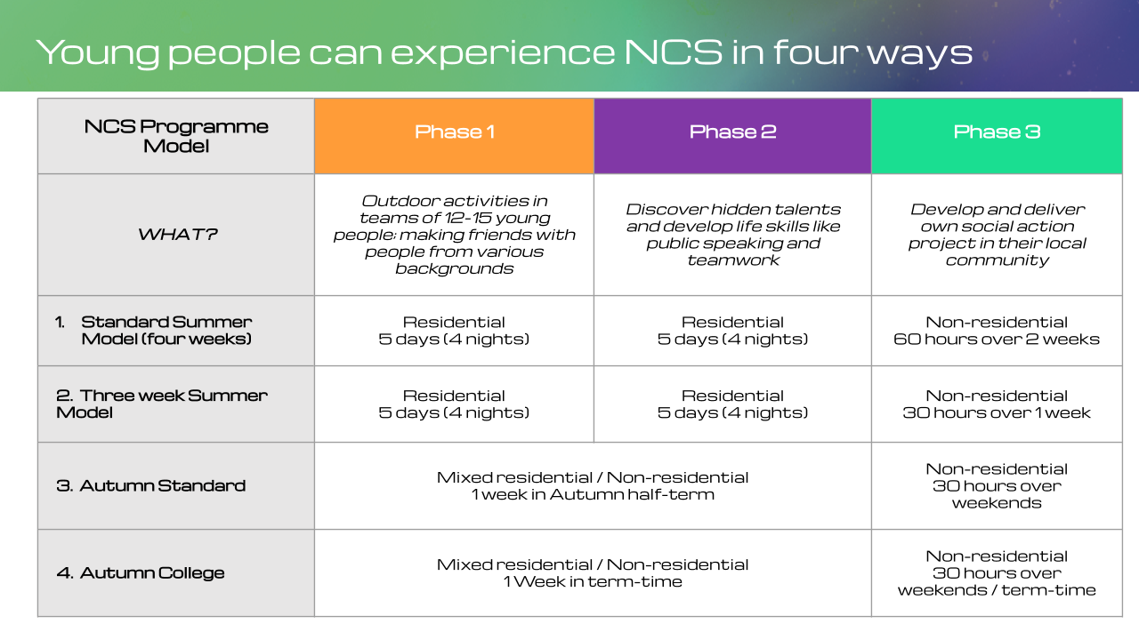

**Scope of the evaluation**

**This evaluation examines the impact of NCS over the summer (three and four week) and autumn (standard only) programmes,** which is when the majority of young people take part in NCS. While both seasons ultimately aim to achieve the same ambitions, summer and autumn NCS programmes are set-up differently. Therefore, it is important that they are evaluated separately in this report.

A note on autumn evaluation: The autumn college model is not included in this evaluation because it is designed and implemented differently to the standard autumn model, and presents logistical challenges for the evaluation methodology. The spring programme is also excluded due to the small participant numbers, meaning it would be very challenging to generate a large enough sample size with which to conduct any meaningful analysis.

It should be noted that there is regional variability in the specific content of the NCS programme, due to the number and range of different partners delivering the programme (over 100). However, all programmes adhere to a core curriculum and the same phased structure of activity set out in Figure 2.1. The impact of individual programme components falls outside of the scope of this evaluation.

**Structure of this report**

This report opens with information about the evaluation methodology and how the data should be interpreted, and then explores the findings of the evaluation. Chapters 4 to 6 cover the following outcome areas - social cohesion, social mobility and social engagement, reflecting the three main social outcomes NCS sets out to achieve. Chapter 7 looks at wellbeing and loneliness. These chapters examine the impact of NCS, based on the matched comparison between the participant and non-participant groups, using difference-in-difference (DiD) analysis.

Chapter 8 presents descriptive analysis of participants’ self-reported experiences and views of the NCS programme. These questions were asked to NCS participants in the follow-up questionnaire only. These findings have also been highlighted in earlier chapters when relevant to provide context to the impact findings.

The report closes with value-for-money analysis and findings in Chapter 9.

1. Methodology

Kantar evaluated the 2018 NCS programme by conducting a baseline and follow-up survey with NCS participants and a comparison group of young people, then analysing the results to assess the impact of the programme on participants. This is consistent with methodologies used in previous NCS evaluations commissioned by DCMS.

This approach was designed to balance robustness, feasibility and value for money. By incorporating a comparison group and difference-in-difference (DiD) analysis, it meets Level 3 out of 5 on the Maryland evaluation scale.[14] Notwithstanding the limitations that come with all research, this design provides confidence that any differences found between participants and the comparison group were a result of the NCS programme.

All those about to embark on an NCS 2018 residential programme in the weeks commencing July 30 and August 6 (summer programme), and from October 12 to November 16 (autumn standard programme) were invited to take part in a baseline survey. A purposive sample was selected to only include participants on these dates as they were peak weeks for attendance on the programme and therefore likely to generate a large number of responses.[15] NCS participants completed the survey at the beginning of their programme experience. Approximately three months later Kantar invited those participants who had agreed to further contact to take part in an online follow-up survey.

Within a similar timeframe, Kantar invited a comparison group of young people who were not participating in the NCS programme to complete a baseline survey online and then, three months later, a follow-up survey online. The questionnaires that the two groups completed were identical, except for a section of questions in the follow-up survey about experience of NCS, which was only applicable to participants.

It has been important to try to ensure this comparison group was as closely aligned as possible to the participant group in terms of profile. Thus, the comparison group mainly comprised of young people who expressed an interest in NCS (by completing an expression of interest form (EOI) but in the end did not go on to take part. As this group was slightly too small to support impact analysis, it was supplemented with online panellists aged 16-17.[16]

Figure 3.1 summarises the relevant elements of the survey fieldwork, including timings of the surveys and number of achieved survey completes. The table also includes response rates for the follow-up survey achieved from the number of young people who were issued invitations after agreeing to be re-contacted when they completed the baseline survey.

**Figure 3.1. Fieldwork summary**

|  |  |  |  |  |  |
| --- | --- | --- | --- | --- | --- |
| **Season** | **Type** | **Group** | **Number of completes** | **Invitations issued** | **Response rates** |
| Summer | Baseline | Participant  25th July – 6th August | 13,714 | N/A[17] | N/A |
| Comparison (EOI)  27th July- 11th September | 3,970 | 85,018 | 5% |
| Comparison (online panel)  13th – 29th August | 326 | N/A | N/A |
| Follow-up | Participant  31st October – 17th December | 1,640 | 6,914 | 24% |
| Comparison (EOI)  29th October – 17th December | 963 | 2,979 | 32% |
| Comparison (online panel)  29th October – 17th December | 167 | 326 | 51% |
| Autumn | Baseline | Participant  12th October – 16th November | 4,079 | N/A | N/A |
| Comparison (EOI)  17th October – 18th January | 1,563 | 20,077 | 8% |
| Comparison (online panel)  18th October – 17th December | 1,171 | N/A | N/A |
| Follow up | Participant  11th February – 25th March | 683 | 2,144 | 32% |
| Comparison (EOI)  11th February – 25th March | 481 | 1,129 | 43% |
| Comparison (online panel)  8th February – 25th March | 448 | 1,171 | 38% |

Kantar further aimed to ensure that the participant and comparison groups were made as comparable as possible by conducting **propensity score matching** (PSM) to control for systematic differences between the two groups. This, in effect, allowed Kantar to control for factors that might influence survey responses (such as demographic characteristics), allowing for more confidence in asserting that differences between the participant and comparison groups are the result of NCS participation as opposed to some other factor.[18]

Following this, Kantar weighted the data to be representative of NCS participants as a whole in order to account for non-response bias. **Difference-in-difference** (DiD) analysis was then carried out to assess the impact of NCS participation on the outcomes measured in the surveys. DiD measures the change in outcome measures for NCS participants pre-programme to post-programme, compared with the change in outcome measures experienced by non-participants (the comparison group) over the same time period (see Figure 3.2). The difference between these two levels of change is the impact that can then be attributed to participation in NCS.

**Figure 3.2. Difference in difference (DiD) analysis**



The full details of the PSM (including variables controlled for), weighting and DiD can be found in the technical report.

The evaluation can be placed at Level 3 because this PSM, weighting and DiD were applied to the data to adjust for differences between treated and untreated groups.[19]

The evaluation was conducted in accordance with the Government Social Research (GSR) ethics guidance.[20]

While Kantar has designed and conducted this evaluation to deliver high quality data and analysis for DCMS, it is important to note some of the limitations with the approach used when interpreting the findings. These are summarised in Appendix 5 and are set out in further detail in the technical report.

**Interpretation guidance**

Throughout this report, DiD analysis is reported in two ways: percentage point difference or difference in mean score. The worked examples below should aid readers in understanding how impacts are calculated.

**Example 1: Percentage point difference**

The participant and the comparison groups were asked the following question in the baseline survey and again in the follow-up survey:

**The next question is about how confident you feel about different areas of your life. How do you feel about the following things, even if you have never done them before...?**

|  |  |  |  |  |  |
| --- | --- | --- | --- | --- | --- |
|  | Very confident | Confident | Neither confident  nor not confident | Not very confident | Not at all confident |
| Being the leader of a team | ⬜ | ⬜ | ⬜ | ⬜ | ⬜ |

In the DiD analysis, Kantar compared the proportion of respondents who select confident or very confident in the baseline survey and in the follow-up survey. For the summer programme, here was a positive difference of **21** percentage points for the NCS participant group and a positive difference of **3** percentage points for the comparison group.

Therefore, there is a **positive, 18 percentage point difference** in this outcome measure for NCS participants when compared with the comparison group; reported as **+18pp.**

Percentage point findings are displayed in bar charts like the one below. In this instance the difference is statistically significant, indicated by the block colour icon.

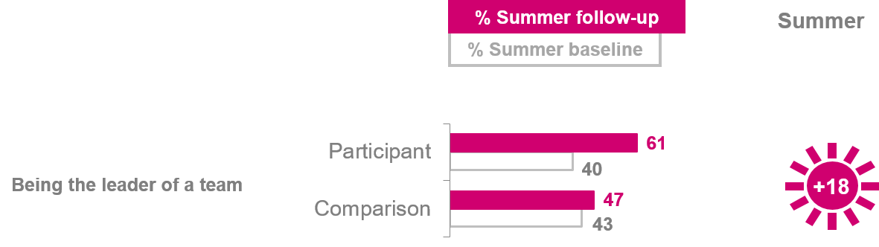

**Example 2: Difference in mean score**

For questions asked on a numeric scale, DiD analysis was conducted using the changes between mean scores.[21] For instance, the participant and the comparison groups were asked the following question at both baseline and follow-up:

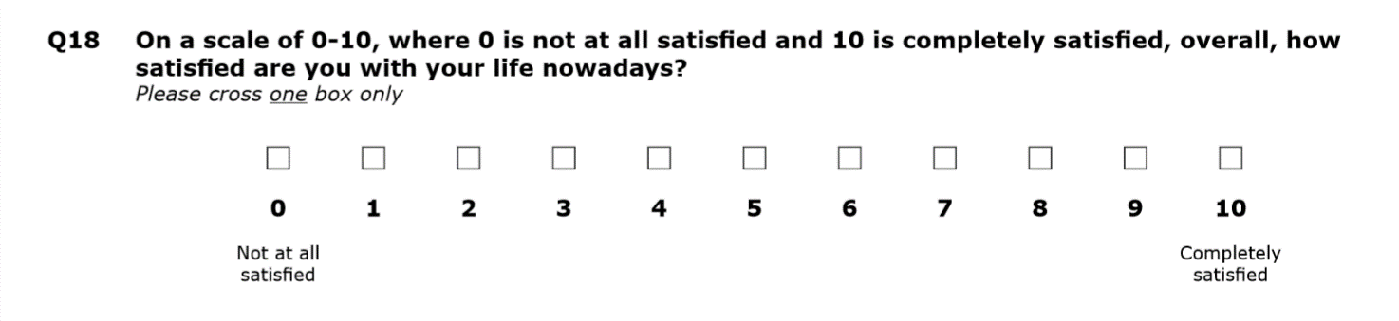

In the autumn evaluation, the participants had a mean satisfaction score of 6.6 at the baseline and 6.93 at follow-up, a **+0.3** difference (when taking rounding into consideration). The comparison group had a mean satisfaction score of 6.71 at the baseline and 6.72 at the follow-up, a difference of **0**. Therefore, there is a positive **0.3 difference in mean scores** between NCS participants and the comparison group; reported as **+0.3**. Mean score findings are shown in line graphs like the one below. In this instance the difference is not statistically significant, indicated by the non-block coloured icon.

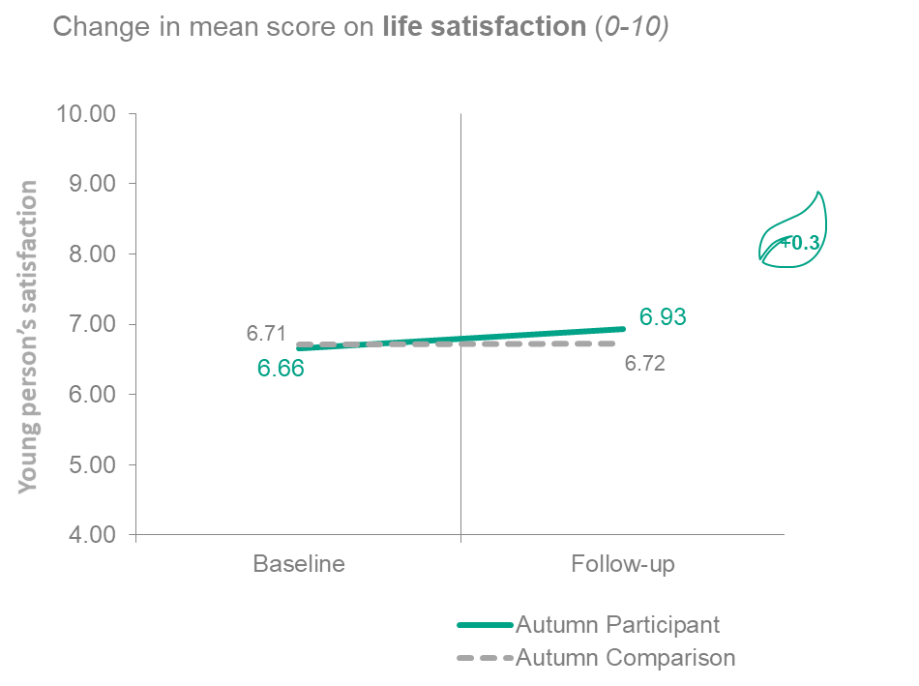

**Explaining impact measurement**

Impacts from the summer NCS programme are reported in a sun icon and impacts from the autumn NCS programme in a leaf icon.

**+13**



**+3**

All impacts have been tested for statistical significance. Statistical significance means we can be confident that the differences seen between the participant and comparison group have not happened by chance. This report uses a 95% confidence interval to test significance. This means we can be confident that if we carried out the same research on other occasions, 95 times out of 100 we would get similar findings.

**The report narrative focuses only on statistically significant findings.** In the charts, significant impacts are reported with a sun or leaf icon in block colour, and non-significant with a white icon with a coloured outline.

**Example of significant and non-significant impact estimates**

Significant Non-significant

The impact estimates are subject to confidence intervals.[22] This is because only a sample of NCS participants took part in the survey, not the whole population. This means that the impact estimates presented will fall within a range of values. This can make it difficult to say whether one impact is larger or smaller than another.

* For example, a reported of impact of +18pp falls within a range of a lower limit of +13pp and an upper limit of +24pp.
* Another impact of +9pp may seem substantially lower than +18pp. However, if it has a lower limit of +3pp and an upper limit of +14pp, the confidence intervals of the two impact estimates overlap.
* This means we cannot be confident that the first impact of +18pp is higher than the second of +9pp.

A subset of survey questions was asked to NCS participants only, because they were aimed at establishing their experience of the programme itself. The answers to these are reported in a standalone chapter, Chapter 8. Where they aid the narrative around the impact reporting, some parts have been integrated into the impact chapters. In these instances, they can be distinguished from the impact reporting because they use percentages (%) rather than in percentage point differences or mean score differences.

As already shown in Figure 2.1, there are some key differences in the way summer and autumn NCS programmes are delivered. The results have been brought together at the beginning of each chapter for the benefit of the reader, but summer and autumn should be considered as separate sets of results as they are not directly comparable to one another.[23]

Likewise, evaluations of the autumn and summer NCS programme do not include comparisons from year to year. The structure and delivery of the programme has developed over time and consists of a fresh cohort of young people each year. As such, it would not be accurate to compare annual differences in impact. Where possible and appropriate, Kantar has set the evaluation findings in the context of relevant wider research.

1. Social cohesion

**Summary: Social cohesion**

* The summer NCS programme has some positive impacts on social cohesion measures, though the autumn programme shows no significant impact. For social cohesion measures, it is not possible to rank impacts by size because of the variety of question scales applied and overlapping confidence intervals around the impact estimates.  
  + **Greater recognition and respect of those from other backgrounds:** The summer NCS programme has an impact of **+9pp** on participants agreeing that their local area is a place where people from different backgrounds get on well together.
  + Participants’ **comfort with a friend or relative going out with someone who is different to them,** or from a minority group**,** is impacted positively for summer participants in only one area: for someone who is disabled (**+0.4**). There was no positive impact detected for autumn participants. These small or non-impacts may be explained by social desirability bias or the positive attitudes already recorded at the baseline among participants.
  + Neither the summer nor autumn NCS programmes have significant impacts on participants’ **trust in others, their experiences (whether positive or negative) with people from the same or different ethnic backgrounds to them, or on the ethnic diversity of their friendship groups.** It is worth noting friendship groups of both participant and comparison groups have low levels of homogeneity from the outset and, existing literature suggests that over time everyday engagement with different groups may positively influence people’s trust in those around them.24
  + The participant experience section of the survey suggests that the programme is helping to improve tolerance towards others. Over three quarters of summer (78%) and autumn (76%) NCS participants agree *‘I now feel more positive towards people from different backgrounds to myself’.*

**Social cohesion outcomes**

NCS aims to support a country in which all young people feel a sense of belonging, based on trust and respect as well as a sense of shared endeavour.

Programmes are designed so that participants mix with other young people from different backgrounds (noting that autumn programmes tend to be drawn from single, larger institutions with less natural diversity than the summer programmes). Social mixing is also promoted through interactions young people have with others in their wider community through the social action phase (Phase 3 – see Figure 2.1). Participants also engage in team-building activities to develop their team-working skills, and take part in celebration events such as a graduation ceremony to encourage reflection on achievements together.

Together, these social mixing and social action elements are intended to broaden participants’ social networks, increase levels of social trust and give them greater recognition and respect of those from different backgrounds to them.

This section examines a series of measures which aim to identify the impact NCS is having in these areas.

**Comfort with those from a different or minority background**

To measure the success of this aim, young people were asked, on a scale of 0-10, how comfortable they would feel with a close relative or friend going out with someone from a different background to them, or who is gay or lesbian, or who is disabled.

**Participating in the summer NCS programme has a positive impact on participants’ levels of comfort when it comes to a close relative or friend going out with someone who is disabled (+0.4).** For other measures we see no statistically significant impact.

The summer programme does not significantly impact on participants feeling comfortable with a friend or relative going out with someone from a different race or ethnicity, a different religious background, or a richer or poorer background, or with someone who is gay or lesbian.

The high baseline scores for both participant and comparison groups may indicate that most young people already feel comfortable with a friend or relative going out with someone from a range of different backgrounds, meaning attitudes are harder to shift by any substantial amount. However, there could be other reasons for these already high scores as well such as social desirability bias, where research participants select answers based on social norms rather than how they really feel.[24]

The participant experience section of the survey suggests that the programme is helping to improve tolerance towards others. Over three quarters of summer (78%) and autumn (76%) NCS participants agree that following their NCS experience *‘I now feel more positive towards people from different backgrounds to myself’.*

Figure 4.1 below shows the change in mean scores for each of the six statements.

**Figure 4.1 Summer: Change in mean score on levels of feeling comfortable with a close relative or friend going out with someone…**

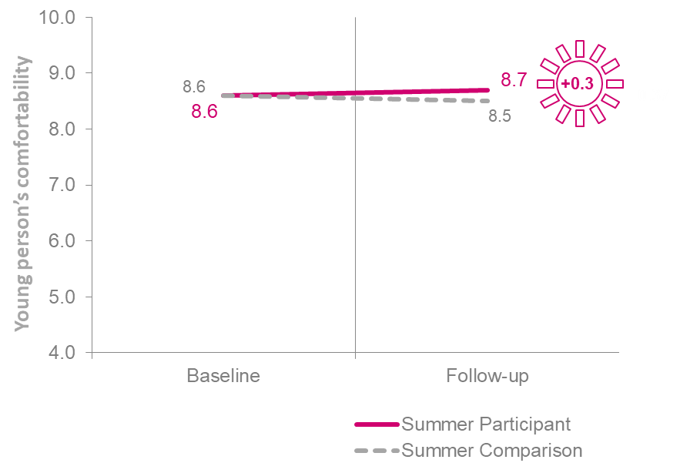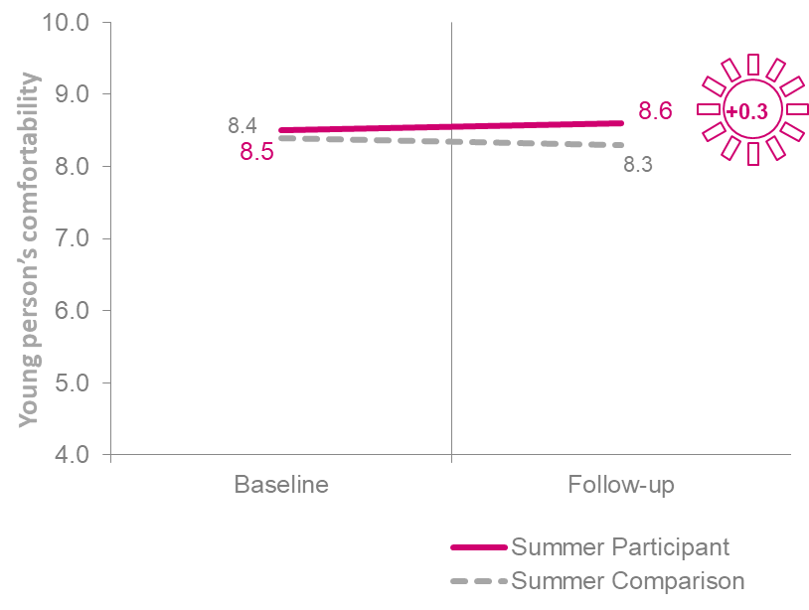… from a **different religious background**…from a **richer or poor background**

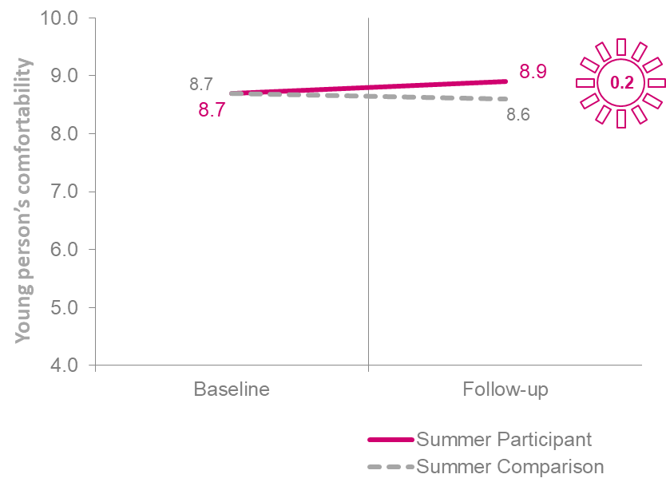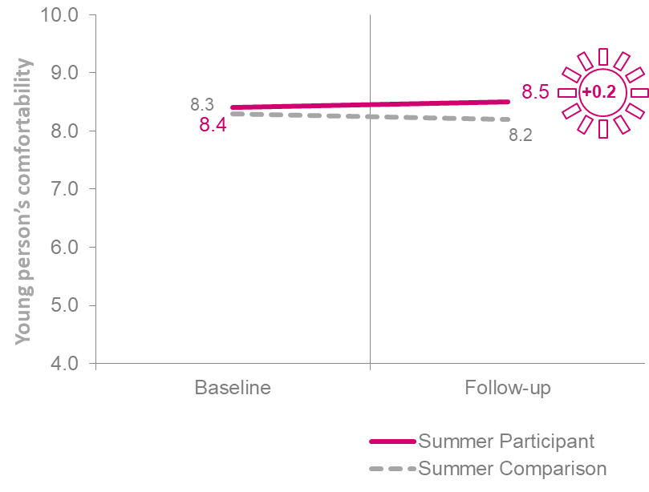…**who is gay or lesbian …** from a **different race or ethnicity**

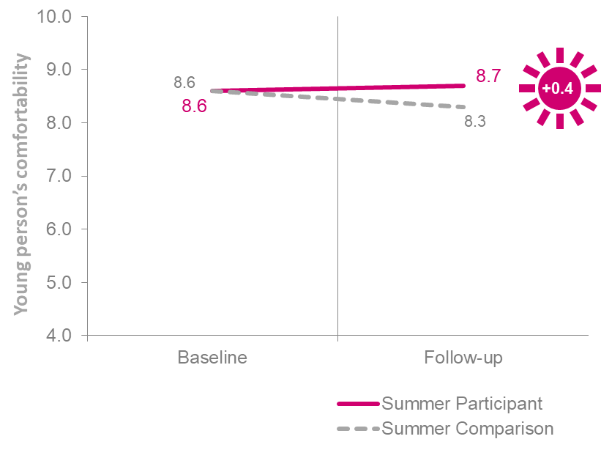… **someone who is disabled**

*Please use this scale to show how you would personally feel about a close relative or friend going out with someone from the following backgrounds. … from a different school or college to you, … from a different race or ethnicity to you, … from a different religious background to you, … from a richer or poorer background to you, … who is gay or lesbian, …who is disabled* Base: Summer NCS participant baseline (completed on paper): 13,714 Summer NCS participant follow-up (completed online): 1,640 Summer Comparison group baseline (completed online): 4,327 Summer Comparison group follow-up (completed online): 1,133

**The autumn NCS programme does not have a significant impact on participants’ comfort with people from any of the different or minority backgrounds**, as demonstrated in Figure 4.2**.** Again, this diverges from what autumn participants report in the participant experience section of the survey, in which **76%** of them agree that following their NCS experience *‘I now feel more positive towards people from different backgrounds to myself’.*

**Figure 4.2 Autumn: Change in mean score on levels of feeling comfortable with a close relative or friend going out with someone…**

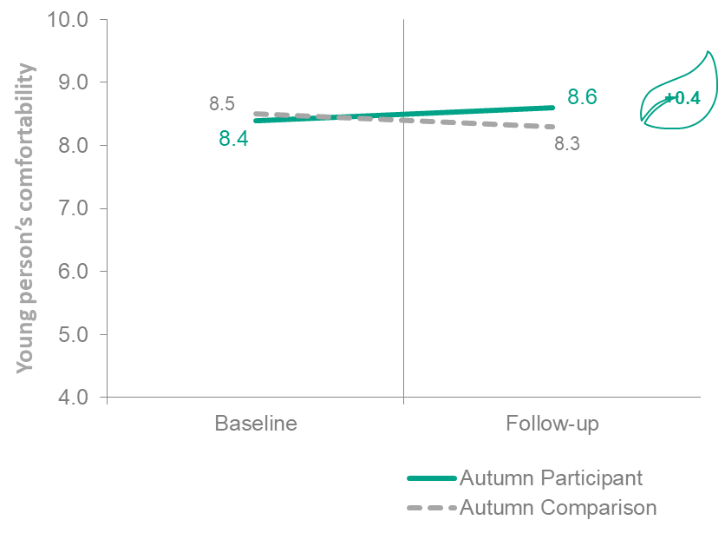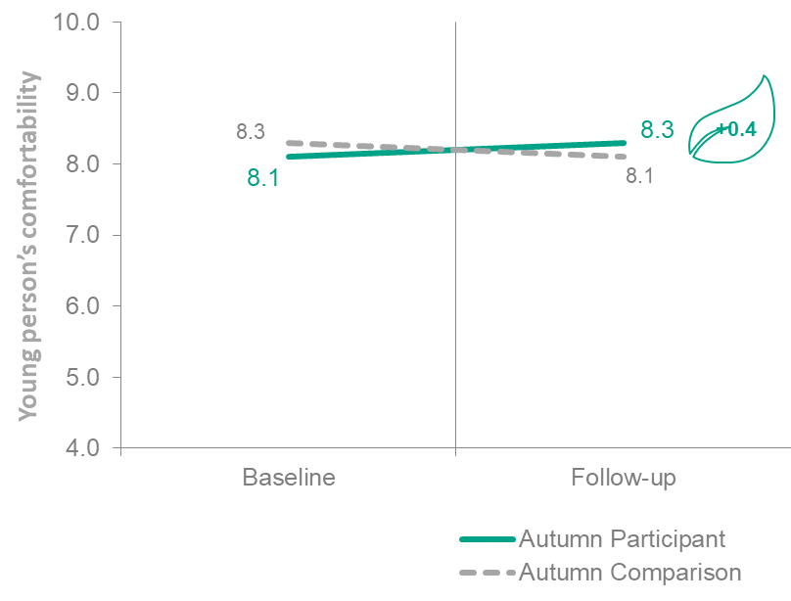 … from a **different religious background**…from a **richer or poor background**

…from a **different race or ethnicity**

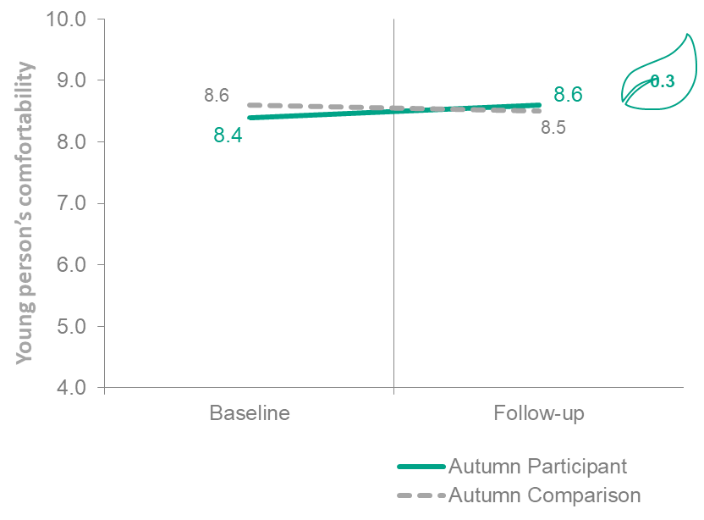

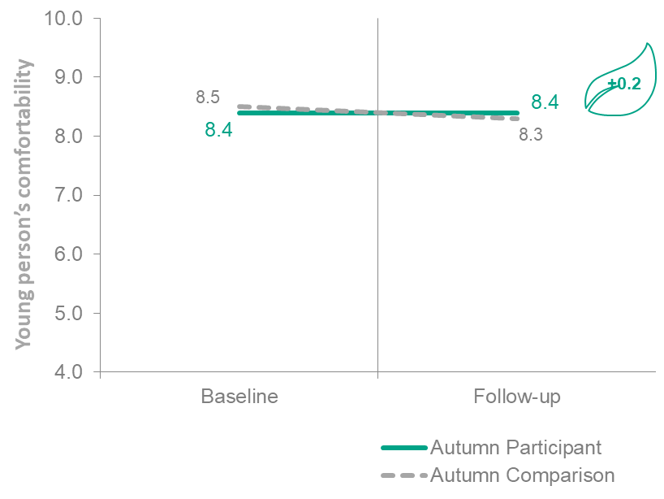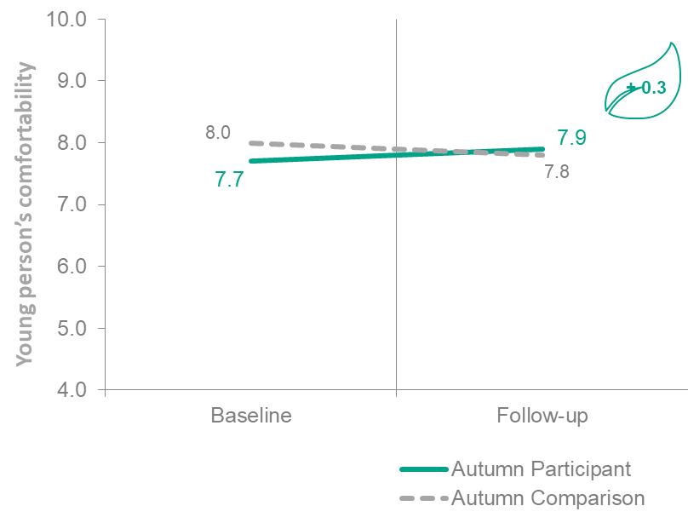…**who is gay or lesbian …who is disabled**

*Please use this scale to show how you would personally feel about a close relative or friend going out with someone from the following backgrounds. A close relative or friend going out with someone…from a different religious background to you…from a richer or poor background to you*

Base: Autumn NCS participant baseline (completed on paper): 1,621 Autumn NCS participant follow-up (completed online): 684 Autumn Comparison group baseline (completed online): 2,731 Autumn Comparison group follow-up (completed online): 932

**Experiences with others**

**The NCS summer programme has no significant impact on how the programme affects young people’s experiences with those from a different race or ethnicity to themselves,** as Figures 4.3 and 4.4 below show. **This is also the case for the autumn NCS programme**, as demonstrated in Figures 4.5 and 4.6.

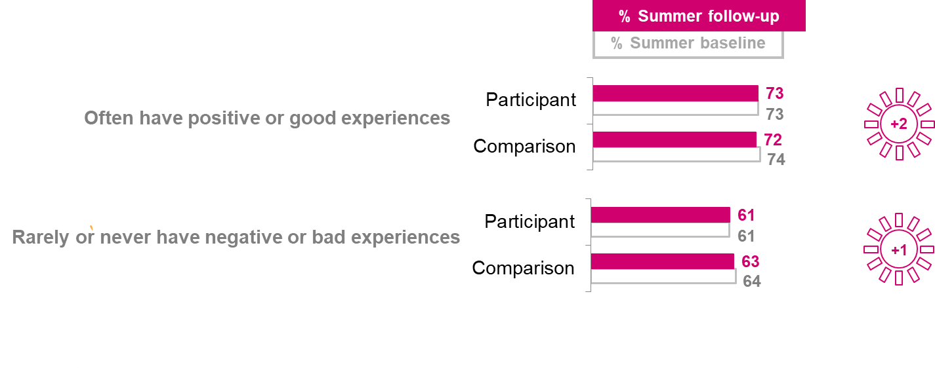**Figure 4.3 Summer: % of those who had positive or ‘non-negative’ experiences with people from a different race or ethnicity**

*Please use this scale to show how you would personally feel about a close relative or friend going out with someone from the following backgrounds. A close relative or friend going out with someone…who is gay or lesbian… who is disabled*

Base: Autumn NCS participant baseline (completed on paper): 1,621 Autumn NCS participant follow-up (completed online): 684 Autumn Comparison group baseline (completed online): 2,731 Autumn Comparison group follow-up (completed online): 932

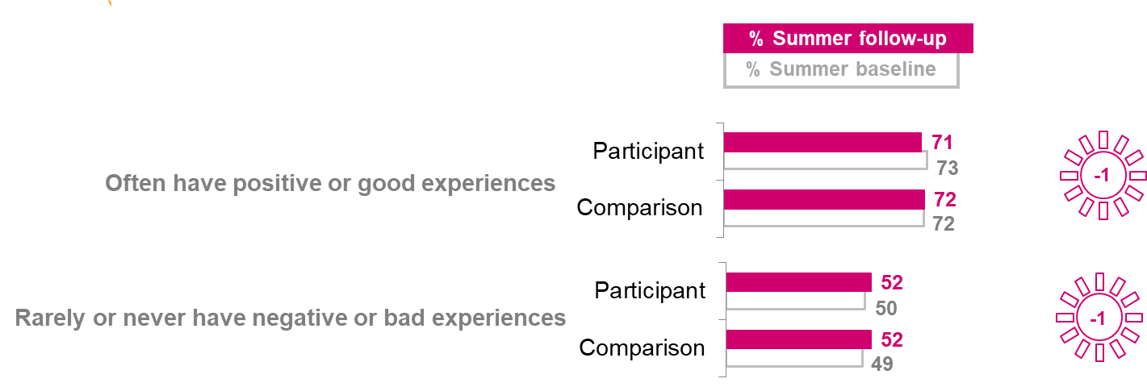**Figure 4.4 Summer: % of those who had positive or ‘non-negative’ experiences with people from the same race or ethnicity**

*Now thinking of your own experiences with people from the same race or ethnicity as you, how often, if at all, would you say you have had…a. POSITIVE or GOOD experiences. For example someone being friendly to you or making you feel welcome? b. NEGATIVE or BAD experiences. For example someone being mean to you, or making you feel unwelcome?*

Base: Summer NCS participant baseline (completed on paper): 13,714 Summer NCS participant follow-up (completed online): 1,640 Summer Comparison group baseline (completed online): 4,327 Summer Comparison group follow-up (completed online): 1,133

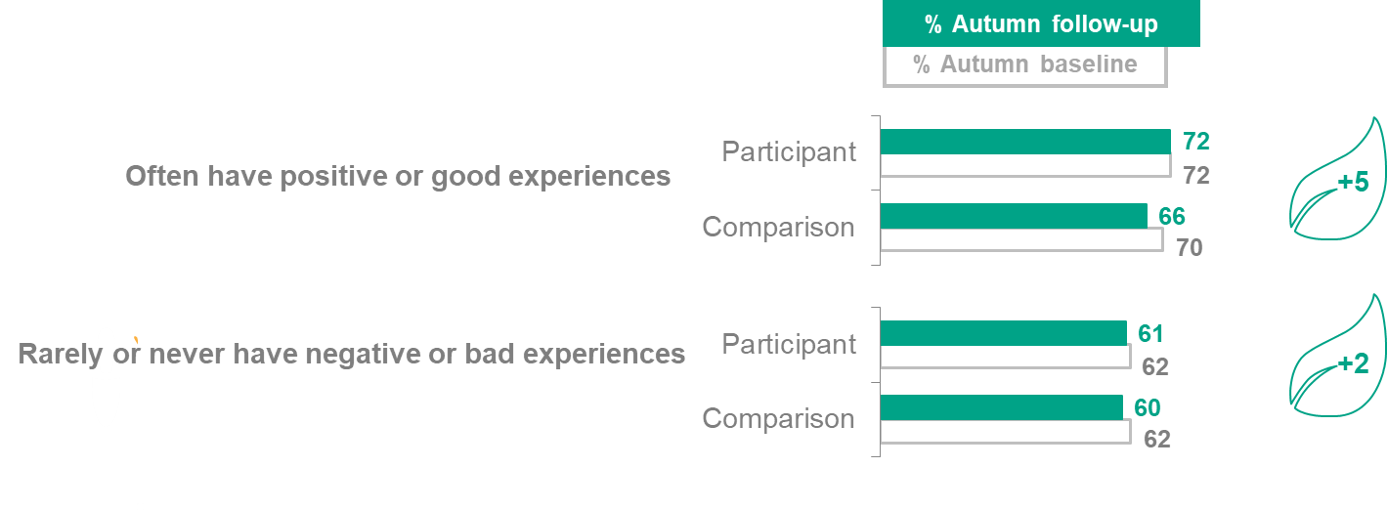**Figure 4.5 Autumn: % of those who had positive or ‘non-negative’ experiences with people from a different race or ethnicity**

*Thinking of your own experiences with people from a different race or ethnicity to you, how often, if at all, would you say you have had…a .POSITIVE or GOOD experiences. For example someone being friendly to you or making you feel welcome? b. NEGATIVE or BAD experiences. For example someone being mean to you, or making you feel unwelcome?*

Base: Autumn NCS participant baseline (completed on paper): 1,621 Autumn NCS participant follow-up (completed online): 684 Autumn Comparison group baseline (completed online): 2,731 Autumn Comparison group follow-up (completed online): 932

**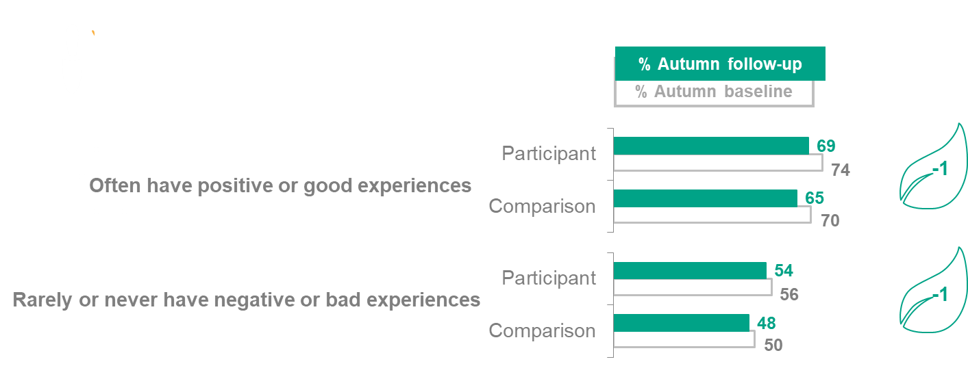****Figure 4.6 Autumn: % of those who had positive or ‘non-negative’ experiences with people from the same race or ethnicity**

*Now thinking of your own experiences with people from the same race or ethnicity as you, how often, if at all, would you say you have had…a. POSITIVE or GOOD experiences. For example someone being friendly to you or making you feel welcome? b. NEGATIVE or BAD experiences. For example someone being mean to you, or making you feel unwelcome? Possible answers: ‘All of them’, ‘Most of them’, ‘Some of them’ and ‘None of them’. The analysis focuses on young people that answered that ‘All of them’ were from the same ethnic group as them.*

Base: Autumn NCS participant baseline (completed on paper): 1,621 Autumn NCS participant follow-up (completed online): 684 Autumn Comparison group baseline (completed online): 2,731 Autumn Comparison group follow-up (completed online): 932

**Ethnic diversity of friendship groups**

Participant and comparison groups were asked how many of their friends are from the same ethnic group as them as a measure of diversity within their social networks. Based on this, **the summer NCS programme has no significant impact on the diversity of participants’ friendship groups**, as Figure 4.7 shows. Friendship groups of both participant and comparison groups have low levels of homogeneity from the outset.

Likewise, **the autumn NCS programme has no significant impact on the diversity of participants’ friendship groups,** as demonstrated in Figure 4.8.

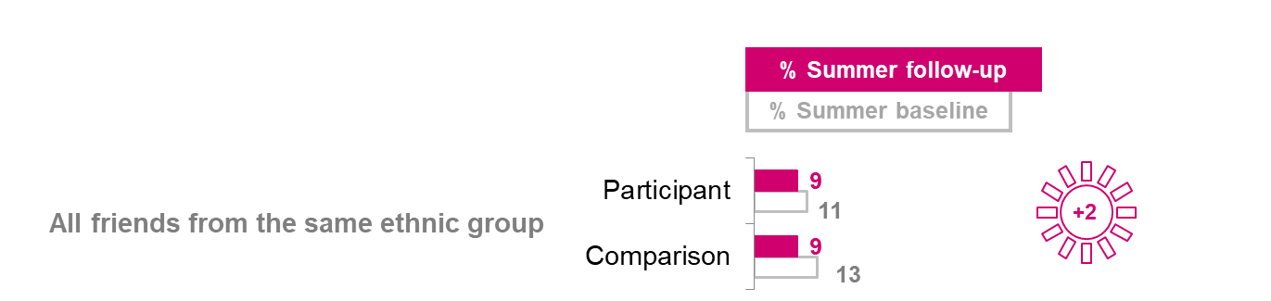**Figure 4.7 Summer: % of those who said all their friends were from the same ethnic group as them**

*And now thinking about your friends. How many of them are from the same ethnic group as you?*

Base: Summer NCS participant baseline (completed on paper): 13,714 Summer NCS participant follow-up (completed on paper): 1,640 Summer Comparison group baseline (completed online): 4,327 Summer Comparison group follow-up (completed online): 1,133

**Figure 4.8 Autumn: % of those who said all their friends were from the same ethnic group as them**

*And now thinking about your friends. How many of them are from the same ethnic group as you?*

Base: Autumn NCS participant baseline (completed on paper): 1,621 Autumn NCS participant follow-up (completed online): 684 Autumn Comparison group baseline (completed online): 2,731 Autumn Comparison group follow-up (completed online): 932

**Sense of community cohesion**

As Figure 4.9 demonstrates, **the summer NCS programme has a positive impact on participants’ sense of community cohesion:** in this case, their agreement that their local area is a place where people from different backgrounds get on well together **(+9pp)**.

While not directly comparable due to different methodologies, the Community Life Survey found that 82% of adults aged over 16 agreed with the statement ‘my local area is a place where people from different backgrounds get on well together’, with those aged 75 or older more likely to agree than those aged 16-24 (89% compared with 82%).[25] In contrast, fewer NCS participants agreed with the same statement at the follow-up stage (64% summer and 66% autumn).

Conversely, **the autumn NCS programme does not have a significant impact on participants’ sense of community cohesion,** as reported in Figure 4.10.

**Figure 4.9 Summer: % who agree that their local area is a place where people from** *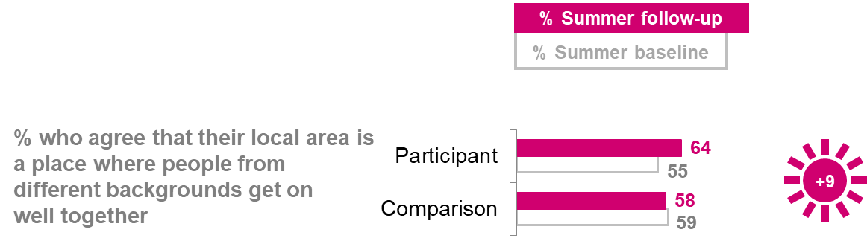***different backgrounds get on well together**

*How much do you agree or disagree with the following statements? My local area is a place where people from different backgrounds get on well together*.

Base: Summer NCS participant baseline (completed on paper): 13,714. Summer NCS participant follow-up (completed online): 1,640. Summer Comparison group baseline (completed online): 4,327. Summer Comparison group follow-up (completed online): 1,133.

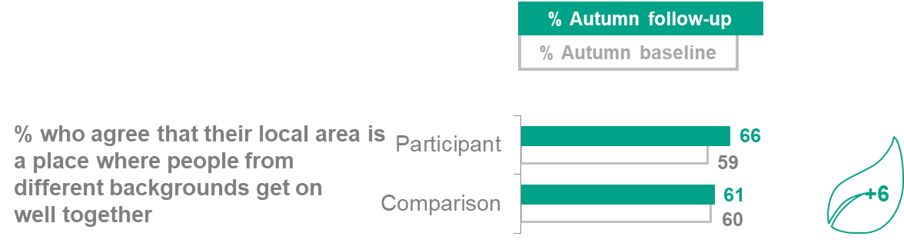**Figure 4.10 Autumn: % who agree that their local area is a place where people from different backgrounds get on well together**

*How much do you agree or disagree with the following statements? My local area is a place where people from different backgrounds get on well together?*

Base: Autumn NCS participant baseline (completed on paper): 1,621 Autumn NCS participant follow-up (completed online): 684 Autumn Comparison group baseline (completed online): 2,731 Autumn Comparison group follow-up (completed online): 932.

**Levels of social trust**

Taking part in activities with shared objectives such as volunteering, coupled with the broadening of social networks is intended to leave participants with higher levels of social trust. The social action, mixing and reflection activities, together with team-building and celebration activities, are intended to lead participants to feel a greater sense of belonging as well as social trust.

**Neither the summer nor the autumn NCS programme has a significant impact on participants’ trust in people.**

On a 0-10 scale, participants put a value to how much they think people can be trusted. Impact estimates for this question are calculated using mean scores.

While the impact of the programme appears to be limited here, it may be the case that the positive shifts across other measures around participation in groups and volunteering will, over time, increase feelings of trust. There is literature to support that every day engagement with different groups, together with volunteering, positively impacts on people’s sense of belonging and trust in those around them.[26]

**Figure 4.11 Summer and Autumn: Mean level of trust in people (0-10)**

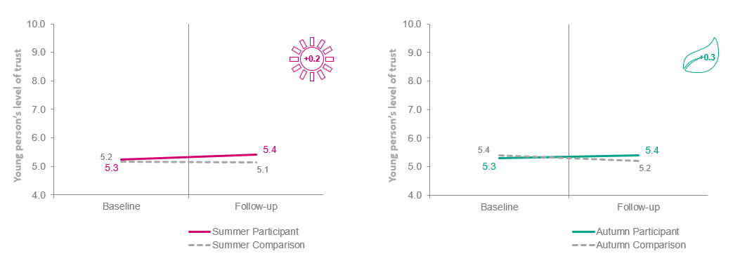

*On a scale of 0-10, where 0 (zero) is not at all and 10 (ten) is completely, in general how much do you think people can be trusted?* Base: Summer NCS participant baseline (completed on paper): 13,714 Summer NCS participant follow-up (completed online): 1,640 Summer Comparison group baseline (completed online): 4,327 Summer Comparison group follow-up (completed online): 1,133

*On a scale of 0-10, where 0 (zero) is not at all and 10 (ten) is completely, in general how much do you think people can be trusted?*

Base: Autumn NCS participant baseline (completed on paper): 1,621 Autumn NCS participant follow-up (completed online): 684 Autumn Comparison group baseline (completed online): 2,731 Autumn Comparison group follow-up (completed online): 932

1. Social mobility

**Summary: Social mobility**

* Across social mobility measures, nearly all summer NCS programme impacts, and many autumn ones, are positive and statistically significant. For some social mobility measures we are able to say which impacts are larger than others, but for most we cannot due to the wider confidence intervals around the impact estimates.  
  + **Making the most of opportunities:** In line with the programme’s aim to **increase participants’ confidence**, the largest social mobility impacts are on self-confidence. The summer NCS programme has a significant positive impact on all self-confidence measures and the autumn NCS programme on nearly all (five out of seven measures), including confidence in being the leader of a team (**+18pp** summer and **+13pp** autumn).
  + The areas of **problem solving and decision-making** and **emotional regulation and resilience** are also positively impacted by both programmes, although not as comprehensively. For instance, the summer NCS programme has a positive impact on all four problem-solving and decision-making measurements, but the autumn NCS programme has an impact on only one: participants’ enjoyment of finding new ways to do things (**+6pp** autumn and **+10pp** summer).
  + **Broader social networks:** Linked to the programme’s intention of widening participants’ social connections, the summer NCS programme has a positive impact on most measures (four out of six measures) of **teamworking and social networking**, including participants’ agreement that if they needed help, there are people who would be there for them (**+9pp).** The autumn NCS programme has animpact on only one teamworking and social networking measure: participants’ agreement that they get along with people easily (**+7pp**)
  + **Awareness of and aspirations to future opportunities:** Following the programme’s ambition to elevate and widen participants’ aspirations, the summer NCS programme has a positive impact on participants’ future outlook, including on how positive they feel about getting a job in future (**+8pp).** However, the autumn NCS programme has no significant impacts on participants’ positivity towards the future.
* The participant experience findings show a positive picture regarding social mobility, with the majority of participants agreeing that NCS helps develop skills for the future (87% both summer and autumn) and almost four in five (**78%**) summer and autumn participants agree that they now ‘feel betterprepared for challenges that life might bring me.’ (See participants experience chapter for more detail).

**Social mobility outcomes**

The NCS programme aims to support a society in which young people from all social backgrounds have the capabilities and connections to take advantage of evolving opportunities, and fulfil their potential. To facilitate this, as well as social mixing, participants have the opportunity to engage with adult role models (whether team leaders or external speakers and trainers). They are also exposed to activities about businesses and employability, and will usually experience Phase 2 of their programme staying in university accommodation. Together with regular moments of guided reflection, the intention is for participants to develop self-expression and goal-setting skills, to learn self-efficacy, and for the programme to help raise aspirations.

**Broader social networks**

The evaluation measures impact of the NCS programme on teamwork and social network building.

**The summer NCS programme has a positive impact on most (four out of six) of these measures,** as demonstrated in Figure 6.1.

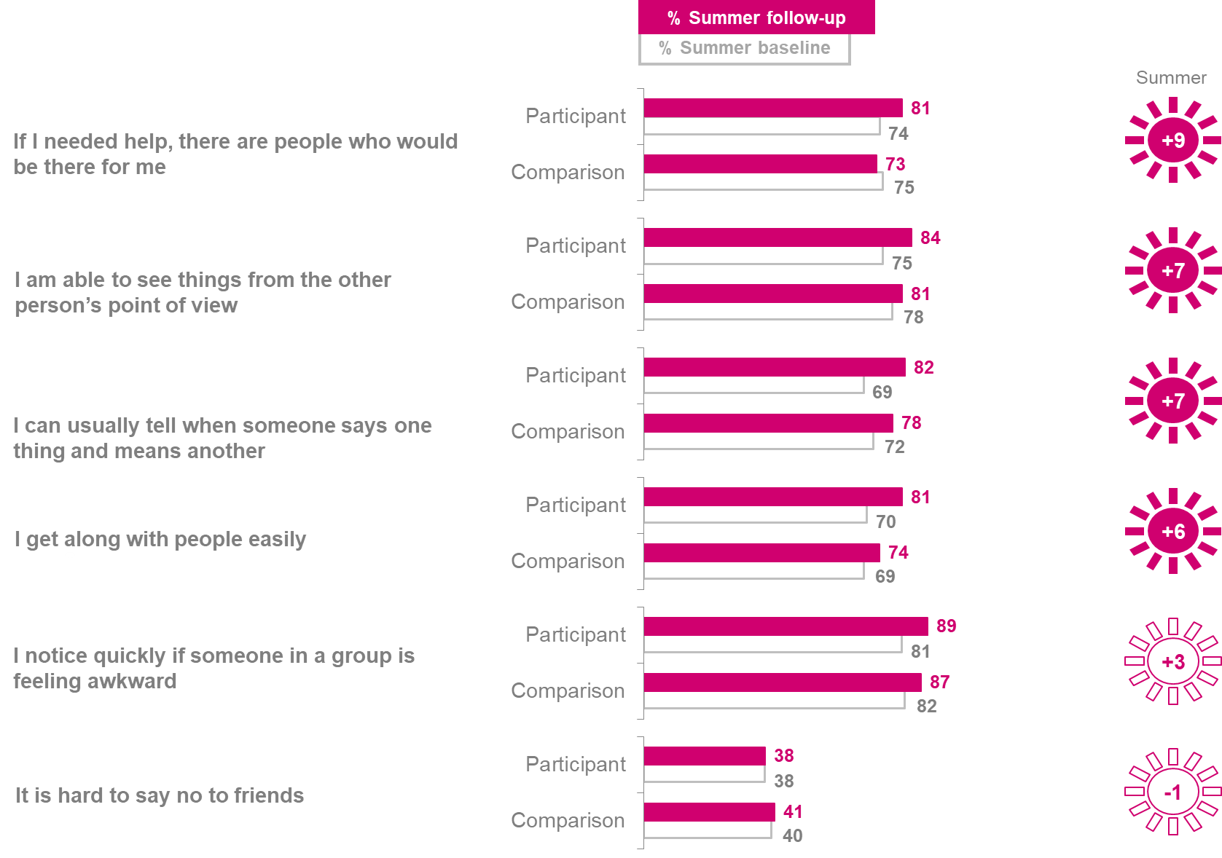**Figure 5.1 Teamwork and social network building - Summer**

*“How much do you agree or disagree with the following statements?” Please read the statements below and say how much you agree or disagree with them.”*Base: Summer NCS participant baseline (completed on paper): 13,714 Summer NCS participant follow-up (completed online): 1,640 Summer Comparison group baseline (completed online): 4,327 Summer Comparison group follow-up (completed online): 1,133

**The autumn NCS programme only has a positive impact on participants’ agreement that they get along with people easily (+7pp)**. As seen in Figure 5.2, there are no significant differences across the other measures.

**Figure 5.2 Teamwork and social network building - Autumn**

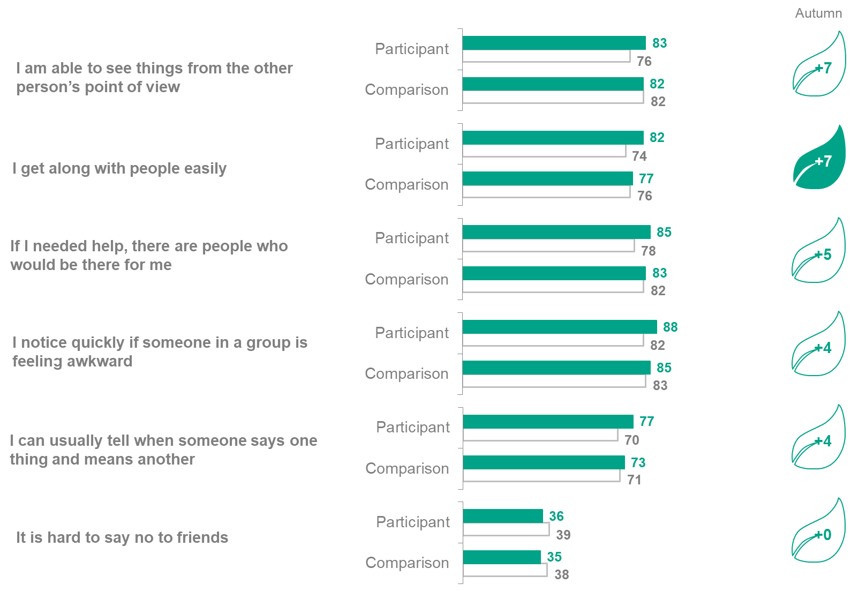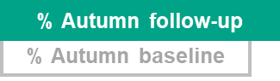

*“How much do you agree or disagree with the following statements? Please read the statements below and say how much you agree or disagree with them.”*

Base: Autumn NCS participant baseline (completed on paper): 1,621. Autumn NCS participant follow-up (completed online): 684. Autumn Comparison group baseline (completed online): 2,731. Autumn Comparison group follow-up (completed online): 932.

**Increasing awareness of and aspirations to future opportunities**

On the programme, course providers run activities about businesses and employability, and provide university accommodation for some of the summer courses. The intention is for participants to develop self-expression and goal-setting skills, and to learn self-efficacy. This is done with a view to **increasing participants’ awareness of career and educational options, and related aspirations**.

As Figure 5.3 shows, **the summer programme has a positive impact on participants’ future outlook**: both in terms of them feeling positive about getting a job in the future (**+8pp**) and their confidence in having the skills and experience to get a job in the future (**+6pp**).

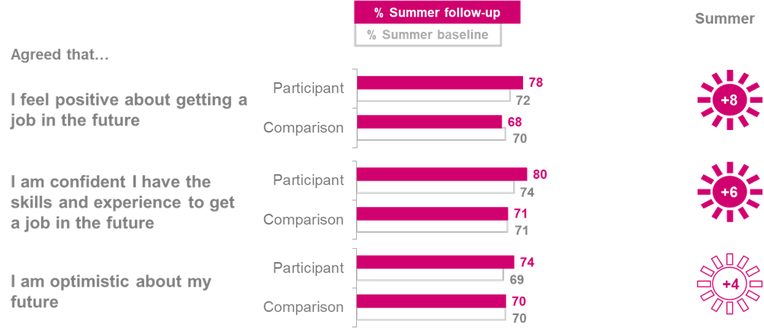**Figure 5.3 Positivity about the future – Summer**

*How much do you agree or disagree with the following statements?*

Base: Summer NCS participant baseline (completed on paper): 13,714. Summer NCS participant follow-up (completed on paper): 1,640. Summer Comparison group baseline (completed online): 4,327. Summer Comparison group follow-up (completed online): 1,133.

**However, the autumn NCS programme does not have a significant impact on participants’ positivity about the future**,as shown in Figure 5.4.

*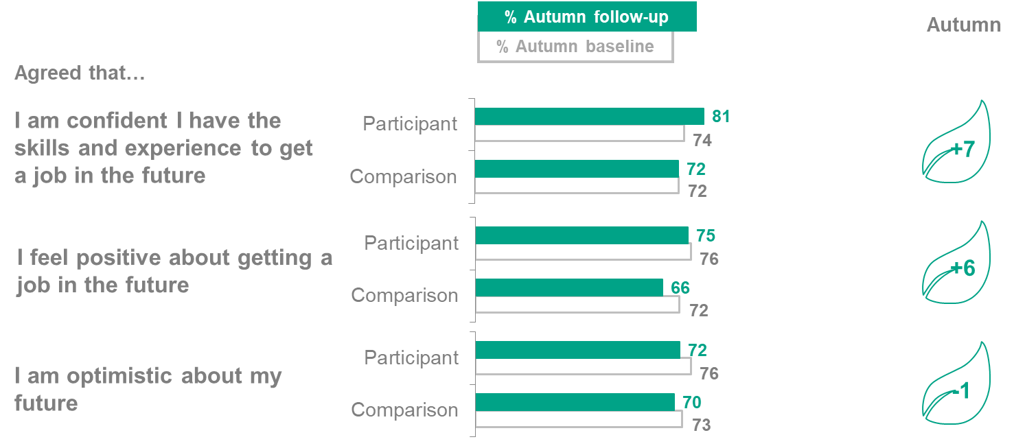***Figure 5.4 Positivity about the future - Autumn**

*How much do you agree or disagree with the following statements?*Base: Autumn NCS participant baseline (completed on paper): 1,621 Autumn NCS participant follow-up (completed online): 684 Autumn Comparison group baseline (completed online): 2,731 Autumn Comparison group follow-up (completed online): 932

**Making the most of opportunities**

NCS is designed to leave participants with the **confidence, connections and attributes to make the most of opportunities** that they encounter. This is developed in the social action projects, social mixing and guided reflection.

**Self-confidence: leadership and communication**

**The summer NCS programme has a positive impact on all measures of self-confidence examined**. As Figure 5.5 shows, these included participants’ confidence in their ability to manage disagreements and conflicts (**+18pp**) and in being leader of the team (**+18pp**). These were among the largest impacts observed for social mobility outcomes, and across the summer DiD analysis as a whole.

**Figure 5.5 Self-confidence: leadership and communication - Summer**

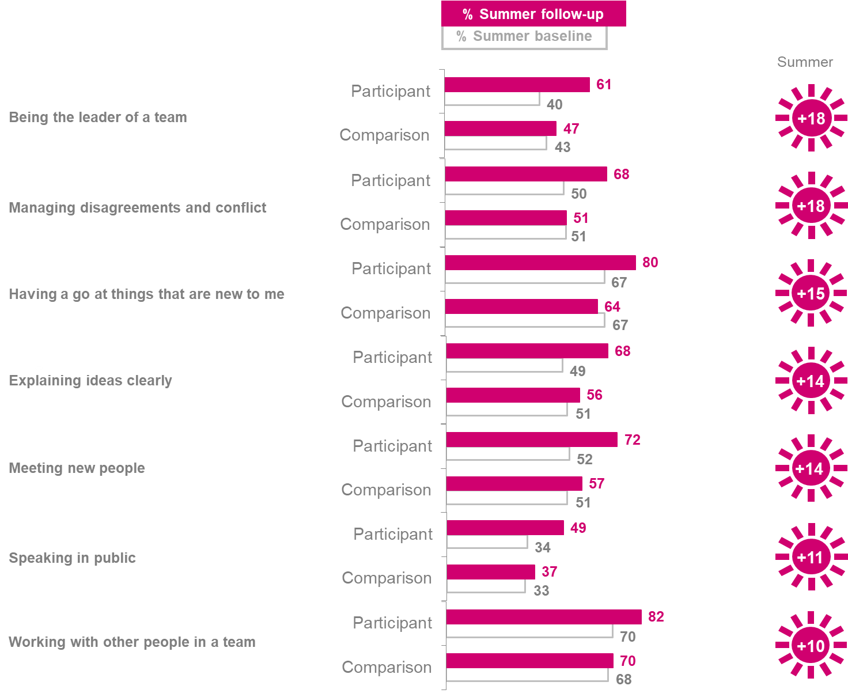

*“How do you feel about the following things, even if you have never done them before…?”*

Base: Summer NCS participant baseline (completed on paper): 13,714. Summer NCS participant follow-up (completed online): 1,640. Summer Comparison group baseline (completed online): 4,327. Summer Comparison group follow-up (completed online): 1,133.

**The autumn NCS programme also has a positive impact on participants’ self-confidence, leadership and communication skills.** Five out of the seven measure were significant as demonstrated in Figure 5.6.

*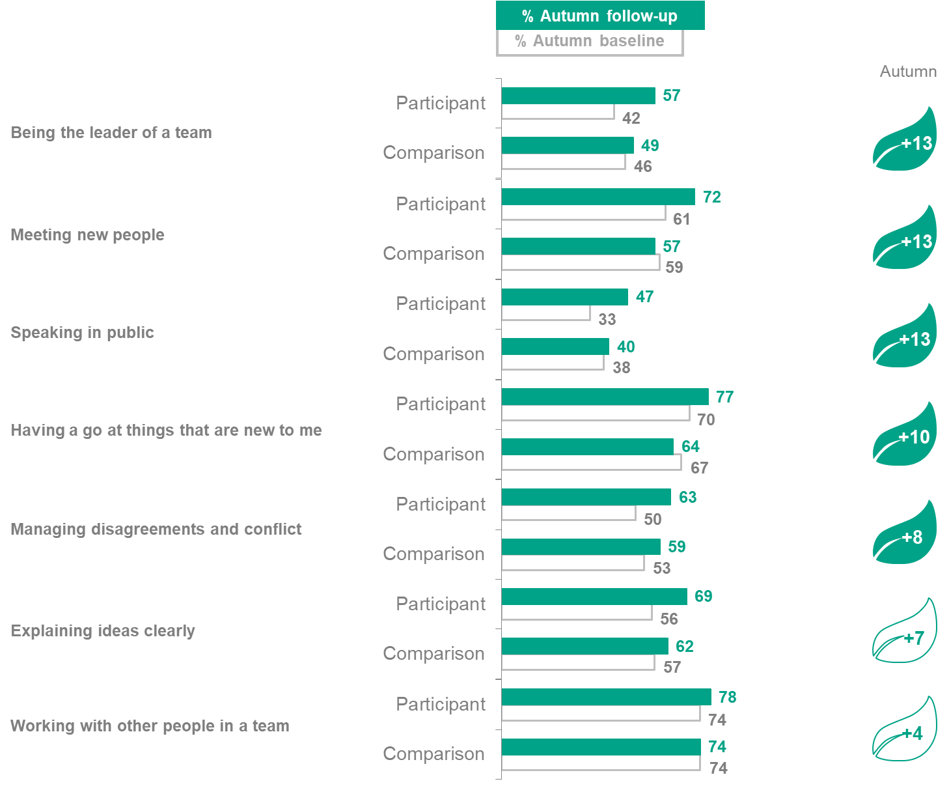***Figure 5.6 Self-confidence: leadership and communication – Autumn**

*“How do you feel about the following things, even if you have never done them before…?”*

Base: Autumn NCS participant baseline (completed on paper): 1,621 Autumn NCS participant follow-up (completed online): 684 Autumn Comparison group baseline (completed online): 2,731 Autumn Comparison group follow-up (completed online): 932

**Problem solving and decision-making skills**

**The summer NCS programme has a positive impact on all measures relating to problem solving and decision-making skills,** as Figure 5.7 shows. All impacts can be considered of a similar strength, when taking into account the confidence intervals surrounding them.

**Figure 5.7 Problem solving and decision-making skills – Summer**

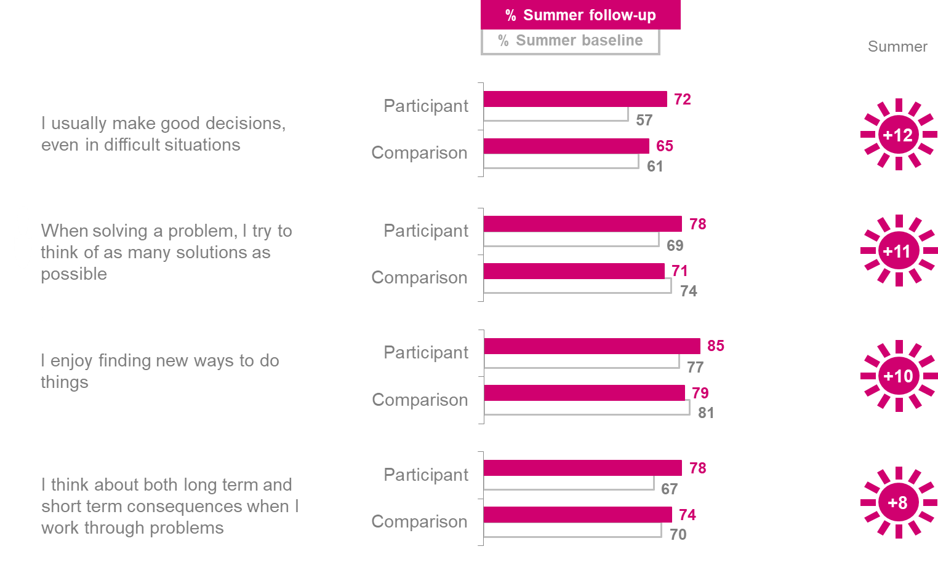

*“How much do you agree or disagree with the following statements?”*

Base: Summer NCS participant baseline (completed on paper): 13,714. Summer NCS participant follow-up (completed online): 1,640. Summer Comparison group baseline (completed online): 4,327. Summer Comparison group follow-up (completed online): 1,133.

**The autumn NCS programme has a positive impact on participants’ agreement that they enjoy finding new ways to do things** (**+6pp**). The other measures, shown in Figure 5.8, are not statistically significant.

**Figure 5.8 Problem solving and decision-making skills – Autumn**

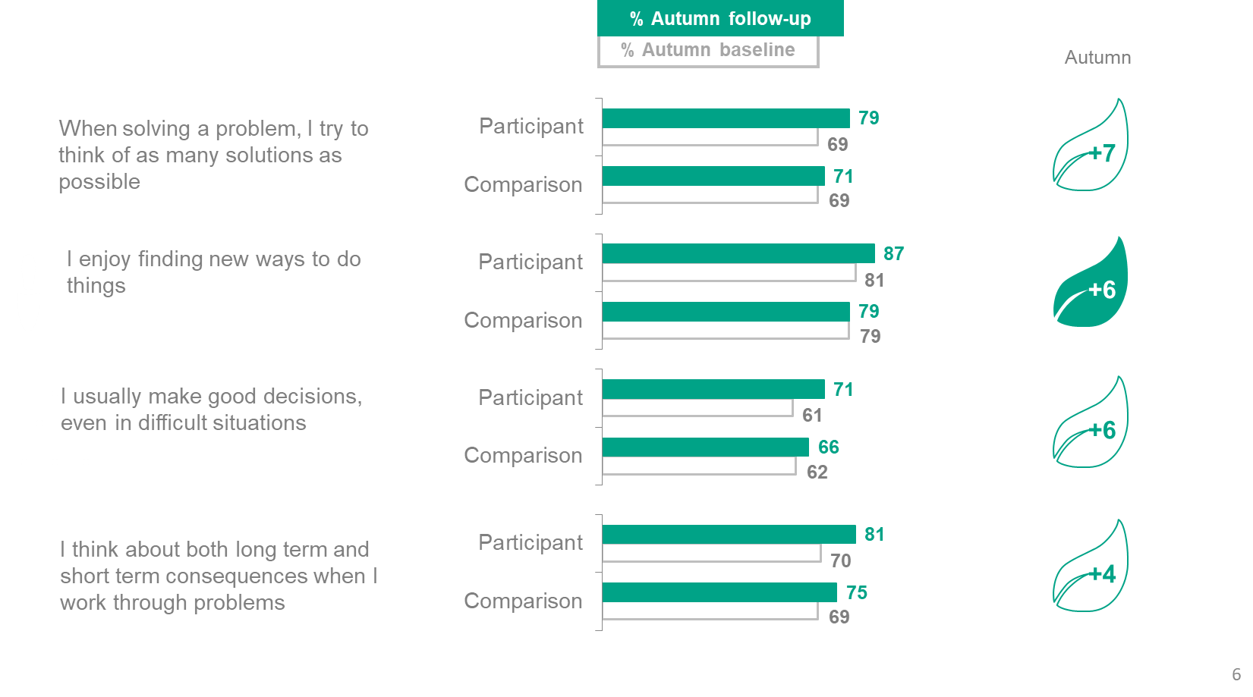

*“How much do you agree or disagree with the following statements?”*

Base: Autumn NCS participant baseline (completed on paper): 1,621 Autumn NCS participant follow-up (completed online): 684 Autumn Comparison group baseline (completed online): 2,731 Autumn Comparison group follow-up (completed online): 932

**Resilience and emotional regulation**

**The summer NCS programme has a positive impact on most measures of participants’ ability to assess and regulate their own emotions.** As shown in Figure 5.9, the only measure that does not experience an impact is participants’ agreement that they can usually handle whatever comes their way.

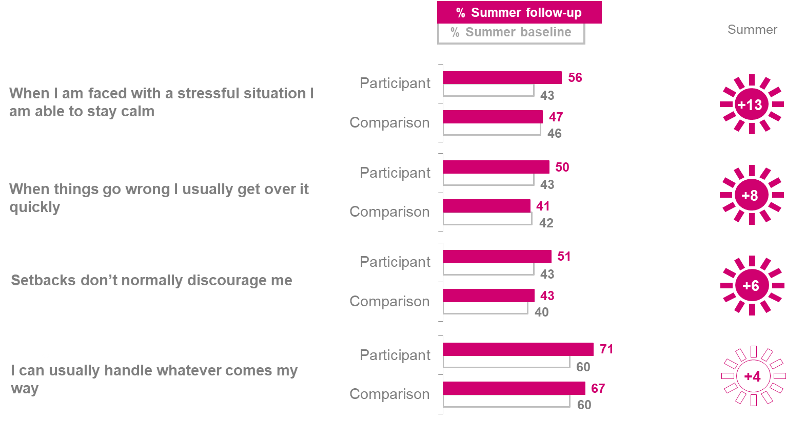**Figure 5.9 Resilience and emotional regulation - Summer**

*How much do you agree or disagree with the following statements? Please read the statements below and say how much you agree or disagree with them.*

Base: Summer NCS participant baseline (completed on paper): 13,714. Summer NCS participant follow-up (completed online): 1,640. Summer Comparison group baseline (completed online): 4,327. Summer Comparison group follow-up (completed online): 1,133.

**The autumn NCS programme has only one positive impact**: on participants’ agreement that when things go wrong they usually get over it quickly (**+9pp**). The impacts on other measures of resilience and emotional regulation are not significant, as reported in Figure 5.10.

**Figure 5.10 Resilience and emotional regulation - Autumn**

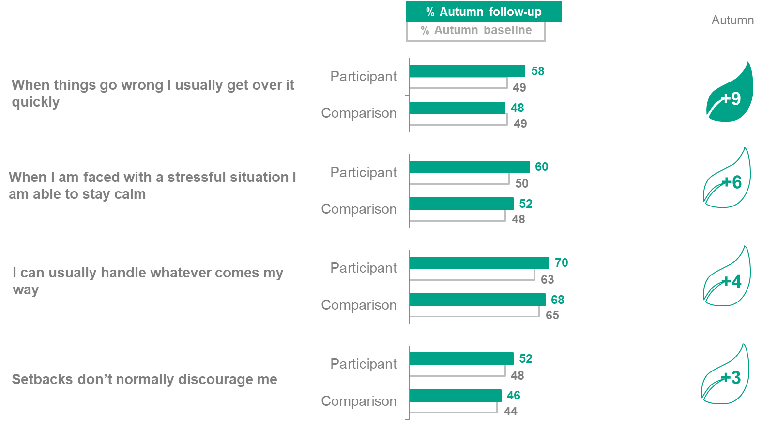

*How much do you agree or disagree with the following statements? Please read the statements below and say how much you agree or disagree with them.*

Base: Autumn NCS participant baseline (completed on paper): 1,621. Autumn NCS participant follow-up (completed online): 684. Autumn Comparison group baseline (completed online): 2,731. Autumn Comparison group follow-up (completed online): 932.

1. Social engagement

**Summary: Social engagement**

* Many social engagement measures were positive and statistically significant for both summer and autumn NCS programmes. However, for most social engagement measures we cannot say which impacts are definitively larger than others, due to wide confidence intervals around the impact estimates.
  + **Awareness of challenges faced by communities and sense of social responsibility:** Both summer and autumn programmes have a positive impact on participants’ agreement that they can have an impact on the world around them (summer **+15pp**; autumn **+17pp**) and that they would know how to deal with a problem in their local area (summer **+20pp**; autumn **+13pp**).
  + **Involvement in activities that benefit others:** The social action element of the programmes is intended to encourage further volunteering among participants. Accordingly, the summer NCS programme has a positive impact on young people taking part in extracurricular activities (**+9pp**), formal volunteering (**+10pp**) and informal volunteering (**+9pp**). The autumn NCS programme has a positive impact on participants taking part in informal volunteering of **+12pp**.
  + Related to the above, both the summer and autumn programmes also had an impact on **time spent volunteering** in a typical four-week period after the programme. Summer NCS participants spent an additional **8 hours** volunteering on average than the comparison group, whilst Autumn NCS participants spent an additional **5 hours** volunteering on average than the comparison group.
  + **Involvement in political processes and public debates:** Other academic research has demonstrated a connection between social action and future political engagement.25 Both summer and autumn NCS programmes are shown to help to promote democratic engagement, with a positive impact on participants’ intention of voting of **+0.6** for both programmes.

**Social engagement outcomes**

The NCS programme aims to contribute to a society in which young people have the awareness, skills and drive to serve and help shape the world around them.

Social action activities, in the form of social action projects in local communities and ‘pitches’ to external panels, are intended to make participants more aware of local community challenges and heighten their sense of social responsibility. Having an opportunity to do social action aims to boost participants’ motivation and give them a broader range of skills and connections to volunteer in the future in their local communities.

Seven in ten (**72%**) summer NCS participants report in the follow-up questionnaire that they spent **20 hours or more** on their NCS community social action project in their local area in summer 2018. In comparison, half **(51%)** of autumn NCS participants spent **20 hours or more** on their local social action project.

Furthermore, the programme aims to connect participants with local political networks and educate them about voting to promote more democratic engagement among the cohort. There is also evidence that volunteering (via social action projects) develops skills and attitudes that encourage political engagement, such as a feeling that one’s voice and actions can make a difference to politics.[27]

**Increased awareness of challenges faced by communities and sense of social responsibility**

The evaluation measures impact of the programme on participants’ sense of agency and their attitudes to community involvement, in relation to the social action activities.

**The summer NCS programme has a positive impact on all measures of community involvement and agency tested,** as Figure 6.1 shows.

**The survey data about summer participant experience corroborates the community involvement impact estimates.** When summer NCS participants were asked directly in the follow-up survey about the effect they think the summer programme had on them, **64%** agreed that they are now more likely to help out in their local area and **58%** agreed that they now feel they have a greater responsibility to their local community.

**Figure 6.1 Agency and attitudes to community involvement - Summer**

*How much do you agree or disagree with the following statements?*

Base: Summer NCS participant baseline (completed on paper): 13,714 Summer NCS participant follow-up (completed online): 1,640 Summer Comparison group baseline (completed online): 4,327 Summer Comparison group follow-up (completed online): 1,133

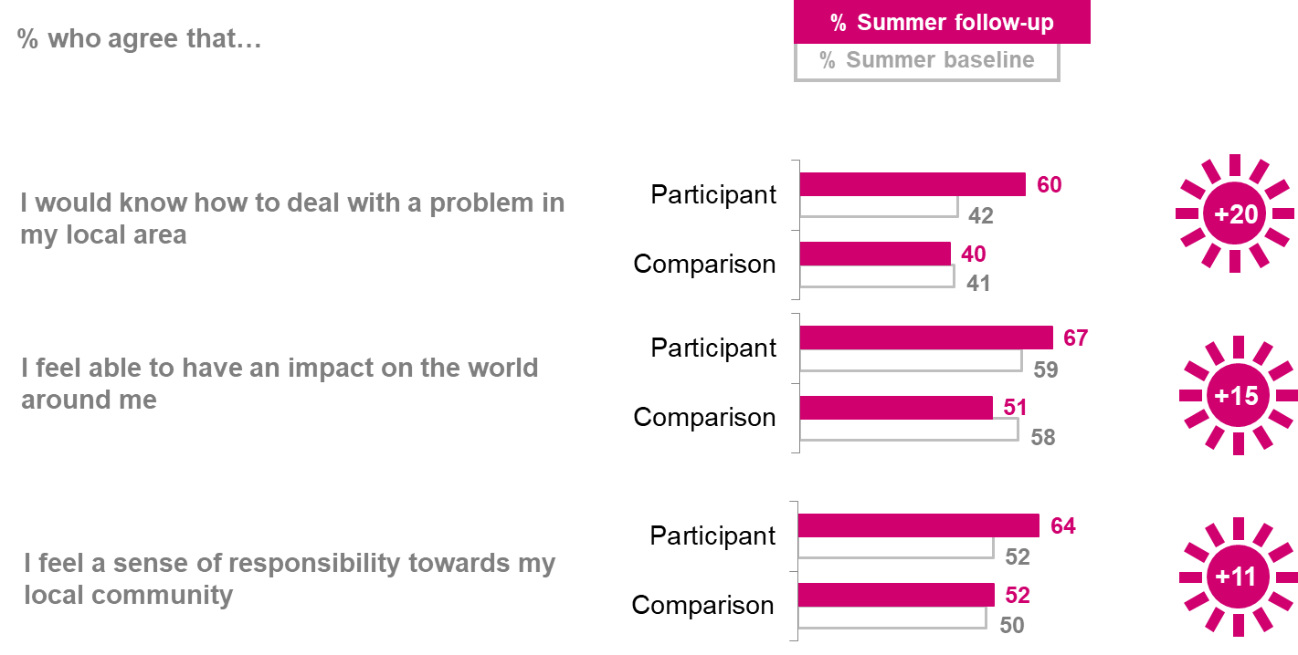

As presented in Figure 6.2 the autumn NCS programme also **has positive impacts across all of the agency and community involvement measures**.

Again, when asked directly in the follow-up survey about the effect they think the course had on them, **autumn NCS participants’ responses also support the impact estimates**. Around seven in ten **(69%)** agree that they are now more likely to help out in their local area, and approximately six in ten **(61%)** agree that they now feel they have a greater responsibility towards their local community.

**Figure 6.2 Agency and attitudes to community involvement - Autumn**

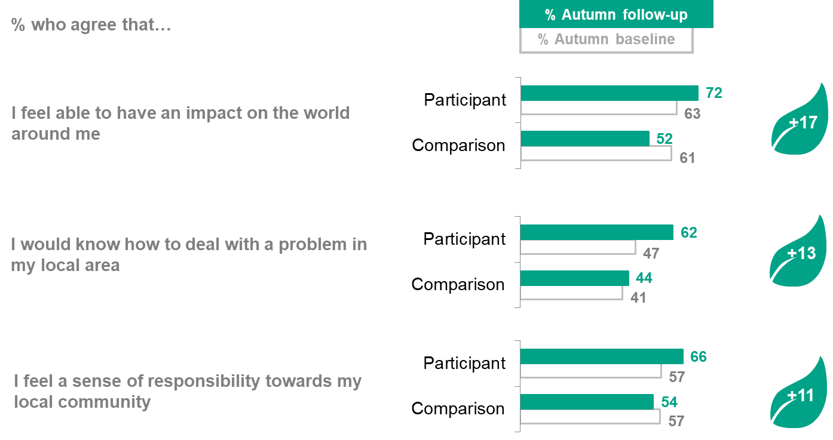

*How much do you agree or disagree with the following statements?*

Base: Autumn NCS participant baseline (completed on paper): 1,621 Autumn NCS participant follow-up (completed online): 684 Autumn Comparison group baseline (completed online): 2,731 Autumn Comparison group follow-up (completed online): 932

**Increased likelihood of getting involved in activities that benefit others**

The evaluation measures participants’ engagement in three different sorts of activities that can benefit others:

* **extracurricular activities** such as sports clubs or uniformed youth groups;
* **formal volunteering**, such as circulating a petition or raising money;
* **informal volunteering**, such as helping someone outside of their family with gardening or shopping.

The evaluation also measures the **number of hours spent on any of the activities above** by participants during the three months since they completed their NCS programme. The ambition is that participants of NCS will have gone out and done more hours of volunteering following their social action and wider programme experience than a young person who has not taken part in NCS.

**Engagement in activities that benefit others**

The NCS summer programme has a **positive impact on participants’ engagement in extracurricular activities**, as Figure 6.3 shows (**+9pp**). It also has a similar impact on participants’ **taking part in at least one form of formal volunteering** (**+10pp**), as demonstrated in Figure 6.4. By formal volunteering, we mean giving their time to help outside of school or college hours.

As context, over half (56%) of participants had taken part in extracurricular activities in the last three months before the baseline survey, and 57% had taken part in formal volunteering. These figures are similar to the 2018 social action participation rates of 57% reported by the National Youth Social Action Survey (NYSAS), although these applied to the last 12 months.[28]

There is a positive impact from the summer programme on most of the specific formal volunteering activities asked about (four out of six of the activities), for example taking action to help other people or improve their local area (**+10pp**) and contacting someone about an issue affecting their local area (**+5pp**).

For those formal volunteering activities where the summer NCS programme has a positive impact, the most popular activity was taking action to help other people or improve their local area, undertaken by nearly three in ten of participants in the three months after the programme (28%). While the 2018 NYSAS survey questions are not directly comparable to the NCS evaluation, it finds that 23% of young people participated in social action by supporting other people (not friends/relatives) and 16% by helping improve their local area.[29]

**Figure 6.3 Extracurricular activities - Summer**

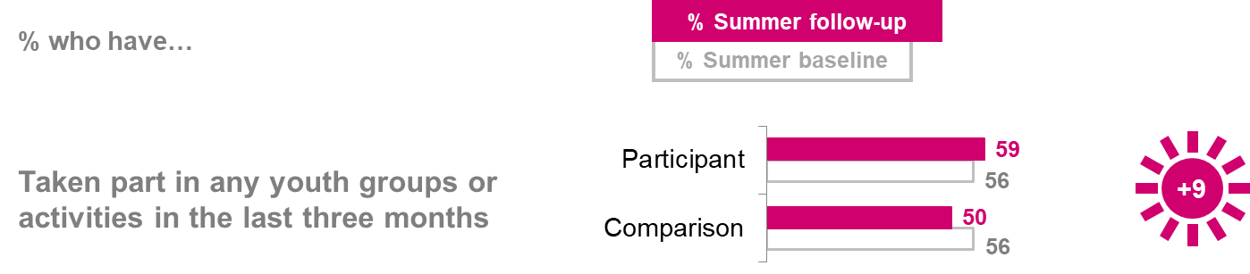

Baseline survey questions: *Have you taken part in any groups or activities such as sports clubs, dance or drama clubs, scouts/guides or cadets outside of school or college hours in the last three months?* Follow up survey question*: Have you taken part in any groups or activities such as sports clubs, dance or drama clubs, scouts/guides or cadets outside of school or college hours ‘since your summer NCS (NCS participants)/ since the summer holidays this year (comparison group)?* Base: Summer NCS participant baseline (completed on paper): 13,714 Summer NCS participant follow-up (completed online): 1,640 Summer Comparison group baseline (completed online): 4,327 Summer Comparison group follow-up (completed online): 1,133

**Figure 6.4 Formal volunteering - Summer**

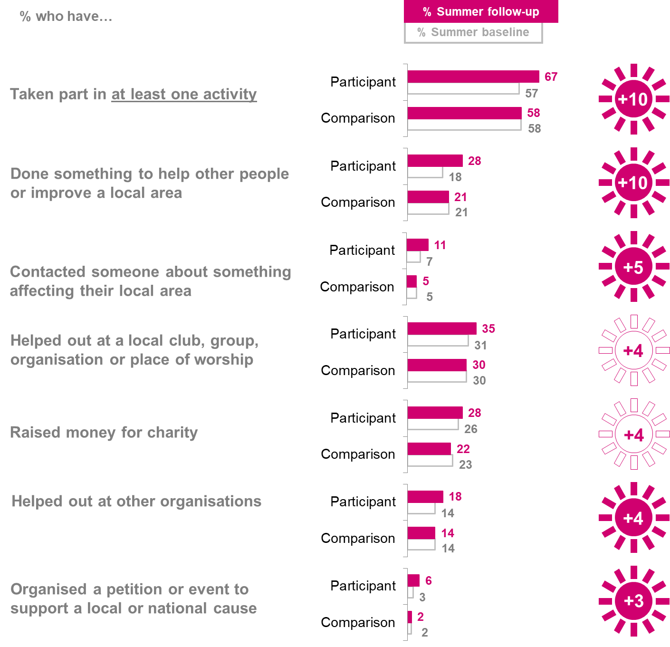

*Baseline survey question: Have you given your time to help in any of the following ways outside of school or college hours in the last three months? Follow up survey question: Have you given your time to help in any of the following ways outside of school or college hours since your summer NCS (NCS participants) /since the summer holidays this year (comparison group)? Please do not include anything you have done as part of NCS.*

Base: Summer NCS participant baseline (completed on paper): 13,714 Summer NCS participant follow-up (completed online): 1,640 Summer Comparison group baseline (completed online): 4,327 Summer Comparison group follow-up (completed online): 1,133

**The autumn NCS programme** **does not have a significant impact on participants’ engagement in either extracurricular activities or in at least one form of formal volunteering**, as Figures 6.5 and 6.6 show.

However, it does have some positive impacts on certain formal volunteering activities, namely raising money for charity (**+12pp**), taking action to help other people or improve their local area (**+11pp**), and helping out at other organisations **(+8pp**).

Once again, out of the formal volunteering activities where the autumn NCS programme has a positive impact, participants are most likely to take action to help other people or improve their local area in the three months following the programme (28%) or raise money for charity (27%).

**Figure 6.5 Extracurricular activities - Autumn**

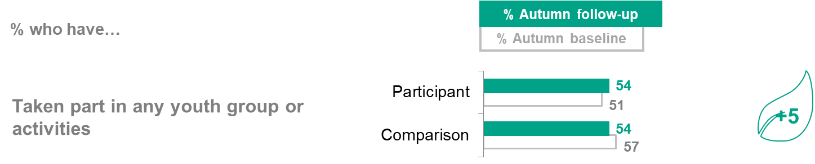

Baseline survey questions: Have you taken part in any groups or activities such as sports clubs, dance or drama clubs, scouts/guides or cadets outside of school or college hours in the last three months? Follow up survey question: *Have you taken part in any groups or activities such as sports clubs, dance or drama clubs, scouts/guides or cadets outside of school or college hours since your autumn NCS (NCS participants)/ since November 2018 (comparison group)?;*

Base: Autumn NCS participant baseline (completed on paper): 1,621 Autumn NCS participant follow-up (completed online): 684 Autumn Comparison group baseline (completed online): 2,731 Autumn Comparison group follow-up (completed online): 932

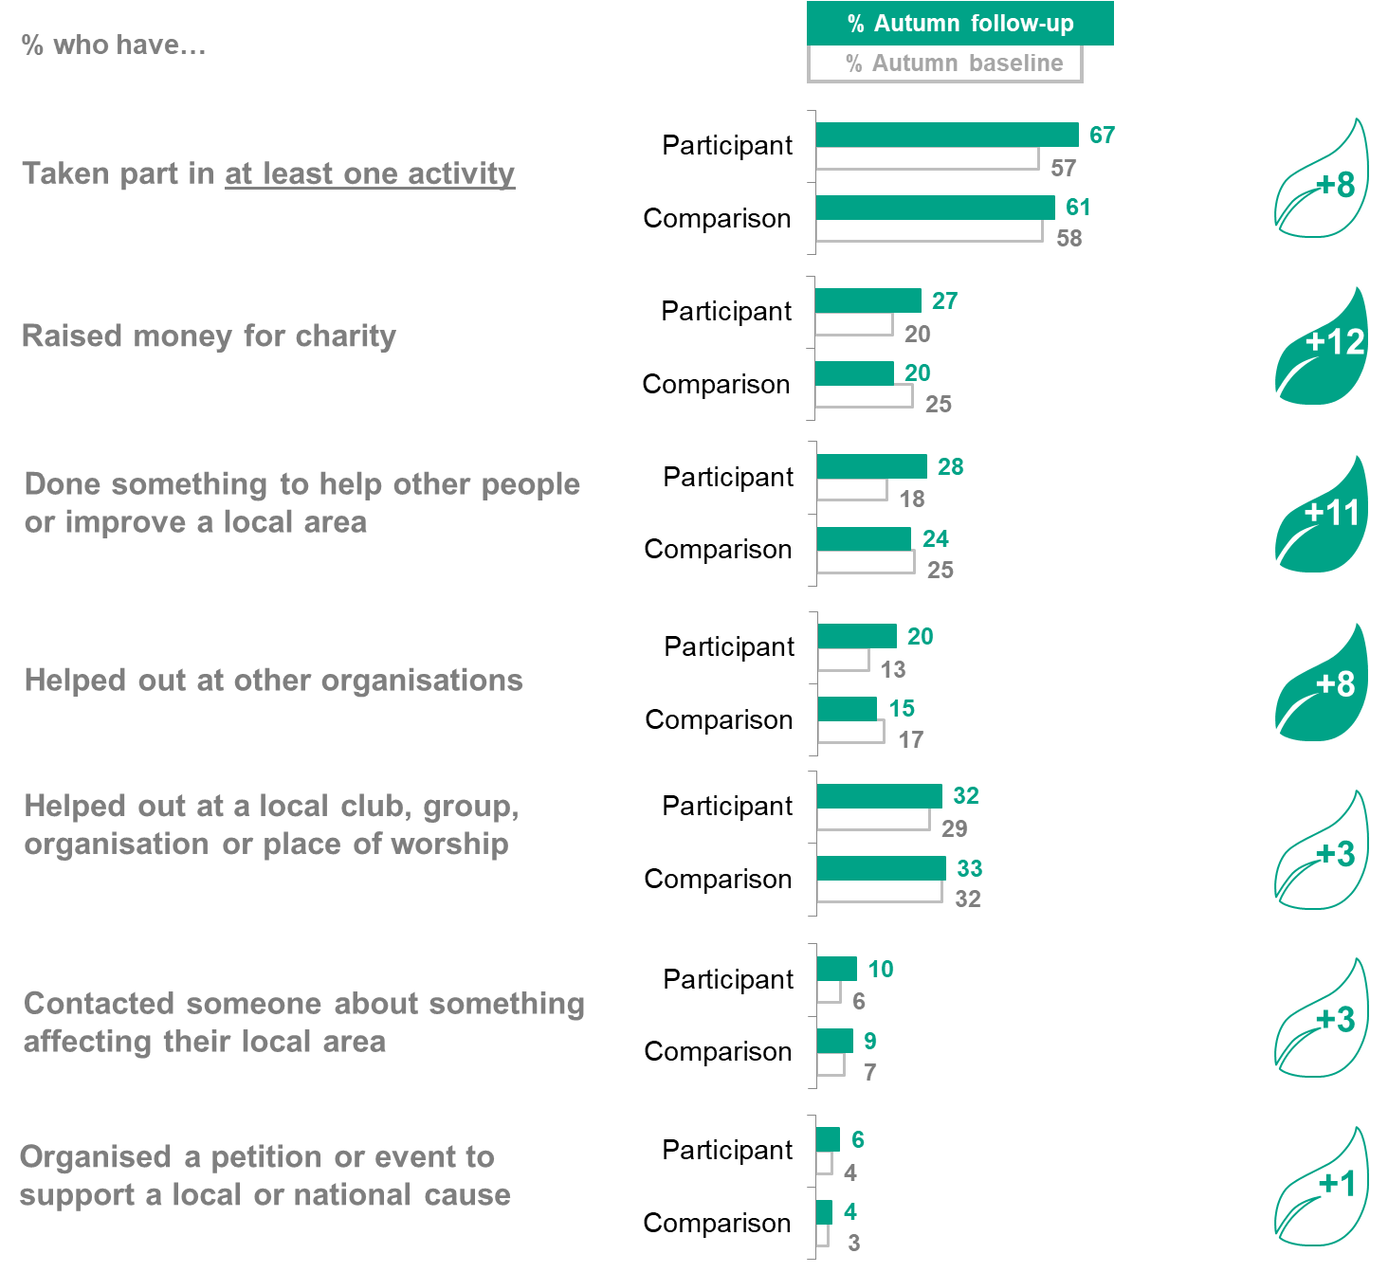**Figure 6.6 Formal volunteering – Autumn**

Baseline survey question: Have you given your time to help in any of the following ways outside of school or college hours in the last three months? Follow up survey question: *Have you given your time to help in any of the following ways outside of school or college hours since your autumn NCS (NCS participants) /since November this year (comparison group)? Please do not include anything you have done as part of NCS.* Base: Autumn NCS participant baseline (completed on paper): 1,621 Autumn NCS participant follow-up (completed online): 684 Autumn Comparison group baseline (completed online): 2,731 Autumn Comparison group follow-up (completed online): 932

**Informal volunteering**

**The summer NCS programme has a clear positive impact on young people’s engagement in informal volunteering (+9pp** taking part in at least one activity**).** By informal volunteering we mean helping someone not in their family.

The programme has an impact on participants’ involvement in particular informal volunteering activities, namely babysitting/caring for children, helping out with a university/job application or writing letters/ filling in forms for someone (all **+6pp**). There is also an impact of **+15pp** for helping out in some other way.

For those activities where the programme has a positive impact, the most popular activities that participants undertake in the three months after the programme are babysitting or caring for children, carried out by a third of participants (33%) or helping out in some other way (45%).

**Figure 6.7 Participation in informal volunteering – Summer**

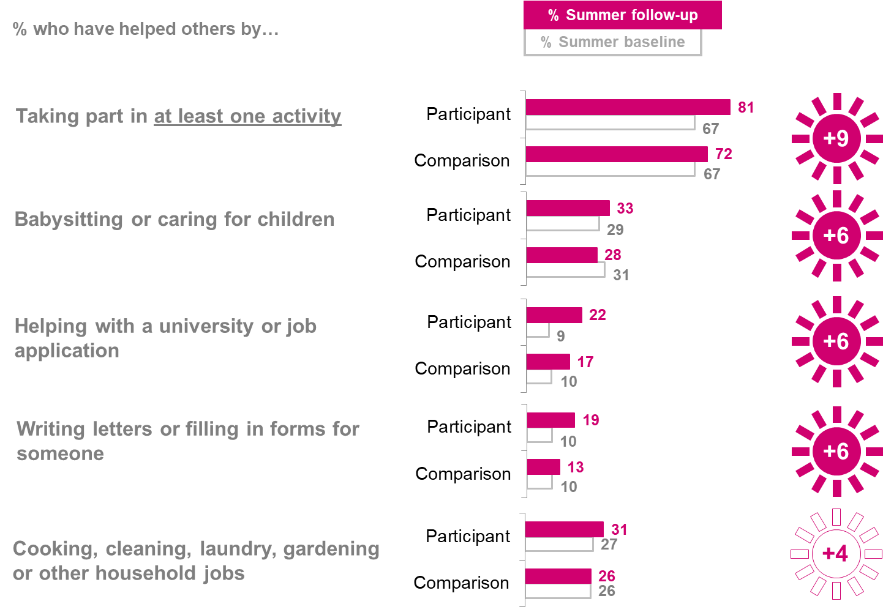

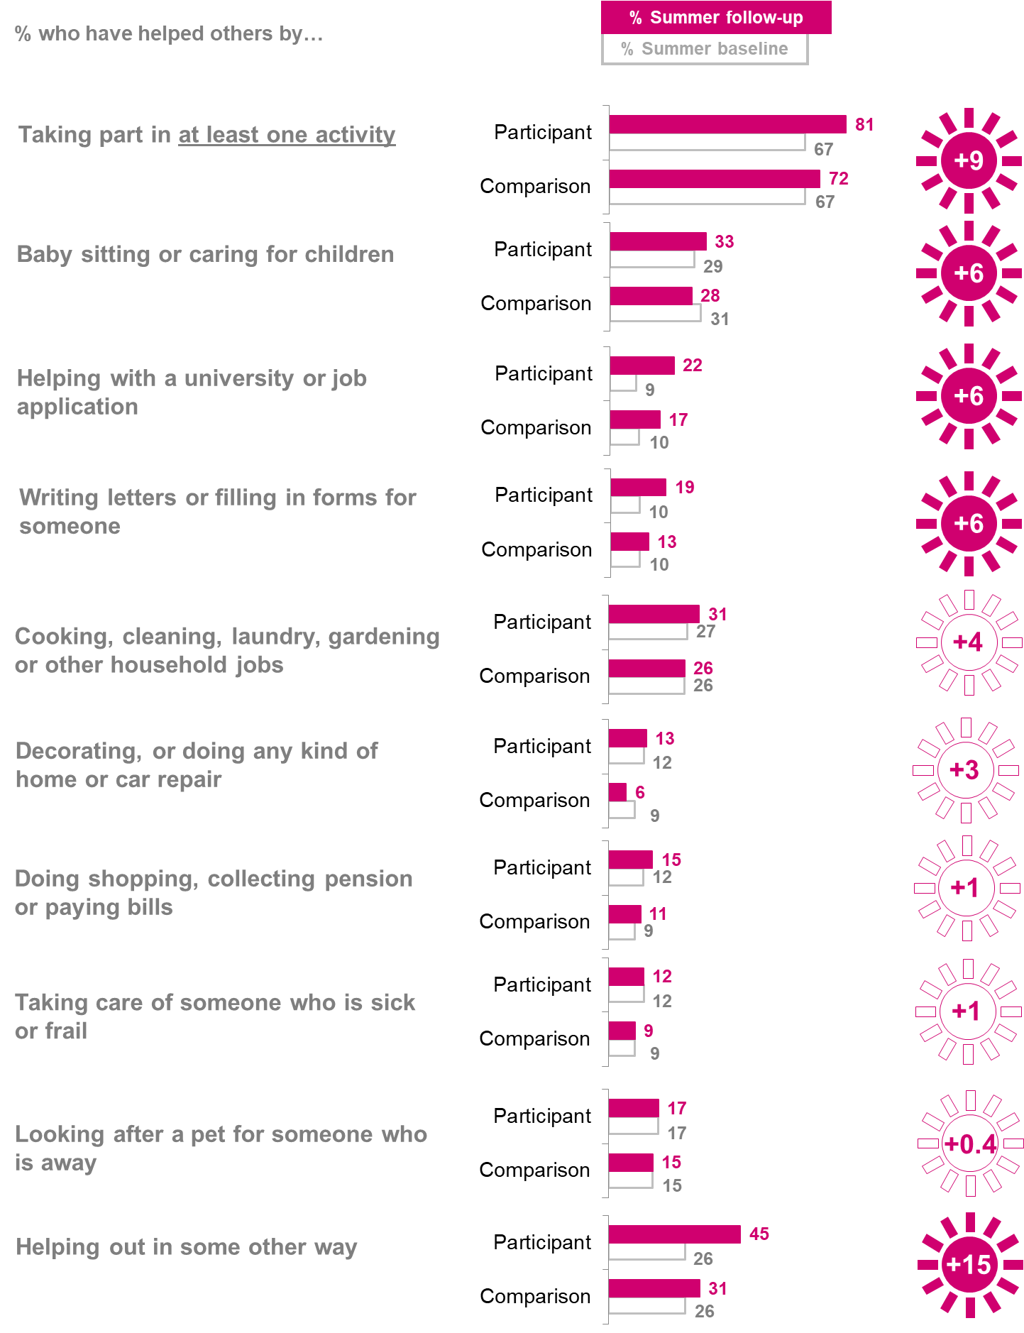

*Baseline survey question:* *Have you helped anyone not in your family in any of these ways in the last three months? Follow up survey question: Have you helped anyone not in your family in any of these ways since your summer NCS (NCS participants)/since the summer holidays this year (Comparison group)? Do not include anything you were paid to do or anything you have done as part of NCS.*

Base: Summer NCS participant baseline (completed on paper): 13,714 Summer NCS participant follow-up (completed online): 1,640 Summer Comparison group baseline (completed online): 4,327 Summer Comparison group follow-up (completed online): 1,133

**The NCS autumn programme also has a positive impact on informal volunteering among participants (+12pp** taking part in at least one activity**)**, as shown below in Figure 6.8.

The programme has positive impacts on three of the specific informal volunteering activities asked about. These include three that are also significant and positive for summer NCS participants: helping out in some other way (**+25pp**), writing letters or filling in forms (**+13pp**) and helping with a university or job application (**+8pp**).

The most popular type of informal volunteering activity for autumn participants following their NCS experience is in line with that of summer participants: helping out in some other way, which was the option chosen by nearly half of participants (49%).

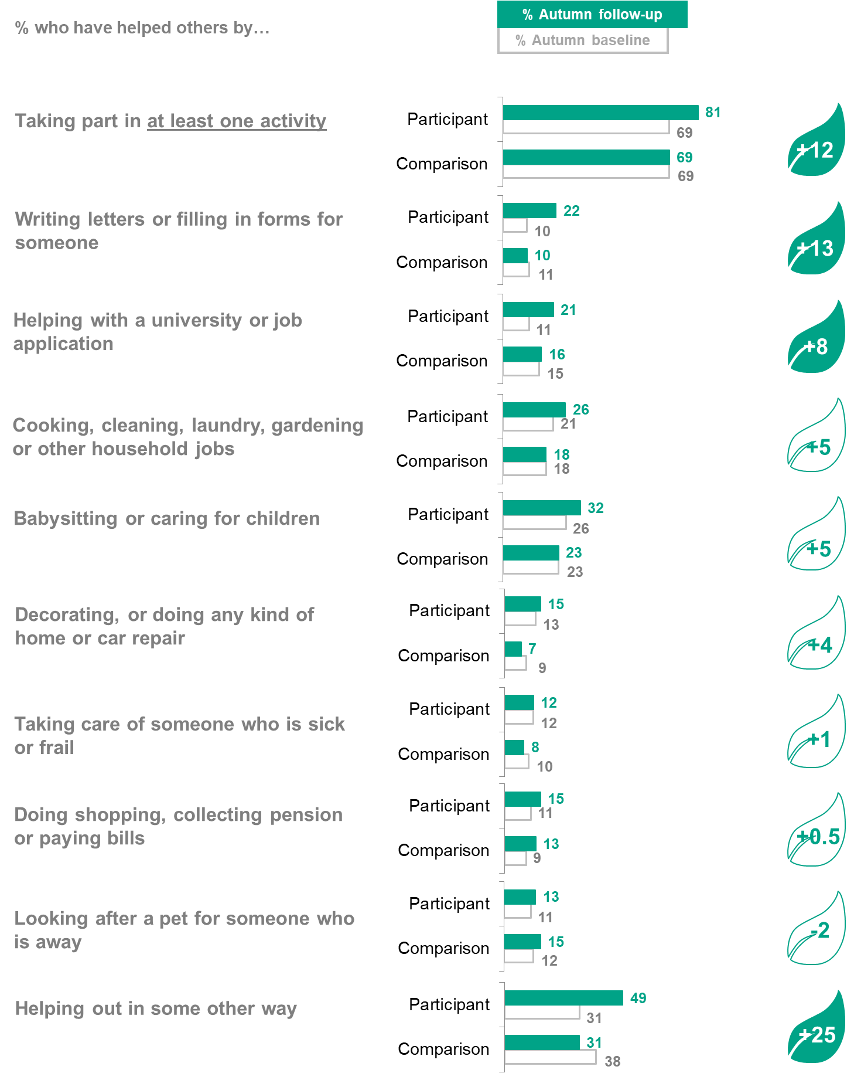**Figure 6.8 Participation in informal volunteering - Autumn**

*Baseline survey question: Have you helped anyone not in your family in any of these ways in the last three months? Follow up survey question: Have you helped anyone not in your family in any of these ways since your autumn NCS (NCS participants)/since November this year (Comparison group)? Do not include anything you were paid to do or anything you have done as part of NCS.*

Base: Autumn NCS participant baseline (completed on paper): 1,621 Autumn NCS participant follow-up (completed online): 684 Autumn Comparison group baseline (completed online): 2,731 Autumn Comparison group follow-up (completed online): 932

**Time spent on volunteering**

In line with the positive impact the summer NCS programme has on activities that benefit others, **it had an additional positive impact on the amount of time participants spend on extracurricular activities, and formal and informal volunteering post-programme.**

On average, in the three months approximately that followed the summer programme, NCS participants spent **8** **hours** **more** volunteering in a four-week period than the comparison group, as demonstrated in Figure 6.9. (This volunteering measure excludes the number of hours that participants would have spent as part of their NCS course as far as possible.)

**Figure 6.9 Hours spent on volunteering - summer**

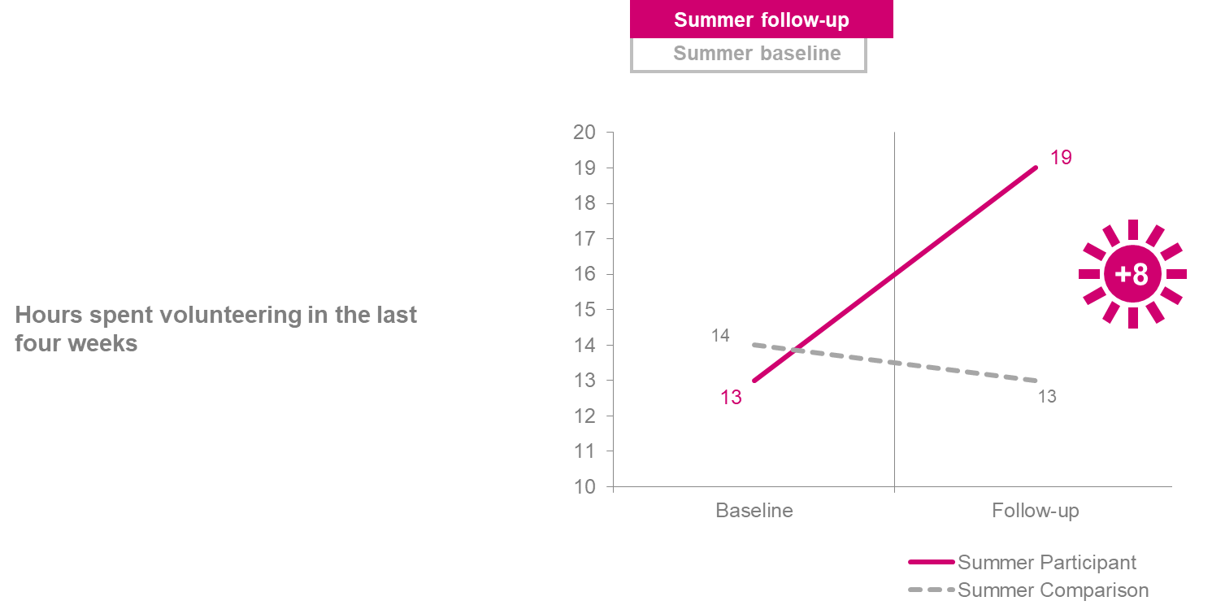

*Now just thinking about the last 4 weeks. Approximately how many hours have you spent helping in any of the ways selected in Q2 and Q3, in the last 4 weeks? If you are not sure, please write your best estimate.*

Base: Summer NCS participant baseline (completed on paper): 13,714 Summer NCS participant follow-up (completed online): 1,640 Summer Comparison group baseline (completed online): 4,327 Summer Comparison group follow-up (completed online): 1,133

Further to this, **the autumn NCS programme also had a significant impact on NCS participants’ time spent volunteering post-programme (5 hours more)**, as shown in Figure 6.10.

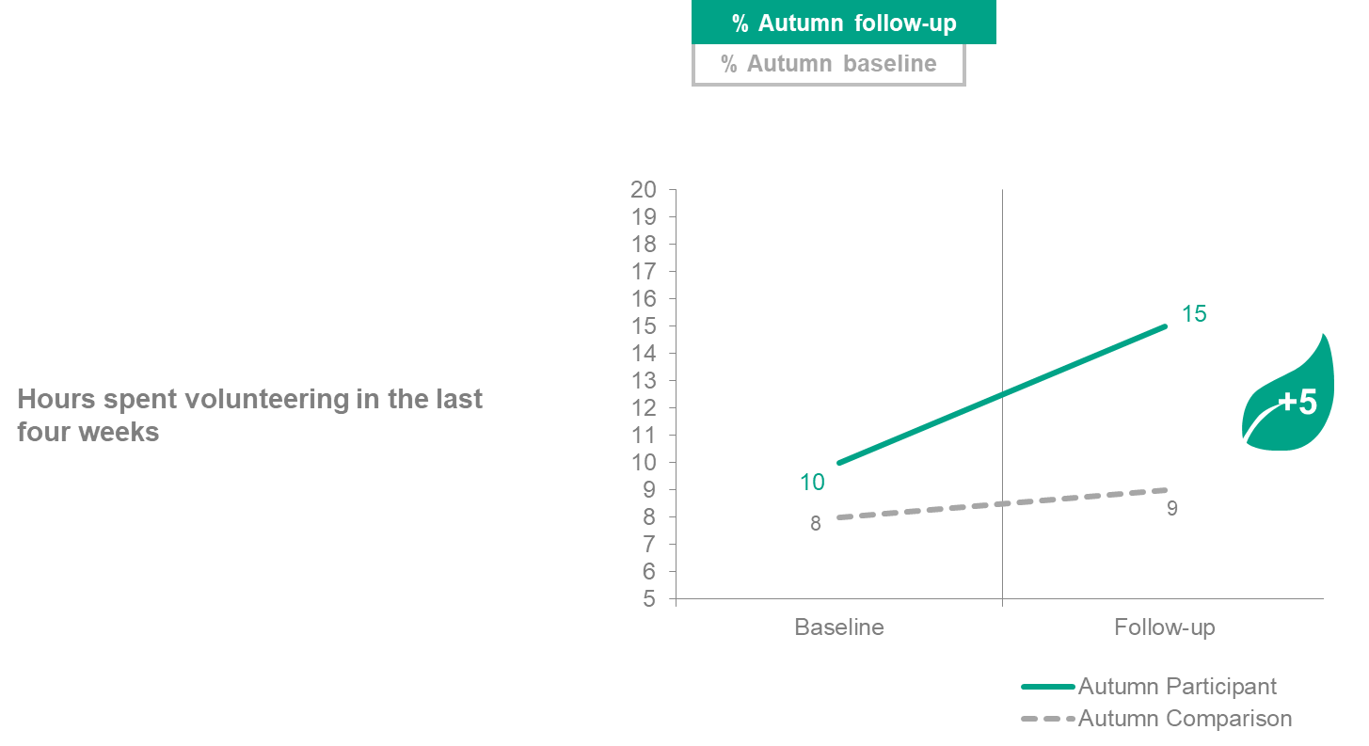**Figure 6.10 Hours spent on volunteering - autumn**

*Now just thinking about the last 4 weeks. Approximately how many hours have you spent helping in any of the ways selected in Q2 and Q3, in the last 4 weeks? If you are not sure, please write your best estimate.*

Base: Autumn NCS participant baseline (completed on paper): 1,621 Autumn NCS participant follow-up (completed online): 684 Autumn Comparison group baseline (completed online): 2,731 Autumn Comparison group follow-up (completed online): 932

**Increased engagement in the democratic process**

**Encouragingly, participants are more open to engaging in the political process after attending the summer NCS programme.** Specifically, the programme has a positive impact onparticipants saying they are likely to vote at the next election or referendum (as scored by respondents on a scale of 1-10). There is a positive impact of **+0.6** on the mean score for summer among those saying they would be ‘absolutely certain’ to vote, as shown in Figure 6.11.

**Figure 6.11 Voting intention - Summer**

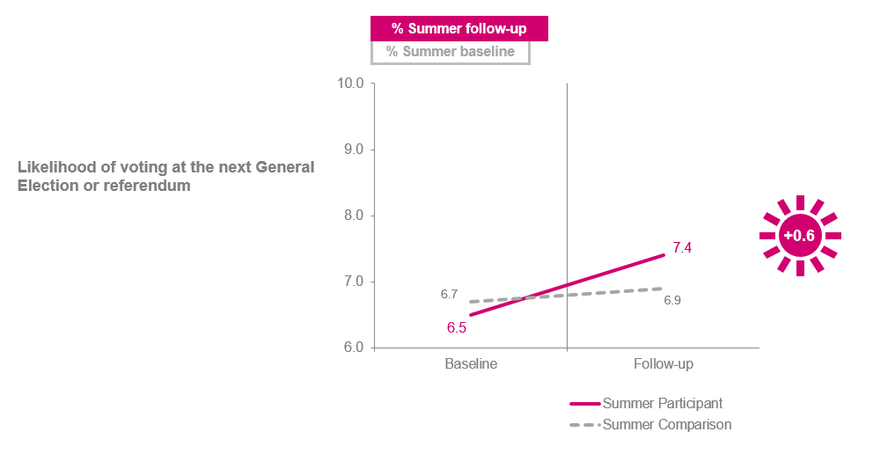

*At the next election or referendum, where you are legally old enough to vote, how likely are you to vote?* *Use a scale of 1 to 10, where 1 means you would be absolutely certain not to vote, and 10 means that you would be absolutely certain to vote.* Base: Summer NCS participant baseline (completed on paper): 13,714 Summer NCS participant follow-up (completed online): 1,640 Summer Comparison group baseline (completed online): 4,327 Summer Comparison group follow-up (completed online): 1,133

There are some caveats to this finding. Other Kantar research shows that young people considerably overstate the probability that they will vote: a young person aged 18-29 who says they will definitely vote (and did not vote in the last election) has approximately a 74% probability of voting.[30] This is supported by analysis of the 2010 British Election Survey microdata, which finds that of those 18-29 year-olds who say they will definitely vote, 69% go on to do so.[31]

It may also be the case that the high baseline scores for both participants and comparison group members indicate that the average 16-18-year-old already plans to vote without the intervention of NCS, or at least thinks that they *should* vote in future.

Nonetheless, the increase in intention can be interpreted as a positive step towards NCS’s goal of engaging young people in political processes and public debates.

**The autumn NCS programme also has a positive impact on participants’ voting intention (+0.6** on the mean score for autumn among those saying they would be ‘absolutely certain’ to vote**),** as demonstrated in Figure 6.12.

**Figure 6.12 Voting intention - Autumn**

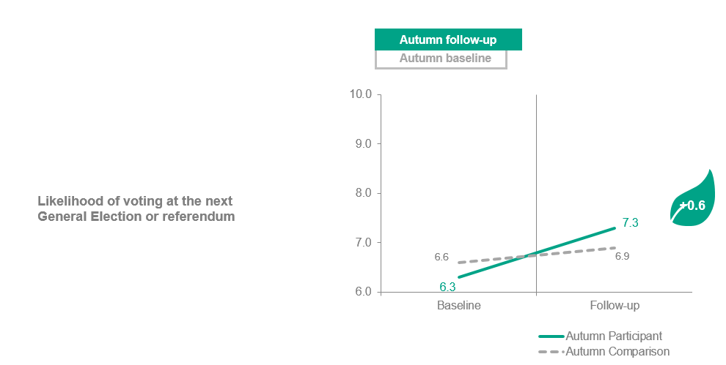

*At the next election or referendum, where you are legally old enough to vote, how likely are you to vote? Use a scale of 1 to 10, where 1 means you would be absolutely certain not to vote, and 10 means that you would be absolutely certain to vote.*

Base: Autumn NCS participant baseline (completed on paper): 1,621 Autumn NCS participant follow-up (completed online): 684 Autumn Comparison group baseline (completed online): 2,731 Autumn Comparison group follow-up (completed online): 932

1. Wellbeing and loneliness

**Summary: Wellbeing and loneliness**

* Overall, the evaluation finds that the NCS summer programme has a positive impact on participants’ wellbeing, but not on loneliness. The autumn programme has no impact on either.
  + **Wellbeing: The summer NCS programme has positive impacts, all of a similar effect size, on all four ONS wellbeing measures**: a) life satisfaction (**+0.4**); b) the extent to which they feel the things they do in their life are ‘worthwhile’ (**+0.5**);c) happiness (**+0.4**); and d) anxiety (**-0.5**). However, the autumn NCS programme does not have a significant impact on any of the same wellbeing measures.
  + **Loneliness: Neither the summer nor autumn NCS programmes have a significant impact on** **loneliness.**

Focusing on the wellbeing of NCS participants may help NCS Trust meet the intended social outcomes of their programme: improved social mobility, social cohesion and civic engagement. For instance, there is some evidence that social action is positively associated with wellbeing measures, such as life satisfaction and trust.[32] As such, assessing the impact of the NCS on young people’s wellbeing was a key part of the 2018 evaluation.

To assess the impact of NCS on participants’ wellbeing the four Office for National Statistics (ONS) measures were used. Young people were asked to refer to a scale of 0-10 and rate: a) their **life satisfaction**; b) the extent to which they feel the things they do in their life are **‘worthwhile’**; c) how **happy** they felt yesterday; and d) how **anxious** they felt yesterday.

**Life satisfaction, ‘worthwhile’, happiness and anxiety**

**The summer NCS programme has a** **positive impact on all four of the wellbeing measures**: life satisfaction (**+0.4**); the extent to which they feel the things they do in their life are ‘worthwhile’ (**+0.5**); happiness (**+0.4**); and anxiety (**-0.5**).[33]

The baseline and follow-up scores for these measures are approximately in line with wider ONS findings on wellbeing among young people aged 16-19 recorded between October 2017 and September 2018.[34] The ONS reports similar mean scores for most counts: life satisfaction (8.0); worthwhile (7.8); and happiness (7.6). However, the ONS reports a mean score for anxiety of 2.8, somewhat lower than that found among both NCS participants and the comparison (ranging between 4 and 4.3 at the baseline). This suggests that young people in both our participant and comparison groups have higher levels of anxiety than the wider youth population.

Figures 7.1-7.4 show the change in mean scores for each of the four wellbeing measures.

**Figure 7.1 Summer: Change in mean score on life satisfaction**

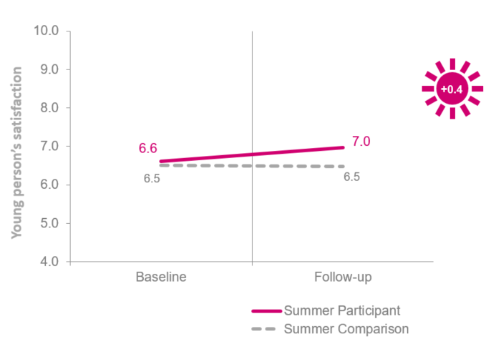

*On a scale of 0-10, where 0 is not at all satisfied and 10 is completely satisfied, overall, how satisfied are you with your life nowadays?*

Base: Summer NCS participant baseline (completed on paper): 13,714 Summer NCS participant follow-up (completed on paper): 1,640 Summer Comparison group baseline (completed online): 4,327 Summer Comparison group follow-up (completed online): 1,133

**Figure 7.2 Summer: Change in mean score on extent to which things you do in your life are worthwhile**

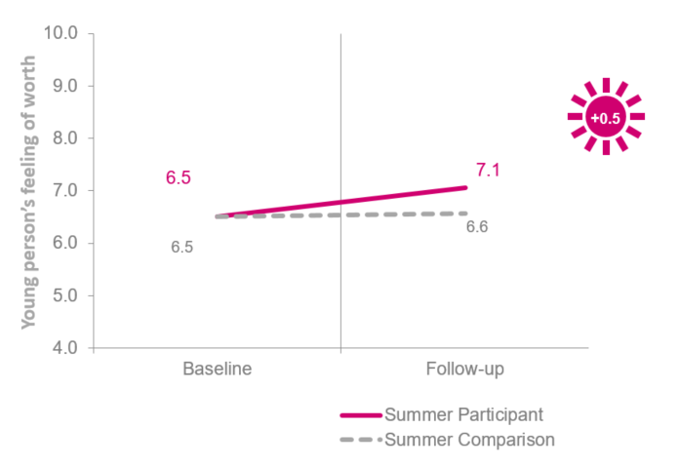

*On a scale of 0-10, where 0 is not at all worthwhile and 10 is completely worthwhile, overall, to what extent do you feel the things you do in your life are worthwhile?*

Base: Summer NCS participant baseline (completed on paper): 13,714 Summer NCS participant follow-up (completed on paper): 1,640 Summer Comparison group baseline (completed online): 4,327 Summer Comparison group follow-up (completed online): 1,133

**Figure 7.3 Summer: Change in mean score on happiness yesterday**

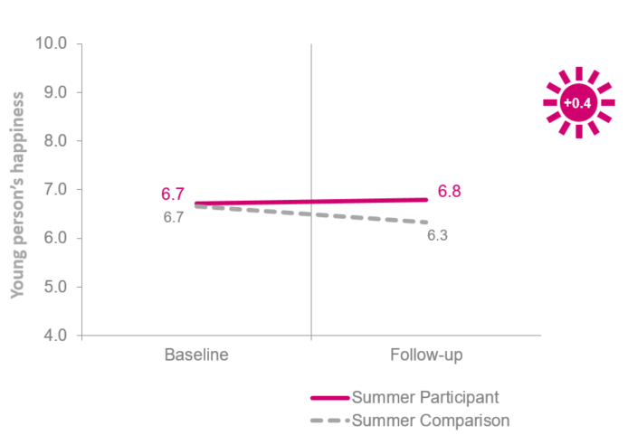

*On a scale of 0-10, where 0 is not at all happy and 10 is completely happy, overall, how happy did you feel yesterday?*

Base: Summer NCS participant baseline (completed on paper): 13,714 Summer NCS participant follow-up (completed on paper): 1,640 Summer Comparison group baseline (completed online): 4,327 Summer Comparison group follow-up (completed online): 1,133

**Figure 7.4 Summer: Change in mean score on anxiety yesterday21**

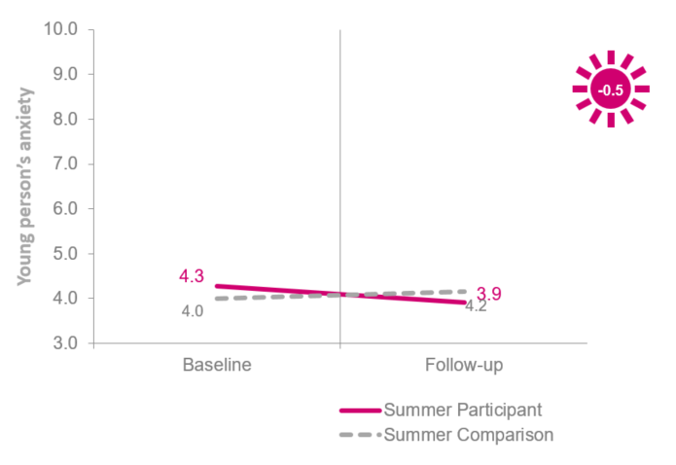

*On a scale of 0-10, where 0 is not at all anxious and 10 is completely anxious, overall, how anxious did you feel yesterday?*

Base: Summer NCS participant baseline (completed on paper): 13,714 Summer NCS participant follow-up (completed on paper): 1,640 Summer Comparison group baseline (completed online): 4,327 Summer Comparison group follow-up (completed online): 1,133

In contrast, **the autumn NCS programme does not have a significant impact on any wellbeing measures,** as Figures 7.5-7.8 demonstrate.

**Figure 7.5 Autumn: Change in mean score on life satisfaction**

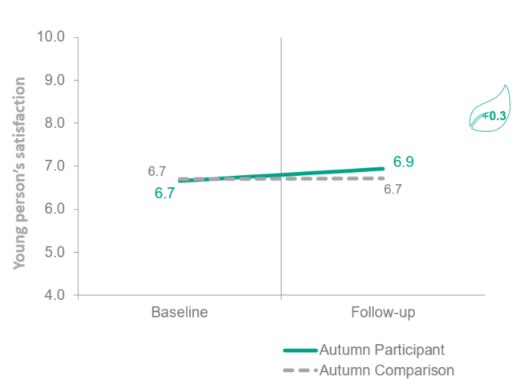

*On a scale of 0-10, where 0 is not at all satisfied and 10 is completely satisfied, overall, how satisfied are you with your life nowadays?*

Base: Autumn NCS participant baseline (completed on paper): 1,621 Autumn NCS participant follow-up (completed online): 684 Autumn Comparison group baseline (completed online): 2,731 Autumn Comparison group follow-up (completed online): 932

**Figure 7.6 Autumn: Change in mean score on extent to which things you do in your life are worthwhile**

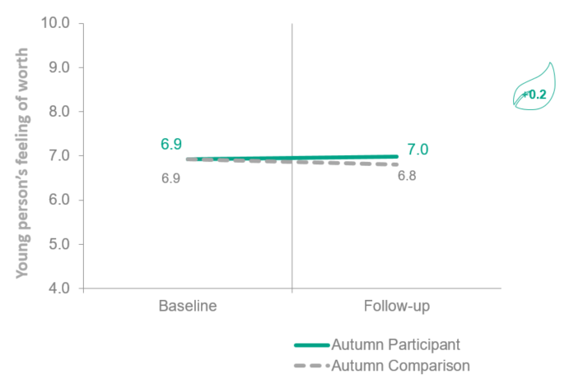

*On a scale of 0-10, where 0 is not at all worthwhile and 10 is completely worthwhile, overall, to what extent do you feel the things you do in your life are worthwhile?*

Base: Autumn NCS participant baseline (completed on paper): 1,621 Autumn NCS participant follow-up (completed online): 684 Autumn Comparison group baseline (completed online): 2,731 Autumn Comparison group follow-up (completed online): 932

**Figure 7.7 Autumn: Change in mean score on happiness yesterday**

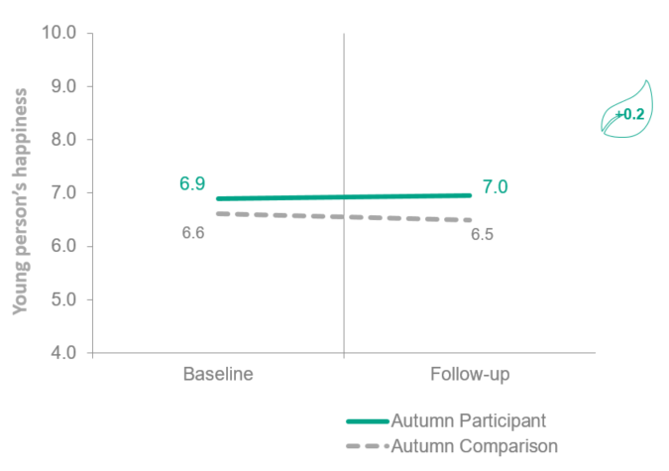

*On a scale of 0-10, where 0 is not at all happy and 10 is completely happy, overall, how happy did you feel yesterday?*

Base: Autumn NCS participant baseline (completed on paper): 1,621 Autumn NCS participant follow-up (completed online): 684 Autumn Comparison group baseline (completed online): 2,731 Autumn Comparison group follow-up (completed online): 932

**Figure 7.8 Autumn: Change in mean score on anxiety yesterday**

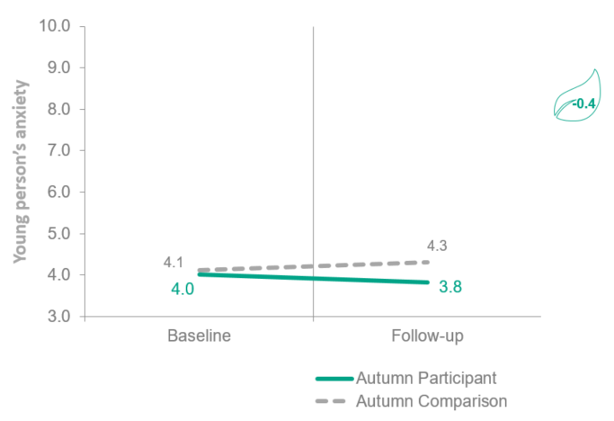

*On a scale of 0-10, where 0 is not at all anxious and 10 is completely anxious, overall, how anxious did you feel yesterday?*

Base: Autumn NCS participant baseline (completed on paper): 1,621 Autumn NCS participant follow-up (completed online): 684 Autumn Comparison group baseline (completed online): 2,731 Autumn Comparison group follow-up (completed online): 932

**Loneliness**

The evaluation also measured how often participants feel lonely.[35] Figures 7.9 and 7.10 show that **neither the summer nor the autumn NCS programme has a significant impact on how often participants feel lonely.**

A substantial minority of participants (32% summer; 30% autumn) say they ‘never’ or ‘hardly ever’ feel lonely during the follow-up survey. To set this in context, the same loneliness question is also asked as part of the Community Life Survey where it provides national figures in England on loneliness for ONS (for the population aged 16 and over). The Community Life Survey finds that of the full population aged 16 or over, 23% say they never feel lonely and 31% say they hardly ever do.[36] This suggests that the young people in both our participant and comparison groups report lower levels of loneliness than the wider population.

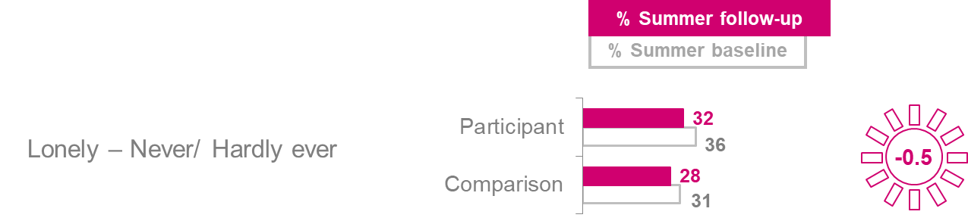**Figure 7.9 Summer: % of those who ‘never’ or ‘hardly ever’ feel lonely**

*How often do you feel lonely?*

Base: Autumn NCS participant baseline (completed on paper): 1,621 Autumn NCS participant follow-up (completed online): 684 Autumn Comparison group baseline (completed online): 2,731 Autumn Comparison group follow-up (completed online): 932

*’*

**Figure 7.10 Autumn: % of those who ‘never’ or ‘hardly ever’ feel lonely**

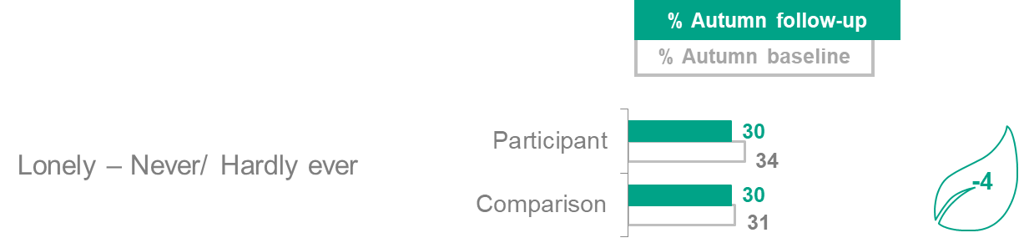

*How often do you feel lonely?*

Base: Summer NCS participant baseline (completed on paper): 13,714 Summer NCS participant follow-up (completed on paper): 1,640 Summer Comparison group baseline (completed online): 4,327 Summer Comparison group follow-up (completed online): 1,133

1. Participant experience

**Summary: Participant experience**

* **Overall enjoyment**: Participants on both the summer and autumn NCS programmes report having positive experiences, with most agreeing they would recommend NCS to other young people **(summer 95%, autumn 96%)** and would like to stay in touch with NCS in the future **(summer 87%, autumn 86%)**.
* **Perceptions of staff:** Overall, NCS participants think the course is well run by staff. Almost seven in ten (**71%**) summer participants agree that NCS staff are supportive and **65%** of summer participants agree ‘they encouraged me to fully take part in the programme.’ A similar proportion of autumn participants agree that staff are supportive (**68%**) and encourage them to fully take part in the programme (**66%**). One area where the evaluation found room for improvement was around staff’s knowledge, with only half of participants agreeing that staff are knowledgeable about the course **(summer 49%, autumn 50%)**.
* **Views on personal development**: The majority of summer and autumn NCS participants feel the programme has had a positive impact on their personal development, with both **87%** of summer and autumn participants agreeing that NCS has helped develop their skills for the future. Participants also say the programme has improved their self-understanding and pride: 89% of both cohorts agree they are proud of what they have achieved and over four in five agree they have a better understanding of their abilities (82% for summer and 80% for autumn).
* **Changes to attitudes to the future**: Summer and autumn NCS participants also agree that the NCS programme has improved their emotional resilience and, ultimately, helped them to be better equipped for the future. Almost four in five (**78%**) summer and autumn participants agree that they now ‘feel better prepared for challenges that life might bring me’ while over seven in ten say they feel better prepared for further education or training (74% for summer and 72% for autumn). A similar proportion say they are more able to see the steps needed to achieve their goals (70% for summer and 71% for autumn).

This chapter examines participants’ experience of the NCS programme and their perceptions of its impact on them. As the findings draw solely on questions asked to participants at the follow-up stage, these are stand-alone figures where there is no baseline, or comparison group data to measure against.

The focus of the analysis is on all participants. Analysis was conducted on the differences between key subgroups of participants – such as Black, Asian and Minority Ethnic (BAME) and White participants – but it was only reported where statistically significant differences existed. .

**Overall perceptions of the NCS programme**

## Participants were asked to score how worthwhile or enjoyable they found the programme on a scale of 0-10. If they chose a score of 7 or higher, this is reported as a positive experience.

**Overall, summer NCS participants are very positive about their NCS experiences**, as shown in Figure 8.1. The majority (**87%**) of participants agree the programme is worthwhile, and a similar proportion (**86%**) agree that it is enjoyable.

**Gender has an influence on enjoyment of the programme**, with male participants more likely than female participants to find the programme enjoyable (**89%,** compared with **83%**).

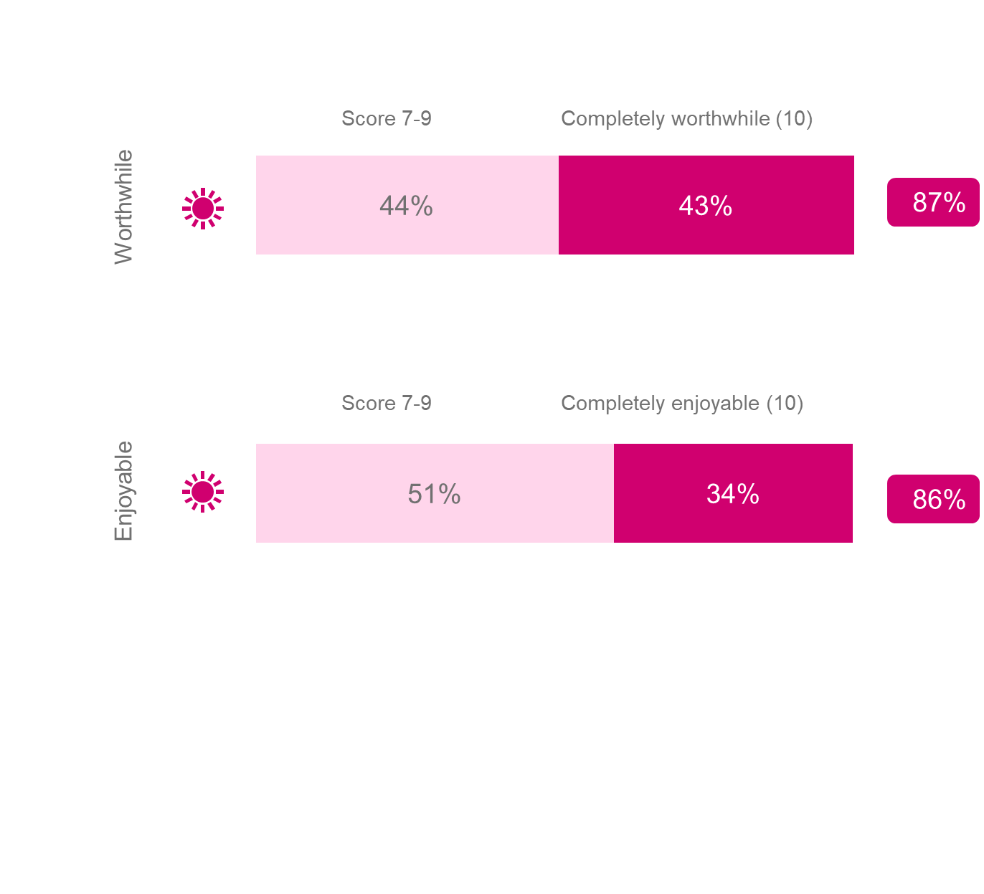**Figure 8.1 Overall Programme experience - Summer**

On a scale of 0-10, where 0 is not at all worthwhile and 10 is completely worthwhile, how worthwhile did you find your National Citizen Service experience overall? On a scale from 0-10, where 0 is not at all enjoyable and 10 is completely enjoyable, how enjoyable did you find your National Citizen Service experience overall?

Base: Summer NCS participant follow-up (completed online): 1,640

**Most** (**95%**) **summer NCS participants would recommend the summer NCS programme to other young people,** as Figure 8.2 demonstrates. Four in five **(87%) would like to stay in touch with NCS in the future.**

**Ethnicity is relevant to both likelihood of recommending the summer programme and preference towards staying in touch**. Summer NCS participants from BAME groups are more likely than White participants to say they would like to stay in touch with NCS (**91%** of Black**, 94%** of Asian and **91%** of Mixed-race participants compared with **85% of** White participants). Asian participants are also more likely to recommend NCS to other 16- and 17-years olds (**99%**) than White participants (**94%**).

*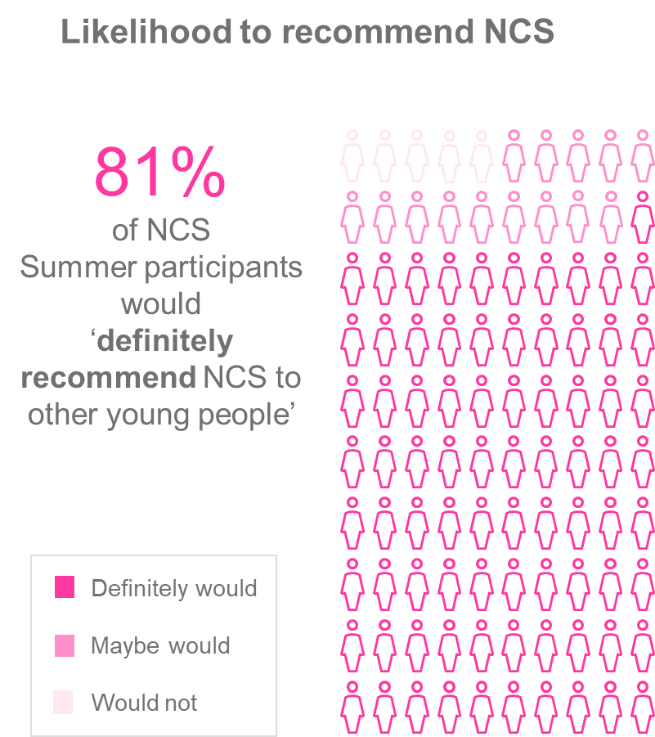***Figure 8.2 Interest in staying involved in NCS in the future and likelihood to recommend NCS – Summer**

**Stay in involved with NCS in the future**

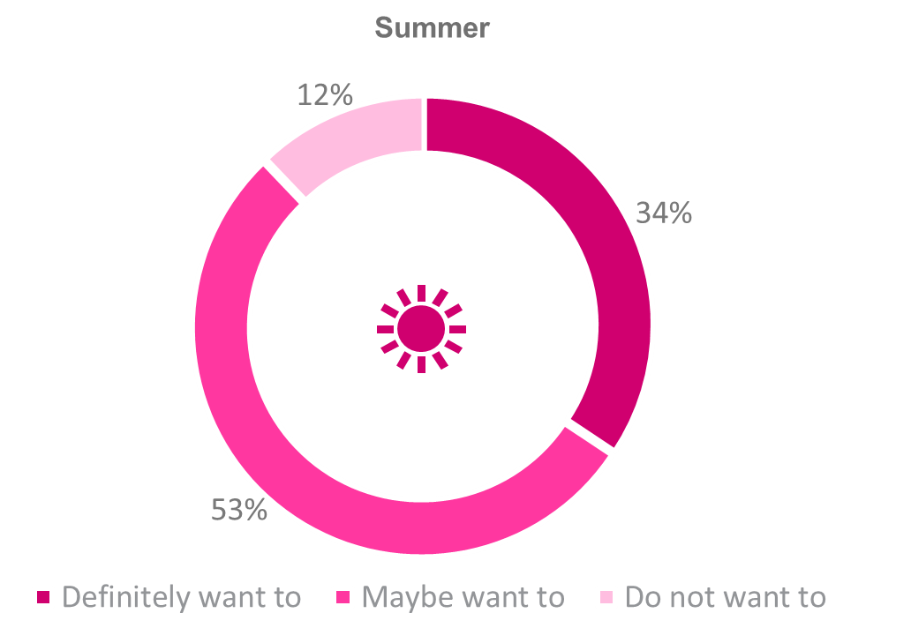

*Would you like to stay involved in National Citizen Service in the future?; Would you like to stay involved in National Citizen Service in the future?* Base: Summer NCS participant follow-up (completed online): 1,640.

Like summer participants, **autumn participants are positive about their NCS experience**, with similar proportions reporting they found the programme worthwhile and enjoyable (**85%** and **86% respectively**), as shown in Figure 8.3.

Once again, **male participants are slightly more likely to think the programme is worthwhile** (**87%** compared with **84%** of female participants).

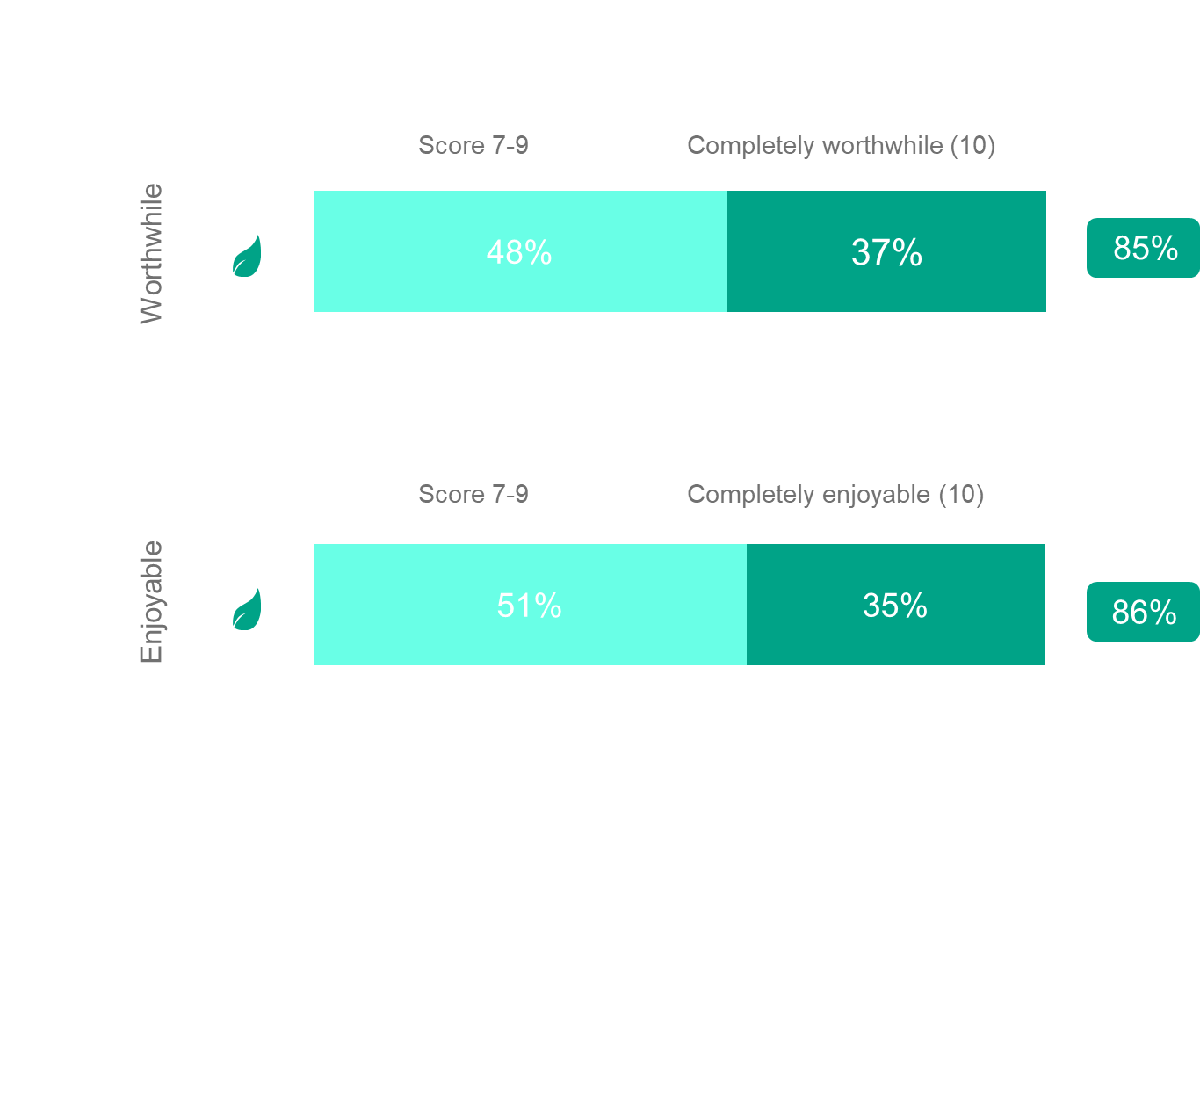**Figure 8.3 Overall participant experience – Autumn**

On a scale of 0-10, where 0 is not at all worthwhile and 10 is completely worthwhile, how worthwhile did you find your National Citizen Service experience overall? On a scale from 0-10, where 0 is not at all enjoyable and 10 is completely enjoyable, how enjoyable did you find your National Citizen Service experience overall?

Base: Autumn NCS participant follow-up (completed online): 684

**Most autumn NCS participants (86%) agree that they would like to stay involved with NCS in the future**, while almost four in five **(79%) would recommend NCS to other young people**, as shown in Figures 8.3 and 8.4.

*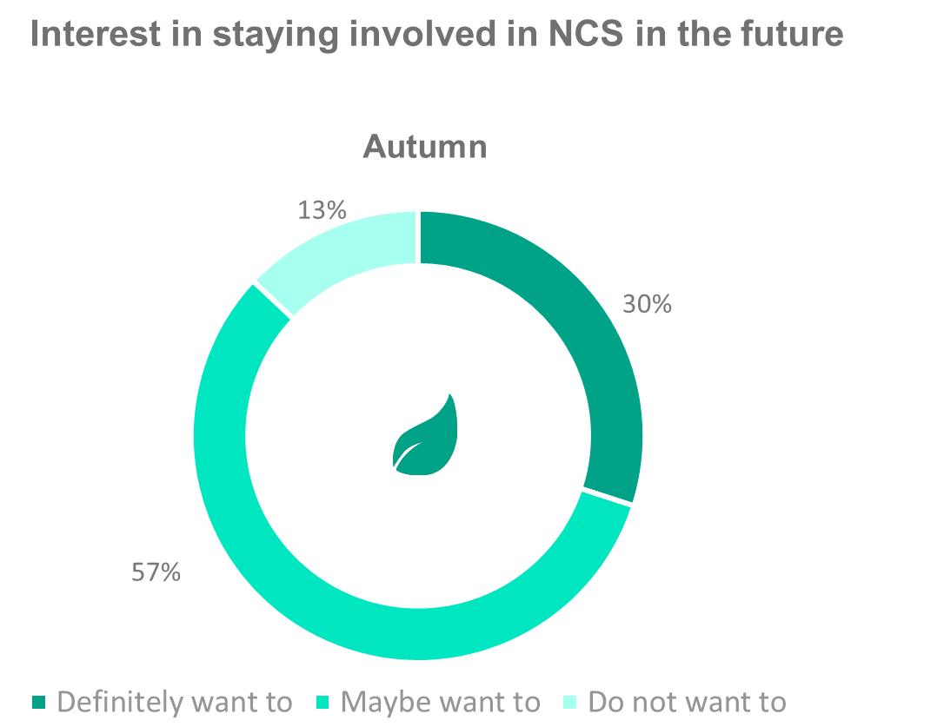***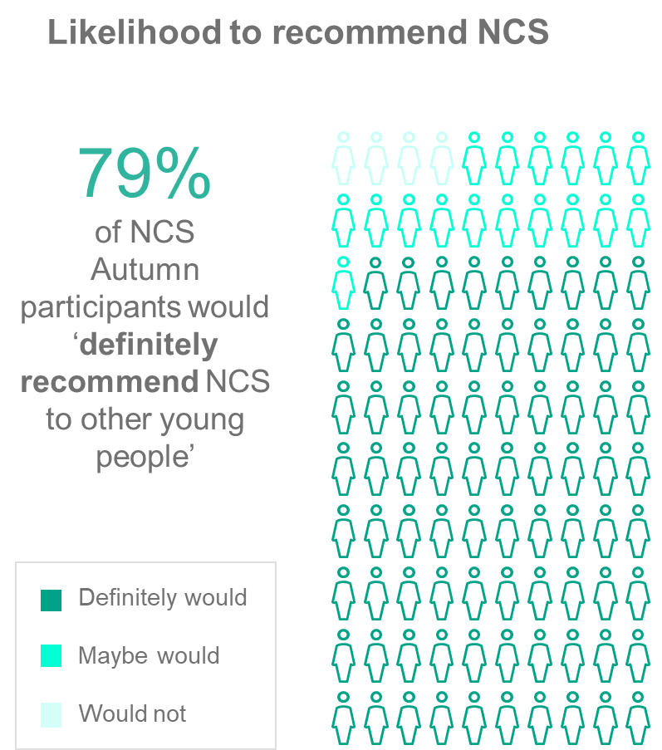Figure 8.4 Interest in staying involved with NCS in the future and likelihood to recommend NCS – Autumn**

*Would you like to stay involved in National Citizen Service in the future?*Base: Autumn NCS participant follow-up (completed online): 684 *Would you recommend National Citizen Service to other young people?* Base: Autumn NCS participant follow-up (completed online): 684

## Perceptions of staff

**Broadly speaking, summer participants’ perceptions of staff were positive.** However, there are several areas that the NCS Trust could focus on to further improve participants’ experience.

**Just over seven in ten (71%) summer participants agree that NCS staff are supportive and almost two thirds (65%) feel staff encouraged them to fully take part in the programme.** However, summer NCS participants are less likely to agree that staff were interested in me and my development **(52%)** and that they were knowledgeable about the programme **(49%)** as highlighted in Figure 8.5. This suggests more detailed training could be offered to brief staff, which could include emphasis on how to encourage participants’ personal development.

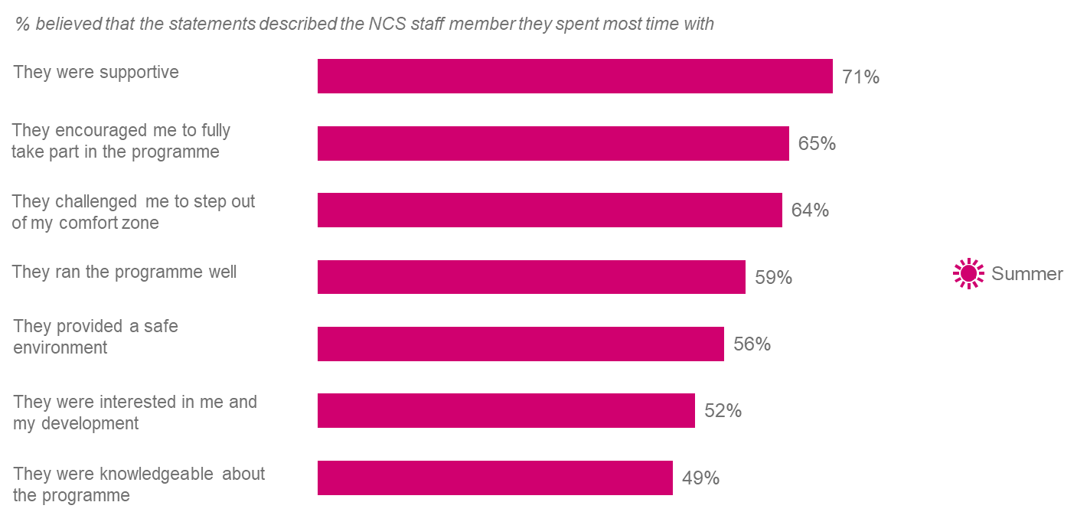**Figure 8.5 Views on staff – Summer**

*Which, if any, of the following statements describes the member of staff who spent the most time with you and your team during your National Citizen Service experience?*

Base: Summer NCS participant follow-up (completed online): 1,640

**Autumn participants’ perceptions of staff follow a similar pattern to those of summer.** Just under seven in ten autumn participants **(68%)** agree that staff are supportive and **66%** feel staff encouraged them to fully part take in the programme, whilst fewer than six in ten **(59%)** agree that staff ran the programme well, as shown in Figure 8.6.

When asked about the member of staff they spent the most time with, **58%** agree they provided a safe environment. Male participants are less likely to agree that staff members provided a safe environment **(57%)** in comparison with female participants (**60%**).

Almost half of autumn participants (48%) think staff were interested in them and their development, suggesting that this is an area for improvement for NCS staff. Similarly, when asked about how knowledgeable they think staff are, only half of autumn participants (**50%**) agree that staff were knowledgeable about the programme. This suggests that more work could be done to brief staff and ensure that they are equipped to answer participants’ questions. However, this could also suggest that the opportunities are limited for staff to demonstrate their knowledgeability about the course to participants.

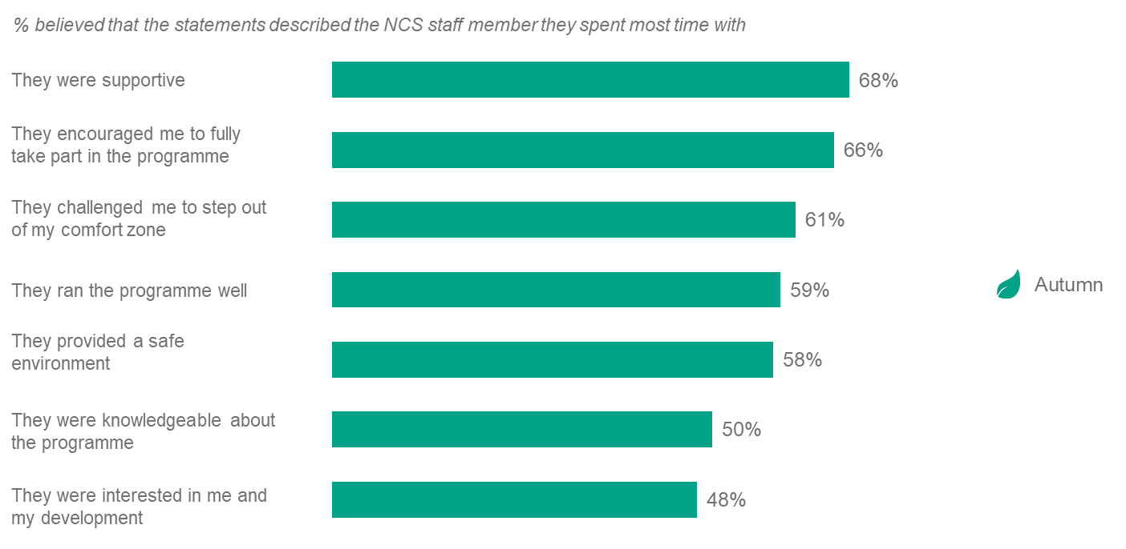**Figure 8.6 Views of staff – Autumn**

*Which, if any, of the following statements describes the member of staff who spent the most time with you and your team during your National Citizen Service experience?*

Base: Autumn NCS participant follow-up (completed online): 684

## Views of personal development

## Overall, summer NCS participants agree that the NCS programme has aided their personal development, with the majority of participants agreeing that NCS helps develop skills for the future (87%) as shown in Figure 8.7.

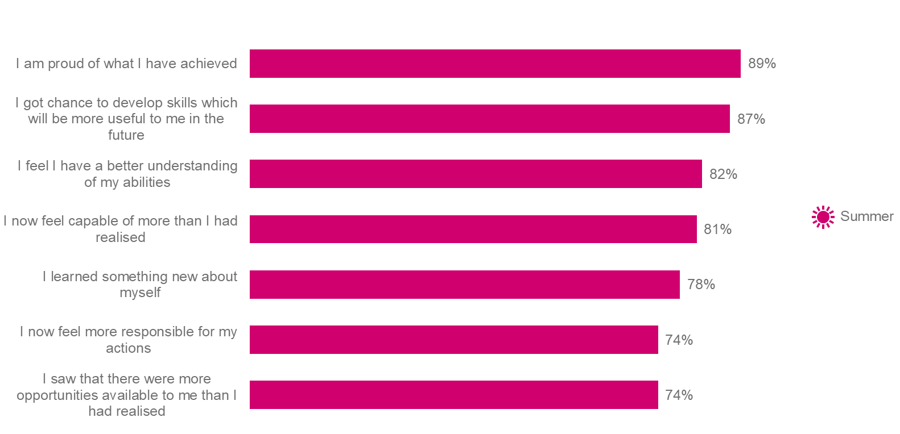**Figure 8.7 Views on personal development – Summer**

*To what extent do you agree or disagree with the following statements about your National Citizen Service experience?*Base: Summer NCS participant follow-up (completed online): 1,640

## There are significant differences in summer participants’ responses around personal development by ethnicity, with Asian participants more likely to agree that they got a chance to develop skills which will be more useful to them in the future (93%) compared with 86% of White participants. Additionally, Asian participants (86%) and Black participants (83%) were more likely to agree they feel they have a better understanding of their abilities compared to White participants (81%).

## Summer participants report a feeling of accomplishment from the programme:

* Almost nine in ten **(89%)** agree that they were proud of what they achieved.
* Over eight in ten **(82%)** agree ‘I feel I have a better understanding of my abilities.’
* Almost eight in ten **(78%)** agree they had learnt something new about themselves.

**Summer participants also feel more capable and responsible after attending the programme**. Just over eight-in-ten **(81%)** agree that they are now more capable than they realised, and three quarters (**74%**) agree they now feel more responsible for their actions.

**Summer NCS participants who are eligible for Free School Meals (FSM) have significantly different outcomes in terms of personal development,** compared with participants who are not eligible:

* They are more likely to agree that they now feel more confident about getting a job in the future after the programme compared to those who are not eligible **(73% vs 69%)**.
* They are less likely to agree they are proud of what they achieved compared with those who are not eligible **(85%** vs **90%)**.
* They are less likely to agree that they learned something new about themselves compared with those who are not eligible **(73% vs 79%)**.

As Figure 8.8 demonstrates, **autumn NCS participants agree that the NCS programme has also helped them in terms of personal development.** Nine in ten are very proud of what they achieved(**89%**), and **87%** agree that they got a chance to develop skills which will be useful to them in the future. A further four in five **(80%)** agree that they now feel they have a better understanding of their abilities and **77%** agree that they now feel more responsible for their actions.’

**There are** **some significant differences by gender**, with female participants more likely than male participants to agree that they had a chance to develop useful skills for the future **(90%** vs **86%)**. Conversely, male participants are more likely than female participants to agree they now feel more responsible for their actions **(79%** compared with **75%)**.

**Figure 8.8 Views on personal development – Autumn**

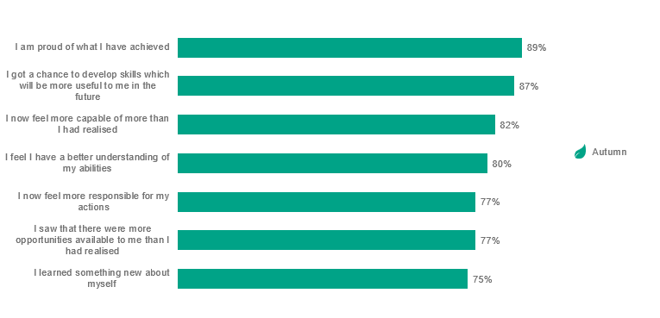

*To what extent do you agree or disagree with the following statements about your National Citizen Service experience?*

Base: Autumn NCS participant follow-up (completed online): 684

## 

## Attitudes towards their future

**Overall, most summer participants agree that they now feel more positive about the future and better prepared for coping with challenges in life**. Almost four in five (**78%**) agree they feel better prepared for challenges that life may bring them and a further seven in ten (**70%**) report feeling more confident about getting a job in the future as highlighted in Figure 8.9.

**Eligibility for FSM significantly affects perceptions of future opportunities for summer NCS participants.** Those who are eligible for FSM are more likely to agree that after the programme they saw that there were more opportunities available to them than they had realised (**78%**) compared with those who are not eligible for FSM (**73%**).

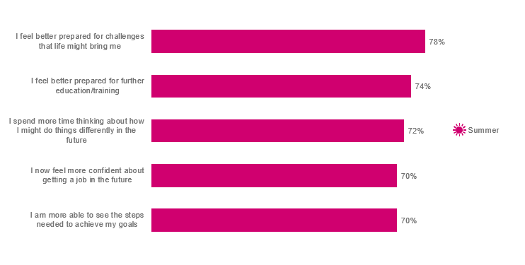**Figure 8.9 Attitudes towards future – Summer**

*To what extent do you agree or disagree with the following statements about your National Citizen Service experience?*

Base: Summer NCS participant follow-up (completed online): 1,640

**Overall, autumn participants also feel better prepared for their future.** In particular, theyhave developed emotional resilience, with **78%** of autumn NCS participants agreeing that they now feel better prepared for the challenges that life might bring them. As presented in Figure 8.10, they also report that the programme has helped prime them for future learning with **72%** agreeing they feel better prepared for further education/training.

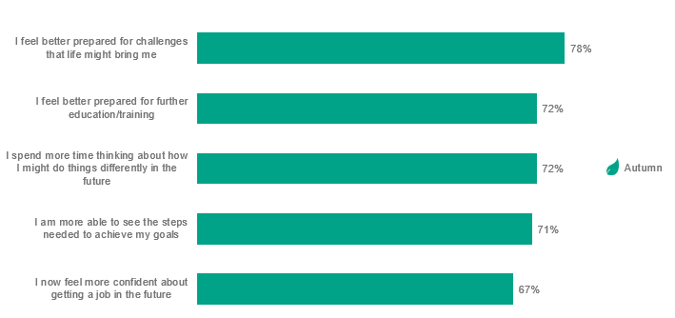**Figure 8.10 Attitude towards future – Autumn**

*To what extent do you agree or disagree with the following statements about your National Citizen Service experience?*

Base: Autumn NCS participant follow-up (completed online): 684

1. Value-for-money

**Overview**

While the previous sections of this report identify the impact of NCS on participants, this section of the evaluation aims to understand the extent to which NCS represents value-for-money. In line with the principles of the HM Treasury *Green Book[37],* London Economics undertook an analysis to monetise the resource costs and benefits associated NCS (as far as possible), and generate estimates of the **net Benefit Cost Ratios** associated with the 2018 NCS summer and autumn programmes.

The value for money analysis adopted **two separate approaches** to determine the financial benefits associated with NCS:

* The **first approach** (Approach 1) focuses primarily on calculating the monetary value associated with the increased lifetime earnings among NCS participants due to enhanced **leadership skills** and **aspiration to enter higher education**, as well as the monetary value of additional hours spent **volunteering** by NCS participants.
* A **complementary approach** (Approach 2) estimates the monetary value associated with the impact of NCS on **wellbeing** based on self-reported life satisfaction scores. This approach is based on a replication of a separate analysis of the value associated with wellbeing improvements that was undertaken as part of previous NCS evaluations.[38]

The value-for-money analysis examines the same populations of participants as in the 2018 impact report[39]. However, for the 2018 impact evaluation, impact estimates were disaggregated by gender.[40] Therefore, in both the approaches above, the value-for-money analysis calculates economic benefits separately for male and female participants, and then combines the respective benefits to calculate aggregates for the two programmes (summer and autumn ‘standard’ model).

We largely follow the methodology from previous years’ analyses. However, one major difference relates to the inclusion of an estimate of the economic benefits associated with **aspiration to enter higher education** in Approach 1. While year-on-year comparisons were not previously recommended (primarily due to changes in sampling and slight changes to methodology over time), the inclusion of the impact relating to higher education aspiration means that results for Approach 1 are not comparable with previous years’ analyses (where economic benefits from higher education aspiration were not calculated). As such, year-on-year comparisons should not be made.

Both Approach 1 and Approach 2 are used to assess the value-for-money associated with the 2018 NCS programme. However, the **results from these two approaches should not be combined** because enhanced leadership skills, aspiration and time spent volunteering could conceivably drive increases in self-reported wellbeing. As such, summing the benefits of NCS from the two approaches is highly likely to lead to double counting. This report presents the net Benefit Cost Ratios achieved using each approach separately.

In previous evaluations, upper and lower bound estimates of the net Benefit-Cost Ratios (BCR) associated with the NCS programme were provided around the central BCR estimates. These upper and lower bound estimates were generated using different assumptions within the BCR calculations. Given the expansion of Approach 1 (thereby increasing the number of possible combinations of upper and lower bound estimates) and the range of estimates provided by using two separate approaches, in this year’s evaluation we have focused on providing greater clarity by providing a single central BCR estimate associated with the NCS programme.

**Key findings**

**Approach 1**

The value for money analysis demonstrates that:

* The total gross benefit of the NCS summer and autumn ‘standard’ programme was estimated to be £554.7 million and £33.2 million, respectively. In summer 2018, this is comprised of £155.8 million in enhanced leadership skills, £302.4 million attributable to improved aspiration to pursue higher education, and £96.5 million associated with additional volunteering hours.[41] In autumn 2018, the comparable figures were £9.1 million, £19.9 million and £4.2 million, respectively.
* Combining information on the relevant total costs and net benefits[42], for Approach 1, the value-for-money analysis suggests that the net Benefit Cost Ratio associated with the 2018 NCS summer programme was 3.49, while the corresponding estimate for the autumn standard model programme was 3.45. In other words, **we estimate that for every £1 spent on the 2018 NCS summer and autumn programmes, an economic benefit of £3.49 and £3.45 was generated, respectively**.
* Of the total gross benefits, more than 50% is contributed through the impact on higher educational aspiration. This element of analysis is new to the evaluation and the measure of aspiration may be much higher or lower in the future. Given this, and its relative contribution to the overall identified benefits, the estimated benefits (using Approach 1) in future years’ evaluations may become more variable.

**Approach 2**

* Using the wellbeing approach (Approach 2), the total gross economic benefit of the NCS summer and autumn standard programme was estimated to be £370.5 million in summer 2018 and £22.6 million in autumn 2018.
* Again, combining the relevant total costs and benefits information associated with wellbeing, the analysis demonstrates that the net Benefit Cost Ratio of the summer 2018 programme was 2.33, and that of the autumn programme was 2.35. In other words, **the wellbeing approach indicates that for every £1 spent on the 2018 NCS summer and autumn programmes, an economic benefit of £2.33 and £2.35 was generated, respectively**.

In the 2017 analysis, the net Benefit Cost Ratios for Approach 2 were larger than those of Approach 1, suggesting that estimates of wellbeing improvements captured a number of additional benefits beyond those just relating to leadership skills and volunteering (aspiration was not included in the 2017 methodology). In the current analysis, with the inclusion of the aspiration benefit, the net Benefit Cost Ratios presented under Approach 1 are larger than Approach 2. As with previous years’ analysis, and in particular because of changes in methodological approach across years, the **two approaches should thus be seen as complementary to each other** and **informative in providing an estimate of the range of potential impact**, and not used as either a direct comparison, or in combination with each other.

The specific methodological approaches, and a breakdown of the value for money estimates, are discussed in turn overleaf.

Approach 1: Valuing the impacts associated with leadership skills, higher education aspiration and volunteering

Leadership skills

The leadership skills indicator used in this value for money assessment relies on a composite variable, calculated as the mean of the impact across four outcome measures identified as part of the survey of participants.[43] Each of the outcome measures is based on a question asking participants to rate their confidence at a certain activity (listed below) on a 5-point scale[44].

|  |
| --- |
| **Questions used to assess leadership skills** |
| How do you feel about the following things, even if you have never done them before...?   1. Being the leader of a team 2. Working with other people in a team 3. Explaining my ideas clearly 4. Meeting new people |

The estimated effect of NCS participation on leadership is large. In particular, the analysis suggests that the relative increase in the proportion of NCS participants indicating a gain in leadership skills was between **9 and 14 percentage points** depending on gender.

To monetise this impact, we rely on external econometric analysis linking perceived changes in leadership skills and earnings outcomes later in life.[45] This is combined with an assumption that the leadership impact persists over the working life. Some additional methodological discussion is presented in Section 5.1 of the technical report.

The specific calculation of the economic benefit associated with **leadership** skills was calculated as follows:

1. The impact analysis demonstrates that NCS was associated with a **13.9** and **13.1 percentage point** impact on leadership skills for males and females in summer 2018. There was a slightly smaller impact in autumn 2018: **11.1 and 9.2 percentage point** impact for males and females respectively.
2. The existing literature suggests that leadership skills can improve the present value of lifetime earnings by between **2.1%** and **3.8%**, holding other factors constant (Kuhn and Weinberger, 2005[46]). We take the mean of this range to provide a central estimate of **2.95%**.
3. The present value of the level of lifetime earnings for non-degree holders stands at approximately **£****783,000** for male participants and **£404,000** for female participants.[47]
4. There were **36,360** male participants and **49,578** female participants on the 2018 summer programme.[48] There were **3,363** male and **2,425** female participants in the 2018 autumn standard programme (excluding the College model[49]).[50]
5. An individual who attains leadership skills is likely to earn more because of those skills directly, but also because those skills will typically help him or her gain a higher level of qualification, which is also associated with higher earnings. In order not to double-count these two confounding effects, and to ensure a relatively conservative approach, a **20%** discount rate is applied to the leadership uplift.

Table 9.1. Summary of value-for-money assessment for leadership skills (Approach 1)

|  |  |  |  |  |  |  |
| --- | --- | --- | --- | --- | --- | --- |
| Factors | Description | Males | | Females | | |
| **Summer 2018** | **Autumn 2018** | | **Summer 2018** | **Autumn 2018** |
| A | Proportion of NCS participants who gained leadership skills | 13.9% | 11.1% | | 13.1% | 9.2% |
| B | Effect of leadership on PV earnings | 2.95% | | | | |
| C | Present value of lifetime earnings | £783,009 | | £404,244 | | |
| D | Number of participants | 36,360 | 3,363 | | 49,578 | 2,425 |
| E | Discount to avoid double counting | Reduction of 20% | | | | |
| A*B*C*D*E | **Total value of leadership** | **Product of all the above** | | | | |

Note: To obtain the total value of leadership for males participating in the NCS summer programme, we undertake the following calculation: 13.9% x 0.0295 x £783,009 x 36,360 x (1-0.2). This equals £93.6 m (any discrepancies are due to rounding). This is combined with the corresponding calculation for summer female participants (£62.2 million), to obtain the total monetary value of aspiration for the summer 2018 programme of £155.8 million.

The total value of **leadership** skills is the product of these five stages (Figure 9.1). The total monetary impact was estimated to be **£155.8 million in summer** and **£9.1 million in autumn**.

**Aspiration**

A core goal of NCS is to support young people in their transition to adulthood, which might include aspiring to attend higher education. The value of this benefit has not been calculated in previous evaluations, because information on young people’s aspirations to enter higher education was not collected.

In Phase 2 of the programme, most NCS participants experience living independently in university accommodation. In other components of the NCS programme, participants are provided with opportunities intended to increase motivation and aspirations, showing them that they can achieve significant goals.

The analysis of participants in 2018 illustrates that the NCS programme increases young people’s aspiration to go on to higher education. If students follow through with these aspirations and progress to higher education, they will (on average) achieve a higher incidence of employment, as well as greater earning potential (reflecting higher levels of productivity in the labour market), ultimately resulting in higher levels of personal consumption, but also additional benefits for the Exchequer in the form of increased tax receipts.

To monetise this impact, we rely on an external analysis from McIntosh (2019) to link educational aspiration with realised progression to higher education.[51] The analysis of data from the Longitudinal Survey of Young People in England (LYPSE)[52] suggests that the proportion of young people completing higher education, conditional on aspirations at age 16 and the route of qualification attainment, stands at approximately **32.8%**. In other words, 32.8% of aspiring Year 11 students are expected to progress to higher education.

Using information on non-completion from the Higher Education Statistics Agency (HESA) in 2017, as well as estimates of the net graduate premium and net Exchequer benefits associated with higher education qualification attainment undertaken for the Gatsby Foundation (2017)[53], we can estimate the expected economic benefit associated with higher education qualification attainment.

Calculations of the monetary value of the additional aspiration benefit are based on these findings, as follows, with further details provided in Section 5.2 of the technical report.

1. The NCS impact analysis estimates that males were **6.5%** more likely to aspire to attend higher education following attendance in the summer NCS programme and **7.0%** more likely to aspire as a result of participation on the autumn standard programme. Females were estimated to be **4.7%** more likely to aspire to attend university following participation on the summer NCS programme and **0.5%** more likely to aspire following the autumn standard model programme.[54]
2. There were **36,360** male and **49,578** female participants on the summer programme and **3,363** male and **2,425** female participants on the autumn standard programme.
3. Using existing economic evidence matching aspiration to progression to post-18 outcomes, the analysis of the LSYPE cohort (using McIntosh (2019)) suggests that approximately **32.8%** of aspiring secondary school students at Key Stage 4 progress to higher education.
4. The completion rate for a 3-year degree is calculated using a compounded non-continuation rate. Of those that attend their first degree on a full-time basis, **6.3%** do not continue their studies at the end of each academic year.[55] Over three years, this compounds to a **17.7%** attrition rate. Hence, we assume that **82.3%** of young people complete their higher education course.
5. A higher level of education is associated with higher earnings and greater tax contributions for the Exchequer. Based on external analysis, the total combined net graduate and net Exchequer benefit has been estimated at approximately **£306,000** for men and **£172,000** for women.[56]

**Table 9.2. Summary of value-for-money associated with aspiration for NCS participants (Approach 1)**

|  |  |  |  |  |  |
| --- | --- | --- | --- | --- | --- |
| Factors | Description | Males | | Females | |
| **Summer 2018** | **Autumn 2018** | **Summer 2018** | **Autumn 2018** |
| A | Proportion of NCS participants with HE aspiration positively impacted by NCS | 6.5% | 7.0% | 4.7% | 0.5% |
| B | Number of NCS participants | 36,360 | 3,363 | 49,578 | 2,425 |
| C | Proportion of aspiring participants who progress to HE (using LSYPE data) | 32.8% | | | |
| D | Completion rate over 3-year degree | 82.3% | | | |
| E | Present value of net graduate premium and Exchequer benefits | £306,256  (comprised of £142,782 net graduate benefit and £163,474 net Exchequer benefit) | | £172,442  (comprised of £83,438 net graduate benefit and £89,004 net Exchequer benefit) | |
| A*B*C*D*E | **Total value of aspiration** | **Product of all the above** | | | |

Note: To obtain the total value of aspiration for males participating in the NCS summer programme, we undertake the following calculation 6.5% x 36,360 x 32.8% x 82.3% x £306,256. This equals £194.8 million (any discrepancies are due to rounding). This is combined with the respective calculation for summer female participants (which equals £107.6 million) to obtain the total monetary value of aspiration for the summer 2018 programme.

Combining this information, the total monetary impact of **aspiration** was estimated to be **£302.4 million in summer** and **£19.9 million in autumn**.

Volunteering

Volunteering is a core theme of NCS. Phase 3 of the programme consists of a social action phase during which participants have up to 60 hours to plan and deliver a social action project in their community (4-week programme[57]). To place a monetary value on this volunteering activity, we combine information on the number of additional volunteering hours committed during NCS participation and the relevant earnings that might be earned by young people in the labour market if they did not undertake this activity.

NCS participants may also continue to contribute additional hours of social action or volunteering after the programme ends. The 2018 impact analysis undertaken three months after NCS graduation illustrated that after both the summer and autumn programmes, NCS participants continued to volunteer at a higher rate than non-participants. In addition, a previous follow up study of NCS participants (two years post completion) indicated that the impact on volunteering has persisted.[58] We use this information combined with relevant wages to estimate the economic value of volunteering after programme completion.

### During the NCS programme

1. There were **36,360** male participants and **49,578** female participants on the summer programme. There were **3,363** male and **2,425** female participants in the standard autumn programme.
2. The impact analysis demonstrated that the average **prior-level** of volunteering was **12.0** hours in a typical month amongst NCS summer and autumn participants, with the average number of hours spent volunteering identified during the NCS programme itself standing at 30 hours.[59] By subtraction, participants in the 2018 NCS programme volunteered an **additional** **18 hours** as a result of the programme.
3. The median wage rate associated with 16 to 17-year-olds derived from the 2017-18 Annual Survey of Hours and Earnings (April 2017-18) was **£5.90 per hour.**[60] [61]

Table 9.3. Summary of value-for-money assessment for volunteering hours supplied within the programme (Approach 1)

|  |  |  |  |  |  |
| --- | --- | --- | --- | --- | --- |
| Factors | Description | Males | | Females | |
| **Summer 2018** | **Autumn 2018** | **Summer 2018** | **Autumn 2018** |
| A | Number of participants | 36,360 | 3,363 | 49,578 | 2,425 |
| B | Additional volunteering hours supplied (30 hours minus baseline hours) | 18.0 | 18.0 | 18.0 | 18.0 |
| C | Median wage rate for 16-17-year-olds | £5.90 | | | |
| A*B*C | **Total** | **Product of all the above** | | | |

Note: To obtain the total value of volunteering supplied within the summer programme for males, we undertake the following calculation: 36,360 x 18.0 x £5.90. This equals £3.9 million. This is combined with the respective calculation for summer female participants (which equals £5.3 million) to obtain the total monetary value of volunteering within the summer 2018 programme of £9.1 million. Any discrepancies in figures quoted here are due to rounding.

The total value of **volunteering** **during the NCS period** itself is the product of these three factors (and presented in Figure 9.3). The monetary impact was estimated to be **£9.1 million** in summer 2018 and **£0.6 million** in autumn 2018.

### After the NCS programme

Additional follow-up evaluations of the 2013 NCS found that the impact of the NCS programme lasted well beyond its lifetime, with significantly higher rates of volunteering observed up to 28 months after graduation**.** In particular, the one year follow-up evaluation[62] indicated that there was a persistent volunteering effect between three months and 15 months post completion, with the two year follow-up study[63] identifying a declining (but positive) incidence of volunteering up to 27 months post completion. This analysis indicates that there is no statistically significant impact after 28 months[64].

Calculations of the monetary value of additional volunteering hours in this evaluation are based on these findings, as follows.

1. There were **36,360** male participants and **49,578** female participants on the summer programme. There were **3,363** male and **2,425** female participants in the autumn standard programme.
2. Additional hours of volunteering: according to the three-month follow on survey for summer NCS 2018 participants, the average additional volunteering hours supplied by participants, relative to the comparison group, was **7.15 hours** per month for male participants and **8.6 hours** per month for female participants. For the autumn programme, the estimate for males was **3.29 hours** per month and **7.07hours** per month for female participants.[65]
3. Rate of decline in hours volunteered: in the first 15 months post completion, we have assumed that the level of volunteering activity remains constant (at the augmented level of volunteering identified in the three-month follow-up). In other words, the assumption is that the number of hours reported in the three-month follow-up survey remains constant over the subsequent 12 months (i.e. up to month 15) and in the prior 2 months. The effect on volunteering is assumed to diminish at a constant rate, starting from month 16 of the post completion period, and falling to zero by the 27th month.
4. Wage rate: In order to monetise the value of volunteering associated with the programme, we again use the median wage rate for a young person’s relevant age category to be the most accurate measure of this opportunity cost. The median pay reported in the Annual Survey for Hours and Earnings (ASHE) in April 2018[66] was **£5.90** for 16-17 year olds and **£7.83** for 18-20 year olds. Beyond the three-month period the wage rate is calculated as follows:
5. Over the first year after graduation, the impact calculations use the median wage rate for 16-17-year-olds of **£5.90** per hour
6. To take account of some participants turning 18 in the second and third years following graduation from the NCS, an average of the two rates (**£6.87** per hour) was applied to additional volunteering hours between month 13 and month 25
7. The calculations for the impact during months 25-28 used the median wage rate for 18-20-year-olds of **£7.83** per hour
8. Economic analysis of streams of future benefits or costs requires discounting in order to make them comparable to benefits and costs accruing in the present. Following HM Treasury’s Green Book[67], the benefits in the first 12 months are not discounted. Thereafter, we use the standard 3.5% discount rate.

Table 9.4. Summary of value-for-money assessment for volunteering hours supplied following the NCS programme (Approach 1)

|  |  |  |  |  |  |
| --- | --- | --- | --- | --- | --- |
| Factors | Description | Males | | Females | |
| **Summer 2018** | **Autumn 2018** | **Summer 2018** | **Autumn 2018** |
| A | Number of participants | 36,360 | 3,363 | 49,578 | 2,425 |
| B | Additional volunteering hours supplied after NCS (three-month follow-up survey) | 7.15 | 3.29 | 8.60 | 7.07 |
| C | (Linear) Rate of decline in hours volunteered | Additional monthly hours supplied assumed to be the same as in three-month follow-up – and last for a further 12 months. Volunteering hours fall at a constant rate after the 15-month point until reaching zero by month 27 | | | |
| D | Wage rate | £5.90 per hour in first 12 months  £6.87 in months 13 to 25  £7.83 in subsequent months | | | |
| E | Discount factor | 3.5% (HM Treasury Green Book) | | | |
| A*B*C*D*E | **Total** | **Product of all the above** | | | |

Note: Calculations are performed for each month after the programme, using the appropriate wage rate, rate of decline in hours volunteered and discount factor. For example, for males participating in the summer programme, the value of volunteering supplied in the first month after programme completion is calculated as follows: 36,360 x 7.15 x 1 x £5.90 x 1. These monthly calculations (up until 28 months) are totalled to provide a valuation of volunteering supplied after the programme for male participants in the summer programme (£33.1 million). The total value for males is combined with the total value for female summer participants (£54.3 million) to provide an overall estimate of £87.4 million.

The total value of **volunteering** **after the NCS period** itself is the product of these factors (and presented in Table 9.4). The monetary impact was estimated to be **£87.4 million** in summer 2018 and **£1.9 million** in autumn 2018.

### Total value of volunteering associated with the NCS programme

Combining this information with the analysis of the monetary benefits achieved during the programme, the total monetary impact of volunteering was estimated to be **£96.5 million** in summer and **£4.2 million** in autumn.

## Total gross economic benefit (Approach 1)

Combining the information on the various strands of analysis relating to the impact of the NCS programme on leadership, aspiration and volunteering, Table 9.5 illustrates that the total gross economic benefit of NCS was estimated to be **£554.7 million** in summer 2018 and **£33.2 million** in autumn 2018. Of this total amount, more than 50% is contributed through the impact on educational aspiration. It is important to note that this element of analysis is new to the evaluation and the valuation measure of aspiration may be much higher or lower in the future. Given this and its relative contribution to the overall identified benefits, the estimated benefits in future years’ evaluations may become more variable.

Table 9.5. Summary of gross benefits from the value-for-money assessment of the 2018 NCS programme (Approach 1)

|  |  |  |
| --- | --- | --- |
|  | Summer 2018 | Autumn 2018 |
| Leadership (£m) | £155.8m | £9.1m |
| Aspiration (£m) | £302.4m | £19.9m |
| Volunteering (£m) | £96.5m | £4.2m |
| Total gross benefits (£m) | **£554.7m** | **£33.2m** |

Note: Totals may not sum due to rounding.

**Understanding costs and value for money**

The costs associated with the NCS programme are either attributable to the delivery of the programme or are centralised costs for the operation and facilitation of the programme. For the purposes of this analysis, we combine the two types of cost to calculate the total cost of providing the NCS summer and standard autumn programmes to the 2018 cohort. We provide additional information on each in turn.

From information provided by NCS Trust, the delivery costs to run the programme were estimated to be £1,497 per participant for the summer programme and £1,304 per participant for the autumn standard programme. Given that there were 85,938 summer participants (both three and four week programmes) and 5,788 autumn standard model participants, delivery costs of the NCS programme are approximately £128.6 million in summer 2018 and £7.6 million in autumn 2018 (excluding College model).

In addition to these delivery costs, NCS Trust also provided information on the central costs associated with the operation and facilitation of the programme.[68] The costs associated with the operation of NCS Trust to deliver the 2018 programme were £35.0 million (equivalent to £351 per participant). Note that this estimate relates to all programme participants – including those undertaking the spring programme and the autumn College model. Given the spring programme and autumn College model are not examined in this evaluation, the central costs and overheads associated with these individuals (as well as the delivery costs of these programmes) were removed from the overall estimate of costs. Hence, the central costs and overheads associated with summer and autumn standard model programmes are £30.2 million and £2.0 million, respectively.

Therefore, in addition to the £128.6 million in delivery costs associated with the summer 2018 programme, an additional £30.2 million in NCS central and overhead costs were incurred, bringing the total cost of providing the NCS summer programme to £158.8 million. Similarly, in addition to the £7.6 million in delivery costs associated with the autumn standard model programme, an additional £2.0 million in NCS central and overhead costs were incurred, bringing the total cost to £9.6 million.

Table 9.6. Cost information

|  |  |  |  |
| --- | --- | --- | --- |
| Factors | Description | Summer 2018 | Autumn 2018 |
| A | Delivery costs per participant | £1,497 | £1,304 |
| B | NCST Central cost and overheads per participant | £351 | £351 |
| (A + B) | Total costs per participant | £1,848 | £1,656[69] |
| C | Number of participants | 85,938 | 5,788 |
| (A+B)*C | Total cost | £158.8m | £9.6m |

**Value-for-money assessment: Approach 1**

Given this information on costs, Table 9.7 presents the net benefit-cost ratios associated with the 2018 NCS summer and autumn standard model programmes.

Note that there was a small contribution towards the costs associated with the NCS from the parents/ guardians of participants. In 2018, this amounted to approximately £1.34 million, which was notionally allocated across all participants. From an economic perspective, this contribution is deducted from the estimate of gross benefits, as this was a cost incurred to achieve the economic benefits associated with leadership, aspiration and volunteering and is not classified as a cost to the taxpayer. This ‘dis-benefit’ was estimated to be approximately £1.15 million and £0.08 million in summer and autumn 2018. Therefore, **the** **net economic benefit for the summer programme was £553.6 million and £33.2 million for the autumn standard model programme.**

**Table 9.7. Value-for-money assessment: summer and autumn 2018 NCS (Approach 1)**

|  |  |  |
| --- | --- | --- |
|  | Summer 2018 | Autumn 2018 |
| Leadership (£m) | £155.8m | £9.1m |
| Aspiration (£m) | £302.4m | £19.9m |
| Volunteering (£m) | £96.5m | £4.2m |
| Total net benefits (£m)[70] | **£553.6m** | **£33.2m** |
| Total costs (£m) | **£158.8m** | **£9.6m** |
| Net benefits to Cost ratio | **3.49** | **3.45** |

Note:The inclusion of the impact of aspiration means that the methodology used in calculating the above results is different from that used in previous years and the results are therefore not directly comparable.

As shown in the Table 9.7. above, the leadership, aspiration and volunteering benefits associated with the 2018 NCS summer and autumn standard model programmes exceed the costs of the programme, with the net Benefit Cost Ratio standing at 3.49 and 3.45 for the summer programme and autumn standard model programme, respectively. **In other words, for every £1 spent on implementing the 2018 summer NCS programme, in terms of its impact on participants’ leadership skills, aspiration and volunteering, a return of £3.49 was achieved. For autumn this was £3.45.**

More than 50% of the benefit is contributed through the newly estimated impact on educational aspiration, which increase the estimated Benefit Cost Ratios. Removing the identified benefits associated with aspiration from the 2018 value for money analysis, the Benefit Cost Ratios stand at 1.58 in summer and 1.38 in autumn. In other words, for every £1 spent on implementing the 2018 summer NCS programme, in terms of its impact on participants’ leadership skills and volunteering, a return of £1.58 was achieved. For autumn this was £1.38.

## Approach 2: Valuing the impact on wellbeing

The second approach is based on monetising the **wellbeing** impact of the 2018 NCS programmes using self-reported life satisfaction scores[71]. This approach is distinct from Approach 1 and the two should not be combined. The following monetisation is based on estimates of impacts three months following the 2018 NCS programmes.

The core of this approach (dating back to Fujiwara (2013)[72]) is to establish a relationship between some measure of wellbeing and financial outcomes. In particular, the original analysis assesses the extent to which an individual’s self-reported assessment of life satisfaction changes following a lottery win. Using this approach, it is possible to assess how much financial compensation might be required following a reduction in wellbeing or life satisfaction, or how much income might be needed to be taken from an individual to ‘compensate’ for a positive change in wellbeing. This is the approach that is adopted to monetise the positive impact of the NCS on wellbeing.

Calculations of the monetary value of wellbeing in this evaluation uses the same methodology as the previous Jump (2017) analysis[73] and are based on these findings, as follows.

1. The impact analysis demonstrates that both NCS summer and NCS autumn had a positive impact on reported levels of life satisfaction. The summer programme (both 3 and 4 week) were associated with an average increase in life satisfaction scores (relative to the control group of non-participants) of approximately **0.237** for males and **0.437** for females. For the autumn ‘standard’ programme, the estimated average increases in scores were **0.374** and **0.232**, respectively[74].
2. Translating the uplift in life satisfaction scores into a monetary equivalent suggests that the value of the wellbeing effect is £**2,999 per participant** for males on the summer programme and **£4,586** for the autumn ‘standard’ programme. For female participants, the respective figures are **£5,275** and **£2,944**.
3. There were **36,360** male participants and **49,578** female participants on the summer NCS programme. There were **3,363** male and **2,425** female participants in the autumn standard programme.

A summary of the calculation is presented in Table 9.8, with further explanation in Section 5.3 of the technical report.

Table 9.8. Summary of value-for-money assessment for wellbeing (Approach 2)

|  |  |  |  |  |  |
| --- | --- | --- | --- | --- | --- |
| Factors | Description | Males | | Females | |
| Summer 2018 | Autumn 2018 | Summer 2018 | Autumn 2018 |
| A | NCS impact on life satisfaction | 0.237 | 0.374 | 0.437 | 0.232 |
| B | Monetary equivalent translation of the wellbeing effect per participant | £2,999 | £4,586 | £5,275 | £2,944 |
| C | Number of participants | 36,360 | 3,363 | 49,578 | 2,425 |
| B * C | **Total** | **Product of B and C above** | | | |

Note: To obtain the total value of wellbeing for males, participating in the NCS summer programme, we undertake the following calculation £2,999 x 36,360. This equals £109.0 million. This is combined with the respective calculation for summer female participants (which equals £261.5 million) to obtain the total monetary value of wellbeing for the summer 2018 programme of £370.5 million.

The total monetary impact from wellbeing benefits was estimated to be **£370.5 million** for the summer 2018 programme and **£22.6 million** for the autumn 2018 standard programme.

### Value-for-money assessment: Approach 2

Using Approach 2 (but with the same costs and dis-benefit for parental contributions as in Approach 1), Table 9.9 presents the net Benefit Cost Ratios associated with the 2018 NCS summer and autumn standard model programmes.

Table 9.9 Value-for-money assessment: summer and autumn 2018 NCS programme (Approach 2)

|  |  |  |
| --- | --- | --- |
|  | Summer 2018 | Autumn 2018 |
| Net wellbeing (£m)[75] | **£369.4m** | **£22.5m** |
| Total costs (£m) | **£158.8m** | **£9.6m** |
| Net Benefit to Total Cost ratio (Wellbeing approach) | **2.33** | **2.35** |

As shown in the Table 9.9 above, the monetised wellbeing benefit from the 2018 NCS summer and autumn standard model programmes exceed the costs of the programmes, with the net Benefit Cost Ratio standing at 2.33 and 2.35 for the summer programme and autumn standard model programme, respectively.[76] **In other words, for every £1 spent on implementing the 2018 summer NCS programme, in terms of its impact on participants’ wellbeing, a return of £2.33 was achieved. For autumn, there was an estimated benefit of £2.35 for every £1 incurred in delivering the programme.**

1. Bibliography

Andersen, H., & Mayerl, J. “Responding to Socially Desirable and Undesirable Topics: Different Types of Response Behaviour?” *Methods, data, analyses: a journal for quantitative methods and survey methodology* (mda), 13(1). (2019): pp7-35. <https://doi.org/10.12758/mda.2018.06>.

Candy, D. et al. *National Citizen Service 2013 Evaluation – Two Years On: Main Report* Ipsos MORI, DCMS: 2017. <https://wearencs.com/sites/default/files/2018-10/NCS%202013%202YO%20Evaluation%20Report.pdf>.

Candy, D. et al. *National Citizen Service 2013 Evaluation – One Year On.* Ipsos MORI, DCMS: 2015.

<https://wearencs.com/sites/default/files/2010/NCS%202013%20One%20Year%20On%20Evaluation_0.pdf>

Comptroller, Auditor General. *National Citizen Service.* National Audit Office, DCMS: January 2017. <https://www.nao.org.uk/wp-content/uploads/2017/02/National-Citizen-Service.pdf>.

Centre for Longitudinal Studies, UCL. “Next steps”. Last accessed 28 April 2020. <https://cls.ucl.ac.uk/cls-studies/next-steps/>.

Conlon, G., Halterbeck, M. *Assessing the economics returns to Level 4 and 5 STEM-based qualifications.* Gatsby Foundation, London Economics:2017. <https://www.gatsby.org.uk/uploads/education/reports/pdf/le-gatsby-assessing-the-economic-returns-to-level-4-and-5-stem-based-qualifications-final-07-06-2017.pdf>.

Department for Digital, Culture, Media and Sport.“Community Life Survey 2017-18 Statistical Release”. July 2018. <https://assets.publishing.service.gov.uk/government/uploads/system/uploads/attachment_data/file/734726/Community_Life_Survey_2017-18_statistical_bulletin.pdf>.

Fujiwara, D. “A general method for valuing non-market goods using wellbeing data: three-stage wellbeing valuation”. *Centre for Economic Performance, LSE,* ISSN 2042-2695. (2013). <http://eprints.lse.ac.uk/51577/1/dp1233.pdf>.

Government Social Research Unit. “Ethical Assurance for Social Research in Government”. Last modified September 1, 2011. <https://www.gov.uk/government/publications/ethical-assurance-guidance-for-social-research-in-government>.

HESA. “Non-continuation: UK Performance Indicators 2017/18”. Last modified March 7, 2019. <https://www.hesa.ac.uk/news/07-03-2019/non-continuation-tables>.

HM Treasury. *The Green Book, Central Government Guidance on Appraisal and Evaluation*. 2018. <https://assets.publishing.service.gov.uk/government/uploads/system/uploads/attachment_data/file/685903/The_Green_Book.pdf>.

Jump x Simetrica. *If you could bottle it…A wellbeing and human capital value-for-money analysis of the NCS 2015 programme*. We Are NCS: 2018. <https://wearencs.com/sites/default/files/2018-10/NCS%20Wellbeing%20and%20Human%20Capital%20Valuation%20-%20Jump_0.pdf>.

Knibbs et al. National Youth Social Action Survey 2018. Summary report. *Ipsos MORI*: 2019.

Kuhn, P., & Weinberger, C. “Leadership skills and wages”. (2005). *Journal of Labor Economics*, 23(3), 395-436.

Lawton, R. & Watt W. [*The ABC of BAME*](https://jump-projects.com/our-work/)*: New, mixed method research into Black, Asian and minority ethnic groups and their motivations and barriers to volunteering.* Jump Projects: January 2019. <https://jump-projects.com/our-work/>.

Lawton, R. & Watt W. *The benefits of volunteering: A summary of work from 2014 to 2019*. Jump Projects: January 2019. <https://jump-projects.com/our-work/>.

Low Pay Commission. *National Minimum Wage: Low Pay Commission Report 2018*. BEIS: 2018. <https://assets.publishing.service.gov.uk/government/uploads/system/uploads/attachment_data/file/759271/National_Minimum_Wage_-_Low_Pay_Commission_2018_Report.pdf>.

McIntosh, S. *Post-16 Aspiration and Outcomes: Comparison of the LSYPE Cohorts.* DfE: 2019. <https://assets.publishing.service.gov.uk/government/uploads/system/uploads/attachment_data/file/804409/LSYPE_report_FINAL_17_May.pdf>.

National Citizen Service. “Our Objectives and Impact” Accessed 28 April 2020. <https://wearencs.com/our-objectives-and-impact>.

ONS. “CPI Annual rate 00: All Items 2015=100”. Last modified April 22 2020. <https://www.ons.gov.uk/economy/inflationandpriceindices/timeseries/d7g7/mm23>.

ONS. *Young people's personal well-being, October 2017 to September 2018. User request 10410.* August 2019. <https://www.ons.gov.uk/peoplepopulationandcommunity/wellbeing/adhocs/10410youngpeoplespersonalwellbeing>.

Quintelier, E. "Who Is Politically Active: The Athlete, the Scout Member or the Environmental Activist? Young People, Voluntary Engagement and Political Participation”. *Acta Sociologica* 51(4) (2008): 355-370.

What Works Centre for Local Economic Growth. “Guide to scoring evidence using the Maryland Scientific Methods Scale”. Last modified June 2016. <https://whatworksgrowth.org/resources/scoring-guide>.

Williams, J. “How does Kantar Public weight its voting intention data?”. *Kantar Website*, February 13, 2018. <https://uk.kantar.com/public-opinion/politics/2018/how-does-kantar-public-weight-its-voting-intention-data/>.

Appendix 1: Full impact results 2018

Below are the full results for the summer and autumn 2018 evaluations. Only results denoted with * are statistically significant.

1. **Social mobility – Self-confidence: leadership and communication**

|  |  |  |  |  |  |  |  |  |  |  |
| --- | --- | --- | --- | --- | --- | --- | --- | --- | --- | --- |
| Outcome: Self-confidence - leadership and communication | Summer Participant | | Summer Comparison | | Impact Summer | Autumn Participant | | Autumn Comparison | | Impact Autumn |
| Baseline | Follow-up | Baseline | Follow-up | Baseline | Follow-up | Baseline | Follow-up |
| % who feel confident being the leader of a team | 40% | 61% | 43% | 47% | **+18pp\*** | 42% | 57% | 46% | 49% | **+13pp\*** |
| % who feel confident explaining ideas clearly | 49% | 68% | 51% | 56% | **+14pp\*** | 56% | 69% | 57% | 62% | **+7pp** |
| % who feel confident meeting new people | 52% | 72% | 51% | 57% | **+14pp\*** | 61% | 72% | 59% | 57% | **+13pp\*** |
| % who feel confident working with other people in a team | 70% | 82% | 68% | 70% | **+10pp\*** | 74% | 78% | 74% | 74% | **+4pp** |
| % who feel confident speaking in public | 34% | 49% | 33% | 37% | **+11pp\*** | 33% | 47% | 38% | 40% | **+13pp\*** |
| % who feel confident having a go at things that are new to them | 67% | 80% | 67% | 64% | **+15pp\*** | 70% | 77% | 67% | 64% | **+10pp\*** |
| % who feel confident managing disagreements and conflict | 50% | 68% | 51% | 51% | **+18pp\*** | 50% | 63% | 53% | 59% | **+8pp\*** |

1. **Social mobility - Problem solving and decision-making**

|  |  |  |  |  |  |  |  |  |  |  |
| --- | --- | --- | --- | --- | --- | --- | --- | --- | --- | --- |
| Outcome: Problem solving and decision-making skills | Summer Participant | | Summer Comparison | | Impact Summer | Autumn Participant | | Autumn Comparison | | Impact Autumn |
| Baseline | Follow-up | Baseline | Follow-up | Baseline | Follow-up | Baseline | Follow-up |
| % who agree that they enjoy finding new ways to do things | 77% | 85% | 81% | 79% | **+10pp\*** | 81% | 87% | 79% | 79% | **+6pp\*** |
| % who agree that when solving a problem, they try to think of as many solutions as possible | 69% | 78% | 74% | 71% | **+11pp\*** | 69% | 79% | 69% | 71% | **+7pp** |
| % who agree that they think about both long-term and short-term consequences when they work through problems | 67% | 78% | 70% | 74% | **+8pp\*** | 70% | 81% | 69% | 75% | **+4pp** |
| % who agree that they usually make good decisions, even in difficult situations | 57% | 72% | 61% | 65% | **+12pp\*** | 61% | 71% | 62% | 66% | **+6pp** |

1. **Social mobility – Team work and social network building**

|  |  |  |  |  |  |  |  |  |  |  |
| --- | --- | --- | --- | --- | --- | --- | --- | --- | --- | --- |
| Outcome: team work and social network building | Summer Participant | | Summer Comparison | | Impact Summer | Autumn Participant | | Autumn Comparison | | Impact Autumn |
| Baseline | Follow-up | Baseline | Follow-up | Baseline | Follow-up | Baseline | Follow-up |
| % who agree that they are able to see things from the other person’s point of view | 75% | 84% | 78% | 81% | **+7pp\*** | 76% | 83% | 82% | 82% | **+7pp** |
| % who agree that they can usually tell when someone says one thing but means another | 69% | 82% | 72% | 78% | **+7pp\*** | 70% | 77% | 71% | 73% | **+4pp** |
| % who agree that they notice quickly if someone in a group is feeling awkward | 81% | 89% | 82% | 87% | **+3pp** | 82% | 88% | 83% | 85% | **+4pp** |
| % who agree that they get along with people easily | 70% | 81% | 69% | 74% | **+6pp\*** | 74% | 82% | 76% | 77% | **+7pp\*** |
| % who agree that if they needed help there are people who would be there for them | 74% | 81% | 75% | 73% | **+9pp\*** | 78% | 85% | 82% | 83% | **+5pp** |
| % who agree that it is hard to say no to friends^ | 38% | 38% | 40% | 41% | **-1pp** | 39% | 36% | 38% | 35% | **+/-0pp** |

^note that on this outcome the desired impact is negative (i.e. a reduction in the proportion agreeing that it is hard to say no to friends)

1. **Social mobility – Positivity about the future**

|  |  |  |  |  |  |  |  |  |  |  |
| --- | --- | --- | --- | --- | --- | --- | --- | --- | --- | --- |
| Outcome: Positivity about the future | Summer Participant | | Summer Comparison | | Impact Summer | Autumn Participant | | Autumn Comparison | | Impact Autumn |
| Baseline | Follow-up | Baseline | Follow-up | Baseline | Follow-up | Baseline | Follow-up |
| % who agree that they feel positive about their chances of getting a job in the future | 72% | 78% | 70% | 68% | **+8pp\*** | 76% | 75% | 72% | 66% | **+6pp** |
| % who agree that they are confident they will have the skills and experience to get a job in the future | 74% | 80% | 71% | 71% | **+6pp\*** | 74% | 81% | 72% | 72% | **+7pp** |
| % who agree that they are optimistic about their future | 69% | 74% | 70% | 70% | **+4pp** | 76% | 72% | 73% | 70% | **-1pp** |

1. **Social mobility – Resilience and emotional regulation**

|  |  |  |  |  |  |  |  |  |  |  |
| --- | --- | --- | --- | --- | --- | --- | --- | --- | --- | --- |
| Outcome: Resilience and emotional regulation | Summer Participant | | Summer Comparison | | Impact Summer | Autumn Participant | | Autumn Comparison | | Impact Autumn |
| Baseline | Follow-up | Baseline | Follow-up | Baseline | Follow-up | Baseline | Follow-up |
| % who agree that they can usually handle whatever comes their way | 60% | 71% | 60% | 67% | **+4pp** | 63% | 70% | 65% | 68% | **+4pp** |
| % who agree that when things go wrong they usually get over it quickly | 43% | 50% | 42% | 41% | **+8pp\*** | 49% | 58% | 49% | 48% | **+9pp\*** |
| % who agree that when they are faced with a stressful situation they are able to stay calm | 43% | 56% | 46% | 47% | **+13pp\*** | 50% | 60% | 48% | 52% | **+6pp** |
| % who agree that setbacks don’t normally discourage them | 43% | 51% | 40% | 43% | **+6pp\*** | 48% | 52% | 44% | 46% | **+3pp** |

1. **Social Cohesion - Social mixing**

|  |  |  |  |  |  |  |  |  |  |  |
| --- | --- | --- | --- | --- | --- | --- | --- | --- | --- | --- |
| Outcome: Social mixing | Summer Participant | | Summer Comparison | | Impact Summer | Autumn Participant | | Autumn Comparison | | Impact Autumn |
| Baseline | Follow-up | Baseline | Follow-up | Baseline | Follow-up | Baseline | Follow-up |
| Extent to which respondents think people can be trusted (mean) | 5.3 | 5.4 | 5.2 | 5.1 | **+0.2** | 5.3 | 5.4 | 5.4 | 5.2 | **0.3** |
| % who agree that their local area is a place where people from different backgrounds get on well together | 55% | 64% | 59% | 58% | **+9pp\*** | 59% | 66% | 60% | 61% | **+6pp** |

1. **Social Cohesion - Attitudes towards protected characteristics**

|  |  |  |  |  |  |  |  |  |  |  |
| --- | --- | --- | --- | --- | --- | --- | --- | --- | --- | --- |
| Outcome: Attitudes towards protected characteristics | Summer Participant | | Summer Comparison | | Impact Summer | Autumn Participant | | Autumn Comparison | | Impact Autumn |
| Baseline | Follow-up | Baseline | Follow-up | Baseline | Follow-up | Baseline | Follow-up |
| Extent to which respondents feel comfortable with friend/relative going out with someone from a different race or ethnicity (mean) | 8.7 | 8.9 | 8.7 | 8.6 | **+0.2** | 8.4 | 8.6 | 8.6 | 8.5 | **+0.3** |
| Extent to which respondents feel comfortable with friend/relative going out with someone from a different religious background (mean) | 8.5 | 8.6 | 8.4 | 8.3 | **+0.3** | 8.1 | 8.3 | 8.3 | 8.1 | **+0.4** |
| Extent to which respondents feel comfortable with friend/relative going out with someone from a richer or poorer background (mean) | 8.6 | 8.7 | 8.6 | 8.5 | **+0.3** | 8.4 | 8.6 | 8.5 | 8.3 | **+0.4** |
| Extent to which respondents feel comfortable with friend/relative going out with someone who is gay or lesbian (mean) | 8.4 | 8.5 | 8.3 | 8.2 | **+0.2** | 7.7 | 7.9 | 8.0 | 7.8 | **+0.3** |
| Extent to which respondents feel comfortable with friend/relative going out with someone is disabled (mean) | 8.6 | 8.7 | 8.6 | 8.3 | **+0.4\*** | 8.4 | 8.4 | 8.5 | 8.3 | **+0.2** |
| Mean across all statements | 8.5 | 8.6 | 8.5 | 8.3 | **+0.3\*** | 8.2 | 8.3 | 8.3 | 8.2 | **+0.3** |

1. **Social Cohesion - Race/ethnicity**

|  |  |  |  |  |  |  |  |  |  |  |
| --- | --- | --- | --- | --- | --- | --- | --- | --- | --- | --- |
| Outcome: Race/Ethnicity | Summer Participant | | Summer Comparison | | Impact Summer | Autumn Participant | | Autumn Comparison | | Impact Autumn |
| Baseline | Follow-up | Baseline | Follow-up | Baseline | Follow-up | Baseline | Follow-up |
| % who often have positive experiences with people from a different race or ethnicity | 73% | 73% | 74% | 72% | **+2pp** | 72% | 72% | 70% | 66% | **+5pp** |
| % who rarely or never have negative or bad experiences with people from a different race or ethnicity | 61% | 61% | 64% | 63% | **+1pp** | 62% | 61% | 62% | 60% | **+2pp** |
| % who often have positive or good experiences with people from the same race or ethnicity | 73% | 71% | 72% | 72% | **-1pp** | 74% | 69% | 70% | 65% | **-1pp** |
| % who rarely or never have negative or bad experiences with people from the same race or ethnicity | 50% | 52% | 49% | 52% | **-1pp** | 56% | 54% | 50% | 48% | **-1pp** |
| % whose friends are all from the same ethnic group as them | 11% | 9% | 13% | 9% | **+2pp** | 8% | 6% | 9% | 10% | **-3pp** |

1. **Wellbeing**

|  |  |  |  |  |  |  |  |  |  |  |
| --- | --- | --- | --- | --- | --- | --- | --- | --- | --- | --- |
| Outcome: Wellbeing | Summer Participant | | Summer Comparison | | Impact Summer | Autumn Participant | | Autumn Comparison | | Impact Autumn |
| Baseline | Follow-up | Baseline | Follow-up | Baseline | Follow-up | Baseline | Follow-up |
| Extent to which respondents feel that things they do in their life are completely worthwhile (mean) | 6.5 | 7.1 | 6.5 | 6.6 | **+0.5\*** | 6.9 | 7.0 | 6.9 | 6.8 | **+0.2** |
| Extent to which respondents felt anxious yesterday (mean) | 4.3 | 3.9 | 4.0 | 4.2 | **-0.5\*** | 4.0 | 3.8 | 4.1 | 4.3 | **-0.4** |
| Extent to which respondents feel satisfied with their lives (mean) | 6.6 | 7.0 | 6.5 | 6.5 | **+0.4\*** | 6.7 | 6.9 | 6.7 | 6.7 | **+0.3** |
| Extent to which respondents felt happy yesterday (mean) | 6.7 | 6.8 | 6.7 | 6.3 | **+0.4\*** | 6.9 | 7.0 | 6.6 | 6.5 | **+0.2** |
| % who never or hardly ever feel lonely | 36% | 32% | 31% | 28% | **-0.5** | 34% | 30% | 31% | 30% | **-4pp** |

1. **Social Engagement – Community involvement and democratic engagement: Attitudes**

|  |  |  |  |  |  |  |  |  |  |  |
| --- | --- | --- | --- | --- | --- | --- | --- | --- | --- | --- |
| Outcome: Community involvement - attitudes | Summer Participant | | Summer Comparison | | Impact Summer | Autumn Participant | | Autumn Comparison | | Impact Autumn |
| Baseline | Follow-up | Baseline | Follow-up | Baseline | Follow-up | Baseline | Follow-up |
| % who agree that they would know how to deal with a problem in their local areas if they wanted to | 42% | 60% | 41% | 40% | **+20pp\*** | 47% | 62% | 41% | 44% | **13pp\*** |
| % agree that they feel able to have an impact on the world around them | 59% | 67% | 58% | 51% | **+15pp\*** | 63% | 72% | 61% | 52% | **+17pp\*** |
| % who agree that they feel a sense of responsibility towards their local community | 52% | 64% | 50% | 52% | **+11pp\*** | 57% | 66% | 57% | 54% | **+11pp\*** |
| Respondents’ likelihood of voting at next general election or referendum (mean) | 6.5 | 7.4 | 6.7 | 6.9 | **+0.6\*** | 6.3 | 7.3 | 6.6 | 6.9 | **+0.6\*** |

1. **Social Engagement – Community involvement - actions**

|  |  |  |  |  |  |  |  |  |  |  |
| --- | --- | --- | --- | --- | --- | --- | --- | --- | --- | --- |
| Outcome: Community involvement - actions | Summer Participant | | Summer Comparison | | Impact Summer | Autumn Participant | | Autumn Comparison | | Impact Autumn |
| Baseline | Follow-up | Baseline | Follow-up | Baseline | Follow-up | Baseline | Follow-up |
| % who have taken part in at least one formal volunteering activity in the last three months | 57% | 67% | 58% | 58% | **+10pp\*** | 57% | 67% | 58% | 61% | **+8pp** |
| % who have taken part in any youth group or activities in the last three months | 56% | 59% | 56% | 50% | **+9pp\*** | 51% | 54% | 57% | 54% | **+5pp** |
| % who have helped out at a local club, organisation or place of worship outside of school or college hours in the last three months | 31% | 35% | 30% | 30% | **+4pp** | 29% | 32% | 32% | 33% | **+3pp** |
| % who have helped out at other organisations outside of school or college hours in the last three months | 14% | 18% | 14% | 14% | **+4pp\*** | 13% | 20% | 17% | 15% | **+8pp\*** |
| % who have raised money for charity (including taking part in a sponsored event) outside of school or college in the last three months | 26% | 28% | 23% | 22% | **+4pp** | 20% | 27% | 25% | 20% | **+12pp\*** |
| % who have contacted someone (e.g. council, media, school) about something affecting their local area outside of school or college hours in the last three months | 7% | 11% | 5% | 5% | **+5pp\*** | 6% | 10% | 7% | 9% | **+3pp** |
| % who have organised a petition or event to support a local or national issue outside of school or college hours in the last three months | 3% | 6% | 2% | 2% | **+3pp\*** | 4% | 6% | 3% | 4% | **+1pp** |
| % who have done something to help other people or improve a local area outside of school or college hours in the last three months | 18% | 28% | 21% | 21% | **+10pp\*** | 18% | 28% | 25% | 24% | **+11pp\*** |
| % who have taken part in at least on informal volunteering activity in the last three months | 67% | 81% | 67% | 72% | **+9pp\*** | 69% | 81% | 69% | 69% | **+12pp\*** |
| % who have helped out by doing shopping, collecting pension, or paying bills for someone not in their family in the last three months | 12% | 15% | 9% | 11% | **+1pp** | 11% | 15% | 9% | 13% | **+/-0.5pp** |
| % who have helped out by cooking, cleaning, laundry, gardening or other household jobs for someone not in their family in the last three months | 27% | 31% | 26% | 26% | **+4pp** | 21% | 26% | 18% | 18% | **+5pp** |
| % who have helped out by decorating, or doing any kind of home or car repairs for someone not in the family in the last three months | 12% | 13% | 9% | 6% | **+3pp** | 13% | 15% | 9% | 7% | **+4pp** |
| % who have helped out by taking care of someone not in the family who is sick or frail in the last three months | 12% | 12% | 9% | 9% | **+1pp** | 12% | 12% | 10% | 8% | **+1pp** |
| % who have helped out by looking after a pet for someone not in their family who was away in the last three months | 17% | 17% | 15% | 15% | **+/-0.4pp** | 11% | 13% | 12% | 15% | **-2pp** |
| % who have helped out by helping someone not in their family with a university or job application in the last three months | 9% | 22% | 10% | 17% | **+6pp\*** | 11% | 21% | 15% | 16% | **+8pp\*** |
| % who have helped out by writing letters or filling in forms for someone not in their family in the last three months | 10% | 19% | 10% | 13% | **+6pp\*** | 10% | 22% | 11% | 10% | **+13pp\*** |
| % who have helped out by baby sitting or caring for children | 29% | 33% | 31% | 28% | **+6pp\*** | 26% | 32% | 23% | 23% | **+5pp** |
| % who have helped out in some other way | 26% | 45% | 26% | 31% | **+15pp\*** | 31% | 49% | 38% | 31% | **+25pp\*** |
| Respondents’ hours spent helping in the community and/or outside the family in a typical recent month (mean) | 13 | 19 | 14 | 13 | **+7.6\*** | 10 | 15 | 8 | 9 | **+5.2\*** |

**Participant experience tables**

The analysis of participant experience reports on statistically significant differences between demographic subgroups. Tables of these significant findings are reported below, with percentages based on weighted data.

**Table 12 Summer participant experience: Subgroup analysis by gender**

|  |  |  |
| --- | --- | --- |
| Statement | Summer Participant | |
| Male  (Unweighted base size: 518) | Female  (Unweighted base size: 1087) |
| % who found NCS enjoyable | 89% | 83% |

**Table 13 Summer participant experience: Subgroup analysis by ethnicity**

|  |  |  |  |  |
| --- | --- | --- | --- | --- |
| Statement | Summer participant | | | |
| White  (Unweighted base size: 1189) | Black  (Unweighted base size: 136) | Asian  (Unweighted base size: 222) | Mixed  (Unweighted base size: 93) |
| % who would want to stay involved in NCS in the future | 34% | 39% | 37% | 31% |
| % who would recommend NCS to other 16 and 17 year olds | 79% | 78% | 89% | 79% |
| % who got a chance to develop skills which will be more useful in the future | 86% | 88% | 93% | 87% |
| % who have a better understanding of their abilities | 81% | 83% | 86% | 90% |

**Table 14 Summer participant experience: Subgroup analysis by eligibility for free school meals (FSM)**

|  |  |  |
| --- | --- | --- |
| Statement | Summer Participant | |
| Eligible for FSM  (Unweighted base size: 230) | Not eligible for FSM  (Unweighted base size: 1410) |
| % who saw that there were more opportunities available to them than they had realised | 78% | 73% |
| % who are proud of what they achieved | 85% | 90% |
| % who learned something new about themselves | 73% | 79% |
| % who feel more confident about getting a job in the future | 73% | 69% |

**Table 15 Autumn participant experience: Subgroup analysis by gender**

|  |  |  |
| --- | --- | --- |
| Statement | Autumn Participant | |
| Male (Unweighted base size: 264) | Female (Unweighted base size: 404) |
| % who found NCS worthwhile | 87% | 84% |
| % who felt the staff members provided a safe environment | 57% | 60% |
| % who felt they had a chance to develop useful skills for the future | 86% | 90% |
| % who felt more responsible for their actions | 79% | 75% |

Appendix 2: Distributions of 2018 mean score data

The charts below show the distributions of responses for summer and autumn, for all questions asked on a numeric scale.

**Social Cohesion measures**

|  |  |
| --- | --- |
| **Trust in others** | |
| NCS Participants (Summer) | Comparison Group (Summer) |
|  |  |

|  |  |
| --- | --- |
| NCS Participants (Autumn) | Comparison Group (Autumn) |
|  |  |
| *Q. On a scale of 0-10, where 0 is not at all and 10 is completely, in general how much do you think people can be trusted?* | |

|  |  |
| --- | --- |
| Comfort with a close relative or friend going out with someone from a **different race / ethnicity** | |
| NCS Participants (Summer) | Comparison Group (Summer) |
|  |  |

|  |  |
| --- | --- |
| NCS Participants (Autumn) | Comparison Group (Autumn) |
|  |  |
| *Q. Please use this scale to show how you would personally feel about a close relative or friend going out with someone from the following backgrounds. On this scale, 0 means that you would be very uncomfortable and 10 means that you would be very comfortable* | |

|  |  |
| --- | --- |
| Comfort with a close relative or friend going out with someone from a **different religious background** | |
| NCS Participants (Summer) | Comparison Group (Summer) |
|  |  |

|  |  |
| --- | --- |
| NCS Participants (Autumn) | Comparison Group (Autumn) |
|  |  |
| *Q. Please use this scale to show how you would personally feel about a close relative or friend going out with someone from the following backgrounds. On this scale, 0 means that you would be very uncomfortable and 10 means that you would be very comfortable* | |

|  |  |
| --- | --- |
| Comfort with a close relative or friend going out with someone from a **richer or poorer background** | |
| NCS Participants (Summer) | Comparison Group (Summer) |
|  |  |

|  |  |
| --- | --- |
| NCS Participants (Autumn) | Comparison Group (Autumn) |
|  |  |
| *Q. Please use this scale to show how you would personally feel about a close relative or friend going out with someone from the following backgrounds. On this scale, 0 means that you would be very uncomfortable and 10 means that you would be very comfortable* | |

|  |  |
| --- | --- |
| Comfort with a close relative or friend going out with someone who is **gay or lesbian** | |
| NCS Participants (Summer) | Comparison Group (Summer) |
|  |  |

|  |  |
| --- | --- |
| NCS Participants (Autumn) | Comparison Group (Autumn) |
|  |  |
| *Q. Please use this scale to show how you would personally feel about a close relative or friend going out with someone from the following backgrounds. On this scale, 0 means that you would be very uncomfortable and 10 means that you would be very comfortable* | |

|  |  |
| --- | --- |
| Comfort with a close relative or friend going out with someone who is **disabled** | |
| NCS Participants (Summer) | Comparison Group (Summer) |
|  |  |

|  |  |
| --- | --- |
| NCS Participants (Autumn) | Comparison Group (Autumn) |
|  |  |
| *Q. Please use this scale to show how you would personally feel about a close relative or friend going out with someone from the following backgrounds. On this scale, 0 means that you would be very uncomfortable and 10 means that you would be very comfortable* | |

**Wellbeing measures**

|  |  |
| --- | --- |
| **Anxiety** | |
| NCS Participants (Summer) | Comparison Group (Summer) |
|  |  |

|  |  |
| --- | --- |
| NCS Participants (Autumn) | Comparison Group (Autumn) |
|  |  |
| *Q. On a scale of 0-10, where 0 is not at all anxious and 10 is completely anxious overall …. how anxious did you feel yesterday?* | |

|  |  |
| --- | --- |
| **Worthwhile** | |
| NCS Participants (Summer) | Comparison Group (Summer) |
|  |  |

|  |  |
| --- | --- |
| NCS Participants (Autumn) | Comparison Group (Autumn) |
|  |  |
| *Q. On a scale of 0-10, where 0 is not at all worthwhile and 10 is completely worthwhile overall …. to what extent do you feel the things you do in your life are worthwhile?* | |

|  |  |
| --- | --- |
| **Life satisfaction** | |
| NCS Participants (Summer) | Comparison Group (Summer) |
|  |  |

|  |  |
| --- | --- |
| NCS Participants (Autumn) | Comparison Group (Autumn) |
|  |  |
| *Q. On a scale of 0-10, where 0 is not at all satisfied and 10 is completely satisfied overall …. how satisfied are you with your life nowadays?* | |

|  |  |
| --- | --- |
| **Happiness** | |
| NCS Participants (Summer) | Comparison Group (Summer) |
|  |  |

|  |  |
| --- | --- |
| NCS Participants (Autumn) | Comparison Group (Autumn) |
|  |  |
| *Q. On a scale of 0-10, where 0 is not at all happy and 10 is completely happy overall …. how happy did you feel yesterday?* | |

**Likelihood to vote**

|  |  |
| --- | --- |
|  | |
| NCS Participants (Summer) | Comparison Group (Summer) |
|  |  |

|  |  |
| --- | --- |
| NCS Participants (Autumn) | Comparison Group (Autumn) |
|  |  |
| *Q. At the next election or referendum where you are legally old enough to vote, how likely are you to vote? Use a scale of 1 to 10, where 10 means you would be absolutely certain to vote, and 1 means that you would be absolutely certain not to vote.* | |

**Participant experience**

|  |  |  |  |  |  |  |  |  |  |  |  |
| --- | --- | --- | --- | --- | --- | --- | --- | --- | --- | --- | --- |
| **How worthwhile respondents found NCS**   |  |  | | --- | --- | | NCS Participants (Summer) | NCS Participants (Autumn) | |  |  |  |  |  | | --- | --- | |  |  | |  |  | | *Q. On a scale of 0-10, where 0 is not at all worthwhile and 10 is completely worthwhile, how worthwhile did you find your National Citizen Service experience overall?* | |   **How enjoyable respondents found NCS** | |
| NCS Participants (Summer) | NCS Participants (Autumn) |
|  |  |

|  |  |
| --- | --- |
|  |  |
|  |  |
| *Q. On a scale from 0-10, where 0 is not at all enjoyable and 10 is completely enjoyable, how enjoyable did you find your National Citizen Service experience overall?* | |

Appendix 3: Theory of change

The theory of change diagram below sets out the activities and outcomes that explain how impact is intended to arise from the 2018 NCS programme.[77]

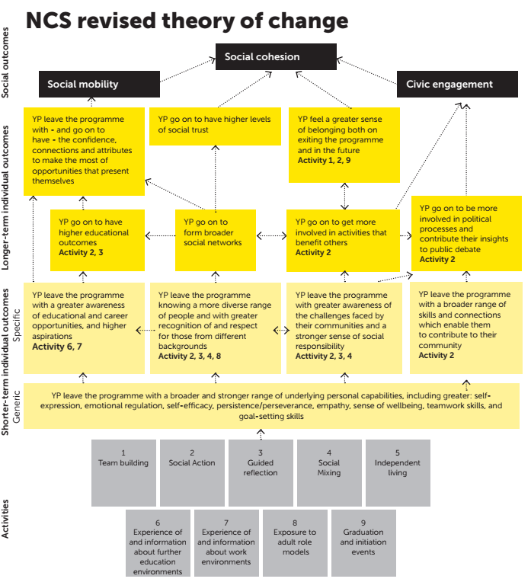

Appendix 4: Methodological limitations

While Kantar has designed and conducted this evaluation to deliver high quality data and analysis for DCMS, it is important to highlight some of the limitations with the approach used. These are noted briefly below to aid the reader in interpreting results (with further details provided in the technical report).

* Those survey respondents who (i) agreed to be re-contacted for the follow-up survey and (ii) completed the follow-up survey, may have been different in various respects to those respondents who did not agree to be re-contacted and/or did not complete the follow-up survey. For example, NCS participants with a less positive experience of the programme may be less inclined to complete the follow-up survey, thus introducing some bias in the follow-up survey estimates. Weighting is unlikely to eliminate *all* non-response bias.
* The baseline and follow-up surveys were both self-completion questionnaires and were, as far as possible, identically worded. However, responses may have been influenced by modal differences. At the baseline NCS participants completed paper questionnaires on their way to programme together with other participants. This would have been at a point in time when young people may have been feeling particularly anxious or nervous as they were about to embark on their NCS journey, and the group dynamic may have also introduced a degree of social desirability bias. Meanwhile, the comparison group answered the baseline survey online. Both participants and the comparison group completed the follow-up questionnaire online.
* We expect there to be systematic differences between the participant and comparison groups. Propensity score weights are designed to control for these observed differences between the two groups and reduce bias, but some unobserved differences that cannot be controlled for are likely to remain.
* DiD analysis assumes that the average level of change observed for the participant group would have been equal to the average level of change observed for the comparison group, had they not taken part in NCS. We think this assumption is reasonable, given the relatively short time-frame of the evaluation during which other events or circumstances might influence the two groups. It is not possible to collect data for participants and a comparison group over a longer period of time prior to their participation in NCS.
* Since the impacts are estimated over a relatively short time-frame, there is a possibility that these differences will not persist over the longer-term. Additional work continues to be undertaken to examine the longer-term impacts of participation in NCS.[78]

1. NCS Theory of Change, completed by social enterprise Shift for the NCS Trust. NCS Trust, *NCS Theory of Change.* (Shift, 2017). p9. See Appendix 3.
2. This is when the majority of young people participate. The evaluation includes both 3 and 4 week summer programmes and autumn standard model programme. It excludes spring and autumn college model programmes. Summer and standard autumn models are set up differently, so they are evaluated separately in this report and their outcomes are deliberately not compared.
3. See methodology section of the report for more detail of difference-in-difference.
4. Between the baseline and follow-up surveys, NCS participants’ agreement with this statement increased from 55% to 64%. The comparison group’s agreement reduced from 59% to 58%. The difference between these two differences is +9 percentage points, once effects from rounding to decimal places are taken into account.
5. Between the baseline and follow-up surveys, NCS participants’ mean score increased from 8.6 to 8.7 while the comparison group’s mean score reduced from 8.6 to 8.3. The difference between the two mean scores is +0.4.
6. Lawton, R. & Watt W. *The ABC of BAME: New, mixed method research into Black, Asian and minority ethnic groups and their motivations and barriers to volunteering*. (Jump Projects: January 2019). <https://jump-projects.com/our-work/>.
7. A negative impact here equates to a reduction in anxiety, which is a positive finding.
8. The value for money assessment is based on the estimates of impact identified as part of the survey of NCS participants, combined with external research and a number of assumptions to estimate the monetised benefit of volunteering, leadership and educational aspiration. As with any analysis, the value for money assessment is subject to margins of error; however, the estimates presented here are central estimates of the value for money associated with the 2018 NCS programme.
9. Note figures may not sum due to rounding.
10. Whilst NCS is funded primarily by the public purse, parents/ guardians are asked to make a small contribution. Thus, it is important to note that there is a small difference between the gross and net benefits associated with NCS as a result of parental contributions, which marginally reduce gross benefits because they are essentially a cost incurred by parents/ guardians to achieve or induce the gross benefits. As such, to generate a BCR from the perspective of the public purse, the value of the parental contributions is deducted from gross benefits.
11. Of the total gross benefits, more than 50% is contributed through the impact on educational aspiration. This element of analysis is new to the evaluation for 2018 and the measure of aspiration may be much higher or lower in the future. Given this and its relative contribution to the overall identified benefits, the estimated benefits (using Approach 1) in future years’ evaluations may become more variable.
12. For previous evaluation reports visit: “Our Objectives and Impact”, NCS, Accessed 28 April 2020, <https://wearencs.com/our-objectives-and-impact>
13. For more information about the NCS programme visit [www.wearencs.com](http://www.wearencs.com). The NCS Theory of Change, which sets out how the programme is designed to meet these social outcomes, is provided in Appendix 3.
14. For more detail, please see “Guide to scoring evidence using the Maryland Scientific Methods Scale*”* What Works Centre for Local Economic Growth, Last modified June 2016. <https://whatworksgrowth.org/resources/scoring-guide>.
15. Further details about the sample, including demographic breakdowns by gender, age, ethnicity, eligibility for free school meals, religion and current activity are included in the technical report tables.
16. An online panel is a selected group of research participants who have agreed to provide information online at specified intervals over a period of time. Panellists were sourced from agencies [Lightspeed](http://www.lightspeedresearch.com/sample-audiences/panel-profiling/) and [Youth Sight](https://www.youthsight.com/panel/services). For more on the method employed to ensure representativeness across sample sources, please see later detail about propensity score matching (PSM) and weighting.
17. Providers were issued with a set number of paper questionnaires based on early estimates of likely turn out numbers for the weeks fieldwork took place. Given turn out numbers fluctuate it is not possible to accurately calculate response rates. The evaluation did not employ a census approach: only those attending NCS in certain weeks were invited to complete the survey as participants, as outlined on p.11 of the report.
18. Note that it is not possible to control for all differences. Further caveats around this approach can be found in the technical report.
19. Levels 4 and 5 would be attained if the evaluation design was quasi experimental or a randomised controlled trial. In those cases, one could be reasonably or completely certain that the only difference between the participant and control groups was the intervention being tested. For more detail, please see “Guide to scoring evidence using the Maryland Scientific Methods Scale*”,* What Works Centre for Local Economic Growth, last modified June 2016, <https://whatworksgrowth.org/resources/scoring-guide>.
20. “Ethical Assurance for Social Research in Government.” Government Social Research Unit, Last modified September 1 2011. <https://www.gov.uk/government/publications/ethical-assurance-guidance-for-social-research-in-government>
21. The mean score is the average score for everyone in the group in question, calculated by dividing the sum of all values by the number of people in this group
22. A confidence interval is a statistically estimated range of values that a calculated figure may fall within.
23. For example, the autumn programmes include shorter residential stays than the summer programmes. See more detail in the technical report.
24. Andersen, H., & Mayerl, J. Responding to Socially Desirable and Undesirable Topics: Different Types of Response Behaviour? Methods, data, analyses: a journal for quantitative methods and survey methodology (mda), 13(1), 7-35. (2019) <https://doi.org/10.12758/mda.2018.06>. Social desirability is influenced by factors including their own personality traits, the content of the question, their “true” answers and the circumstances of the survey.
25. Department for Digital, Culture, Media and Sport. *Community Life Survey 2017-18 Statistical Release*. (July 2018). <https://assets.publishing.service.gov.uk/government/uploads/system/uploads/attachment_data/file/734726/Community_Life_Survey_2017-18_statistical_bulletin.pdf>.
26. Lawton, R. & Watt W. *The ABC of BAME: New, mixed method research into Black, Asian and minority ethnic groups and their motivations and barriers to volunteering*. (Jump Projects: January 2019). <https://jump-projects.com/our-work/>.
27. Quintelier, E. "Who Is Politically Active: The Athlete, the Scout Member or the Environmental Activist? Young People, Voluntary Engagement and Political Participation” *Acta Sociologica* 51(4) (2008):355-370.
28. Knibbs et al, *National Youth Social Action Survey 2018. Summary report.* (Ipsos MORI: 2019) p.7.
29. Ibid. p.8.
30. Kantar surveyed adults eligible to vote before the election to ask if they would vote and then returned to them after the election to ask them if they actually voted. With that data, Kantar was able to model the probability of someone voting based on their stated likelihood of voting (before the election). The analysis is unpublished but some discussion of the method and associated matters can be found in: “How does Kantar Public weight its voting intention data?”. Williams, J. Kantar Website. Last modified 13 February 2018. <https://uk.kantar.com/public-opinion/politics/2018/how-does-kantar-public-weight-its-voting-intention-data/>. The Voting Intention research draws on an older audience (aged 18+) but may still be useful to set the findings from NCS participants, who are a few years younger, in context.
31. Unpublished Kantar analysis of British Election Study 2010 microdata analysing voting intention on a scale of 0-10 against actual voting behaviour.
32. Lawton, R. & Watt W. *The benefits of volunteering: A summary of work from 2014 to 2019*. (Jump Projects: January 2019). <https://jump-projects.com/our-work/>.
33. Please note, the negative score for anxiety is a positive finding and indicates a decrease in anxiety post-programme.
34. ONS. *Young people's personal well-being, October 2017 to September 2018. User request 10410*. (August 2019). <https://www.ons.gov.uk/peoplepopulationandcommunity/wellbeing/adhocs/10410youngpeoplespersonalwellbeing>.
35. The summer participants and comparison group could answer ‘Often’, ‘Sometimes’, ‘Hardly ever’ or ‘Never’. Whilst the autumn participants and comparison group could answer ‘Often’, ‘Sometimes’, ‘Occasionally’, ‘Hardly ever’ or ‘Never’. Analysis focused on the percentage of who chose ‘Hardly ever’ or ‘Never’.
36. Department for Digital, Culture, Media and Sport. *Community Life Survey 2017-18 Statistical Release.* (July 2018). <https://assets.publishing.service.gov.uk/government/uploads/system/uploads/attachment_data/file/734726/Community_Life_Survey_2017-18_statistical_bulletin.pdf>. Last accessed 19 February 2020.
37. HM Treasury. *The Green Book, Central Government Guidance on Appraisal and Evaluation.* (2018). <https://assets.publishing.service.gov.uk/government/uploads/system/uploads/attachment_data/file/685903/The_Green_Book.pdf>. Last accessed 28 April 2020.
38. Jump x Simetrica. *If you could bottle it…A wellbeing and human capital value-for-money analysis of the NCS 2015 programme*. (We are NCS: 2018). <https://wearencs.com/sites/default/files/2018-10/NCS%20Wellbeing%20and%20Human%20Capital%20Valuation%20-%20Jump_0.pdf>. Last accessed 28 April 2020.
39. This includes three and four week summer programme, and ‘standard’ autumn programme.
40. This approach was adopted because of the difference in impacts identified by gender, but also because of the difference in monetised benefits depending on gender. In particular, the assessment of the monetary impact associated with leadership and higher education aspiration are in part dependent on measures of lifetime earnings. Since sufficient evidence exists to allow for analysis disaggregated by gender, this approach was incorporated into the methodology in 2018.
41. Note figures may not sum due to rounding.
42. Whilst NCS is funded primarily by the public purse, parents/ guardians are asked to make a small contribution. Thus, it is important to note that there is a small difference between the gross and net benefits associated with NCS as a result of parental contributions, which marginally reduce gross benefits because they are essentially a cost incurred by parents/ guardians to achieve or induce the gross benefits. As such, to generate a BCR from the perspective of the public purse, the value of the parental contributions is deducted from gross benefits.
43. All estimates were included in the analysis, regardless of statistical significance. All estimates were significant at the 1% level for summer 2018, except the estimate for “working with others in a team” for males, which was significant at the 5% level. For autumn 2018, both genders’ estimates for “working with others in a team” and the male estimate of “explaining ideas clearly” were insignificant. All other estimates for autumn 2018 were significant at the 1% or 5% level. A sensitivity analysis excluding insignificant estimates is reported in Section 5.4 of the technical report.
44. 5 point scale- Very confident, confident, neither, not very confident, not at all confident.
45. Kuhn, P., & Weinberger, C. “Leadership skills and wages”. (2005). *Journal of Labor Economics*, 23(3), 395-436.
46. Ibid
47. London Economics’ analysis of the Labour Force Survey. Original 2016 estimates (£384,016 for females and £743,828 for males) are updated to account for CPI inflation in 2017 and 2018 (2.7% and 2.5% respectively; source: “CPI Annual rate 00: All Items 2015=100” ONS, Last modified April 22 2020, <https://www.ons.gov.uk/economy/inflationandpriceindices/timeseries/d7g7/mm23>). These estimates refer to the net present value associated with individuals not in possession of higher education qualifications.
48. Summer 2018 participants. Both 3 and 4 week programmes are included to be consistent with the impact analysis.
49. Autumn 2018 ‘standard’ model participants (excluding the College model). Note that this represents a difference compared to the 2017 evaluation, where both standard and College model autumn participants were surveyed. In relation to the value for money analysis, the effect of this adjustment means total gross benefits and costs are not comparable across the two years. However, it does not affect Benefit Cost Ratios - since any changes in both gross costs and benefits are in the same proportions, the estimates of the various Benefit Cost Ratios are unchanged.
50. Since participation figures disaggregated by gender were only available for the autumn standard and College model combined, we assumed that the gender split on the autumn standard model was the same as the gender split on the autumn programme as a whole (standard and College model).
51. McIntosh, S. *Post-16 Aspiration and Outcomes: Comparison of the LSYPE Cohorts*. (DfE: 2019). https://assets.publishing.service.gov.uk/government/uploads/system/uploads/attachment_data/file/804409/LSYPE_report_FINAL_17_May.pdf.
52. “Next steps”. Centre for Longitudinal Studies, UCL. Last accessed 28 April 2020. https://cls.ucl.ac.uk/cls-studies/next-steps/.
53. Conlon, G., Halterbeck, M. *Assessing the economics returns to Level 4 and 5 STEM-based qualifications*. (Gatsby Foundation, London Economics: 2017). <https://www.gatsby.org.uk/uploads/education/reports/pdf/le-gatsby-assessing-the-economic-returns-to-level-4-and-5-stem-based-qualifications-final-07-06-2017.pdf>.
54. The survey question used to assess aspiration was “What activity would the young person most like to do when they are 18 after they have finished school or college?”, with 4 options: ‘Get a full-time or part-time job’, ’go to/stay in FE college’, ’get an apprenticeship’, ’go to university or HE institution’. The last category was used to inform this analysis. The male estimate for summer programmes was significant at the 5% level and the female summer estimate was significant at the 10% level. Other estimates were insignificant. A sensitivity analysis excluding insignificant estimates is reported in Section 5.4 of the technical report.
55. “Non-continuation: UK Performance Indicators 2017/18”. HESA. Last modified March 7 2019. <https://www.hesa.ac.uk/news/07-03-2019/non-continuation-tables>.
56. For the analysis estimating the economic benefit associated with leadership, information on the lifetime earnings achieved by individuals not in possession of higher education qualifications was used. In this element of the analysis (based on estimates from Gatsby Foundation (2017)), we estimate the additional economic impact of a higher education qualification. This is not the same as assessing the earnings achieved by individuals in possession of higher education qualifications (which would be greater than those presented here). The reason for this is that the econometric analysis in Gatsby Foundation (2017) strips out those other characteristics of higher education qualification holders that might also impact earnings, leaving only the impact of the higher education qualification itself. This approach allows the estimation of the leadership and aspiration effects independently.
57. In the summer 4-week programme, participants spend Week 3 and 4 (equivalent to 30 hours per week) planning, and then delivering, a social action project, respectively. However, over recent years, with Week 3 and 4 becoming a combined single phase of the programme, the distribution between planning and volunteering time has become unspecified for partners, and it is likely that actual volunteering time begins in Week 3 and continues into Week 4. For the 3-week summer programme and the autumn standard model, planning and delivering the social action is condensed into the final week of the course (equivalent to 30 hours). Therefore, given allowances for planning time, the 30-hour volunteering requirement we use in this analysis may slightly underestimate the hours volunteered for the 4-week programme, but overestimate the volunteering hours in the summer 3-week and autumn standard model.
58. Candy, D. et al. *National Citizen Service 2013 Evaluation – Two Years On: Main Report.* (Ipsos MORI, DCMS: 2017). See: <https://wearencs.com/our-objectives-and-impact>
59. See footnote 53 around this.
60. Table 3.2, Low Pay Commission. *National Minimum Wage: Low Pay Commission Report 2018*. (BEIS: 2018). <https://assets.publishing.service.gov.uk/government/uploads/system/uploads/attachment_data/file/759271/National_Minimum_Wage_-_Low_Pay_Commission_2018_Report.pdf>.
61. Note that despite the heterogeneity in terms of the volunteering activities undertaken by NCS participants, there is no way to accurately identify a relevant opportunity cost associated with volunteering activities. This is because of either the limited information on the specific nature of the volunteering activities undertaken by participants (and how this might translate to industrial classification – and ‘which’ wage rate to use), or because of sample size, where measures of this opportunity cost in the labour market is insufficiently robust. Given this, London Economics use information on the median hourly wage as identified in the (ONS) Annual Survey of Hours and Earnings from Low Pay Commission (2018), which is the most reliable source of information on labour market remuneration in the United Kingdom.
62. Candy, D. et al. *National Citizen Service 2013 Evaluation – One Year On*. (Ipsos MORI, DCMS: 2015). See: <https://wearencs.com/our-objectives-and-impact>
63. Candy, D. et al*. National Citizen Service 2013 Evaluation – Two Years On: Main Report*. (Ipsos MORI, DCMS: 2017). See: <https://wearencs.com/our-objectives-and-impact>
64. The results of the evaluations of summer 2013 NCS suggest that the NCS had an impact on the volunteering behaviour of participants that lasted beyond the short-term period. These findings suggested that participants continue to supply additional volunteering hours at a similar level (relative to a comparison group) for an *additional* 12 months post programme completion. However, the magnitude of these effects declines over the following year, and by the 27/28th month following completion of NCS, the effects were not statistically significantly different from zero.
65. The estimate for males in the autumn programme was not statistically significant. All other estimates were significant at the 5% level. A sensitivity analysis excluding insignificant estimates is reported in Section 5.4 of the technical report.
66. Table 3.2, Low Pay Commission. *National Minimum Wage: Low Pay Commission Report 2018*. (BEIS: 2018). <https://assets.publishing.service.gov.uk/government/uploads/system/uploads/attachment_data/file/759271/National_Minimum_Wage_-_Low_Pay_Commission_2018_Report.pdf>
67. HM Treasury. *The Green Book, Central Government Guidance on Appraisal and Evaluation.* (2018). <https://assets.publishing.service.gov.uk/government/uploads/system/uploads/attachment_data/file/685903/The_Green_Book.pdf>.
68. There is a mismatch between the financial year in which these costs are accounted for against the calendar year in which the 2018 programme activity took place. Therefore, these costs from an accounting perspective have been re-allocated to align with the timing of NCS participant activity.
69. Note that totals may not sum as a result of rounding.
70. Net of the parental contribution, approximately £1.15 million and £0.08 million in summer and autumn 2018 respectively.
71. Participants were asked to rate their life satisfaction on a scale of 0-10.
72. Fujiwara, D. “A general method for valuing non-market goods using wellbeing data: three-stage wellbeing valuation”. (2013). <http://eprints.lse.ac.uk/51577/1/dp1233.pdf>.
73. Jump x Simetrica, *If you could bottle it…A wellbeing and human capital value-for-money analysis of the NCS 2015 programme.* (2018). <https://wearencs.com/sites/default/files/2018-10/NCS%20Wellbeing%20and%20Human%20Capital%20Valuation%20-%20Jump_0.pdf>.
74. Only the impact estimate for females in the summer programme was statistically significant (at the 10% level). A sensitivity analysis excluding non-significant estimates is reported in Section 5.4 of the technical report.
75. Net of the parental contribution, approximately £1.15 million and £0.08 million in summer and autumn 2018 respectively.
76. In the 2017 analysis (which can be found at <https://wearencs.com/our-objectives-and-impact>), the net Benefit Cost Ratios for Approach 2 were larger than those of Approach 1, suggesting that estimates of wellbeing improvements captured a number of additional benefits beyond those of leadership skills and volunteering (aspiration was not included in the 2017 methodology). In the current analysis, however, with the inclusion of the aspiration benefit, the net Benefit Cost Ratios in Approach 1 are larger than Approach 2. Again, and in particular because of the changes in methodological approach between years, the two approaches should thus be seen as complementary to each other and informative in providing an estimate of the range of potential impact, and not directly compared with each other or evaluations from previous years.
77. NCS Theory of Change, completed by social enterprise Shift for the NCS Trust. NCS Trust, *NCS Theory of Change.* (Shift, 2017). p9.
78. For example, see: Kantar Public, National Citizen Service 2016 Evaluation, Dec 2017 which can be found at <https://wearencs.com/our-objectives-and-impact>, accessed 18 November 2019.