Annexes for the assessment of scallop stock status for selected waters around the English Coast 2018/2019

Table of Contents

Tables 3

Figures 3

1 Scallop Biological Sampling Procedure 5

1.1 Methodology 5

1.2 Sampling Targets 5

1.3 Data Raising Process 6

1.3.1 Age-Length Key (ALK) 6

1.3.2 Length Distribution 6

1.3.3 Age Distribution 7

2 Dredge Survey Design 8

2.1 Terminology 8

2.2 Identification of Scallop Beds 9

2.3 Station Selection 10

3 Dredge Survey Data Processing 14

3.1 Scallop Density Raising - Arithmetic Approach 14

3.2 Sample Processing 14

3.3 Swept Area Estimation 15

3.4 Substrate Specific Dredge Efficiency 16

4 Underwater Television (UWTV) Survey Methods 18

4.1 Survey Design 18

4.2 Video Survey Processing 19

5 UWTV Surveys 20

5.1 Results 20

6 Supporting Research and Development 23

6.1 Dredge Efficiency Estimates 23

6.2 Biomass Estimates from UWTV 24

6.2.1 Camera System 24

6.2.2 Camera Efficiency 25

6.2.3 Population Structure 25

6.2.4 Connectivity Between Dredged and Un-Dredged Beds 25

7 Dredge Survey of Bed 7.d.2 in 27.7.d.S 26

7.1 2018 Dredge Survey 26

7.2 Raised Biomass Estimates and Uncertainty 27

7.3 Size Composition from Dredge Survey 29

7.4 Conclusions 29

Tables

Table 2.1: The cell thresholds used to determine whether a block was deemed valid. 10

Table 3.1: Number of tows by ground type in each bed with proportion described by the survey vessel skipper as having significant amounts of flint or cobbles. 17

Table 5.1: Summary of UWTV survey results by un-dredged zones 2017 and 2019. Number of transects, mean density, minimum and maximum numbers 100 m2 and the number of transects with no observed scallops are shown. 20

Table 5.2: Zone abundance (median and point estimate in millions) with percentiles from un-dredged zones (estimated by UWTV survey) and estimated harvestable biomass and spawning stock biomass. 22

Table 7.1: Sampling summary from dredge survey in bed 7.d.2 in 2018. 26

Table 7.2: Biomass estimation for the dredge surveyed bed 7.d.2 for 2018. 28

Figures

Figure 2.1: An example scallop dredge bed (red outline) with 0.1-degree blocks (black) and 0.025-degree cells (blue) 9

Figure 2.2: Valid (blue) and invalid (red) blocks for beds 7.e.1-8 in 27.7.e and 7.f.1 in 27.7.f, along with the number of cells within each block. 11

Figure 2.3: Valid (blue) and invalid (red) blocks for bed 7.d.1 in 27.7.d.N along with the number of cells within each block. 12

Figure 2.4: Valid (blue) and invalid (red) blocks for bed 4.b.1-2 in 27.4.b.S along with the number of cells within each block. 13

Figure 4.1: The UWTV survey un-dredged zones as defined in 2017 and 2019. 18

Figure 5.1: Estimated density (numbers m-2) on the 2017 and 2019 TV survey by block and un-dredged zones TV.7.e.A-E and TV.7.d.A. 21

Figure 7.1: Sampled blocks in Bed 7.d.2, in assessment area 27.7.d.S in 2018. Block shading indicates the total number of stations within each block 0 =grey, 1=blue. 27

Figure 7.2: Biomass (Tonnes) of harvestable (≥ 110 mm length, the MLS) scallops in the surveyed areas within bed 7.d.2, assessment area 27.7.d.S in 2018. 28

Figure 7.3: Dredge survey: Numbers (millions) per length class (mm) for the scallop population in surveyed areas of 7.d.2 in 2018. The vertical line represents MLS. 29

# Scallop Biological Sampling Procedure

## Methodology

The fishing industry proposed a methodology for the sampling procedure, which is a modification of an earlier scheme:

1. Cefas identifies sampling opportunities based on regular reports of the positions of participating vessels from the Vessel Monitoring Scheme (VMS) and requests a length or age sample from the processor.
2. The processor contacts the vessel by phone or internet-based messaging and requests a sample to be collected from the next haul.
3. The vessel crew collect a bag of scallops in a labelled and coloured bag (to aid identification at the processor) and land it along with the rest of the catch. Length samples are retained in red bags, and those for age determination are retained in a blue bag.
4. At the processors, the industry staff measure the length samples (height of round shell) and return the size distributions along with sample weight and sample details to Cefas. Age samples are processed at the factory as per the usual procedure, but flat shells are sent to Cefas for age determination.
5. A supplementary and opportunistic method was introduced, where samples are pre-ordered by the processor contacts in consideration of target shortfalls.

In the laboratory low power microscopes are used to confirm age, as growth rings observed with the naked eye have shown to be unreliable in the English Channel. Initial ages are checked and where discrepancies exist between readers, they are further validated by consensus.

## Sampling Targets

The spatial distribution of fishing effort and catches within each fishing season can be difficult to predict and appears to be influenced by irregular recruitment events. VMS data were used to define ICES statistical rectangles where fishing activity had occurred over the past 8 years and warranted sampling. Sampling targets in the first year (2017) were set at 5 length samples per ICES rectangle per quarter year, where one of the length samples is retained for subsequent age determination to facilitate the construction of an age-length key for each ICES rectangle. From 2018 sampling targets were revised to better reflect fishing patterns as defined by reported landings. One sample was requested for a threshold of 1 tonne of scallop landed per ICES rectangle and then another for each subsequent 50 t. To provide an improved estimation of age structure two age samples were requested for every 3 length samples.

In a process parallel to that used by finfish stock assessments, estimates of age composition were obtained from length distributions (LDs) of landings and conversion to ages with an age-length key.

Given the limited mobility of scallops, together with pre-existing knowledge on the patchiness of scallop settlement and variability in growth rates, the sampling strata employed for scallops are much smaller than those for finfish.

The basic strata for the targeting of age and length are ICES rectangles and reported landings. Samples are requested from named vessels when it is observed fishing in an area on a given day. The unit of sampling is therefore a combination of vessel, rectangle and day.

## Data Raising Process

### Age-Length Key (ALK)

1. From the age samples (blue-bag), 5 shells per 5mm length class are retained for age-determination
2. Within each 5mm length class, the proportion of each age was determined to give an ALK for each rectangle-quarter stratum.
3. To fill any strata for which there were missing ALKs, all age (blue-bag) samples were pooled to the quarter - assessment area level to generate an ALK.

### Length Distribution

1. Sample LDs were raised to the reported catch of the vessel within the day using the ratio of reported sample weight to landings.
2. Sample LDs and weights from step 4 were aggregated to the level of rectangle and quarter.
3. The pooled LDs from step 5 were raised to the total UK landings for that rectangle and quarter using the ratio of the sampled weight to total landings.
4. Not all strata with landings records had length samples. Missing strata were assumed to come from the same length distribution as the aggregate quarter – assessment area. The LDs from step 6 were pooled and then raised to each missing stratum using the ratio of sampled weight to strata landings.
5. Numbers in each size class from step 7 were summed within each stock area and sampling season (quarter 4 of the previous year plus quarter 1-3 of the current year) to give total numbers in each size class per assessment area and sampling season.

### Age Distribution

1. For directly sampled strata, the raised rectangle-quarter numbers at length were multiplied by the corresponding ALK and then summed to give the total numbers at age per rectangle - quarter
2. For un-sampled strata, the in-fill LD (step 7) were multiplied by the in-fill ALK (step 3) and summed to give numbers at age per un-sampled rectangle-quarter.
3. These numbers at age were summed over all quarters and rectangles within each stock area and for quarters 4(year n-1) – 3(year n) to give total removals at age per assessment area and sampling season.

# Dredge Survey Design

## Terminology

The following spatial areas were used during the survey design process:

* Bed – A polygon representing a fished scallop ground, identified using Vessel Monitoring System (VMS) data.
* Block – A regular grid of 0.1-by-0.1-degree (latitude/longitude) rectangles, with an approximate area of 80 km2.
* Cell – A regular grid of 0.025-by-0.025-degree rectangles, with an approximate area of 5 km2 and a maximum of 16 cells per block (4 by 4). This is the scale to which the VMS data were aggregated as part of the survey design methodology. Mid points of cells are used as potential sampling positions, randomly selected as part of the dredge survey design. This also forms the grid over which the data are raised to calculate the bed biomass and age-length population structure.
* Valid cell – A cell with VMS data reported within.
* Valid block – A block with a specific number (threshold) of valid cells within.

These concepts are graphically presented in Figure 2.1.

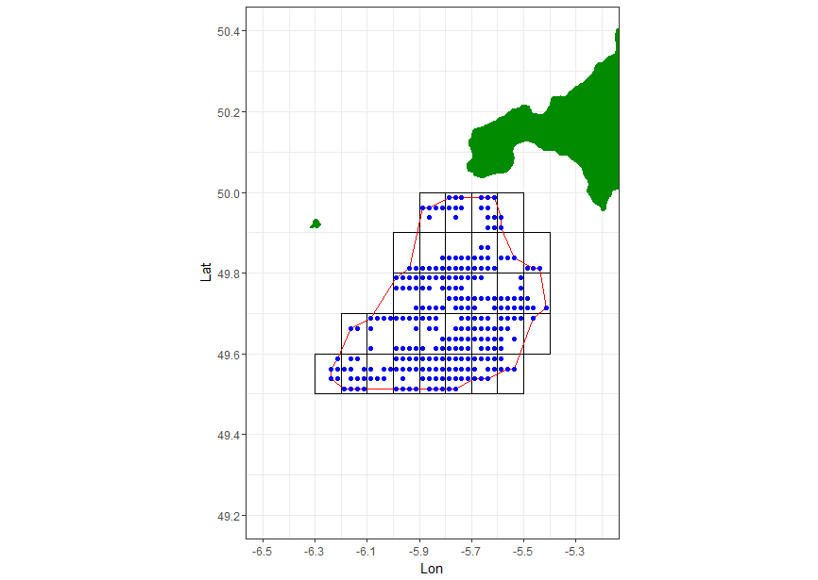

Figure 2.1: *An example scallop dredge bed (red outline) with 0.1-degree blocks (black) and 0.025-degree cells (blue)*

## Identification of Scallop Beds

VMS data from 2009 to 2016 for trips where scallop dredges were deployed were used to identify the location of scallop grounds targeted by the commercial scallop dredge fleet in the English Channel. For the first four years of data, only vessels 15 m and above were available but changes to the VMS scheme enabled all vessels 12 m and above to be included from 2013.

VMS data were processed as follows:

* Vessels were assumed to be fishing when the reported speed was between 1 and 5 knots; this assumption was used to remove records where vessels were likely to be transiting between grounds, or in harbour.
* VMS data were aggregated to the cell level (0.025-degree grid). Cells with less than 10 reported positions over the full-time series were removed.
* LPUE was derived for each VMS position by dividing the reported trip landings for the relevant combination of vessel-day-rectangle by the fishing hours estimated from VMS data for the same strata.

Bed boundary polygons were created using the R function ashape from the alphahull package. This function uses the algorithm defined by Edelsbrunner *et al* (1983) to construct an α-shape around a set of points, in this case VMS points (cells), based upon the Delaunay triangulation.

The resulting α-shape was converted to a polygon (bed) representing a scallop fishing ground. Within each bed there are patches where VMS data are absent, these are represented as areas without valid cells (Figure 2.1). When aggregating the survey results within each scallop bed only those cells with scallop-related VMS points are used. The assumption is that no commercial fishing (at least by vessels that are part of the VMS scheme) takes place in these cells and therefore that there are no scallops in those cells that are accessible to standard fishing gear.

Eight scallop beds within ICES SubDivision 27.7.e and one scallop bed within 27.7.d were defined using the above approach. In 2018 three additional scallop beds were identified using the same time series of VMS data, one in 27.7.f and two in 27.4.b. Following recent expansion of the fishery in 27.7.d., a further bed (7.d.2.) was identified by including 2017 fishing activity in the VMS time series.

## Station Selection

A random stratified sampling design was used. As it is not clear if scallop density is randomly distributed across the whole bed, it was considered important to ensure broad spatial coverage of the sampling design. Therefore, within each bed, blocks were used to represent the different strata. Broad spatial coverage is provided by ensuring that most blocks are sampled. Within each block, one valid cell was selected at random, the midpoint of which was a potential sampling position. This procedure ensured stations were only placed in areas commercially fished for scallops, and generated mean tow position separations in line with those suggested by earlier scoping work carried out in 2016 (Lawler, 2017. Unpublished).

For the available survey time it was not possible to sample each block which intersected the bed boundary. Many blocks, particularly around the boundary had very few valid cells contained within them (Figures 2.2, 2.3 & 2.4). A protocol was therefore developed to ensure that the sampled blocks represented as many of the valid cells as possible within the sampling time frame. For each bed a threshold number of valid cells per block was established such that >85% of the cells within each bed fell inside the sampled blocks. Table 2.1 gives the threshold per bed. This ensured that the main fishing areas are sampled within each bed and ensured the number of stations were consistent with the optimal tow separation suggested by the earlier scoping work. However, it does also mean that densities around the boundary of each bed were less well sampled which could introduce bias into the approach if there is a steeper gradient of density at boundary edges than in the main fishing grounds.

Table 2.1: *The cell thresholds used to determine whether a block was deemed valid.*

|  |  |  |  |  |  |  |
| --- | --- | --- | --- | --- | --- | --- |
| **Bed** | **Total number of blocks that intersect bed** | **Cell threshold** | **Blocks dropped** | **Cells dropped** | **% Cells Dropped** | **No. Stations per bed (no. valid blocks)** |
| 7.e.1 | 32 | 5 | 11 | 36 | 14 | 21 |
| 7.e.2 | 47 | 9 | 13 | 60 | 11 | 34 |
| 7.e.3 | 3 | 2 | 1 | 2 | 13 | 2 |
| 7.e.4 | 46 | 6 | 15 | 65 | 14 | 31 |
| 7.e.5 | 30 | 4 | 11 | 27 | 11 | 19 |
| 7.e.6 | 5 | 2 | 2 | 3 | 11 | 3 |
| 7.e.7 | 11 | 3 | 4 | 9 | 11 | 7 |
| 7.e.8 | 37 | 6 | 15 | 47 | 13 | 22 |
| 7.f.1 | 21 | 5 | 8 | 19 | 12 | 13 |
| 7.d.1 | 100 | 8 | 31 | 91 | 8 | 69 |
| 4.b.1 | 38 | 4 | 15 | 33 | 11 | 23 |
| 4.b.2 | 8 | 2 | 4 | 6 | 20 | 4 |

Schematic map showing number of valid cells within each block and dredge survey bed in 7.e and 7.f

Figure 2.2: *Valid (blue) and invalid (red) blocks for beds 7.e.1-8 in 27.7.e and 7.f.1 in 27.7.f, along with the number of cells within each block.*



Figure 2.3: Valid (blue) and invalid (red) blocks for bed 7.d.1 in 27.7.d.N along with the number of cells within each block.

Schematic map showing number of valid cells within each block in dredge survey beds 4.b.1 and 4.b.2 in assessment area 4.b.South

Figure 2.4: Valid (blue) and invalid (red) blocks for bed 4.b.1-2 in 27.4.b.S along with the number of cells within each block.

Initially, Industry collaborators were keen to contribute to the tow position selection process in line with some other collaborative surveys. It was agreed that industry could select 25% of the tow positions per bed. Therefore, 75% of the valid blocks were selected at random, from which a suite of scientifically derived station tow positions was selected by randomly choosing valid cells from the selected block. No rationale behind the choice of industry location was sought or provided, but the basic assumption must be that these were not selected at random, but rather on prior knowledge. The inclusion of subjectively chosen station points has the potential to bias the result. If positions of known high density are selected, then high-density locations will be over-represented and are likely to bias the total population estimate upwards. Conversely over-representation of low-density areas will lead to an under-estimate of the population. Such bias is likely to be realised most strongly if all stations are pooled together to generate an average density per bed, and indeed this approach would violate the statistical integrity of any abundance estimate. From 2018 tow selection was entirely by random selection, although the focus is still on the main fishing areas.

# Dredge Survey Data Processing

## Scallop Density Raising - Arithmetic Approach

The stratified random design dictated that the data were processed by block as the sampling strata, the density estimate from stations within a block were considered representative of the surface area of the block, and the block mean density was used if more than one station was in a single block. Within each block there were a limited number of valid cells, as defined by the VMS data, so the valid surface area of the block is the sum of the surface area of all valid cells. Total block abundance (in numbers) is then given by

$N=\sum_{c}{ ρ_{c} A_{c}}$,

where *c* are the valid cells, $ρ_{c}$ is the areal number density, and $A_{c}$ is the surface area of each cell.

There were however, unsampled blocks which had a surface area defined by the valid cells within that block. The stock lying within the unsampled blocks was estimated by applying the mean density from the survey stations (bed mean densities) to the total valid surface area of the unsampled blocks.

The remaining issue was how to incorporate the industry selected stations within this approach. As we cannot guarantee that the industry station locations have been chosen at random, statistically speaking they cannot be used to represent the mean density for the whole block. Because they are chosen specifically for a site, the Industry selected stations can only be used as observations for that specific site (cell). The science-derived estimate of scallop abundance was used for all cells except for those were an industry selected station occurred where the abundance was replaced by that observed at the industry selected station.

## Sample Processing

Sampling was carried out from the set of gear on only one side of the vessel which provided adequate sampling levels throughout the surveys. As such samples were raised to the catches and area swept by sampled dredges alone, avoiding the need to consider any potential bias between starboard and port gears.

The following raising procedure was carried out on the survey data for the commercial dredge gear:

1. The sampled length distribution (LD) was raised to the total caught per station, using the raising factor calculated as caught weight or numbers over sampled weight or numbers for the two catch components, discards (below minimum landing size) and retained.
2. The catch components were aggregated to get total raised numbers at size by station.
3. The catch density (number/m2) for each station was calculated by dividing the count by the swept area of the gear.
4. The station catch densities from 3 above, were raised using the appropriate substrate-specific gear efficiency factor to estimate scallop density on the seabed.
5. For randomly allocated stations, and for blocks which had one or more sampled cells, the block mean density per length class was calculated.
6. For randomly allocated stations, the bed mean density per length class was calculated.
7. Block mean densities were applied to all cells within blocks, where there was at least one sampled cell.
8. Bed mean densities were applied to all cells in all unsampled blocks.
9. Densities in cells where an industry selected station was available were substituted with the density generated for that industry station. (For 2017 dredge surveys only. From 2018 all stations were randomly selected)
10. Cell densities were raised to the area of each cell.
11. Number densities from step 10 were summed within each Assessment Area to generate raised numbers at size.

Steps 3 to 11 were repeated with the age converted data, using the sample ALKs, to generate the age profile of the population. The harvestable biomass was calculated for the assessment area by using the length-weight conversion parameters to calculate weight at length for the scallops over the minimum landing size. For assessment areas in ICES subdivision 27.7e, the MLS is 100 mm shell length, whilst for ICES subdivision 27.7d it is 110 mm.

## Swept Area Estimation

Internally logging data storage tags (Cefas G5) recording depth and time were attached to the bridles on the dredges to provide depth profiles and an accurate indication of the time of deployments. GPS receivers (RoyalTech MBT1100) provided ship positions. These loggers provided the positions of the tow tracks with depth profiles of the gear and allowed the calculation of distance run at each tow position. This integrated method is a more accurate measure of tow distance than calculating straight line distances between start and end points and eliminates potential data recording errors. From 2018 a smooth line (tensor line) was fitted through the positional information to provide a more accurate interpretation of the distance run. For some tows GPS data failed to log. For these, distance run was calculated as the product of mean tow speed and tow duration. The swept area was then calculated as the sum of the dredge width (0.75*number of dredges) multiplied by the tow distance. As the data were only raised to the dredges on one side of the vessel, the number of dredges used in the calculation of swept area only included this side.

## Substrate Specific Dredge Efficiency

The vessel skipper reported ground type at each survey tow location based on acoustic information in the wheelhouse and the contents of the dredges. The distribution of these ground types by bed and survey year is presented in table 3.1. The skipper reported ground types were related to two ground types described by historic depletion studies carried out by Cefas in the English Channel. These substrate-specific gear efficiencies are presented in Table 2.5 of the main part of the report. The data were therefore adjusted for gear efficiency at each station based upon the skipper determined ground type, prior to the raising procedure. The assumption of this method is that the ground types encountered at each tow position were representative of the wider area (block).

Table 3.1: Number of tows by ground type in each bed with proportion described by the survey vessel skipper as having significant amounts of flint or cobbles.

|  |  |  |  |  |  |
| --- | --- | --- | --- | --- | --- |
| **Bed** | **Year** | **Ground type** | | **Total** | **Proportion of tows with Flint Cobbles** |
| **Clean, some Stones** | **Flint Cobbles** |
| **4.b.1** | 2018 | 8 | 15 | 23 | 0.65 |
|  | 2019 | 19 | 3 | 22 | 0.14 |
| **4.b.2** | 2018 | 2 | 2 | 4 | 0.50 |
|  | 2019 | 1 | 1 | 1 | 0.00 |
| **7.d.1** | 2017 | 49 | 14 | 63 | 0.22 |
|  | 2018 | 38 | 28 | 66 | 0.42 |
|  | 2019 | 50 | 17 | 67 | 0.25 |
| **7.d.2** | 2018 | 1 | 3 | 4 | 0.75 |
|  | 2019 | 0 | 3 | 3 | 1.00 |
| **7.e.1** | 2017 | 20 | 1 | 21 | 0.05 |
|  | 2018 | 18 | 2 | 20 | 0.10 |
|  | 2019 |  |  |  |  |
| **7.e.2** | 2017 | 32 | 3 | 35 | 0.09 |
|  | 2018 | 29 | 3 | 32 | 0.09 |
|  | 2019 | 32 | 0 | 32 | 0.00 |
| **7.e.4** | 2017 | 31 | 0 | 31 | 0.00 |
|  | 2018 | 31 | 0 | 31 | 0.00 |
|  | 2019 | 29 | 0 | 29 | 0.00 |
| **7.e.5** | 2017 | 16 | 8 | 24 | 0.33 |
|  | 2018 | 18 | 2 | 20 | 0.10 |
|  | 2019 | 18 | 0 | 18 | 0.00 |
| **7.e.7** | 2017 | 7 | 2 | 9 | 0.22 |
|  | 2018 | 6 | 2 | 8 | 0.25 |
|  | 2019 | 4 | 0 | 4 | 0.00 |
| **7.e.8** | 2017 | 13 | 8 | 21 | 0.38 |
|  | 2018 | 9 | 10 | 19 | 0.53 |
|  | 2019 | 5 | 3 | 8 | 0.38 |
| **7.f.1** | 2018 | 8 | 6 | 14 | 0.43 |
|  | 2019 | 12 | 0 | 12 | 0.00 |

# Underwater Television (UWTV) Survey Methods

## Survey Design

Beds where scallop fishing takes place had already been defined for the scallop dredge surveys. For UWTV, survey area boundaries were defined as likely scallop ground (from habitat modelling), as well as areas considered by industry to contain scallop populations but cannot be fished due to unsuitable ground type, conservation management, or gear conflict issues. Four zones adjacent to current fishing grounds that are typically not fished by scallop dredgers were defined in 2017 (TV.7.e.A-D, Figure 4.1). Ten further un-dredged zones were defined in 2018.

Once the un-dredged zones had been determined, random positions were selected using the same procedure as for the dredge surveys (see Annex 2).

Limited survey vessel time necessitated prioritisation of the survey areas. Three zones were surveyed in 2017 (TV.7.e.A, C and D). Two un-dredged zones were surveyed in the western English Channel (TV.e.B and E) and another in the eastern English Channel (TV.d.A) during 2019.

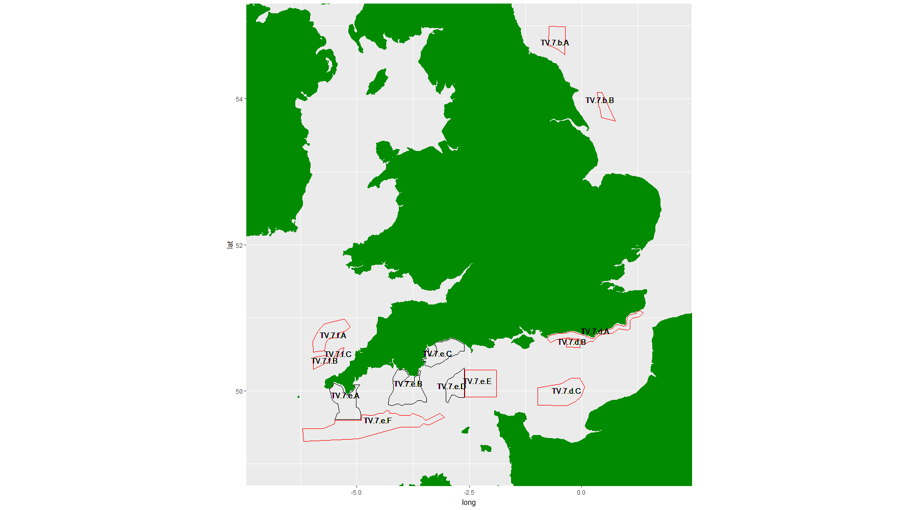

Figure 4.1: The UWTV survey un-dredged zones as defined in 2017 and 2019.

The research vessel (RV) Cefas Endeavour was used to survey a grid of randomly selected positions in the identified un-dredged zones. During the 2017 survey, at each position, an STR High Definition (HD) video camera and an SLR stills camera were deployed on an STR drop frame system for an 11 min track. Tow direction and speed were with the tide at 0.3 knots, controlled by the ships dynamic positioning system and equated to a distance run typically of just over 100 m. During the 2nd UWTV survey in 2019 the tow speed of the drop frame was increased to 0.4 knots, and track duration was increased to 20 minutes to increase the distance covered to just under 250 m. An altimeter on the drop frame enabled it to be maintained at a relatively consistent depth of 0.5 m above the seabed. Field of view was determined by the view within the drop frame (~1.35 m), and determination of scale was facilitated by point lasers fitted to the camera mounts to mark a consistent distance on the seabed.

Video images were viewed live on board the RV and all observed scallops counted. Digital stills were manually taken when scallops or indications of scallops were observed to provide more detailed images for subsequent count confirmation.

As is standard practice for other UWTV surveys, video footage was reviewed later by trained staff for additional verification and the median count per transect standardised to area. The Linn’s Concordance Correlation Coefficient (CCC) methodology used for the Cefas *Nephrops* UWTV survey quality control is not considered to be suitable for the scallop survey footage due to the very low counts and resulting integer artefacts (~ 1 per minute, compared to ~ 30 for *Nephrops*). When *Nephrops* stations get to similarly low densities, the CCC criterion is waived.

## Video Survey Processing

Arithmetic methods were used to raise observed counts to survey areas using a similar methodology as that used for the dredge surveys. As with the dredge survey, the conversion of the relative density of scallops to absolute abundance indices requires an assumption about the relative efficiency of the camera gear, in this case the proportion of observed scallops. Again, this is likely to be dependent upon the ground type, with scallops on softer ground being more difficult to identify when they are partially buried. At present there are no data available for the specific gear configuration being used, and a coefficient of 1.0 (i.e., 100% efficiency) will be used. There is, as yet, no information on the size range of animals observed. It is assumed that scallops become detectable on UWTV footage at 80 mm shell height, which is at the low end of the range of sizes at maturity.

# UWTV Surveys

## Results

The density estimates from the 2017 survey have been reworked to enable improved assignment to each assessment area and are presented together with those from the 2019 survey. A summary of UWTV results from both surveys is presented in Table 5.1.

Table 5.1: Summary of UWTV survey results by un-dredged zones 2017 and 2019. Number of transects, mean density, minimum and maximum numbers 100 m2 and the number of transects with no observed scallops are shown.

|  |  |  |  |  |  |
| --- | --- | --- | --- | --- | --- |
| Un-Dredged Zone | Number Of Transects | Mean density | Min Density | Max Density | Number of Zero Counts |
| TV.7.e.A | 25 | 1.71 | 0 | 7.01 | 9 |
| TV.7.e.C | 26 | 0.53 | 0 | 3.71 | 19 |
| TV.7.e.D | 12 | 0.43 | 0 | 2.42 | 7 |
| TV.7.e.B | 21 | 0.17 | 0 | 0.94 | 14 |
| TV.7.e.E | 11 | 0.05 | 0 | 0.30 | 9 |
| TV.7.d.A | 15 | 0 | 0 | 0 | 15 |

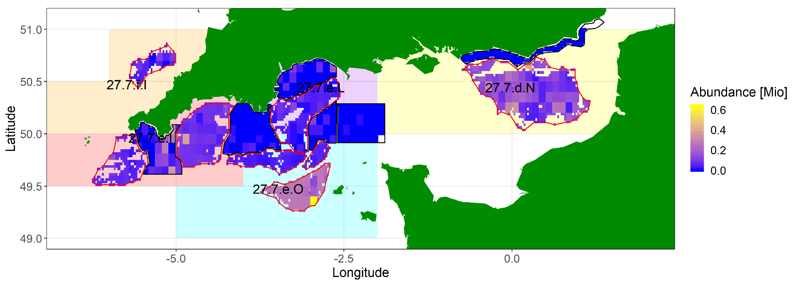

Figure 5.1: Estimated density (numbers m-2) on the 2017 and 2019 TV survey by block and un-dredged zones TV.7.e.A-E and TV.7.d.A.

Estimated abundance in millions of scallops presented by block in the surveyed un-dredged zones show that highest numbers of scallops were observed in the eastern side of Zone TV.7.e.A (Figure 5.1).

Zone abundance with percentiles from un-dredged areas estimated by UWTV survey are presented with estimates of harvestable biomass and spawning stock biomass in Table 5.2.

Table 5.2: Zone abundance (median and point estimate in millions) with percentiles from un-dredged zones (estimated by UWTV survey) and estimated harvestable biomass and spawning stock biomass.

|  |  |  |  |  |  |  |  |
| --- | --- | --- | --- | --- | --- | --- | --- |
| Assessment Area | TV Zone | 25th percentile | Median Abundance | Point Estimate Abundance | 75th percentile | Estimated Harvestable Biomass (Tonnes) | Estimated Spawning Stock Biomass (Tonnes) |
| 27.7.d.N | TV.7.d.A | 0 | 0 | 0 | 0 | 0 | 0 |
| 27.7.d.N | TV.7.e.E | 0.05 | 0.1 | 0.1 | 0.15 | 29.0 | 28.0 |
| 27.7.e.I | TV.7.e.A | 24.0 | 27.9 | 28.3 | 31.5 | 4559.0 | 4264.2 |
| 27.7.e.I | TV.7.e.B | 0.7 | 0.9 | 0.8 | 1.1 | 124.0 | 115.9 |
| 27.7.e.L | TV.7.e.B | 0.9 | 1.1 | 1.1 | 1.4 | 245.2 | 229.2 |
| 27.7.e.L | TV.7.e.C | 6.2 | 8.0 | 7.3 | 9.8 | 1610.4 | 1505.5 |
| 27.7.e.L | TV.7.e.D | 1.9 | 3.0 | 2.9 | 3.6 | 627.5 | 586.6 |
| 27.7.e.L | TV.7.e.E | 0.5 | 0.7 | 0.8 | 1.1 | 166.2 | 155.4 |
| 27.7.e.O | TV.7.e.B | 1.3 | 1.8 | 2.0 | 2.2 | 372.3 | 342.9 |
| 27.7.e.O | TV.7.e.D | 0.9 | 1.2 | 1.1 | 1.5 | 193.5 | 178.2 |
| 27.7.e.O | TV.7.e.E | 0.2 | 0.3 | 0.3 | 0.4 | 53.9 | 49.6 |
| 27.7.f.I | TV.7.e.A | 1.7 | 2.3 | 1.7 | 3.1 | 375.2 | 350.8 |

# Supporting Research and Development

Additional research would enable refinement of our current stock assessment processes and we consider our priorities below:

## Dredge Efficiency Estimates

These are required to relate dredge survey catch rates to absolute abundance. Biomass estimates are generated using substrate specific estimates of dredge efficiency derived from earlier work by Palmer *et al*, 2001. Although these efficiency estimates are in line with some other work, a method to determine the dredge efficiency, in particular on the dredge survey vessel, is required to further refine the efficiency estimates we use. Historically, depletion studies or diver surveys have been used to estimate dredge efficiency, but results can be inconsistent or logistically problematic. In 2017, a Defra funded R&D project was started to determine if novel technology (Radio Frequency Identification, RFID) could provide a solution.

This project was designed to derive a method that could generate vessel specific efficiency rates. The ultimate aim is to design a method that can be replicated on a commercial scallop dredging vessel to provide robust efficiency coefficients of direct relevance to the vessel and ground types surveyed. The equipment counts the number of uniquely tagged scallops in the path of a dredge using an antenna mounted in front of the scallop dredge. This total is then compared to the actual number of tagged scallops caught by the dredge.

The initial phases included land, aquaria and beach trials of the technology. The resulting rig was then mounted to scallop dredging gear and tested at sea on the RV Endeavour in the Western Channel in June 2018. These at-sea trials aimed to determine several factors: a) How to achieve a dispersal pattern that was dense enough to re-locate tags, yet sufficiently dispersed to avoid “tag-clash” (detection errors when tags are too close together); b) the time required for tagged scallops to reacclimatise and behave “normally” on release; c) how the antennae performed at depth; and d) how the antenna mount performed in front of the dredge.

A satisfactory dispersal pattern was achieved by hand-releasing scallops from the deck (as opposed to cage-borne releases in mid-water). The released scallops typically took longer than 24 hours to commence “normal” behaviour, although the length of time between initial capture and final release is considered to have been highly influential. The antennae worked at depth although with a reduced range compared to that experienced on land. The prototype electronics also require further development to be sufficiently robust. The antennae mounting mechanism (a wooden trolley in front of the dredge) appeared to work well but was prone to damage (principally on retrieval).

These initial trials have prompted further work which is planned for April 2019. Glue-mounting the tags to the scallops is time consuming and involves the individuals being out of water for quite some time; an alternative mounting mechanism involving drilling a small hole in the “ear” of the shell (away from any living tissue) should be quicker and more practical on commercial vessels. A shorter time between initial capture and release should reduce the time scallops take to behave “normally” on re-release and avoid the survival issues encountered (survival in the tanks deteriorated after 24 hours).

A small boat survey is planned for April 2019 to establish the settlement period of freshly caught tagged scallops. Further testing of the RFID equipment will also be carried out. The equipment has been re-configured to improve efficiency and maximise read range.

A full progress report will be available soon.

## Biomass Estimates from UWTV

UWTV surveys are used to determine abundance of scallop populations in un-dredged areas. This is important as we would expect populations in some of these areas to contribute to recruitment to adjacent exploited populations by larval dispersal.

### Camera System

A non-contact camera system is used, as ground types may not be suitable for camera platforms that are towed along the seabed (sledges). Such towed systems may not be appropriate for sensitive habitats. However, the non-contact system currently used from the Cefas research vessel (STR SeaSpyder drop frame with HD video and stills) is limited to low tow speed deployment. This system does not cover much ground and there is a risk of under sampling scallops which are distributed at relatively low densities. In addition, scallop can be cryptic by recessing into the substrate and covering themselves with a fine layer of sediment. Alternative camera platforms have been investigated and some trialled for suitability.

1. Devon and Severn IFCA “flying array” (a device originally developed by Plymouth Marine Laboratory) which was deployed from both an inshore vessel (D&SIFCA) and the Cefas RV with dynamic positioning.
2. Cornwall IFCA STR SeaSpyder drop frame system (more compact than the Cefas system and suitable for small vessel deployments) deployed from CIFCA RV.
3. Videoray Pro4 mini ROV deployed from CIFCA RV.
4. The Marine Scotland “Sea Chariot” was investigated but not deployed.

Some optimisation of the current Cefas STR SeaSpyder drop frame system has been carried out to provide more ground coverage without compromising scallop visibility and maximise the potential of the captured imagery.

Development of a high-speed, non-contact camera platform with a camera system optimised for scallop survey is ongoing, as resources allow.

### Camera Efficiency

The cryptic behaviour of scallop means that in some circumstances not all of the scallops in the field of view of the video camera will be observed. The video camera and human observer combination has an efficiency that, analogous to the scallop dredges, is likely dependent on substrate type. As yet, there are no data available for the specific gear configuration used. Therefore, a coefficient of 1.0 is used, assuming that all scallops in the camera field of view are identified. The same RFID technology used to determine dredge efficiency is currently also being developed to determine camera/human observer efficiency on various substrates (see above).

### Population Structure

Relating video observations of scallops in the un-dredged areas directly to the harvestable biomass of the population is not straightforward. In our assessment we have assumed that the camera has a knife edge selection at 80 mm shell height, which is at the low end of the range of sizes at maturity. Automated image analysis software has been considered as an alternative to manual methods of determining scallop size from video and stills images. However, application of this technology to scallop species is relatively new and in the early stages of development. The potential application of any new developments in video or still image analysis and machine learning, both at Cefas and at external agencies, will be considered as resources allow.

### Connectivity Between Dredged and Un-Dredged Beds

To enable appropriate incorporation of biomass estimates from un-dredged beds into the assessment process we need to determine the level of linkage between scallop populations in un-dredged beds and the fishery. This might best be achieved by calculating harvest ratios that incorporate a proportion of the biomass estimated in un-dredged areas derived from UWTV, with biomass estimated in the dredged beds derived from the dredge surveys. These proportions could be defined by the levels of recruitment to the dredged beds which are derived from those un-dredged beds.

Recent work by Nichol *et al* 2017 used particle dispersal modelling in the English Channel to provide some answers as to the level of linkage between fished areas but does not describe the specific connectivity between most of the un-dredged beds with the dredged beds defined for Cefas scallop stock assessments. Further oceanographic modelling is required and colleagues at Cefas are currently investigating the resource requirements for a project to assist with this aspect.

# Dredge Survey of Bed 7.d.2 in 27.7.d.S

## 2018 Dredge Survey

Results from four dredge tows carried out in a new bed (7.d.2) are presented below. Bed 7.d.2 comprises an area of 140km2 and was defined at the request of industry colleagues using the latest VMS data available at that time (defined early in 2018 and includes 2017 data).

The sampling summary is presented in Table 7.1 and the number of sampled blocks in Figure 7.1.

Table 7.1: Sampling summary from dredge survey in bed 7.d.2 in 2018.

|  |  |  |  |  |  |
| --- | --- | --- | --- | --- | --- |
| Bed | Number of stations | Number of length samples |  | Number measured | Number aged |
| 7.d.2 | 4 | 4 |  | 238 | 46 |

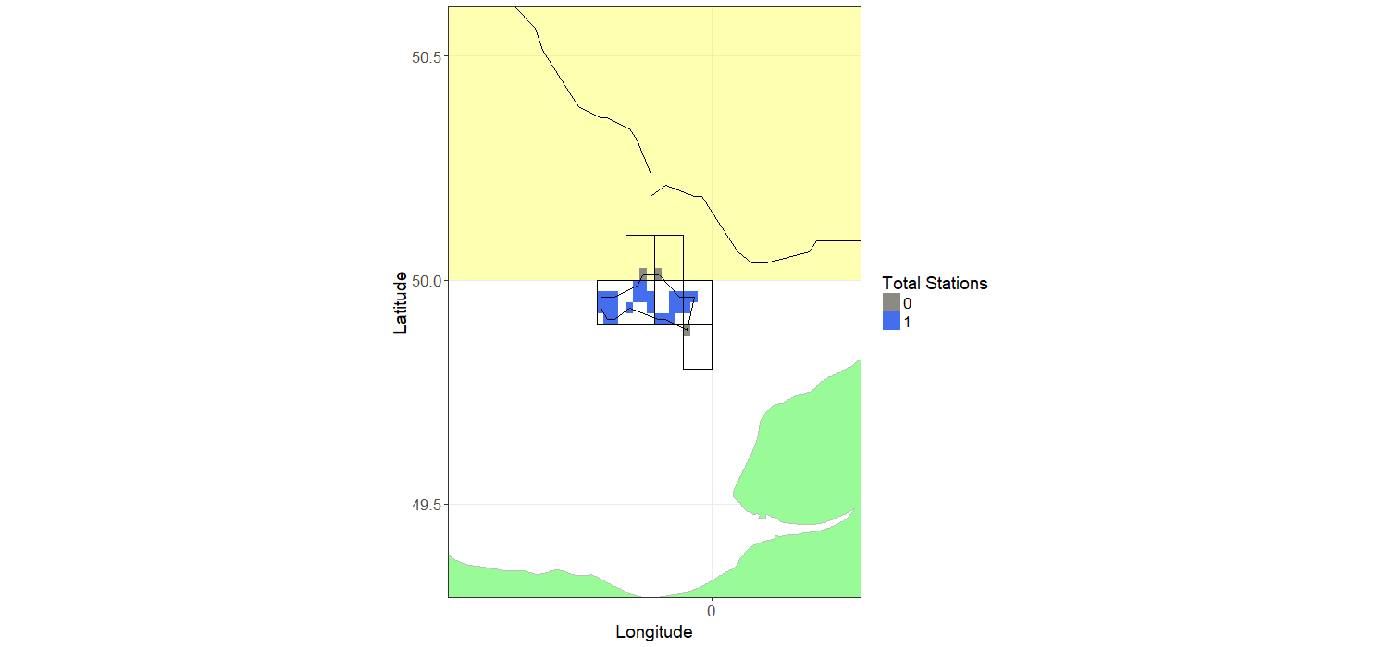

Figure 7.1: Sampled blocks in Bed 7.d.2, in assessment area 27.7.d.S in 2018. Block shading indicates the total number of stations within each block 0 =grey, 1=blue.

## Raised Biomass Estimates and Uncertainty

The estimated harvestable biomass of harvestable scallop (≥ 110 mm shell length, the MLS) raised to each block is presented in Figure 7.2.

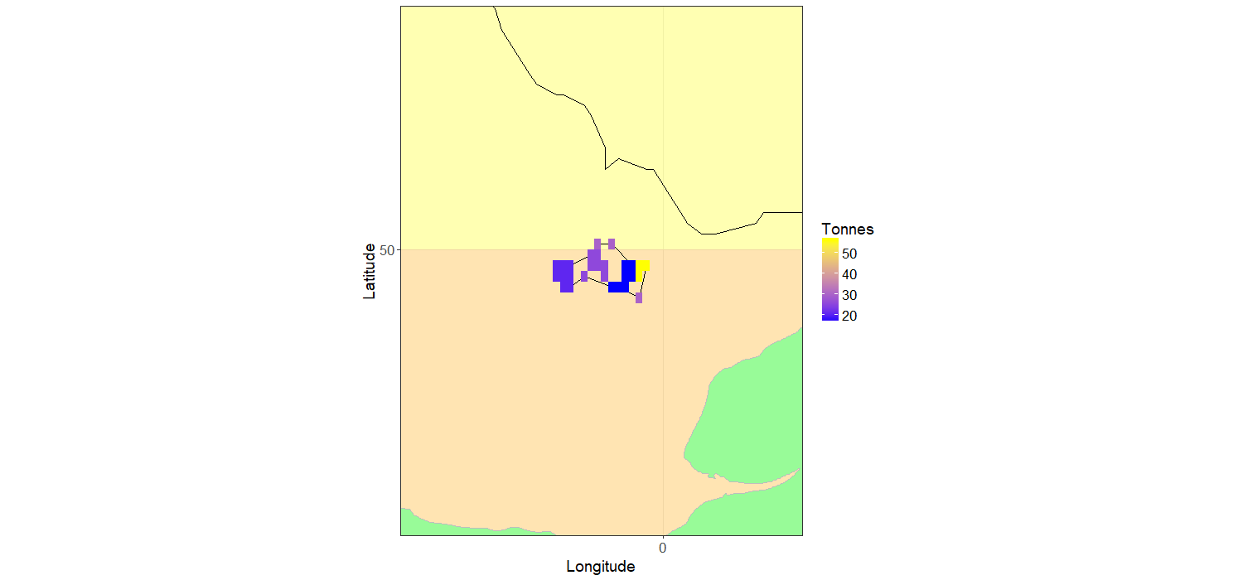

Figure 7.2: Biomass (Tonnes) of harvestable (≥ 110 mm length, the MLS) scallops in the surveyed areas within bed 7.d.2, assessment area 27.7.d.S in 2018.

In order to estimate the uncertainty around the estimate of harvestable biomass, the samples for each bed were bootstrapped 5000 times with replacement. For each iteration, the same raising procedure was used as for the main biomass estimation routine. The median, 25th and 75th percentiles and point estimates are given for each assessment area in Table 7.2.

Table 7.2: Biomass estimation for the dredge surveyed bed 7.d.2 for 2018.

|  |  |  |  |  |
| --- | --- | --- | --- | --- |
| Bed | 25th percentile (tonnes) | Median harvestable biomass tonnes | Point estimate (tonnes) | 75th percentile (tonnes) |
| 7.d.2 | 628 | 738 | 721 | 833 |

## Size Composition from Dredge Survey

From the size frequencies taken at each station, a total length frequency was pooled to the total population estimate for the bed (Figure 7.3).

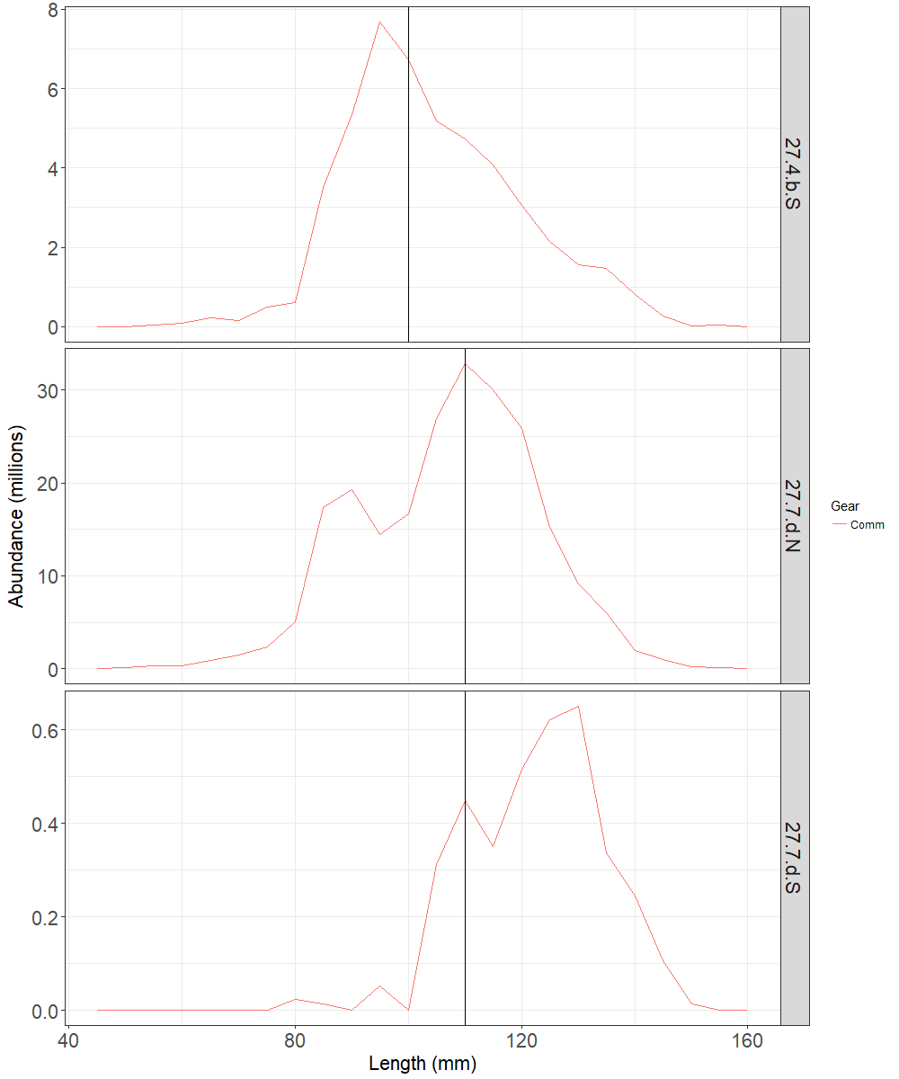

Figure 7.3: Dredge survey: Numbers (millions) per length class (mm) for the scallop population in surveyed areas of 7.d.2 in 2018. The vertical line represents MLS.

## Conclusions

This bed was defined following recent spatial expansion of fishing activity by both UK and French fleets and is the first dredge survey undertaken for scallops in this bed. This bed is positioned between 7.d.1 in assessment area 27.7.d.N and areas in the Baie de Seine (assessment area 27.7.d.S) which is surveyed by IFREMER. There is scope for assessment area 27.7.d.S to be internationally assessed.

Only four tows were carried out in this small bed and as such the biomass estimates are only indicative.

A presentation of the assessment approach to the ICES Scallop Working Group highlighted that there are several key areas of uncertainty that require further work to better understand their impact and influence. With the swept area biomass assessment, the key parameter is the gear-efficiency estimate, and even relatively small changes to this estimate would have a significant impact upon the estimated harvestable biomass and harvest rate. Research to develop novel technology to resolve gear efficiency estimates are still ongoing.