Assessment of Scallop stock status for selected waters around the English Coast 2018/2019
Defra and Industry Funded Project

Author(s): Lawler, A. and Nawri, N.

Issue Date: 31 March 2020

Disclaimer: The content of this report does not necessarily reflect the views of Defra, nor is Defra liable for the accuracy of information provided, or responsible for any use of the reports content.

European Structural and Investment Funds


- Cefas Document Control
Submitted to: | Defra
Date submitted: | 31st March 2020
Project Manager: | David Pettengell
Report compiled by: | Andy Lawler and Nick Nawri
Quality control by: | Stuart Reeves
Approved by and date: | 30th January 2020
Version: | v.1.0
Recommended citation for this report: | Lawler, A. & Nawri, N. (2019). Assessment of scallop stock status for selected waters around the English Coast 2018/2019. Cefas Project Report for Defra, x + 91 pp.

Version control history
Version | Author | Date | Comment
d.1.0 | Lawler & Nawri | 26th January 2020 | First draft for internal review
d.1.1 | Lawler & Nawri | 31st January 2020 | Post internal review
d.1.2 | Lawler & Nawri | 26th February 2020 | Post industry review
v.1.0 | Lawler & Nawri | 24th March 2020 | Accessibility enhancements

- Executive Summary
King scallop fisheries around English coasts represent the most valuable single species in the region. The stocks are internationally exploited primarily by the UK and France using towed dredges. These fisheries are not governed by EU or national total allowable catches (TACs), and the stocks have not been subject to routine monitoring or formal assessment prior to 2017.
This report describes the assessment of the status of some of these stocks undertaken annually since 2017 by the Centre for Environment, Fisheries and Aquaculture Science (Cefas) as part of a collaborative project with the UK fishing industry, the UK Department for Environment, Farming and Rural Affairs (Defra), and Seafish. The results from the earlier surveys are included for context and have been updated for this report to account for improvements in the methods used to analyse the data. Recent international landings were not available at the time of writing of this report. Harvest rates presented here are therefore provisional estimates of what will be taken from the stock over the 12 months following the survey.
In 2017, five stock assessment areas were identified as being of importance to UK fisheries: three in ICES subdivision 27.7.e (Inshore Cornwall, I; Offshore, O; Lyme Bay, L) and two in 27.7.d (North, N; South, S). In 2018 two additional areas were defined, one in the approaches to the Bristol Channel (27.7.f.I) and another in 27.4.b (North Sea South, S). These assignments are based on regional differences in growth and fishery exploitation patterns. Commercial landings data are available at the spatial resolution of ICES statistical rectangle, and their boundaries are used to describe the extent of the assessment areas.
This report assesses the status of the dredged portion of stocks in 7.d.N, 7.e.I, 7.e.L, 7.e.O, 7.f.I and 4.b.S, using dredge surveys, with additional estimates of unfished biomass in some parts of 7.e.I, 7.e.L, 7.e.O and 7.d.N from underwater television (UWTV) surveys. There is likely to be biomass of scallops outside those areas surveyed, for which there are no data to make any estimates. The biomass and exploitation rate of the fished portion of stock in the Bay de Seine (part of 27.d.S) is routinely estimated by France. In 2018 we surveyed a small bed in 7.d.S that is not covered by the IFREMER assessment, the results of which are presented in the annex of this report.
Three data streams were used for the assessments described in this report: dredge surveys, UWTV surveys, and a biological sampling programme. Dredge surveys in the main fished beds of 7.d.N, 7.e.I, 7.e.L, 7.e.O, 7.f.I, and 4.b.S were used to estimate scallop biomass available to the dredge fishery. The scallop biomass in some un-dredged regions of assessment areas 7.e.I and 7.e.L was estimated from UWTV surveys in the first year (2017), and areas in 7.e.O, 7.f.I and 7.d.N in the third year (2019). No UWTV survey was undertaken in 4.b.S.
A biological sampling programme will provide a time series of age structure of the removals, but these data are currently under review, and only size distributions are presented here. Estimates of harvestable biomass (i.e., biomass above minimum landing size and in areas in which dredgers can operate), and the exploitation rate experienced by harvestable scallops are covered by this assessment. However, the assessment is not able to fully estimate the impact of the fishery on the wider stock, as we were unable to estimate the scallop biomass in all un-dredged areas. Dredge surveys and catch sampling only cover the portions of stock found on the main fished grounds, as identified by the areal density of Vessel Monitoring System (VMS) pings. Harvest rate estimates from dredge surveys or commercial sampling therefore only apply to the fished portion of the stock. In situations where there are significant portions of un-dredged stock that are contributing offspring to the fished areas, any estimates of Maximum Sustainable Yield (MSY) harvest rates will, in future, need to be adjusted to compensate for this.
The potential harvest rates experienced by the surveyed portion of stocks were estimated by comparing international landings, or a proxy for them, to the available biomass estimates, either for the dredged area only, or including also the biomass from un-dredged areas.

Estimates of harvest rate from dredge and UWTV surveys, together with a candidate for MSY.
 | Provisional Harvest Rate  on Dredged Portion of Stock  (Dredge Survey Only, %) |  |  | Provisional Harvest Rate  for Wider Stock where  UWTV available***  (Not 100% Coverage, %) |  |  |  | MSY Candidate (%)
 | 2017* | 2018* | 2019** | 2017* | 2018* | 2019**
7.d.N | 74.4 | 57.0 | 41.2 | 74.3 | 56.9 | 41.2 | 21.5
7.e.I | 38.1 | 17.1 | 14.8 | 23.2 | 11.2 | 10.2 | 19.5
7.e.L | 55.2 | 77.7 | 65.4 | 27.5 | 40.3 | 36.7 | 21.0
7.e.O | 11.2 | 16.9 | 12.1 | 10.5 | 16.0 | 11.7 | 20.9
7.f.I | NA | 9.6 | 28.3 | NA | 7.8 | 21.3 | NA
4.b.S | NA | 47.2 | 45.2 | NA | NA | NA | NA

* estimated from UK removals and average UK share, to be revised
** estimated from UK removals and average UK share or estimate from previous year, whichever is the highest, to be revised

As this is only the third scallop stock assessment, with the short time period covered by surveys, the results presented here are still preliminary. They are the start of a long-term monitoring and assessment programme, and processes and methodologies are likely to evolve in the future. As the time series of data develops and increases in comprehensiveness, this will in turn contribute to a more robust determination of the stock status of king scallops in this region.

- Table of Contents
1 Introduction 1
1.1 Fishery Overview 1
1.2 Stock Unit Assessment Areas 2
1.3 Biology 4
1.3.1 Range and habitat 4
1.3.2 Reproduction 4
1.3.3 Growth 4
1.4 Fishery Management 5
2 Stock Assessment for surveyed areas of 7.d.N 5
2.1 Area Definition 5
2.2.2 Discards 8
2.2.3 Size composition 9
2.3 Biological Parameters and Dredge Efficiency 10
2.3.1 Natural mortality 10
2.3.2 Size at maturity 10
2.3.3 Growth 11
2.3.4 Shell metric conversions 11
2.3.5 Weight – length relationship 11
2.3.6 Dredge efficiency 12
2.4 Dredge and Underwater TV Surveys 13
2.4.1 Survey design description 13
2.4.2 2019 dredge survey 13
2.4.3 Video survey 16
2.5 Survey Processing 16
2.5.1 Raised biomass estimates and uncertainty 16
2.5.2 Size composition from dredge survey 18
2.5.3 Relative abundance from video survey 19
2.6 Harvest Rate Estimation 20
2.6.1 Landings size compositions – cohort modelling 21
2.8 Conclusions 25
3 Dredge survey of bed 7.d.2 in 7.d.S 27
3.1 Area Definition 27
3.1.1 2019 dredge survey 27
4 Stock Assessment in surveyed areas of 27.7.e and 27.7.f 27
4.1 Area Definitions 27
4.2 Data Available 27.7.e and 27.7.f 28
4.2.1 Catch, and survey data 28
4.2.2 Discards 35
4.2.3 Size composition 35
4.3 Biological Parameters and Dredge Efficiency 37
4.3.1 Natural mortality 37
4.3.2 Size at maturity 38
4.3.3 Growth 38
4.3.4 Shell metric conversions 38
4.3.5 Weight – length relationship 38
4.3.6 Dredge efficiency 39
4.4 Dredge and Underwater TV Surveys 41
4.4.1 2019 dredge survey 41
4.4.2 Video survey 42
4.5 Survey Processing 42
4.5.1 Raised biomass estimates and uncertainty 43
4.5.2 Size composition from dredge survey 45
4.5.3 Relative abundance from video survey 47
4.6 Harvest Rate Estimation 48
4.6.1 Landings size compositions - cohort modelling 50
4.8 Conclusions 56
5 Stock Assessment in surveyed areas of 27.4.b 57
5.1 Area Definitions 57
5.2 Data Available 4.b.S 59
5.2.1 Catch and survey data 59
5.2.2 Discards 60
5.2.3 Size composition 61
5.3 Biological Parameters and Dredge Efficiency 62
5.3.1 Natural mortality 62
5.3.2 Size at maturity 62
5.3.3 Growth 62
5.3.4 Shell metric conversions 63
5.3.5 Weight – length relationship 63
5.3.6 Dredge efficiency 63
5.4 Dredge Survey 65
5.4.1 2019 dredge survey 65
5.5 Survey Processing 66
5.5.1 Raised biomass estimates and uncertainty 67
5.5.2 Size composition from dredge survey 68
5.6 Harvest Rate Estimation 69
5.6.1 Fishing mortality estimates from the landings size composition 70
5.7 Conclusions 71
6 Future Developments 71
7 References 73

- Tables
Table 1.1: Assessment areas by ICES rectangle 3
Table 2.1: Landings (tonnes) by country (STECF 2009-2016) in assessment area 7.d.N. 6
Table 2.2: UK fleet proportion of international landings by quarter. 7
Table 2.3: UK Landings (tonne) for 7.d.N by quarter. * provisional. 8
Table 2.4: Sampling programme summary for stock assessment area 7.d.N. ‘*‘ awaiting update. 9
Table 2.5: Assessment parameters. 13
Table 2.6: Median biomass, point estimate and percentiles for dredged areas of 7.d.N, 2017-2019. 17
Table 2.7: Biomass and Provisional harvest rate estimate for the dredged areas of 7.d.N for 2017-2019. 20
Table 2.8: Removals (tonnes), estimated harvestable biomass (tonnes) and provisional harvest rate (%) incorporating biomass estimate from dredge and TV surveys by assessment area in 2017-2019. 21
Table 2.9: Provisional harvest rate estimates for dredged areas of 7.d.N and an MSY candidate. 22
Table 2.10: Fishing mortality, harvest rate and spawner per recruit at reference points F0.1, FSpR35% and Fmax. 24
Table 4.1: Landings (tonnes) by country (STECF 2009-2016) for the four assessment areas in ICES divisions 27.7.e and 27.7.f. 29
Table 4.2: Quarterly landings UK data by assessment area in 27.7.e and 27.7.f. * provisional. 30
Table 4.3: Sampling programme summary. ‘*‘awaiting update. 36
Table 4.4: Assessment parameters. 40
Table 4.5: Sampling summary from dredge surveys in 2019. ‘*‘ awaiting update. 41
Table 4.6: Median biomass, point estimate and percentiles for the dredged areas in 7.e.I, L, O and 7.f.I, 2017-2019. 44
Table 4.7: Assessment in 27.7.e and 27.7.f. Proportion of scallops below the MLS in the commercial dredges from the dredge surveys. 45
Table 4.8: Harvestable biomass estimates and provisional harvest rates for dredged areas of 27.7.e and 27.7.f for 2017-2019. 49
Table 4.9: Removals, estimated harvestable biomass and provisional harvest rate incorporating biomass estimate from dredge and UWTV survey by assessment area in 2017-2019. 50
Table 4.10: Provisional harvest rate estimates for dredged and wider areas and MSY candidates by assessment area and year. 52
Table 4.11: Fishing mortality, harvest rate and spawner per recruit by assessment area at reference points F0.1, FSpR35% and Fmax. 54
Table 5.1: Landings (tonnes) by country (STECF 2009-2016) in assessment area in 4.b.S. 59
Table 5.2: Quarterly landings UK data by assessment area in 4.b.S. * provisional. 60
Table 5.3: Sampling programme summary. ‘*‘ awaiting update. 61
Table 5.4: Assessment parameters. 65
Table 5.5: Sampling summary from dredge survey 2019. ‘*‘ awaiting update. 65
Table 5.6: Biomass estimation for the dredge surveyed areas in 4.b.S (two beds combined) for 2018-2019, 67
Table 5.7: Harvestable biomass estimates and harvest rates for the areas covered by the dredge survey in 2018-2019. 70

- Figures

Figure 1.1: Stock unit assessment areas defined in the English Channel, Celtic and North Sea 3
Figure 2.1: Surveyed dredge area (Bed 7.d.1) within Assessment Area 7.d.N. 6
Figure 2.2: Assessment Area 7.d.N. Landings by country and by quarter (N.B. Isle of Man, Guernsey and Jersey landings <1t per annum. Belgian landings only recorded since 2012). 7
Figure 2.3: Estimated numbers by size group landed in 7.d.N. for 2017 (red), 2018 (blue) and 2019 (green) sampling seasons. The vertical grey line indicates MLS. 10
Figure 2.4: Sampled blocks in Bed 7.d.1, 7.d.N. Block shading indicates the total number of stations within each block 0 =grey, 1=blue and 2=green. 14
Figure 2.5: Gear configuration on survey vessel. 15
Figure 2.6: Biomass (Tonnes) of harvestable (above 110mm length) scallops in Bed 7.d.1, Assessment Area 7.d.N (yellow). 17
Figure 2.7: Distribution of biomass estimates for Bed 7.d.1 in 2019 from bootstrapping procedure. 18
Figure 2.8: Dredge survey: Length distributions of the scallop population in surveyed areas of Assessment Area 7.d.N for 2017 (red), 2018 (green) and 2019 (blue). The vertical grey line indicates MLS. 19
Figure 2.9: Scaled landed size distributions as a proportion of highest mode. Horizontal reference lines at 25% (black) and 50% (red). 23
Figure 2.10: Yield (left) and relative spawner per recruit (right) against fishing mortality. Three reference points indicated F0.1 (red), FSpR35% (green) and Fmax (blue). 25
Figure 4.1: Beds 7.e.1 and 7.e.2 within Assessment Area 7.e.I (red), Beds 7.e.3, 7.e.4 and 7.e.6 in 7.e.L (purple), Beds 7.e.5, 7.e.7 and 7.e.8 in 7.e.O (green), and bed 7.f.1 in 7.f.I (orange). N.B. beds 7.e.3 and 7.e.6 are no longer accessible to larger vessels including our survey vessel and have been surveyed using underwater TV survey instead. 28
Figure 4.2: Assessment areas in 27.7.e. Landings by country and by quarter (NB. Isle of Man, Guernsey and Jersey landings <1t per annum. Belgian landings only recorded since 2012). 34
Figure 4.3 continued: Assessment 27.7.e and f. Landings by country and by quarter (NB. Isle of Man, Guernsey and Jersey landings <1t per annum. Belgian landings only recorded since 2012). 35
Figure 4.4: Estimated numbers in size group landed in 7.e.I, L and O during the 2017 (red), 2018 (blue) and 2019 (green) sampling seasons. The vertical grey line indicates MLS. 37
Figure 4.5: Sampled blocks in Beds 7.e.1-8 and 7.f.1, in assessment areas 7.e.I, O, L, and 7.f.I. Block shading indicates the total number of stations within each block 0 =grey, 1=blue and 2=green. 42
Figure 4.6: Biomass (Tonnes) of harvestable (above 100mm length) scallops in the surveyed areas within 7.e.I (red), 7.e.L (purple), 7.e.O (green), and 7.f.I (orange). 43
Figure 4.7: Distribution of biomass estimates for beds 27.7.e.1-7.e.8 and 7.f.1, 2019 from the bootstrapping procedure. 45
Figure 4.8: Dredge survey: Bed raised length distributions for Beds 7.e.1-8 (2017, red, 2018, green and 2019, blue) and 7.f.1 (2018 and 2019 only). The vertical grey lines indicate MLS. 46
Figure 4.9: Dredge survey: Length distributions of the scallop population in surveyed areas of 7.e.I, 7.e.L, 7.e.O (2017 - red; 2018 - blue 2019 - green) and 7.f.I (2018 and 2019 only). The vertical grey line indicates MLS. 47
Figure 4.10: Landed size distributions as a proportion of the mode. Horizontal reference lines at 0.25 (black) and 0.50 (red). 51
Figure 4.11: Yield (left) and relative spawner per recruit (right) against fishing mortality for assessment areas 7.e.I, L and O (top-bottom). Three reference points indicated F0.1 (red), FSpR35% (green) and Fmax (blue). 55
Figure 5.1: Beds 4.b.1 and 4.b.2 within Assessment Area 4.b.S (light blue). 57
Figure 5.2: Landings by country and by quarter in assessment area 4.b.S. 59
Figure 5.3: Estimated numbers in size groups landed from 4.b.S during 2018-2019 sampling seasons. The vertical grey line indicates MLS. 62
Figure 5.4: Sampled blocks in Beds 4.b.1 and 4.b.2, in assessment area 4.b.S, 2019. Block shading indicates the total number of stations within each block 0 =grey, 1=blue, 2=green and 3=red. 66
Figure 5.5: Biomass (Tonnes) of harvestable (above 100mm length) scallops in the surveyed areas within 4.b.S (light blue), 2019. 67
Figure 5.6: Distribution of 2019 biomass estimates for beds 4.b.1 from the bootstrapping procedure (N.B. only 2 tow in 4.b.2 prevents random sampling in this bed). 68
Figure 5.7: Dredge survey: Bed raised length distributions for Beds 4.b.1 and 4.b.2 in 2018 (blue) and 2019 (green). 69
Figure 5.8: Dredge survey: Length distribution for the scallop population in surveyed areas of 4.b.S 2018 (blue) and 2019 (green). 69

Introduction

Fishery Overview
The fishery for the scallop Pecten maximus in the Channel (ICES sub-divisions 7.d and 27.7.e) is the most valuable single species fishery in the region with over 45,000 tonnes of international landings reported in 2018. An additional 3,800 tonnes were reported for the fisheries off the English coasts in the North Sea and approaches to the Bristol Channel. The stocks are exploited principally by the UK and France, with additional activity from Ireland, the Netherlands and Belgium. Targeted fisheries predominantly use towed dredges although some commercial dive fisheries exist, particularly around Lyme Bay. Pecten maximus fisheries lie outside the EU TAC and quota regime and fishery management measures are largely under the control of the member states. EU regulations stipulate the minimum size of scallop that can be retained by vessels and also cap the level of effort that vessels ≥15m can utilise in area 7.
There is a distinct contrast between the UK and French fisheries, with the UK fisheries comprising a mix of large (≥15m) nomadic vessels and smaller (10-15m) vessels with a more localised range. Scallop fishery management for UK vessels consists of licence conditions (for vessels over 10m) and gear restrictions, with some spatial differentiation in vessel access in inshore (<6 nautical miles) areas. The French fishery is dominated by smaller vessels fishing much more inshore (on the French side of the Channel), and concentrated in two zones, the Baie de Seine and the Baie de Saint Brieuc. The French management system is complex, with a range of quotas, and layers of temporal restrictions (seasonal and daily hours), with access and quota being determined at a local level.
Although the EU leaves scallop fishery management to the member states, the fisheries are in fact quite international, with multiple member states fishing upon the same stock units. The lack of agreements and coordination of fishery management measures at an official level has led to tension between fishers from the UK and France when some vessels are seen to be operating in places and at times that other fishers are prevented by their own national rules (i.e. UK vessels fishing during the French closed season). A voluntary seasonal closure harmonisation has existed since 2013 between the majority of the UK scalloping industry and the French industry.
The implications of EU exit on fishery access, markets and management measures scheduled for the 31st January 2020 are currently unknown.

Stock Unit Assessment Areas
Investigations into the transport and distribution of scallop larvae (ICES 2015, Catherall et al., 2014) indicate that scallops within ICES subdivisions 27.7.d and 27.7.e are likely to compromise at least two biological populations, when viewed at the scale of multiple generations. However, given the fact that a) larval interchange is considered to be only sporadic (rather than regular) b) there are distinct regional differences in growth rates and fishery management and c) post-larval scallops exhibit largely sessile behaviour, more regional stock assessments are appropriate.
Two stock assessment areas have been designated for ICES subdivision 27.7.d split along the 50-degree North line termed 7.d.N and 7.d.S. This division, dictated by the resolution of the landings data, allows a separation of the faster growing Baie de Seine stock from the rest of the eastern Channel, is considered appropriate for stock assessment purposes. Three stock assessment areas have been designated for ICES subdivision 27.7.e to reflect slow-growing inshore areas around Cornwall (7.e.I), faster growing areas around Lyme Bay (7.e.L), and offshore scallop beds (7.e.O). Additional stock areas in the Approaches to the Bristol Channel (7.f.I) and North Sea (4.b.S) were introduced in 2018, as indicated in Figure 1.1. The ICES rectangles that sit within the assessment areas are listed in Table 1.1.
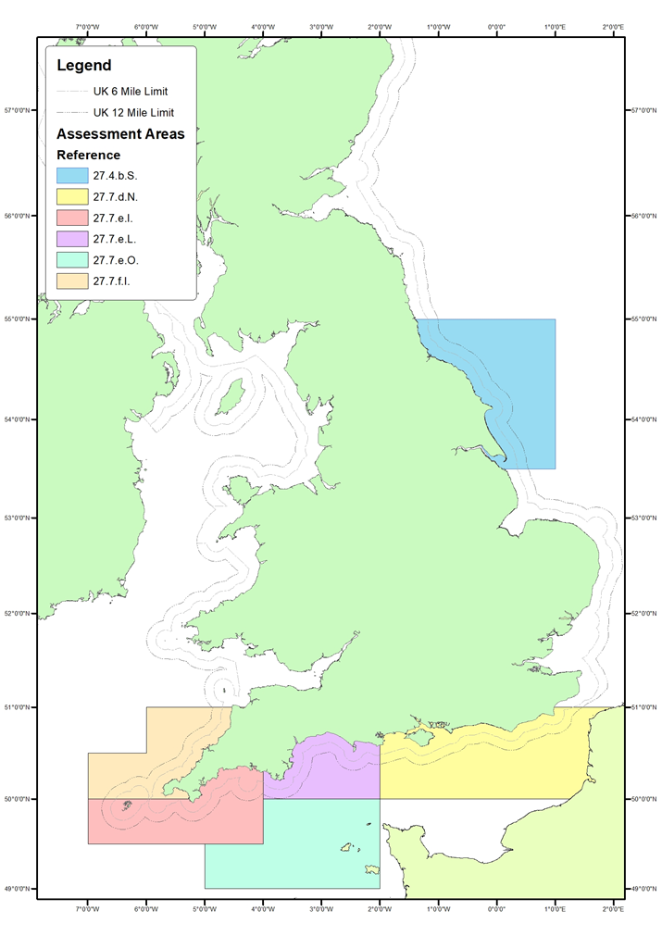
Figure 1.1: Stock unit assessment areas defined in the English Channel, Celtic and North Sea

Table 1.1: Assessment areas by ICES rectangle
7.d.N | 29E8 | 29E9 | 29F0 | 29F1 | 30E8 | 30E9 | 30F0 | 30F1
7.e.I | 28E3 | 28E4 | 28E5 | 29E5 | 29E4*
7.e.L | 29E6 | 29E7 | 30E6 | 30E7
7.e.O | 27E5 | 27E6 | 27E7 | 28E6 | 28E7
7.f.I | 29E3 | 29E4+ | 30E4 | 30E5
4.b.S | 36F0 | 37E9 | 37F0 | 38E8 | 38E9 | 38F0
* area within boundaries of division 27.7.e, + area within boundaries of division 27.7.f.
Scallop fisheries in the remaining ICES rectangles in 27.7.e are dominated by French coastal activity and therefore beyond the scope of this report. The area of 7.d.S representing the majority of landings is covered by a survey operated by IFREMER (France) and is also not covered by this assessment report.

Biology

Range and habitat
The scallop Pecten maximus is a large bivalve mollusc (up to 175mm shell length, 153mm shell height) that is resident on the continental shelf of NW Europe. It is common at depths from 5 – 200m on substrates ranging from muddy sand to coarse gravel. The species ranges from northern Norway to Morocco, the Canaries and the Azores. Scallops are common around the British Isles.

Reproduction
Scallops are permanent hermaphrodites and are very fecund; a large scallop may produce 2 million eggs per spawning event. Spawning times vary from spring to autumn with some populations exhibiting two peaks of spawning over that period. Larvae remain in the plankton for around 30 days and may thus be dispersed over long distances. At metamorphosis the larvae settle onto a primary site (often erect Hydrozoans and Bryozoans) to which they attach by means of byssus threads. On reaching a size of approximately 1-5mm they then detach and settle onto the seabed where they take up their normal habit, recessed into the substrate.

Growth
Growth in scallops is continuous with new material laid down along the outside edge of the shell in very fine ridges (striae). There is considerable seasonal variation in growth rates and a compression of the growth ridges indicates periods of slower growth usually associated with winter conditions. Other causes of slower growth (so called ‘growth checks’) occur when animals are stressed (such as after damage caused by interaction with scallop dredges) or sudden climatic changes. Age determination of scallops is performed by reading the annual growth rings on the upper (flat) shell; however, care must be taken not to confuse stress induced growth checks with annual patterns. Growth rates are extremely variable between areas and even between adjacent beds with the time required to reach the local Minimum Landing Size (MLS) varying from 2 to more than 5 years.

Fishery Management
EU legislation sets a MLS of 100mm shell length except for the Irish Sea (107A) and Eastern Channel (107D) where it is 110mm. Prior to 2019 there was a limit on retained fish by-catch of 5% of the total retained catch, the remaining 95% being bivalve molluscs. This changed in 2019 to permit compliance with the Landing Obligation and now retained bycatch of non-quota species should be no greater than 5% of total retained catch. The Western Waters effort regime places an upper ceiling on the number of kilowatt days (KWdays) fished by vessels ≥15m towing dredges for scallops. Within the UK this pool of effort is administered by the Marine Management Organisation (MMO) in a system which sets a maximum number of days (per quarter) that any vessel with a scallop entitlement may fish, these limits being revised on a quarterly basis. In recent years this effort cap has been limiting, however the Western Waters effort restrictions are not considered to be restrictive on French activity.
National legislation limits the number of licenses for scallop vessels >10m. The English Scallop Order applies in England to British vessels and places spatial restrictions on number of dredges that can be employed at any one time and specifies technical measures defining the type of dredge that can be used.

Stock Assessment for surveyed areas of 7.d.N

Area Definition
As described in Section 1.2, the stock area for 7.d.N covers the northern half of ICES subdivision 7.d, with the main fishery covering a large bed which stretches across the mid-eastern part of the Channel, straddling the border between UK and France. The perimeter of the bed was defined using VMS data (see Figure 2.1 and Annex 2). Using VMS data does mean that the bed represents only those grounds used by vessels >=12 m, however as vessels >=12 m land 93% of scallops from 7.d.N, this designation captures the vast majority of landings. Recent expansion of the fishery to the south of bed 7.d.1 has led to the definition of a second bed (7.d.2) in area 7.d.S (Section 3 of this report and annex 7).
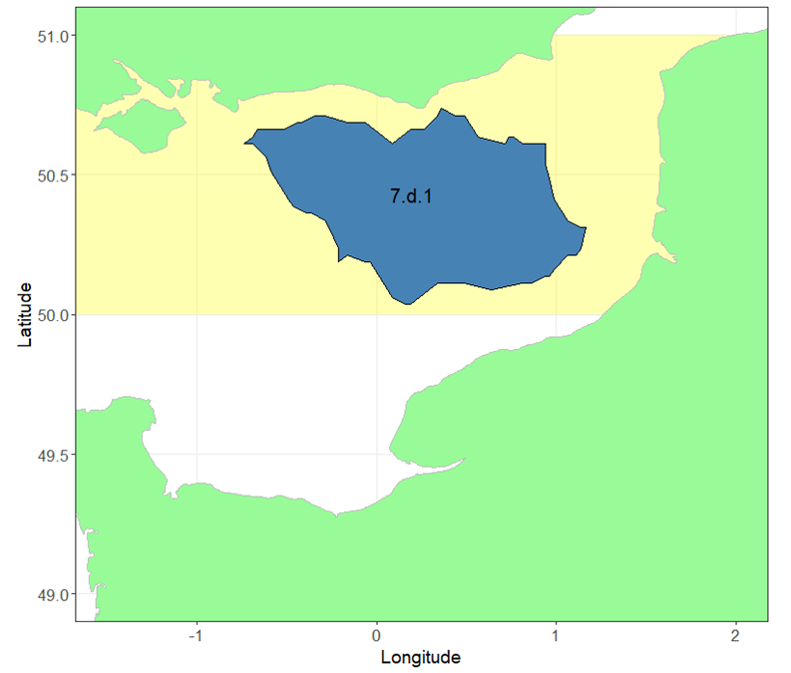
Figure 2.1: Surveyed dredge area (Bed 7.d.1) within Assessment Area 7.d.N.
  - Data Available 7.d.N
    - Catch and survey data
Annual landings by country as reported to STECF (2009-2016) for the rectangles in assessment area 7.d.N are given in Table 2.1. Note that Belgian data are likely to be missing prior to 2012 although the tonnages are small. International landings after 2016 are not yet available from STECF.
Table 2.1: Landings (tonnes) by country (STECF 2009-2016) in assessment area 7.d.N.
 | BEL | FRA | NLD | IRL | GBG | GBJ | IOM | UK | International total
2009 | - | 7375 | 299 | - | - | - | 15 | 5888 | 13577
2010 | - | 6701 | 148 | - | - | - | - | 9509 | 16359
2011 | - | 6792 | - | 5 | - | - | - | 8077 | 14874
2012 | 214 | 5747 | - | - | - | - | - | 3061 | 9023
2013 | 271 | 13190 | - | 14 | - | - | - | 3178 | 16653
2014 | 576 | 4190 | - | 232 | - | - | - | 4163 | 9160
2015 | 354 | 2983 | - | 7 | - | - | - | 1590 | 4935
2016 | 354 | 4323 | - | 86 | - | - | - | 1896 | 6659

The proportion of international landings, by quarter, that are generated by the UK fleet are given in Table 2.2. The landings (tonnes) by country and by quarter are shown below (Figure 2.2) with grouped UK data. Winter seasons tend to show the greatest activity with the least landings occurring in the summer months (during which there is a voluntary closure by part of the UK fleet).
Table 2.2: UK fleet proportion of international landings by quarter.
 | Q1 | Q2 | Q3 | Q4
2012 | 38.6% | 16.3% | 97.5% | 23.1%
2013 | 36.4% | 53.4% | 67.6% | 12.8%
2014 | 45.4% | 43.5% | 59.1% | 44.5%
2015 | 24.8% | 27.1% | 82.8% | 51.2%
2016 | 11.8% | 8.5% | 44.0% | 38.1%
mean | 31.4% | 29.7% | 70.2% | 33.9%

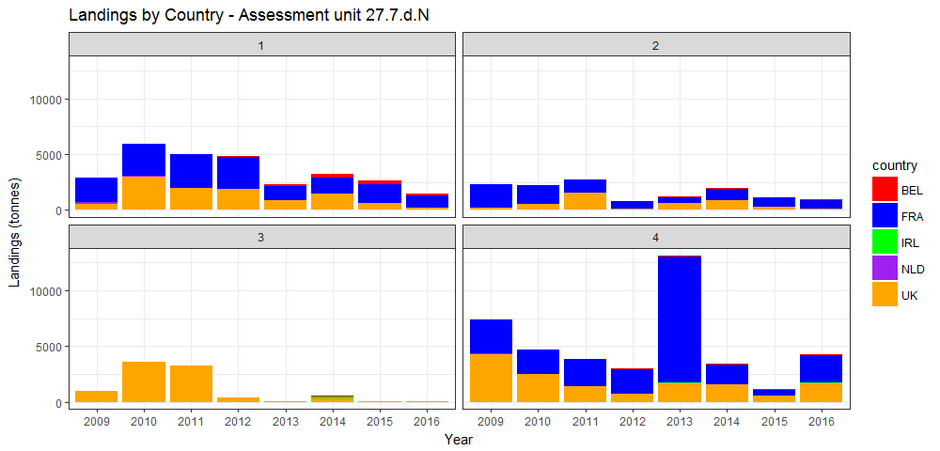
Figure 2.2: Assessment Area 7.d.N. Landings by country and by quarter (N.B. Isle of Man, Guernsey and Jersey landings <1t per annum. Belgian landings only recorded since 2012).

The fishery tends to be more active during the autumn and winter, therefore an appropriate way of viewing the landings data is by sampling season, in which a season comprises Q4 of the preceding year and the first three quarters of the current year. UK landings data for area 7.d.N by quarter are summarised in Table 2.3 and indicate a large increase in 2009 compared to earlier in the time series, peaking in 2010, and followed by a decline in recent years back to more typical values. This sudden increase in landings appears to have resulted from an increase in catch rates which drew in additional effort from the nomadic fleet at a time when access to other waters was becoming limited.
There is also a lag interval in the collation of landings data within the UK; at the time of report writing (January 2020), landings data to the end of September (Q3, 2019) are considered reliable.

Table 2.3: UK Landings (tonne) for 7.d.N by quarter. * provisional.
 | Q1 | Q2 | Q3 | Q4 | Annual Total | Sampling Season Total (Q4, Q1, Q2, Q3)
2001 | 653 | 96 | 24 | 201 | 974
2002 | 380 | 220 | 63 | 647 | 1310 | 864
2003 | 1228 | 111 | 6 | 487 | 1832 | 1992
2004 | 889 | 107 | 6 | 383 | 1385 | 1489
2005 | 553 | 133 | 18 | 529 | 1234 | 1088
2006 | 749 | 305 | 30 | 475 | 1559 | 1614
2007 | 653 | 152 | 51 | 1559 | 2414 | 1330
2008 | 686 | 479 | 51 | 606 | 1823 | 2776
2009 | 533 | 174 | 962 | 4242 | 5911 | 2275
2010 | 2947 | 514 | 3591 | 2458 | 9509 | 11294
2011 | 1922 | 1509 | 3256 | 1397 | 8083 | 9144
2012 | 1872 | 131 | 368 | 690 | 3061 | 3768
2013 | 831 | 620 | 40 | 1688 | 3179 | 2182
2014 | 1463 | 850 | 310 | 1541 | 4163 | 4310
2015 | 644 | 306 | 59 | 584 | 1594 | 2551
2016 | 168 | 78 | 21 | 1629 | 1897 | 851
2017 | 426 | 174 | 410 | 2419 | 3429 | 2639
2018 | 1338 | 1387 | 1591 | 1849 | 6165 | 6735
2019 | 1814 | 1790 | 165 | 2016* | 5784* | 5617

Discards
Discards are known to occur in the fishery. However, no quantitative estimates have been made and therefore this assessment does not include discards. As almost all discards are due to minimum size restrictions, the omission of discard data does not affect the estimation of fishable biomass. Scallops are assumed to have a high survival rate and therefore discard induced mortality is considered to be low.

Size composition
An extensive biological sampling programme was started in 2017 and is described in Annex 1. The program collected both length and age samples with a higher sample collection rate on lengths than ages as is standard for fishery data collection programs. Age determination had highlighted some inconsistencies between the first two years of data that were not picked up during routine quality control and which required further investigation. These inconsistencies have been resolved but an ICES workshop has been scheduled early in 2020 to assist with development of ageing technique and to provide international contribution. As such, although we continue to add to our valuable time series of age structure data, only size compositions are presented in this report. We intend to carry out age structured assessments when a longer time series of age data are available.
Length samples for individual vessels were raised to UK landings on a quarterly basis before summation to total landings during each sampling season.
The number of samples collected for both years of the programme is shown below (Table 2.4) along with the number of age samples collected during the dredge survey. Age samples will be an important part of any future assessment process and are included for completeness.
Table 2.4: Sampling programme summary for stock assessment area 7.d.N. ‘*‘ awaiting update.
 | Commercial Landings |  |  |  | Dredge Survey
Sampling Season | Length samples | Animals measured | Age samples | Shells aged | Age samples | Shells aged
2017 | 10 | 1594 | 1 | 24 | 9 | 335
2018 | 47 | 7191 | 16 | 458 | 17 | 717
2019 | 67 | 10699 | 26 | 774 | 18 | *

The landed numbers at size, raised to the landings data are show in Figure 2.3. There are significantly more animals at size groups above MLS in 2018 and 2019 compared to 2017.
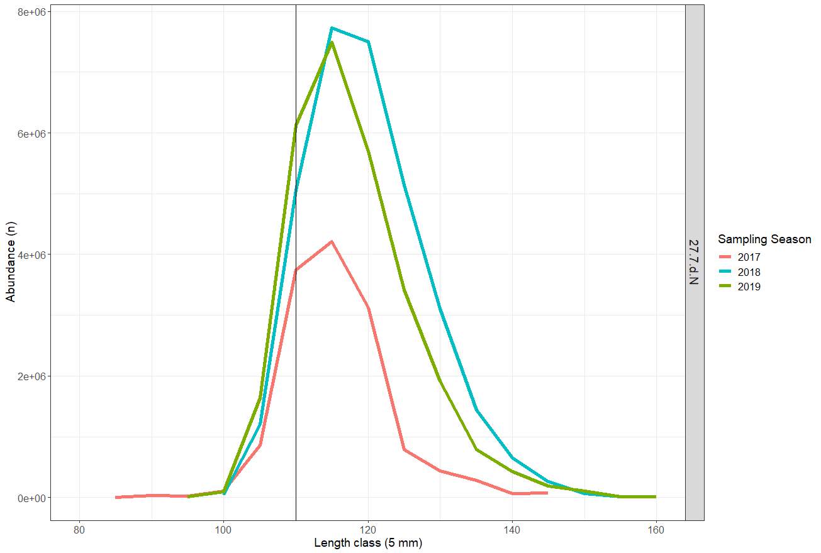
Figure 2.3: Estimated numbers by size group landed in 7.d.N. for 2017 (red), 2018 (blue) and 2019 (green) sampling seasons. The vertical grey line indicates MLS.

Biological Parameters and Dredge Efficiency

Natural mortality
Predation is the likely cause of most of the natural mortality, with brown crab and starfish being the most significant predator on scallops less than two years old. Scallops that reach sexual maturity are less vulnerable to predation due to the robustness of their shells. Natural mortality is not precisely known. However, in common with other fish and shellfish stocks of similar longevity (up to 20 years), it is assumed to be 0.15 yr-1 for all ages and areas (Cook et al., 1990).

Size at maturity
Animals above Minimum Landing Size (MLS, 110 mm shell length) are almost exclusively found to be mature. Maturity is assumed to be knife-edged at 80mm shell height (based on Cefas data, unpublished).

Growth
Methodology for ageing at Cefas is based on work carried out by Dare and Deith (1989). Oxygen isotope assay was used to validate traditional ring counting methods and to produce von Bertalanffy growth parameters. A review of historic growth estimates including different grounds in the English Channel by Dare and Palmer provided von Bertalanffy growth parameters for assessment area 7.d.N (Cefas unpublished, 2001).
The von Bertalanffy model was used to estimate size at age:
,
where is asymptotic shell height, is the growth rate, and is the time at zero size.

Shell metric conversions
The growing edge of scallop shells is the most fragile part of the shell and prone to damage. Scientific shell measurements are therefore generally taken on shell height (perpendicular to the hinge) as this axis has the least potential for damage. The minimum landing size for scallop is, however, determined using the shell length (parallel to the hinge across the widest point). As one purpose of the stock assessment is to estimate fishable biomass it is desirable to present results in length equivalents. Consequently, parameters for converting shell metrics to the equivalent length of the round shell have been determined.
Two size metrics were used; the round shell is the lower curved valve and its length is measured in line with the hinge, the flat shell is the top valve and its height is measured perpendicular to the hinge axis. In this report we specifically state which size metric is used.

Weight – length relationship
Scallops were not individually weighed as part of this project but parameters for a weight- length relationship for 7.d was obtained from IFREMER.
The relationship between live weight and shell length is defined by
,
where and are positive constants.

Dredge efficiency
Pecten maximus inhabits substrates from fine sand through to coarse sand and gravel, in which it lies recessed into the seabed. However, such substrates may exist among varying amounts of rocks, stones, outcrops of bedrock and associated benthos, all of which will affect the efficiency of the fishing gear, which is defined as the percentage of captured scallops in the path of the dredge. In order to assess the spatial distribution of the stock, whether from commercial catch per unit effort (CPUE) data, or from research surveys, it is important to be able to account for such variations in gear performance. Any biomass estimates presented in this assessment are sensitive to the choice of substrate-specific efficiency parameters. The efficiency of spring-loaded dredges has been studied using diver observations, mark recapture methods and depletion studies (Chapman et al, 1977, Jenkins et al 2001 and Dare et al 1993 and 1994). However, it is a subset of results from a more recent depletion study carried out in the English Channel by Palmer et al (Cefas, unpublished data) that have been used in this analysis.
Recent work to determine a methodology for estimating dredge efficiency using a novel approach (Radio Frequency Identification, RFID technology) has made significant progress but has not yet provided alternative efficiency coefficients to those used last year. Research with the aim of providing updated methodology and efficiency coefficients is ongoing.
The biological and dredge efficiency parameters used in this assessment are presented in Table 2.5.

Table 2.5: Assessment parameters.
Description | Parameter | Source
Gear efficiency – Ground type clean or clean becoming stony | 30% | Cefas (Palmer: 2001, unpublished)
Gear efficiency – Ground type flint cobbles | 43% | Cefas (Palmer: 2001, unpublished)
Weight – Shell length | a= 1.55x10-3  b=2.45609 | IFREMER (unpublished)
Shell metric conversion - Flat height to round length | a=1.208916  b=-5.386429 | Eastern Channel dredge survey 2017
Size at Maturity | 80mm shell height  (~90 length) | Cefas (unpublished)
Natural Mortality | 0.15 all ages | Cook et al., 1990
Von Bertalanffy Growth | h∞=119.3, k=0.516, t0=0.692 | Cefas (unpublished review)

Dredge and Underwater TV Surveys

Survey design description
The dredge survey design and station selection are described in Annex 2.

2019 dredge survey
The 2019 survey is the third dredge survey carried out it in this region as part of this programme.
In 2017 the survey was restricted to the UK Exclusive Economic Zone (EEZ) whereas the survey in 2018 included tows in the French EEZ. For 2018 four additional tows were carried out in a small recently defined bed (7.d.2) in the 7.d.S assessment area to the south of bed 7.d.1. Surveying in these four tows was intended for the 2019 dredge survey but was not achieved during the survey period.
A chartered commercial fishing vessel was used to survey a grid of fishing stations as defined in the survey design (Annex 2) and shown in Figure 2.4. The commercial fishing vessel used for the survey this year and last was a 24m scallop dredger which usually fishes 10 “Newhaven” type dredges each side, and which facilitates short tow durations for effective sampling. A larger vessel was used in the first survey carried out in 2017 (details in first report). The vessel deploys a conveyor system to take catch down from the main deck to the factory deck for sorting.
The starboard side used 4 modified dredges and 6 standard dredges, and a wooden marker was used to keep the catch from the two gear types separate on the conveyor belt (see Figure 2.5). The port side beam used a standard 10 commercial dredge configuration. The beams were deployed synchronously for 15 minutes at approximately 2.5-3 knots (kts). Where the commercial dredges were observed to be full of bulk on recovery the tow was rejected, and a further 5-minute tow carried out at the same site. This was to avoid underestimation of scallop biomass at tow sites where dredges may have stopped fishing during the course of the tow. The inclusion of the modified dredges was to allow for sampling of smaller size scallops that would otherwise be under-sampled using the standard commercial gear. The length distributions from the 4 modified dredges have been used for exploratory purposes only and are not included in this assessment.
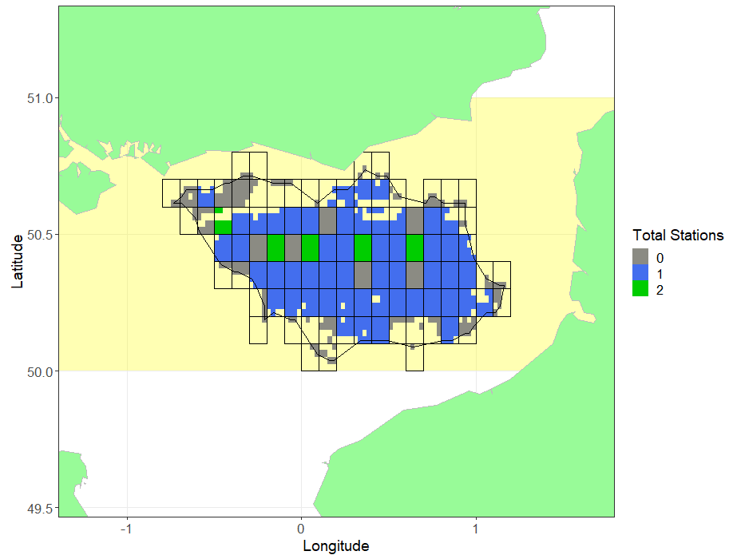
Figure 2.4: Sampled blocks in Bed 7.d.1, 7.d.N. Block shading indicates the total number of stations within each block 0 =grey, 1=blue and 2=green.

Sixty-five randomly selected tows were surveyed in bed 7.d.1 between 8th – 14th September 2019, resulting in the sampled blocks shown in Figure 2.4.

Figure 2.5: Gear configuration on survey vessel.

The standard gear (Newhaven type dredges) were 75cm wide and fitted with 85-mm ring bellies and 8-teeth swords (tooth bars). The modified dredges were 75cm wide with 55-mm rings in the belly, nylon mesh backs and 13-teeth swords. Dredge spring tension was manually tested regularly by the crew throughout the survey and the vessel’s usual schedule of gear refurbishment was carried out to maintain efficiency.
At each tow position catches of scallops were processed and measured as follows.
- Starboard side – scallop catch sorted into retained and discarded component for each of the two gear types (all dredges within gear type pooled). Numbers of each component was recorded, and components were then subsampled for length purposes, shell length measured to the nearest mm. The numbers of scallop in each length sample and each sampled component of the catch were recorded to provide raising factors.
- Five individuals per 5mm size bin were retained for age determination at selected sites within each bed.

Video survey
In 2019 underwater TV (UWTV) surveys were used to determine the distribution and relative abundance of scallops in selected areas inaccessible to fishing gear including Marine Protected Areas (MPAs) and areas with unsuitable ground types. Two un-dredged zones surveyed, lie within in the 7.d.N assessment area (TV.d.A and TV.e.E). The methods for the video surveys are included in annex 4.

Survey Processing
The processing of the dredge survey data is detailed in Annex 3. The essence of the approach is to determine the swept area of the gear and then calculate the relative biomass density and total catch of scallops at or above MLS from the swept. Catch densities are then converted to population densities using the gear efficiency parameter appropriate to the particular ground type (Table 2.5). An arithmetic approach was taken to raise the survey data, as per last year, with the observed cells of randomly selected stations first being raised to the valid surface area of the containing block. Cells within unsampled blocks were assumed to have the same density as the average sample density from randomly selected stations. This year all tow positions were randomly selected negating the need to apply appropriate procedures to industry selected tows to maintain statistical integrity.

Raised biomass estimates and uncertainty
The estimated biomass of harvestable scallops (>110mm) raised to each block is presented for 2019 in Figure 2.6.
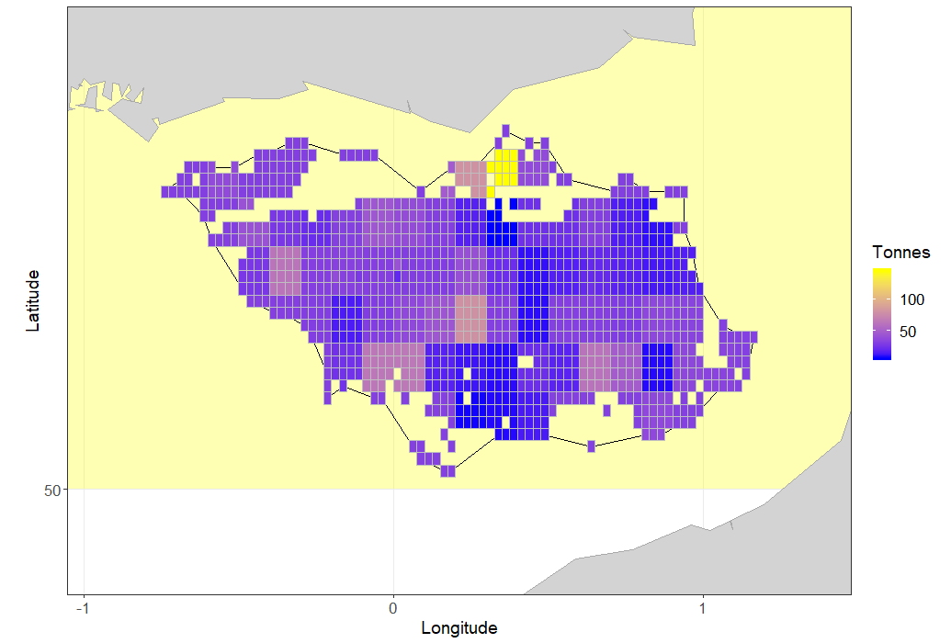
Figure 2.6: Biomass (Tonnes) of harvestable (above 110mm length) scallops in Bed 7.d.1, Assessment Area 7.d.N (yellow).

In order to estimate the uncertainty around the estimate of harvestable biomass, the samples for each bed were bootstrapped 5000 times with replacement (Figure 2.7). For each iteration, the same raising procedure was used as for the main biomass estimation routine. The point estimate, along with median, 25th and 75th percentiles are given in Table 2.6. As the point estimate utilises all available data it is considered the most appropriate value for the biomass estimates.
In 2017, areas in the French EEZ were not surveyed and a bed mean density was used to estimate biomass there. In 2018 and 2019 the French EEZ was surveyed allowing actual densities to be raised to this area.
Table 2.6: Median biomass, point estimate and percentiles for dredged areas of 7.d.N, 2017-2019.
Year | 25th percentile (Tonnes) | Median  Biomass  (Tonnes) | Point Estimate  (Tonnes) | 75th  percentile  (Tonnes)
2017 | 20876 | 22732 | 22981 | 24602
2018 | 23506 | 24965 | 25047 | 26332
2019 | 33157 | 34752 | 34612 | 36477

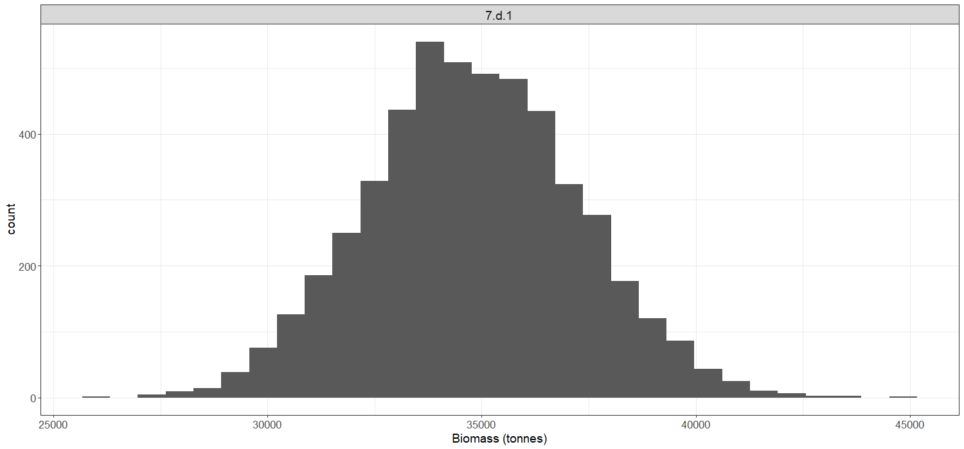
Figure 2.7: Distribution of biomass estimates for Bed 7.d.1 in 2019 from bootstrapping procedure.

Size composition from dredge survey
From the size frequencies taken at each station, a total length frequency was derived and raised to the total population estimate (biomass). The proportion of the catches below MLS taken by the commercial gear in 2019 was 29%, lower than the earlier two surveys in this area (36% in 2017, 53% in 2018).
The size distributions of the survey catches do not compare directly to those from the commercial landings as they are raised to total estimated biomass as opposed to reported removals (Figure 2.8). There was evidence of a pulse of smaller scallop below MLS in the 2018 survey size distributions, unlike in those generated from the commercial samples. This is understandable given the large proportion of catch that was below the minimum landing size in the surveys. There were significantly more scallops in the 110mm size group in the 2018 and 2019 surveys compared to the 2017 survey.
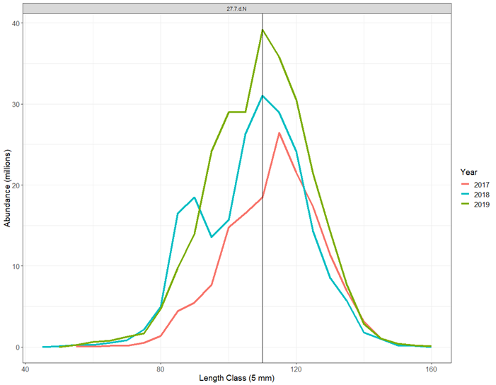
Figure 2.8: Dredge survey: Length distributions of the scallop population in surveyed areas of Assessment Area 7.d.N for 2017 (red), 2018 (green) and 2019 (blue). The vertical grey line indicates MLS.

Relative abundance from video survey
Video survey work was carried out in 2019. The video surveys observed scallops to be distributed on the seabed in the un-dredged zones at low density. Tow speed was 0.4 knots and tow duration was 20-minutes which provided a transect length of just under 250m. All transects in zone TV.d.A. within 7.d.N gave zero counts and the highest observed number of scallops observed was 0.30 scallops per 100m2 in zone TV.e.D (only a small part in 7.d.N). Although zero densities are not uncommon in surveys where target species are aggregated on the seabed, further development of the camera deployment platform is expected.
Further results from the 2019 UWTV survey are reproduced in Annex 5. The 29 tonnes of biomass estimated for selected un-dredged zones in this assessment area are incorporated in the harvest rates tables 2.8 and 2.9. There is likely additional resource in other un-dredged zones already defined but yet to be surveyed (e.g.TV.7.d.C) and possibly other un-dredged areas yet to be defined. We anticipate these areas will be the subject of future UWTV surveys.

Harvest Rate Estimation
The harvest rate (i.e. the ratio of landings to total harvestable biomass) is proposed to give a proxy for the fishing mortality experienced by this stock area. Ideally this will be constructed from the biomass immediately prior to the fishery and then compared to the removals from the observed biomass. However, international landings for the 12-month periods after the surveys were not available at the time of this assessment. Instead, for those rectangles which intersect bed 7.d.1, the UK landings as reported on the national database were used, raised by the average ratio of the UK component of the international landings (2009-2016) reported to STECF (Table 2.7). This assumes that the UK share of the international landings has been consistent in recent times. For the latest survey year, 2019, and where the reported landings are less than for 2018, we have substituted the estimated international landings from 2018. This is more likely to be indicative of future landings than an estimate based on incomplete UK landings data. Estimates of removals and the harvest rates based on them are provisional at the time of this report and will be revised when data become available.
The best estimate of harvest rate uses the point estimate from all data, while a confidence interval is obtained from the 25th and 75th percentiles of the randomised resampling distribution.
Biomass estimates for selected un-dredged areas of 7.d.N were assessed for the first-time using UWTV in 2019. As such, harvest rate estimates include the fished part of the stock, together with small amounts from un-dredged areas. There is additional stock outside the area surveyed with dredges and UWTV, for which there are currently no data on their biomass or ability to contribute to recruitment to the main areas of fished stock.
Table 2.7: Biomass and Provisional harvest rate estimate for the dredged areas of 7.d.N for 2017-2019.
Year | Biomass Removed (tonnes) | Harvestable Biomass  Estimate in Dredged Area (tonnes) | Provisional Harvest Rate on Dredged Portion of Stock (%) | Provisional Harvest Rate  Range (%, from resampling exercise)
2017 | 17107* | 22981 | 74.4 | 69.5-81.9
2018 | 14269* | 25047 | 57.0 | 54.2-60.7
2019 | 14269** | 34612 | 41.2 | 39.1-43.0
* estimated from UK removals and average UK share, to be revised
** estimate from previous year, to be revised, See explanation in text.

Table 2.8: Removals (tonnes), estimated harvestable biomass (tonnes) and provisional harvest rate (%) incorporating biomass estimate from dredge and TV surveys by assessment area in 2017-2019.
Assessment Area | Year | Biomass Removed (tonnes) | Estimated Harvestable Biomass from Dredge Survey Areas (tonnes) | Estimated Harvestable Biomass from 2017 TV Survey Areas [Not 100%] (tonnes) | Estimated Total Harvestable Biomass (tonnes) | Provisional Harvest Rate incl. UWTV (%)
7.d.N | 2017 | 17107* | 22981 | 29.0 | 23010 | 74.3
7.d.N | 2018 | 14269* | 25047 | 29.0 | 25076 | 56.9
7.d.N | 2019 | 14269** | 34612 | 29.0 | 34641 | 41.2
* estimated from UK removals and average UK share, to be revised
** estimate from previous year, to be revised, See explanation in text.

Landings size compositions – cohort modelling
Most fully analytical fish stock assessments use a time series of age composition of the landings (along with other data such as total landings/catch and a survey series) to estimate the rate at which the fishery is exploiting the stock.
In the first assessment in 2017 (2018 report) we used an age-based cohort model to determine fishing mortality, assuming the populations had been at equilibrium (“steady-state”), that is that fishing effort, recruitment and growth have all been constant. Deviations from this assumption will result in unreliable simulations.
Marked differences in the reported landings between the two assessment years have highlighted that the populations are not at equilibrium, Therefore, for this report a method has been employed that is less susceptible to fluctuations in recruitment and fishing. Scaled length distributions were used to determine gear selection parameters (L25 and L50) to facilitate a length-based cohort method (Figure 2.9). Length-based methods are routinely used for shellfish assessments where only size structure of the removals is available and is typical for many shellfish species where routine age determination is problematic. The length-based assessment uses growth parameters to determine the time spent in each size class and projects the spawning biomass and catch expected from a batch of recruits (a Yield and Spawner per recruit model).
The provisional harvest rate for the dredged portion of the stock, and a candidate harvest rate consistent with MSY, estimated using the length-based cohort method, are presented in Table 2.9. Age compositions are not presented in this report.

Table 2.9: Provisional harvest rate estimates for dredged areas of 7.d.N and an MSY candidate.
Year | Provisional harvest rate on dredged portion of stock  (Dredge Survey Only, %) | Provisional harvest rate on Wider Stock  (Inc. UWTV Survey [Not 100%], %) | MSY  Candidate Harvest Rate (%)
2017* | 74.4 | 74.3 | 21.5
2018* | 60.7 | 56.9 | 21.5
2019** | 41.2 | 41.2 | 21.5
* estimated from UK removals and average UK share, to be revised
** estimate from previous year, to be revised

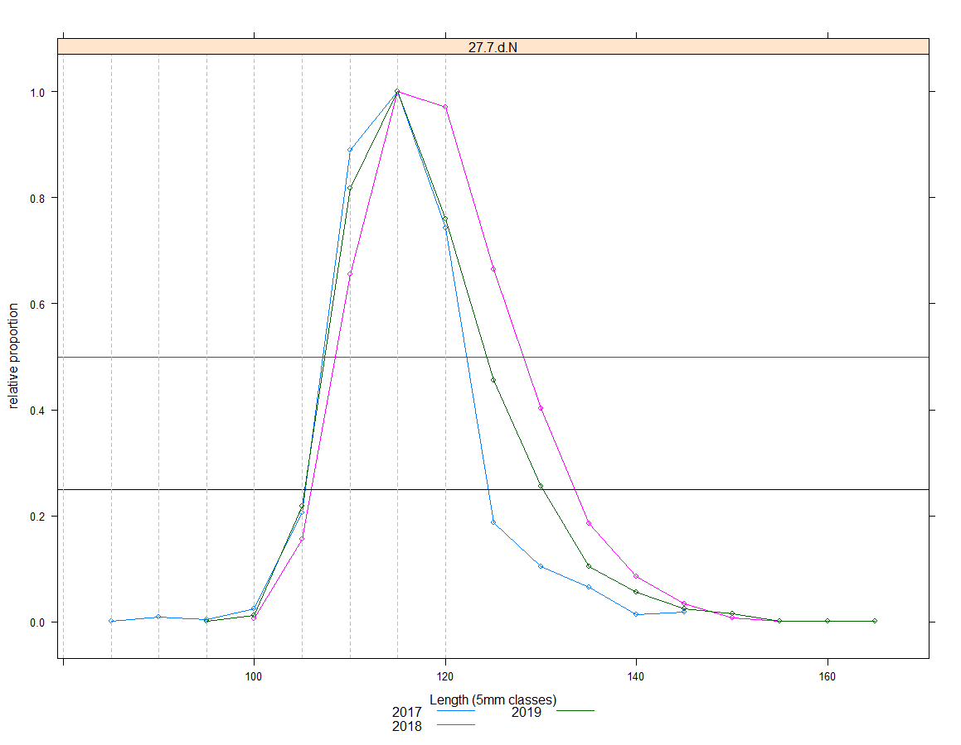
Figure 2.9: Scaled landed size distributions as a proportion of highest mode. Horizontal reference lines at 25% (black) and 50% (red).

  - MSY Reference Point Estimation
Full estimation of the fishing mortality that generates maximum sustainable yield (MSY) requires a full analytical assessment, including an estimate of the stock-recruitment relationship. Clearly, as is the case with many stocks assessed by ICES, this is not yet possible. For these stocks, ICES scientists use proxy reference points that have been found to be reasonable approximations to MSY reference points. The fishing mortality which generates 35% of the virgin spawning potential (F35%SpR) is a commonly used reference point, not only within ICES advisory areas, but also globally. Fmax, the fishing mortality which gets the maximum yield from each recruited individual is also sometimes used as a proxy for the fishing mortality which provides the maximum sustainable yield (Fmsy), This however, is unlinked to spawning potential, is more uncertain in its estimation and, in some circumstances, suggests fishing rates which are highly risky for the stock size.
A simple yield-per-recruit model was constructed using selection-at-size and maturity-at-size parameters estimated in this assessment. The fishing mortality, harvest rate and spawner-per-recruit are presented for 3 reference points in table 2.10.
This model estimates that in order to achieve F35%SpR, a harvest rate in the vicinity of 25% would be required. The Fmax estimate for this stock is very high, because there is relatively little growth potential after the MLS has been reached compared to expected losses through natural mortality. Exploitation at the Fmax estimate for this stock would remove ~66% of the harvestable stock in each year and reduce the spawning potential to ~18% of its virgin state is therefore considered to be a high-risk strategy. Instead, the recommended FMSY reference point for this stock is F35%SpR. The relationship between yield or spawner-per-recruit to fishing mortality is presented by assessment area in figure 2.10.

Table 2.10: Fishing mortality, harvest rate and spawner per recruit at reference points F0.1, FSpR35% and Fmax.
Reference Point | Fishing Mortality | Harvest Rate % | Spawner per Recruit | Fbar
F0.1 | 0.210 | 18.1 | 0.392 | 0.106
FSpR35% | 0.252 | 21.5 | 0.350 | 0.127
Fmax | 0.680 | 51.9 | 0.178 | 0.342

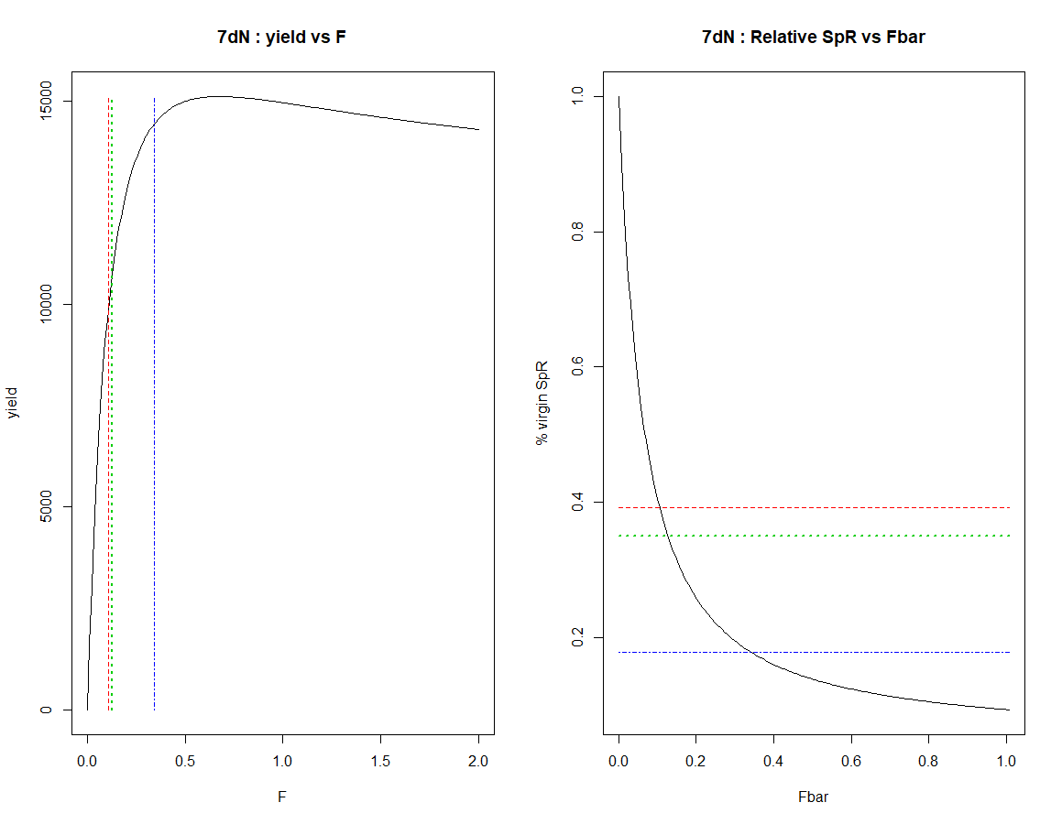
Figure 2.10: Yield (left) and relative spawner per recruit (right) against fishing mortality. Three reference points indicated F0.1 (red), FSpR35% (green) and Fmax (blue).

Conclusions
This is the third stock assessment undertaken for scallops in this region. This year the assessment includes biomass estimates and provisional harvest rates from the dredge survey, together with, for the first time, modest amounts of biomass estimated using underwater TV survey data in selected un-dredged areas.
A few years of data are always more uncertain than an extended time-series, so the results of this assessment should still be viewed with some caution.
Length-structured cohort modelling provides context for the harvest rate estimates. Presently the provisional harvest rate for this area is nearly twice as high as the harvest rate consistent with MSY. However, the harvest rates are provisional and need revision when actual data become available. The size of this discrepancy may be due to the assumption that foreign landings are proportional to UK landings. This highlights the importance of having access to the most recent international landings data and retrospectively updating estimates with actual landings when they become available.
The large variation in reported landings between 2017 and 2018, combined with a potential pulse in incoming recruitment, suggests that the population in this area is not at equilibrium. The assumption of equilibrium is fundamental to cohort model and yield-per-recruit estimates investigated in the 2017 report. As a result of these concerns, a modelling method which utilises scaled length samples was considered more appropriate than the age-based method used for the first assessment.
In 2018 a change to a smaller survey vessel deploying fewer dredges was unavoidable. Both survey vessels deploy very similar gear and catches of scallop are standardised to area swept. However, no comparative tow work was carried out to confirm that there was no change in catchability. As such caution should be used when comparing the 2017 and 2018 survey results. The dredge surveys in 2019 were carried out by the same vessel used in 2018.
A presentation of the assessment approach to the ICES Scallop Working Group highlighted that there are several key areas of uncertainty that require further work to better understand their impact. With the swept area biomass assessment, the key parameter is the gear-efficiency estimate, and even relatively small changes to this estimate would have a significant impact upon the estimated harvestable biomass and harvest rate. Research to develop novel technology to resolve gear efficiency estimates is still ongoing.
It should be noted that the assessment of scallops in 7.d.N only covers the fished part of the stock and selected areas of un-dredged parts. Additional stock is known to be outside the surveyed area, for which there are currently no data on either their biomass or ability to contribute to recruitment to the fished stock. Further surveys of un-dredged areas are planned and, provided that there is evidence that scallops in un-dredged areas make significant contributions to those in dredge areas, proportionate inclusion of biomass from un-dredged areas is likely to revise the estimates of realised harvest rate downwards.
We would hope that in future assessments we will be able to see weak and strong year-classes moving through the population structure to give confidence that the sampling scheme is able to adequately follow the population development. As a time-series of age compositions develops, the use of age structured assessment methods will be investigated. A time series as long as the number of year classes in the fishery is preferred which in this case is eight years (8 year plus group).

Dredge survey of bed 7.d.2 in 7.d.S

Area Definition
VMS data from 2009 to 2016 were used to define the original beds in all assessment areas, but reported and recent expansion of the fishery to the south of bed 7.d.1 led to further investigation of these data. Inclusion of 2017 VMS data (the latest available at the time) enabled the definition of a second bed (7.d.2) in the Eastern English Channel. This bed falls almost exclusively within area 7.d.S but as it lies between the area in the Baie de Seine assessed by French scientists and Bed 7.d.1 assessed as part of this project it was deemed appropriate to survey this area.

2019 dredge survey
The four stations in bed 7.d.2 were not surveyed this year. The results from last year’s survey are presented in annex 7.

Stock Assessment in surveyed areas of 27.7.e and 27.7.f

Area Definitions
As described in Section 1.2, three scallop assessment areas which encompass the majority of areas fished by UK vessels have been defined within ICES division 27.7.e; 7.e.I (Inshore Cornwall), 7.e.L (Lyme Bay) and 7.e.O (Offshore). Within these there are eight scallop beds; two scallop beds are within 7.e.I, three within 27.e.L, and three within 7.e.O. Two of the beds (7.e.4 and 7.e.5) straddle two of the assessment areas; these beds have been assigned to the assessment area into which the majority of it lies (Figure 4.1). Beds 7.e.7 and 7.e.8 lie predominantly in the French EEZ with a small part of bed 7.e.8 lying in the Guernsey territorial waters and a small part of bed 7.e.7 in the UK EEZ. In 2018 a new bed 7.f.1, was defined and surveyed in assessment area 7.f.I (Inshore). 7.f.I is within ICES division 7.f and located off the North Cornish coast.
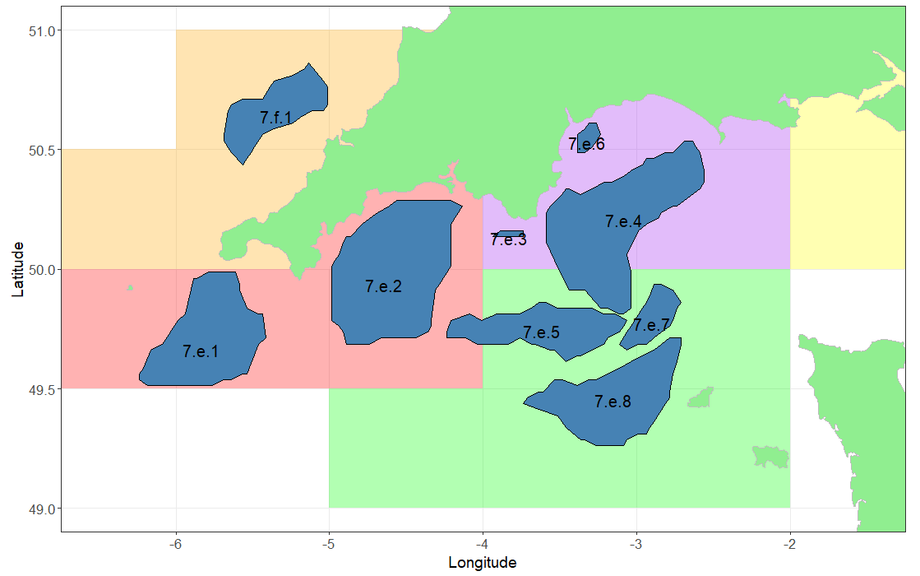
Figure 4.1: Beds 7.e.1 and 7.e.2 within Assessment Area 7.e.I (red), Beds 7.e.3, 7.e.4 and 7.e.6 in 7.e.L (purple), Beds 7.e.5, 7.e.7 and 7.e.8 in 7.e.O (green), and bed 7.f.1 in 7.f.I (orange). N.B. beds 7.e.3 and 7.e.6 are no longer accessible to larger vessels including our survey vessel and have been surveyed using underwater TV survey instead.

Data Available 27.7.e and 27.7.f

Catch, and survey data
Landings by country as reported to STECF (2009-2016) for the three assessment areas in 27.7.e and the one assessment area in 7.f are given in Table 4.1. Note that Belgian data are likely to be missing prior to 2012 although the tonnages are generally small. Rectangle 29E4 contains waters in both 27.7.e and 27.7.f. It is assumed that non-UK landings from 29E4 are from the 27.7.f area because all the 27.7.e waters lie inside 6 nautical miles where non-UK vessels are not entitled to fish.

Table 4.1: Landings (tonnes) by country (STECF 2009-2016) for the four assessment areas in ICES divisions 27.7.e and 27.7.f.
7.e.I | BEL | FRA | NLD | IRL | GBG | GBJ | IOM | UK | International
2009 | - | 36 | 181 | - | - | - | - | 2261 | 2478
2010 | - | 37 | 107 | - | - | - | - | 1029 | 1173
2011 | - | 55 | - | 1 | - | - | - | 1790 | 1846
2012 | 55 | 7 | - | 2 | - | - | - | 2502 | 2565
2013 | 1 | 34 | - | 1 | - | - | - | 2372 | 2409
2014 | 79 | 0 | - | 4 | - | - | - | 1667 | 1751
2015 | 102 | 0 | - | 33 | - | - | - | 3711 | 3846
2016 | 71 | 4 | - | 28 | - | - | 0 | 2836 | 2938
7.e.L | BEL | FRA | NLD | IRL | GBG | GBJ | IOM | UK | International
2009 | - | 37 | 47 | - | 0 | - | - | 1725 | 1809
2010 | - | 30 | 16 | - | - | - | - | 2554 | 2600
2011 | - | 40 | - | - | - | - | - | 3720 | 3761
2012 | 13 | 3 | - | - | 0 | - | - | 2953 | 2969
2013 | 4 | 35 | - | - | - | - | - | 2351 | 2390
2014 | 24 | 0 | - | - | - | - | - | 1834 | 1858
2015 | 10 | 1 | - | - | - | - | - | 1246 | 1257
2016 | 5 | 1 | - | - | - | - | - | 1416 | 1422
7.e.O | BEL | FRA | NLD | IRL | GBG | GBJ | IOM | UK | International
2009 | - | 828 | 66 | - | - | - | - | 2054 | 2948
2010 | - | 808 | - | - | 0 | 1 | - | 3140 | 3949
2011 | - | 671 | - | - | - | 0 | - | 1638 | 2309
2012 | 171 | 635 | - | - | 0 | - | - | 2643 | 3449
2013 | 14 | 817 | - | 2 | - | - | - | 3032 | 3866
2014 | 104 | 1141 | - | 1 | - | - | - | 1352 | 2597
2015 | 47 | 717 | - | 3 | 0 | - | - | 1055 | 1823
2016 | 58 | 764 | - | - | 0 | - | 0 | 891 | 1713

There is also a lag in the collation of landings data within the UK. At the time of writing (January 2020), landings data to the end of September (Q3, 2019) are considered reliable. A sampling season is defined as quarter 4 in the preceding year and quarters 1 to 3 in the current calendar year.
There is a seasonal pattern within the three areas, with Lyme Bay tending towards a year-round fishery, Inshore Cornwall being more of a Q2-3 fishery and offshore being more a Q3. UK data for the three assessment areas in 27.7.e and the one in 27.7.f by quarter are given in Table 4.2.

Table 4.2: Quarterly landings UK data by assessment area in 27.7.e and 27.7.f. * provisional.
7.e.I | Q1 | Q2 | Q3 | Q4 | Annual | Sampling Season (Q4, Q1, Q2, Q3)
2001 | 222 | 1063 | 1071 | 145 | 2523
2002 | 145 | 613 | 1182 | 95 | 2001 | 2086
2003 | 186 | 812 | 1169 | 208 | 2374 | 2261
2004 | 208 | 1050 | 1390 | 132 | 2780 | 2856
2005 | 441 | 1330 | 1389 | 162 | 3321 | 3292
2006 | 385 | 1280 | 1486 | 126 | 3277 | 3314
2007 | 207 | 550 | 684 | 82 | 1524 | 1567
2008 | 85 | 259 | 760 | 161 | 1265 | 1187
2009 | 219 | 791 | 1150 | 110 | 2271 | 2321
2010 | 92 | 461 | 401 | 80 | 1033 | 1063
2011 | 96 | 737 | 892 | 65 | 1791 | 1806
2012 | 241 | 1299 | 856 | 114 | 2509 | 2460
2013 | 194 | 822 | 1250 | 107 | 2372 | 2380
2014 | 81 | 578 | 890 | 119 | 1667 | 1655
2015 | 173 | 2255 | 1113 | 171 | 3711 | 3660
2016 | 321 | 1414 | 878 | 235 | 2847 | 2783
2017 | 241 | 882 | 1023 | 210 | 2356 | 2381
2018 | 269 | 1017 | 395 | 110 | 1792 | 1892
2019 | 220 | 580 | 954 | 73* | 1827* | 1864

7.e.L | Q1 | Q2 | Q3 | Q4 | Annual | Sampling Season (Q4, Q1, Q2, Q3)
2001 | 515 | 423 | 176 | 361 | 1475
2002 | 518 | 490 | 284 | 176 | 1468 | 1652
2003 | 131 | 330 | 276 | 236 | 973 | 913
2004 | 325 | 511 | 385 | 553 | 1775 | 1458
2005 | 626 | 721 | 465 | 977 | 2788 | 2365
2006 | 860 | 777 | 194 | 455 | 2286 | 2808
2007 | 521 | 740 | 268 | 482 | 2011 | 1984
2008 | 332 | 450 | 414 | 542 | 1737 | 1677
2009 | 544 | 539 | 395 | 343 | 1821 | 2019
2010 | 697 | 695 | 302 | 939 | 2633 | 2037
2011 | 1168 | 934 | 839 | 865 | 3807 | 3880
2012 | 964 | 591 | 558 | 915 | 3029 | 2979
2013 | 871 | 591 | 493 | 452 | 2408 | 2871
2014 | 504 | 611 | 416 | 354 | 1896 | 1988
2015 | 293 | 336 | 421 | 321 | 1371 | 1410
2016 | 385 | 278 | 408 | 493 | 1564 | 1391
2017 | 410 | 534 | 331 | 427 | 1703 | 1768
2018 | 304 | 399 | 575 | 630 | 1908 | 1705
2019 | 518 | 462 | 272 | 369* | 1622* | 1882

7.e.O | Q1 | Q2 | Q3 | Q4 | Annual | Sampling Season (Q4, Q1, Q2, Q3)
2001 | 183 | 350 | 35 | 11 | 578
2002 | 116 | 450 | 118 | 37 | 720 | 695
2003 | 138 | 572 | 296 | 133 | 1139 | 1043
2004 | 205 | 318 | 72 | 105 | 700 | 728
2005 | 90 | 179 | 91 | 22 | 381 | 465
2006 | 150 | 140 | 147 | 122 | 559 | 458
2007 | 417 | 1108 | 817 | 65 | 2407 | 2464
2008 | 94 | 1022 | 411 | 81 | 1609 | 1593
2009 | 428 | 1299 | 314 | 13 | 2054 | 2121
2010 | 418 | 2251 | 465 | 7 | 3141 | 3147
2011 | 350 | 1116 | 158 | 13 | 1638 | 1631
2012 | 939 | 1488 | 120 | 114 | 2662 | 2561
2013 | 449 | 1351 | 1165 | 68 | 3032 | 3078
2014 | 184 | 427 | 695 | 45 | 1352 | 1375
2015 | 133 | 313 | 589 | 20 | 1055 | 1080
2016 | 130 | 272 | 480 | 11 | 892 | 902
2017 | 44 | 307 | 192 | 57 | 600 | 553
2018 | 91 | 368 | 431 | 429 | 1319 | 947
2019 | 49 | 514 | 827 | 14* | 1403* | 1818

7.f.I | Q1 | Q2 | Q3 | Q4 | Annual | Sampling Season (Q4, Q1, Q2, Q3)
2001 | 10 | 14 | 20 | 2 | 46
2002 | 6 | 6 | 15 | 2 | 29 | 29
2003 | 15 | 10 | 31 | 2 | 58 | 58
2004 | 78 | 23 | 32 | 6 | 138 | 134
2005 | 12 | 33 | 3 | 0 | 49 | 55
2006 | 5 | 16 | 80 | 55 | 156 | 101
2007 | 6 | 39 | 16 | 2 | 62 | 116
2008 | 10 | 116 | 18 | 12 | 156 | 146
2009 | 9 | 7 | 150 | 47 | 214 | 179
2010 | 15 | 309 | 203 | 36 | 563 | 574
2011 | 11 | 137 | 53 | 18 | 218 | 237
2012 | 10 | 22 | 173 | 1 | 205 | 222
2013 | 85 | 173 | 259 | 12 | 529 | 517
2014 | 15 | 59 | 124 | 7 | 204 | 210
2015 | 35 | 46 | 59 | 9 | 149 | 147
2016 | 19 | 21 | 97 | 4 | 141 | 146
2017 | 93 | 88 | 169 | 1 | 351 | 354
2018 | 2 | 61 | 40 | 3 | 106 | 103
2019 | 2 | 27 | 161 | 13* | 203* | 193

Figure 4.2 shows the landings by country and quarter within the assessment areas in 27.7.e and 27.7.f. Annual landings in 7e inshore and Lyme Bay assessment regions are almost exclusively UK landings, with small tonnages in both areas from France, Belgium and the Netherlands. UK landings are most prevalent in 7e offshore with the exception of quarter 4 and some recent years in quarter 1, where French landings are higher. Landings from area 7f are small.
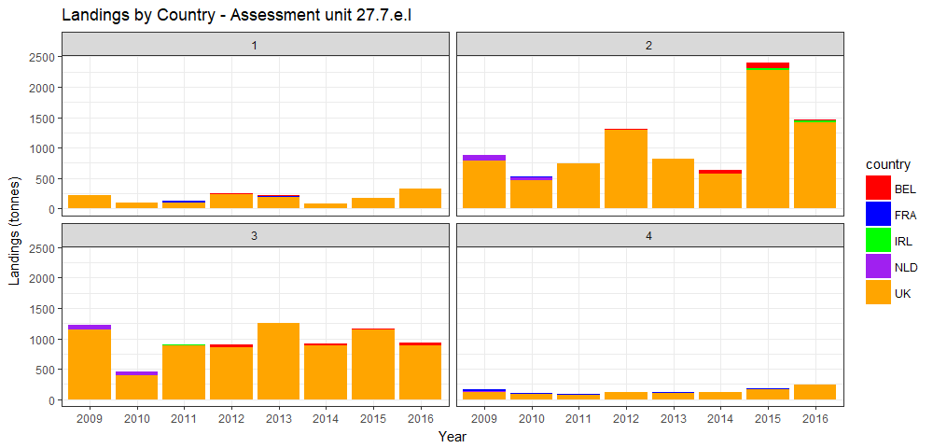
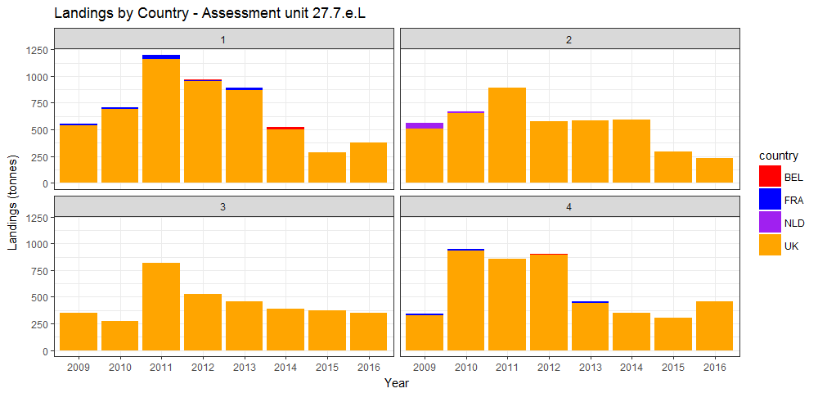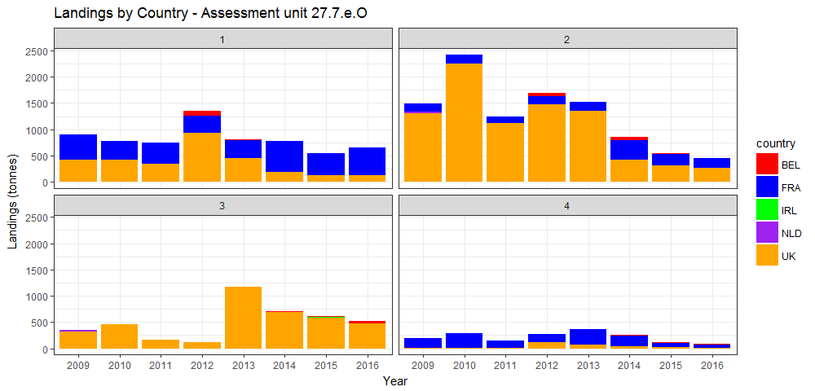
Figure 4.2: Assessment areas in 27.7.e. Landings by country and by quarter (NB. Isle of Man, Guernsey and Jersey landings <1t per annum. Belgian landings only recorded since 2012).

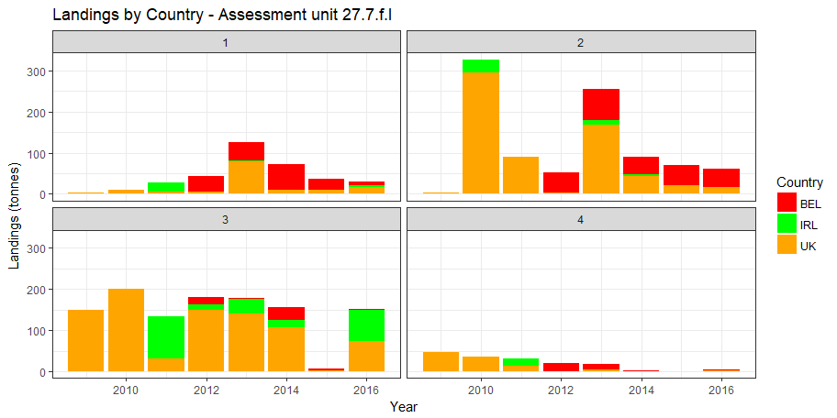
Figure 4.3 continued: Assessment 27.7.e and f. Landings by country and by quarter (NB. Isle of Man, Guernsey and Jersey landings <1t per annum. Belgian landings only recorded since 2012).

Discards
Discards are known to occur in the fishery. However, no quantitative estimates have been made and therefore this assessment does not include discards. As almost all discards are due to minimum size restrictions, the omission of discard data does not affect the estimation of harvestable biomass. Scallops are assumed to have a high survival rate and therefore discard induced mortality is considered to be low.

Size composition
An extensive biological sampling programme was started in 2017 and is described in Annex 1. The program collected both length and age samples with a higher sample collection rate on lengths than ages as is standard for fishery data collection programmes. Age determination in the first two years of sampling highlighted some inconsistencies between the two years of data that were not picked up during routine quality control and which required further investigation. These inconsistencies have been resolved but an ICES workshop has been scheduled early in 2020 to assist with development of ageing techniques and to provide international collaboration. As such, although we continue to add to our time series of age structure data, only size compositions are presented in this report. We intend to carry out age structured assessments once consistent age structured data are available. A time series as long as the number of year classes in the fishery is preferred which in this case is eight years (8 year plus group).
Length samples for individual vessels were raised to UK landings on a quarterly basis before summation to total landings during each sampling season.
The number of samples collected for both years of the programme is shown below (Table 4.3) below along with the number of age samples collected during the dredge survey. Age samples will be an important part of any future assessment process and are included for completeness where available.

Table 4.3: Sampling programme summary. ‘*‘awaiting update.
 |  | Commercial Landings |  |  |  | Dredge Survey
Assessment Area | Sampling season | Length samples | Animals measured | Age samples | Shells aged | Age samples | Shells aged
7.e.I | 2017 | 25 | 4472 | 9 | 237 | 8 | 330
 | 2018 | 24 | 4353 | 9 | 243 | 17 | 524
 | 2019 | 16 | 3000 | 7 | 215 | 12 | *
7.e.L | 2017 | 19 | 3502 | 7 | 271 | 3 | 141
 | 2018 | 24 | 5231 | 10 | 317 | 7 | 212
 | 2019 | 14 | 2674 | 10 | 344 | 6 | *
7.e.O | 2017 | 8 | 1340 | 3 | 85 | 6 | 260
 | 2018 | 9 | 1397 | 6 | 178 | 14 | 487
 | 2019 | 8 | 1209 | 2 | *44 | 7 | *
7.f.I | 2017 | 2 | 404 | 0 | 0 | 0 | 0
 | 2018 | 1 | 173 | 1 | 26 | 3 | 100
 | 2019 | 2 | 295 | 1 | 30 | 4 | *

The landed numbers at size, raised to the landings data, by each assessment area are shown in Figure 4.3. The size distributions for 7.e.L and 7.e.O indicate a significant increase in the numbers of scallop at MLS in 2019 compared to the previous two years (more than twice for 7.e.L and six times higher for 7.e.O). This effect is not as evident in 7.e.I. The length distributions for 7.f.I were not adequately sampled and are not presented.

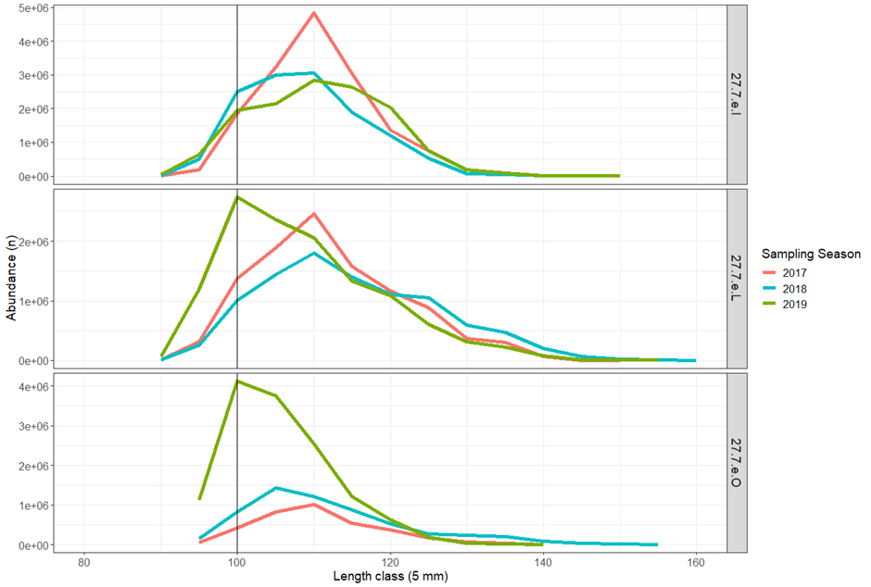
Figure 4.4: Estimated numbers in size group landed in 7.e.I, L and O during the 2017 (red), 2018 (blue) and 2019 (green) sampling seasons. The vertical grey line indicates MLS.

Biological Parameters and Dredge Efficiency

Natural mortality
Predation is the likely cause of most of the natural mortality, with the brown crab and starfish being the most significant predator on scallops less than two years old. Scallops that reach sexual maturity are less vulnerable to predation due to the robustness of their shells.
Natural mortality is not precisely known. However, in common with other fish and shellfish stocks of similar longevity (up to 20 years), it is assumed to be 0.15 yr-1 for all ages and areas (Cook et al., 1990).

Size at maturity
Animals above MLS (100 mm shell length) are almost exclusively found to be mature. Maturity is assumed to be knife-edged at 80mm shell height (based on Cefas data, unpublished).

Growth
Methodology for ageing at Cefas is based on work carried out by Dare and Deith (1989). Oxygen isotope assay was used to validate traditional ring counting methods and to produce von Bertalanffy growth parameters. A review of historic growth estimates including different grounds in the English Channel by Dare and Palmer (1994) was available but more recent estimates by Palmer (Cefas, unpublished data) are used for assessment areas in 27.7.e and 27.7.f.
The von Bertalanffy model was used to estimate size at age:
,
where is asymptotic shell height, is the growth rate, and is the time at zero size.

Shell metric conversions
The growing edge of scallop shells is the most fragile part of the shell and prone to damage. Scientific shell measurements are always taken on shell height (perpendicular to the hinge) as this axis has the least potential for damage, however the minimum landing size for scallop is set on the length (parallel to the hinge across the widest point). As one purpose of the stock assessment is to estimate harvestable biomass it is desirable to present results in length equivalents. Consequently, parameters for converting shell metrics to the equivalent length of the round shell have been determined.
Two size metrics were used; the round shell is the lower curved valve and its length is measured in line with the hinge, the flat shell is the top valve and its height is measured perpendicular to the hinge axis. In this report we specifically state which size metric is used.

Weight – length relationship
Scallops were not individually weighed as part of this project but an earlier Cefas project weighed component parts which when combined provide total weight of individuals (Cefas, 2012 unpublished report). Samples were collected from 5 sea areas in the English Channel, described as; 1. East of the Eddystone, 2. West of the Eddystone, 3. Scillies, 4. Offshore, 5. Lyme Bay (348 samples, 10,680 scallops).
The relationship between live weight and shell length is defined by
,
where and are positive constants.

Dredge efficiency
Pecten maximus inhabits substrates from fine sand through to coarse sand and gravels in which it lies recessed into the seabed. However, such substrates may exist among varying amounts of rocks, stones, outcrops of bedrock and associated benthos, all of which will affect the efficiency of the fishing gear, which is defined as the percentage of captured scallops in the path of the dredge. In order to assess the spatial distribution of the stock, whether from commercial catch per unit effort (CPUE) data, or from research surveys, it is important to be able to account for such variations in gear performance. Any biomass estimates presented in this assessment are sensitive to the choice of substrate-specific efficiency parameters. The efficiency of spring-loaded dredges has been studied using diver observations, mark recapture methods and depletion studies (Chapman et al., 1977, Jenkins et al., 2001 and Dare et al 1993 and 1994). However, it is a subset of results from a more recent depletion study carried out in the English Channel by Palmer et al (Cefas, unpublished data) that have been used in this analysis.
Recent work to determine a methodology for estimating dredge efficiency using a novel approach (Radio Frequency Identification, RFID technology) has made significant progress but has not yet provided alternative efficiency coefficients to those used last year. Research with the aim of providing updated methodology and efficiency coefficients is ongoing.
The biological and dredge efficiency parameters used in this assessment are presented in Table 4.4.

Table 4.4: Assessment parameters.
Description | Parameter | Stock Area | Source
Gear Efficiency – Ground type  clean or clean becoming stony | 30% | 7.e.I, O and L and 7.f.I | Cefas (Palmer, 2001, unpublished)
Gear Efficiency – Ground type flint cobbles | 43% | 7.e.I, O and L and 7.f.I | Cefas (Palmer, 2001 unpublished)
Weight – Shell length | a= 1.189x10-3  b=2.488354 | 7.e.I and 7.f.I | Cefas 2012 (unpublished)
Weight – Shell length | a= 0.808x10-4  b=2.573519 | 7.e.O | Cefas 2012 (unpublished)
Weight – Shell length | a= 1.326x10-3  b=2.478189 | 7.e.L | Cefas 2012 (unpublished)
Shell metric conversion - Flat height to round length | a=1.209837  b=-4.904044 | 7.e.O, I and L, and 7.f.I | Western channel dredge survey 2017
Size at Maturity | 80mm shell height (~90 length) | 7.e.I, O and L, and 7.f.I | Cefas (unpublished)
Natural Mortality | 0.15 all ages | 7.e.I, O and L, and 7.f.I | Cook et al., 1990
Von Bertalanffy Growth | h∞=116.5, k=0.584, t0=0.715 | 7.e. L | Cefas (unpublished)
Von Bertalanffy Growth | h∞=106.3, k=0.518, t0=0.921 | 7.e. O | Cefas (unpublished)
Von Bertalanffy Growth | h∞=105.5, k=0.437, t0=0.682 | 7.e. I and 7.f.I | Cefas (unpublished)

Dredge and Underwater TV Surveys

2019 dredge survey
The survey design was essentially the same as that for the survey in 7.d (section 2.4.2) and described in Annex 2. The commercial scallop vessel outlined in survey description for 7.d (Section 2.3) was used for dredge surveys in 27.7.e and 27.7.f.
Data available for analysis are described in Table 4.5.

Table 4.5: Sampling summary from dredge surveys in 2019. ‘*‘ awaiting update.
Bed | Number of Stations | Number of Length Samples | Number of Age Samples | Number Measured | Number Aged
7.e.1 | 21 | 21 | 5 | 1951 | *
7.e.2 | 32 | 32 | 7 | 4412 | *
7.e.3 | 0 | 0 | 0 | 0 | *
7.e.4 | 29 | 29 | 6 | 1659 | *
7.e.5 | 18 | 18 | 3 | 731 | *
7.e.6 | 0 | 0 | 0 | 0 | *
7.e.7 | 4 | 4 | 1 | 156 | *
7.e.8 | 8 | 8 | 3 | 1522 | *
7.f.1 | 12 | 12 | 4 | 1091 | *

A total of 124 randomly selected stations were surveyed in the Western English Channel and approaches to the Bristol Channel between 10th -19th May 2019 and operating from Newlyn (Figure 4.4). Of the 124 stations 12 were carried out in 27.7.f and 112 in 27.7.e. Because of sensitivities associated with EU Exit, tow positions were not carried out in the French EEZ in 2019, resulting in lower tow numbers and samples for beds 7.e.7 and 7.e.8 compared to last year.
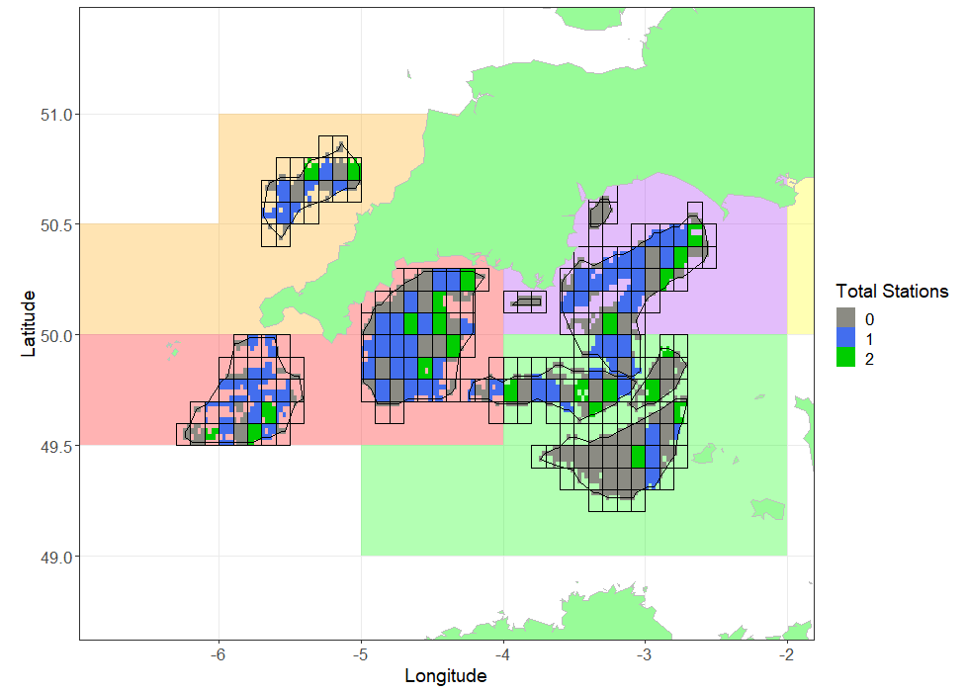
Figure 4.5: Sampled blocks in Beds 7.e.1-8 and 7.f.1, in assessment areas 7.e.I, O, L, and 7.f.I. Block shading indicates the total number of stations within each block 0 =grey, 1=blue and 2=green.

Video survey
In 2017 underwater TV (UWTV) surveys were used to determine the distribution and relative abundance of scallops in selected areas inaccessible to fishing gear, including Marine Protected Areas (MPA) and areas with unsuitable ground types. No UWTV surveys were undertaken in 2018 as research resources were used to progress technical and methodological advances for both underwater TV survey and other scallop research requirements. In June 2019 UWTV surveys resumed, covering two un-dredged zones that lie within 27.7.e (TV.7.e.B and TV.e.E). The methods for the video surveys are included in Annex 4.

Survey Processing
The processing of the dredge survey data is detailed in Annex 3. The essence of the approach is to determine the swept area of the gear and then determine the relative biomass density and total catch of scallops at or above MLS from the swept area. Catch densities are then converted to population densities using the gear efficiency parameter appropriate to the particular ground type (Table 4.4). An arithmetic approach was taken, with the observed cells of randomly selected stations first being raised to the valid surface area of the containing block. Cells within unsampled blocks were assumed to have the same density as the average sample density from randomly selected stations.

Raised biomass estimates and uncertainty
The estimated harvestable biomass of harvestable scallops (>100mm) raised to each block is presented for 2019 in Figure 4.5.

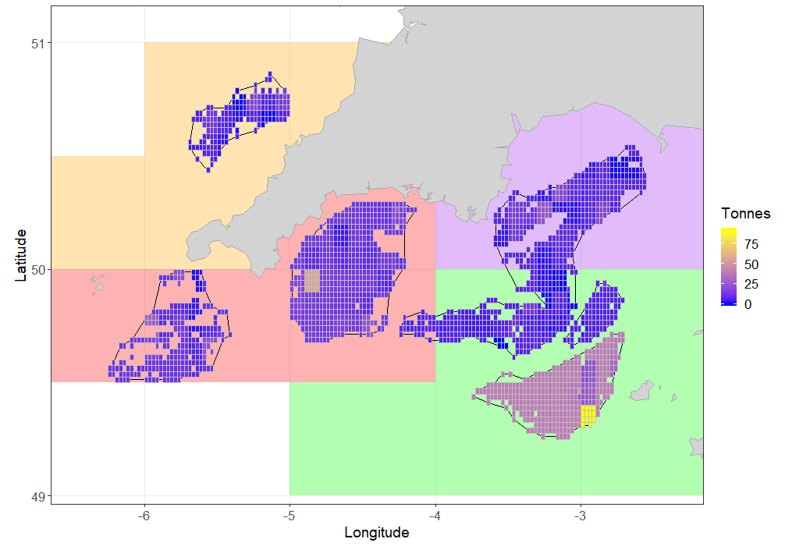
Figure 4.6: Biomass (Tonnes) of harvestable (above 100mm length) scallops in the surveyed areas within 7.e.I (red), 7.e.L (purple), 7.e.O (green), and 7.f.I (orange).

In 2019, areas in the French EEZ were not surveyed and a mean bed density was used to estimate biomass there (beds 7.e.7 and 8).

In order to estimate the uncertainty around the estimate of harvestable biomass, the samples for each bed were randomly resampled with replacement (“bootstrapped”) 5000 times (Figure 4.6). For each iteration, the same raising procedure was used as for the main biomass estimation routine. The median, 25th and 75th percentiles and point estimates for each year are given in Table 4.6. As the point estimate utilises all available data it is considered the most appropriate value for the biomass estimates. The point estimates of biomass for 7.e.I, 7.e.L and 7.e.O were higher in 2019 compared to the previous year (15.7%, 29.7% and 48.7%). The point estimate for 2019 was 32% lower than that in the previous year for 7.f.I.

Table 4.6: Median biomass, point estimate and percentiles for the dredged areas in 7.e.I, L, O and 7.f.I, 2017-2019.
Assessment  Area | Year | 25th percentile (tonnes) | Median  Harvestable Biomass  (tonnes) | Point Estimate (tonnes) | 75th percentile (tonnes)
7.e.I | 2017 | 6417 | 7045 | 7337 | 7608
 | 2018 | 8585 | 9059 | 8971 | 9518
 | 2019 | 9547 | 10286 | 10378 | 10864
7.e.L | 2017 | 2449 | 2563 | 2636 | 2722
 | 2018 | 2593 | 2792 | 2849 | 2995
 | 2019 | 3056 | 3362 | 3384 | 3664
7.e.O | 2017 | 6919 | 8469 | 8673 | 9401
 | 2018 | 9119 | 10403 | 10746 | 11809
 | 2019 | 13382 | 14877 | 15987 | 19868
7.f.I | 2018 | 1532 | 1674 | 1687 | 1815
 | 2019 | 945 | 1104 | 1143 | 1283

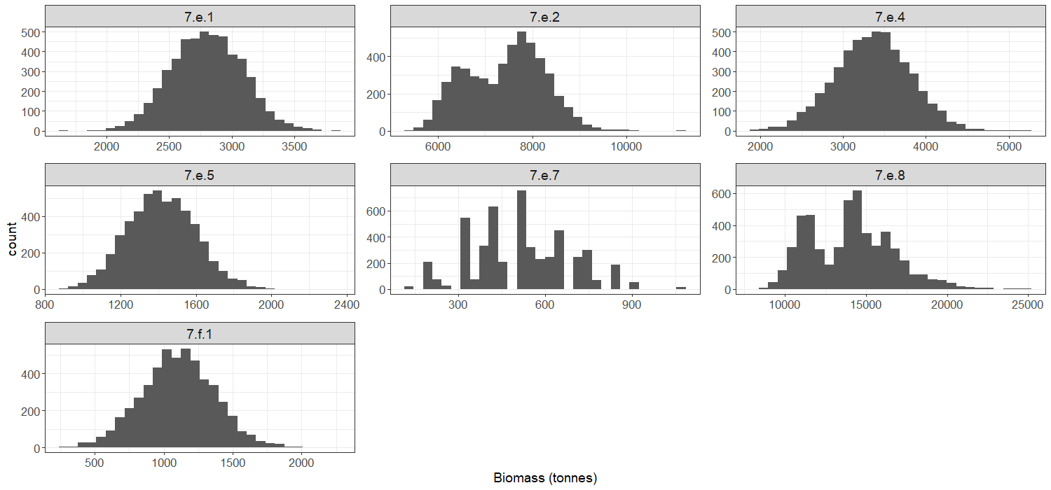
Figure 4.7: Distribution of biomass estimates for beds 27.7.e.1-7.e.8 and 7.f.1, 2019 from the bootstrapping procedure.

Size composition from dredge survey
From the size frequencies taken at each station, a total length frequency was first derived by Bed (Figure 4.7), which were then pooled to the total population estimate for each assessment area (Figure 4.8). A significant portion of the catch from assessment areas in 27.7.e and 27.7.f were below the MLS (Table 4.7).
Table 4.7: Assessment in 27.7.e and 27.7.f. Proportion of scallops below the MLS in the commercial dredges from the dredge surveys.
Assessment area | 2017 (%) | 2018 (%) | 2019 (%)
7.e.I | 21 | 23 | 17
7.e.O | 32 | 32 | 31
7.e.L | 16 | 52 | 17
7.f.I |  | 24 | 45

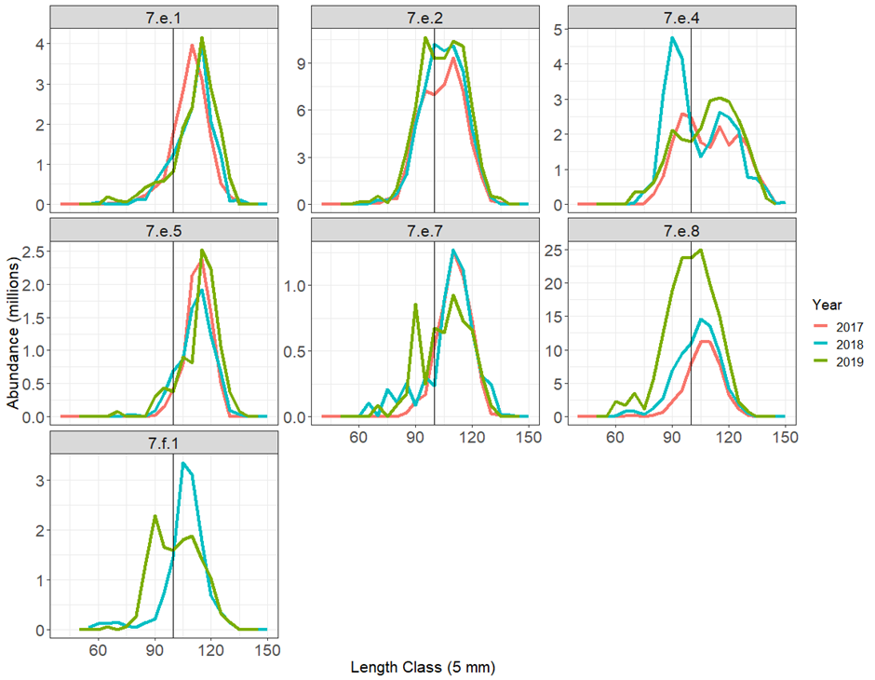

Figure 4.8: Dredge survey: Bed raised length distributions for Beds 7.e.1-8 (2017, red, 2018, green and 2019, blue) and 7.f.1 (2018 and 2019 only). The vertical grey lines indicate MLS.
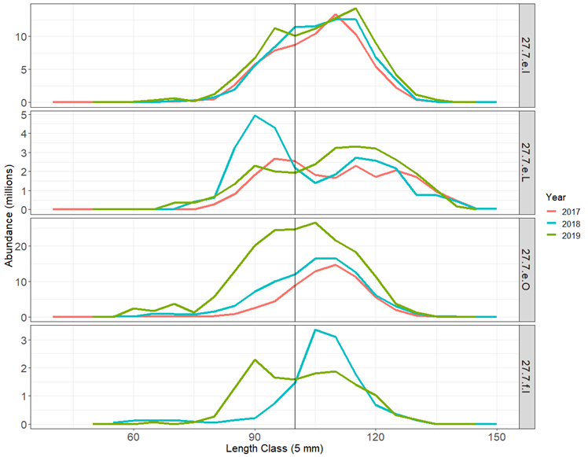
Figure 4.9: Dredge survey: Length distributions of the scallop population in surveyed areas of 7.e.I, 7.e.L, 7.e.O (2017 - red; 2018 - blue 2019 - green) and 7.f.I (2018 and 2019 only). The vertical grey line indicates MLS.

Relative abundance from video survey
Video survey work was carried out in 2017 and 2019. The video surveys observed scallops to be distributed on the seabed in the un-dredged zones at low density. The 2017 survey carried out 11-minute tows to optimise coverage in the survey grid with the ship time available, and in line with similar underwater surveys. The camera drop frame required a slow tow speed and these limited the transect length to a little over 100 m. In 2019 tow speed and duration were increased to provide a transect length of just under 250 m. Despite the increase in ground coverage in the later survey a significant proportion of the transects gave zero counts and the highest observed number of scallops observed during the 2019 survey was 0.94 scallops per 100 m-2. Although zero densities are not uncommon in surveys where target species are aggregated on the seabed, further development of the camera deployment platform is expected to improve sampling coverage.
Further results from the 2017 and 2019 UWTV surveys are reproduced in Annex 5. Biomass estimates from the un-dredged zones are incorporated in tables 4.9 and 4.10.

Harvest Rate Estimation
The harvest rate (i.e. the ratio of landings to total harvestable biomass) is proposed to give a proxy for the fishing mortality experienced by this stock area. Ideally this will be constructed from the biomass immediately prior to the fishery and then compared to the removals from the observed biomass (from June to May). However, international landings were not available at the time of this assessment. Instead, for those rectangles which intersect beds in 27.7.e and 27.7.f, the UK landings as reported on the national database were used, raised by the average ratio of the UK component of the international landings (2009-2016) reported to STECF (Table 4.9). This assumes that the UK share of the international landings has been consistent in recent times. For the latest survey year, 2019 and where the reported landings are less than for 2018, we have substituted the estimated international landings from 2018. This is more likely to be indicative of future landings than an estimate based on incomplete UK landings data. Estimates of removals and the harvest rates based on them are provisional at the time of this report and will be revised when data become available.
The best estimate of harvest rate uses the point estimate from all data, while a confidence interval is obtained for the 25th and 75th percentile of the randomised resampling distribution.
Biomass estimates for selected un-dredged areas of 27.7.e were assessed in 2017 and again in 2019 using UWTV (in addition to a small area in 7.f.). Harvest rate estimates include the fished part of the stock and biomass estimated for selected un-dredged areas. There is additional stock outside the area surveyed with dredges and UWTV, for which there are currently no data on their biomass or ability to contribute to recruitment to the main areas of fished stock.
Harvest rates estimated using biomass from un-dredged areas (UWTV, where available) added to that from dredged areas are included for reference (Table 4.9). Un-dredged areas are assumed to be at carrying capacity with no fishing mortality and the biomass estimates from 2017 video surveys have been included in estimates for 2017-2019. These harvest rates are applicable only when connectivity between dredged and un-dredged populations is complete.

Table 4.8: Harvestable biomass estimates and provisional harvest rates for dredged areas of 27.7.e and 27.7.f for 2017-2019.
Assessment Area | Year | Biomass Removed (tonnes) | Harvestable  Biomass Estimate in Dredge Area (tonnes) | Provisional Harvest Rate on Dredged Portion of Stock (%) | Provisional Harvest Rate Range (%, from resampling exercise)
7.e.I | 2017 | 2793* | 7337 | 38.1 | 36.7-43.5
 | 2018 | 1532* | 8971 | 17.1 | 16.1-17.8
 | 2019 | 1532** | 10378 | 14.8 | 14.1-16.0
7.e.L | 2017 | 1456* | 2636 | 55.2 | 53.5-59.4
 | 2018 | 2214* | 2849 | 77.7 | 73.9-85.4
 | 2019 | 2214** | 3384 | 65.4 | 60.4-72.4
7.e.O | 2017 | 973* | 8673 | 11.2 | 10.4-14.1
 | 2018 | 1819* | 10746 | 16.9 | 15.4-20.0
 | 2019 | 1937** | 15987 | 12.1 | 10.9-14.1
7.f.I | 2017 | 358* | - | - | -
 | 2018 | 161* | 1687 | 9.6 | 8.9-10.5
 | 2019 | 323** | 1143 | 28.3 | 25.2-34.2
* estimated from UK removals and average UK share, to be revised
** estimated from UK removals and average UK share or estimate from previous year, whichever is the highest, to be revised. See explanation in text.

Table 4.9: Removals, estimated harvestable biomass and provisional harvest rate incorporating biomass estimate from dredge and UWTV survey by assessment area in 2017-2019.
Assessment Area | Year | Biomass Removed (tonnes) | Estimated Harvestable Biomass from Dredge Survey Areas (tonnes) | Estimated Harvestable Biomass from TV Survey Areas [Not 100%] (tonnes) | Estimated Total Harvestable Biomass (tonnes) | Provisional Harvest Rate inc. UWTV (%)
7.e.I | 2017 | 2793* | 7337 | 4683.0 | 12020 | 23.2
 | 2018 | 1532* | 8971 | 4683.0 | 13654 | 11.2
 | 2019 | 1532** | 10378 | 4683.0 | 15061 | 10.2
7.e.L | 2017 | 1456* | 2636 | 2649.3 | 5286 | 27.5
 | 2018 | 2214* | 2849 | 2649.3 | 5498 | 40.3
 | 2019 | 2214** | 3384 | 2649.3 | 6033 | 36.7
7.e.O | 2017 | 973* | 8673 | 619.7 | 9293 | 10.5
 | 2018 | 1819* | 10746 | 619.7 | 11366 | 16.0
 | 2019 | 1937** | 15987 | 619.7 | 16607 | 11.7
7.f.I | 2017 | 358* | - | 375.2 | - | -
 | 2018 | 161* | 1687 | 375.2 | 2062 | 7.8
 | 2019 | 323** | 1143 | 375.2 | 1518 | 21.3
* estimated from UK removals and average UK share, to be revised
** estimated from UK removals and average UK share or estimate from previous year, whichever is the highest, to be revised. See explanation in text.

Landings size compositions - cohort modelling
Most fully analytical fish stock assessments use a time series of age composition of the landings (along with other data such as total landings/catch and a survey series) to estimate the rate at which the fishery is exploiting the stock.
In the first assessment (2018 report) we used an age-based cohort model to determine fishing mortality, assuming the populations had been at equilibrium, that is that fishing effort, recruitment and growth have all been constant. Deviations from this assumption will result in unreliable results.
Marked differences in the reported landings between the two assessment years in some assessment areas have highlighted that the populations are not at equilibrium. Therefore, for this report a method has been employed that is less susceptible to fluctuations in recruitment and fishing rate. Scaled length distributions were used to estimate gear selection parameters (L25 and L50) to facilitate a length-based cohort method (Figure 4.10). Length-based methods are routinely used for shellfish assessments where only size structure of the removals is available, typical for many shellfish species where age determination is problematic. The length-based assessment uses growth parameters to determine the time spent in each size class and projects the spawning biomass and catch expected from a batch of recruits (a Yield and Spawner-per-recruit model).
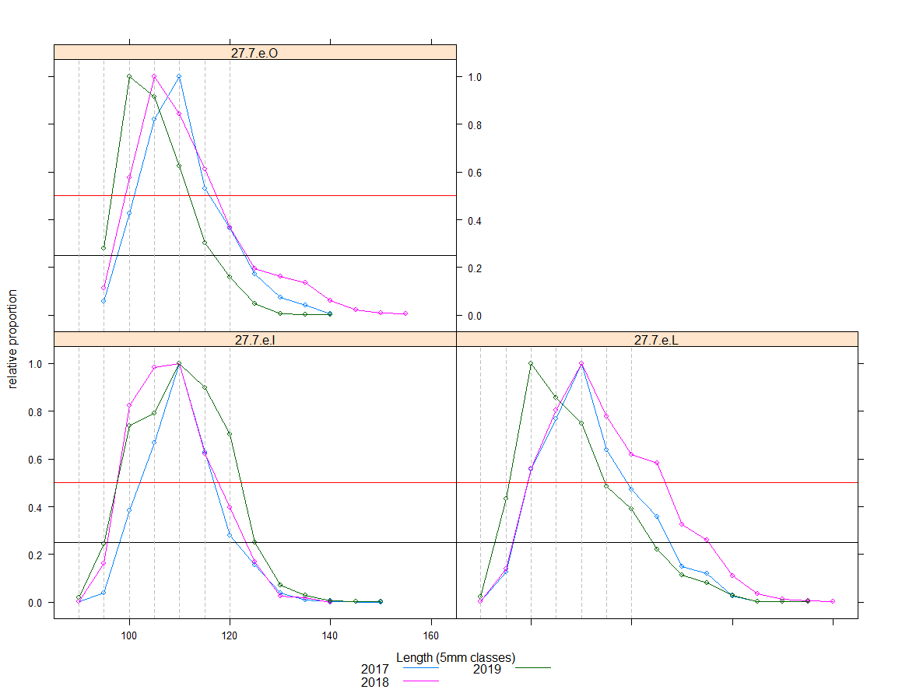
Figure 4.10: Landed size distributions as a proportion of the mode. Horizontal reference lines at 0.25 (black) and 0.50 (red).

The provisional harvest rates for the dredged portion of the stocks, and candidate harvest rates consistent with MSY, estimated using the cohort method, are presented in Table 4.10.
Table 4.10: Provisional harvest rate estimates for dredged and wider areas and MSY candidates by assessment area and year.
Assessment  Area | Year | Provisional Harvest Rate on Dredged Portion of Stock  (Dredge Survey Only, %) | Provisional Harvest Rate on Wider Stock  (Inc. UWTV Survey [Not 100%], %) | MSY  Candidate Harvest Rate (%)
7.e.I | 2017 | 38.1* | 23.2 | 19.5
 | 2018 | 17.1* | 11.2 | 19.5
 | 2019 | 14.8** | 10.2 | 19.5
7.e.L | 2017 | 55.2* | 27.5 | 21.0
 | 2018 | 77.7* | 40.3 | 21.0
 | 2019 | 65.4** | 36.7 | 21.0
7.e.O | 2017 | 11.2* | 10.5 | 20.9
 | 2018 | 16.9* | 16.0 | 20.9
 | 2019 | 12.1** | 11.7 | 20.9

* estimated from UK removals and average UK share, to be revised
** estimated from UK removals and average UK share or estimate from previous year, whichever is the highest, to be revised. See explanation in text.

Lack of sampling opportunities led to inadequate sampling for 7.f.I and as such no size-based modelling was undertaken for this assessment area.
Age compositions are not presented in this report.
  - MSY Reference Point Estimation
Full estimation of the fishing mortality that generates maximum sustainable yield (MSY) requires a full analytical assessment, including an estimate of the stock-recruitment relationship. Clearly, as is the case with many stocks assessed by ICES scientists, this is not yet possible for scallops. For these stocks, ICES scientists use proxy reference points that have been found to be reasonable approximations to MSY reference points. The fishing mortality which generates 35% of the virgin spawning potential (F35%SpR) is a commonly used reference point, not only within ICES advisory areas, but also globally. Fmax, the fishing mortality which gets the maximum yield from each recruited individual is also sometimes used as a proxy for Fmsy. This, however, is unlinked to spawning potential, is more uncertain in its estimation and, in some circumstances, suggests fishing rates which are highly risky for the stock size.
A simple yield-per-recruit model was constructed using selection-at-size and maturity-at-size parameters estimated in this assessment. The fishing mortality, harvest rate and spawner-per-recruit are presented by assessment areas for 3 reference points in table 4.11.
This model estimates that in order to achieve F35%SpR, a harvest rate in the vicinity of 25% would be required. The Fmax estimates for these areas are high, because there is relatively little growth potential after the MLS has been reached compared to expected losses through natural mortality. Following exploitation at the Fmax estimates for these stocks would remove all or most of spawning stock in one year and is therefore highly risky. The recommended FMSY reference point for this stock is therefore F35%SpR. The relationship between yield or spawner-per-recruit to fishing mortality is presented by assessment area in figure 4.10.

Table 4.11: Fishing mortality, harvest rate and spawner per recruit by assessment area at reference points F0.1, FSpR35% and Fmax.
Assessment Area | Reference Point | Fishing Mortality | Harvest Rate % | Spawner per Recruit | Fbar
7.e.I | F0.1 | 0.235 | 17.1 | 0.382 | 0.120
 | FSpR35% | 0.272 | 19.5 | 0.350 | 0.138
 | Fmax | 0.995 | 52.3 | 0.146 | 0.506
7.e.L | F0.1 | 0.230 | 19.1 | 0.372 | 0.117
 | FSpR35% | 0.253 | 21.0 | 0.350 | 0.129
 | Fmax | 0.760 | 56.2 | 0.158 | 0.388
7.e.O | F0.1 | 0.245 | 18.2 | 0.383 | 0.126
 | FSpR35% | 0.285 | 20.9 | 0.350 | 0.146
 | Fmax | 1.170 | 62.2 | 0.139 | 0.602
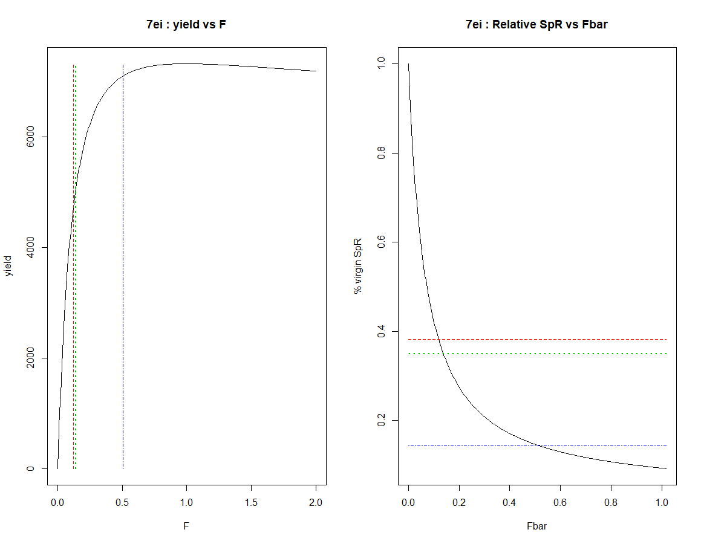
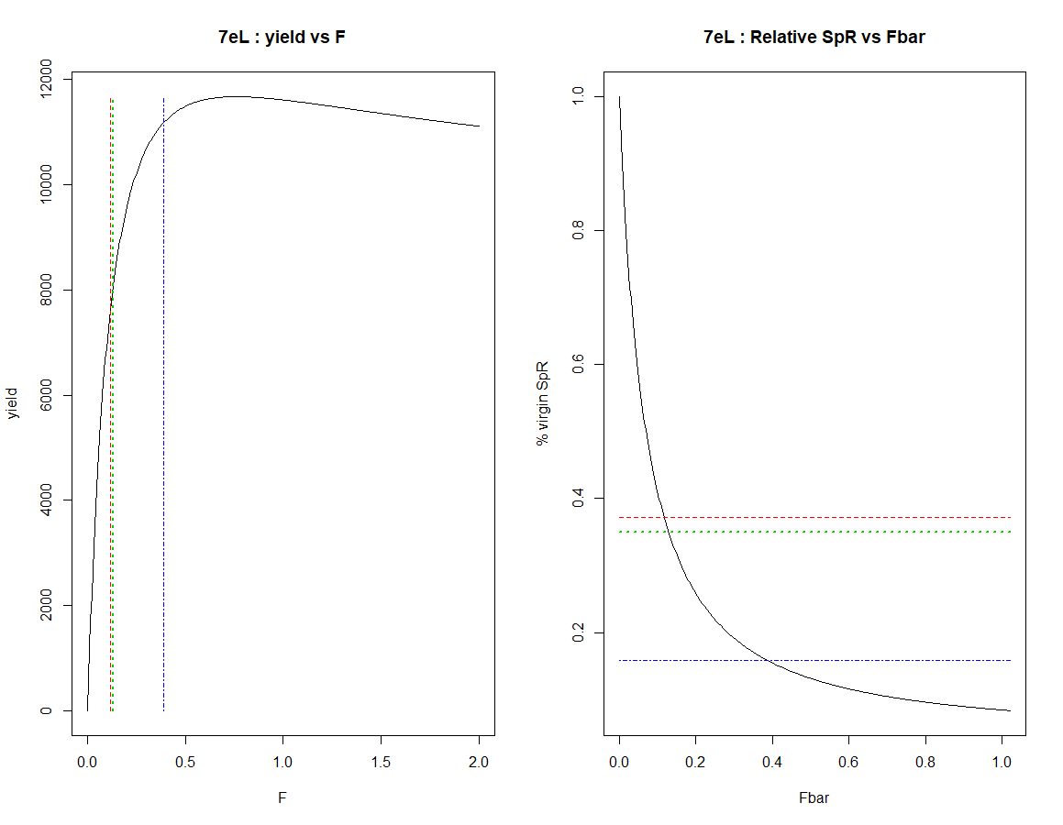
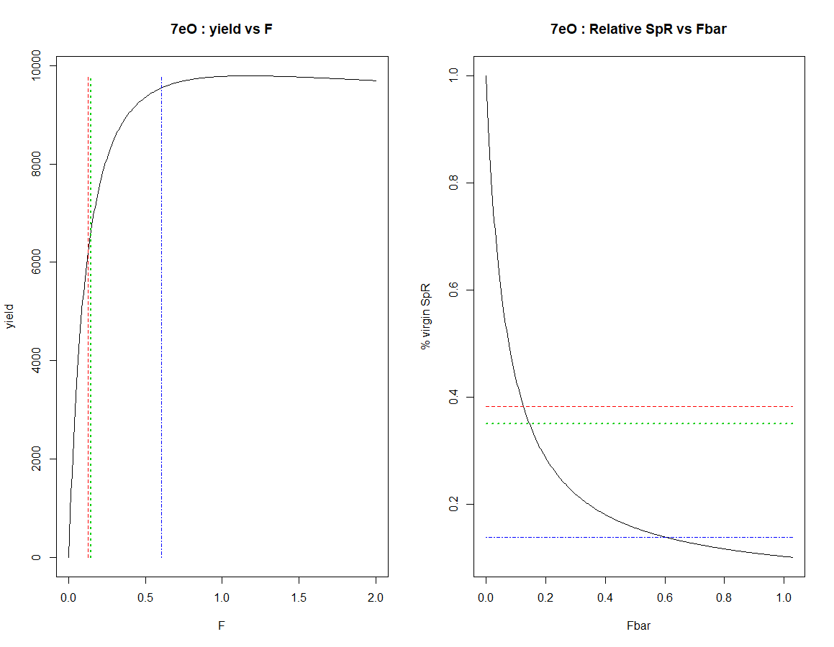
Figure 4.11: Yield (left) and relative spawner per recruit (right) against fishing mortality for assessment areas 7.e.I, L and O (top-bottom). Three reference points indicated F0.1 (red), FSpR35% (green) and Fmax (blue).

Conclusions
This is the third stock assessment undertaken for scallops in this region, and the second for 7.f. This year the assessment includes biomass estimates from the dredge surveys, together with, biomass estimates form UWTV survey data in selected un-dredged areas in 2017 and 2019.
A few years of data are always more uncertain than an extended time-series, so the results of this assessment should still be viewed with some caution.
Variation in reported landings between years suggests that the populations in this region are not at equilibrium. The assumption of equilibrium is fundamental to the cohort models and yield per recruit estimates investigated in the 2017 report. As a result of these concerns, a modelling method which utilises scaled length samples was considered more appropriate than the age-based method used in the first assessment.
Length-structured cohort modelling provide context for the harvest rate estimates. The provisional harvest rate for 2017 and for assessment area 7.e.I are higher than the harvest rate consistent with MSY (HRmsy), but the estimates for 2018 and 2019 are below. The provisional harvest rate for 7.e.L in 2017 was more than double that consistent with HRmsy, and more than three times higher in the subsequent two years. Harvest rates for 7.e.O for all years, are below HRmsy.
In 2018 a change to a smaller survey vessel deploying fewer dredges was unavoidable. Both survey vessels deploy very similar gear and catches of scallop are standardised to area swept. However, no comparative tow work was carried out to confirm that there was no change in catchability. As such caution should be used when comparing the 2017 with the 2018 and 2019 survey results. The dredge surveys in 2019 were carried out by the same vessel used in 2018.
A presentation of the assessment approach to the ICES Scallop Working Group highlighted that there are several key areas of uncertainty that require further work to better understand their impact. With the swept area biomass assessment, the key parameter is the gear-efficiency estimate, and even relatively small changes to this estimate would have a significant impact upon the estimated harvestable biomass and harvest rate. Research to develop novel technology to resolve gear efficiency estimates are still ongoing.
It should be noted that the estimates of harvest rate for areas in 27.7.e. and 7.f include some biomass estimates from selected un-dredged areas using UWTV. Additional stock is known to be outside the surveyed area, for which there are currently no data on either their biomass or ability to contribute to recruitment to the fished stock. Further surveys of un-dredged areas are planned and, provided that there is evidence that scallops in un-dredged areas make significant contributions to the recruitment in the dredged areas, proportionate inclusion of biomass from un-dredged areas is likely to revise the estimates of realised harvest rate downwards.

Stock Assessment in surveyed areas of 27.4.b

Area Definitions
As described in Section 1.2, an additional scallop assessment area has been defined within ICES division 27.4.b, this encompasses the scallop fishing activity within English waters in the North Sea by UK vessels >=12 m length. Within this division there are two scallop beds; 4.b.1 and 4.b.2 (Figure 5.1). These beds were defined in 2018 using VMS data (includes 2017 data) and first surveyed in 2018.
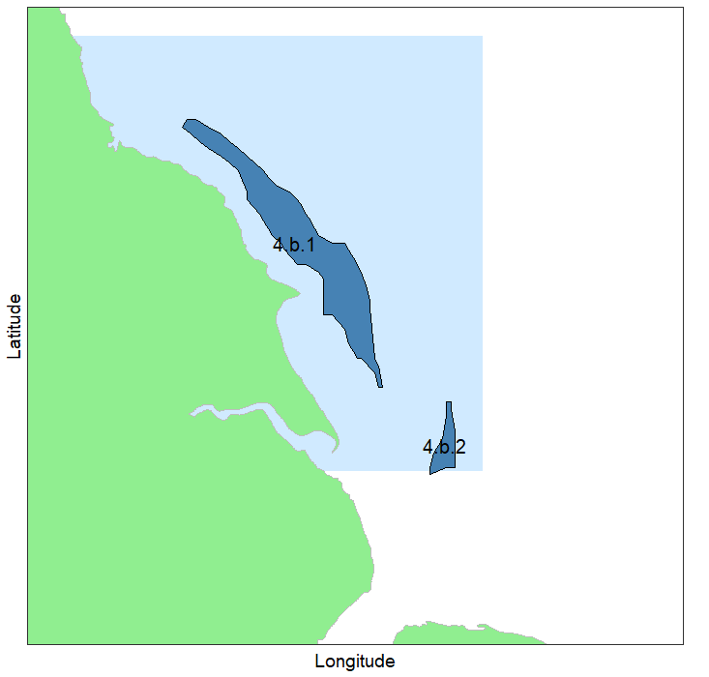
Figure 5.1: Beds 4.b.1 and 4.b.2 within Assessment Area 4.b.S (light blue).

Data Available 4.b.S

Catch and survey data
Landings by country as reported to STECF (2009-2016) for the one assessment area in 27.4.b is given in Table 5.1. This fishery is exploited almost exclusively by UK registered vessels.
Table 5.1: Landings (tonnes) by country (STECF 2009-2016) in assessment area in 4.b.S.
 | BEL | FRA | IRL | IOM | UK | International
2009 | - | - | - | - | 394 | 394
2010 | - | - | - | - | 361 | 361
2011 | - | - | - | - | 699 | 699
2012 | 0 | - | - | 6 | 985 | 991
2013 | 0 | - | - | 1 | 352 | 353
2014 | 0 | 0 | - | - | 2300 | 2301
2015 | 0 | - | - | - | 3172 | 3172
2016 | 0 | - | 0 | - | 1047 | 1047

Figure 5.2 shows the landings by country and quarter within the assessment areas in 27.4.b. Annual landings in the 4b South assessment regions are almost exclusively UK landings, with small tonnages from Isle of Man in 2012.

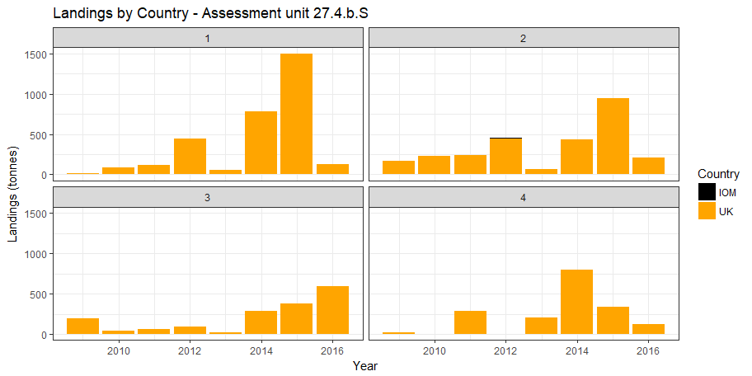
Figure 5.2: Landings by country and by quarter in assessment area 4.b.S.

UK data for the assessment area in 27.4.b by quarter are given in Table 5.2. There is a lag in the collation of landings data within the UK. At the time of writing (January 2020), landings data to the end of September (Q3, 2019) are considered reliable. A sampling season is defined as quarter 4 of the preceding year and quarters 1 to 3 of the current calendar year.
Table 5.2: Quarterly landings UK data by assessment area in 4.b.S. * provisional.
4.b.S | Q1 | Q2 | Q3 | Q4 | Annual |  | Sampling Season (Q4, Q1, Q2, Q3)
2001 | 12 | 1 | 0 | 762 | 775
2002 | 417 | 610 | 11 | 30 | 1068 |  | 1800
2003 | 434 | 112 | 3 | 6 | 554 |  | 579
2004 | 34 | 68 | 2 | 0 | 103 |  | 109
2005 | 161 | 0 | 0 | 121 | 282 |  | 161
2006 | 141 | 41 | 26 | 49 | 258 |  | 330
2007 | 21 | 119 | 144 | 1 | 285 |  | 333
2008 | 36 | 165 | 169 | 1 | 370 |  | 371
2009 | 18 | 166 | 190 | 20 | 394 |  | 375
2010 | 88 | 227 | 44 | 1 | 361 |  | 379
2011 | 117 | 239 | 57 | 286 | 699 |  | 414
2012 | 441 | 453 | 95 | 2 | 991 |  | 1275
2013 | 60 | 70 | 18 | 204 | 353 |  | 150
2014 | 786 | 435 | 283 | 797 | 2300 |  | 1708
2015 | 1506 | 951 | 377 | 340 | 3173 |  | 3630
2016 | 129 | 215 | 591 | 118 | 1054 |  | 1275
2017 | 936 | 886 | 385 | 297 | 2503 |  | 2325
2018 | 689 | 838 | 366 | 434 | 2328 |  | 2190
2019 | 998 | 839 | 294 | 87* | 2218* |  | 2565

Discards
Discards are known to occur in the fishery however no quantitative estimates have been made and therefore this assessment does not include discards. As almost all discards are due to minimum size restrictions, the omission of discard data does not affect the estimation of harvestable biomass. Scallops are assumed to have a high survival rate and therefore discard induced mortality is considered to be low.

Size composition
An extensive biological sampling programme started in 2017 in the English Channel was expanded to include this assessment area in 2018 and is described in Annex 1. The program collected both length and age samples with a higher sample collection rate on lengths than ages as is standard for fishery data collection programmes. Age determination for other assessment areas highlighted some inconsistencies between the first two years of data that were not picked up during routine quality control and which will require further investigation. These inconsistencies have been resolved but an ICES workshop has been scheduled early in 2020 to assist with development of ageing techniques and to provide international collaboration. As such, although we continue to add to our valuable time series of age structure data, only size compositions are presented in this report. We intend to carry out age structured assessments once a consistent duration of age structured data is available.
Length samples for individual vessels were raised to UK landings on a quarterly basis before summation to total landings during each sampling season.
The number of samples collected in this the first year of the programme in this area is shown below (Table 5.3) below along with the number of age samples collected during the dredge survey. Age samples will be an important part of any future assessment process and are included for completeness.

Table 5.3: Sampling programme summary. ‘*‘ awaiting update.
 | Commercial landings |  |  |  | Dredge survey
Sampling Season | Length samples | Animals measured | Age samples | Shells aged | Age samples | Shells aged
2018 | 8 | 998 | 11 | 411 | 7 | 288
2019 | 6 | 965 | 4 | 124 | 6 | *

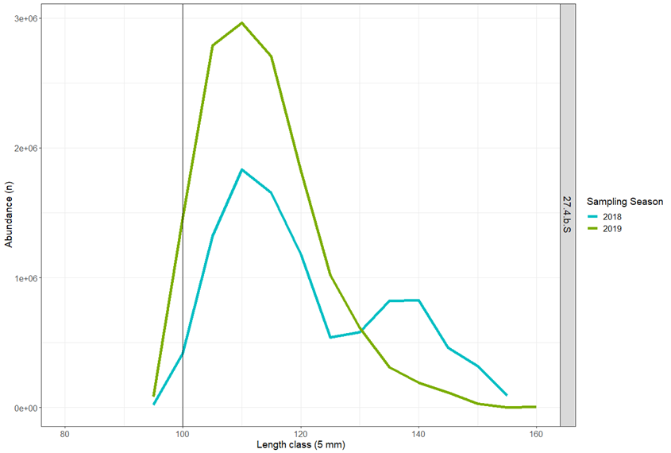
Figure 5.3: Estimated numbers in size groups landed from 4.b.S during 2018-2019 sampling seasons. The vertical grey line indicates MLS.

Biological Parameters and Dredge Efficiency

Natural mortality
Predation is the likely cause of most of the natural mortality, with the brown crab and starfish being the most significant predator on scallops less than two years old. Scallops that reach sexual maturity are less vulnerable to predation due to the robustness of their shells.
Natural mortality is not precisely known. However, in common with other fish and shellfish stocks of similar longevity (up to 20 years), it is assumed to be 0.15 yr-1 for all ages and areas (Cook et al., 1990).

Size at maturity
Animals above MLS (100 mm shell length) are almost exclusively found to be mature. Maturity is assumed to be knife-edged at 80mm shell height (based on Cefas data, unpublished).

Growth
Methodology for ageing at Cefas is based on work carried out by Dare and Deith (1989). Oxygen isotope assay was used to validate traditional ring counting methods and to produce von Bertalanffy growth parameters. A review of historic growth estimates including different grounds in the English Channel by Dare and Palmer (1994) was available but the more recent estimates by Palmer (Cefas, unpublished data) for assessment area 27.7.d are used for 27.4.b until more local estimates become available.
The von Bertalanffy model was used to estimate size at age:
,
where is asymptotic shell height, is the growth rate, and is the time at zero size.

Shell metric conversions
The growing edge of scallop shells is the most fragile part of the shell and prone to damage. Scientific shell measurements are always taken on shell height (perpendicular to the hinge) as this axis has the least potential for damage, however the minimum landing size for scallop is set on the length (parallel to the hinge across the widest point). As one purpose of the stock assessment is to estimate harvestable biomass it is desirable to present results in length equivalents. Consequently, parameters for converting shell metrics to the equivalent length of the round shell have been determined.
Two size metrics were used; the round shell is the lower curved valve and its length is measured in line with the hinge, the flat shell is the top valve and its height is measured perpendicular to the hinge axis. In this report we specifically state which size metric is used.

Weight – length relationship
Scallops were not individually weighed as part of this project but parameters for a weight- length relationship for 27.7.d was used for the North Sea. These estimates will be revised when more specific data become available.
The relationship between live weight and shell length is defined by
,
where and are positive constants.

Dredge efficiency
Pecten maximus inhabits substrates from fine sand through to coarse sand and gravel, in which it lies recessed into the seabed. However, such substrates may exist among varying amounts of rocks, stones, outcrops of bedrock and associated benthos, all of which will affect the efficiency of the fishing gear, which is defined as the percentage of captured scallops in the path of the dredge. In order to assess the spatial distribution of the stock, whether from commercial catch per unit effort (CPUE) data, or from research surveys, it is important to be able to account for such variations in gear performance. Any biomass estimates presented in this assessment are sensitive to the choice of substrate-specific efficiency parameters. The efficiency of spring-loaded dredges has been studied using diver observations, mark recapture methods and depletion studies (Chapman et al., 1977, Jenkins et al., 2001 and Dare et al 1993 and 1994). However, it is a subset of results from a more recent depletion study carried out in the English Channel by Palmer et al (Cefas, unpublished data) that we use in this analysis.
Recent work to determine a methodology for estimating dredge efficiency using a novel approach (Radio Frequency Identification, RFID technology) has made significant progress but has not yet provided alternative efficiency coefficients to those used last year. Research with the aim of providing updated methodology and efficiency coefficients is ongoing.
The parameters, biological and dredge efficiency, used in this assessment are presented in Table 5.4.

Table 5.4: Assessment parameters.
Description | Parameter | Source
Gear Efficiency – Ground type - clean or clean becoming stony | 30% | Cefas (Palmer: 2001, unpublished)
Gear Efficiency - Ground type - flint cobbles | 43% | Cefas (Palmer: 2001, unpublished)
Weight – Shell length | a= 1.55x10-3  b=2.456095 | IFREMER (unpublished)
Shell Metric Conversion - Flat height to round length | a=1.208916  b=-5.386429 | Eastern Channel dredge survey 2017
Size at Maturity | 80mm shell hgt (~90 length) | Cefas (unpublished)
Natural Mortality | 0.15 all ages | Cook et al., 1990
Von Bertalanffy Growth | h∞=119.3, k=0.516, t0=0.692 | Cefas (unpublished review)

Dredge Survey

2019 dredge survey
The survey design was essentially the same as that for the surveys in the English Channel and is described in Annex 2. This was the second dredge survey in assessment area 4.b.S and was carried out on the same vessel and during the same trip as that for 7.d.N.
23 randomly selected stations were surveyed in 4.b.S between 6th -7th September 2019 and operating from Hartlepool. Of the 23 stations 22 were carried out in Bed 4.b.1 and 1 in the smaller bed, 4.b.2. Data available for analysis are described in Table 5.5.
Table 5.5: Sampling summary from dredge survey 2019. ‘*‘ awaiting update.
Bed | Number of stations | Number of length samples | Number of age samples | Number measured | Number aged
4.b.1 | 22 | 22 | 6 | 3716 | *
4.b.2 | 1 | 1 | 0 | 69 | *

The same gear deployment configuration and sampling procedure outlined in survey description for 7.d was used (section 2.4.1. and annex 2). N.B. The length distributions from the 4 modified dredges have been used for exploratory purposes only and are not included in this assessment. The number of stations per block is shown in figure 5.4.
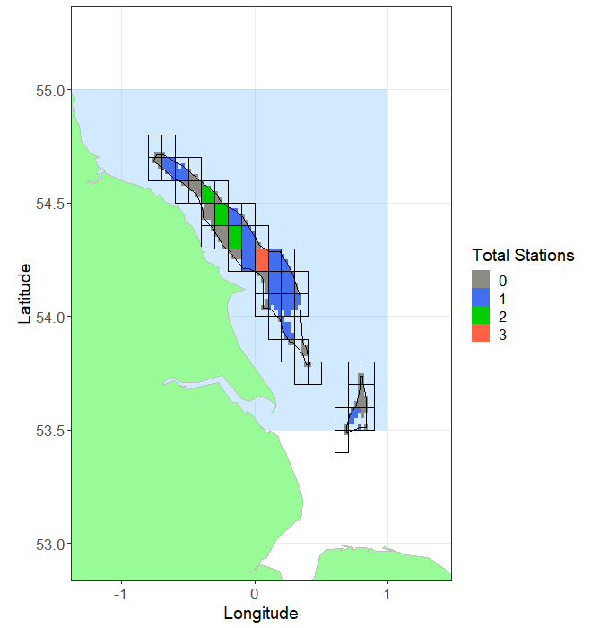
Figure 5.4: Sampled blocks in Beds 4.b.1 and 4.b.2, in assessment area 4.b.S, 2019. Block shading indicates the total number of stations within each block 0 =grey, 1=blue, 2=green and 3=red.

Survey Processing
The processing of the dredge survey data is detailed in Annex 3. The essence of the approach is to determine the swept area of the gear and then determine the relative biomass density and total catch of scallops at or above MLS from the swept area. Catch densities are then converted to population densities using the gear efficiency parameters appropriate to the particular ground type (Table 5.4). An arithmetic approach was taken, with the observed cells of randomly selected stations first being raised to the valid surface area of the containing block. Cells within unsampled blocks were assumed to have the same density as the average sample density from randomly selected stations. All tow positions were randomly selected.

Raised biomass estimates and uncertainty
The estimated harvestable biomass of harvestable scallops (>100mm) raised to each block is presented in Figure 5.5.
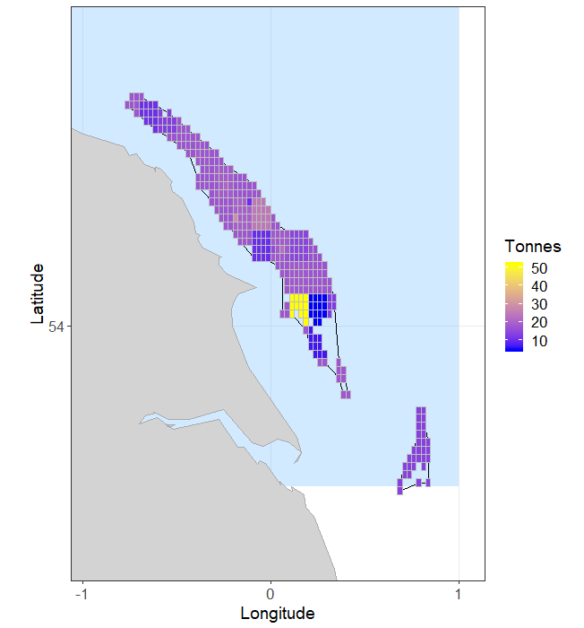
Figure 5.5: Biomass (Tonnes) of harvestable (above 100mm length) scallops in the surveyed areas within 4.b.S (light blue), 2019.
In order to estimate the uncertainty around the estimate of harvestable biomass, the samples for each bed were randomly resampled with replacement (“bootstrapped”) 5000 times (Figure 5.6). There is no bootstrap distribution for 4.b.2 in 2019 as only 1 tow was carried out during the 2019 survey due to the presence of static gear. For each iteration, the same raising procedure was used as for the main biomass estimation routine. The point estimate, along with median, 25th and 75th percentiles for each year are given in Table 5.6.
Table 5.6: Biomass estimation for the dredge surveyed areas in 4.b.S (two beds combined) for 2018-2019,
Assessment  area | Year | 25th centile (tonnes) | Median  harvestable biomass  (tonnes) | Point estimate (tonnes) | 75th centile (tonnes)
4.b.S | 2018 | 5219 | 5483 | 5517 | 5739
 | 2019 | 5392 | 5797 | 5754 | 6142

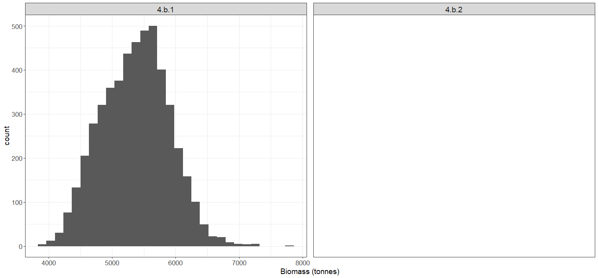
Figure 5.6: Distribution of 2019 biomass estimates for beds 4.b.1 from the bootstrapping procedure (N.B. only 2 tow in 4.b.2 prevents random sampling in this bed).

Size composition from dredge survey
From the size frequencies taken at each station, a total length frequency was first derived by Bed (Figure 5.7), which were then pooled to the total population estimate for each assessment area (Figure 5.8). Only 21% off the catch taken in the commercial gear this year was below MLS compared to 39% last year.
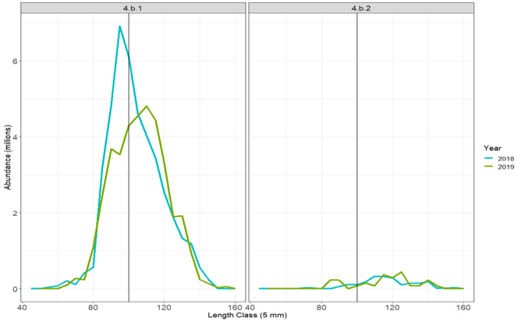
Figure 5.7: Dredge survey: Bed raised length distributions for Beds 4.b.1 and 4.b.2 in 2018 (blue) and 2019 (green).
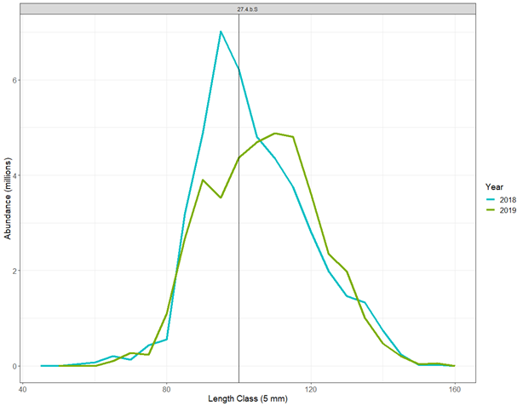
Figure 5.8: Dredge survey: Length distribution for the scallop population in surveyed areas of 4.b.S 2018 (blue) and 2019 (green).

Harvest Rate Estimation
The harvest rate (i.e. the ratio of landings to total harvestable biomass) is proposed to give a proxy for the fishing mortality experienced by this stock area. Ideally this will be constructed from the biomass immediately prior to the fishery and then compared to the removals from the observed biomass during the subsequent 12-month period. However, international landings were not available at the time of this assessment. Instead, those rectangles which intersect bed 4.b.1 and 4.b.2, the UK landings as reported on the national database were used, raised by the average ratio of the UK component of the international landings (2009-2016) reported to STECF (Table 5.7). This assumes that the UK share of the international landings has been consistent in recent times. For the latest survey year, 2019, we have substituted the estimated international landings from 2018 as this is more likely to be indicative of future landings than an estimate based on incomplete UK landings data. Estimates are provisional at the time of this report and will be revised when data become available. We note foreign landings from this area have been historically insignificant and we expect the harvest rate estimate for 2018 and 2019 to be realistic.
The best estimate of harvest rate uses the point estimate from all data, while a confidence interval is obtained from the 25th and 75th percentile of the randomised resampling distribution.
Biomass estimates for selected un-dredged areas of 27.4.b have not been assessed using UWTV survey and as such harvest rate estimates only cover the fished part of the stock. There is additional stock outside the area surveyed with dredges but for which there are currently no data on either their biomass or ability to contribute recruitment to the main areas of fished stock.
Table 5.7: Harvestable biomass estimates and harvest rates for the areas covered by the dredge survey in 2018-2019.
Year | Biomass Removed  (tonnes) | Harvestable Biomass Estimate in Dredged Area  (tonnes) | Harvest Rate on Dredged Portion of Stock (%) | Harvest Rate  Range (%, from Resampling Exercise)
2018 | 2603* | 5517 | 47.2 | 45.4-49.9
2019 | 2603** | 5754 | 45.2 | 42.4-48.3
* estimated from UK removals and average UK share, to be revised
** estimated from UK removals and average UK share or estimate from previous year, whichever is the highest, to be revised. See explanation in text.

Fishing mortality estimates from the landings size composition
Most fully analytical fish stock assessments use a time series of age composition of the landings (along with other data such as total landings/catch and a survey series) to estimate the rate at which the fishery is exploiting the stock.
This is the second year the biological sampling was carried out in this area and sampling opportunities only provided six length samples totalling 965 scallops. We have considered this sampling level to be below that required to enable a reliable length-based analysis at this time.

Conclusions
This is the second stock assessment undertaken for scallops in this region. The assessment in this area is dependent on the results of the dredge survey and is restricted to the biomass estimates and implied harvest rate. A few years of data is always more uncertain than an extended time-series are available, so the results of this assessment should still be viewed with some caution.
A presentation of the assessment approach to the ICES Scallop Working Group highlighted that there are several key areas of uncertainty that require further work to better understand their impact and influence. With the swept area biomass assessment, the key parameter is the gear-efficiency estimate, and even relatively small changes to this estimate would have a significant impact upon the estimated harvestable biomass and harvest rate. Research to develop novel technology to resolve gear efficiency estimates are still ongoing.
It should be noted that the estimates of harvest rate for 4.b.S is for the fished portion of the stocks only; unfished portions of stock were not surveyed in this area. Additional stock is known to be outside the surveyed area, for which there are currently no data on either their biomass or ability to contribute to recruitment to the fished stock.
Future surveys of un-dredged areas are planned and are likely to revise the estimates of realised harvest rate downwards, provided that un-dredged areas are considered to contribute to the recruitment in the dredged areas.
We would hope that in future assessments, and as our sampling scheme becomes more comprehensive, we will be able to determine the harvest rate which is compatible with MSY using the same method used for assessment areas in the English Channel.

Future Developments
These assessments mark the third in what is expected to be an ongoing series of assessments for scallop stocks around the English coast. The assessment techniques employed are expected to evolve over the coming years as more data become available and data quality improves.
Key data issues to develop as resources permit include:
- Gear efficiency (dredge and UWTV) estimates.
- UWTV relate counts to biomass and size structure.
- Greater understanding of the recruitment linkage between dredged scallop beds and un-dredged areas.
Annex 6 describes progress and current status of these issues.

References
Catherall, C.L., Hold, N., Murray, L.G., Bell, E. & Kaiser, M.J. (2014). English Channel King Scallops - Research summary: Genetic Population Structure. Bangor University, Fisheries and Conservation Report No. 45, pp. 5.
Cefas (2012). Spatial and temporal patterns in scallop recruitment and their implications for management. M1104 Project Final Report to Department for Environment Food and Rural Affairs (unpublished).
Cefas (2018). Assessment of Scallop stock status for selected waters within the Channel 2017/2018. Report to Department for Environment Food and Rural Affairs (unpublished).
Chapman C. J., Mason J., Kinnear J. A. M. (1977). Diving Observations on the Efficiency of Dredges used in the Scottish Fishery for the Scallop, Pecten maximus (L.). Marine Laboratory Aberdeen.
Cook, R, Bailey, N, McKay, D, Howell, D, Fraser, D. and Thain, S. (1990). Report of an internal scallop workshop 23-27 April 1990. Scottish Fisheries Working Paper No. 5/90,7pp.
Dare, P. and Deith, M. (1989). Age determination of scallops, Pecten maximus (L.), using stable oxygen isotope analysis, with some implications for fisheries management in British waters. 7th International Pectinid workshop, Portland, Maine, USA, April, 1989.
Dare P. J., Key D., Darby C. D., Connor P. M. (1993). The efficiency of spring-loaded dredges used in the western English Channel fishery for scallops, Pecten maximus (L.). ICES CM1993/B:15
Dare, P.J., Palmer, D.W., Howell, M.L. and Darby, C.D. (1994). Experiments to assess the relative dredging performances of research and commercial vessels for estimating the abundance of scallops (Pecten Maximus) in the western English Channel fishery. Cefas Fisheries Research Technical Report Number 96.
Jenkins S. R., Beukers-Stewart B. D., Brand A. R. (2001). Impact of scallop dredging on benthic megafauna: a comparison of damage levels in captured and non-captured organisms. Ma. Ecol. Prog. Ser 215: 297-301.
Lawler, A.R., Masefield, R. and Vanstaen, K.R. 2017. Scallop Dredge Scoping Study – King Scallop Stock Assessment in English Waters (C7335). Cefas report. Unpublished.
Motova, A., Curtis, H., Moran Quintana, M., Metz S. 2016. Economic analysis of the UK 15m and over scallop fishing fleet in ICES Area VII. March 2016. Seafish. Seafish report No. SR692. 38p.
Nicolle, A., Dumas, F., Foveau, A., Foucher, E., Thiebaut, E. 2013. Modelling larval dispersal of the king scallop(Pecten maximus) in the English Channel: examples from the bay of Saint-Brieuc and the bay of Seine. Ocean Dynamics (2013) 63:661–678.

Nicolle, A., Moitie, R., Ogor, J., Dumas, F., Foveau, A., Foucher, E., Baut, E. 2017. Modelling larval dispersal of Pecten maximus in the English Channel: a tool for the spatial management of the stocks. ICES Journal of Marine Science (2017), 74(6), 1812–1825.

Acknowledgements
This project was co-funded by Defra and the UK scallop fishing industry.
We would like to thank the fishing industry for their considerable help towards the aims of this project which included but was not restricted to provision of scallop length data and biological samples and substantial contributions to the project steering board. We would also like to thank the crew of FV Evening Star for their expertise and hard work during the two dredge surveys.

Assessment caveats and assumptions
- Landings data for the 12-month period post survey are required to provide a realised harvest rate. At the time of this report international landings since 2016 were not available. Instead harvest rates are estimated from UK landings and the UK historic share of the international landings. Harvest rates for the last year are based on the previous estimate of removals if these are higher than those reported. As such harvest rates presented in this report are provisional. If the UK share of the total international landings has changed then realised harvest rates can be higher or lower than our provisional estimates. Harvest rates will be retrospectively updated in future reports as data become available.
- Dredge surveys and catch sampling only cover the portions of stock found on the main fished grounds. Harvest rate estimates from dredge surveys or commercial sampling only apply to the fished portion of the stock.
- The gear-efficiency factor used to convert dredge survey data to total harvestable biomass used unpublished Cefas data. These data came from depletion experiments which although broadly in line with some similar studies remain uncertain. Further refinement/data for this parameter is required including the testing of key assumptions. Revised efficiency factors could have a large influence on the estimates of stock status.
- UWTV surveys detected biomass of scallop on grounds not exploited by dredgers and not all un-dredged grounds were surveyed with UWTV.
- Studies of larval connection between beds indicate incomplete interchange of larvae but the main dredged areas appear to have a degree of larval retention (i.e. self-perpetuating). Incorporation of the un-dredged area biomass into harvest rate calculations assumes complete interchange. Restricting the biomass estimate to the dredged beds assumes no interchange.
- Once complete coverage of un-dredged beds is achieved, these two biomass estimates would be the basis for the maximum and minimum harvest rates experienced in an assessment area.
About us
We are the Government’s marine and freshwater science experts. We help keep our seas, oceans and rivers healthy and productive and our seafood safe and sustainable by providing data and advice to the UK Government and our overseas partners.

We are passionate about what we do because our work helps tackle the serious global problems of climate change, marine litter, over-fishing and pollution in support of the UK’s commitments to a better future (for example the UN Sustainable Development Goals and Defra’s 25-year Environment Plan).

We work in partnership with our colleagues in Defra and across UK government, and with international governments, business, maritime and fishing industry, non-governmental organisations, research institutes, universities, civil society and schools to collate and share knowledge.

Together we can understand and value our seas to secure a sustainable blue future for us all, and help create a greater place for living.

Head office
Pakefield Road
Lowestoft
Suffolk
NR33 0HT
Tel: +44 (0) 1502 56 2244
Fax: +44 (0) 1502 51 3865

Weymouth office
Barrack Road
The Nothe
Weymouth
DT4 8UB

Tel: +44 (0) 1305 206600
Fax: +44 (0) 1305 206601

Innovative, world-class science is central to our mission. Our scientists use a breadth of surveying, mapping and sampling technologies to collect and analyse data that are reliable and valuable. We use our state-of-the-art Research Vessel Cefas Endeavour, autonomous marine vehicles, remotely piloted aircraft and utilise satellites to monitor and assess the health of our waters.

In our laboratories in Lowestoft and Weymouth we:
• safeguard human and animal health
• enable food security
• support marine economies.

This is supported by monitoring risks and disease in water and seafood; using our data in advanced computer models to advise on how best to manage ﬁsh stocks and seafood farming; to reduce the environmental impact of man-made developments; and to respond to serious emergencies such as ﬁsh disease outbreaks, and to respond to oil or chemical spills, and radioactivity leaks.

Overseas, our scientists currently work in Commonwealth countries, United Kingdom Overseas Territories, South East Asia and the Middle East.

Our customer base and partnerships are broad, spanning Government, public and private sectors, academia, non-governmental organisations (NGOs), at home and internationally.



- www.cefas.co.uk

