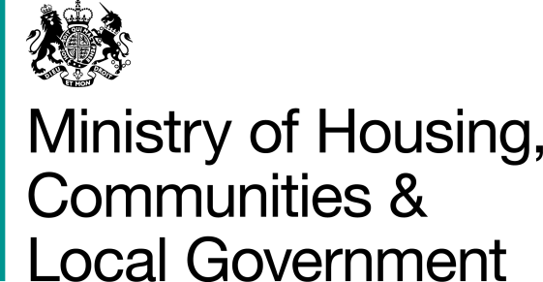

2020/21 Faith, Race and Hate Crime Grant Scheme
Logic Model Template and Guidance

Outline logic model and guidance for completion
Your bid should be based on assumptions about how certain activities will produce specific outputs, which in turn will have a wider set of outcomes and impact. To produce clear and measurable impacts and resident benefits, it is crucial to capture neatly and explicitly the logical pathway your project will follow to achieve success. This means showing the links between the resources you will use and a range of specific activities, each of which is designed to produce outputs that contribute to your intended outcomes, impacts and resident benefit.
To produce the clearest possible account of the logic of your proposal, you should complete an outline in the format provided below and attach it to your submitted proposal. If successful, a fully completed version will need to be submitted prior to payment being made. For the purposes of applying for funding however, you need only submit a draft version and are free to use your own format if it captures the same content.

Example 1: Example format for capturing project logic:
…With these outcomes and impacts…
…To deliver these outputs…
Using these resources and activities…

Input / Resource | Input / Activity | Baseline output level (if known) | Target output level | Actual Outputs (to be completed at close of project) | Intended Outcome | Intended Broader Impact
What will you use? | What will you do? | What are you currently doing? What is the current context? | What do you want to achieve by way of outputs and how have you determined these outputs? | N/A at this stage. | What change do you want to see? How will this be measured?  How have you determined the intended outcome? | What impact will this have?  How will you measure this impact?  How does this link back to the context?  What will success look like?
Example 2: Example format for capturing project logic:

Project Name:

Conditions:
What is the local context, policy context?
What needs to change for the impacts to be realised?
What factors could affect the starting point and the results eventually being achieved? (you can include risks to delivery here; capability and capacity etc)

Programme objectives:
Include a high-level summary of intended outcomes

Rationale:
Evidence and assumptions linking outputs to outcomes and impacts.
Evidence of the need for intervention and approach

Inputs /Activities:
What resources do you have?
Money
Time
People
Processes
Systems
Projects

Outputs:
What will be counted?
What will be measured to show inputs and activities are delivering on schedule?

Intended Impacts:
What change do you want to see among target population and/or at community and at a national and local level?

Intended outcomes:
What are you trying to achieve in the short term?
What changes will you see to take you closer to the impact you want to achieve based on the inputs and activities you have undertaken?

