Dear Click here to enter text.
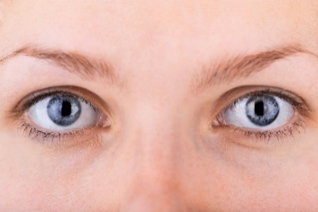 | We are inviting you to have a test to check if diabetes is damaging your sight.  People with diabetes have more chance of having problems with their eyes.  The test can find problems early. This means we can treat the problems to stop them getting worse.
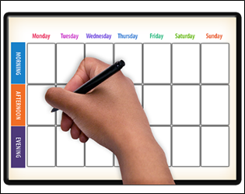 | Your appointment is at Click here to enter text.  on Click here to enter text.
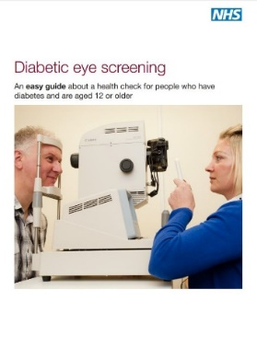 | There is an easy guide leaflet with this letter that tells you about the test and why it is important for your health.  The leaflet can help you decide if you would like to do the test.  You can say yes or no. It is your choice.
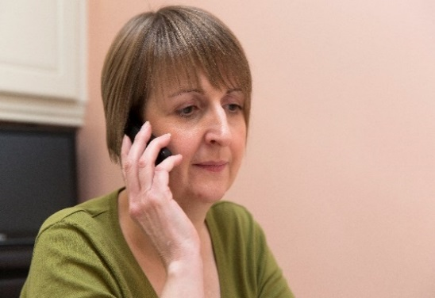 | If you want an appointment at a different time or place, please call us on Click here to enter text.  You can bring somebody to support you at your appointment if you would like.  If you think you do not want to have the test or are worried about it, then talk to your GP before you decide. Or you can call us.
Yours sincerely

