Monitoring and Evaluation Context (Call 3)
UK Space Agency: International Partnerships Programme

Document Context
This document provides guidance on the key M&E processes and documents to be used in IPP projects. Note that requirements for the context/landscape analysis do not apply for the Satellite-enabled Data Services – Public Policy Course Call.

Key Takeaways
- Monitoring & Evaluation (M&E) is critical for ODA projects and is a requirement for all IPP projects, during the Operational Phase. You will need to plan for it during the Discovery Phase, specifically through the M&E Plan and associated deliverables (See IPP Call 3 Application Guidance for full details of deliverables).
- M&E is a process of setting, checking and assessing your progress against established objectives/impacts and indicators.
- M&E is the responsibility of grantees and needs to be budgeted for. During your Discovery Phase a minimum of 5% of budget should be devoted to developing your M&E. During the Operational Phase 5-15% of overall budget should to dedicated to M&E, and in both phases is resourced by the grantees.
- During the Discovery Phase, focus will be on defining the intended impacts, and relevant measurement frameworks for each project.
- During the Operational Phase, focus will be on monitoring and evaluating progress against these frameworks
- UKSA have engaged a specialist M&E& partner (Caribou Space) to provide guidance and quality assurance to grantees for their M&E, but grantees need to execute their own M&E activities.

Monitoring and Evaluation
The greatest impact on people’s lives in developing and emerging countries will come not from a short term intervention, but from a sustained and long term intervention. To ensure a sustained and long term intervention you need to provide inputs (e.g. resources, equipment), to carry out activities (e.g. software development, equipment installations, field visits), which will lead to outputs (e.g. working equipment/applications, people using special content, tracking), which will lead to outcomes (e.g. flood warnings, illegal logging detection, midwives improving the care offered, behaviours changed), which in turn cause an impact on the ground (e.g. ‘x’ lives saved, infant mortality reduced, ‘y’ disasters averted, ‘z’ hectares of forest not destroyed).
Figure 1: Impact Chain
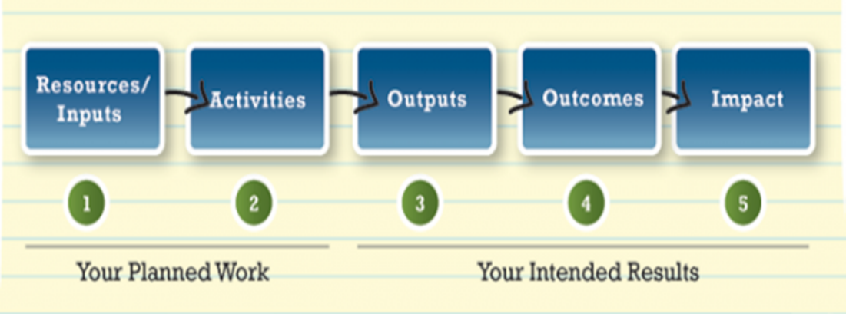
This sequence will need an underpinning rationale in order to help justify its continuation in a sustainable manner, i.e. where the costs to keep the outputs running (and hence outcomes and impacts) are covered after the UKSA grant ends. This often will be because there is a commercial value proposition where someone is prepared to pay for the service (not necessarily the ‘end user’) that helps improve lives. Building a business case in these environments is particularly challenging given the economic climate where the end user is poor, but that is the risk versus reward equation that needs to be considered at the beginning of the project.
In order to properly evaluate the outcomes and impacts achieved, and the commercial sustainability of the project, it is essential to have a monitoring and evaluation process in place.

Why Monitor and Evaluate?
For two distinct reasons: One, to ask ourselves if we are doing what we planned, i.e. making the impact we intended, and two, for project management and accountability. In ODA projects, it is especially important to understand if that plan is actually leading to the positive impacts that we wanted and not just if the technology proposed has been delivered.

The M&E Process
A typical M&E process will have a few common elements, including baseline and endline evaluations at the start and end of the project. Midline evaluations are typically used in projects that are longer than 1 year. Note that the IPP Discovery Phase does not require a baseline or midline evaluation, only the baseline evaluation terms of reference is required in the Discovery Phase. Monitoring happens at regular, predictable intervals during the project timeline.

Figure 2: High Level M&E Process
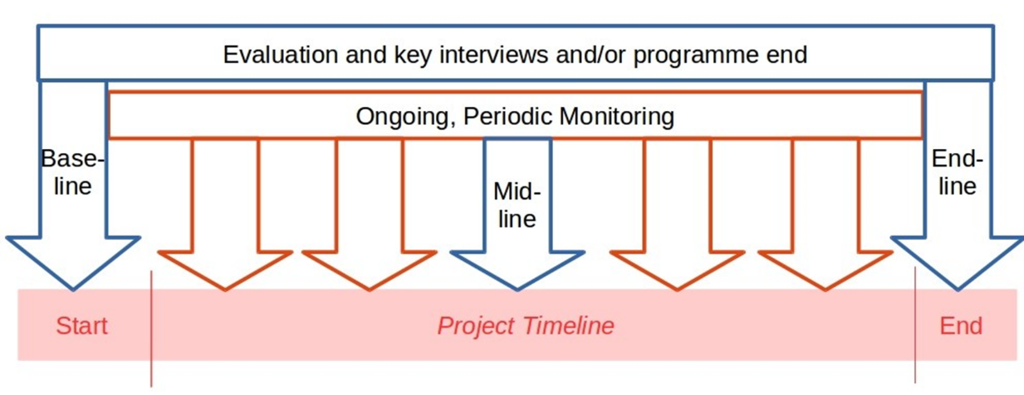

What is M&E?
M&E is a requirement for ODA projects consisting of three stages that show what the project does and what measurable impacts it will have:
- Defining intended impacts
- Checking progress against objectives, and
- Evaluating (ongoing and long-term) results

M&E Requirements in IPP
Figure 3: M&E Requirements in IPP

Defining Intended Impacts (Discovery Phase)
Creating an M&E plan is the first phase of the process and is where you lay out your objectives (outcomes and impacts), how you will measure success, who has responsibility for elements of the process, and when you will monitor (and evaluate) the different pieces.
The basic elements you need to understand and define are:
- Landscape/Context Analysis (Not Applicable for the Satellite-enabled Data Services – Public Policy Course Call)
- Theory of Change
- Objectives (outcomes and impacts)
- Measures of success (targets) for each output, outcome and impact (documented in a Logical Framework)
- Based on your Theory of Change
- They should be qualitative and quantitative, and there will possibly be several for a single outcome or impact
- Targets should be SMART (specific, measurable, attainable, relevant and timebound)
- Plans for how and when you monitor and evaluate the project (documented in an M&E Plan)

N.B.: If you put forward a multi-country proposal, you must produce the outputs above for each country, with the exception of the project M&E plan. The M&E plan should be created once for the entire project, but where relevant with separate detail per country for logframe targets, budgets, and gender analysis.
Landscape/Context Analysis (Not Applicable for Satellite-enabled Data Services – Public Policy Course Call)
Also referred to as a political economy analysis (PEA) is a written report identifying and anlysising the key actors, institutions and structures that are operating in your project’s space. It aims to understand how they make decisions already and how they will interact with the project. It is useful to help projects develop a deeper understanding of the setting they are entering, what can realistically be achieved, over what time scale, and the risks involved. It helps to inform and strengthen your project theory of change as it gives more detailed context to how change already happens, and what the main drivers of change are for the agents and institutions you will work with. It should be not only produced using desk research, but also based on detailed knowledge held by your international partners, field visits, and where relevant gathering information from potential end-users and beneficiaries.
All projects are required to conduct a context/landscape analysis and submit a full report as part of the Discovery Phase. Projects will be supported by Caribou Space with advice, tools and feedback to conduct these analysis but are expected to complete the reports themselves with partners.
Theory of Change
The Theory of Change is a comprehensive description and illustration of how and why a desired change is expected to happen in a particular context. It is an explanation of how you expect your project to result in the ultimate changes you seek. It provides the logical explanation and flow between project inputs and activities, to project outputs, to outcomes and finally to impact. It is typically provided as both a written narrative and a diagram. For evaluations, a Theory of Change is rapidly becoming a standard expectation for developing an evaluation framework. This is because it lays out the 'expected story' of the project in advance, thus provides an explicit framework for assessing the long-term results against. However, (unlike a logframe) a theory of change in and of itself does not include any thinking about data collection or how an impact assessment will be managed. A clear Theory of Change is usually the foundation for creating a results framework (like a logframe). An example Theory of Change is below.
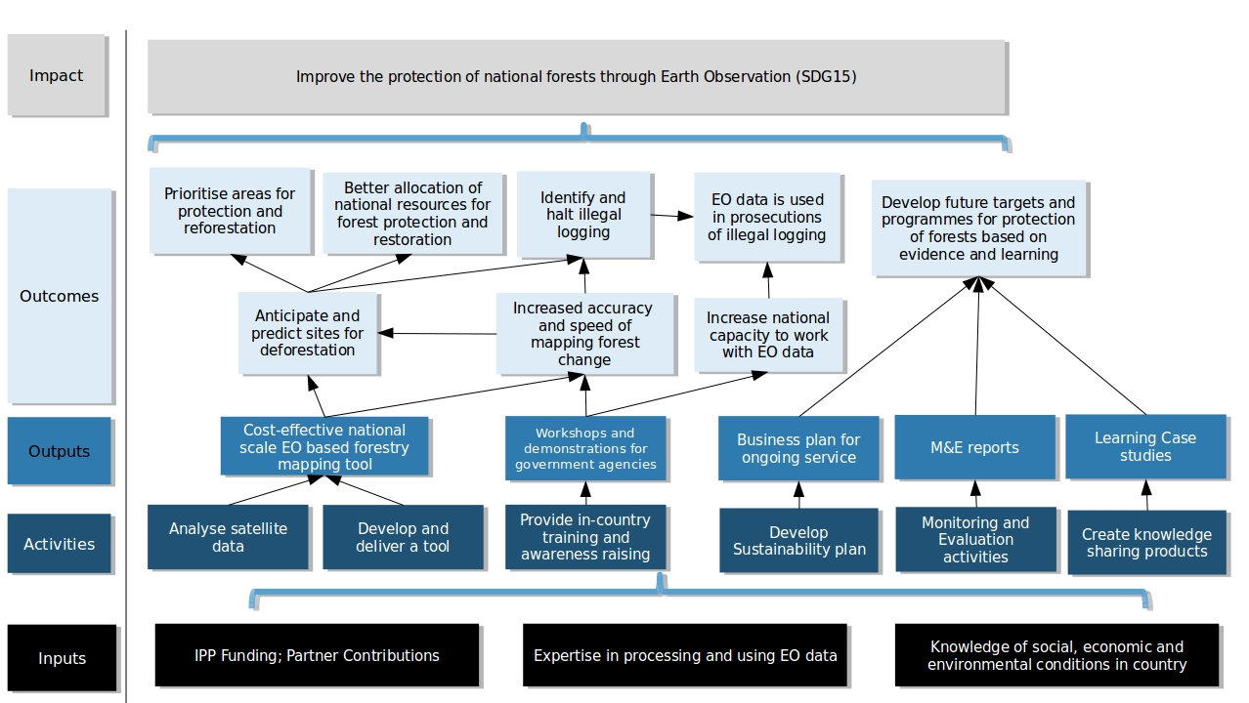
Figure 4: Example Theory of Change for an Earth Observation Deforestation Project

All projects are required to submit an initial Theory of Change with the Call 3 Bid, which will be further developed throughout the Discovery Phase in both narrative and diagrammatic formats. Projects will be supported by Caribou Space, but are expected to develop their Theories of Change through intensive collaboration with International Partners.
Logical Framework
A Logical Framework (Logframe), is one of the most common planning, monitoring and evaluation tools used to describe the anticipated chain of cause and effect in development interventions. They are based on a simple grid and describe your Theory of Change in a more measurable (and reportable) format. Logframes should include quantified SMART targets (Specific, Measurable, Achievable, Relevant and Time-bound), indicators for measurement, plans for verification of indicators and key assumptions.
Key Definitions
Outputs: These are the more detailed outputs of your project, which show what you will be creating in order to achieve the high-level aims.
E.g. – Full working dashboard for the government to monitor weather and release alerts to subsistence farmers in 30 states across the country; Trainings delivered to first responders in the use of new satellite data enabled systems.
Outcomes: these are the changes (short, medium and long term) that you expect to achieve because you have produced the above outputs.
E.g. – Farmers change agricultural to more sustainable practices for irrigation based on satellite enabled data recommendations; First responders are better able to map flood risk zones and prepare emergency response equipment before disaster events; Government ministries change their investment strategies to prioritise funding for Renewable Energy.
Impacts: These are the very high-level impacts of what your Operational Phase project will achieve. We will use this at the end of the project to check that your project has achieved what it set out to. These should be linked to targets and indicators from the UN SDGs.
E.g. Increase subsistence farmer incomes by 3% in 30 states across the country by 2020; Fewer lives are lost to climate change induced natural disasters
All IPP projects during the Discovery Phase are required to draft a project specific logframe per implementation country, in excel format. This will be used in the Operational Phase to track output, outcome and impact related through regular monitoring and the Operational Phase evaluations. Projects will be supported by Caribou Space to develop their Logframes, but will be expected to develop targets, metrics and measurement plans in collaboration with international partners.
M&E Plans
M&E plans are the final piece of M&E documentation, which pull together the Theory of Change, Logframe, budget, resources, evaluations, gender analysis and other project planning information into a cohesive document explaining the project’s overall approach to M&E. It is a guide as to what you will monitor and evaluate, what information you need, and who you are evaluating for. It is the central repository for all project M&E plans, and reference tool that guides M&E activities throughout the project.
The plan outlines the key evaluation questions and the approach to monitoring that will help to design evaluations and data collection activities. This allows you to identify the information you need to collect, how you can collect it, and who will collect it. The plan should be able to be picked up by anyone involved in the project at anytime and be clear as to what is happening in terms of monitoring and evaluation.
It also includes a data collection table/matrix; a critical tool for planning and managing data collection, analysis, and use. Finally the M&E plan includes an initial gender analysis and strategy, detailing how the project will have an impact on people of different genders, and relations between genders. It will elaborate any plans that projects have to collect gender-disaggregated data,
All IPP projects are required to complete an M&E Plan by the end of the Discovery Phase. This M&E plan will then be applied during the Operational Phase to support ongoing M&E activities. It will require periodic updates as the project changes and evolves during implementation. In IPP, these will be developed with successful projects after grant award, with support from Caribou Space, and input from international partners.

Checking Progress/Monitoring (Operational Phase)
Ongoing monitoring helps to track progress against your plans both during the project and after the delivery/implementation has finished. Monitoring is the routine collection and analysis of information based on your M&E plan and is focused on monitoring inputs, activities, outputs and (short term) outcomes. In your M&E plan, you will have defined how you will monitor against these indicators, who will do so and at what frequency; thus monitoring is the implementation of that plan.
In IPP, projects are expected to monitor their results periodically (monthly, quarterly, annually and/or in evaluations, as defined in the M&E plan for each individual target). For example, output related targets on capacity building, system development and knowledge sharing may be reported in monthly reports and quarterly progress meetings. Outcome and Impact targets will be evaluated less frequently (when relevant).

Evaluating Results (Operational and Post-Grant Phases)
Evaluations are the systematic, objective assessment of your intervention's design, implementation and results (impacts). Evaluations should:
- Provide accountability and track/record learnings
- Focus on outcomes and overall impact - don’t be fooled into thinking it is all about the inputs and activities.
- Be measured against a baseline assessment, to show the impact (change) that your intervention has had
- Be implemented at the end of all projects, and for projects of 12 months or more, should also have a mid-line evaluation. Note: that is can also be useful to carry out evaluations of some targets at a set time after a project closes, once impacts start to materialise.
- Be able to make some claims about what degrees of results are attributable to the project, through the use of a counterfactual study, i.e. what would have happened anyway if the project wasn’t implemented?
- Include an assessment of:
- Process: how was the project implemented?
- Impact: what changed as a result of the project?
- Cost-Effectiveness: was the project cost efficient compared to alternatives?

Evaluation Criteria
Evaluations are typically carried out using the OECD DAC Criteria for Evaluating Development Assistance. Grantees will be expected to plan for, and conduct independent evaluations that assess their project against these criteria:
- Relevance: The extent to which the project is suited to the priorities and policies of the target group, recipient and donor.
Figure 5: OECD DAC Evaluation Criteria
- Effectiveness: A measure of the extent to which an project attains its objectives.
- Efficiency: Efficiency measures the outputs - qualitative and quantitative - in relation to the inputs. It is an economic term, which signifies that project aid uses the least costly resources possible in order to achieve the desired results.
- Impact: The positive and negative changes produced by a development intervention, directly or indirectly, intended or unintended. This involves the main impacts and effects resulting from the activity on the local social, economic, environmental and other development indicators. The examination should be concerned with both intended and unintended results and must also include the positive and negative impact of external factors, such as changes in terms of trade and financial conditions.
- Sustainability: Sustainability is concerned with measuring whether the benefits of an activity are likely to continue after donor funding has been withdrawn. Projects need to be environmentally as well as financially sustainable.

In IPP, all projects are expected to complete baseline, midline and endline evaluations during the Operational Phase. Legacy evaluations (post-grant) are expected to be completed by all projects. Each evaluation will be required to meet specific criteria defined by Caribou Space, and will include a:
- Terms of Reference (Plan for what the evaluation will include and how it will be conducted) to be delivered at least 1 month before evaluation work is due to commence.
- Process and Impact Evaluation Report (A word document summarising and analysing the main findings and recommendations)
- Cost-Effectiveness Evaluation (A written report and excel model, produced using guidance from Caribou Space)
- Case Study (A document summarising the main findings and results of the project – at midline and endline to be published publicly)

Common M&E Challenges to Be Aware of
- Attribution vs. Contribution
- Attribution is the idea that a change (outcome or impact) is solely due to your intervention, i.e. you can say that with certainty you 'caused' something to happen.
- Contribution is the idea that your influence is just one of many factors which contribute to a change. i.e. you might be able to show that your project contributed to changes in people's behaviour, but you can never be sure that other social, political, economic or environmental factors also influenced the change.
- No one works in a vacuum, so it is very rare that you will know that a change is solely attributable to your intervention.
- So, focus on your contribution to an outcome or impact, rather than attribution and consider other environmental factors that may have an impact.
- Also consider how you can measure ‘what would have happened anyway’ (i.e. the counterfactual).
- Consider how you might make use of a comparison group for evaluating outcomes.
- Comparison groups have similar characteristics to your target group, but do not benefit from intervention of your project.
- Setting the 'right' indicators
- There is always pressure to set quantifiable and easy to measure indicators instead of qualitative information (e.g. about behavioural changes).
- However, there are established tools and processes to gather qualitative data (see the Resources section at the end of this guide as a starting point).
- Remember to consider, when setting your indicators, how you will get baseline measurements for each indicator, and consider a baseline assessment just before or when your project kicks off.
- Reporting on long-term outcome and impacts
- Results may not materialise during project timeline, and may not be evident for significant periods of time to come.
- Be realistic about what you can achieve – and measure – during the project lifespan, and consider if you need to conduct a follow-up evaluation at a time after the project closes.

Planning for M&E During your Operational Phase
- Allow a minimum of 5% of your Discovery Phase budget for M&E activities. Remember that it is not only about producing the M&E Plan, Context/Lanscape Analysis and associated theories of change, logframes and evaluation terms of reference, but also about the process, in-country, with partners to get to those deliverables.
- Allow 5% to 15% of the overall cost of the project for M&E, (including any match funding). Don’t underestimate the amount of effort it will take to calculate robust impact indicators, gather data from end beneficiaries, write up detailed reports and embed learning back into your project.
- Consider both quantitative & qualitative assessments.
- Ensure there is a qualified person, or contracted team, who is responsible for managing the M&E process and enough skilled resources are allocated for implementation.
- Also, consider the third party resources that may be required, e.g. on the ground resources to carry out the baseline, midline and endline assessments, especially as these may require qualitative assessments which could involve door-to-door surveys, key informant interviews and focus groups, etc. Consider the use of comparison group studies if applicable.
- Consider how you will learn from and communicate the results of your project. The information you will gather from the M&E process can be invaluable to your own project strategy and to others, so find ways to plan for how you will share it.

Benefits of M&E
- It is important for UKSA to be able to quantify the benefits that the IPP programme has had, to demonstrate cost-effectiveness/Value for Money (VFM) and ODA impact.
- Provides for a process to ensure progress towards targets and course corrections if necessary.
- Enables process and product improvement through evaluation of what worked well/didn’t work.
- Provides a unified project vision to provide cohesion and buy-in across the consortium.
- Enables learning for IPP and the wider space and development sector.
- Allows you to communicate the positive impact story with evidence to back it up.
- Provides you with evidence and quantified results that can be used to support future expansion and sale of your services.

Resources
About Theory of Change (reference only, use the template in the Application Form):
Theory of Change Basics (Act Knowledge) (9 Pages)
How does Theory of Change Work? (TheoryofChange.org) (1 page)

About Logframes
Logframe Guidance and Template (Tools 4 Dev)
The logical framework (INTRAC) (4 pages)
How to write a logical framework (Tools 4 Dev)

About M&E Plans:
M&E Plans (INTRAC) (3 pages)
UNDP Handbook on M&E (232 pages)
M&E Plan Template from Tools4Dev

About Evaluation Planning
DFID International Development Evaluation Policy (26 pages)
Plan and Manage an Evaluation (Better Evaluation)

Contacts for help/more information
Elise Montano/Diogo Silva
IPP@cariboudigital.net
Caribou Space use space for positive impact on society, economy and environment, for all countries. As part of Caribou Digital, we work with governments, space agencies, development agencies and space companies.

See www.caribou.space

http://www.oecd.org/dac/evaluation/daccriteriaforevaluatingdevelopmentassistance.htm

