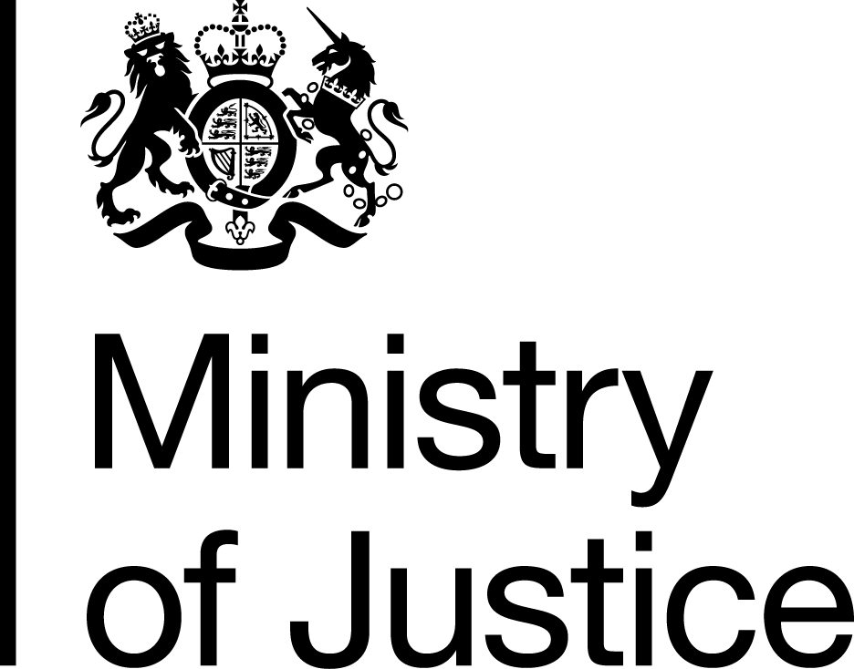 | November 2019

Freedom of Information Act (FOIA) Request – 191104012

Thank you for your request in which you asked for the following information from the Ministry of Justice (MoJ):

I would be most grateful if you could please tell me, for a work presentation, how many hours of Community Payback/unpaid work were ordered and delivered in England, during 2018 if possible but if not, for the most recent dates you have available.

Thank you very much in advance for your help.

Your request has been handled under the FOIA.

I can confirm that the MoJ holds the information that you have requested and I have provided it, covering England in 2018, below

Data reflect Unpaid Hours Ordered and Delivered during calendar year 2018 in England only.

Hours ordered include all sentenced requirements transferred to CRCs for delivery post-sentence. Hours delivered is the total number of hours credited to service users following attendance at Unpaid Work placements during the period in question.

UPW Hours Ordered 6,550,000
UPW Hours Delivered 4,941,000

