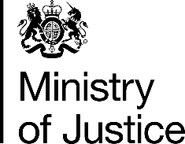 | November 2019

Freedom of Information Act (FOIA) Request – 191029017

Thank you for your request in which you asked for the following information from the Ministry of Justice (MoJ):

I am a solicitor in the above named firm. One of my particular areas of interest relates to prison law matters.
I am writing to you to request information regarding the total number of prison staff in England and Wales who are Muslim.
If you are unable to provide this total figure, I would be grateful for any information that you hold that may allow an estimate to be made.
This request for this information is made under the Freedom of Information Act ("FOIA") 2000.
If, for whatever reason, you are either unable or unwilling to provide me with the above information, I request that you provide me with the reason(s) for this refusal.
Finally, I should be grateful if you would acknowledge safe receipt of this letter.

Your request has been handled under the FOIA.

I can confirm that the MoJ holds the information that you have requested and I have provided it below:

- As at 30th June 2019 there were 398 prison staff, headcount, who had a declared faith of ‘Muslim’. This figures only includes staff allocated to HM Prison Service or the Youth Custody Service, ie excludes National Probation Service and HQ staff. Religion is a self-declared, optional field and across all prison staff 54% had declared a religion and 46% had not.

