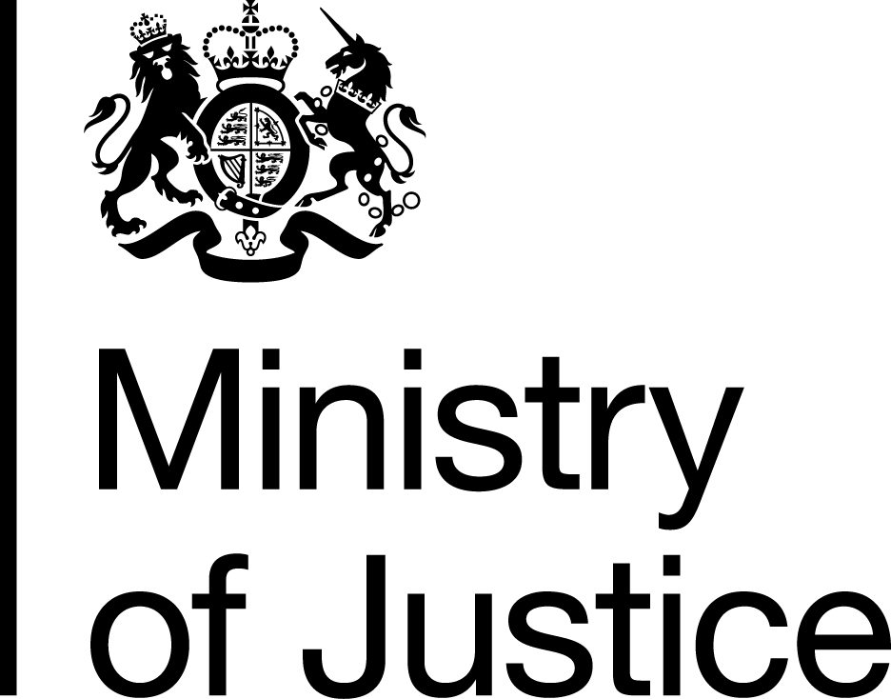 | November 2019

Freedom of Information Act (FOIA) Request – 191014010

Thank you for your request in which you asked for the following information from the Ministry of Justice (MoJ):

How many people in mens and womans jails and juvenille detention centres and their ethnic origin. Plus the full list of different ethnic origins you break the figures into, someone told me it was about 30.
Plus I would like the same categories for people arrested.

Your request has been handled under the FOIA.

In relation to the part of your request about the ethnic origins of men and women in jail, I can confirm that the MoJ holds the information that you have requested. However, the information is exempt from disclosure under section 21 of the FOIA, because it is reasonably accessible to you. The information can be accessed via the following link, Table 1.4 shows the prison population by ethnic group and sex as at 30 September 2019 (latest currently available):

https://assets.publishing.service.gov.uk/government/uploads/system/uploads/attachment_data/file/842604/Population_Q2_2019.xlsx

In relation to juvenile detention centres, this information is also exempt under S21 of the FOIA. Statistics on the population in custody of children and young people within secure children’s homes (SCHs), secure training centres (STCs) and young offender institutions (YOIs), by ethnicity, can be accessed via the following link: https://assets.publishing.service.gov.uk/government/uploads/system/uploads/attachment_data/file/845310/youth-custody-data-september-2019.ods

In relation to the full list of ethnic origins that these data can be broken down by, I can confirm that the MoJ holds the information that you have requested and I have provided it below:

Code |  | Ethnicity
 |  | Asian or Asian British
A1 |  | Indian
A2 |  | Pakistani
A3 |  | Bangladeshi
A4 |  | Chinese
A9 |  | Any other Asian background
 |  | Black or Black British
B1 |  | Caribbean
B2 |  | African
B9 |  | Any other Black background
 |  | Mixed
M1 |  | White and Black Caribbean
M2 |  | White and Black African
M3 |  | White and Asian
M9 |  | Any other mixed background
 |  | Other ethnic group
O1 |  | Chinese [Legacy Code]
O2 |  | Arab
O9 |  | Any other ethnic group
 |  | White
W1 |  | British
W2 |  | Irish
W3 |  | Gypsy or Irish Traveller
W8 |  | Irish Traveller / Gypsy [Legacy Code]
W9 |  | Any other White background

In relation to the part of your request about people arrested, the MoJ does not hold any information in the scope of your request. This is because we are not the appropriate authority to contact on this subject.

You may wish to contact the Home Office as they may hold some of the information you requested. Their contact details are:

foirequests@homeoffice.gov.uk

The FOIA does not oblige a public authority to create information to answer a request if the requested information is not held. The duty is to only provide the recorded information held.

