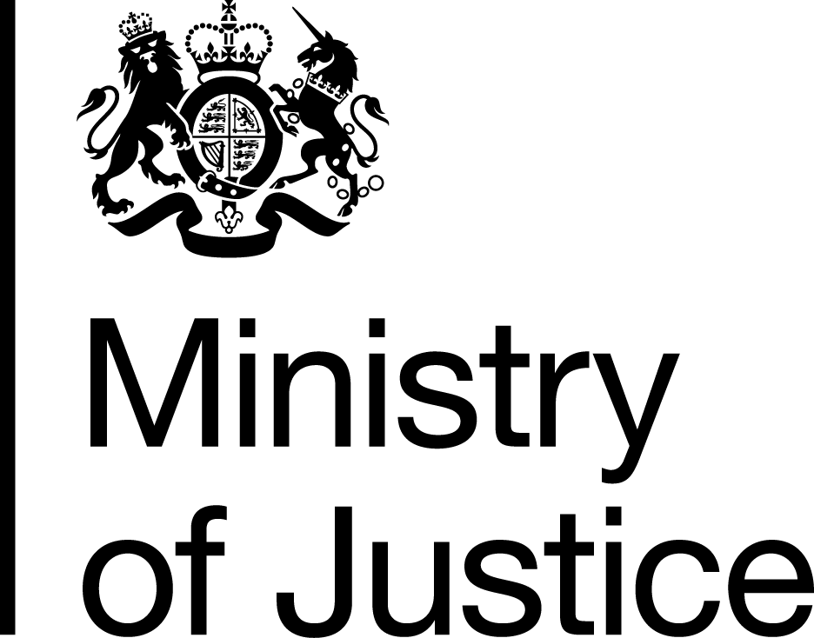 | July 2019

Freedom of Information Act (FOIA) Request – 190617007

Thank you for your request in which you asked for the following information from the Ministry of Justice (MoJ):
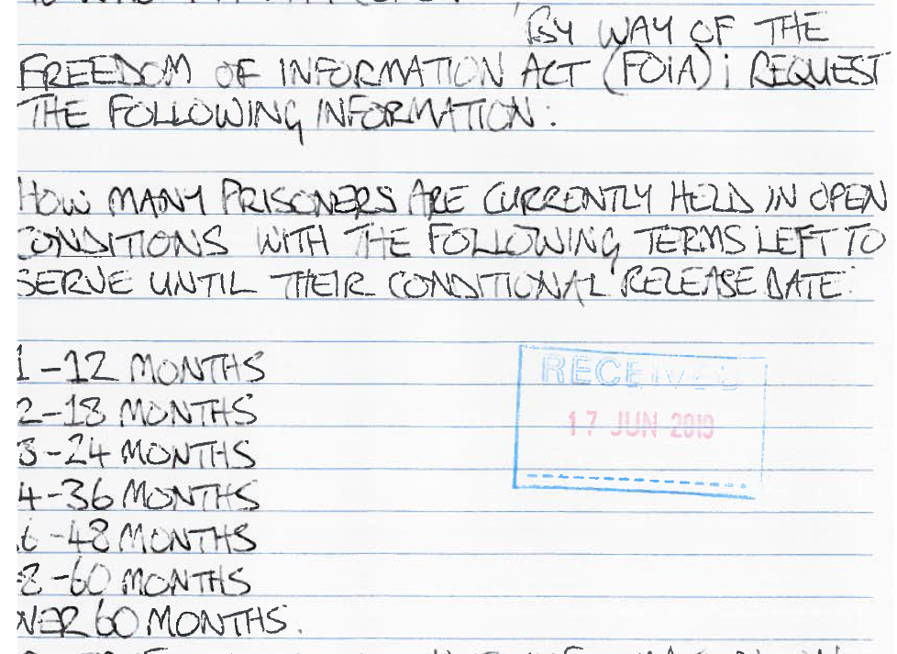

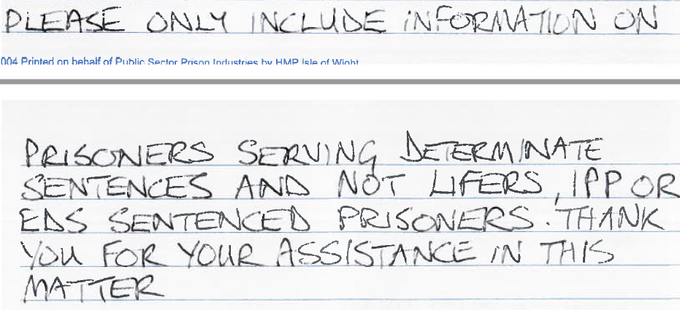
Your request has been handled under the FOIA.

I can confirm that the MoJ holds the information that you have requested and I have provided it in the attached table which shows prisoners with determinate sentences (excluding lifers, IPPS, EDS, fine defaulters, and recalls) in open prisons by their time left to serve, 31 March 2019 (latest currently available), England and Wales.

