|  |  |  |  |
| --- | --- | --- | --- |
|  |  |  |  |

Corrections notice: Data in section 5 on Newspaper Readership were updated on 4th November 2019 due an error in the underlying data.

Taking Part Survey: Free Time Activities Focus Report, 2017/18

Taking Part is a household survey in England and measures engagement with the cultural sectors. The data are widely used by policy officials, practitioners, academics and charities.

This report presents the latest headline estimates of how adults (16+) spent their free time for the year April 2017 to March 2018.

**Responsible statisticians:**

Benjamin Baxter

Alex Björkegren

020 7211 6776

**Statistical enquiries:**

[takingpart@culture.gov.uk](mailto:takingpart@culture.gov.uk)

[@DCMSInsight](http://www.twitter.com/DCMSInsight)

**Media enquiries:**

020 7211 2210

**Date:** 8th November 2018

**Contents**

1. Overview ………………...…….2

2. Demographics 3

3. Video Games 5

4. Internet and social media 6

5. Engagement with the news 8

6. Enjoyment of culture 11

An. A: Background 14

An. B: Key terms & definitions 16

An. C: Sector definitions 18

An. D: Significance testing 20

Watching TV[1] has tended to be the most common free time activity for adults since the question was first included and this has continued in 2017/18.

Popularity of the top five**[2]** free time activities over time, adults (16+), England, 2006/07 to 2017/18

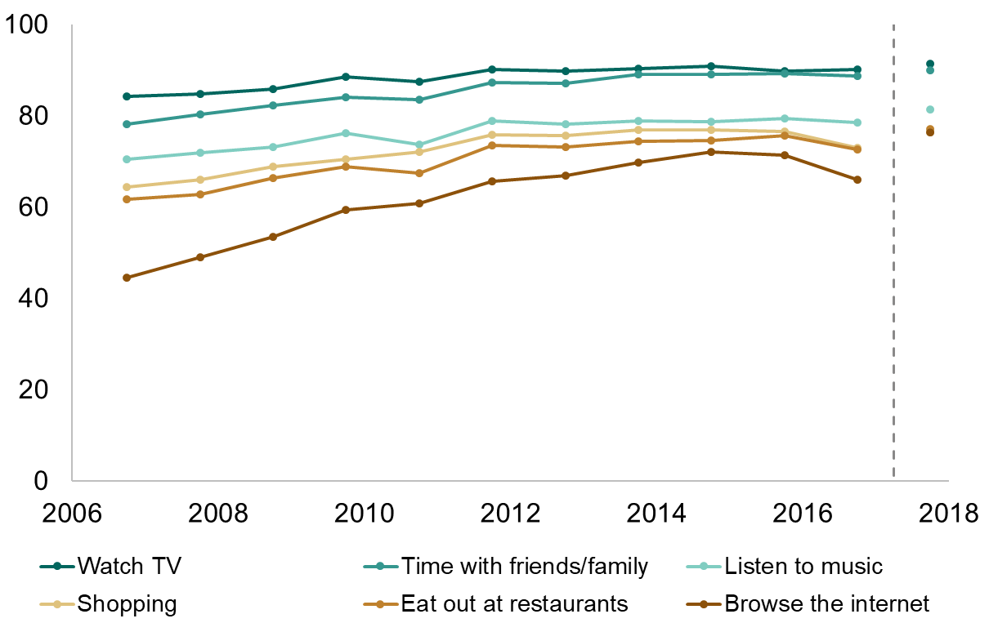

Question change

In 2017/18:

* Playing video or computer games was the least popular activity amongst both men and women. Nearly half of women who played computer games did so daily, compared to only a third of men.
* 90% of people watched the news on TV, and over half did so daily. The BBC website was the most popular source of news online.
* About one in three people who visited a heritage site or museum, or who attended or participated in an arts activity, rated their experience 10 out of 10.

# 1. Overview

92% of adults said that they watched television in their free time, making it the most popular free time activity in 2017/18. Slightly fewer people (90%) said they spent their free time with friends or family, and only three in four people listed listening to music, eating out at restaurants, browsing the internet or shopping as activities they tended to do in their free time. Playing video or computer games was the least popular activity, with only one in four adults saying that they did it in their free time.

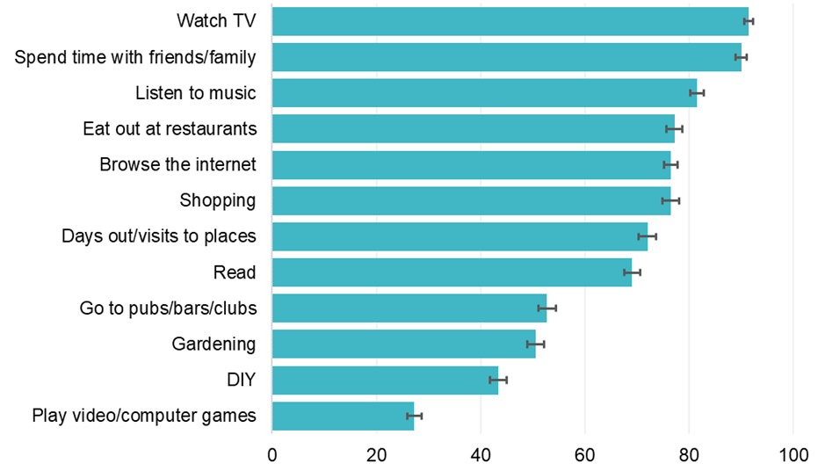Figure 1.1: Proportion of adults participating in selected free time activities, 2017/18

95% confidence interval

For each activity surveyed in both 2016/17 and 2017/18[3], the proportion of adults in 2017/18 who reported that they had participated in the past 12 months increased. This may be due to changes to the question between 2016/17 and 2017/18. In 2016/17 respondents could choose from 21 free time activities, but in 2017/18 this was reduced to 12 to enable respondents to read the whole list more easily. As the remaining categories are easier for a respondent to identify, it may be that they are more likely to select them, increasing the apparent popularity of these activities.

Eating out at restaurants, and going to pubs, bars or clubs had amongst the largest increases in popularity between 2016/17 and 2017/18 (both 5 percentage points). In 2017/18 76% of adults in England spent their free time browsing the internet, compared to 66% who reported that they spent their free time doing ‘Internet/Emailing’ the previous year. This 10 percentage point difference may in part be due to the change to the response option wording and should therefore be treated with caution.

# 2. Demographics

In 2017/18 watching TV was the most popular activity for men (90%), similar to 2016/17. The proportion of women who watched TV in their free time (93%) increased compared to 2016/17 but was similar to the other most popular activity (spending time with friends/family, 93%).

A bar chart which shows the percentage of people who have taken part in various free time activities by gender.  The chart shows that the most popular activity for men was watching TV and the most popular for women was watching TV and spending time with friends and family. 

The chart also shows that going to pubs/bars/clubs, playing video/computer games, and DIY were all more popular with men than women. Watching TV, spending time with friends or family, eating out at restaurants, going on days out or visits to places, shopping, and reading were all more popular with women than men. Going to pubs/bars/clubs, playing video/computer games, and DIY were all more popular with men than women. Watching TV, spending time with friends or family, eating out at restaurants, going on days out or visits to places, shopping, and reading were all more popular with women than men. Apart from reading, the popularity of these activities increased significantly amongst women compared to 2016/17, as did going to pubs/bars/clubs, listening to music and playing video or computer games.

95% confidence interval

The least popular activity for both genders was playing video/computer games with 37% and 18% for men and women respectively. This report includes more detail on this topic in chapter 3.

People in the younger age groups tended to choose different free time activities to those in the older age groups. Spending time with friends and family was the most popular activity for people aged 16 – 44, with watching TV coming second for those aged 25-44 and fourth (behind listening to music and browsing the internet) for those aged 16-24.

Only 85% of people aged 16-24 watched TV in their free time. This figure rose to 95% for those aged 65 and over. Some of this difference may be due to the ambiguous wording of the question, which does not specify whether non-traditional methods such as streaming are included.

Significantly more people aged 16-24 year olds spent their free time listening to music than any other age group. Browsing the internet was also strongly age dependent, falling from third place amongst those aged 16 to 44 to ninth for those aged 75 and over (31%), significantly lower than any other age group. Playing video/computer games was the least common activity for all age groups apart from 16-24 year olds for whom it is ranked ninth out of twelve categories.

**Figure 2.2: Proportion of adults who participated in free time activities by age group, 2017/18[4]**

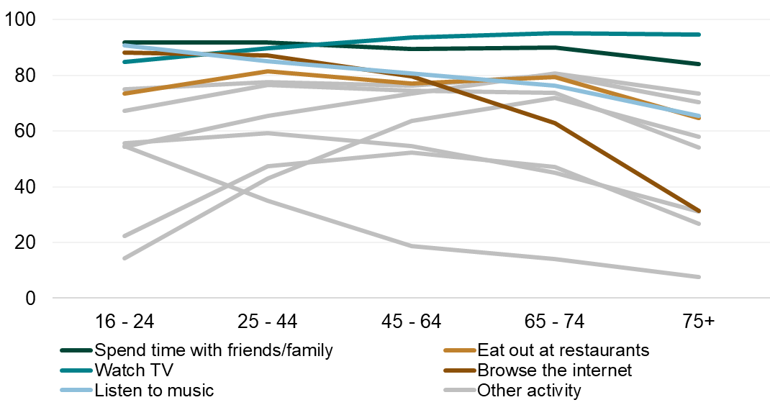

The proportion of the total population (92%) who watched TV in their free time is significantly higher than the previous year. Watching TV was popular across all ethnic groups, along with listening to music (people in the Mixed ethnic group), and spending time with friends or family (people in the Asian, Black and Other ethnic groups). The white ethnic group was the only ethnic group for which watching TV was significantly more popular than any other free time activity.

# 3. Video Games

Whilst more men than women reported playing computer or video games in their spare time, women who played computer or video games tended to do so more often than their male counterparts.

In 2017/18, close to half (45%) of the women who played video/computer games did so at least once a day, significantly more than men (34%).

**Figure 3.1: Frequency of playing video/computer games for those who reported playing video/computer games by gender, 2017/18**

A bar chart which shows that of those who said they play computer/video games in their spare time, women were more likely than men to play them at least once a day. Men were more likely than women to say they play at least once a week.

Most people who said they play video games do so at least once a week or more.

95% confidence interval

Playing computer or video games was more popular amongst people living in urban (29%) than rural (22%) areas, and amongst those who were employed (29%, compared to 19% for those who were not working). Although the popularity of playing video or computer games appeared to decrease with increasing affluence, there was no significant difference between people living in the most and least deprived areas. As discussed previously, the popularity of playing video or computer games was found to decline with increasing age group. Over half (55%) of those aged 16-24 played computer or video games at least once in the 12 months prior to interview, compared to fewer than one in ten (8%) of those aged 75 and over.

Playing video or computer games was most popular amongst people in the black ethnic group, and least popular amongst people in the Asian and Other ethnic groups. Popularity was higher amongst people with no religion, and those without a long standing illness or disability.

# 4. Internet and social media

|  |
| --- |
| 90% of households in Great Britain had internet access in 2018 (Opinions and Lifestyle Survey[5]) and 86% of adults use the internet daily.  78% of those who accessed the internet in the past 3 months did so using a mobile phone or smart phone, 61% used a laptop or netbook, 56% a tablet, 42% a desktop computer and 23% some other internet enabled device, including games consoles. |

90% of adults stated that they had used the internet, in their home or otherwise, at least once in their lifetime. These form the population from which the remaining figures in this section are calculated unless otherwise stated.

The most common devices used to access the internet in the month prior to interview were mobile devices, including smartphones or tablets (89%), and computers, including desktops and laptops (83%).

Almost all (99%) of 16-24 year olds had accessed the internet through a mobile device. This was the most popular device for 16-64 year olds, whilst internet access via a computer was the most common for adults aged above 65. Plurality of device use decreased with increasing age - accessing the internet via a games console was most common amongst those aged 16-24 (41%), and accessing via a TV amongst those aged 16 to 44 (47%).

**Figure 4.1: Device used to access internet in the month prior to interview by age group, 2017/18**

A line chart that shows the most popular device used to access the internet among 16-64 year was a mobile device. The chart shows the popularity of using a mobile device, games console and TV to access the internet decreases with age. 

In 2017/18, 77% of internet users (70% of the general population) stated that they used social media. The majority (57%) of those who used it did so to find out what was happening in their local area. Other reasons selected for using social networking sites or applications were to find places to do an activity (26%) and to get information on local sports facilities (21%).

Social media use decreased with increasing age: almost all (98%) of adults aged 16-24 used social media in their free time, compared to only a third of those aged 75 and over (33%). Social media use in the two oldest age groups increased between 2016/17 and 2017/18, but proportions for other three groups remained steady. The largest increase was in 75+ age group with a difference of 6.5 percentage points between the two years.

|  |
| --- |
| The 2018 Communications Market report (Office for Communications, Ofcom)[6] found that over three quarters of UK internet users (77%) have an account on a social media or messaging site or app.  Facebook was the most visited social media platform, reaching 90% of UK internet users. This audience is aging – the number of those aged 18-24 accessing Facebook fell by 4% whilst the number aged over 54 grew by 24% compared to the previous year. |

More women said they used social media (80%) than men (74%) and people in the white ethnic group were significantly less likely to use social media than people from the Mixed, Asian or Black ethnic groups.

Social media use was more prevalent amongst those who were employed (82% compared to 62% for non-working), who rented their accommodation (90% private renters, 82% social renters), rather than owning it (72%), and those who were not disabled (80%) compared to those with a long term illness or disability (69%).

It is likely that some of these factors overlap – social media use is lowest in the older age groups and people in these age groups are also more likely to be white[7], non-working (retired)[8], suffering from a long term illness or disability[9], and own their home rather than rent it[10], when compared to people in the other age groups.

Figure 4.2: Social media users by age group, 2016/17 and 2017/18

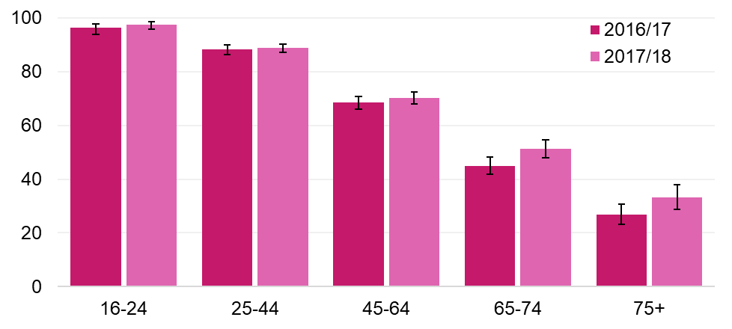

95% confidence interval

# 5. Engagement with the news

The following section is about how adults access the news. In 2017/18, nine out of ten adults watched the news on TV, approximately three quarters listened to the news on the radio or read it on a website or app, and nearly two thirds read the news in a newspaper.

Adults that access the news tend to do so at least once a day. People aged 75 or over were far more likely to read a newspaper every day, whilst daily app/website usage for news is highest amongst those aged 25-44.

Figure 5.1: Frequency of news consumption by mode, 2017/18

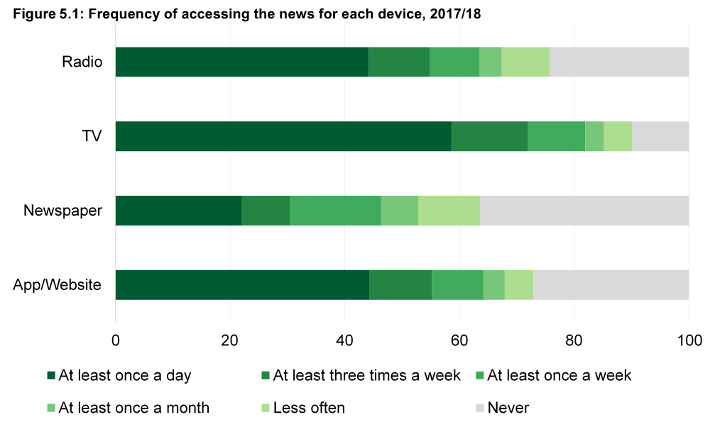

Three quarters of adults aged 75 and over never use an app or website to access the news, however nearly half of this age group read a newspaper at least once a day. In contrast, 44% of 16-24 year olds and 43% of 25-44 year olds never read a newspaper, the latter is a significant increase from 2016/17. This has contributed to an overall decrease in daily newspaper readership from 24% to 22%.

Conversely, the total proportion of adults using an app or website to access the news at least once a day has significantly increased from 39% to 44% between 2016/17 and 2017/18. The proportions of respondents who listened to the radio, or who watched TV, to access the news on a daily basis have remained stable.

The percentage of adults who had never used a news app or website in 2017/18 decreased by 4 percentage points (pp), whilst the proportion of adults who never watched the news on TV increased by 2 pp compared to 2016/17.

**Newspaper Readership**

Data for 2016/17 in the Newspaper Readership section were updated on 4th November 2019 due to the discovery of an error in the underlying data.

There has been an overall decrease in newspaper readership going from 67% in 2016/17 to 64% in 2017/18 this decrease coincided with an increase in popularity of news websites and applications.

In 2017/18 the newspaper read most often by adults was the Daily Mail (11%), however this was a decrease from 18% in 2016/17. The Daily Mail was also the most popular newspaper for women (12%).

There has also been a decrease in the percentage of adults who most often read their local newspaper (from 12% in 2016/17 to 7% in 2017/18) or The Sun/Sun on Sunday (from 13% in 2016/17 to 7% in 2017/18)

Figure 5.2: Newspaper read most often by adults in England, 2016/17 to 2017/18

**Online Readership**

73% of adults accessed the news via a website or app. Of these, over two thirds used the BBC website as one of their main sources of news. The BBC website was by far the most popular source of news online – over four times as many people cited it as a news source than the second most popular site – Sky News.

Print readership was higher than online readership for the majority of newspapers except for the Guardian, the Independent and the Financial Times, for which online readership was higher, and the Telegraph, for which print and online readership were similar. On average, about twice as many people read a specific newspaper than accessed the equivalent site, however this varied by publication. Metro readers were five times more likely to read the news in print than online, followed by readers of the Daily Star and the Daily Express (both three times as likely to read in print vs. online).

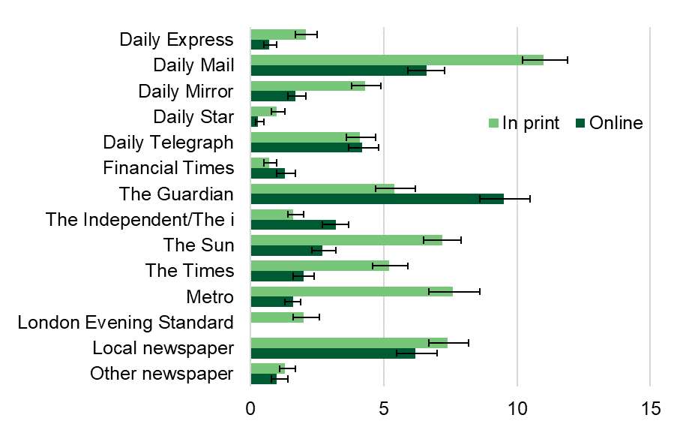Figure 5.3: Main newspaper read, and the proportion who use their equivalent website of those who access the news via websites or apps, all adults, England 2017/18

Figure 5.4 Popularity of news websites or apps without a print media equivalent, all adults, England 2017/18

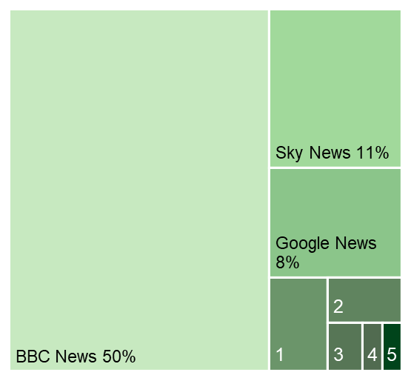

1: Huffington Post, 3%

2: MSN News and weather, 2%

3: CNN Digital Network, 1%

4: AOL News, 1%

5: Bing News, 1%

95% confidence interval

Ofcom is responsible for the annual News Consumption survey (ca. 4,000 participants). This survey covers modes of news access for the entire UK, however results are also provided at nation level.

The 2018 News Consumption survey[11] found that in England:

* 45% of adults listened to the news on the radio
* 79% of adults watched the news on TV
* 41% of adults read the news in a printed newspaper
* 66% of adults accessed the news online

Whilst the overall pattern is similar to that observed in the Taking Part survey, the Ofcom figures are lower by 7 to 31 percentage points. This may be due to differences in survey wording; the Taking Part survey asks about frequency of use, whereas the News Consumption survey asks about how people access the news ‘nowadays’.

Reported patterns of newspaper readership (daily newspapers) in the News Consumption survey (UK) are similar to the Taking Part results (England only): the Daily Mail, the Metro and the Sun were the most popular publications in print whilst the Guardian and the Mail had the largest audience online. The popularity of the Daily Mail was higher amongst older people, whilst the Sun, the Metro, and the Guardian were more popular with younger age groups.

The News Consumption survey distinguishes between news consumption via social media (44%) of adults and other internet sources. As with the Taking Part data, around two thirds (63%) of adults in England accessing non-social media online news sources used the BBC news website, whilst 75% of those who consumed news via social media used Facebook as a source.

# 6. Enjoyment of culture

The Taking Part survey asks people whether they have done any of the following:

* visited a heritage site
* visited a museum or gallery
* attended an arts event
* participated in an arts activity

The main results for these questions are published in the annual Taking Part report[12]. This section will instead focus on how much respondents said they enjoyed these activities and results will be reported as a proportion of those who did the activities listed above, unless otherwise stated. For consistency with previous results, museum and gallery visit enjoyment figures reported here are derived from quarter 4 data only[13]. As there is less data, differences between groups need to be larger before we can be confident that they represent a difference in the population, rather than appearing by chance. Annex A contains more detail on what is included as a heritage site visit, an arts activity or event, or a museum or gallery visit.

Respondents who had done one of the activities listed above were asked how much they had enjoyed the relevant activity[14] on a scale of 1 to 10, with 1 being awful and 10 being brilliant. As expected, the majority of those who had visited or participated enjoyed the activity, with around three quarters rating it 8 or higher.



Awful Brilliant %

Figure 6.1: Ratings for most recent visit or activity, 2017/18

**Overview**

Nearly a third (31%) of the 73% of adults who visited a heritage site as part of their own time, voluntary work or academic work[15] in the 12 months prior to the 2017/18 interview rated their visit 10 out of 10, similar to the previous year. The average rating for visiting a heritage site was 8.4, the highest of the four activities surveyed.

The half (50%) of all adults who had visited a museum or gallery at least once in either their own time or as voluntary work[16] gave an average enjoyment score of 8.3, similar to that given the previous year. A third (33%) of the 69% of adults who had attended at least one arts event in the 12 months prior to interview rated their visit 10 out of 10, and the average enjoyment score was 8.3, down from 8.5 the previous year. A slightly smaller proportion (31%) of those who had participated in an arts activity (53%) rated the activity 10 out of 10, and the average score was again 8.3, lower than in 2016/17.

**Gender**

Women reported consistently higher enjoyment across all activities than men. The difference ranged from 0.3 for visits to heritage sites (women: 8.6, men: 8.3) to 0.5 for participating in arts activities (women: 8.5, men: 8.0).

**Age**

Enjoyment of cultural activities tended to be lower for younger people. Those aged 16-24 enjoyed visits to heritage sites (average score, 7.8), and participating in arts activities (average score, 8.0) significantly less than all other age groups. The picture was more mixed for visits to museums; enjoyment was similar amongst the oldest (over 75, 8.3) and youngest (16-24, 8.1) age groups, peaking amongst those age 65-74 (8.6). Enjoyment of attending arts events was broadly similar across all age groups.

**Ethnicity**

People in the Asian ethnic group reported significantly below average enjoyment of visits to heritage sites and for participating in arts activities. There were no significant differences in enjoyment for people in the White, Mixed, and Black ethnic groups. Results for people in the Other ethnic group have not been reported as the number of respondents was very low.

**Disability**

More than one in ten people who didn’t participate in one of the four activities examined in this section cited a health problem or disability as a contributing factor, and nearly one in four people cited it as a reason for not attending arts events. However, for those that did attend arts events, there was no difference in enjoyment by disability status. The same is true for visits to museums. For visits to heritage sites and for participation in arts activities, people with disabilities reported higher enjoyment on average than people without.

**Socio economic and employment status**

There was no significant difference by socio-economic group, except for attending arts events, where people in the lower socio-economic group enjoyed the events more (8.4) than those in the upper socio economic group (8.2). Results were similar for employment status; the only significant difference was for attendance at arts events, where those who were retired or otherwise not in work reported higher enjoyment (8.4) than those in work (8.2)

**Libraries**

In 2017/18, 33% of adults had used a public library[17] in their own time or for voluntary work at least once in the 12 months prior to interview[18]. When asked about the service provided, over 95% of those who had used library services said that they were ‘fairly’ or ‘very’ satisfied, a significant increase compared to the previous year.

Figure 6.2: Library satisfaction, 2017/18

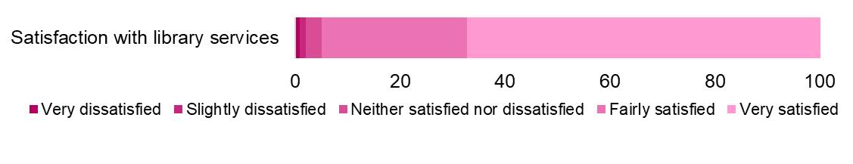

Satisfaction rates were lower for the younger age groups. People in the Asian and Black ethnic groups reported satisfaction rates that were significantly above average. There was no significant difference in reported satisfaction with library services between disabled and non-disabled people.

1. Background
2. The Taking Part survey is commissioned by the Department for Digital, Culture, Media and Sport and its partner Arm’s Length Bodies. For 2011 to 2018, these are Arts Council England, Historic England and Sport England.
3. The fieldwork for the Taking Part survey over the period 2005/06 to 2015/16 was conducted by TNS-BMRB and for 2016/17 – 2017/18 was conducted by Ipsos Mori and NatCen Social Research.
4. The United Kingdom Statistics Authority has designated these statistics as National Statistics, in accordance with the Statistics and Registration Service Act 2007 and signifying compliance with the Code of Practice for Official Statistics.

Designation can be broadly interpreted to mean that the statistics:

* meet identified user needs
* are well explained and readily accessible
* are produced according to sound methods
* are managed impartially and objectively in the public interest

Once statistics have been designated as National Statistics, it is a statutory requirement that the Code of Practice shall continue to be observed.

1. Stringent quality assurance procedures have been adopted for this statistical release. All data and analysis has been checked and verified by at least two different members of the DCMS to ensure the highest level of quality.
2. Guidance on the quality that is expected of Taking Part statistical releases is provided in a [quality indicators document](https://www.gov.uk/government/statistics/quality-indicators-taking-part-survey). These quality indicators outline how statistics from the Taking Part survey match up to the six dimensions of quality defined by the European Statistical System (ESS). These are: relevance, accuracy, timeliness, accessibility, comparability and coherence.
3. The Taking Part survey measures participation by adults (aged 16 and over) and children (aged 5-10 and 11-15) living in private households in England. No geographical restriction is placed on where the activity or event occurred. Further information on data for Scotland, Wales and Northern Ireland can be found in question 2 of the “[Taking Part: Guidance Note”](https://www.gov.uk/government/publications/guidance-note-taking-part-survey).
4. Unless stated, participation in activities must be for the purpose of recreation or leisure, including voluntary work. It excludes involvement in activities where the prime motivation is paid work or academic studies. The exception to this is engagement with heritage which includes visits made for academic study and use of library services, which can be for any reason.
5. Sample sizes for each year and data breakdown can be found in the accompanying tables.
6. All estimates have been rounded to one decimal place.
7. Changes over time and differences between groups are only reported on where they are statistically significant at the 95% level. This means that we can be confident that the differences seen in our sampled respondents are reflective of the population. Specifically, the statistical tests used mean we can be confident that if we carried out the same survey on different random samples of the population, 95 times out of 100 we would get similar findings. When sample sizes are smaller we can be less confident in our estimates so differences need to be greater to be considered statistically significant.
8. The upper and lower bounds presented in this report have been calculated using a 95% confidence interval. This means that had the sample been conducted 100 times, creating 100 confidence intervals, then 95 of these intervals would contain the true value. When the sample size is smaller, as is the case for certain groups and in certain years, the confidence intervals are wider as we can be less certain that the individuals in the sample are representative of the population. This means that it is more difficult to draw inferences from the results.
9. The data are weighted to ensure representativeness of the Taking Part sample. There are two types of weighting:

* to compensate for unequal probabilities of selection
* to adjust for non-response

Weighting is based on mid-2016 population estimates from the Office for National Statistics.

1. For more information about the Taking Part survey and to access previous publications and the questionnaires, see the [Taking Part survey webpages](https://www.gov.uk/guidance/taking-part-survey).
2. The responsible statistician for this release is Alex Bjorkegren. For enquiries on this release, please contact Alex on 0207 211 6776 or via email at TakingPart@culture.gov.uk.
3. To be kept informed about Taking Part publications and user events, please sign up to the Taking Part online newsletter [here](http://culture.us5.list-manage.com/subscribe?u=75369368ec98d5e713dae3779&id=f8b0e8d3ba). You can follow us on Twitter [@DCMSInsight](https://twitter.com/dcmsinsight).
4. Key terms and definitions

|  |  |
| --- | --- |
| Term | Definitions |
| 2005/06 | This is the time period covering April 2005 to March 2006. In this release, this refers to the date that the interviews were conducted. The activities reported on took place in the year prior to interview. Other years referenced in this way cover the equivalent time period. |
| Arts | A list of activities that are classified as engagement with the arts is given in Annex C. |
| Black and Minority Ethnic (BME) | The ‘Black and Minority Ethnic’ group includes adults who have identified as being in the following ethnic groups:   * Mixed (and multiple):   + White and Black Caribbean   + White and Black African   + White and Asian   + Any other Mixed/Multiple Ethnic background * Asian   + Indian   + Pakistani   + Bangladeshi   + Chinese   + Any other Asian background * Black   + African   + Caribbean   + Any other Black/African/Caribbean background * Other   + Arab   + Any other ethnic group |
| Confidence interval | A confidence interval provides a range in which there is a specific probability that the true value for the population will fall. For the Taking Part survey, 95% confidence intervals are used which means, had the sampling been conducted 100 times, creating 100 confidence intervals, then 95 of these intervals would contain the true value for adults in England. |
| DCMS sectors | The DCMS sectors referred to in this report are the arts, heritage, museums and galleries, libraries, archives and sport. |
| Digital engagement | Digital engagement in each cultural sector is defined as visiting a website or using an app related to that sector. |
| Digital participation | Digital participation in culture is defined as visiting websites or apps for at least one of the reasons outlined in Annex C. The list excludes visiting websites to find out information such as location or opening hours, or to buy tickets for an event. |
| Engagement | This refers to either attending and/or participating in a cultural or arts sector, for example, going to the theatre (attendance) or playing a musical instrument (participation). |
| Heritage | A list of activities that are classified as engagement with heritage is given in Annex C. |
| Public library use | The list of activities that are classified as public library use is given in Annex C. |
| Significant increase/decrease | A significant increase/decrease at the 95% level means that if we carried out the same survey on different random samples of the population, 95 times out of 100 we would observe the increase/decrease. |
| Socio-economic group | This is a form of socio-economic classification based on the employment status and occupation of the household reference person. The household reference person is the person responsible for owning or renting, or who is otherwise responsible for the accommodation. In the case of joint householders, the person with the highest income is the household reference person. In the case of joint incomes, the oldest person is taken as the household reference person.  More information about the NS-SEC socio-economic classification, please see this [page](https://www.ons.gov.uk/methodology/classificationsandstandards/otherclassifications/thenationalstatisticssocioeconomicclassificationnssecrebasedonsoc2010) on the Office for National Statistics website. |
| ‘White’ ethnic group | The ‘White’ ethnic group includes adults who have identified as being in the following ethnic groups:   * English / Welsh / Scottish / Northern Irish / British * Irish * Gypsy or Irish Traveller * Any other White background |

1. Sector definitions

**Arts**

The respondent was asked whether they had participated in a given list of arts activities, or attended a given list of arts events. Eligible activities and events were as follows.

Participation:

* Dance – ballet or other dance (not for fitness)
* Singing – live performance or rehearsal/practice (not karaoke), singing as part of a group or taking singing lesson
* Musical instrument – live performance, rehearsal/practice or playing for own pleasure
* Written music
* Theatre – live performance or rehearsal/practice (e.g. play or drama)
* Opera/musical theatre – live performance or rehearsal/practice
* Carnival (e.g. as a musician, dancer or costume maker)
* Street arts (art in everyday surroundings like parks, streets, shopping centre)
* Circus skills (not animals) – learnt or practised
* Visual art – (e.g. painting, drawing, printmaking or sculpture)
* Photography (as an artistic activity, not family or holiday ‘snaps’)
* Film or video making (as an artistic activity, not family or holiday videos)
* Digital art – producing original digital artwork or animation with a computer
* Craft – any craft activity (e.g. textiles, wood, metal work, pottery, calligraphy)
* Creative writing – original literature (e.g. stories, poems or plays)
* Book club – being a member of one

Attendance:

* Visual art exhibition (e.g. paintings, photography or sculpture)
* Craft exhibition (not crafts market)
* Event which included video or digital art
* Event connected with books or writing
* Street arts (art in everyday surroundings like parks, streets or shopping centre)
* Public art display or installation (an art work such as sculpture that is outdoors or in a public place)
* Circus (not animals)
* Carnival
* Culturally specific festival (e.g. Mela, Baisakhi, Navratri)
* Theatre (e.g. play, drama, pantomime)
* Opera/musical theatre
* Live music performance (e.g. classical, jazz or other live music event but not karaoke)
* Live dance event (e.g. ballet, African People’s dance, South Asian, Chinese, contemporary or other live dance)
* Screening of a live arts event, such as a theatre show or opera, in a cinema or other venue

**Heritage**

The respondent was asked whether they had visited any of the following types of heritage sites:

* A city or town with historic character
* A historic building open to the public (non-religious)
* A historic park or garden open to the public
* A place connected with industrial history or historic transport system
* A historic place of worship attended as a visitor (not to worship)
* A monument such as a castle, fort or ruin
* A site of archaeological interest
* A site connected with sports heritage (not visited for the purpose of watching sport)

**Libraries**

The respondent was asked whether they had used a public library service. If the respondent was unsure what was in scope, the interviewer had the following definition to refer to:

“Use of a public library can include:

* A visit to a public library building or mobile library to make use of library services (including to print/use electronic resources or to take part in an event such as a reading group or author visit)
* The use of on-line library resources or services remotely (i.e. used a computer outside the library to view the website, catalogue or databases)
* Access, and receipt, of the library service by email, telephone, fax or letter
* Receipt of an outreach service such as home delivery or library events outside a library building

Use of other libraries and archive services is excluded.”

1. Significance testing

Any comparisons of values (rather than ranks) in this report where differences are reported as ‘higher’, ‘lower’, ‘highest’, ‘lowest’, ‘rising’, ‘falling’, ‘similar’, ‘stable’, or equivalents have been significance tested.

The weighted Student’s t test was chosen to assess the significance of any observed difference, as comparisons were often between different samples, with unequal sample sizes and variance (for example, comparing sample years with different numbers of respondents). All analysis was performed in R, using the wtd.t.test function in the weights package[19].

The function was set to return two-tailed p-values for all comparisons. Even when comparisons were made within the same survey year, tests were run using all available data, i.e., tests were not limited to cases with non-missing data in either variable as this would bias results towards respondents who participate in multiple activities.

Weights for each dataset were forced to have an average value of 1 as the true number of respondents was not equal to the sum of the weights. Standard errors were produced using bootstrapping, and p-values were calculated using the default method.

© Crown copyright 2018

You may re-use this information (not including logos) free of charge in any format or medium, under the terms of the Open Government Licence.

To view this licence, visit www.nationalarchives.gov.uk/doc/open-government-licence/ or write to the Information Policy Team, The National Archives, Kew, London TW9 4DU, or email: [psi@nationalarchives.gsi.gov.uk](mailto:psi@nationalarchives.gsi.gov.uk)



**4th Floor**100 Parliament Street  
London  
SW1A 2BQ



1. What is included in 'Watching TV' is defined by the respondent - the question does not state whether it includes streaming television/films from the internet and this may affect figures, particularly for the younger age groups.
2. ‘Shopping’ and ‘Browsing the internet’ were equally popular in 2017/18.

   **Note:** Differences over time and between groups are only reported on where they are statistically significant, i.e. where we can be confident that the differences seen in our sampled respondents reflect the population. The statistical tests used mean we can be confident that if we carried out the same survey on different random samples of the population, 95 times out of 100 we would get similar findings. When sample sizes are smaller we can be less confident in our estimates so differences need to be greater to be considered significant. For more details on the statistical tests applied, see Annex D.
3. A direct comparison between 2016/17 and 2017/18 for playing computer/video games cannot be made due to wording of questions on the survey being altered.

   **What is a 95% confidence interval?**

   A confidence interval provides a range in which there is a specific probability that the true value for the population will fall. For the Taking Part survey, 95% confidence intervals are used which means that had the sampling been conducted 100 times, creating 100 confidence intervals, then 95 of these intervals would contain the true value for adults in England. When sample sizes are smaller we can be less certain in our estimates so confidence intervals are wider.
4. Lines in colour represent the 5 most popular free time activities for all adults.
5. ONS (2018) *Internet access – households and individuals, Great Britain: 2018* [Online] <https://www.ons.gov.uk/peoplepopulationandcommunity/householdcharacteristics/homeinternetandsocialmediausage/bulletins/internetaccesshouseholdsandindividuals/2018#9-out-of-10-households-have-internet-access> [Accessed online 17/10/2018]
6. Ofcom (2018) *The Communications Market 2018* [Online] <https://www.ofcom.org.uk/research-and-data/multi-sector-research/cmr/cmr-2018> [Accessed online 17/10/2018]
7. ONS (2018) *Ethnicity Facts and Figures* [Online] <https://www.ethnicity-facts-figures.service.gov.uk/british-population/demographics/age-groups/latest> [Accessed online 15/10/2018]
8. ONS (2018) *A05 NSA: Employment, unemployment and economic inactivity by age group (not seasonally adjusted)* [Online] <https://www.ons.gov.uk/employmentandlabourmarket/peopleinwork/employmentandemployeetypes/datasets/employmentunemploymentandeconomicinactivitybyagegroupnotseasonallyadjusteda05nsa> [Accessed online 15/10/2018]
9. ONS (2017) *CT0734_2011 Census - Age by long-term health problem or disability by general health by sex - National, England, Wales* [Online] <https://www.ons.gov.uk/peoplepopulationandcommunity/healthandsocialcare/disability/adhocs/007503ct07342011censusagebylongtermhealthproblemordisabilitybygeneralhealthbysexnationalenglandwales> [Accessed online 15/10/2018]
10. ONS (2017) *CT0732_2011 Census - Age by tenure by household size - England and Wales* [Online] <https://www.ons.gov.uk/peoplepopulationandcommunity/housing/adhocs/007434ct07322011censusagebytenurebyhouseholdsizeenglandandwales> [Accessed online 15/10/2018]
11. Ofcom (2018) *News consumption in the UK* [Online] <https://www.ofcom.org.uk/research-and-data/tv-radio-and-on-demand/news-media/news-consumption> [Accessed online 17/10/2018]
12. DCMS (2018) *Taking Part 2017/18 Quarter 4: Report* [Online]<https://www.gov.uk/government/statistics/taking-part-201718-quarter-4-statistical-release> [Accessed online 16/10/2018]
13. The wording and position of the museums and galleries question were changed for quarters 1-3 of the 2017/18 questionnaire as part of a wider review of the questionnaire structure. Following analysis and review of the provisional data from quarters 1 and 2, these changes were reverted for quarter 4. See AnnexE of the Taking Part 2017/18 Quarter 4 adult report for full details.
14. Where respondents had been to or participated in more than one relevant activity, they were asked how much they enjoyed a randomly selected activity or event (attendance at an arts event, participation in an arts activity) or about the most recent visit (visit to a museum or gallery, visit to a heritage site).
15. For full demographic details of visiting heritage sites, see Chapter 2: Heritage in the Taking Part Annual Adult Report.
16. For full demographic details of visiting museums and galleries, see Chapter 3: Museums and galleries in the Taking Part Annual Adult Report.
17. Public library use covers any use of a public library service and is not restricted to visiting in person to borrow books. This includes going to the library to do printing, taking part in a reading group and using on-line library resources. A full list can be found in Annex B
18. For full demographic details of using public libraries, see Chapter 4: Libraries in the Taking Part Annual Adult Report.
19. J. Pasek (2018) Package ‘weights’ [Online] <https://cran.r-project.org/web/packages/weights/weights.pdf> [Accessed online 06/11/2018]