VOLUNTARY REPORTING ON DISABILITY, MENTAL HEALTH AND WELLBEING

Introduction
In November 2018 the government launched a new framework to encourage businesses to report how many of their staff have a disability or health condition, and also to report on the health and wellbeing of staff. The framework is voluntary, and was created in partnership with employers and charities. The Civil Service as a whole currently reports against the framework in full - this report provides HM Treasury’s latest report in accordance with the guidance for voluntary reporting.
Voluntary Reporting on Disability
HM Treasury seeks to promote a culture which values difference and recognises that diversity enriches the economy and society. To support this work the Treasury has a four-year Diversity and Inclusion Action Plan (2016-20) setting out agreed initiatives which aim to recruit, develop and retain a diverse workforce in a working environment that is seen as an inclusive and supportive place to work. The current action plan is being reviewed and a consultation process is now underway to ensure the new plan for 2020-24 continues to support these objectives.

Support for colleagues with a disability and disability awareness raising are key parts of our diversity and inclusion agenda which includes:
- A central workplace adjustments budget allowing adjustments to be implemented as effectively as possible and removing barriers around funding. This work is supported by a workplace adjustments passport process and an on-site occupational health adviser to ensure managers have expert advice and colleagues with a disability can access support when needed.
- Two talent management schemes for employees with a disability (and other under-represented groups) to help promote career progression. The two bespoke schemes are:
- Range D (HEO) talent management initiative, aims to promote career progression to the next level i.e. Range E (Grade 7). This scheme has been in place for several years and participants have a Senior Civil Service (SCS) mentor and receive individual feedback with a focus on career progression and development; and
- Accelerate, a targeted talent development scheme for Range E and E2 (Grade 7/6) colleagues with a disability (and other under-represented groups) to help promote career progression to the Senior Civil Service (SCS) and ensure there is a steady pipeline of people ready for the SCS. This initiative was launched in November 2018.
- Each of HM Treasury’s main business areas has a Disability Champion, at Senior Civil Service level. The Disability Champions help to challenge and remove barriers experienced by colleagues with a disability and provide information or support.
- In addition to the disability awareness training provided centrally by Civil Service Learning, HM Treasury offers its own in-house Disability Confident Manager training to ensure managers know how to support colleagues with a disability and to raise awareness of the support available.
- The Treasury has achieved Disability Confident Leader Level 3 employer, the highest level, and is a member of the Business Disability Forum.
- HM Treasury has three active employee networks focussed on disability: the Disability Action Group, the Mental Wellbeing Network and the Neurodiversity Network and (i) consults with the networks on changes to policies and process that may impact on colleagues with a disability; and (ii) works with them to implement initiatives that promote an inclusive culture.

Voluntary Reporting on Mental Health and Wellbeing
HM Treasury wants to support any of its employees who are experiencing poor mental health to cope and recover. This support includes early intervention to help prevent the need for sickness absence and the condition from worsening. Absence from work should not be the only trigger for such intervention. We want HM Treasury to be an organisation where our employees:
- Feel comfortable speaking about mental health as part of their overall health.
- Feel comfortable to share when they may be going through a period of poor mental health.
- Feel supported when they are experiencing poor mental health.
- Know that they are not being judged or alienated in any way should they have poor mental health.
HM Treasury wants its managers to be equipped to:
- Have an increased understanding of mental health issues that they may have to deal with.
- Understand what they need to do to support their member of staff through a difficult phase in their mental wellbeing.
- Know where to get help, should they need it, when supporting a member of staff with poor mental health.
With this in mind, HM Treasury continues to create a culture that supports its employees to be open about their mental health and help them to stay mentally healthy. This can also help their overall wellbeing which in turn will mean a happier workforce that know they are valued and improved employee engagement and productivity.
We have self-assessed ourselves to ensure HM Treasury adheres to both the core and enhanced standards set out in the Thriving at Work (Lord Stephenson and Paul Farmer, CBE) review of mental health. We provide many areas of mental health support and training, including policy and guidance on recognising and dealing with poor mental health. These are all accessible via Treasury’s Wellbeing Hub which also details videos and blogs by Senior Managers talking about their own experiences and activities to maintain their mental health.
The Employee Assistance Programme provides a confidential 24/7 helpline, 365 days a year, giving practical and emotional support, advice and information to callers and counselling if needed. A website, downloadable material and workshops are also available.

Treasury Supporters are Treasury staff who are trained to help colleagues cope with problems that may have an adverse effect on their working life; and Mental Health First Aiders are Treasury staff who have been trained in mental health first aid and have a higher level of knowledge about mental health issues. They can help to spot the early signs and help someone experiencing poor mental health and offer guidance on the right support for the individual.

All staff are able to access training on stress management, and mental health awareness. HM Treasury also offers training on mental health for line managers, and Wellbeing Confident Leaders training has been delivered to SCS staff. This training explores what wellbeing is and identifies the steps each can take as leaders and areas to make a positive difference to their teams’ lives in work and beyond.
This is supported by the work of the Mental Wellbeing Network who aim to raise awareness and improve understanding while dispelling misunderstandings around mental health conditions. The network highlights the support available to Treasury staff and promotes the benefits of positive wellbeing for all staff in the department.
The latest data
Overall sickness absence is low compared to other government departments at 2.6 Average Working Days Lost in the last financial year. 70% of staff took no sickness absence in financial year 2018-19.
The Office for National Statistics (ONS) measures and publishes data on personal wellbeing across the UK on a quarterly basis. The statistics relate to three positive wellbeing measures – life satisfaction, sense of purpose “activities in life are worthwhile”, and happiness, along with one negative measure “anxiety”. The most notable ways we measure wellbeing in HM Treasury is through an annual Staff Survey. These ONS measures are used in the Staff Survey.
The trend over the last three annual Staff Surveys (2015-2018) are detailed in the Chart below.
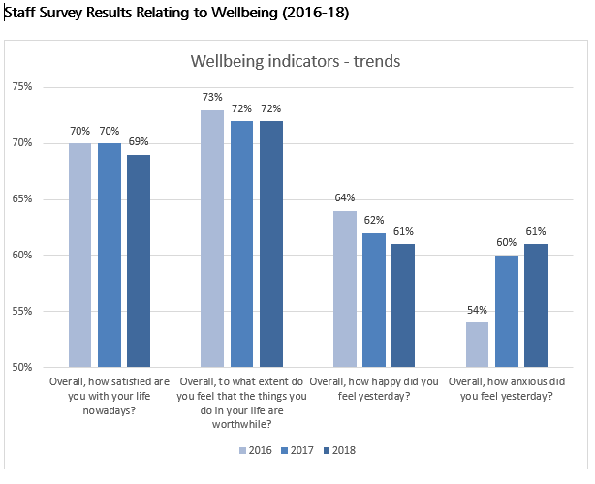
What we’ve been doing
To build leader confidence in wellbeing we have been rolling out Wellbeing Confident Leaders training. 90 of the Treasury’s 115 Senior Civil Servants have attended, a 78% completion rate against 74% Civil Service wide.
Senior Civil Servants and members of staff have written blogs and appeared in videos including ‘One You’ on mental health awareness day and other times throughout the year, speaking of their own experiences which makes employees realise it’s OK to speak about their own mental health.
Our Wellbeing Strategy is being developed and will roll up much of our existing activity into a holistic whole and track our progress against key measures.
Actions already underway include:
- Time to Talk Workshops (open to any member of staff to attend).
- Providing more information and again encourage use of Attendance Management and Health and Wellbeing Gateway products.
- Providing guidance including the Civil Service Employee Assistance Manager’s Toolkit
- Offering face to face support and assistance.
- Hold events that will showcase guest speakers and their experiences of mental health. Events might also include Treasury employees speaking of their own experiences of poor mental health and how they manage it.
- Regular blogs by members of staff about their mental health which are always well received by employees.
- HM Treasury also holds quarterly “pulse checks” that measure wellbeing and work-life balance at team level based on anonymous surveys completed by staff.
Planned actions in the coming months:
- Training for managers so they have an improved understanding of poor mental health and how to respond to those experiencing it.
- Training 30 new Mental Health First Aiders to ensure we have enough people trained to provide support when needed and signpost colleagues when a member of staff is facing mental health distress or crisis.
- Publish a quarterly Health, Safety and Wellbeing Newsletter incorporating any new initiatives for Wellbeing.
- Use the PERMA Index Dashboard (measures Positive Emotion, Engagement, Relationships, Meaning, Accomplishment) to assess how we are doing regarding mental wellbeing.
This is the first report – if you have any comments on the data, suggestions for action for measurement, do let us know.
We will next report in October 2020.

