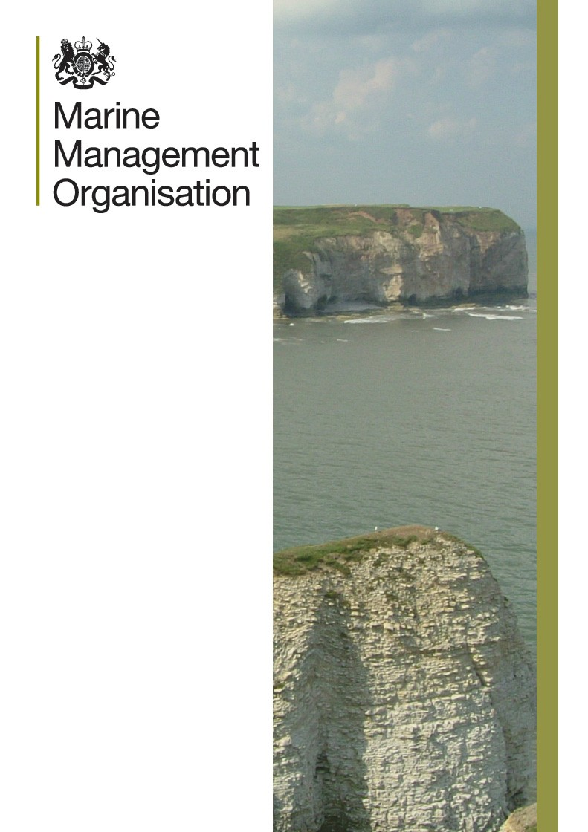
f

Maritime and Fisheries Fund (MFF)
Guidance on Serious Infringements and
Fraud
February 2019

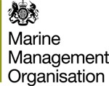

Maritime and Fisheries Fund
Guidance on ineligibility

Version | Author | Note
0.1 | MMO | First draft
1 | MMO | Approved
1.1 | MMO | Approved

© Marine Management Organisation 2016
Information about this publication and further copies are available from: Marine Management Organisation
Lancaster House Hampshire Court Newcastle upon Tyne NE4 7YH

Tel: 0300 123 1032
Email: info@marinemanagement.org.uk Website: www.gov.uk/mmo

If referencing this document, please cite it as: Maritime and Fisheries Fund: Guidance on ineligibility (MMO) February 2019

Contents
- Introduction 5
- Definitions 5
- Inadmissibility 6
  - Operators who have committed serious infringements 6
  - Vessels included in the IUU vessel list 7
    - Inadmissibility of applications by operators included in the IUU vessel list 7
    - Inadmissibility of applications by operators in a non-cooperating third country 7
  - Inadmissibility of applications by operators that have committed fraud in the context of the MFF 8
  - Inadmissibility of applications by operators that have been convicted of certain environmental offences 8
- Common provisions 8
  - Calculation of the inadmissibility period where the operator owns more than one fishing vessel 8
  - Transfer of ownership 9
  - Permanent withdrawal of the fishing licence 9
  - Revision of inadmissibility period 9
Annex A: Table of Serious infringements for the purposes of The Common Fisheries Policy (Amendment etc.) (EU Exit) Regulations 2019
Annex B: Categories of environmental offences under The Common Fisheries Policy (Amendment etc.) (EU Exit) Regulations 2019
1

Introduction
In order that English public funding is not distributed to those who have been convicted of serious infringements or who have committed fraud, the Government has set out regulations detailing those who will be ineligible to receive funding under the scheme.

The legal basis for the rules is The Common Fisheries Policy (Amendment etc.) (EU Exit) Regulations 2019.

This guidance sets out the practical operation of those rules and contains details of how the MMO will verify that those who apply for funding are eligible to do so.

Definitions
“MFF” means the Maritime and Fisheries Fund as per The Grants for Fishing and Aquaculture Industries Regulations 2015 no. 1711.

“Fraud” shall mean:

  - any intentional act or omission relating to the use or presentation of false, incorrect or incomplete statements or documents, which has as its effect the misappropriation or wrongful retention of funds from the general budget of the European Communities or budgets managed by, or on behalf of, the European Communities, or

  - non-disclosure of information in violation of a specific obligation with the same effect, or

  - the misapplication of such funds for purposes other than those for which they were originally granted.

“IUU vessel list” means the list of vessels marked as having conducted illegal, unreported or unregulated (“IUU”) fishing as provided for in The Common Fisheries Policy (Amendment etc.) (EU Exit) Regulations 2019

“Operator” means the natural or legal person who operates or holds any undertaking carrying out any of the activities related to any stage of production, processing, marketing, distribution and retail chains of fisheries and aquaculture products;

“Points for serious infringements” means points assigned to the holder of a fishing licence or to a master of a fishing vessel in accordance with The Common Fisheries Policy (Amendment etc.) (EU Exit) Regulations 2019.

“Serious infringement” means any act which falls within the definitions set out in The Common Fisheries Policy (Amendment etc.) (EU Exit) Regulations 2019, The Sea Fishing (Points for Masters of Fishing Boats) Regulations 2014 (SI No. 3345) and in accordance with guidance published by the MMO as set out at annex A.

Inadmissibility
Applicants for MFF grants will be required to notify the MMO if they have been convicted by a United Kingdom court of criminal jurisdiction of any of the following offences:

  - An offence resulting in the imposition of points for serious infringements as defined by The Common Fisheries Policy (Amendment etc.) (EU Exit) Regulations 2019 and set out at annex A to this guidance, or

  - An offence1 of fraud relating to MFF funding, or

  - An environmental offence which falls within one of the categories of offences set out at annex b to this guidance.

The information supplied above, if any, will be verified in any event by the MMO. An applicant should also be aware that checks will be undertaken to verify whether any information supplied in relation to the MFF funding application is accurate.

The MMO will reject any application where any of the following situations arise.

Operators who have committed serious infringements

Where a competent authority has determined that an operator has committed a serious infringement, applications for MFF support by that operator shall be ineligible for a period of 12 months from the first official decision by a competent authority assigning infringement points following a conviction for a serious infringement. For the purposes of calculating the ineligibility period, only serious infringements committed from 1 January 2013 will be taken into account.

However, in the case of serious infringements which have attracted points for serious infringements the ineligibility period will be calculated as follows:

1 An offence of fraud in this context will be considered to have been committed where the offender has been subject of a criminal investigation which has resulted in a criminal sanction of an official written warning (or the equivalent sanction e.g. a police caution), a financial administrative penalty which has been accepted, or has been convicted by a court of criminal jurisdiction of an offence of fraud or the facts of which fall within one or more of the definitions above.

If, at the time of the application for funding under the MFF scheme, the total infringement points accumulated by an operator in respect of a fishing vessel is
    - 8 or less, the applicant remains eligible for funding,
    - If the number of infringement points by an operator in respect of a fishing vessel is 9 points, the inadmissibility period shall be 12 months.
    - For each point above 9 an additional 1 month period of inadmissibility will be added. See example below;

Number of infringement points | Period of inadmissibility
9 | 12 months
10 | 13 months
11 | 14 months
12 | 15 months
13 | 16 months
For each additional infringement point | Increase this period by 1 month.

The starting point of the inadmissibility period referred to above will be the date of the first official decision by a competent authority assigning infringement points following a conviction for a serious infringement which resulted in that operator being assigned a total of 9 or more points in respect of a fishing vessel.

Vessels included in the IUU vessel list.

Vessels included on the IUU vessel list or flagged to a country listed as a non- cooperating third country are ineligible to apply for grant funding under the MFF scheme.

Inadmissibility of applications by operators included in the IUU vessel list.

The period of inadmissibility for an operator whose fishing vessel is included in the Union list of fishing vessels engaged in illegal, unreported and unregulated (IUU) fishing will be a minimum of 24 months from the date the fishing vessel is included on that list and for the whole period during which the fishing vessel remains on the list.

Inadmissibility of applications by operators in a non-cooperating third country.

Operators whose fishing vessel is flagged to a non-cooperating third country shall be inadmissible for a minimum period of 12 months and during the whole period while that country is listed.

Inadmissibility of applications by operators that have committed fraud in the context of the MFF

Where it is determined by the MMO that an operator has committed a fraud in the context of MFF, all applications for MFF support by that operator shall be inadmissible from the date of the first official decision establishing the fraud until the end of the eligibility period of the MFF which runs to 31st December 2023.

A conviction for inciting, aiding and abetting the intentional conduct referred to in the above paragraph will also give rise to a period of ineligibility.

Inadmissibility of applications by operators that have been convicted of certain environmental offences.

An applicant of MFF funding who has been convicted of certain environmental offences falling within the categories of offences set out The Common Fisheries Policy (Amendment etc.) (EU Exit) Regulations 2019 will be ineligible for grant funding. The ineligibility of applications by the operator will be applied even if the sentence for the offence is suspended or its execution made dependent on the fulfilment of other conditions.

A conviction for inciting, aiding and abetting the intentional conduct referred to in the above paragraph will also give rise to a period of ineligibility.

The period of ineligibility of applications will be calculated on the basis of the following formula:

Penalty Applied * Total length of the eligibility period Maximum Penalty

The total length of the Eligibility Period is to 01 January 2014 to 31st December 2023

Common provisions

Calculation of the inadmissibility period where the operator owns more than one fishing vessel

Where an operator owns or controls more than one fishing vessel, the inadmissibility period of an application by that operator shall be determined separately in relation to each individual fishing vessel, in accordance with the list of offences at annex A.

However applications for MFF support by that operator shall also be inadmissible if:

    - applications in relation to more than half of fishing vessels owned or controlled by that operator are ineligible. For example if an operator owns 3 vessels and 2 of those vessels have been deemed ineligible through inadmissibility outlined in this guidance then that operator becomes entirely ineligible for MFF support.

    - if in the case of offences for serious infringements listed in points 1, 2 and 5 of the table at annex a, the average number of points assigned per fishing vessel in ownership of the applicant is 7 or more.

For example if an operator accumulates 7 or more points through not fulfilling obligations to record and report catch or catch related data, including data to be transmitted by satellite vessel monitoring system or use of prohibited or non-compliant gear according to national legislation or Taking on board, transshipping or landing of undersized fish in contravention of the legislation in force that operator becomes entirely ineligible for MFF support.

Transfer of ownership

In the case of a sale or other type of transfer of ownership of a fishing vessel any inadmissibility period should not be transferred to the new owner. The inadmissibility of applications by the new owner can only result from new serious infringements committed by the new owner.

However, where infringement points are assigned for serious infringements within table 2 and table 3 committed prior to the change of ownership of the fishing vessel, those points shall be taken into account for the purposes of calculating the inadmissibility period of the new owner if that operator commits a new serious infringement.

Permanent withdrawal of the fishing licence

The accumulation of 90 infringement points by the holder of a fishing licence shall automatically trigger the permanent withdrawal of the fishing licence.

Where the fishing licence of an operator has been permanently withdrawn for any of the fishing vessels owned or controlled by that operator all applications by that operator shall be inadmissible for support from the MFF from the date of the withdrawal until the 31st December 2023.

Revision of inadmissibility period

Provided the inadmissibility period lasts at least 12 months in total, the inadmissibility period:

- shall be reduced by 2 months if, in the case of offences for serious infringements listed in points 1, 2 or 5, 2 infringement points are deleted for one of the following reasons:

- the fishing vessel which has been used in committing the infringement for which points were assigned uses thereafter VMS or records and transmits thereafter fishing logbook, transhipment and landing declaration data electronically without being legally subject to these technologies; or

- the holder of the fishing licence volunteers after the assignation of points to take part in a scientific campaign for the improvement of the selectivity of the fishing gear; or

- the holder of the fishing licence is a member of a producer organisation and the holder of the fishing licence accepts a fishing plan adopted by the producer organisation in the year following the assignation of the points involving a reduction of 10 % of the fishing opportunities for the holder of the fishing licence; or

- the holder of the fishing licence joins a fishery covered by an eco-labelling scheme that is designed to certify and promote labels for products from well- managed marine capture fisheries and focus on issues related to the sustainable use of fisheries resources.

- shall be extended by 12 months for each additional offence for a serious infringement listed in annex a committed by the applicant during the inadmissibility period.

- by way of derogation from paragraph (b), inadmissibility shall be extended by 1 additional month for each point above 9 for each additional serious infringement committed by the applicant during the inadmissibility period.

Annex A: Table of Serious infringements for the purposes of The Common Fisheries Policy (Amendment etc.) (EU Exit) Regulations 2019.

The legal basis for all serious infringements set out in the table below is The Common Fisheries Policy (Amendment etc.) (EU Exit) Regulations 2019.

No. | Serious infringement | Points
1 | Not fulfilling of obligations to record and report catch or catch related data, including data to be transmitted by satellite vessel monitoring system | 3
2 | Use of prohibited or non-compliant gear according to current legislation | 4
3 | Falsification or concealing of markings, identity | 5
4 | Concealing, tampering or disposal of evidence relating to an investigation | 5
5 | Taking on board, transshipping or landing of undersized fish in contravention of the legislation in force | 5
6 | Carrying out of fishing activities in the area of a regional fisheries management organisation in a manner inconsistent with or in contravention of the conservation and management measures of that organisation | 5
7 | Fishing without a valid licence, authorisation or permit issued by the relevant issuer | 7
8 | Fishing in a closed area or during a closed season, without or after attainment of a quota or beyond a closed depth | 6
9 | Directed fishing for a stock which is subject to a moratorium or for which fishing is prohibited | 7
10 | Obstruction of work of officials in the exercise of their duties in inspecting for compliance with the applicable conservation and management measures or the work of observers in the exercise of their duties of observing compliance with the applicable rules | 7

11 | Transshipping to or participating in joint fishing operations with, support or re-supply of fishing vessels identified as having engaged in IUU fishing legisation | 7
12 | Use of a fishing vessel with no nationality and that is therefore a stateless vessel in accordance with international law | 7

Annex B: Categories of environmental offences

The legal basis for all serious infringements set out in the table below is The Common Fisheries Policy (Amendment etc.) (EU Exit) Regulations 2019.

The following conduct constitutes a criminal offence, when unlawful and committed intentionally or with at least serious negligence:
(a) | the discharge, emission or introduction of a quantity of materials or ionising radiation into air, soil or water, which causes or is likely to cause death or serious injury to any person or substantial damage to the quality of air, the quality of soil or the quality of water, or to animals or plants;
(b) | the collection, transport, recovery or disposal of waste, including the supervision of such operations and the after-care of disposal sites, and including action taken as a dealer or a broker (waste management), which causes or is likely to cause death or serious injury to any person or substantial damage to the quality of air, the quality of soil or the quality of water, or to animals or plants;
(c) | the shipment of waste, where this activity falls within the scope of current and relevant legislation on shipments of waste and is undertaken in a non-negligible quantity, whether executed in a single shipment or in several shipments which appear to be linked;
(d) | the operation of a plant in which a dangerous activity is carried out or in which dangerous substances or preparations are stored or used and which, outside the plant, causes or is likely to cause death or serious injury to any person or substantial damage to the quality of air, the quality of soil or the quality of water, or to animals or plants;
(e) | the production, processing, handling, use, holding, storage, transport, import, export or disposal of nuclear materials or other hazardous radioactive substances which causes or is likely to cause death or serious injury to any person or substantial damage to the quality of air, the quality of soil or the quality of water, or to animals or plants;
(f) | the killing, destruction, possession or taking of specimens of protected wild fauna or flora species, except for cases where the conduct concerns a negligible quantity of such specimens and has a negligible impact on the conservation status of the species;
(g) | trading in specimens of protected wild fauna or flora species or parts or derivatives thereof, except for cases where the conduct concerns a negligible quantity of such specimens and has a negligible impact on the conservation status of the species;
(h) | any conduct which causes the significant deterioration of a habitat within a protected site;

(i)
the production, importation, exportation, placing on the market or use of ozone-depleting substances.

