

Estimating and adjusting for changes in the method of severity reporting for road accidents and casualty data

Final Report

David Braunholtz and Duncan Elliott
Office for National Statistics
July 2019
Tel: 01633 455620
Email: duncan.elliott@ons.gov.uk, david.braunholtz@ons.gov.uk
Contents
1. Introduction 3
2. Background 3
3. Aim and requirements 3
4. Methods 4
5. Time series approach 6
6. Logistic regression approach 10
7. Comparing approaches 17
8. Trends at Police Force level 23
9. Conclusions 23
10. Way Forward 24
Annex A: RegARIMA model 27
Annex B: Adjusting to IBRS……………………………………………………………………………………………………………….35
Annex C: Logistic Regression model outputs……………………………………………………………………………………38
Annex D: Comparison of logistic and time series approaches…………………………………………………………..45

Introduction
This report discusses methods for estimating and adjusting for possible discontinuities in severity reporting of road accidents and casualty data arising from an increased use of Injury-Based Reporting Systems (IBRS). Two approaches have been considered, a time series approach that models the discontinuity for aggregate level time series, and a logistic regression model on casualty level data.
In the interim report the two methods were explored and compared at a high level. This final report summarises the conclusions of a more detailed comparison with data up to 2018 and recommends an approach to adjust for this discontinuity going forward.

2. Background
The Department for Transport (DfT) publishes road casualty statistics based on the Stats19 data collection system. This well-established system sets out the variables and data standards to which each of the police forces in Great Britain submit data relating to vehicle accidents in which an injury has occurred.
Historically each police force has operated its data collection system independently. In recent years, DfT and Home Office developed a standardised reporting tool (called CRASH - Collision Recording and SHaring) which is designed to provide a common way for police forces to collate and submit data. Further information on data collection systems and discussion on the development of severity reporting is given in Ward et al (2010). The CRASH system was first rolled out in 2012, being adopted by the Surrey police force. Apart from brief usage in one other police force, further adoption of CRASH did not begin until the end of 2015. By the end of 2016, however, CRASH was being used by nearly half of all English police forces. Separately, the Metropolitan Police Service (MPS) adopted a similar IBRS to CRASH during the latter part of 2016 – this is called COPA (Case Overview and Preparation Application). For more details of the background on changes in severity reporting, dates of adoption, and details of how severity is derived from injuries see DfT (2018).
The introduction of IBRS appears to have led to a change in the reported severity of road casualties. This can be explained by the change of reporting systems from Non-Injury-Based Reporting Systems (NIBRS), where judgment of the casualty severity is made by the reporting police officer, to IBRS, where the severity of the injury is determined automatically from the most severe type of injury suffered. It appears that some casualties that would have been categorised as ‘slight’ on NIBRS are recorded as ‘serious’ in IBRS. This became apparent from initial analysis of high level data suggesting that switching to CRASH and COPA added between 5 and 15% to the Great Britain total for ‘serious’ injuries (DfT, 2017).

3. Aim and requirements
DfT commissioned the Methodology Advisory Service at the Office for National Statistics (ONS) to explore the magnitude of any discontinuity caused by the change in reporting systems and to propose robust methods to adjust the historical data at both accident and casualty level.
The initial requirements were for an adjustment method that could provide a consistent time series for measuring the total number of ‘serious’ injuries and total number of ‘slight’ injuries, including these totals for certain subcategories, for example by police force, gender, road type, age group, and type of road user. The method should be able to adjust for a discontinuity in each time series that has been caused by the change in reporting systems.
Estimating adjustments for each sub-aggregate time series separately has the potential to cause slight inconsistencies as the adjustment in such an approach is not at the level of a reported casualty. A more challenging task is to investigate methods for potentially adjusting the severity of a reported casualty based on the system on which it was recorded which would ensure that if such an adjusted dataset were available there would be consistency in any cross-tabulation or aggregation.

4. Methods
Two approaches to addressing the issue of estimating the discontinuity have been explored. These include time series modelling of aggregate level time series and logistic regression on casualty level data. For both approaches it is assumed that the total number of casualties is not affected by a change from NIBRS to IBRS as it is assumed that if both systems were used to record severity the number of fatalities would be the same, it is only the classification between ‘slight’ and ‘serious’ that changes. Under both approaches, estimates of discontinuities due to changes from NIBRS to IBRS are obtained. While only around 50% of casualties are recorded on IBRS rather than NIBRS, predictions are made, assuming that the models are correctly specified, to provide estimates of the number of casualties categorized as ‘serious’ and ‘slight’.

4.1 Time series methods
Under the time series approach the methods tested assumed that an aggregate time series (either levels, such as the total number of serious casualties, or proportions such as serious casualties as a proportion of all non-fatal casualties) follow a stochastic process. The dynamics of each time series are described with a model that accounts for patterns in the series while including a regression variable based on the proportion of casualties recorded on IBRS to test for the significance of this in explaining variation in the series.
A few alternative time series models were tested
- Univariate regARIMA models on aggregate level data
- Bivariate state space models on pairs of aggregate level data (ie total serious and total slight at various sub-aggregates by variables of interest)
- Univariate regARIMA models on serious casualties as a proportion of non-fatal casualties
The regARIMA models were fitted using X-13ARIMA-SEATS (X13), the GSS recommended software for seasonal adjustment, and the bivariate state space models were fitted using the dlm package (Petris, 2010) in R (R Core Team, 2017). For the purposes of modelling, time series were aggregated to monthly periodicity and the data used started in January 2004 and ended in December 2018.
The univariate regARIMA models on aggregate level data found evidence of discontinuities for different aggregates especially sub-aggregates of total ‘serious’ casualties. However, the discontinuities in the number of ‘slight’ casualties were more difficult to identify and it was not always the case that an estimated increase in the number of serious casualties was balanced by an equivalent decrease in the number of slight casualties. The main reason for this is that there is a more noticeable shift in the level of ‘serious’ casualties as the numbers are generally much smaller than the number of ‘slight’ casualties.
To estimate the discontinuities by assuming that any increase or decrease in the number of ‘serious’ casualties is equal to the decrease or increase in the number of ‘slight’ casualties for any aggregate bivariate models were used to include the constraint in the estimation. Each series was assumed to follow a basic structural model with the proportion of non-fatal casualties recorded in IBRS used as a regressor in each series and the estimated coefficient constrained such that the total number of non-fatalities would not change. For many of the aggregates the series are relatively volatile and there were issues of non-convergence in maximum likelihood estimation. Given the number of series to explore this approach was not considered any further as it would require considerable resource to develop appropriate models.
The automatic modelling routines in X13 have been well tested over many years on various official statistics time series and so given the number of series to test, these regARIMA modelling capabilities were used. In order to address the consistency problem from the first set of regARIMA models where there were no equal and opposite effects, the third time series approach modelled a logistic transformation of serious casualties as a proportion of non-fatal casualties. The order of the seasonal ARIMA model including additional regressors for potential outliers and calendar effects used the model selection routines in X13. The results of this approach are discussed further below in section 5.
4.2 Regression methods on casualty level data
The second approach using logistic regression on casualty level data aims to address a potential limitation of the time series approach by estimating potential adjustments to each reported casualty that was reported on NIBRS. Adjustments at the reported casualty level could provide an approach consistent over time allowing consistent time series to be produced for any aggregation category.
There are some features to be desired in making such individual-level adjustments, including:
- casualty severities assigned under IBRS are not changed.
- casualty severities assigned under NIBRS are changed to the least possible extent compatible with the overall estimated effect of moving to IBRS. If this seems unreasonable - for example, if ‘serious’ casualties under NIBRS and IBRS have rather different characteristics - then maybe NIBRS and IBRS severities are measuring different things, and it does not really make sense to attempt to produce a ‘comparable’ dataset at all.
- any data in NIBRS datasets on the nature of injuries is used to maximise the information about the severity which would be assigned under IBRS (ie make the probability under IBRS as close as possible to 0 or 1).
- whether or not severity rating is changed depends on the estimated ‘transition probability’, which in turn depends on the change in the probability resulting from assuming a change in the collection method from NIBRS to IBRS. Casualties with larger transition probability are more likely to be re-assigned, casualties with a transition probability greater than zero all have some non-zero chance of being re-categorised.
- after re-categorisation, there should be no detectable level change in any time-series that is caused by the change in reporting system. This depends on the assumption that total casualties recorded is unaffected by the recording system used. Any real change in the probability of a casualty being ‘serious’ happening at the same time as the introduction of IBRS will potentially be detected as a level change – for instance due to a relative shift to cycles or motorcycles (or less experienced riders).
- the maximum severity of accident records is re-categorised deterministically using the re-categorised casualty records.
- methods should be available for determining and describing the extra uncertainty in tables and analyses resulting from uncertainty about which casualties would have been re-categorised under IBRS.
A logistic regression model allows all these criteria to be met. It gives the probability for each casualty being reported as ‘serious’ rather than ‘slight’ given the various variables available in the dataset and the type of system the casualty was reported on. The same model can be extrapolated to give an estimated probability of each casualty being reported as ‘serious’ or ‘slight’ under the alternate system, and the difference between these probabilities is a measure of the effect of the reporting system. However, for each specific casualty only the outcome under one system is actually known with certainty, and at an individual casualty level the required effect of the system is the ‘transition probability’ i.e. the probability that the (known) severity would have been different under the alternate system. Unfortunately, there are no data where individual casualties are reported on both systems, police forces have used one or the other. To obtain transition probabilities thus requires an assumption of what is essentially a correlation coefficient between the classifications from the two systems. For instance, casualties with predicted probabilities of ‘serious’ of 0.5 under both systems could all have matching outcomes under the two systems, or all have opposite outcomes, or anywhere in between. Expert opinion suggests that the correlation coefficient should be 1 so as to maximise agreement between the two systems.
After comparison of the two approaches and consultation with key stakeholders, it was decided to proceed using the logistic regression approach to produce adjustments at individual casualty level, and to use the time-series approach to help validate the adjustments from the logistic regression. Both approaches examine ‘serious’ casualties as a proportion of non-fatal casualties, and use the same (logit) transformation. These are described in more detail below.

5. Time series approach
Although the (aggregated) time-series approach does not easily allow consistency when aggregating by different variables in the way a casualty-level approach may, it can nevertheless provide useful comparisons, and differences between the two approaches give some idea of the uncertainties inherent in an adjustment where different methods could be used. The time series approach is to model ‘serious’ casualties as a proportion of total casualties. Section 5.1 provides an overview of the model and resulting adjustment at the aggregate level for total ‘serious’ and total ‘slight’ casualties. Section 5.2 gives a brief validation of the approach by testing it on a related time series for which it is firmly believed there should be no discontinuity.

5.1 Time series model
The general form of the regARIMA model used can be thought of as generalising a standard regression model to account for certain dynamic effects in the series, such as trend, seasonal, calendar effects, outliers and autocorrelation of model residuals that would otherwise distort the estimation of a possible discontinuity.
The discontinuity is estimated in the regARIMA model by including a regressor that is the proportion of total casualties that have been reported on IBRS. The discontinuity can then be derived using the estimated coefficient from the model. The regARIMA model accounts for trends, seasonality, calendar effects and auto-correlation. Annex A explains the model in more detail. Figure 1 shows the percentage of total casualties reported on IBRS by year, which has increased significantly in the last three years, and IBRS for just over 50% of reported casualties in Great Britain since 2017.

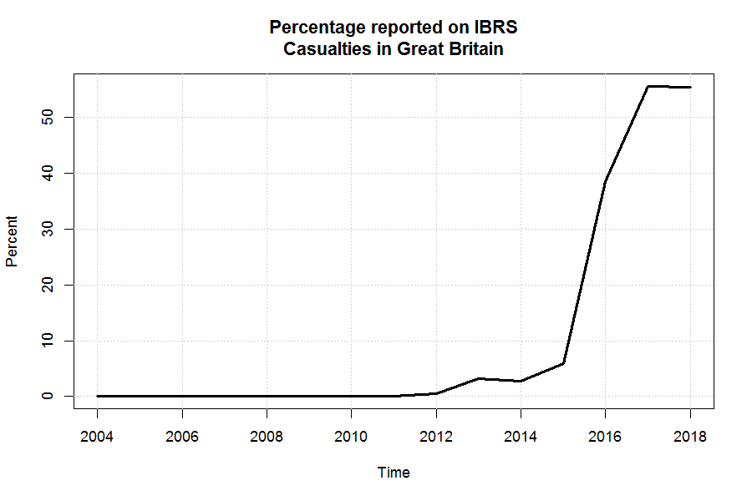
Figure 1: Percentage of total casualties in Great Britain reported on IBRS
Figure 2 shows the number of serious casualties by year for Great Britain. The ‘unadjusted’ data is using data as reported by the police (either using IBRS or NIBRS). The orange dashed line adjusts this series to provide a consistent time series based on NIBRS, that is to say, removing the impact of the introduction of IBRS from the time series. The blue dotted line provides a consistent time series assuming all casualties are reported on IBRS, that is to say, if all police forces had used IBRS at all time points. The shaded area around each adjusted line is a confidence interval based on twice the standard error of the discontinuity.

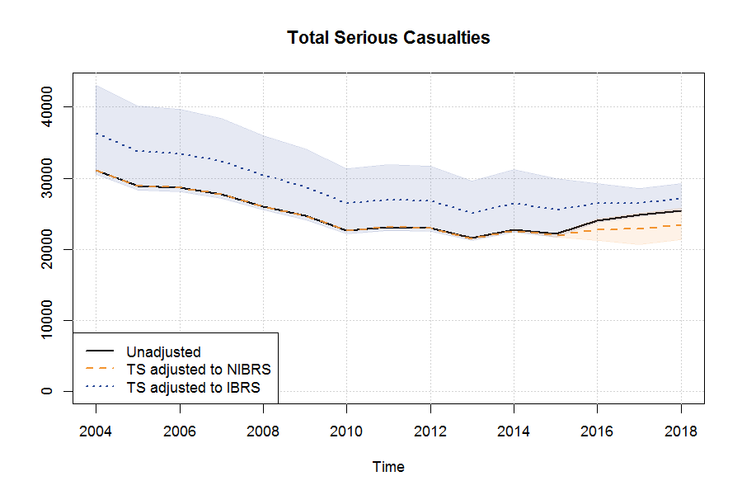
Figure 2: Total number of serious casualties in Great Britain by year. Shaded areas represent confidence intervals based on twice the estimated standard error of estimated discontinuity.
As the adjustment is made to the estimated ‘serious’ casualties as a proportion of all casualties this ensures the total number of casualties is not adjusted. Therefore, the sum of ‘slight’ and ‘serious’ casualties will be consistent between adjusted and unadjusted time series. Figure 3 shows the number of ‘slight’ casualties by year for Great Britain.

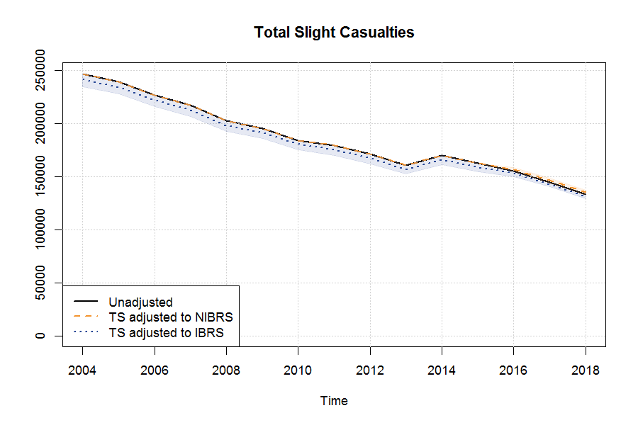
Figure 3: Total number of slight casualties in Great Britain by year. Shaded areas represent confidence intervals based on twice the estimated standard error of estimated discontinuity.
The model for ‘serious’ casualties as a proportion of all non-fatal casualties finds a marginally significant discontinuity (an estimated coefficient of 0.1755 with a standard error of 0.0992). While there is no evidence of residual autocorrelation in the model, there is some evidence of skewness in the model residuals which can affect the estimated confidence intervals of the parameter estimates. However, if the model is assumed to be correct then for this series it is estimated that there is an increase in the proportion of ‘serious’ casualties of nearly 20 percent due to IBRS. If the time series approach to adjustment were to be used for adjusting aggregate-level series, then adjustments could be made where there is evidence of a discontinuity based on the significance of the estimated coefficient for the discontinuity variable (proportion of total casualties recorded on IBRS).
Similar adjustments can be made for other aggregations of serious casualties by variables of interest. However, adjusted sub-aggregate time series may not exactly sum to a total adjusted aggregate time series which means that there is the possibility of inconsistencies. Inconsistencies with pre-specified sub-aggregates can be avoided by use of factors to force consistency – but non-pre-specified sub-aggregates will still (in general) be inconsistent. For this reason, the logistic regression approach is explored to address this limitation. Nevertheless, the time series approach is useful to provide a consistency check for adjustments based on the casualty level approach and to test that approach for potential residual discontinuities. This is discussed further in section 7.
5.2 Model validity
The model assumes that there is some reclassification between ‘serious’ and ‘slight’ casualties that would take place if you were to change the reported severity from one system to another. However, since the change only affects how severity is recorded by police officers, it is not expected to have any impact on the total number of casualties or accidents reported, or on the number of fatalities reported. We can use this hypothesis to sense-check the validity of the approach presented above. To check this, a similar model was run to test whether it finds any significant discontinuity in fatalities as a proportion of all casualties (including fatalities). As expected, the estimated coefficient was not found to be statistically significant.
While the focus of the models in this section have been on modelling proportions, levels can also be modelled. As an additional validation, the level of total casualties is also assessed for evidence of a discontinuity, using a regARIMA model. The model is almost identical, but there is no use of the logistic transformation. Rather, the levels are modelled with a log transformation to help stabilise the variance in the series. The estimated coefficient has a value of 0.007 (approximately a 0.7 percent adjustment of periods where all casualties are recorded on NIBRS to adjust to be consistent with IBRS) and is found not to be statistically significant with an estimated standard error of 0.101. The adjusted and actual yearly totals are found to be similar as shown in figure 4. This supports the assumption that the changes in severity reporting systems do not impact the total number of casualties reported.

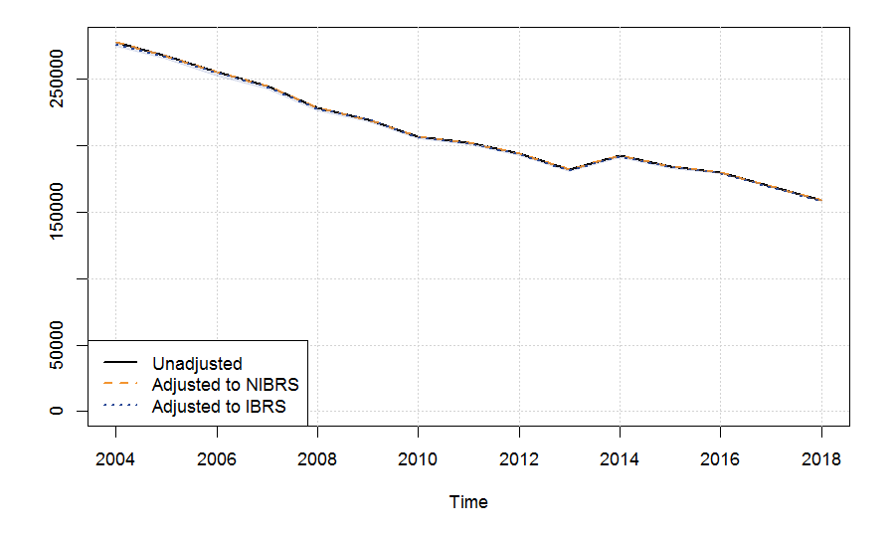
Figure 4: Total number of casualties in Great Britain by year. Shaded areas represent confidence intervals based on twice the estimated standard error of estimated discontinuity.

6. Logistic regression approach

A logistic regression model has been used to assess the effect of IBRS on the proportion of casualties that are rated ‘serious’. Section 6.1 discusses the logistic regression approach from a theoretical point while section 6.2 provides a high-level summary of the model in practice. The modelling has been done in both R (R Core team, 2017) using the glm function and with the proc logistic function in the SAS software version 9.3.
6.1 Theory
Logistic regression models the probability of a binary outcome (‘serious’ or ‘slight’), given the event (a casualty, with associated characteristics such as transport mode, vehicle manoeuvres during accident, impacts, time of day, speed limit, age, did police officer attend, Police Force, severity reporting system (IBRS or not), etc). The logistic regression model assumes the number and characteristics of casualties recorded is fixed, and only models the probability that a casualty is ‘serious’ rather than ‘slight’. As per the time-series approach modelling proportions, described above, the assumption has been made - based on expert opinion - that the total number of casualties recorded is not affected by the recording system. If this assumption is found or thought to be unjustified, a different process would be required to model the change in total casualties, possibly alongside the logistic regression model described here.
The result of the logistic regression model is a set of coefficients which predict the probability of severity being ‘serious’ given a set of values of the variables in the model. One of the variables in the model is an indicator of whether the assessment was made using NIBRS or IBRS. By switching the value of this for each casualty (but keeping everything else fixed), the model can provide two probabilities for each casualty ; that such a casualty would be rated ‘serious’ using IBRS (), and that such a casualty would be rated ‘serious’ using NIBRS (). These are called marginal probabilities because in a 2x2 table of injury and non-injury-based probabilities of ‘serious’ (and ‘slight’), they refer to the (unconditional) margins (see Figure 5). Of course, one actual assessment () for each casualty is known for one system (), and what is required is the conditional probability that this would have been different using the other. Such probabilities, in the 4 central cells of the 2x2 table, are known as transition probabilities, and by far the best way of estimating them is from studies where both assessment systems are used in parallel (see Annex B for further detail of this method). In the absence of recorded injury data in both systems, there will in general be uncertainty as to what the assessment would have been on IBRS, hence probabilities are used.

 | Severity in IBRS
Severity in NIBRS |  | Serious | Slight
Severity in NIBRS | Serious | 0.84 | 0.02 | 0.86
Severity in NIBRS | Slight | 0 | 0.14 | 0.14
 |  | 0.84 | 0.16 | 1

Figure 5: example of 2x2 table of injury vs non-injury based marginal and transitional probabilities.

Police forces have been adopting IBRS without simultaneously preserving the legacy system so we do not have a natural experiment, or any study, where both NIBRS and IBRS of the assessment of severity are made on the same casualties. Such a study (somewhat difficult operationally) would provide (albeit in a limited set of circumstances, for instance only in a few Police Forces which are in the process of adopting IBRS) information directly on transition probabilities. For example, given a casualty (with a set of characteristics) is recorded as ‘slight’ using NIBRS, what is the probability they will be recorded as ‘serious’ using IBRS.
In the absence of direct information on transition probabilities, these must be based on assumptions. There is some evidence to suggest that IBRS and NIBRS are maximally correlated, though with likely different marginal probabilities, see for example Ward et al (2010) and Lyons et al (2008). In other words, while the alternative recording systems may assess a different proportion of casualties as ‘serious’, this will arise from as few casualties as possible having their severity status changed. This is a strong assumption, and it is perfectly possible to relax it e.g. by specifying a correlation () less than 1, or even a distribution for the correlation. Given a correlation, and the marginal probabilities provided by the logistic regression model, it is straightforward to calculate the transition probabilities. Given the actual assessment (), the system used for this assessment, and the ‘target’ system to which the data is being adjusted, the transition probability () for the casualty is easily calculated. This can be expressed as:

where is a known mathematical function.
For each casualty, the result of the whole logistic regression modelling process (fitting the model, applying it ‘as if’ the data had been collected using IBRS and NIBRS, assuming a value for the correlation, and then using function ) is a transition probability . This (if the model assumptions are correct) gives the chance that the severity status of the casualty would have been reversed. For example, a casualty who was recorded as ‘serious’ using NIBRS will (with and ) have a probability of zero () that this severity status would have been reversed to ‘slight’ had IBRS been used. In other words, if the marginal probability of being rated ‘serious’ is greater under IBRS, to maximise requires that all ‘serious’ casualties recorded under NIBRS would also have been recorded as ‘serious’ using IBRS. Note that this does not lead to an overestimate of the number of ‘serious’ casualties under IBRS – it is simply stating that the minimum number of casualties possible will change status to meet the required number of extra ‘serious’ casualties predicted by the logistic regression model under IBRS. On the other hand, a casualty who was recorded as ‘slight’ using NIBRS will have a non-zero probability, that the severity would have been recorded as ‘serious’ using IBRS. The size of this probability will depend on the values of the explanatory variables used in the logistic regression model for the casualty. (and the assessed state ) can thus be used to calculate the probability (‘serious’) that casualty will be ‘serious’ in the target system . In other words, for casualties assessed under IBRS the severity status stays the same, for casualties assessed under NIBRS the transitional probability is used for casualties assessed as slight, and the casualty stays as serious if it is classed as serious.
The question remains of how to use to produce analyses which are ‘as if’ all data had been collected using the new injury-based systems. It needs to be reiterated that the process of adjusting data, to be able to produce analyses consistent across the NIBRS and IBRS data, inevitably results in some (and likely to be considerable) uncertainty. There is uncertainty about the right assumptions to make (for instance:
- Should each Police Force be allowed its own trend / level / IBRS-effect?
- What assumption to make about Forces which have not introduced IBRS?
- What mathematical form should trends take?
- What mathematical form should the model take?
- Which variables should be included?
There is also uncertainty in estimates from the chosen model, and uncertainty due to these estimates being probabilities. It is also inevitably the case that (adjusted or not) the data will not perfectly reflect the underlying reality which it is being used to shed light on. For aggregated graphs and tables, the individual casualty probabilities of being ‘serious’ () or ‘slight’ () using IBRS can be summed (this might be termed as using the as weights) and will give the statistically ‘expected’ (i.e. what might be expected on average) totals for aggregates. Deriving accident adjustment figures is based on the casualty probabilities. Non-fatal accident probabilities could be calculated by coding between 0 and 1 (inclusive) to denote the probability that at least one casualty is ‘serious’ - which in non-fatal accidents is 1-(probability all casualties are ‘slight’), which in turn is 1-(product of probability of each casualty in an accident being slight). These accident level probabilities of serious can then be summed in the same way as the casualty level probabilities, to produce adjusted totals of serious accidents. For both casualty and accident adjustments, to produce adjusted slight figures the adjusted serious figures are subtracted from the recorded slight plus serious figures.
For analyses (such as logistic regressions) where individual-level severity status is required, the can be used to randomly generate one or more severity status variables, which will differ reflecting the degree of uncertainty from the being probabilities. Analyses can be run using one or more of these generated severity status variables – differing results will reflect some of the uncertainty from the adjustment process. However, further, and almost certainly much larger, uncertainties remain - arising from having chosen one model from many that could have been chosen, and from imprecision in the estimated values of coefficients for the chosen model (these affect the values of ). So deriving uncertainties solely from the estimated would engender false confidence in the precision of analyses, and is not recommended.

6.2 Practice
The dataset consists of all non-fatal recorded road-traffic casualties from 2004 to 2018 in Great Britain. This timeframe was chosen after consultation with key stakeholders, as providing a usefully long historical series without perhaps extrapolating too far. The binary outcome modelled is whether the severity of a casualty’s injuries was assessed as ‘serious’ or ‘slight’. A standard set of data is available on data.gov for each accident and casualty, which comprises many variables:
- administrative data such as Police Force, Local Authority, road classification and number, whether an officer attended, speed limit, … also importantly the system used to assess casualty severity.
- details of the casualties such as sex, age, casualty severity, role (e.g. driver of a vehicle, or pedestrian).
- details of any vehicles involved in the accident such as vehicle type, age, manoeuvres, impacts, skids.
- details of the accident, such as date, time, place, weather, road conditions, road layout.
- for accidents recorded by Police Forces using an injury-based severity assessment system, there are further details of injuries, but obviously these could not be used in the logistic regression modelling.
The existence of the casualties, with all variables fixed, is taken as given. The logistic model is to predict casualty severity from the data, and in doing so highlights which ‘explanatory’ variables are most important in ‘predicting’ whether a casualty was ‘slight’ or ‘serious’, and which values of such variables are associated with higher, or lower, risk of being ‘serious’. Note that the dataset does not straightforwardly allow determination of which modes of transport, or road types, or personal characteristics are more dangerous, for two reasons:
- most importantly, there is no information on the extent of exposure to risk of being a casualty for each factor. For instance, it appears from the data and model that rain, and snow, reduce the risk of a casualty being ‘serious’. But the data cannot inform on whether rain increases or decreases the chance of becoming a casualty in the first place, because there is no information on how much of the time it is raining or more specifically of how many people are travelling on the roads in the rain compared to how many are out in dry conditions. Thus, it is perfectly possible that rain increases risk of serious injury, by ‘causing’ many more accidents and casualties even though the proportion of ‘serious’ casualties is decreased.
- The data is observational not experimental, and so relationships described are associations not necessarily causes. Further strong assumptions are needed to infer causation, and omission of an important variable from a model can easily result in misleading associations. For instance, a model with just month as explanatory variable shows summer months associated with higher risk of a casualty being ‘serious’. However, this association disappears when road user type of casualty is introduced to the model, as proportionately more casualties in summer months are cyclists and motorcyclists, and such casualties have high probabilities of being ‘serious’.
A ‘core’ set of variables thought likely to be important, or of central interest, were included from the start, for example road user type, police force, road classification, whether the vehicle impacted, weather, age of casualty, severity reporting system. All other variables were individually examined to see if they substantially improved the explanatory power of the base model, and if so added to the model. ‘Substantial improvement’ was judged somewhat subjectively, but roughly as explaining (per variable-level) at least 2% as much as the average variable in the model. This requirement was relaxed if there was a coherent interpretation of the apparent associations. Most variables were simplified from the form present in the dataset, primarily to allow the model to run with the software/hardware being used, but also to make understanding and interpreting the model easier. Road user type of casualty (whether the casualty was a pedestrian, or what type of vehicle they were in or on) was by far the most important explanatory variable.
The model includes many variables which are fairly strong predictors of severity, and many of these are indeed correlated with each other. It is a well-known theoretical result that such correlations do not affect the ability of the model to predict the dependent variable (in this case, severity), but can increase uncertainty around estimates of the effects of the predictive variables in question, and complicate their interpretation. Large datasets, such as the casualty dataset used here, can reduce this problem by enabling the separate effects to be reasonably well estimated, even for correlated variables, unless the two variables are intrinsically related – in which case they may be better combined into a single variable without any (nearly) empty categories. Strong correlations with severity reporting system might thus increase uncertainty in or even preclude estimation of its effect. Interactions (i.e. the effect of severity reporting system varying depending on the value of the other variable) also potentially complicates interpretation. Severity reporting system is strongly correlated with (a combination of) two variables: Year and Police Force, because IBRS have been brought in usually over only a few months, and only in a subset of Forces. An assumption that there is some continuity of the effect of Year over time stabilises estimation of the effect of severity reporting system, so Year is modelled as a continuous quadratic variable: it was not expected that the probability of a casualty being assessed as serious (all other things being equal) would change rapidly or discontinuously, or for trends to differ between Police Forces. An interaction term was included in the model for Police Force and IBRS with Police Force being grouped in the interaction term according to the size of the effect of individual police forces.
For each of the other model variables, interaction with road user type was examined to see if this improved the model, but none did. For instance, it might be hypothesized that cyclist casualties might be more likely to be ‘serious’ in the rain than in the dry – but allowing for this possibility didn’t substantially improve the model. Severity reporting system was of course of central interest, and in any case did contribute quite substantially to the model (indicating a casualty is more likely to be ‘serious’ if assessed using IBRS), even if it was not amongst the most important variables. Each of the other variables in the model was also tested for interaction with severity reporting system. The only one improving the model was Force, suggesting the effect of changing to IBRS varied substantially between police forces (but always increased the probability of being assessed as ‘serious’). The effect of severity reporting system (or effects, since it varies by Force) takes into account all other variables in the model e.g. rurality, speed limit, vehicle type, Force, etc. The remaining interaction with Force is after these (rurality, speed limit, Force, etc.) effects have been applied to casualties. If it can be assumed that IBRS are more objective than NIBRS, then an implication of the appreciable differences in IBRS effect between forces (but not between levels of other variables) is that the NIBRS probabilities of a casualty being rated ‘serious’ also varied appreciably between forces. In other words, there were differences in approaches to severity between forces before taking on injury based reporting systems. If this is the case, then there is just as much uncertainty (all be it hidden) in comparisons and totals for reported NIBRS data as there is in the adjusted-to-IBRS figures. Comparisons within the same force, from year to year, will be less uncertain under the assumption (which is in the model used) that the IBRS effect for each force is constant over time, than under NIBRS.
There remains the unavoidable problem that about half of Forces have no experience of IBRS whatsoever – for these there is no data to estimate the size of the interaction with severity reporting system. The question of what assumption to make for the size of IBRS effect for forces with no IBRS data is difficult and important in that it strongly affects the total adjusted ‘serious’ casualty figures especially for earlier years. In the current model it has been assumed that these forces would have an effect similar to the mode (i.e. the most typical size of effect across forces). An alternative assumption would be (for example) to assume the mean effect across forces – which is considerably larger. An assumption of effect similar to mode was thought most appropriate to avoid effect size being skewed by outliers.

The full model results are in Annex C. The most important variables (in ‘explanatory power’) included:
Road user type of casualty, Police Force, Police Officer attended (whether a Police Officer attended the scene of the accident), Vehicle Manoeuvre.

The effect of severity system type (IBRS versus NIBRS) was always positive (i.e. increased the probability of ‘serious’) but varied with police force. The other estimates of the model are credible and in the expected direction (e.g. the odds ratios were higher for higher speed limits (excluding 70 i.e. motorways and dual-carriageways), meaning accidents at higher speeds increases the odds the casualties will be serious) giving confidence in the results of the logistic regression model.

The model was rather better at predicting casualty severity than had been expected, given the nature of the explanatory variables (with none of them reflecting actual health information). The area under the ‘Receiver Operating Curve’ was 0.77, and a table of the predicted probabilities compared to the actual assessments shows the model is well calibrated, in that the proportions of each row who are ‘serious’ is roughly correct. While over half the casualties actually assessed as serious have predicted probabilities below 0.2 – suggesting the model is not successfully identifying serious casualties, nevertheless, for example, choosing a cut off of 0.1 would give a sensitivity of 0.79 and specificity of 0.61 so it is being reasonably successful at separating the serious and slight casualties.

Predicted | Actual Assessed Severity
P(Serious) | Slight | Serious | Proportion of serious
0.0-0.1 | 1,662,681 | 76,933 | 0.04
0.1-0.2 | 700,185 | 122,747 | 0.15
0.2-0.3 | 291,075 | 91,231 | 0.24
0.3-0.4 | 88,629 | 45,211 | 0.34
0.4-0.5 | 29,403 | 23,088 | 0.44
0.5-0.6 | 10,577 | 12,037 | 0.53
0.6-0.7 | 2,937 | 4,837 | 0.62
0.7-0.8 | 511 | 966 | 0.65
0.8-0.9 | 16 | 50 | 0.76
Table 1: Predicted probabilities from logistic regression model and actual assessed severity for road casualties in Great Britain
The adjustment process outlined above allocates an expected total of 87,987 casualties (out of 2,551,410 over the years of 2004 to 2018) assessed as ‘slight’ in NIBRS to ‘serious’ had they been assessed using IBRS, adding to the 337,419 casualties already assessed as ‘serious’ by NIBRS, and to the 39,681 assessed as serious by IBRS. As mentioned above, for tables and graphs the expected numbers can be calculated by summing the probabilities (that the casualties are ‘serious’), or using them as weights.

7. Comparing approaches
The time-series approach has been used to assess the adjustments of the logistic regression: where the adjustments are within the confidence intervals of the time-series data, and producing similar trends, this engenders confidence. However, changes in vehicle user patterns in the same time-frame as the introduction of IBRS may cause the two approaches to differ. There are also instances where the standard errors in the time-series approach are not so reliable, where residuals are not normal, in part, where some of the proportions of aggregate data are small. With this in mind, the time-series approach has been used alongside inspection of the adjustment trends, and considering what is expected when adjusting data to IBRS systems.

In this section the logistic approach refers to the unit level logistic regression model, while the time series approach refers to the time series model (which itself uses a logistic transformation but is referred simply as the time series approach to avoid confusion).

The logistic regression and time series approaches give slightly different estimates of the adjustment for the discontinuity, although at the level of total serious casualties both are estimated to adjust the data in the same direction. Figure 6 plots the annual totals for serious casualties comparing the unadjusted series with the time series and logistic regression approaches to adjusting the data under the assumption that all casualties were recorded on IBRS. As can be seen there is a larger adjustment using the logistic approach. However, the adjustment from the logistic regression approach is within the confidence interval estimated from the time series approach.
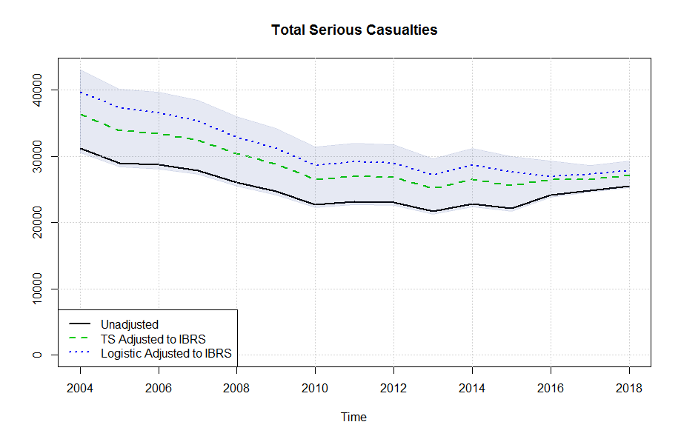
Figure 6: Total number of serious casualties in Great Britain by year. Shaded areas represent confidence intervals of the time-series method based on twice the estimated standard error of estimated discontinuity.
A similar analysis has been conducted with aggregate variables including road user type, sex and age. These comparisons have been used to ensure the quality and appropriateness of the adjustments from the logistic regression. The estimated adjustments using the logistic regression approach are tested for any evidence of a residual discontinuity by testing those series using the time series approach. In other words, the time-series approach is used to validate the results of the logistic regression approach, checking that no discontinuity remains.
For selected aggregation categories plots of the annual numbers of serious casualties are presented with estimated adjustments to both IBRS and NIBRS using both the time series and logistic regression approaches. A 95% confidence interval for the time series based adjustments is also presented. A selection of the graphs are shown in this section, with all charts and tables with results of test for remaining discontinuity presented in Annex D.
Road user type
Car occupants, motor cyclists, bus occupants, and pedal cyclist adjustments are very similar between the time-series and logistic regression, with no residual discontinuity found, providing confidence that the logistic regression approach is robust.
The other road user type categories show some marginal discontinuity after the logistic regression, however there is no statistically significant discontinuity, apart from HGV casualties which shows some small residual discontinuity.
The plot for the ‘other vehicle’ category has adjustments in the opposite direction for the logistic and time series approaches, although the time series approach does not find the discontinuity in the unadjusted series to be statistically significant at the 5% level. The underlying numbers for this category are small which can make the adjustments more volatile. Furthermore, the time-series adjustment has been adjusted down, which is not expected to happen.
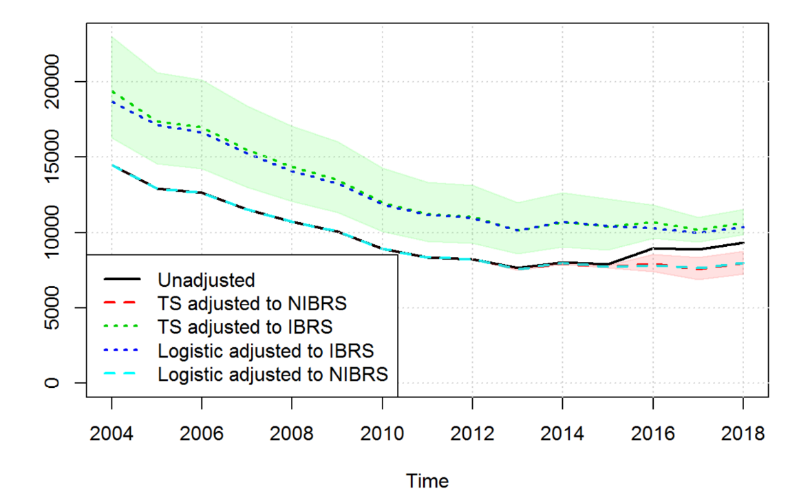
Graphs for car occupants, pedestrians, pedal cyclists, motor cyclists, and other vehicles are presented in this section, and bus, van, and HGV occupants are in Annex D.

Figure 7: Total number of serious car occupant casualties in Great Britain by year. Shaded areas represent confidence intervals based on twice the estimated standard error of estimated discontinuity
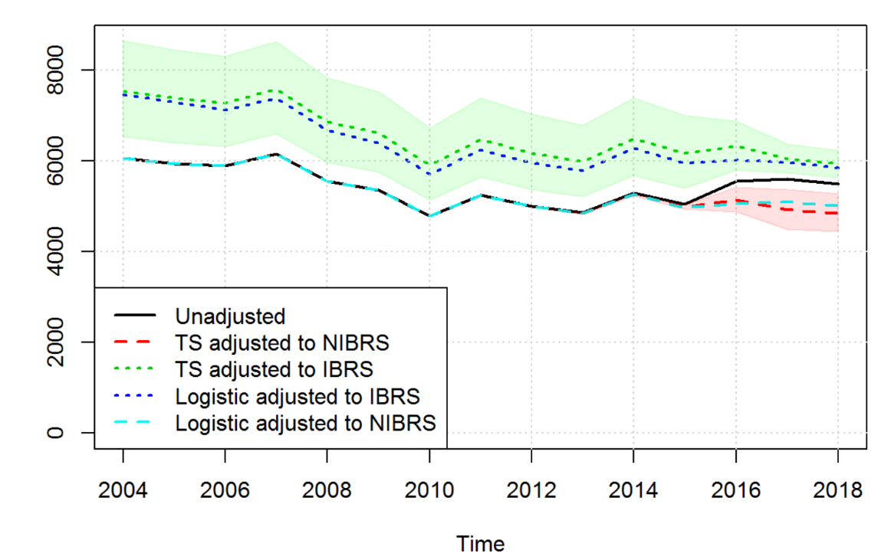

Figure 8: Total number of serious motor cyclist casualties in Great Britain by year. Shaded areas represent confidence intervals based on twice the estimated standard error of estimated discontinuity.

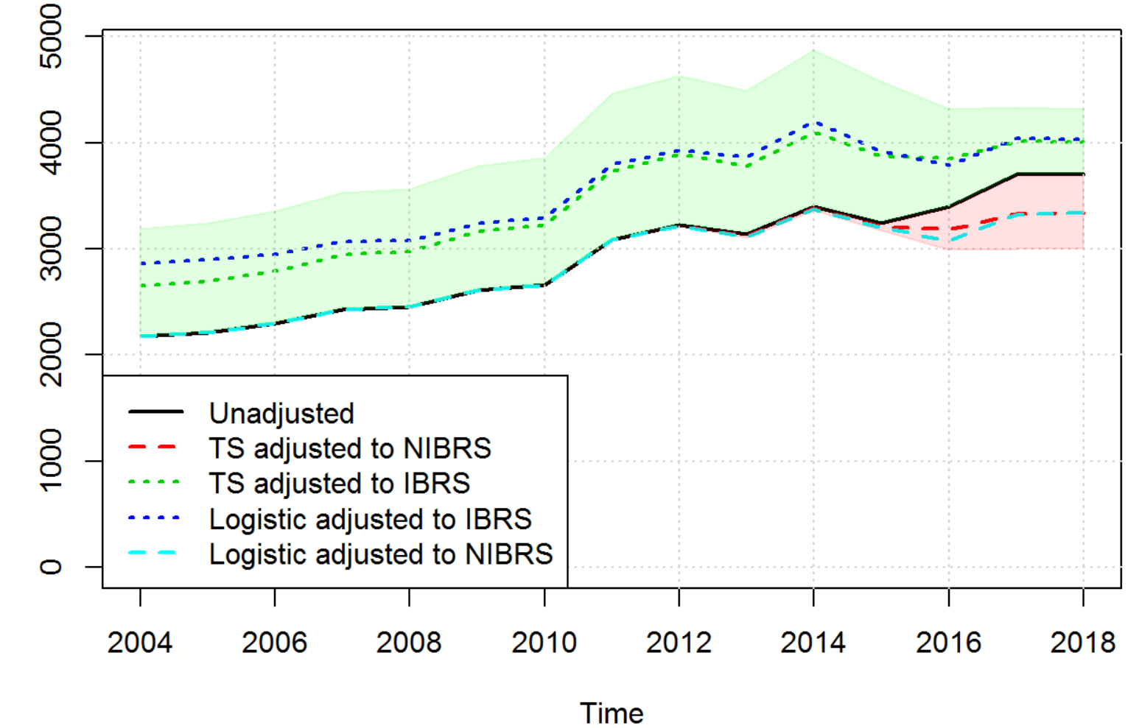

Figure 9: Total number of serious pedal cyclist casualties in Great Britain by year. Shaded areas represent confidence intervals based on twice the estimated standard error of estimated discontinuity.
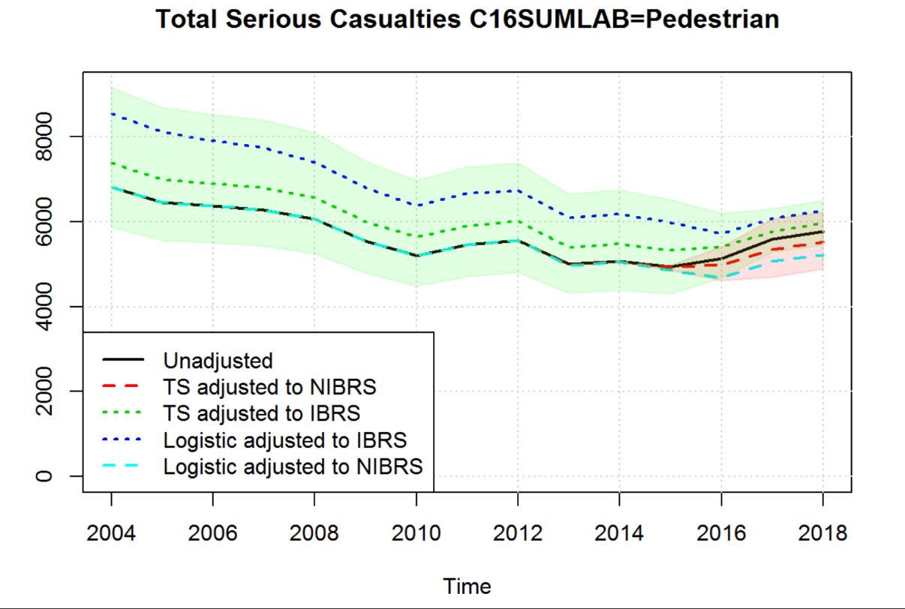

Figure 10: Total number of serious pedestrian casualties in Great Britain by year. Shaded areas represent confidence intervals based on twice the estimated standard error of estimated discontinuity.

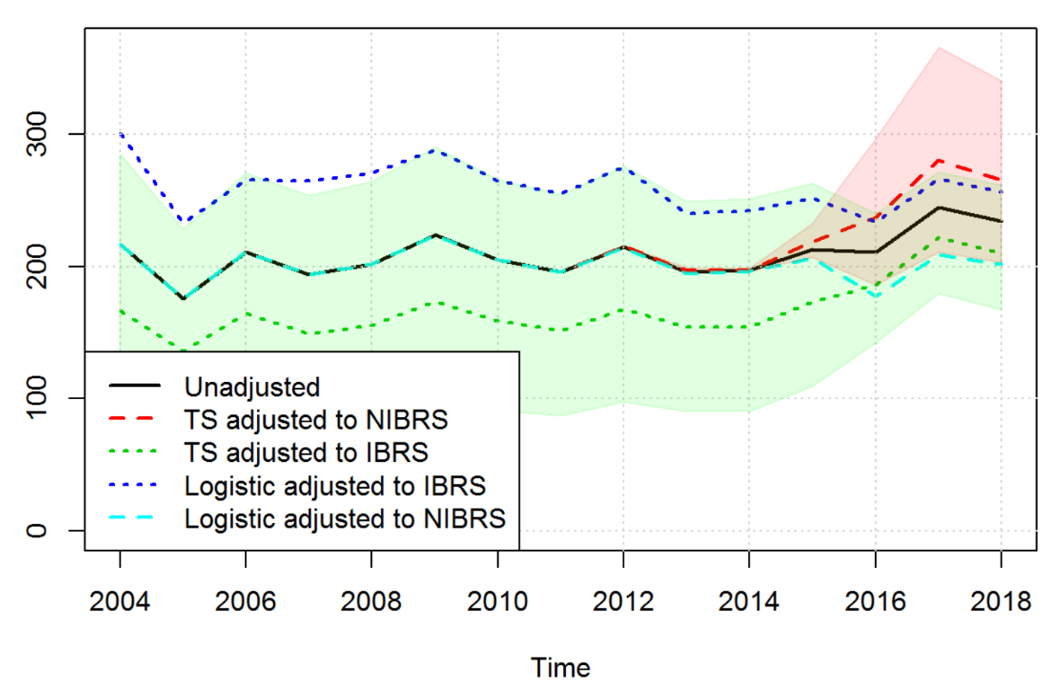

Figure 11: Total number of serious other vehicle casualties in Great Britain by year. Shaded areas represent confidence intervals based on twice the estimated standard error of estimated discontinuity.

Sex
There is no residual discontinuity for male or female logistic adjustments. There is some marginal discontinuity for males and females with the logistic adjustments being larger compared to the time series approach, the time series approach does not find the discontinuity in the unadjusted series to be statistically significant at the 5% level.

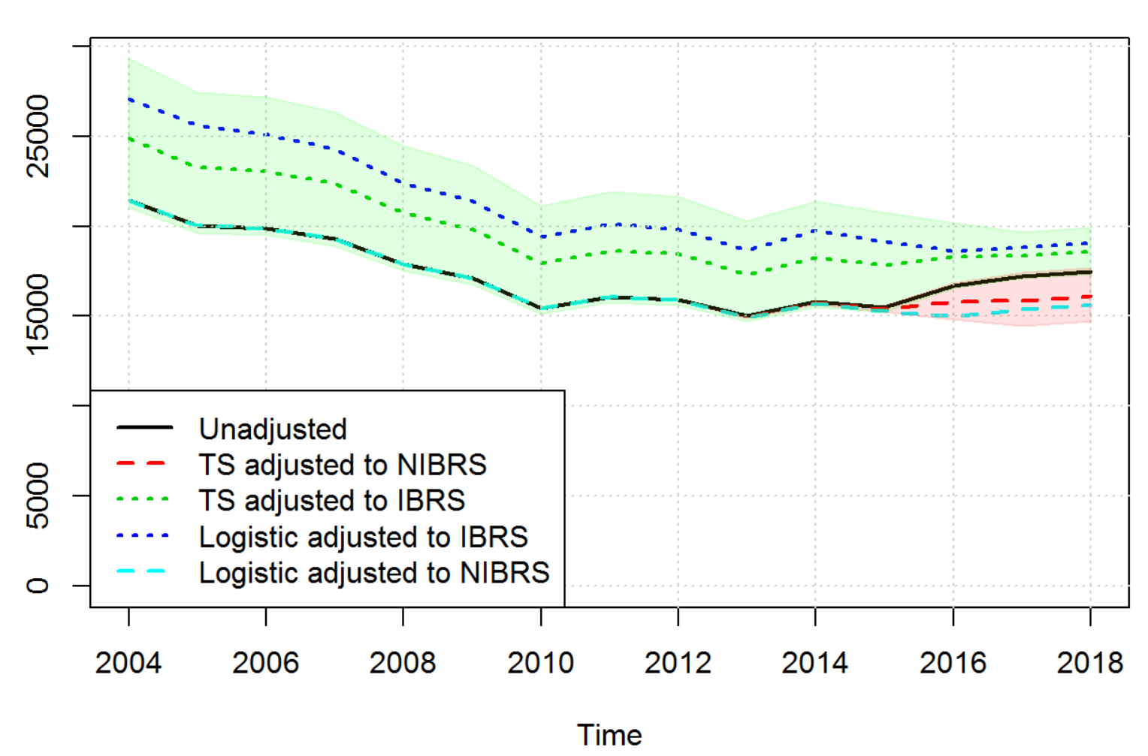

Figure 12: Total number of serious male casualties in Great Britain by year. Shaded areas represent confidence intervals based on twice the estimated standard error of estimated discontinuity.

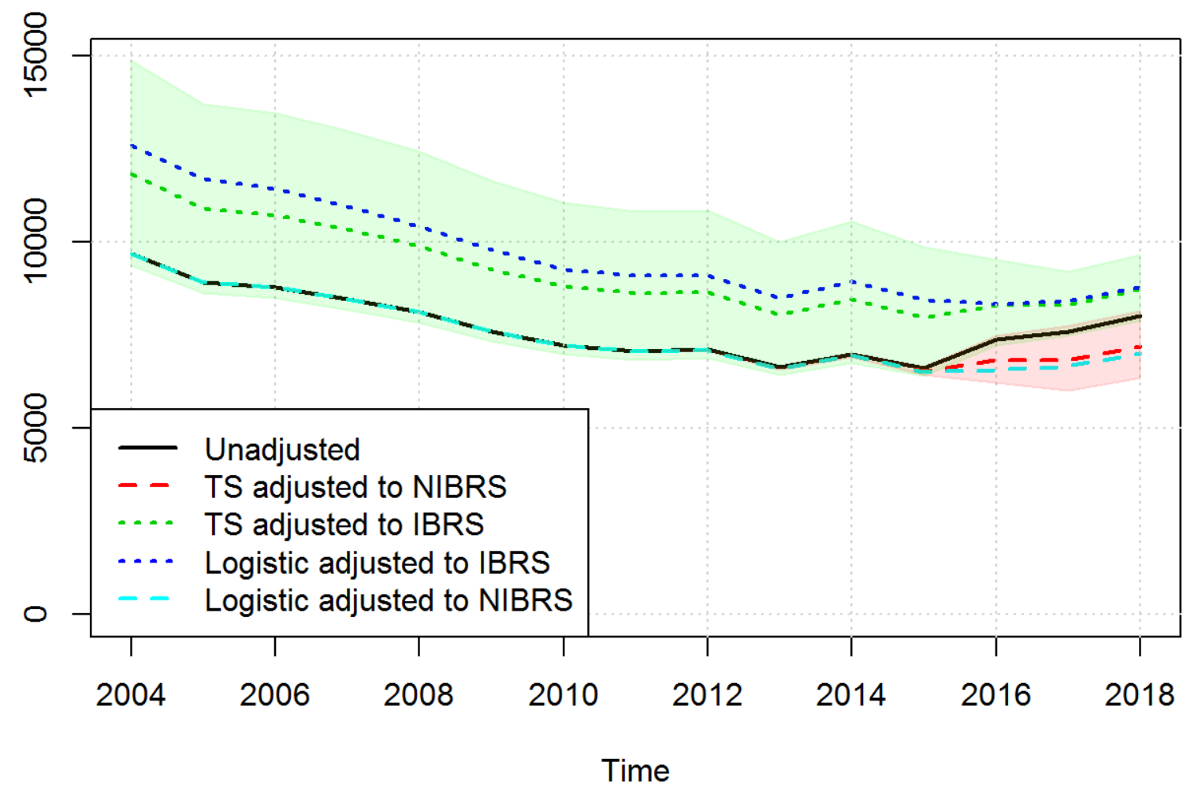

Figure 13: Total number of serious female casualties in Great Britain by year. Shaded areas represent confidence intervals based on twice the estimated standard error of estimated discontinuity.

Age
For most age bands (see charts in Annex D) the time series approach does not find the discontinuity in the unadjusted series to be statistically significant at the 5% level, most but not all categories appear to have a significant discontinuity in the unadjusted data according to the time series approach.
Some age groups have a larger adjustment using the logistic approach and some have a smaller adjustment compared to the time series approach. A few different age groups (e.g. 0-5 and 6-10) have negative t-values so negative correlation between the proportion of serious casualties and the proportion of casualties reported on IBRS for these age groups, which might be an indication of an over adjustment by the logistic approach.

In summary, the fact that most of the aggregate breakdowns are within the confidence intervals of the time-series approach instils confidence that the logistic adjustment method is a valid approach to use. Furthermore, the trends for both methods are broadly the same meaning the trends are likely to be accurate. It should be noted that the differences between the time-series and logistic approach have become smaller from the 2017 analysis to the 2018 analysis. It is expected with more years of data that the two approaches will become more stable and the differences will be even smaller. Moreover, the time series approach has used some default parameter selection for the models, and a more in-depth analysis of individual series could improve the time series estimates further. This has not been pursued at this stage as the focus has been on developing the logistic regression model.

8. Trends at Police Force Level
Examination of the data, and the logistic model fitted above, suggests that, contrary to expectations, some Police Forces do appear to have a trend (in P(‘serious’)) markedly different from average. Allowing individual trends for each force improves the model fit from a purely statistical viewpoint, but also considerably complicates it and makes interpretation more difficult. Importantly, because IBRS has been introduced only recently, the introduction of individual trends considerably affects the estimates of the effect of IBRS for individual forces. It also means that IBRS data will not contribute as much as pre-IBRS data to estimating the trends. If for example a previous trend has flattened off recently, this will be under-represented in the model.
As an example, suppose Force X has a downward trend in contrast to the overall (average) upward trend. Then in a model with just the overall trend, the IBRS effect will be underestimated, since the IBRS level (in the last few years) will be compared to a fitted line with the average gradient rather than with a fitted line with the specific Force X trend which is considerably lower.
If forces are to be ‘allowed’ their own trend, the question of what assumption to make for the trends of forces with no IBRS data also arises.
Further analysis is required, but broadly the effect of allowing individual trends for forces appears (from comparing a single global effect for IBRS) to be a moderate increase overall on estimates of the IBRS effect. Many forces (those close to the average slight upward trend) are little affected, but some – notably The Metropolitan Police (downward trend), and Gloucestershire and Devon & Cornwall (steeply upward trends) are strongly affected. The size of some of the estimated effects (with or without individual force trends) may be considered implausible – many of the estimates being an Odds Ratio of around 2 or more (i.e. roughly twice as likely to be rated ‘serious’ under IBRS as under NIBRS)
There is no ‘correct’ technical answer to these problems, since in large part the best answer depends on what is believed about trends and their causes, and the uses to which the data will be put. One possibility is to moderate more extreme estimates by developing a random-effects model, or by using Bayesian priors for effect sizes. This requires further work. A random-effects model might include random effects for severity reporting system for each police force, and is likely to include random slopes for police forces. This moderates individually fitted police force slopes towards the overall mean, by assuming the slopes are drawn from a common distribution. In any case, until there are many more years of IBRS data available it is unavoidable that assumptions about trend will strongly affect estimates of IBRS effect at force level for some forces, and to a lesser extent overall.

9. Conclusions
The logistic regression model helps to address some of the limitations from the time series approach as the time series approach only makes adjustment to aggregate level data, therefore requiring separate adjustments for any aggregate being analysed. Moreover, the time series approach does not provide adjustments at the casualty level which may cause problems for those analysing the data at this level. The logistic regression approach provides a set of probabilities which when summed can be used to provide consistent series and could also be used to generate datasets where binary response variables rather than probabilities might be required. This is an approach favoured by the key stakeholders consulted for the ability of the logistic regression approach to more easily produce adjustments at a local level.
However, while the logistic regression approach will ensure consistency in aggregation there is a risk that certain aggregates may not be appropriately adjusted for the discontinuity. Further analysis of this has been carried out in section 7. The time series approach is useful to highlight categories where the logistic regression approach is making a different adjustment and it is possible to evaluate the logistic regression-adjusted proportion of serious casualties for any evidence of residual discontinuity using the time series models discussed in this report. Understanding why the two approaches differ can help improve the modelling.
In making adjustments to improve comparability between casualty severities assessed using IBRS and NIBRS, the logistic regression approach has considerable advantages - principally by providing adjustment at casualty level and so allowing bespoke and local analyses (which is important to stakeholders) whilst ensuring consistency across analyses. It can also make due allowance for changing casualty characteristics. The estimated coefficients, for instance associated with modes of transport, are both credible and interesting. Comparisons with a time-series approach give similar results in most of the subgroups examined, while further examination of the reasons for differences between the two approaches will be of interest and may lead to model improvements. One subgrouping which is problematic is Police Force: there are unexplained differences in trends in P(‘serious’) between Forces, so in some Forces modelling local trends (or not) leads to large differences in estimated IBRS effect. Whether the current modelling assumptions are optimal, including for Forces which have not implemented IBRS, is not yet clear and changes may have a large impact on cross-Force comparisons and totals, less so on trends. But the variation in estimated effects of IBRS highlights the implicit variation between Forces in the meaning of ‘serious’ in NIBRS data.
Adjusting the data to be ‘as if’ IBRS was used is straightforward: each casualty has a modelled probability of being ’serious’ under IBRS (this will be 0 or 1 unless the casualty was assessed ‘slight’ under NIBRS), and these probabilities can be summed in tables to give frequencies, or used as weights, or as a predictive variable in other analyses, or to generate random datasets with ‘known’ severities, a similar process to that used in multiple imputation of missing values. A random effects model will be explored to investigate if this provides a better method of representing individual police force trends in order to produce local level severity adjustment breakdowns.

10. Way Forward
The Department for Transport and the Office for National Statistics would like to thank users for their feedback on the interim report released in September 2018, any feedback received has been addressed in this report. Users are still encouraged to provide feedback on the logistic regression approach, in particular the development of the police force trends in the logistic regression model for the September annual report. For any feedback, please contact the Road Safety Statistics team at: roadacc.stats@dft.gov.uk.
This report is published alongside the Road Safety Statistics Main Results 2018 publication where high-level adjustment figures for slight and serious casualties have been presented within publication tables alongside the police recorded figures. The adjustments are published for further breakdowns of slight and serious including speed limit, road class, casualty road user type, casualty age, and quarter. It is expected that these adjustments will need to be provided for each year that there are police forces using a non-injury based reporting system. When other police forces move over to an injury based reporting system, the model will be reviewed and this will be taken into account, which we expect would be for at least the next couple of years.
The Department for Transport and the Office for National Statistics will continue to investigate the development of police force trends in the logistic regression model and explore random effects with the aim of publishing police force breakdowns in the September annual report. Aside from this, for more detailed breakdowns on serious and slight injuries, the Department will wait to have three full years of data for injury reporting systems to produce detailed adjustments in tables. This is to ensure there is sufficient data to provide stable adjustments across the publication. Therefore, no further adjustment figures will be published in September 2019 beyond those identified above. With the September publication, the Department will also publish an extract of the adjusted probabilities on data.gov alongside the usual road safety open data extract for users to test and use themselves. This extract will provide record-level adjustment figures which can be aggregated to produce any breakdown.
References
DfT (2017). Reported Road Casualties Great Britain Annual Report 2017, Department for Transport. URL https://www.gov.uk/government/statistics/reported-road-casualties-great-britain-annual-report-2016
DfT (2018). Reported Road Casualties Great Britain Annual Report 2017, Department for Transport. URL https://www.gov.uk/government/statistics/reported-road-casualties-great-britain-annual-report-2017
Giovanni Petris (2010). An R Package for Dynamic Linear Models. Journal of Statistical Software, 36(12), 1-16. URL http://www.jstatsoft.org/v36/i12/.
Lyons, R., H. Ward, H. Brunt, S. Macey, R. Thoreau, O.G. Bodger and M. Woodford (2008). Using multiple datasets to understand trends in serious road traffic casualties, Accident Analysis & Prevention. URL. http://citeseerx.ist.psu.edu/viewdoc/download?doi=10.1.1.582.3987&rep=rep1&type=pdf
R Core Team (2017). R: A language and environment for statistical computing. R Foundation for Statistical Computing, Vienna, Austria. URL https://www.R-project.org/.
USCB (2016). X-13ARIMA-SEATS Reference Manual Version 1.1, Time Series Research Staff, Center for Statistical Research and Methodology, U.S. Census Bureau. URL. http://www.census.gov/srd/www/x13as/
Ward, H., R. Lyons, B. Gabbe, R. Thoreau, L. Pinder, and S. Macey (2010). Review of Police Road Casualty Injury Severity Classification – A Feasibility Study. Road Safety Research Report No. 119, Department for Transport. URL. http://webarchive.nationalarchives.gov.uk/20110131201606/http:/www.dft.gov.uk/pgr/roadsafety/research/rsrr/theme5/rs-rep119/pdf/report.pdf

Annex A: RegARIMA model
Following the notation used in X-13ARIMA-SEATS Reference Manual (USCB, 2016; Chapter 4) a seasonal regARIMA model can be fitted to an observed time series with regressors

where is the backshift operator (), is the seasonal period, which for the time series models tested in this report is equal to 12 as aggregates have been constructed on a monthly basis. is the non-seasonal autoregressive operator, is the seasonal autoregressive operator, is the non-seasonal moving average operator, is the seasonal moving average operator, and specify the order of non-seasonal and seasonal differencing respectively and are errors that are assumed to be independent and identically distributed with mean zero and variance .
The series for the models discussed in this report use a logistic transformation as it is proportions () that are being modelled. Hence .
As the main focus of the work is estimating a discontinuity based on the proportion of casualties recorded on the new system () where is the number of casualties recorded on the new system in period and is the total number of casualties recorded at period we can consider a simpler representation of the regARIMA model such that

Where represents an ARIMA process and the additional regressors may be outlier or calendar variables, see USCB (2016) chapter 4 for more details.
The order of the ARIMA models and the decision on whether to include outliers and calendar regressors were based on the default parameters for the outlier routine in X13 (USCB, 2016; Chapter 7.11) which is essentially a stepwise selection procedure or additive outliers and level shifts, the inclusion of trading day and Easter regressors based on AICC tests (USCB, 2016; Chapter 7.13) and the automatic selection of the order of the ARIMA model using the automdl procedure in X13 (USCB, 2016, Chapter 7.2). An example specification file for X13 is shown in box 1.
To obtain an estimated adjustment it is possible either to remove the discontinuity to make a consistent time series with the older severity-based system or to adjust the series to make it consistent with an assumption that all casualties were recorded on the newer injury-based system. In both cases the estimated coefficient () from the regARIMA model and it’s estimated standard error can be used for the adjustment and forming of confidence intervals.
To obtain an estimated number of serious casualties that assumes all periods are consistent with the older severity-based system, adjusted proportions are derived as

And then an adjusted estimate of the number of serious casualties () given by with adjusted estimates of the number of slight casualties () given by .
To obtain an estimated number of serious casualties that assumes all periods are consistent with assuming all casualties are recorded on the newer injury-based system, adjusted proportions are derived as

Then adjusted estimates of serious () and slight () are derived from the adjusted proportions and total number of casualties.

Box 1: Example specification file for X13

series{
title = "y"
file = "C:\Users\elliod\AppData\Local\Temp\RtmpeGS2sx\x13a845051246/data.dta"
format = "datevalue"
period = 12
}

transform{
function = logistic
}

regression{
aictest = (td easter)
user = xreg1
file = "C:\Users\elliod\AppData\Local\Temp\RtmpeGS2sx\x13a845051246/xreg.dta"
format = "datevalue"
}

outlier{
}

automdl{
}

RegARIMA model outputs
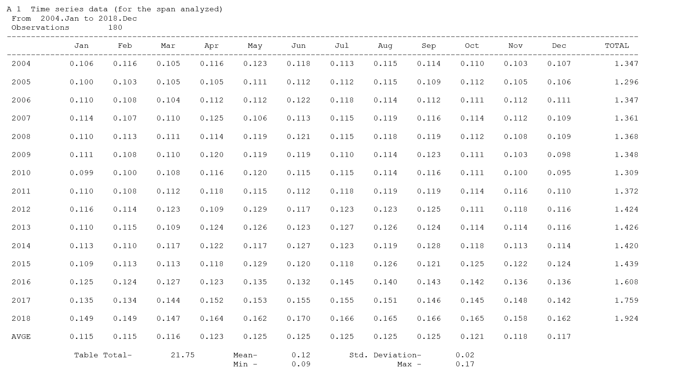
Automatic ARIMA Model Selection

Procedure based closely on TRAMO method of Gomez and Maravall (2000)
"Automatic Modeling Methods for Univariate Series",
A Course in Time Series (Edited by D. Pena, G. C. Tiao, R. S. Tsay),
New York : J. Wiley and Sons

Maximum order for regular ARMA parameters : 2
Maximum order for seasonal ARMA parameters : 1
Maximum order for regular differencing : 2
Maximum order for seasonal differencing : 1

Results of Unit Root Test for identifying orders of differencing:
Regular difference order : 1
Seasonal difference order : 0

Mean is not significant.

Best Five ARIMA Models

Model # 1 : (0 1 1)(1 0 1) (BIC = -3.070)
Model # 2 : (1 1 1)(1 0 1) (BIC = -3.041)
Model # 3 : (0 1 2)(1 0 1) (BIC = -3.041)
Model # 4 : (2 1 1)(1 0 1) (BIC = -3.017)
Model # 5 : (1 1 2)(1 0 1) (BIC = -3.014)

Automatic model choice : (0 1 1)(1 0 1)
Model changed to
( 0, 1, 1) ( 0, 1, 1) with constant term

Final Checks for Identified Model

Checking for Unit Roots.
No unit roots found.

Checking for nonseasonal overdifferencing.
Nonseasonal MA not within 0.001 of 1.0 - model passes test.

Checking for insignificant ARMA coefficients.

Final automatic model choice : (0 1 1)(0 1 1)
End of automatic model selection procedure.

Average absolute percentage error in within-sample forecasts:
Last year: 3.96 Last-1 year: 2.53 Last-2 year: 3.43
Last three years: 3.31

Estimation converged in 21 ARMA iterations, 87 function evaluations.

Regression Model
------------------------------------------------------------------------------
Parameter Standard
Variable Estimate Error t-value
------------------------------------------------------------------------------
User-defined
xreg1 0.1755 0.09922 1.77

Constant 0.0006 0.00020 2.84
------------------------------------------------------------------------------

ARIMA Model: (0 1 1)(0 1 1)
Nonseasonal differences: 1
Seasonal differences: 1
Standard
Parameter Estimate Errors
-----------------------------------------------------
Nonseasonal MA
Lag 1 0.7749 0.04514

Seasonal MA
Lag 12 1.0000 0.05560

Variance 0.19493E-02
SE of Var 0.21332E-03
-----------------------------------------------------

Likelihood Statistics
------------------------------------------------------------------
Number of observations (nobs) 180
Effective number of observations (nefobs) 167
Number of parameters estimated (np) 5
Log likelihood 267.3857
Transformation Adjustment 374.8936
Adjusted Log likelihood (L) 642.2793
AIC -1274.5586
AICC (F-corrected-AIC) -1274.1859
Hannan Quinn -1268.2310
BIC -1258.9686
------------------------------------------------------------------

DIAGNOSTIC CHECKING
Sample Autocorrelations of the Residuals with the Ljung-Box diagnostic.

Lag 1 2 3 4 5 6 7 8 9 10 11 12
ACF -0.00 0.03 -0.02 -0.09 -0.05 0.05 0.01 0.02 0.03 0.12 0.08 0.02
SE 0.08 0.08 0.08 0.08 0.08 0.08 0.08 0.08 0.08 0.08 0.08 0.08
Q 0.00 0.20 0.27 1.55 2.03 2.50 2.54 2.60 2.80 5.54 6.84 6.89
DF 0 0 1 2 3 4 5 6 7 8 9 10
P 0.000 0.000 0.606 0.461 0.566 0.645 0.771 0.857 0.902 0.699 0.653 0.736

Lag 13 14 15 16 17 18 19 20 21 22 23 24
ACF -0.01 -0.00 -0.13 0.16 0.10 0.01 -0.03 -0.04 -0.11 0.07 -0.11 -0.11
SE 0.08 0.08 0.08 0.08 0.08 0.08 0.08 0.08 0.08 0.09 0.09 0.09
Q 6.91 6.92 9.93 14.96 16.84 16.88 17.01 17.39 19.58 20.56 22.94 25.44
DF 11 12 13 14 15 16 17 18 19 20 21 22
P 0.806 0.863 0.699 0.381 0.329 0.394 0.454 0.496 0.420 0.424 0.347 0.277

The P-values approximate the probability of observing a Q-value at least
this large when the model fitted is correct. When DF is positive, small
values of P, customarily those below 0.05, indicate model inadequacy.

Sample Autocorrelations of the Residuals
-1.0 -0.8 -0.6 -0.4 -0.2 0.0 0.2 0.4 0.6 0.8 1.0
+----+----+----+----+----+----+----+----+----+----+
1 . | . -0.004
2 . |X . 0.034
3 . | . -0.019
4 . XX| . -0.086
5 . X| . -0.052
6 . |X . 0.052
7 . | . 0.015
8 . | . 0.019
9 . |X . 0.034
10 . |XXX. 0.123
11 . |XX . 0.085
12 - - - - - - - - - . | . - - - - - - - - 0.016
13 . | . -0.012
14 . | . -0.002
15 .XXX| . -0.128
16 . |XXXX 0.164
17 . |XX . 0.100
18 . | . 0.015
19 . X| . -0.027
20 . X| . -0.045
21 .XXX| . -0.106
22 . |XX . 0.071
23 .XXX| . -0.110
24 - - - - - - - - - .XXX| . - - - - - - - - -0.113

Sample Partial Autocorrelations of the Residuals

Lag 1 2 3 4 5 6 7 8 9 10 11 12
PACF -0.00 0.03 -0.02 -0.09 -0.05 0.06 0.02 0.01 0.03 0.13 0.10 0.01
SE 0.08 0.08 0.08 0.08 0.08 0.08 0.08 0.08 0.08 0.08 0.08 0.08

Lag 13 14 15 16 17 18 19 20 21 22 23 24
PACF -0.01 0.03 -0.10 0.16 0.10 -0.01 -0.06 -0.05 -0.09 0.06 -0.14 -0.16
SE 0.08 0.08 0.08 0.08 0.08 0.08 0.08 0.08 0.08 0.08 0.08 0.08

Sample Partial Autocorrelations of the Residuals
-1.0 -0.8 -0.6 -0.4 -0.2 0.0 0.2 0.4 0.6 0.8 1.0
+----+----+----+----+----+----+----+----+----+----+
1 . | . -0.004
2 . |X . 0.034
3 . | . -0.019
4 . XX| . -0.088
5 . X| . -0.052
6 . |X . 0.057
7 . | . 0.016
8 . | . 0.006
9 . |X . 0.026
10 . |XXX. 0.132
11 . |XX . 0.097
12 - - - - - - - - - . | . - - - - - - - - 0.011
13 . | . -0.009
14 . |X . 0.025
15 .XXX| . -0.105
16 . |XXXX 0.161
17 . |XXX. 0.104
18 . | . -0.007
19 . XX| . -0.062
20 . X| . -0.052
21 . XX| . -0.089
22 . |XX . 0.061
23 .XXX| . -0.136
24 - - - - - - - - - XXXX| . - - - - - - - - -0.157

Sample Autocorrelations of the Squared Residuals with the Ljung-Box diagnostic.

Lag 1 2 3 4 5 6 7 8 9 10 11 12
ACF 0.21 -0.05 0.02 -0.03 0.03 0.02 -0.06 -0.13 -0.05 -0.04 0.13 0.02
SE 0.08 0.08 0.08 0.08 0.08 0.08 0.08 0.08 0.08 0.08 0.08 0.08
Q 7.36 7.71 7.76 7.96 8.09 8.20 8.86 11.82 12.32 12.59 15.77 15.88
DF 0 0 1 2 3 4 5 6 7 8 9 10
P 0.000 0.000 0.005 0.019 0.044 0.085 0.115 0.066 0.091 0.127 0.072 0.103

Lag 13 14 15 16 17 18 19 20 21 22 23 24
ACF -0.07 -0.03 0.03 0.14 0.07 -0.05 -0.08 -0.14 -0.12 -0.09 -0.00 -0.10
SE 0.08 0.08 0.08 0.08 0.09 0.09 0.09 0.09 0.09 0.09 0.09 0.09
Q 16.85 17.03 17.16 20.79 21.63 22.07 23.17 27.00 29.78 31.29 31.29 33.35
DF 11 12 13 14 15 16 17 18 19 20 21 22
P 0.112 0.148 0.192 0.107 0.118 0.141 0.144 0.079 0.055 0.052 0.069 0.057

The P-values approximate the probability of observing a Q-value at least
this large when the model fitted is correct in a way that supports the
standard interpretations of the test statistics, standard errors, and
prediction intervals output by X-13ARIMA-SEATS. When DF is positive, small
values of P, customarily those below 0.05, suggest that model-based
inferences about statistical significance and uncertainty will be less
dependable than usual.
Sample Autocorrelations of the Squared Residuals
-1.0 -0.8 -0.6 -0.4 -0.2 0.0 0.2 0.4 0.6 0.8 1.0
+----+----+----+----+----+----+----+----+----+----+
1 . |XXXXX 0.208
2 . X| . -0.045
3 . | . 0.017
4 . X| . -0.033
5 . |X . 0.028
6 . |X . 0.024
7 . XX| . -0.061
8 .XXX| . -0.129
9 . X| . -0.053
10 . X| . -0.039
11 . |XXX. 0.133
12 - - - - - - - - - . |X . - - - - - - - - 0.024
13 . XX| . -0.073
14 . X| . -0.032
15 . |X . 0.026
16 . |XXX. 0.139
17 . |XX . 0.067
18 . X| . -0.048
19 . XX| . -0.076
20 XXXX| . -0.141
21 .XXX| . -0.120
22 . XX| . -0.088
23 . | . -0.002
24 - - - - - - - - - .XXX| . - - - - - - - - -0.102

Histogram of the Standardized and Mean-Centered Residuals
Standard
Deviations Frequency

Outlier [##

-3 +#
|##
-2 +########
|#########
-1 +#############
|#########################
0 +########################################
|###############################
1 +####################
|###########
2 +#####
|
3 +

One '#'= 1 observation[s]

Residuals with |t|>3.25

Obs t-value
-----------------
2006.Apr -3.61
2011.Mar -3.36

Summary Statistics for the Unstandardized Residuals
Minimum -0.144
Maximum 0.089
Median 0.003
Robust Std Dev 0.041

Normality Statistics for regARIMA Model Residuals:

Number of residuals : 167

Skewness coefficient : -0.6432 (significant negative skewness at one percent level)
Geary's a : 0.7639
Kurtosis : 3.6721

Significant skewness has been detected in the model residuals;
this makes the Geary's a and Kurtosis statistics unreliable indicators
of the normality of the residuals.

Durbin-Watson Statistic for regARIMA Model Residuals:
dw = 2.003537

Friedman Non-Parametric Test for regARIMA Model Residuals:
ken = 4.029586 ( Asymptotically distributed as Chi-Square(11), P-Value = 0.969044 )

QS Statistic for regARIMA Model Residuals (full series): 0.04
(P-Value = 0.9791)

QS Statistic for regARIMA Model Residuals (starting 2011.Jan): 0.00
(P-Value = 1.0000)

Annex B: Adjusting to IBRS
This Annex provides an in-depth explanation of the method of adjusting data to IBRS.
- The Logistic regression provides estimates for each casualty of the probability the severity is serious, either under NIBRS or IBRS. Even if the model is not very predictive, if the model is reasonably valid (i.e. the residuals are suitably random) these probabilities will be well calibrated for cells defined by the model variables – i.e. the aggregated probabilities will fit well to the cell-observations. For analyses at an aggregated level (e.g. total serious casualties, or total serious casualties by vehicle type etc) we could simply aggregate the model probabilities to give ‘expected counts’. However, note that what we actually want to do, at an individual casualty level, is predict what the status of the casualty would have been using the alternative RS to that which was actually used. It is clear from the opinions of subject-matter experts that there is a lot of information (far more than in the logistic model) about this in the actual recorded severity of a casualty - & this information is not being used if we only use the model probabilities.
  - The table below represents probabilities for casualties with a particular combination of values of the explanatory variables in the logistic model. In the table the + column indicates recorded as ‘serious’ under IBRS, the - row indicates recorded as ‘slight’ under NIBRS etc. We have no direct evidence to fill in the body of the 2x2 table as no casualties have been assessed using both systems. The logistic regression model effectively provides the marginal probabilities, but what we want are transition probabilities i.e. the probability that a slight casualty under NIBRS becomes serious under IBRS etc – these come from the body of the table i.e. b/(a+b). We can also require that the marginal probabilities of the table match those from the logistic model, which will ensure that when casualties are aggregated up the information from the logistic model is included. Given the marginals there is only one degree of freedom, so choosing any one of a-d fixes the remainder (& of course we require that none are negative). How to choose (say) d ? Yule’s Q is a measure of agreement of two rating-systems = (ad-bc)/(ad+bc), similar in nature to a correlation coefficient. If we can assume a value (or even a distribution) for Q (from expert opinion), then we can ‘solve’ the table to give a valid value (or distribution) for d, & hence all the transition probabilities, and hence the probability for each casualty that it would be rated ‘serious’ under the alternate RS. The current model assumes Q to be 1 – but note this does not result in an upward bias as might be feared, as the marginal probabilities (from the logistic model) are still kept.
  - There is an advantage to doing this calculation for each casualty and aggregating up to whatever level, rather than simply using the probabilities from the logistic model. Using the considerable information from the actual casualty status to determine the predicted status will mean analyses are more robust, even if the logistic model is in a sense not a good one (e.g. omits an important variable, maybe because it wasn’t available) – since most of the information on the estimated ‘serious’ casualties (under IBRS) will be derived from the observed ‘serious casualties’ (under NIBRS) plus the assumption of a high value for Q.

 | IBRS
NIBRS |  | - | +
NIBRS | - | a | b | 1-P(NIBR)
NIBRS | + | c | d | P(NIBR)
 |  | 1-P(IBR) | P(IBR) | 1

  - For example, suppose a particular casualty is rated ‘Slight’ under a NIBRS, and the (well calibrated) logistic regression gives probabilities that a casualty with the same characteristics would be ‘Serious’ as 0.14 (under NIBRS) and 0.16 (under IBRS). Then assuming we choose Q=1 (i.e. maximum agreement between NIBRS & IBRS compatible with the logistic regression) we get the table below. From this table, the probability this casualty is rated ‘Serious’ under an IBRS is 0.02/0.86. The requirement for the logistic model to be well calibrated ensures that of IBRS casualties with similar characteristics (i.e. matching values of the variables in the regression), 86% will be ‘Slight’ and 14% ‘Serious’, so that the transition probabilities implied by the table will result in the predicted 84% ‘Slight’ and 16% ‘Serious’ under IBRS.
 | IBRS
NIBRS |  | - | +
NIBRS | - | 0.84 | 0.02 | 0.86
NIBRS | + | 0 | 0.14 | 0.14
 |  | 0.84 | 0.16 | 1

- The process above provides estimates for each casualty of the probability the severity is serious, either under NIBRS or IBRS. The obvious question is how to use these probabilities in analyses?
  - The probabilities can be used in analyses ‘as is’. For instance, in producing tables, or in some more sophisticated analyses that properly allow weighting, they can be used as weights. However some analyses or statistical packages do not easily allow weights in this way (e.g. logistic regression)
  - The probabilities can be used to generate a set of datasets – in each dataset each casualty will be either Serious or Slight, this being determined using an independently generated (pseudo) random number and the model P(Serious) for that casualty. The multiple datasets can each be used in any type of analysis whatsoever, and the spread of results (across the multiple datasets) used to describe some of the uncertainty arising from the adjustment process (but not the major uncertainty arising from the variety of ways that could have been chosen to perform adjustment).

Annex C Logistic regression model outputs
This annex provides the logistic regression model output, and the calculated odds ratios from the model. Most variables were simplified from the form present in the dataset, primarily to allow the model to run with the software/hardware being used, but also to make understanding and interpreting the model easier.
Logistic regression model output
Deviance Residuals:
Min | 1Q | Median | 3Q | Max
-1.9989 | -0.5471 | -0.3570 | -0.2052 | 3.5600

Coefficients: (5 not defined because of singularities)
 |  | Estimate | Std. Error | z value | Pr(>|z|)
(Intercept) |  | -3.16E+00 | 6.81E-01 | -4.642 | 3.46E-06 | ***
C16SUMLABBus Occupant |  | -5.75E-03 | 4.21E-02 | -0.136 | 0.891558
C16SUMLABHGV Occupant |  | 3.64E-01 | 2.02E-02 | 18.011 | < 2e-16 | ***
C16SUMLABMotor Cyclist |  | 1.90E+00 | 6.51E-03 | 291.618 | < 2e-16 | ***
C16SUMLABOtherVehOccupant |  | 9.30E-01 | 2.08E-02 | 44.746 | < 2e-16 | ***
C16SUMLABPedal Cyclist |  | 1.59E+00 | 9.36E-03 | 169.637 | < 2e-16 | ***
C16SUMLABPedestrian |  | 1.83E+00 | 8.74E-03 | 209.716 | < 2e-16 | ***
C16SUMLABVan Occupant |  | 1.07E-01 | 1.44E-02 | 7.475 | 7.73E-14 | ***
VMbend |  | 7.99E-02 | 6.07E-03 | 13.151 | < 2e-16 | ***
VMparked |  | -9.30E-02 | 2.05E-02 | -4.544 | 5.52E-06 | ***
VMslow |  | -1.93E-01 | 5.96E-03 | -32.416 | < 2e-16 | ***
VMstationary slowing |  | -6.44E-01 | 8.85E-03 | -72.759 | < 2e-16 | ***
VLCother |  | 3.71E-01 | 7.33E-03 | 50.55 | < 2e-16 | ***
VLCst or cross |  | 6.39E-01 | 1.92E-02 | 33.233 | < 2e-16 | ***
Skidother |  | 1.30E-01 | 5.14E-03 | 25.294 | < 2e-16 | ***
Impactnone |  | -3.37E-02 | 9.29E-03 | -3.623 | 0.000291 | ***
Impactrear |  | -5.97E-01 | 7.97E-03 | -74.866 | < 2e-16 | ***
Impactside |  | -1.39E-01 | 4.32E-03 | -32.183 | < 2e-16 | ***
Speed20 |  | -4.68E-02 | 1.35E-02 | -3.468 | 0.000524 | ***
Speed40 |  | 2.47E-01 | 7.29E-03 | 33.896 | < 2e-16 | ***
Speed50 |  | 3.73E-01 | 1.06E-02 | 35.096 | < 2e-16 | ***
Speed60 |  | 4.53E-01 | 6.95E-03 | 65.146 | < 2e-16 | ***
Speed70 |  | 2.89E-01 | 1.10E-02 | 26.365 | < 2e-16 | ***
HitOffother |  | 3.56E-02 | 8.44E-03 | 4.222 | 2.42E-05 | ***
HitOfftree etc |  | 4.14E-01 | 1.03E-02 | 40.289 | < 2e-16 | ***
HitInother |  | 9.47E-02 | 8.55E-03 | 11.071 | < 2e-16 | ***
HitInsubstantial |  | 2.01E-01 | 1.37E-02 | 14.733 | < 2e-16 | ***
BusSb not seated |  | 8.54E-01 | 4.66E-02 | 18.327 | < 2e-16 | ***
BusSc seated |  | -2.98E-01 | 4.61E-02 | -6.467 | 9.98E-11 | ***
WeatherSb Rain |  | -1.22E-01 | 6.99E-03 | -17.431 | < 2e-16 | ***
WeatherSc Snow |  | -1.20E-01 | 3.03E-02 | -3.964 | 7.38E-05 | ***
WeatherSd missing/other |  | -7.86E-02 | 1.07E-02 | -7.335 | 2.22E-13 | ***
WeatherSe fog |  | -6.28E-02 | 2.42E-02 | -2.596 | 0.009436 | **
VAgeGrpa 1-5 |  | 4.19E-03 | 1.01E-02 | 0.416 | 0.677374
VAgeGrpb 6-10 |  | 5.14E-02 | 1.02E-02 | 5.047 | 4.48E-07 | ***
VAgeGrpc 11-15 |  | 1.50E-01 | 1.06E-02 | 14.137 | < 2e-16 | ***
VAgeGrpd 16+ |  | 2.47E-01 | 1.28E-02 | 19.265 | < 2e-16 | ***
VAgeGrpe missing |  | 1.11E-01 | 1.11E-02 | 10.018 | < 2e-16 | ***
RdTypeSb Other |  | -1.52E-01 | 8.69E-03 | -17.503 | < 2e-16 | ***
X1RoadSb Other |  | 2.39E-01 | 1.31E-02 | 18.266 | < 2e-16 | ***
X2RoadSb Major |  | -5.46E-02 | 2.17E-02 | -2.514 | 0.011921 | *
X2RoadSc Minor |  | 3.60E-03 | 2.06E-02 | 0.175 | 0.861151
SpecialCSb other |  | -1.51E-01 | 1.22E-02 | -12.387 | < 2e-16 | ***
RoadSurfSb Wet |  | -6.02E-03 | 5.30E-03 | -1.136 | 0.256101
RoadSurfSc Snow |  | -3.03E-01 | 3.50E-02 | -8.646 | < 2e-16 | ***
RoadSurfSd other / missing |  | -2.67E-01 | 1.36E-02 | -19.669 | < 2e-16 | ***
PedLocSb at nr Zebra |  | 8.17E-02 | 6.80E-01 | 0.12 | 0.90444
PedLocSc Carriageway DK |  | -1.70E-02 | 6.80E-01 | -0.025 | 0.980032
PedLocSd Footpath |  | -4.06E-01 | 6.80E-01 | -0.596 | 0.55088
JdetailSb T Junc |  | -9.84E-02 | 2.10E-02 | -4.681 | 2.85E-06 | ***
JdetailSc other |  | -1.43E-01 | 2.03E-02 | -7.042 | 1.90E-12 | ***
JdetailSd slip rd |  | -1.05E-01 | 2.69E-02 | -3.913 | 9.12E-05 | ***
JdetailSe roundabout |  | -2.87E-01 | 2.31E-02 | -12.441 | < 2e-16 | ***
DvrSex2 |  | -1.12E-01 | 5.47E-03 | -20.438 | < 2e-16 | ***
DvrSex3 |  | -2.55E-01 | 1.30E-02 | -19.587 | < 2e-16 | ***
DvrAgeBdb 16-25 |  | 3.62E-02 | 6.40E-03 | 5.646 | 1.64E-08 | ***
DvrAgeBdc 66+ |  | -6.30E-02 | 9.15E-03 | -6.886 | 5.72E-12 | ***
JnyPurpSb school |  | -1.50E-01 | 1.81E-02 | -8.304 | < 2e-16 | ***
JnyPurpSc other |  | 1.08E-01 | 4.99E-03 | 21.562 | < 2e-16 | ***
TimeZoneCommute pm |  | 5.44E-02 | 1.52E-02 | 3.586 | 0.000336 | ***
TimeZoneearly |  | 1.65E-01 | 1.48E-02 | 11.155 | < 2e-16 | ***
TimeZoneevening |  | 9.67E-02 | 1.90E-02 | 5.1 | 3.39E-07 | ***
TimeZonelate |  | 1.30E-02 | 2.39E-02 | 0.544 | 0.586364
TimeZoneMiddle of day |  | 1.62E-02 | 1.34E-02 | 1.206 | 0.227781
CosTim |  | -2.78E-02 | 9.09E-03 | -3.055 | 0.002252 | **
Cos2Tim |  | -1.14E-01 | 6.04E-03 | -18.86 | < 2e-16 | ***
SinTim |  | -3.01E-01 | 1.13E-02 | -26.584 | < 2e-16 | ***
Sin2Tim |  | -3.00E-02 | 4.92E-03 | -6.093 | 1.11E-09 | ***
YearN |  | 2.98E-02 | 1.49E-03 | 20.074 | < 2e-16 | ***
YearN2 |  | 2.00E-03 | 1.25E-04 | 16.066 | < 2e-16 | ***
POattendNo |  | -6.77E-01 | 6.32E-03 | -107.033 | < 2e-16 | ***
POattendSelf-Report |  | -7.11E-01 | 5.35E-02 | -13.287 | < 2e-16 | ***
VRefb second |  | -1.70E-01 | 5.18E-03 | -32.75 | < 2e-16 | ***
VRefc other |  | -4.04E-01 | 1.45E-02 | -27.842 | < 2e-16 | ***
CRefb second |  | -1.12E-01 | 7.05E-03 | -15.881 | < 2e-16 | ***
CRefc other |  | -1.69E-01 | 9.78E-03 | -17.248 | < 2e-16 | ***
Age_Band_of_Casualty1 |  | -1.38E-01 | 1.39E-02 | -9.942 | < 2e-16 | ***
Age_Band_of_Casualty2 |  | -1.68E-01 | 1.32E-02 | -12.7 | < 2e-16 | ***
Age_Band_of_Casualty3 |  | -1.07E-01 | 1.02E-02 | -10.523 | < 2e-16 | ***
Age_Band_of_Casualty4 |  | -1.77E-01 | 8.09E-03 | -21.899 | < 2e-16 | ***
Age_Band_of_Casualty5 |  | -8.48E-02 | 7.87E-03 | -10.774 | < 2e-16 | ***
Age_Band_of_Casualty7 |  | 3.69E-02 | 6.83E-03 | 5.406 | 6.44E-08 | ***
Age_Band_of_Casualty8 |  | 8.74E-02 | 9.12E-03 | 9.579 | < 2e-16 | ***
Age_Band_of_Casualty9 |  | 1.28E-01 | 1.43E-02 | 8.984 | < 2e-16 | ***
Age_Band_of_Casualty10 |  | 2.22E-01 | 2.27E-02 | 9.802 | < 2e-16 | ***
Age_Band_of_Casualty11 |  | 2.90E-01 | 3.50E-02 | 8.305 | < 2e-16 | ***
CasAgeN2 |  | 2.07E-04 | 1.00E-05 | 20.664 | < 2e-16 | ***
Sex_of_Casualty2 |  | -6.70E-02 | 5.00E-03 | -13.404 | < 2e-16 | ***
Sex_of_Casualty3 |  | -6.72E-01 | 1.53E-01 | -4.403 | 1.07E-05 | ***
NofVsGroupxx |  | 8.97E-04 | 6.50E-03 | 0.138 | 0.890342
NofVsGroupxxx+ |  | 2.02E-01 | 8.92E-03 | 22.678 | < 2e-16 | ***
NofCsGroupxx |  | 1.13E-01 | 6.29E-03 | 17.898 | < 2e-16 | ***
NofCsGroupxxx+ |  | 4.70E-01 | 7.85E-03 | 59.838 | < 2e-16 | ***
UrbanUrban |  | -1.96E-01 | 5.84E-03 | -33.665 | < 2e-16 | ***
PFlabelAvon and Somerset |  | 6.66E-02 | 1.86E-02 | 3.585 | 0.000337 | ***
PFlabelBedfordshire |  | 9.22E-02 | 3.50E-02 | 2.638 | 0.008343 | **
PFlabelCambridgeshire |  | 2.78E-01 | 1.93E-02 | 14.42 | < 2e-16 | ***
PFlabelCentral |  | 7.04E-01 | 3.02E-02 | 23.292 | < 2e-16 | ***
PFlabelCheshire |  | 4.61E-01 | 1.87E-02 | 24.7 | < 2e-16 | ***
PFlabelCity of London |  | 2.52E-02 | 4.22E-02 | 0.597 | 0.550355
PFlabelCleveland |  | 4.57E-01 | 2.62E-02 | 17.446 | < 2e-16 | ***
PFlabelCumbria |  | 3.26E-01 | 2.73E-02 | 11.958 | < 2e-16 | ***
PFlabelDerbyshire |  | 3.29E-01 | 1.94E-02 | 16.961 | < 2e-16 | ***
PFlabelDevon and Cornwall |  | 1.77E-01 | 2.41E-02 | 7.355 | 1.91E-13 | ***
PFlabelDorset |  | 3.82E-01 | 2.08E-02 | 18.41 | < 2e-16 | ***
PFlabelDumfries and Galloway |  | 5.45E-01 | 3.48E-02 | 15.638 | < 2e-16 | ***
PFlabelDurham |  | 3.34E-01 | 2.87E-02 | 11.636 | < 2e-16 | ***
PFlabelDyfed-Powys |  | 4.11E-01 | 2.16E-02 | 19.045 | < 2e-16 | ***
PFlabelEssex |  | 8.51E-01 | 2.40E-02 | 35.545 | < 2e-16 | ***
PFlabelFife |  | 6.41E-01 | 3.15E-02 | 20.371 | < 2e-16 | ***
PFlabelGloucestershire |  | 7.29E-01 | 2.85E-02 | 25.61 | < 2e-16 | ***
PFlabelGrampian |  | 8.83E-01 | 2.34E-02 | 37.767 | < 2e-16 | ***
PFlabelGreater Manchester |  | 2.44E-01 | 1.72E-02 | 14.148 | < 2e-16 | ***
PFlabelGwent |  | 3.76E-01 | 2.75E-02 | 13.673 | < 2e-16 | ***
PFlabelHampshire |  | 5.27E-01 | 1.67E-02 | 31.492 | < 2e-16 | ***
PFlabelHertfordshire |  | 2.00E-01 | 1.91E-02 | 10.518 | < 2e-16 | ***
PFlabelHumberside |  | 4.64E-01 | 1.83E-02 | 25.344 | < 2e-16 | ***
PFlabelKent |  | 2.02E-01 | 2.28E-02 | 8.887 | < 2e-16 | ***
PFlabelLancashire |  | 4.15E-01 | 1.71E-02 | 24.336 | < 2e-16 | ***
PFlabelLeicestershire |  | 2.52E-02 | 2.10E-02 | 1.202 | 0.229494
PFlabelLincolnshire |  | 9.84E-02 | 2.02E-02 | 4.875 | 1.09E-06 | ***
PFlabelLothian and Borders |  | 2.94E-01 | 2.05E-02 | 14.334 | < 2e-16 | ***
PFlabelMerseyside |  | 5.39E-01 | 1.85E-02 | 29.14 | < 2e-16 | ***
PFlabelMetropolitan Police |  | -2.10E-01 | 1.98E-02 | -10.582 | < 2e-16 | ***
PFlabelNorfolk |  | 2.34E-01 | 1.99E-02 | 11.745 | < 2e-16 | ***
PFlabelNorth Wales |  | 3.26E-01 | 2.21E-02 | 14.753 | < 2e-16 | ***
PFlabelNorth Yorkshire |  | 4.90E-01 | 1.89E-02 | 25.927 | < 2e-16 | ***
PFlabelNorthamptonshire |  | 7.95E-01 | 2.16E-02 | 36.873 | < 2e-16 | ***
PFlabelNorthern |  | 1.09E-01 | 2.96E-02 | 3.688 | 0.000226 | ***
PFlabelNorthumbria |  | 6.18E-01 | 2.44E-02 | 25.305 | < 2e-16 | ***
PFlabelNottinghamshire |  | 4.91E-01 | 1.86E-02 | 26.383 | < 2e-16 | ***
PFlabelSouth Wales |  | 2.02E-02 | 2.07E-02 | 0.978 | 0.327827
PFlabelSouth Yorkshire |  | 6.86E-01 | 2.34E-02 | 29.38 | < 2e-16 | ***
PFlabelStaffordshire |  | 6.38E-02 | 2.62E-02 | 2.438 | 0.014759 | *
PFlabelStrathclyde |  | 5.14E-01 | 1.75E-02 | 29.401 | < 2e-16 | ***
PFlabelSuffolk |  | 4.27E-02 | 3.46E-02 | 1.232 | 0.217815
PFlabelSussex |  | 5.42E-01 | 1.69E-02 | 32.071 | < 2e-16 | ***
PFlabelTayside |  | 8.62E-01 | 2.59E-02 | 33.251 | < 2e-16 | ***
PFlabelThames Valley |  | 2.48E-01 | 1.66E-02 | 14.911 | < 2e-16 | ***
PFlabelWarwickshire |  | 3.91E-01 | 2.11E-02 | 18.591 | < 2e-16 | ***
PFlabelWest Mercia |  | 3.22E-01 | 2.44E-02 | 13.188 | < 2e-16 | ***
PFlabelWest Midlands |  | 4.06E-01 | 1.60E-02 | 25.325 | < 2e-16 | ***
PFlabelWest Yorkshire |  | 3.34E-01 | 1.66E-02 | 20.052 | < 2e-16 | ***
PFlabelWiltshire |  | 3.02E-01 | 2.19E-02 | 13.783 | < 2e-16 | ***
online1 |  | 5.42E-02 | 3.14E-02 | 1.727 | 0.084089 | .
P_Ind1 |  | 5.07E-01 | 3.87E-02 | 13.094 | < 2e-16 | ***
C_Ind1 |  | 2.74E-01 | 1.28E-02 | 21.376 | < 2e-16 | ***
C_Ind0:PFCdiffCu Dm Kent WMerc |  | -1.66E-01 | 2.12E-02 | -7.832 | 4.79E-15 | ***
C_Ind1:PFCdiffCu Dm Kent WMerc |  | NA | NA | NA | NA
C_Ind0:PFCdiffD&C Esx |  | -3.30E-01 | 2.27E-02 | -14.577 | < 2e-16 | ***
C_Ind1:PFCdiffD&C Esx |  | NA | NA | NA | NA
C_Ind0:PFCdiffMetropolitan |  | 2.22E-01 | 1.85E-02 | 11.965 | < 2e-16 | ***
C_Ind1:PFCdiffMetropolitan |  | NA | NA | NA | NA
C_Ind0:PFCdiffStaffs Syk Numb Glos |  | -4.39E-01 | 2.14E-02 | -20.548 | < 2e-16 | ***
C_Ind1:PFCdiffStaffs Syk Numb Glos |  | NA | NA | NA | NA
C_Ind0:PFCdiffSuf Bed |  | 1.20E-01 | 3.42E-02 | 3.5 | 0.000464 | ***
C_Ind1:PFCdiffSuf Bed |  | NA | NA | NA | NA

Signif. codes: 0 ‘***’ 0.001 ‘**’ 0.01 ‘*’ 0.05 ‘.’ 0.1 ‘ ’ 1
(Dispersion parameter for binomial family taken to be 1)
Null deviance: 2311376 on 3163113 degrees of freedom
Residual deviance: 1988319 on 3162962 degrees of freedom
AIC: 1988623
Number of Fisher Scoring iterations: 6

Odds ratios
(Intercept) | C16SUMLABBus Occupant | C16SUMLABHGV Occupant
0.04 | 0.99 | 1.44
C16SUMLABMotor Cyclist | C16SUMLABOther Veh Occupant | C16SUMLABPedal Cyclist
6.68 | 2.54 | 4.89
C16SUMLABPedestrian | C16SUMLABVan Occupant | VMbend
6.26 | 1.11 | 1.08
VMparked | VMslow | VMstationary slowing
0.91 | 0.82 | 0.53
VLCother | VLCst or cross | Skidother
1.45 | 1.89 | 1.14
Impactnone | Impactrear | Impactside
0.97 | 0.55 | 0.87
Speed20 | Speed40 | Speed50
0.95 | 1.28 | 1.45
Speed60 | Speed70 | HitOffother
1.57 | 1.33 | 1.04
HitOfftree etc | HitInother | HitInsubstantial
1.51 | 1.10 | 1.22
BusSb not seated | BusSc seated | WeatherSb Rain
2.35 | 0.74 | 0.89
WeatherSc Snow | WeatherSd missing/other | WeatherSe fog
0.89 | 0.92 | 0.94
VAgeGrpa 1-5 | VAgeGrpb 6-10 | VAgeGrpc 11-15
1.00 | 1.05 | 1.16
VAgeGrpd 16+ | VAgeGrpe missing | RdTypeSb Other
1.28 | 1.12 | 0.86
X1RoadSb Other | X2RoadSb Major | X2RoadSc Minor
1.27 | 0.95 | 1.00
SpecialCSb other | RoadSurfSb Wet | RoadSurfSc Snow
0.86 | 0.99 | 0.74
RoadSurfSd other / missing | PedLocSb at nr Zebra | PedLocSc Carriageway DK
0.77 | 1.09 | 0.98
PedLocSd Footpath | JdetailSb T Junc | JdetailSc other
0.67 | 0.91 | 0.87
JdetailSd slip rd | JdetailSe roundabout | DvrSex2
0.90 | 0.75 | 0.89
DvrSex3 | DvrAgeBdb 16-25 | DvrAgeBdc 66+
0.78 | 1.04 | 0.94
JnyPurpSb school | JnyPurpSc other | TimeZoneCommute pm
0.86 | 1.11 | 1.06
TimeZoneearly | TimeZoneevening | TimeZonelate
1.18 | 1.10 | 1.01
TimeZoneMiddle of day | CosTim | Cos2Tim
1.02 | 0.97 | 0.89
SinTim | Sin2Tim | YearN
0.74 | 0.97 | 1.03
YearN2 | POattendNo | POattendSelf-Report
1.00 | 0.51 | 0.49
VRefb second | VRefc other | CRefb second
0.84 | 0.67 | 0.89
CRefc other | Age_Band_of_Casualty1 | Age_Band_of_Casualty2
0.84 | 0.87 | 0.85
Age_Band_of_Casualty3 | Age_Band_of_Casualty4 | Age_Band_of_Casualty5
0.90 | 0.84 | 0.92
Age_Band_of_Casualty7 | Age_Band_of_Casualty8 | Age_Band_of_Casualty9
1.04 | 1.09 | 1.14
Age_Band_of_Casualty10 | Age_Band_of_Casualty11 | CasAgeN2
1.25 | 1.34 | 1.00
Sex_of_Casualty2 | Sex_of_Casualty3 | NofVsGroupxx
0.94 | 0.51 | 1.00
NofVsGroupxxx+ | NofCsGroupxx | NofCsGroupxxx+
1.22 | 1.12 | 1.60
UrbanUrban | PFlabelAvon and Somerset | PFlabelBedfordshire
0.82 | 1.07 | 1.10
PFlabelCambridgeshire | PFlabelCentral | PFlabelCheshire
1.32 | 2.02 | 1.59
PFlabelCity of London | PFlabelCleveland | PFlabelCumbria
1.03 | 1.58 | 1.39
PFlabelDerbyshire | PFlabelDevon and Cornwall | PFlabelDorset
1.39 | 1.19 | 1.47
PFlabelDumfries and Galloway | PFlabelDurham | PFlabelDyfed-Powys
1.72 | 1.40 | 1.51
PFlabelEssex | PFlabelFife | PFlabelGloucestershire
2.34 | 1.90 | 2.07
PFlabelGrampian | PFlabelGreater Manchester | PFlabelGwent
2.42 | 1.28 | 1.46
PFlabelHampshire | PFlabelHertfordshire | PFlabelHumberside
1.69 | 1.22 | 1.59
PFlabelKent | PFlabelLancashire | PFlabelLeicestershire
1.22 | 1.51 | 1.03
PFlabelLincolnshire | PFlabelLothian and Borders | PFlabelMerseyside
1.10 | 1.34 | 1.71
PFlabelMetropolitan Police | PFlabelNorfolk | PFlabelNorth Wales
0.81 | 1.26 | 1.39
PFlabelNorth Yorkshire | PFlabelNorthamptonshire | PFlabelNorthern
1.63 | 2.22 | 1.12
PFlabelNorthumbria | PFlabelNottinghamshire | PFlabelSouth Wales
1.86 | 1.63 | 1.02
PFlabelSouth Yorkshire | PFlabelStaffordshire | PFlabelStrathclyde
1.99 | 1.07 | 1.67
PFlabelSuffolk | PFlabelSussex | PFlabelTayside
1.04 | 1.72 | 2.37
PFlabelThames Valley | PFlabelWarwickshire | PFlabelWest Mercia
1.28 | 1.48 | 1.38
PFlabelWest Midlands | PFlabelWest Yorkshire | PFlabelWiltshire
1.50 | 1.40 | 1.35
online1 | P_Ind1 | C_Ind1
1.06 | 1.66 | 1.31
C_Ind0:PFCdiffCu Dm Kent WMerc | C_Ind1:PFCdiffCu Dm Kent WMerc | C_Ind0:PFCdiffD&C Esx
0.85 | NA | 0.72
C_Ind1:PFCdiffD&C Esx | C_Ind0:PFCdiffMetropolitan | C_Ind1:PFCdiffMetropolitan
NA | 1.25 | NA
C_Ind0:PFCdiffStaffs Syk Numb Glos | C_Ind1:PFCdiffStaffs Syk Numb Glos | C_Ind0:PFCdiffSuf Bed
0.64 | NA | 1.13
C_Ind1:PFCdiffSuf Bed
NA

Annex D: Comparison of logistic and time series approaches
At the end of each section of plots a table is presented that includes the estimated adjustment coefficient and standard error from the time series regression model. Also given in the table is the minimum and maximum proportion of Serious casualties for the pre-IBRS period and after the introduction of IBRS. The final column in the table present the t-value for the coefficient on the discontinuity regressor when testing the logistic adjusted to IBRS series using the time series approach (absolute values greater than 2 are considered as possible indications for a residual discontinuity).

In this annex the logistic approach refers to the unit level logistic regression model, while the time series approach refers to the time series model (which itself uses a logistic transformation but is referred simply as the time series approach to avoid confusion).

Total casualties

Figure 1: Unadjusted and adjusted values for total serious casualties

Table 1: Estimated adjustment coefficient modelling total serious casualties, including the ranges of the proportion of serious accidents (proportion of non-fatal) for periods without and with IBRS
Aggregation | Coefficient | SE | Min_PreIBRS | Max_PreIBRS | Min_IBRS | Max_IBRS | Test_logistic
All non-fatal | 0.175 | 0.099 | 0.095 | 0.129 | 0.109 | 0.17 | -1.373

Road user type

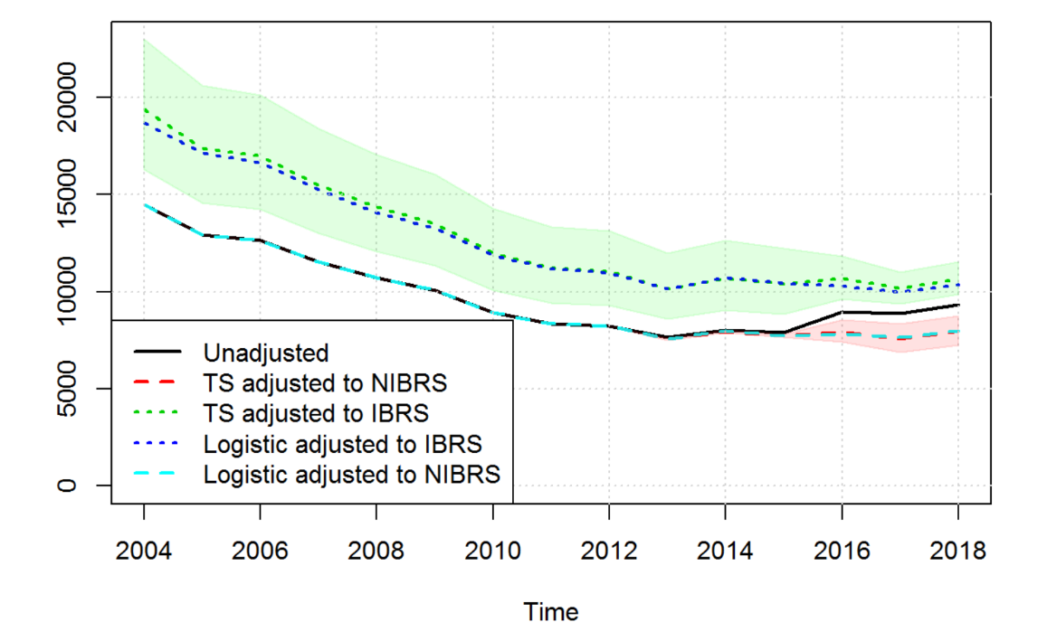
Figure 2: Unadjusted and adjusted values for total car occupant serious casualties

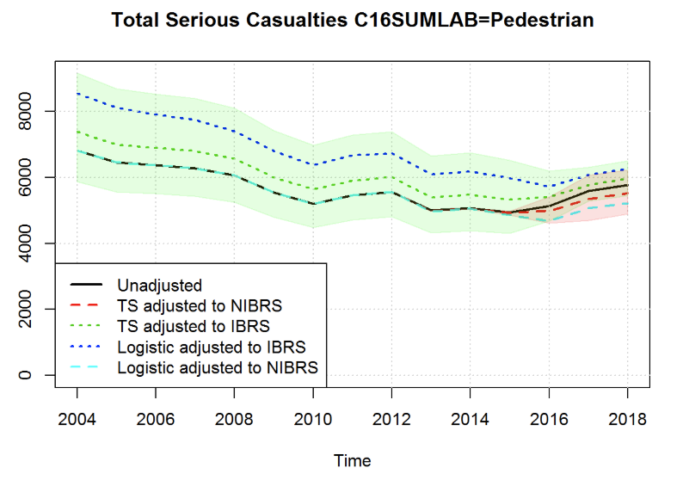
Figure 3: Unadjusted and adjusted values for total pedestrian serious casualties

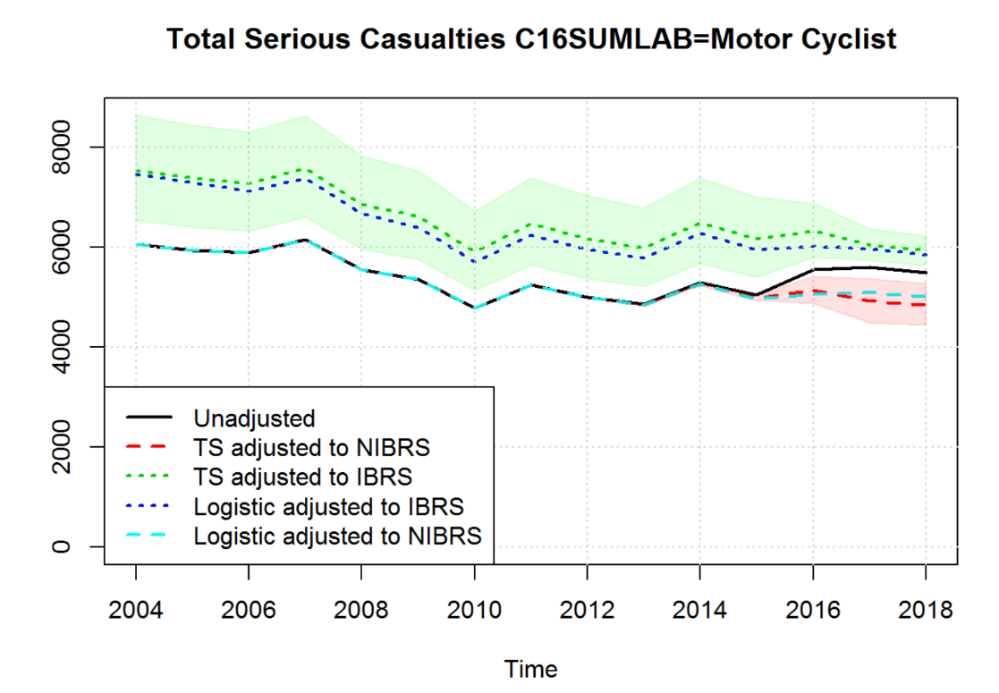
Figure 4: Unadjusted and adjusted values for total motor cyclist serious casualties

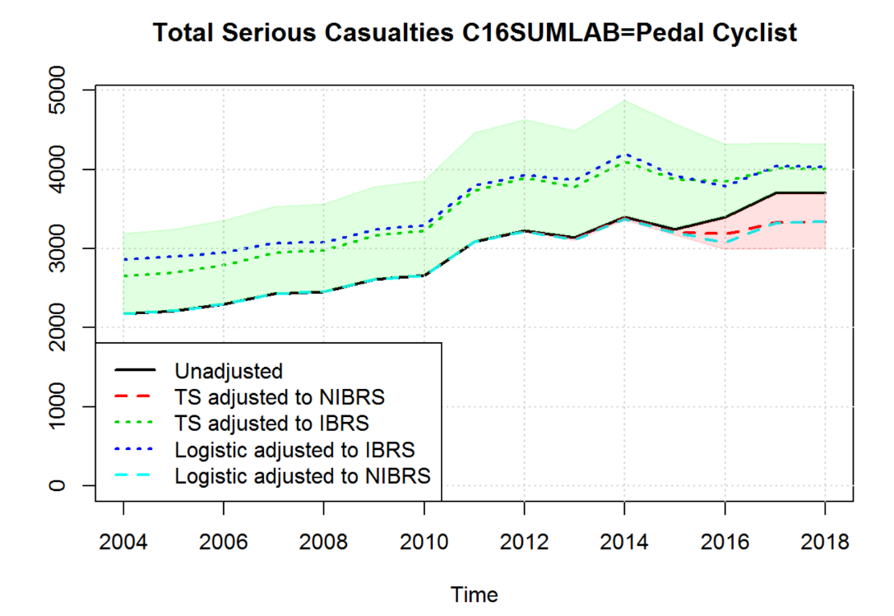
Figure 5: Unadjusted and adjusted values for total pedal cyclist serious casualties

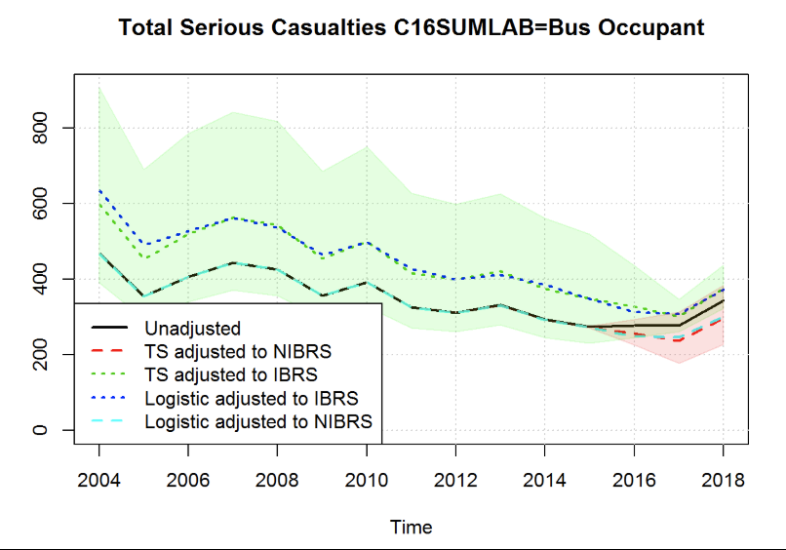
Figure 6: Unadjusted and adjusted values for total bus occupant serious casualties

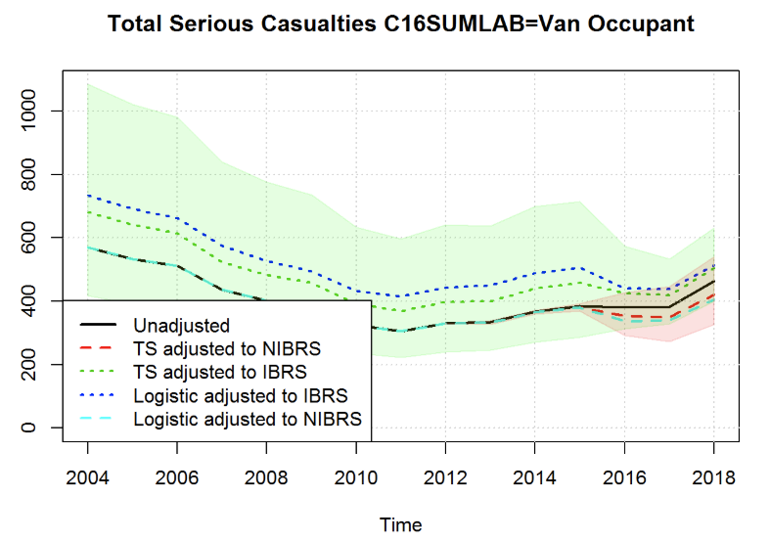
Figure 7: Unadjusted and adjusted values for total van occupant serious casualties

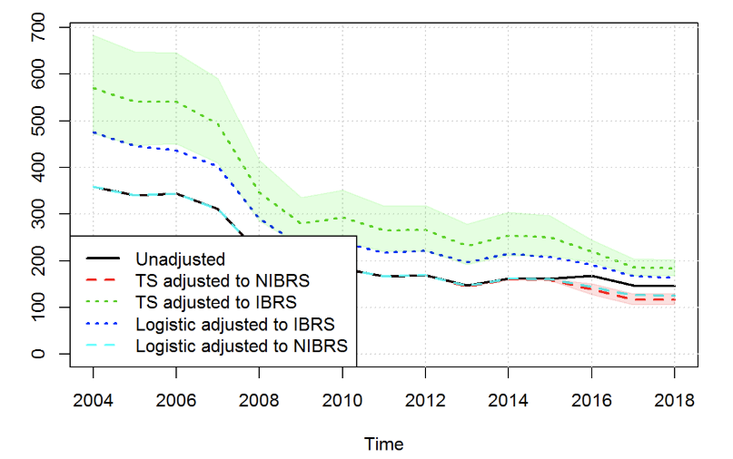
Figure 8: Unadjusted and adjusted values for total HGV occupant serious casualties

Table 3: Estimated adjustment coefficient modelling serious accidents by road user type, including the ranges of the proportion of serious casualties (proportion of non-fatal) for periods without and with IBRS
Aggregation | Coefficient | SE | Min_PreIBRS | Max_PreIBRS | Min_IBRS | Max_IBRS | Test_logistic
C16SUMLAB=Motor Cyclist | 0.300 | 0.100 | 0.169 | 0.312 | 0.220 | 0.366 | -1.759
C16SUMLAB=Pedestrian | 0.102 | 0.142 | 0.175 | 0.234 | 0.188 | 0.285 | -1.106
C16SUMLAB=Car Occupant | 0.322 | 0.096 | 0.063 | 0.085 | 0.063 | 0.108 | -0.585
C16SUMLAB=Pedal Cyclist | 0.234 | 0.113 | 0.107 | 0.186 | 0.140 | 0.248 | -0.286
C16SUMLAB=Bus Occupant | 0.262 | 0.227 | 0.034 | 0.129 | 0.029 | 0.124 | 0.320
C16SUMLAB=Van Occupant | 0.203 | 0.272 | 0.039 | 0.131 | 0.035 | 0.139 | 0.868
C16SUMLAB=HGV Occupant | 0.554 | 0.116 | 0.029 | 0.190 | 0.051 | 0.276 | 2.578
C16SUMLAB=Other Veh Occupant | -0.296 | 0.306 | 0.061 | 0.286 | 0.092 | 0.333 | -2.285

Age
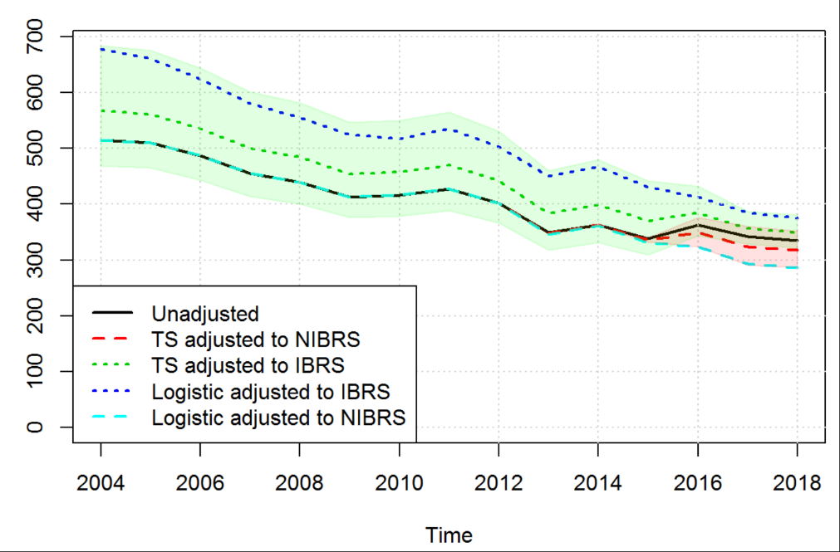

Figure 9: Unadjusted and adjusted values for total age 0-5 serious casualties

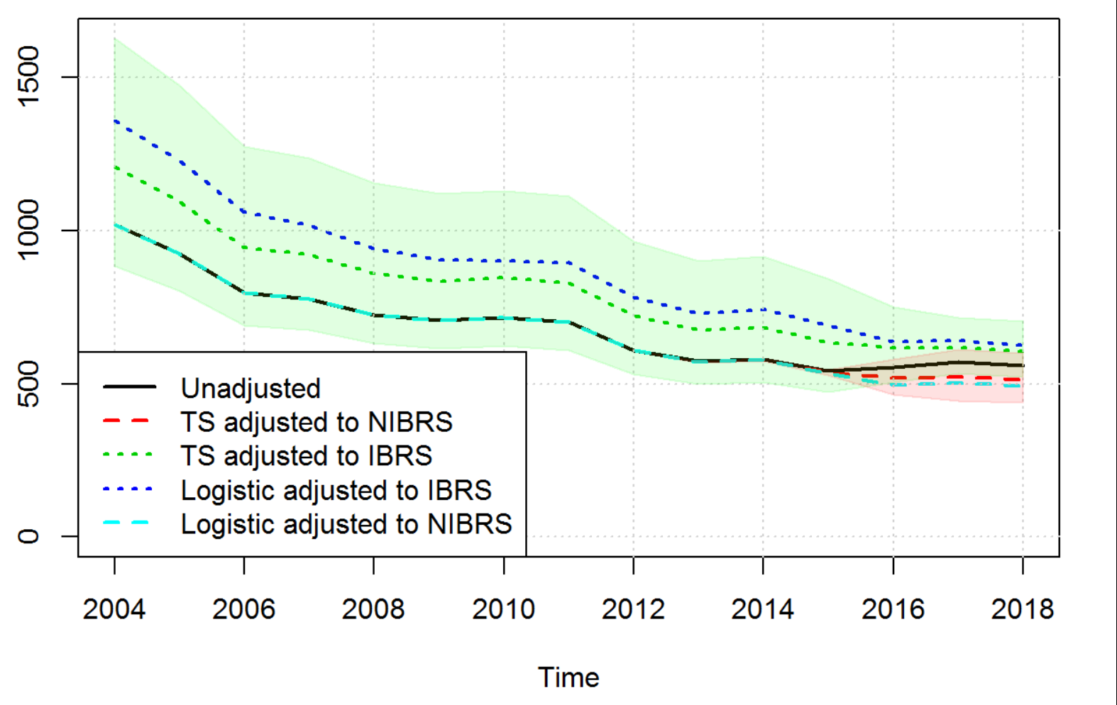

Figure 10: Unadjusted and adjusted values for total age 6-10 serious casualties

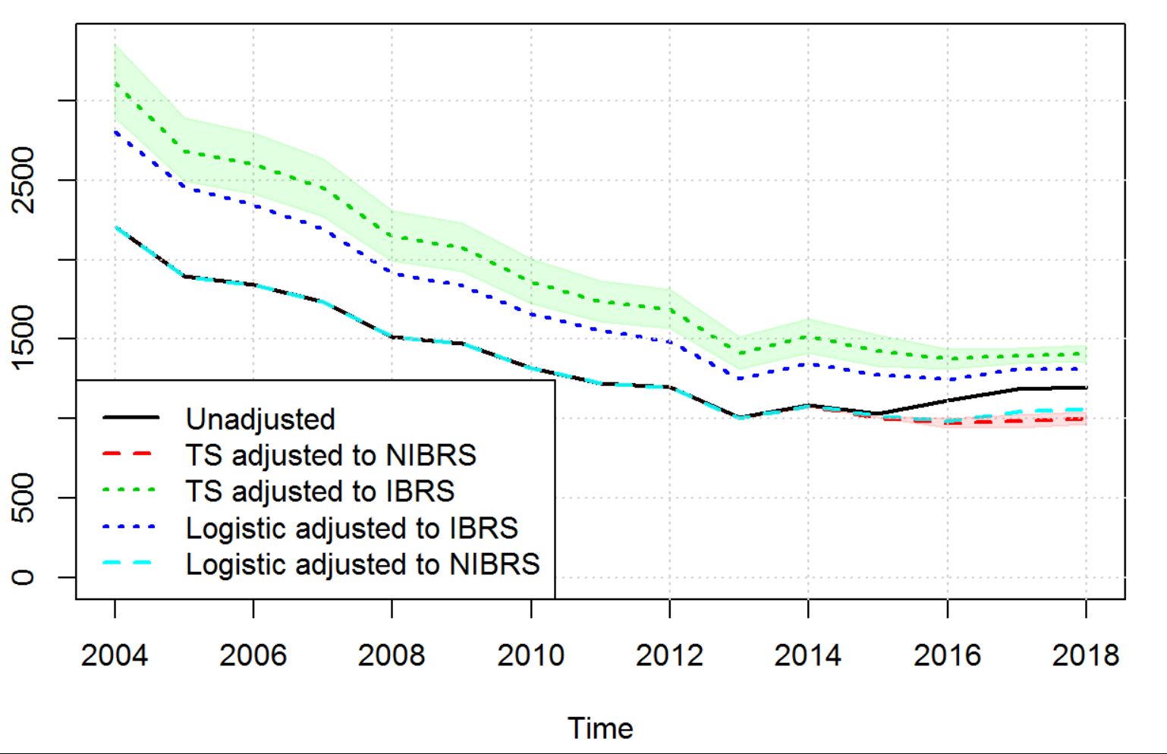
Figure 11: Unadjusted and adjusted values for total age 11-15 serious casualties

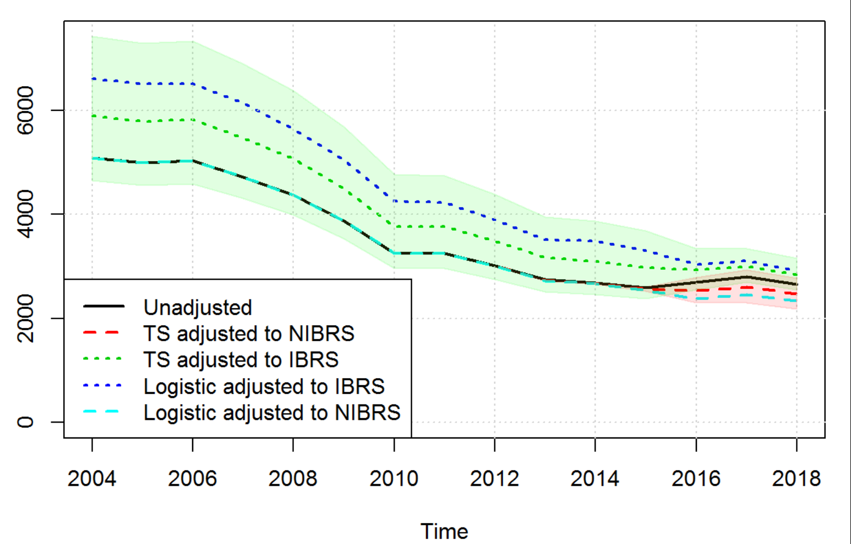

Figure 12: Unadjusted and adjusted values for total age 16-20 serious

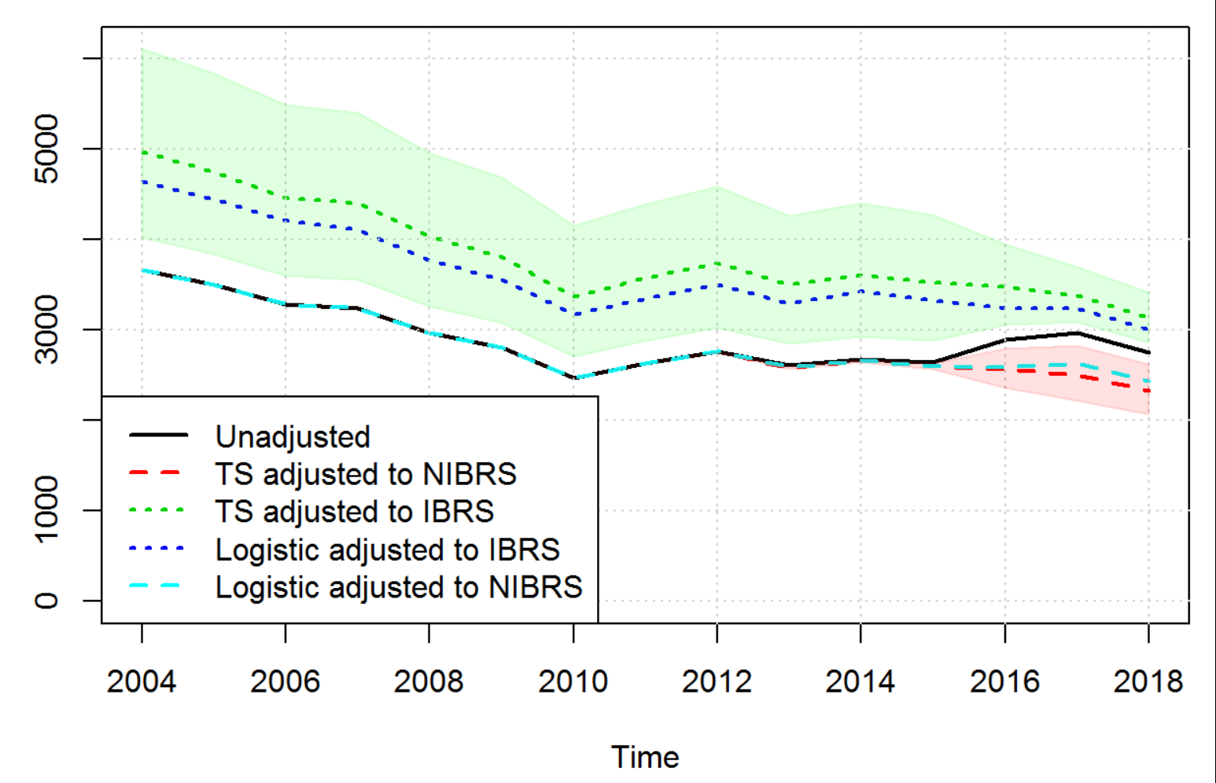

Figure 13: Unadjusted and adjusted values for total age 21-25 serious casualties

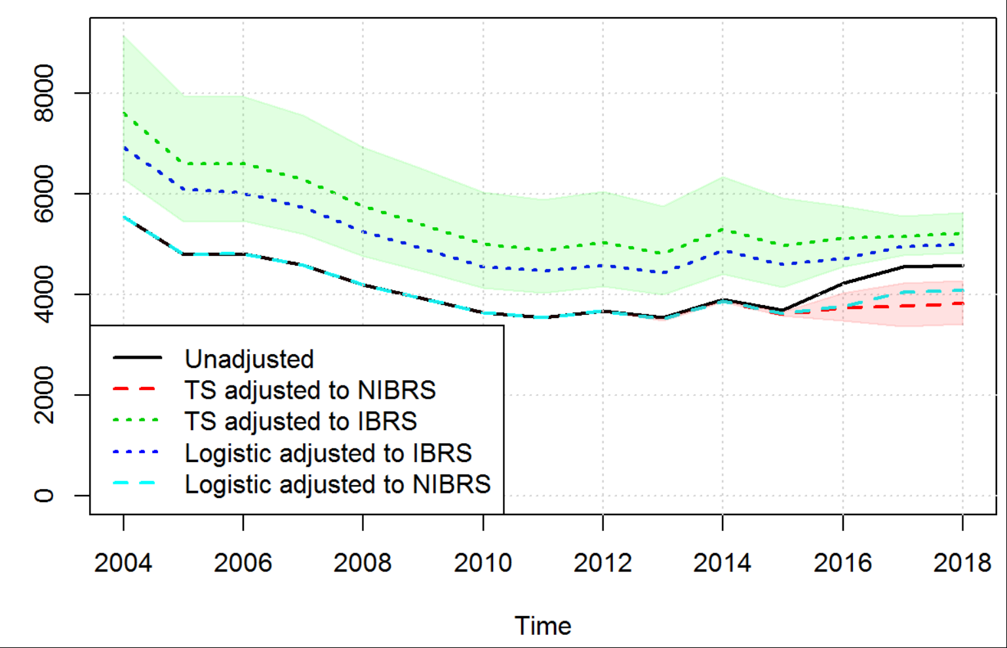

Figure 14: Unadjusted and adjusted values for total age 26-35 serious casualties

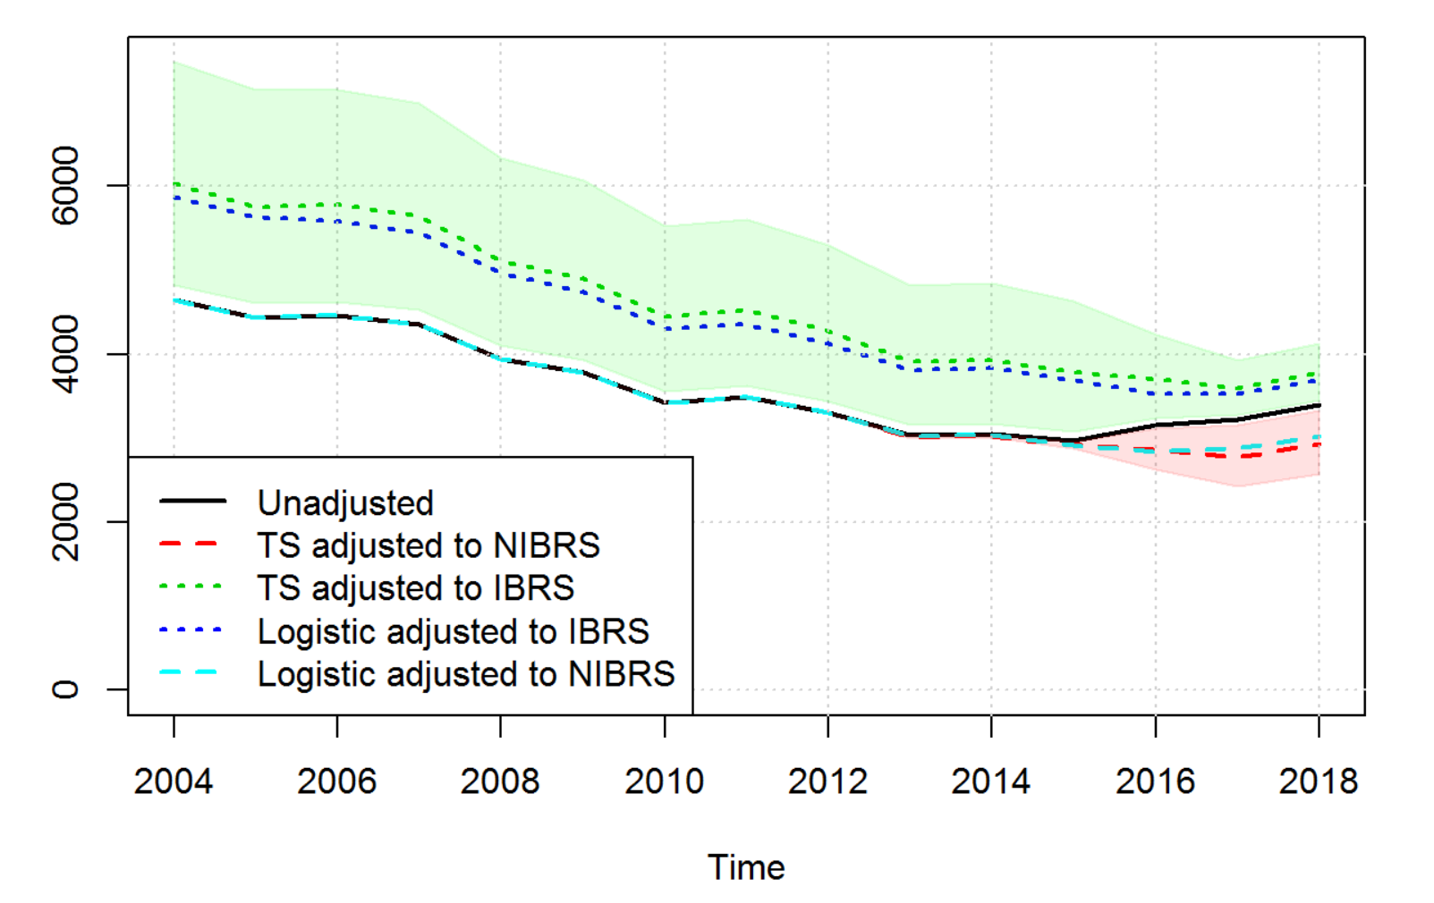
Figure 15: Unadjusted and adjusted values for total age 36-45 serious casualties

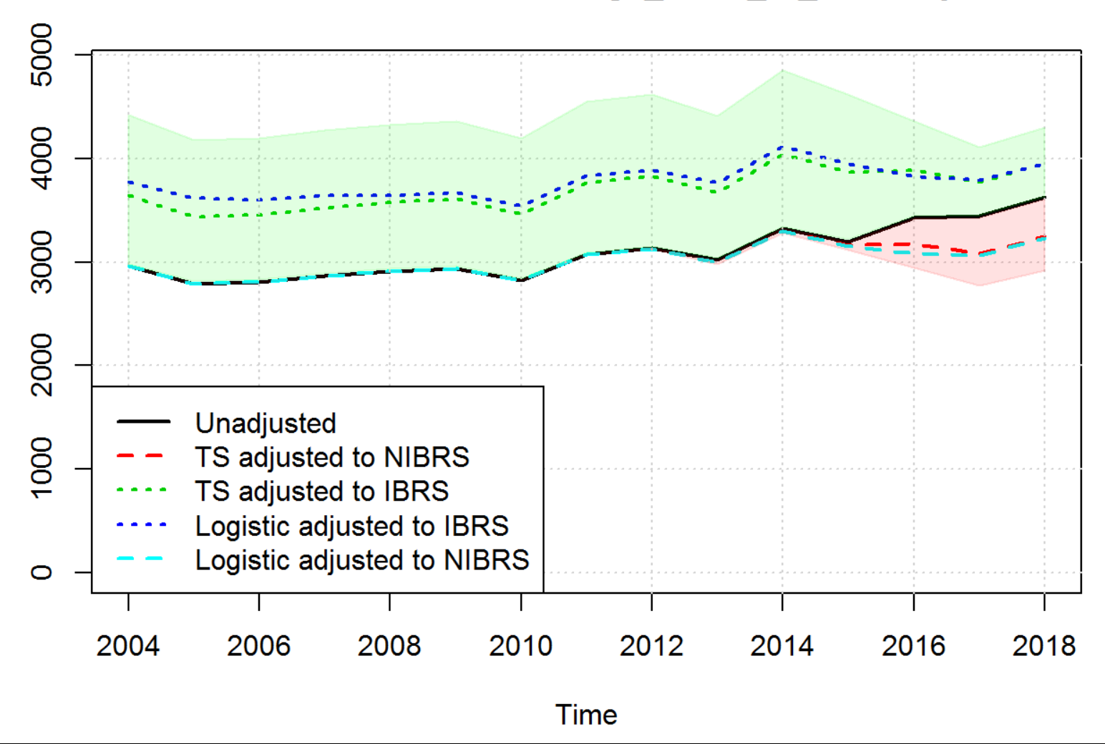

Figure 16: Unadjusted and adjusted values for total age 46-55 serious casualties

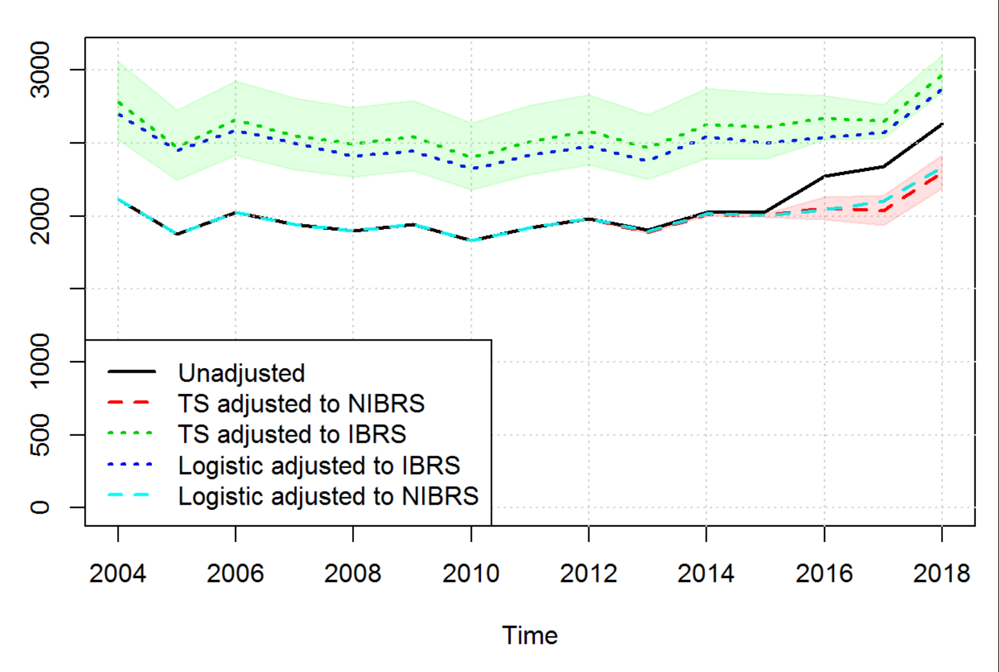
Figure 17: Unadjusted and adjusted values for total age 56-65 serious casualties

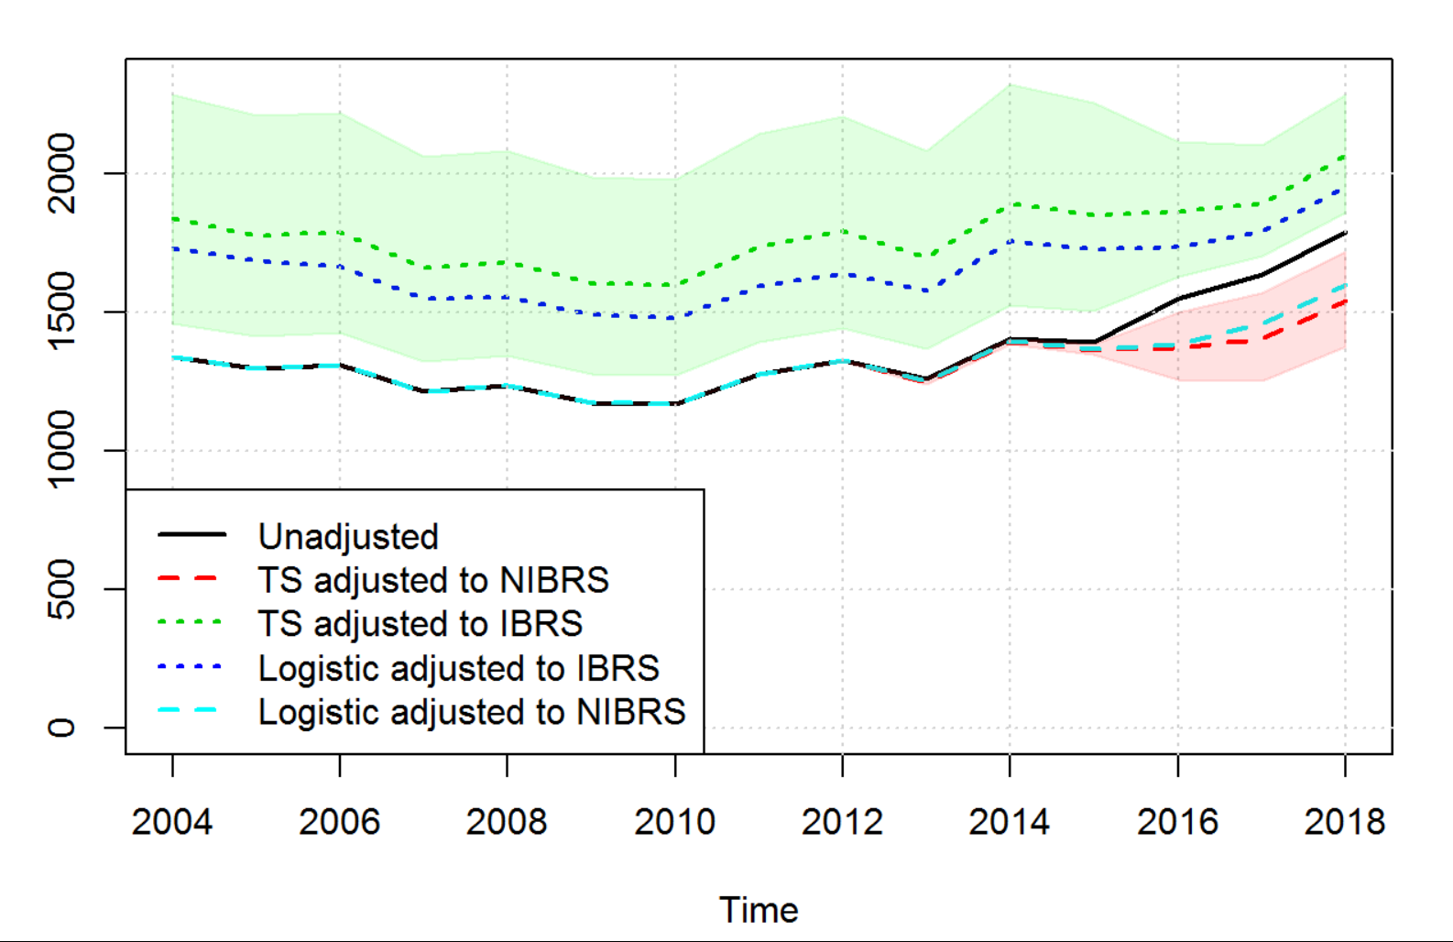
Figure 18: Unadjusted and adjusted values for total age 66-75 serious casualties

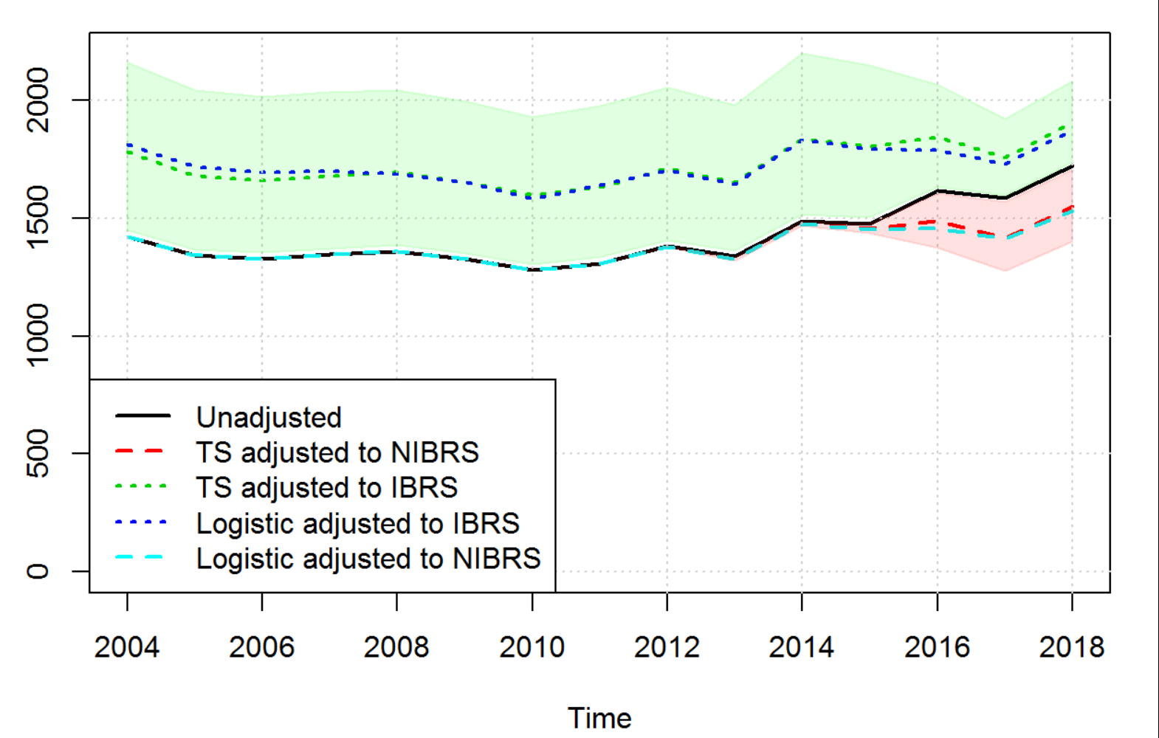
Figure 19: Unadjusted and adjusted values for total age 75 and over serious casualties

Table 4: Estimated adjustment coefficient modelling serious accidents by age group, including the ranges of the proportion of serious accidents (proportion of non-fatal) for periods without and with IBRS
Aggregation | Coefficient | SE | Min_PreIBRS | Max_PreIBRS | Min_IBRS | Max_IBRS | Test_logistic
Age_Band_of_Casualty=10 | 0.376 | 0.137 | 0.094 | 0.184 | 0.132 | 0.241 | 0.302
Age_Band_of_Casualty=6 | 0.359 | 0.109 | 0.078 | 0.116 | 0.072 | 0.152 | -2.614
Age_Band_of_Casualty=5 | 0.348 | 0.123 | 0.067 | 0.126 | 0.092 | 0.172 | 0.226
Age_Band_of_Casualty=7 | 0.296 | 0.127 | 0.080 | 0.126 | 0.083 | 0.158 | -1.079
Age_Band_of_Casualty=8 | 0.235 | 0.113 | 0.086 | 0.142 | 0.103 | 0.180 | -0.465
Age_Band_of_Casualty=11 | 0.282 | 0.130 | 0.148 | 0.250 | 0.164 | 0.291 | -0.094
Age_Band_of_Casualty=3 | 0.412 | 0.046 | 0.105 | 0.170 | 0.107 | 0.210 | -0.170
Age_Band_of_Casualty=1 | 0.109 | 0.107 | 0.055 | 0.159 | 0.061 | 0.151 | -2.450
Age_Band_of_Casualty=9 | 0.316 | 0.057 | 0.087 | 0.150 | 0.116 | 0.207 | 0.538
Age_Band_of_Casualty=2 | 0.193 | 0.175 | 0.067 | 0.150 | 0.066 | 0.159 | -2.298
Age_Band_of_Casualty=4 | 0.170 | 0.136 | 0.087 | 0.137 | 0.100 | 0.197 | -0.895

Sex

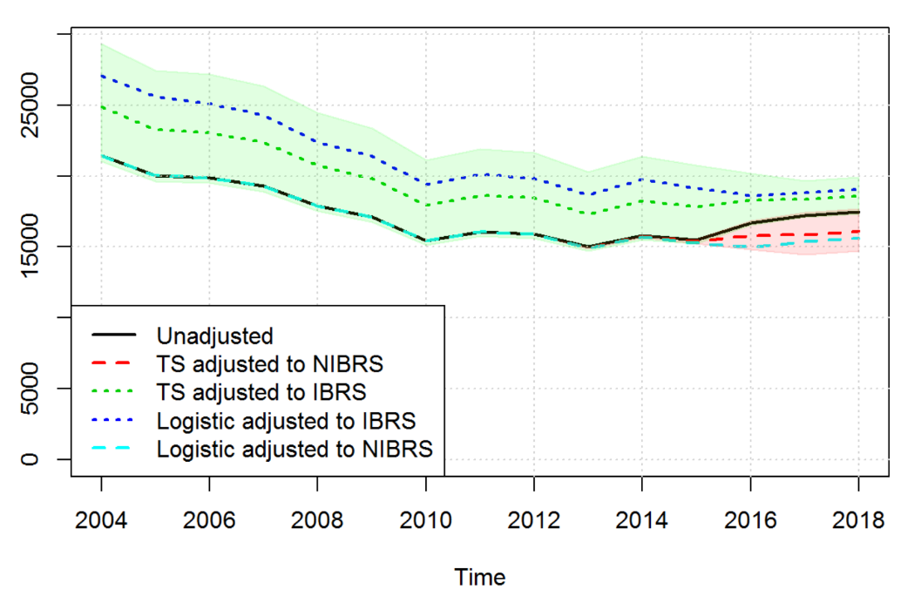
Figure 20: Unadjusted and adjusted values for total male serious casualties

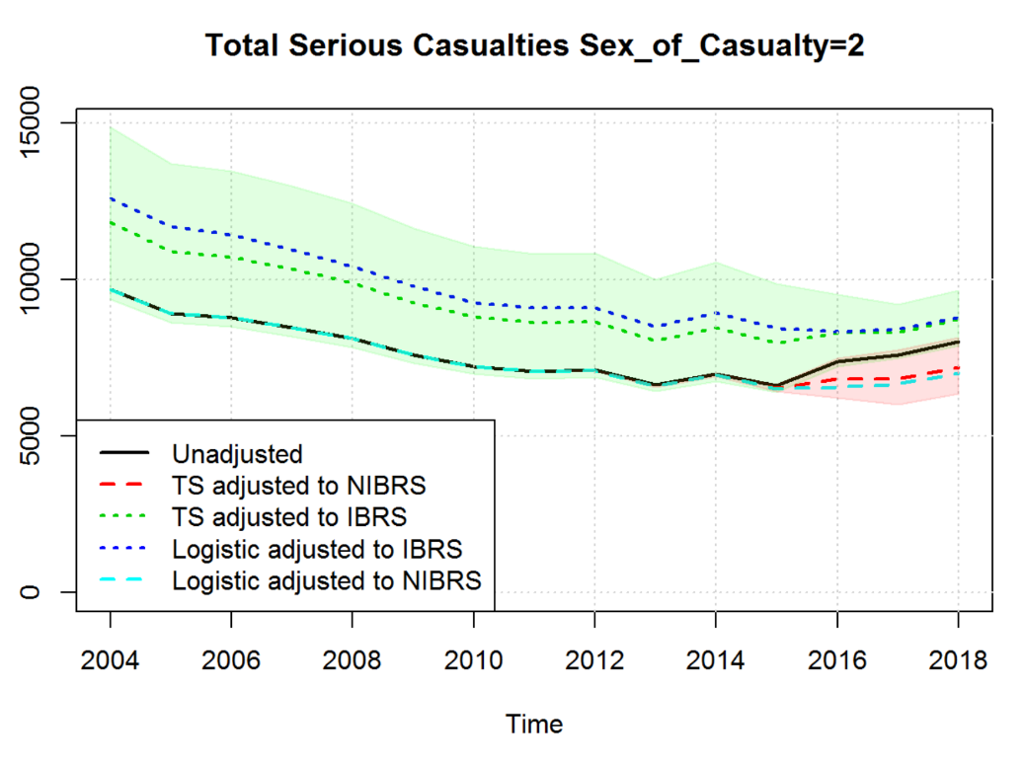

Figure 21: Unadjusted and adjusted values for total female serious casualties

Table 5: Estimated adjustment coefficient modelling serious accidents by sex of casualty, including the ranges of the proportion of serious accidents (proportion of non-fatal) for periods without and with IBRS
Aggregation | Coefficient | SE | Min_PreIBRS | Max_PreIBRS | Min_IBRS | Max_IBRS | Test_logistic
Sex_of_Casualty=1 | 0.174 | 0.099 | 0.110 | 0.157 | 0.126 | 0.202 | -1.295
Sex_of_Casualty=2 | 0.219 | 0.129 | 0.071 | 0.093 | 0.079 | 0.132 | -0.773

Copyright © 2018 SAS Institute Inc. SAS and all other SAS Institute Inc. product or service names are registered trademarks or trademarks of SAS Institute Inc., Cary, NC, USA.
https://data.gov.uk/dataset/cb7ae6f0-4be6-4935-9277-47e5ce24a11f/road-safety-data
https://data.gov.uk/dataset/cb7ae6f0-4be6-4935-9277-47e5ce24a11f/road-safety-data

