Recycle your old electricals and electronic devices for free at the local recycling centre at:
Add address of local recycling centre 1
Add address of local recycling centre 2
Why recycle?
Unwanted electrical equipment is the UK’s fastest growing type of waste.
Many electrical items can be repaired or recycled, saving natural resources and the environment. If you do not recycle, electrical equipment will end up in landfill where hazardous substances will leak out and cause soil and water contamination – harming wildlife and human health.
Crossed out wheeled-bin symbol  To remind you that old electrical equipment can be recycled, it is now marked with a crossed‐out wheeled bin symbol. Please do not throw any electrical equipment (including those marked with the crossed out wheeled bin symbol) in your bin. | 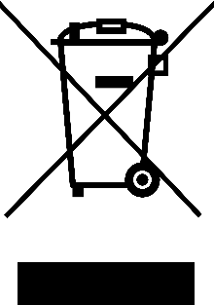
The Waste Electrical and Electronic Equipment (WEEE) Directive requires EU Member States to maximise separate collection and environmentally friendly processing of WEEE. In the UK, distributors (including retailers) are required to provide a system which allows all customers buying new electrical equipment the opportunity to recycle their old items free of charge. As a responsible retailer, we have met the requirements placed on us by financially supporting the national network of WEEE recycling centres established by local authorities.
The Waste Electrical and Electronic Equipment Regulations 2013

