Childcare providers and inspections
This release contains:
- The number of Ofsted registered childcare providers and places and their most recent inspection outcomes on 31 December 2018.
- The number of providers that have registered with Ofsted (joiners) and the number that have left (leavers) between 31 August 2018 and 31 December 2018.
The number of childminders registered with Ofsted has continued to decrease. | There were 39,700 childminders registered with Ofsted on 31 December 2018. This was down by 1,000 (3%) since 31 August 2018, and by 8,200 (17%) since the introduction of the common inspection framework (CIF) on 1 September 2015.
The overall number of childcare places on the Early Years Register has remained fairly stable. | Despite the decreasing numbers of childminders, the number of childcare places has remained fairly stable, due to an increase in the number of places offered by childcare on non-domestic premises.
More than nine in 10 providers on the Early Years Register were judged good or outstanding. | The proportion of childcare providers on the Early Years Register judged good or outstanding was 95%. This has remained broadly the same since 31 August 2018, but represents an increase of 10 percentage points since the introduction of the CIF.
A higher proportion of non-domestic providers were judged outstanding, compared with childminders. | At their most recent inspection, 24% of non-domestic providers were judged outstanding, compared with 17% of childminders. However, the proportion of providers judged either good or outstanding for these two provider types was very similar.
Figure 1: Overall effectiveness of active early years registered providers at their most recent inspection over time
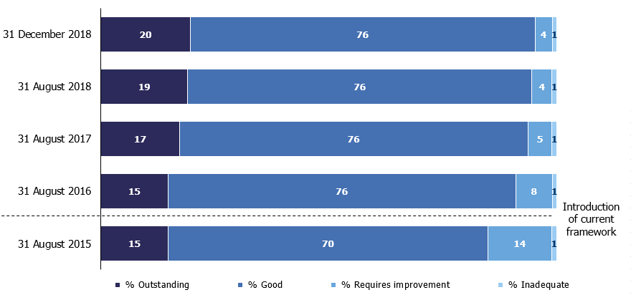

Contents

Introduction 3
Number of providers 4
Number of places 6
Inspection outcomes 8
Childminder agencies 10
Early years provision in the schools sector 10
Notes 11
Glossary 12
Further information 16

Acknowledgements
Thanks to the following for their contribution to this statistical release: Lucy Conway, Louis Noble, Tristan Browne and Helen Woodley.

Introduction
The early years and childcare sector is primarily made up of private nurseries, pre-schools and childminders. Early years provision is categorised into four provider types:

Type of provider | Description
Childcare on non-domestic premises | Nurseries, pre-schools, holiday clubs and other group-based settings, usually registered on the Early Years Register (EYR) because they look after children aged 0 to 5.
Childminders | People who are paid to look after one or more children they are not related to in a home that is not the child’s. The majority are registered on the EYR because they look after children aged 0 to 5, but those who look after 5 to 7 year olds need to register on the Childcare Register (CR).
Childcare on domestic premises | Where four or more people look after children together in a home that is not the child’s. The majority are registered on the EYR and some are registered on the CR, depending on the age of the children they look after.
Home childcarers (nannies) | Individuals who care for children aged 0 to 18 wholly or mainly in the child’s own home. They are not required to register with Ofsted but may choose to do so on the Voluntary Childcare Register (VCR).

Childcare on non-domestic premises and childminders make up the majority of early years provision registered with Ofsted. Further information about provider types is available in the Glossary.

Childcare in early years also occurs in the schools sector. This takes place in state-funded nurseries, early years provision within state-funded schools and independent schools. Since May 2015, childcare on non-domestic premises that are part of a school are not required to register on the EYR if they are only looking after children aged two and over. For more information, see the ‘Early years provision in the schools sector’ section of this document.

Number of providers
Changes in provider numbers, by provider type
There were 77,200 childcare providers registered with Ofsted on 31 December 2018, down by 2% (1,700) since 31 August 2018. Ofsted’s common inspection framework (CIF) was introduced on 1 September 2015. Since then, the number of providers has fallen by 11%.

- Childminders: 39,700 providers on 31 December 2018, down by 1,000 since 31 August 2018. This continues a downward trend, with 17% fewer providers than on 31 August 2015.

- Childcare on non-domestic premises: 27,200 providers on 31 December 2018, down by fewer than 50 providers since 31 August 2018. Numbers are fairly stable over time, having decreased by just 1% since 31 August 2015.

- Home childcarers: 10,000 providers on 31 December 2018, down by 600 since 31 August 2018. Although numbers of home childcarers have fluctuated over time, they are now 12% lower than they were on 31 August 2015.

- Childcare on domestic premises: 200 providers on 31 December 2018. Due to the small numbers, these are not included in Figure 2.

Figure 2: Childcare providers registered with Ofsted on any register over time, by provider type
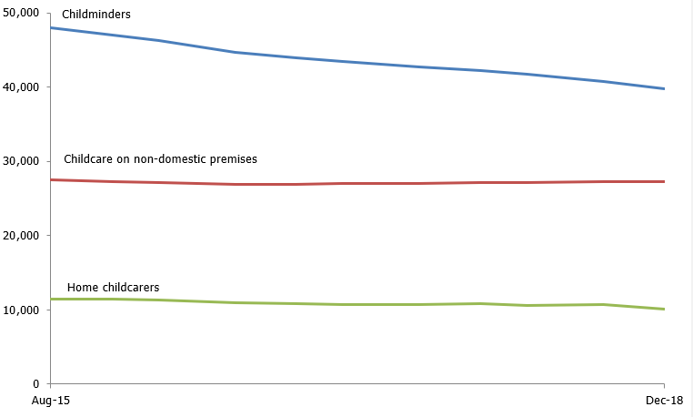

Childminder movement in the sector over time
Overall, childcare provider numbers have decreased steadily since August 2015. A large decrease in the number of childminders is the main contributing factor to this decrease (Figure 2). The decline in the number of childminders is due to a trend of more providers leaving than joining the childcare sector, even though the number of childminders leaving is decreasing compared with previous years (Figure 3).

Figure 3: Childminder movement within successive September to December periods¹
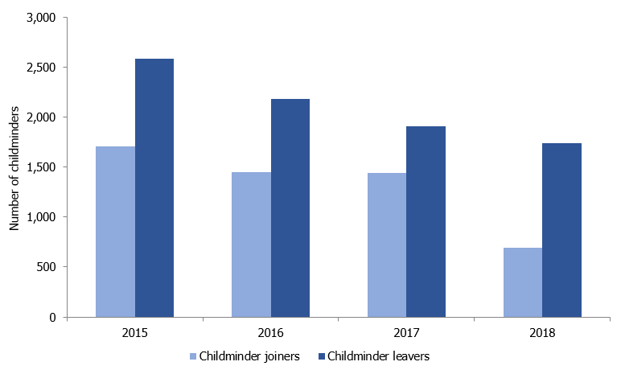
- Data refers to childminders’ movement between 31 August and 31 December in each year.

Since the previous official statistics (31 August 2018), 1,700 childminders have left the sector and 700 joined – a net decrease of 1,000. The childminders who left the register during this period had been registered for around nine years on average (based on the assumption that the exact date they left the register was 31 December 2018).

Whilst the number of childminder leavers has decreased steadily over time, the number of joiners is much lower for the current reporting period (31 August 2018 to 31 December 2018) than it has been over the previous three years. For instance, between 31 August 2017 and 31 December 2017 there were 1,400 joiners – around double the number seen for this release (700).

Number of places
Registers and places
On 31 December 2018, 81% (62,400) of Ofsted registered childcare providers were on the Early Years Register (EYR). The remaining 19% were not on the EYR and so only appeared on the voluntary (VCR) and/or compulsory (CCR) parts of the Childcare Register (CR). More information about the different register types is available in the Glossary.

Places data is reported for the 62,400 providers registered on the EYR, with a high proportion of these (90%) also being registered on the CR. When considering places data it is important to note it covers all places for children up to the age of eight. This encompasses all EYR places for children under five and CCR places for five- to seven-year-olds. For more methodological notes on places data, please see the methodology and quality report which accompanies this release.
Providers and places
Despite decreasing numbers of childminders, the number of childcare places has remained broadly stable since August 2015 (Figure 4). While childminder places decreased slightly between August and December 2018, there was a larger increase in the number of places offered by childcare on non-domestic premises. This meant that the overall number of places increased by around 2,100 (less than 1%) since August 2018. On 31 December 2018, there were 1.3 million childcare places offered by providers on the EYR.

Looking at the number of childcare places by provider type, on 31 December 2018:

- Childcare on non-domestic premises: offered 81% (1.1 million) of all childcare places, which is an increase of one percentage point since August 2015.

- Childminders: offered 19% (244,400) of all places, a decrease of one percentage point since August 2015.

- Childcare on domestic premises: offered less than 1% (4,800) of places. These are not shown in Figure 4 due to the relatively small number of places offered.
Figure 4: Childcare providers and places on the Early Years Register over time, by provider type¹
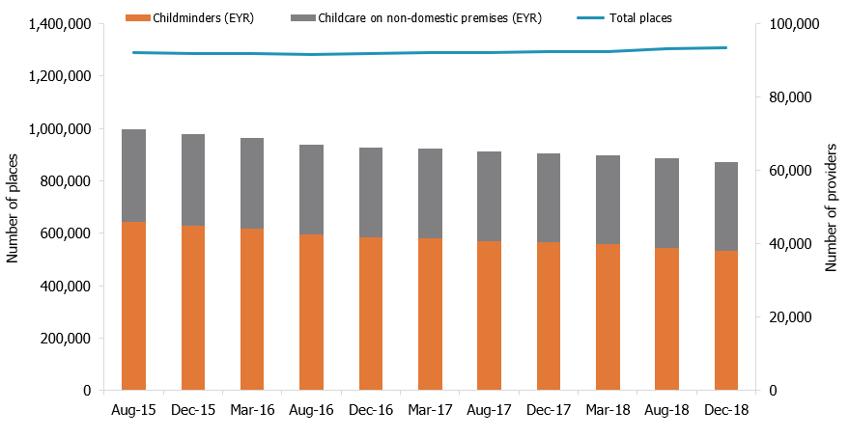
- Places data from August 2018 onwards is recorded in an updated administrative system and captures slightly more childcare places than previously.

Childminder provider numbers on the EYR have decreased by 17% since 31 August 2015, but the number of places offered by childminders has only decreased by 6%. This means that the individual childminders are each offering a higher number of places on average, even though there are fewer childminders and fewer places offered by childminders overall.

On 31 December 2018, the average number of places offered by childminders on the EYR was 6.4. This average takes into account childminders with assistants, who are permitted to offer more than six places.
30 hours free childcare
Since 1 September 2017, working parents of three- and four-year-olds in England have been eligible for 30 hours of free childcare. In January 2018, there were around 296,900 three- and four-year-olds benefiting from a 30 hours place. Estimates suggest around 390,000 children were eligible for the extended hours nationally, suggesting around three out of four eligible children have taken up some extended hours.
This may have contributed to the rise of 25,600 (2%) EYR places in childcare on non-domestic premises since 31 August 2017.

Inspection outcomes
New providers joining the Early Years Register (EYR) are normally inspected within 30 months of registration. The ‘Being inspected as a childminder or childcare provider’ guidance (www.gov.uk/ofsted-inspection-childcare-provider) provides more information about inspection. On 31 December 2018, 51,000 (82%) providers on the EYR had received a full inspection. Most of the providers that have not yet been inspected joined the EYR within the last two years.

Proportion of providers on the EYR judged good or outstanding
On 31 December 2018, 95% of childcare providers on the EYR were judged either good or outstanding at their most recent inspection. This has not changed since 31 August 2018, but is a substantial increase from 31 August 2015 when the proportion was 85% (Figure 1).

Looking at the two main provider types on 31 December 2018 (Figure 5) :

- Childcare on non-domestic premises: 96% were good or outstanding at their most recent inspection, an increase of one percentage point since August 2018. This was made up of 73% of childcare on non-domestic premises judged good and 24% outstanding.

- Childminders: 95% were good or outstanding, a slight increase from 94% on 31 August 2018. This was made up of 78% of childminders judged good and 17% judged outstanding.

Figure 5: Percentage of childminders and non-domestic providers judged good or outstanding at their most recent full inspection over time
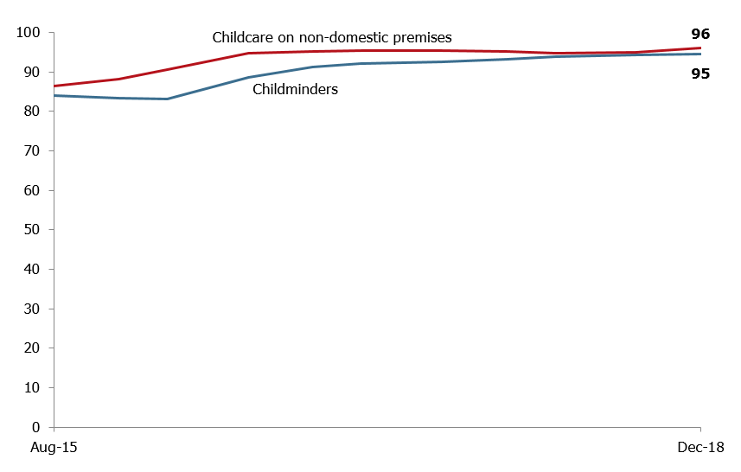

Changes in the proportion of childminders judged good or outstanding
Since the beginning of August 2016, Ofsted has prioritised inspections for childminders who had previously been judged requires improvement (RI) or inadequate. On 31 December 2018, 92% of childminders who were previously judged RI or inadequate, improved to good or outstanding at their most recent inspection.

Another factor which may have contributed to the rise in good or outstanding providers is the quality of those leaving the sector. Providers leaving the sector are more likely to have been judged requires improvement or inadequate at their most recent inspection, than those that remain. Since September 2015, 23% of providers who had left and received an EYR inspection were judged requires improvement or inadequate, compared with only 5% of all active providers.

Changes in the proportion of childcare on non-domestic premises judged good or outstanding
Over time, the proportion of childcare on non-domestic premises judged good or outstanding has increased. Part of this increase can be attributed to a change in the childcare inspection policy. Since November 2013, all childcare on non-domestic premises judged requires improvement must be re-inspected within 12 months. This means that non-domestic providers have had more opportunity to demonstrate improvement than they did previously.

Regional inspection outcomes
On 31 December 2018, all regions had fairly similar proportions of providers judged good or outstanding. The North East and the South West had the highest proportion (97%) and London the lowest (93%). The South East had the highest proportion of providers judged outstanding (23%) and the East Midlands and Yorkshire and The Humber had the lowest (15%).
Non-domestic providers had either a higher or equal proportion of providers judged good or outstanding compared with childminders in all regions (Table 1). London had the largest difference between non-domestic providers (95%) and childminders (91%) judged good or outstanding.

Across the regions, the difference in the proportion of non-domestic providers judged outstanding compared with childminders was notably more pronounced. The North East and the North West had the largest difference between non-domestic providers (27% and 26%) and childminders (17% and 16%) judged outstanding.

Table 1: Percentage of childminders and non-domestic providers judged good or outstanding on 31 December 2018, by region
Region | Childcare on non-domestic premises (%) | Childminders (%)
England | 96 | 95
North West | 97 | 94
North East | 99 | 96
Yorkshire and the Humber | 97 | 95
East Midlands | 95 | 94
West Midlands | 95 | 95
East of England | 96 | 96
London | 95 | 91
South East | 96 | 96
South West | 97 | 97

Additional information on local authorities and parliamentary constituencies can be found in the provider level data file accompanying this release.

Childminder agencies
Childminder agencies were introduced in September 2014, enabling new childminders to choose to register with Ofsted directly or register with an agency. Existing childminders could also choose to deregister with Ofsted and register instead with a childminder agency. Childminder agencies have the responsibility of inspecting the childminders who are registered with them, with Ofsted inspecting the childminder agencies.

Childminder agencies are only eligible for inspection when they have childminders on roll. There are only two overall effectiveness inspection outcomes: ‘Effective’ and ‘Ineffective’. On 31 December 2018, 11 childminder agencies were registered with Ofsted. Of these, six had childminders on roll and were therefore eligible for inspection. All six childminder agencies have been inspected to date and all have been judged ‘Effective’.

Data for childminder agencies is available from the provider level data file on the page for the Official Statistics release on 31 December 2018:
www.gov.uk/government/collections/early-years-and-childcare-statistics.

Early years provision in the schools sector
Childcare in early years also occurs in the schools sector. This takes place in state-funded nurseries and early years provision within state-funded schools. Where nurseries in schools are only looking after children aged two and over, they are exempt from registration on the Early Years Register (EYR). School nurseries looking after children younger than this are still required to register, and are therefore covered in the previous sections.
On 31 December 2018, there were 392 state-funded nursery schools in England. Of these, 390 had been inspected and 98% received a grade of good or outstanding at their most recent inspection. This was made up of 62% of nursery schools judged outstanding and 35% judged good.
In state-funded schools, early years provision is given its own judgement as part of the overall inspection of the school. On 31 December 2018, there were around 10,300 state-funded schools with an early years judgement at their most recent school inspection. Of these, 88% were judged to be good or outstanding on the overall effectiveness of early years. Ofsted did not provide separate graded judgements on the overall effectiveness of early years between January 2012 and August 2014. If the most recent inspection of the school was a short inspection that confirmed the school was still good or outstanding overall, a separate judgement for early years was not provided.
For more information on school inspections and outcomes, please refer to Ofsted’s official statistics on state-funded schools inspections and outcomes: https://www.gov.uk/government/collections/maintained-schools-and-academies-inspections-and-outcomes-official-statistics.
Many independent schools also provide nursery provision. On 31 December 2018, there were 268 non-association independent schools with an early years judgement at their most recent standard inspection. Of these, 74% were judged good or outstanding on the overall effectiveness for early years. For more information on non-association independent schools inspections and outcomes, please see Ofsted’s management information release on non-association independent schools: www.gov.uk/government/statistical-data-sets/non-association-independent-schools-inspections-and-outcomes-management-information.
Please note that Ofsted only inspects non-association independent schools. Association independent schools are inspected by the Independent Schools Inspectorate (ISI) – www.isi.net – or the School Inspection Service (SIS) – www.schoolinspectionservice.co.uk.

Notes
An explanation about main uses of this data, further contextual information and the arrangements for quality assurance is provided in the methodology and quality report accompanying this release.

The methodology and quality report also provides information on the strengths and limitations of the statistics.

Revisions to previous release
The provisional data in the previous release related to inspections which took place between 1 April 2018 and 31 August 2018 and were published by 30 September 2018. A revised list of inspections in this period is provided in Tables 14–19 of the ‘Childcare providers and inspections charts and tables’ document for this release. This revised data includes 44 inspections that were published by 31 January 2019 (that were not published by 30 September 2018).

These revisions did not result in any changes to the main findings identified in the previous publication.
Revisions to data in this publication are published in line with Ofsted’s revisions policy for official statistics, which can be found here: www.gov.uk/government/publications/ofsted-standards-for-official-statistics.
Common Inspection Framework (CIF)
Inspections from 1 September 2015 were carried out under the Common Inspection Framework (CIF), meaning that the inspection judgements are common across the Early Years, Schools and Further Education and Skills remits. Ofsted evaluates the overall quality and standards of the early years provision in line with the principles and requirements of the Early Years Foundation Stage statutory framework. Inspectors judge the overall effectiveness of the early years provision, taking into account four judgements:
- quality of teaching, learning and assessment;
- personal development, behaviour and welfare;
- effectiveness of leadership and management;
- outcomes for children.

Ofsted is required to inspect all providers who were on the Early Years Register (EYR) on 1 August 2016 at least once by 31 July 2020. Providers who register after this date will normally be inspected within 30 months of registration.

Glossary

Under the Childcare Act 2006 (www.legislation.gov.uk/ukpga/2006/21/contents) childcare providers register on either or both of two registers:

- Early Years Register (EYR)
The EYR is for providers who care for children in the early years age group, from birth to 31 August following their fifth birthday. Registration is compulsory for such providers and they must meet the requirements of the Early Years Foundation Stage (EYFS).
All providers on the EYR are inspected on a four-year cycle. The last inspection cycle ran from 1 September 2012 to 31 July 2016. The current inspection cycle runs from 1 August 2016 to 31 July 2020.

- Childcare Register (CR)
The CR is for providers who care for children from birth to 18 years. It has two parts:
- Compulsory Childcare Register (CCR) – for providers caring for children from 1 September after the child's fifth birthday up until their eighth birthday.

- Voluntary Childcare Register (VCR) – for providers for whom registration is not compulsory, for example nannies, or providers who care for children aged eight and over.
Providers who are registered on either part of the Childcare Register do not need to submit their places information to Ofsted.
For providers registered on the Childcare Register, Ofsted inspects a sample of 10% of active providers per year.
Venn diagram showing the Ofsted registers for childcare providers
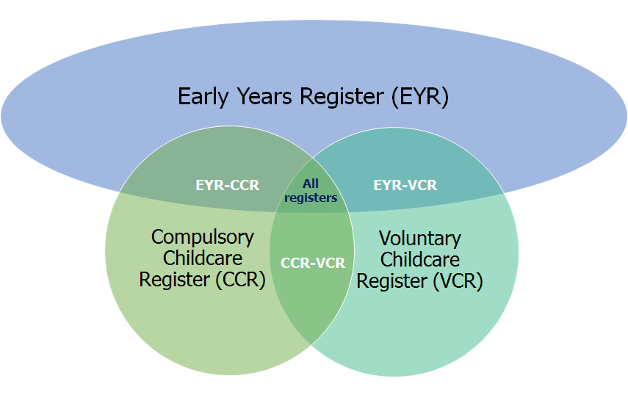

Early Years Foundation Stage (EYFS)
The EYFS is the statutory framework for the early education and care of children from birth to 31 August following their fifth birthday: www.gov.uk/government/publications/early-years-foundation-stage-framework--2.

Childcare providers
Childcare providers care for at least one individual child for a total of more than two hours in any one day. This is not necessarily a continuous period of time. They must register on the CCR to care for children under the age of eight, although there may be some exceptions to this. They can register on the VCR to care for older children.
Domestic premises
These are any premises which are wholly or mainly used as a private dwelling, in other words someone’s home.

Childcare providers on domestic and non-domestic premises
If four or more people look after children at any one time in someone’s home, they are providing childcare on domestic premises, not childminding.

Childcare providers on non-domestic premises are people or organisations providing care for individual children in premises that are not someone’s home. These premises can range from converted houses to purpose-built nurseries.
Childminder
This is a person who is registered to look after one or more children, to whom they are not related, for reward. Childminders work on domestic premises alongside no more than two other childminders or assistants. They must register if they care for children under the age of eight, and can choose to register if they care for older children. They care for:
- Children on domestic premises that are not usually the home of one of the children unless they care for children from more than two families, wholly or mainly in the homes of the families.

- At least one individual child for a total of more than two hours in any day. This is not necessarily a continuous period of time.
Childminder agencies
Childminder agencies were introduced in September 2014 as an alternative registration option for childminders. Childminders who register with an agency no longer need to register or be inspected by Ofsted, although the agency itself will receive an inspection.

Childminder agencies are only eligible for inspection by Ofsted when they have childminders on roll. Childminder agencies have the responsibility of inspecting the childminders who are registered with them.

Home childcarers
Home childcarers are usually nannies who care for children of any age up to their 18th birthday wholly or mainly in the child’s own home, and care for children from no more than two families. They are not required to register with Ofsted but may choose to do so on the voluntary part of the Childcare Register.

Inspection cycles
All providers on the Early Years Register which were registered before the start of Ofsted’s four-year inspection cycle are inspected within the cycle. The previous inspection cycle ran from 1 September 2012 to 31 July 2016. The current inspection cycle runs from 1 August 2016 to 31 July 2020. New providers joining the EYR are normally inspected within 30 months of registration. For providers on the CCR, a sample of 10% of active providers are inspected per year.
No Children on Roll (NCOR)
If there are no children present on the day of the provider's inspection, they receive an NCOR inspection. The inspector will make a judgement on the ‘Overall quality and standards of the early years provision’, with three possible outcomes:
- met
- not met - actions
- not met - enforcement action

Number of places
Registered places are the number of children that may attend the provision at any one time. Registered places are not the number of places occupied, nor the number of children who may benefit from receiving places through providers offering sessions at different times of the day. Place numbers are only collected for providers on the EYR. Provider type averages are used to estimate the number of places for a very small number of providers whose place numbers are not available at the time of the analysis. There may also be small discrepancies in totals due to rounding.

Joiners and leavers
Joiners are childcare providers that have registered with Ofsted during this reporting period. Most of these are new registrations, but Tables 3–4 and Chart 1 within the ‘Childcare providers and inspections charts and tables’ document also include providers with re-activated registrations and those that have changed provider type or register. At local authority or regional level, this may also include providers that have relocated into a new geographical area.
Leavers are mostly childcare providers that have left Ofsted during the reporting period. Most of these are resignations, but some are also providers that have had their registration cancelled or have changed provider type or register. At local authority or regional level, this may also include providers that have relocated out of a geographical area.

Further information
Ofsted publishes information on the inspection of early years providers on the gov.uk website:

www.gov.uk/government/collections/early-years-and-childcare-statistics

www.gov.uk/government/publications/common-inspection-framework-education-skills-and-early-years-from-september-2015

www.gov.uk/government/publications/framework-for-the-regulation-of-provision-on-the-childcare-register.

Contact for comments or feedback
If you have any comments or feedback on this publication, please contact Anita Patel on 03000 130 914 or Anita.Patel@ofsted.gov.uk.

The Office for Standards in Education, Children's Services and Skills (Ofsted) regulates and inspects to achieve excellence in the care of children and young people, and in education and skills for learners of all ages. It regulates and inspects childcare and children's social care, and inspects the Children and Family Court Advisory and Support Service (Cafcass), schools, colleges, initial teacher training, further education and skills, adult and community learning, and education and training in prisons and other secure establishments. It assesses council children’s services, and inspects services for children looked after, safeguarding and child protection.
If you would like a copy of this document in a different format, such as large print or Braille, please telephone 0300 123 1231, or email enquiries@ofsted.gov.uk.
You may reuse this information (not including logos) free of charge in any format or medium, under the terms of the Open Government Licence. To view this licence, visit www.nationalarchives.gov.uk/doc/open-government-licence, write to the Information Policy Team, The National Archives, Kew, London TW9 4DU, or email: psi@nationalarchives.gsi.gov.uk.
This publication is available at www.gov.uk/government/organisations/ofsted.
Interested in our work? You can subscribe to our monthly newsletter for more information and updates: http://eepurl.com/iTrDn.

Piccadilly Gate
Store Street
Manchester
M1 2WD

T: 0300 123 1231
Textphone: 0161 618 8524
E: enquiries@ofsted.gov.uk
W: www.gov.uk/ofsted

© Crown copyright 2019

Numbers are rounded to the nearest 100.
Numbers are rounded to the nearest 100.
Places numbers of less than one million are rounded to the nearest hundred. Places numbers of more than one million are rounded to the nearest 100,000.
For childminders, the maximum number of places they can offer if they do not have assistants is six. All childminders are recorded as offering six places at registration.
Education provision: children under 5 years of age, January 2018: https://www.gov.uk/government/statistics/education-provision-children-under-5-years-of-age-january-2018
A small proportion of providers may have received a No Children on Roll inspection. These are excluded from the total number of providers on the EYR who have received an inspection.
Percentages may not sum due to rounding.
Announcement of update in early years inspection policy from Her Majesty’s Chief Inspector (August 2013): https://www.gov.uk/government/news/ofsted-calls-for-swift-improvement-in-pre-schools-and-nurseries
Percentages may not sum due to rounding.

