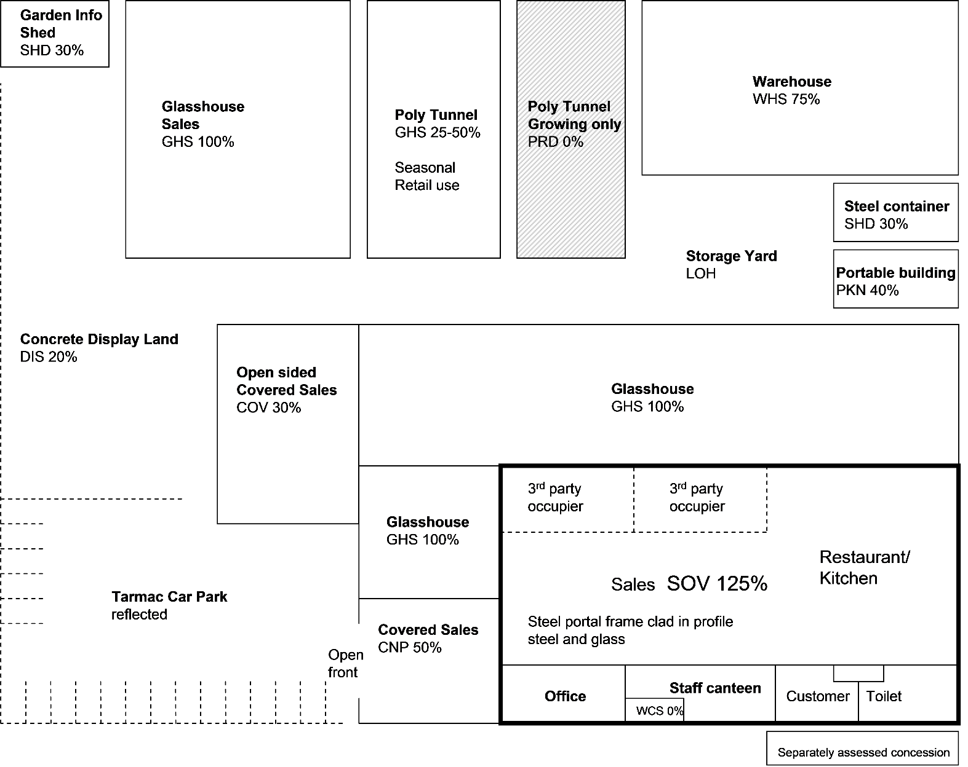
Appendix 1 - Referencing Aid
Poly Tunnel 30% - 50%
Reflected
DIS 20%

If Atcost building WHS 35%
See para 8.13 for range of values

See para 8.17

Office use 40%
Storage use 30%
See paragraph 8.21

Open on one side only 50%
Open on three of four sides the relativity should be 40%
See paragraph 8.15

