Influencing behaviours through science: UK-France perspectives

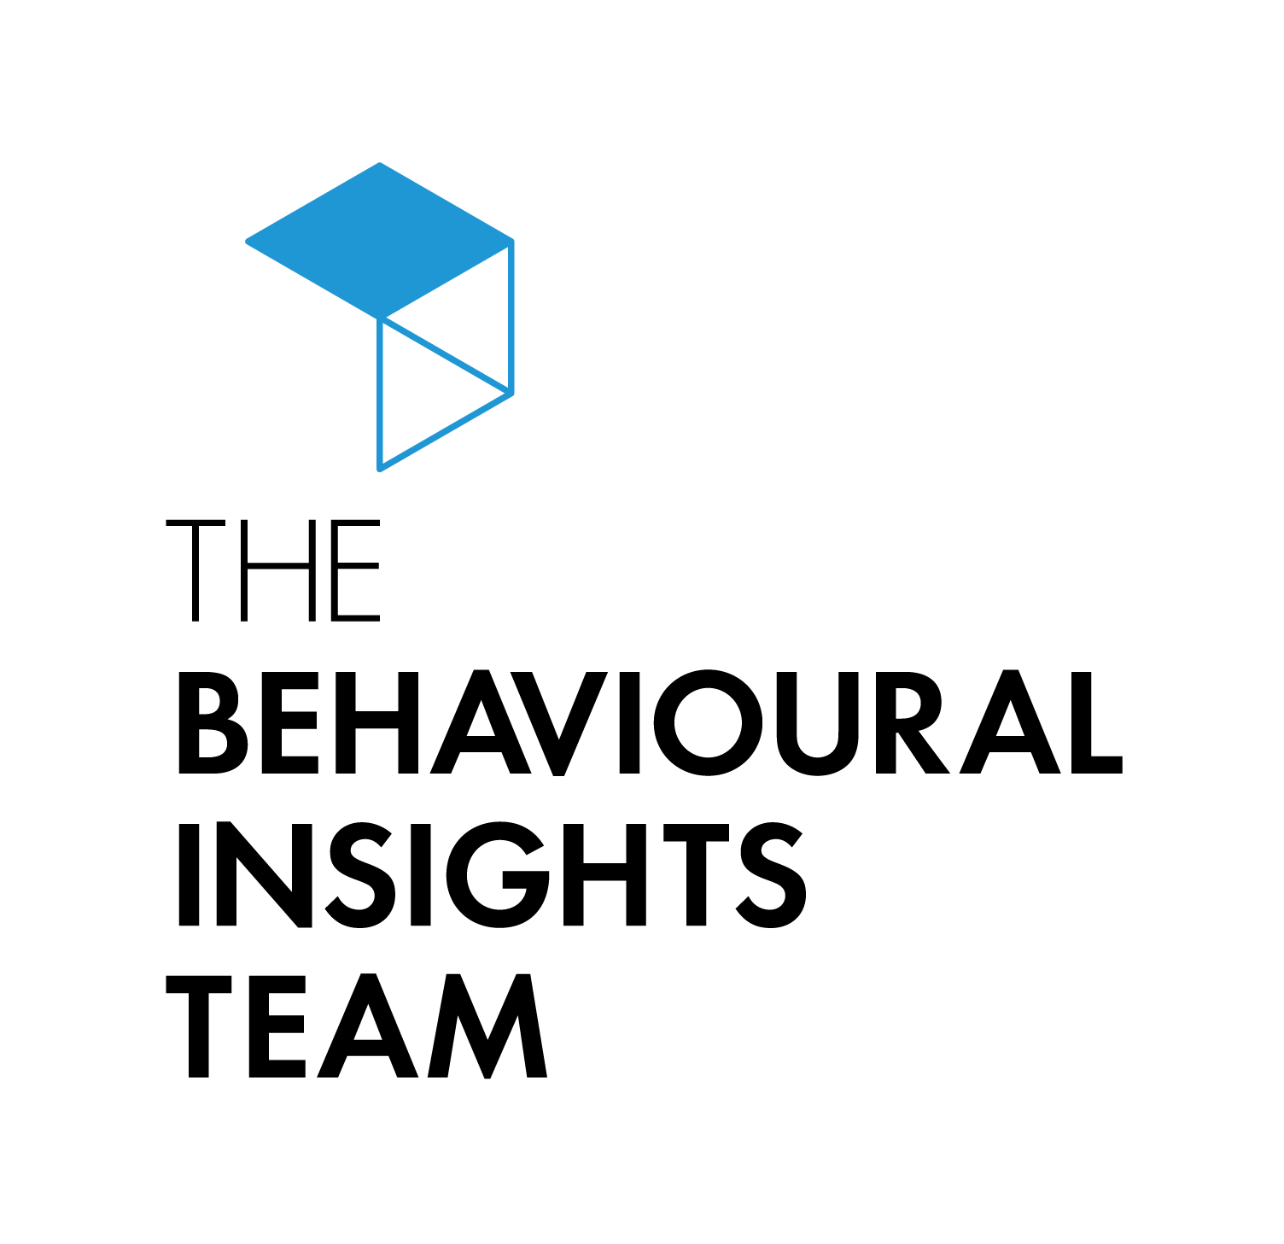
A report by the Behavioural Insights Team

Context
The use of behavioural science and evidence in public policy-making has developed dramatically over the last few years, both in the UK and France.

In the UK, the Public Health Improvement Research Network (PHIRN) has led the way for the use of evidence and evaluation in policy-making. It has established a history of policy trials in health, education and social care. Similarly, the UK has benefited from having the world’s first unit dedicated to applying to behavioural science to public policy (the Behavioural Insights Team). The field continues to grow: 15 Policy Research Units (PRUs) were recently created to ensure that government decisions affecting health and care are robust and evidence-based. Each PRU has its own priority topic area, and one unit focuses specifically on behavioural science. This Behavioural Science PRU forms part of nationwide strategy produced by Public Health England (PHE), aiming to apply behavioural and social sciences to improve health and wellbeing in England.

Behavioural science teams are also increasingly being set up throughout UK government departments and agencies. PHE, for example, now has its own behavioural science team (PHE Behavioural Insights), led by Tim Chadborn. More generally, increasing efforts are being made to raise awareness of behavioural science in policy-making circles. Charlotte Kume-Holland (Senior Strategy Advisor, Department of Health and Social Care) described some of her department’s work to familiarise policy professionals with behavioural science, provide them with greater access to behavioural experts and embed behavioural thinking upfront in key departmental policy priorities.

While behavioural research is a thriving field in France, the country’s journey towards widespread application of behavioural science to public policy remains in its relative infancy. However, it seems that appetite for applying these concepts is spreading outside of the academic community: a behavioural sciences unit has been established within the Direction Interministérielle de la Transformation Publique (DITP). This team was recently granted one million euros to undertake multiple streams of behavioural work. In their call for behaviourally-related projects, Stéphan Giraud (Behavioural Science Project Lead, DITP) and his team were encouraged to receive five times the number of applications than they were able to accept.

The British Embassy’s Science and Innovation Network (SIN) team organised the “Influencing behaviours through science: UK-France perspectives” conference at the British Ambassador’s Residence in Paris on 7th February 2019. The aim of the conference was to establish dialogue, share knowledge and experience, as well as promote co-operation between British and French experts at the academic and policy level. This report provides an overview of many of the subjects discussed at the conference.

Dr Louisa Zanoun
Senior Science and Innovation Officer
UK Science and Innovation Network
British Embassy, Paris

Influencing behaviours through science

Government priorities: examples of recent work
Table 1: Government health priorities in the UK and France
UK | France
Prevention | Equal access to healthcare
Workforce | Premature mortality
Technology | Antimicrobial resistance
Tackling obesity | Vaccine hesitancy
Antimicrobial resistance | Tackling obesity
Patient safety | Sexual health
Mental health | -

In both the UK and France, a considerable amount of work has been carried out in terms of behavioural research and applying learnings from this research to influence behaviour. A few examples of the work described during the conference are included below.

Reducing antibiotic prescribing (UK)
Social norm information can be an extremely powerful tool for encouraging people to change their behaviour. For example, the Behavioural Insights Team (BIT) was able to bring forward hundreds of millions of pounds of tax payments through the inclusion of social norm information in letters sent out by Her Majesty’s Revenue and Customs.

In 2014-2015 BIT, the Department of Health and Social Care (DHSC) and Public Health England (PHE) decided to apply this concept to encourage GPs to reduce the number of inappropriate antibiotic prescriptions. The project team conducted a randomised controlled letter trial, in which half of the top 20% of prescribing practices in the UK were randomly allocated to receive an intervention letter. This letter drew on three behavioural insights:
- The power of social norms. The letter stated: “The great majority (80%) of practices in [UK region] prescribe fewer antibiotics per head than yours.”
- Substituting behaviours is easier than stopping them altogether. The letter outlined three easy alternatives that a GP could take in cases where antibiotics might not be needed (for example, issuing a delayed prescription).
- The influence of a relatable messenger. The intervention letter was signed by the Chief Medical Officer to England. Being a physician herself, the Chief Medical Officer’s signature provided an authoritative yet relatable seal of approval.

The letter proved successful: GP practices who received the letter consistently prescribed fewer antibiotics per head than practices that did not receive the letter. The project team calculated that if the letter had been sent to all practices at the start of the trial, this would have led to a 0.85% reduction in England’s antibiotic prescribing rate. For context, the government had recently set aside £23 million to incentivise a reduction in antibiotic prescriptions by 1%. This letter trial cost somewhere in the region of £7,000 to run. This intervention has been repeated in subsequent years and has led to continued improvements. Applying behavioural science research to policy issues can therefore be both effective and cost-effective.

Understanding vaccine hesitancy (France)
Jeremy Ward (Sociologist and post-doctoral researcher, Centre National de la Recherche Scientifique (CNRS)) discussed Vitrome’s work on understanding vaccine hesitancy in France. Vitrome has taken a multi-modal approach to understand this behaviour, including conducting quantitative and qualitative research (to understand the views of healthcare professionals and the general population) and controversy analysis. This latter entity refers to researching how information (or misinformation) about vaccines is disseminated.

This work has unearthed several insights about vaccine hesitancy in France. First, France exhibits an unusual form of vaccine hesitancy: hesitancy exists around some vaccines, rather than all vaccines (as is more common). Second, it is likely that public discourse influences public behaviours, and that the manner in which information is embedded in public discourse can determine how people are influenced by it. In France, public debate centres on some vaccines but not others. This discourse if often presented by individuals who bring specific details about particular aspects of a vaccine that make it dangerous. This apparent expertise gives credibility to these critics, as does their tendency to criticise those who are sceptical of vaccines more broadly.

Investigating routines that impact health (France)
Caroline Huyard (Researcher in Sociology, CNRS) explained that a better understanding of the causes of routines that lead to negative health outcomes is important for appropriate design of effective public policies aiming to influence behaviour. Replacing or modifying routines that lead to detrimental health consequences with routines that lead to better outcomes is beneficial for the individual and for society. This this the aim of Caroline’s team’s work. For example, her team have conducted interviews with patients with chronic conditions (such as diabetes and high blood pressure) to find out about their medication adherence. Caroline’s team then used Failure Modes and Effects Analysis to differentiate between intentional and unintentional causes of medication non-adherence. An interventional study is now planned to target these causes in order to develop a tool that could be used by healthcare professionals.

The Soft Drinks Industry Levy (UK)
Working closely with the DHSC and PHE, BIT first modelled the structure and likely impact of the recently introduced UK ‘Sugar Tax’ in 2013. The tax introduced new sugar content thresholds, set at levels which industry would be able to reformulate to meet without compromising consumer price or drink quality. The results were astounding: before any tax was introduced, many popular brands reduced the sugar content of their drinks, resulting in an 11% overall reduction in sugar.

This is an example of how behavioural insights can be applied to improve health outcomes without any need for consumers to actually change their behaviours. In addition, reformulation confers health benefits to everyone. This is important from a health inequalities perspective, as those with less health knowledge may benefit less from more traditional policy levers, such as food labelling.

This work raises another important point: new initiatives are likely to be much more readily accepted if there is some assurance that industry will not be affected by the changes made. In this case, reformulation was able to occur without sales being impacted. This provides a helpful precedent, which may increase the acceptability of similar future initiatives.

Improving the healthiness of food choices (France)
Pierre Chandon (Director, INSEAD-Sorbonne University Behavioural Lab) spoke about his work on how to improve healthiness of food choices in France, and how to align this with business interests, while still maintaining the pleasure of eating food.

Through his recent work on a meta-analysis of 96 field experiments, Professor Chandon has compared the impact of three broad means of influencing consumer choices:
- Informing people (for example, nutritional labelling) has a maximum effect of reducing calorie intake by 64 calories.
- Affective nudges (for example, hedonic enhancements) has a maximum effect of reducing calorie intake by 129 calories.
- Behavioural nudges (for example, convenience enhancements (making choosing and eating healthy food easy) or portion size reduction over time) has a maximum effect of reducing calorie intake by 209 calories.

The question of intervention acceptability was also addressed by Professor Chandon: only around 40% of people would approve implementation of the most effective ‘nudges’. However, evaluated approaches seem to be better accepted. This is an important insight for public policy making.

Reducing smoking (Wales and France)
Simon Murphy (Professor in Social Interventions and Health, Cardiff University, Director DECIPHer) shared the work conducted as part of the ASSIST programme. This programme used informal peer influence to reduce and prevent smoking. This intervention led to a 2.1% reduction in smoking prevalence at a cost of £32 per student. The incremental cost per student not smoking at two years was £1,500. The intervention has consequently been implemented across Wales, South West England, London, Scotland, Columbia, and France. Similar interventions are being considered to improve physical activity and to reduce substance abuse.
Pierre Arwidson (Deputy Director, Directorate of the Prevention and Promotion of Health, Santé Publique France) spoke about work in France being undertaken to reduce the number of people smoking. This work has included replication of the ASSIST work conducted in Wales, and “Mois sans tabac”.
- The ASSIST programme has been well accepted in France, and is coming into its third year with nearly 20 schools now included in the programme. This success has been made possible through the collaboration of Santé Publique France with DECipher, who are responsible for the programme’s training and licencing.
- Mois sans tabac was launched in 2016, and closely resembles the British Stoptober. This programme was evaluated through the 2017 health barometer. 15.9% of smokers at the launch of Mois sans tabac made a quit attempt in the last quarter of 2016 (about 2 million people). 18.4% of these people (approximately 380,000 people) reported that their quit attempt was related to Mois sans tabac.

Work to understand behaviour, and the use of science to influence behaviour, is therefore a growing field in both France and the UK. This work is increasing in both scope and scale, and initial collaboration attempts between the UK and France have proved successful.

Evidence in policy making
Within the field of behavioural science in public policy, it is widely accepted that the use of evidence and scientific evaluation is essential if we are to create informed, effective and cost-effective policies. However, this opinion is less widely held amongst policy makers.

Whilst one challenge might be to highlight and embed the importance of evidence in policy making, another is to ensure that evidence used for this purpose is collected and interpreted in a reliable and accurate manner. The examples presented below outline ways in which evidence can misinform policy-making if collected or interpreted incorrectly.
- Archana Singh-Manoux (Research Director, Institut national de la santé et de la recherche médicale - Inserm) spoke about the dangers of reporting bias, showing conference attendees how BMI and PA are much more strongly (inversely) correlated when using accelerometer data versus self-report data.
Dr Singh-Manoux also explained how a holistic approach to data interpretation must be taken. In her work looking at the risk factors for dementia, Dr Singh-Manoux found that there appears to be no association between BMI and dementia when data from older adults only is reviewed. However, a more longitudinal approach to the question reveals that high BMI 20 years before dementia diagnosis is related to dementia. This discrepancy makes sense: dementia itself may cause weight loss through a variety of its pathological effects. Therefore, simply observing the relationship between BMI and dementia in older adults is unreliable.
- Hugo Harper (Head of Health, BIT) highlighted that an appreciation of the data on which policies are based is essential. For example, UK trends in calorie consumption show a gradual decline since the 1960s. The natural inference from this is that reducing levels of physical activity must be to blame for the UK’s increasing waistlines. However, work conducted by the BIT revealed that this scenario is impossible: the general public cannot be eating the number of calories they are reporting, yet still gaining weight. Instead, people must be underreporting the calories they are consuming. Without this insight, the policy focus would understandably be to increase physical activity of the nation. However, what the data really show is that yet more effort on reducing calorie consumption is required.
Sufficient expertise is therefore required for successful evidence-based policy making. It is hoped that the UK’s recently established Policy Research Units (PRUs) will provide this expertise, and maintain a holistic view of changing behaviour and systems.

Falko Sniehotta (Professor of Behaviour Medicine and Behaviour Psychology, Newcastle University, Director, National Institute for Health Research Policy Research Units) discussed a recent example of PRU work: the DiRECT trial. In this work, primary care practices in Scotland and the Tyneside region of England were randomly assigned to provide either a weight management programme (intervention) or best-practice care by guidelines (control) to patients with type 2 diabetes. At 12 months, almost half of participants in the intervention group had achieved diabetic remission, and almost a quarter had lost 15kg or more in weight. This type of work and expertise will likely be invaluable to creating robust and evidence-based health policies.

Whilst quantitative skills are abundant in France, administrations would benefit from incorporating these skills into their policy making to a greater extent.

Future directions

New research directions
While traditional experiments in behavioural research are becoming more frequent and touch on an increasing variety of subjects, this research merely provides a snapshot of how a target behaviour can be affected by an intervention. Meanwhile, vast datasets exist and are routinely collected but this information is not linked to experimental evidence. Linking these two data sources would convey huge advantages, namely being able to:
- Move away from self-reported health.
- Assess sustained change in health behaviour: not just short-term effects, but also carryover effects of nudges & interventions.
- Assess behavioural spill-overs of interventions: ramification effects.
- Identify psychological and behavioural mechanisms driving, mediating, and moderating behavioural change.
- Design ‘nudges’ at a more granular and personalised level.
- Track effects of environment, interaction, and social networks.

While data linking would confer many advantages, concerns surrounding logistics and confidentiality of course exist. Matteo Galizzi (Associate Professor, Department of Psychological and Behavioural Science, London School of Economics - LSE) spoke about LSE’s work on data linking and how to practically achieve this. This work is ongoing.

What can we do together

DITP Behavioural Science work stream
Laurianne Vagharchakian (Behavioural Science Project Lead, DITP) and her team recently received a grant of one million euros to apply behavioural science through a range of policy areas. Her team was encouraged to receive 35 responses to their call for appropriate projects. The responses covered a wide range of subjects, from reducing screen addiction in children to improving pollution levels.

Seven projects were chosen through predetermined selection criteria. The winning projects are:
- Encouraging GPs to reduce antibiotic prescription rates
- Encouraging micro-entrepreneurs/self-employed individuals to pay social contributions online rather than by cheque
- Encouraging job-seekers and employers to reverse their stereotypes towards age / disability so as to limit their impact on application, recruitment and training processes
- Improving strategies for preventing sleep deprivation in 1st grade children
- Using behavioural sciences to encourage people who don't participate in physical activity to lead a healthier lifestyle
- Encouraging people in Paris to change their behaviour in terms of heating (reduce residential wood smoke)
- Creating a consumer information system displaying the reparability of products to stimulate repairs

The DITP has concluded agreements with the BIT and the CEPREMAP (Centre Pour La Recherche Economique et ses Applications) to support the delivery of this work. For each of these projects, the team at the DITP will work with its partner to understand the barriers causing these problems, and to design and evaluate behavioural solutions to improve these key policy issues. The conversations to define these projects have started. The first results are expected in 2019.

Further collaboration
There is much enthusiasm for collaboration in behavioural science research and policy application on both sides of the Channel. While it appears that there is great demand for behavioural science work, the number of experts within this field remains small. As such, collaboration to share knowledge, avoid duplication and expand our knowledge efficiently is essential. In addition, it is through working together than we will be able to understand variation in applicability of behavioural science research across different contexts and cultures.

Conclusion

There is considerable evidence to suggest that behavioural approaches to policy challenges can be more effective and more cost-effective than traditional policy levers. In a time when political capital is limited, we should aim to design interventions and target behaviours that will have maximum positive impact. We should also target behaviours that can be measured. This will allow us to evaluate any intervention and determine if it is effective and cost-effective. Evaluated approaches also seem to be more acceptable than those that have not been evaluated.

While these principles are widely accepted within the behavioural science community, they are less frequently acknowledged amongst policy-makers (especially in France). Work must continue to promote this approach to policy-making.

From the findings presented at the conference, it is apparent that behavioural work now extends beyond simple ‘nudges’ in the UK and in France. The application of science to influence behaviour is an expanding field, and is now being used to inform how systems and policies can best be designed and evaluated.

The UK-France perspectives shared at the conference promise to be the start of a new dynamic international network. The UK Science and Innovation Network (SIN) and BIT hope that this network will allow sharing of knowledge and the promotion of behavioural science and scientific evaluation within public policy in the UK and France.

Acknowledgements

This day of thought-provoking findings and discussion was organised by:
Louisa Zanoun, Senior Science and Innovation Officer, British Embassy in Paris
louisa.zanoun@fco.gov.uk
Elise Graham. Economic and Social Affairs Affairs Attachée, British Embassy in Paris
elise.graham@fco.gov.uk
With the support of Sylvie Mostyn-Dignan, Business Support Officer, British Embassy in Paris
sylvie.mostyn-dignan@fco.gov.uk
The organisers would like to thank the UK Science and Innovation Network (SIN) for funding this event. With approximately 110 officers in over 40 countries and territories around the world, SIN’s main mission is to foster partnerships and co-operation on science and innovation. For further info about SIN, please visit https://www.gov.uk/world/organisations/uk-science-and-innovation-network.
The organisers would also like to thank the conference’s speakers and participants, as well as the British Ambassador’s Residence in Paris for kindly hosting the event.
Conference speakers
Behavioural Science and Policy in the UK
Tim Chadborn, Head of Behavioural Insights, Public Health England
Simon Robinson, Principal Research Analyst, Department of Health and Social Care
Charlotte Kume-Holland, Senior Strategy Advisor, Department of Health and Social Care
Falko Sniehotta, Professor of Behaviour Medicine and Behaviour Psychology, Newcastle University, Director, National Institute for Health Research Policy Research Units
Hugo Harper, Principal Advisor, Head of Health, Behavioural Insights Team
Matteo Galizzi, Associate Professor, Department of Psychological and Behavioural Science, London School of Economics
Simon Murphy, Professor in Social Interventions and Health, Cardiff University, Director, DECIPHer
Behavioural Science and Policy in France
Jérôme Weinbach, Adviser for European Affairs, Directorate General for Health, French Ministry of Health and Solidarities
Pierre Arwidson, Deputy Director, Directorate of the Prevention and Promotion of Health, Santé Publique France
Jeremy Ward, Sociologist and post-doctoral researcher, Centre National de la Recherche Scientifique (CNRS)
Archana Singh-Manoux, Research Director, Institut national de la santé et de la recherche médicale (INSERM)
Pierre Chandon, Director, INSEAD-Sorbonne University Behavioural Lab
Caroline Huyard, Researcher in Sociology, Centre National de la Recherche Scientifique (CNRS)
Laurianne Vagharchakian, Behavioural Science Project Leads, Direction interministérielle de la transformation publique (DITP)

The Behavioural Insights Team. EAST Four simple ways to apply behavioural insights. Retrieved from: https://www.behaviouralinsights.co.uk/wp-content/uploads/2015/07/BIT-Publication-EAST_FA_WEB.pdf [accessed 11 February 2019]
Hallsworth, M., Chadborn, T., Sallis, A., Sanders, M., Berry, D., Greaves, F., ... & Davies, S. C. (2016). Provision of social norm feedback to high prescribers of antibiotics in general practice: a pragmatic national randomised controlled trial. The Lancet, 387(10029), 1743-1752.
The Behavioural Insights Team. (2018). Sugaring the Bill: why lower revenue from the sugar tax is probably a good thing. Retrieved from: https://www.bi.team/blogs/sugaring-the-bill-why-lower-revenue-from-the-sugar-tax-is-probably-a-good-thing/ [accessed 11 February 2019]
Cadario, R., & Chandon, P. (2018). Which healthy eating nudges work best? A meta-analysis of field experiments. Marketing Science (forthcoming).
Campbell, R., Starkey, F., Holliday, J., Audrey, S., Bloor, M., Parry-Langdon, N., ... & Moore, L. (2008). An informal school-based peer-led intervention for smoking prevention in adolescence (ASSIST): a cluster randomised trial. The Lancet, 371(9624), 1595-1602.
Singh-Manoux, A., Dugravot, A., Shipley, M., Brunner, E. J., Elbaz, A., Sabia, S., & Kivimaki, M. (2018). Obesity trajectories and risk of dementia: 28 years of follow-up in the Whitehall II Study. Alzheimer's & Dementia, 14(2), 178-186.
The Behavioural Insights Team. (2012). Counting Calories. Retrieved from: http://38r8om2xjhhl25mw24492dir.wpengine.netdna-cdn.com/wp-content/uploads/2016/08/16-07-12-Counting-Calories-Final.pdf [accessed 11 February 2019]
Lean, M. E., Leslie, W. S., Barnes, A. C., Brosnahan, N., Thom, G., McCombie, L., ... & Rodrigues, A. M. (2018). Primary care-led weight management for remission of type 2 diabetes (DiRECT): an open-label, cluster-randomised trial. The Lancet, 391(10120), 541-551.

