IA Calculator Supplementary information
User guide
- The first step is to ensure the green table in the inputs tab is filled in correctly for each option and select the appropriate discount rate (the default of 3.5% should be used in most cases).
  - Appraisal period is the total length that the policy is expected to have costs and benefits for.
  - Price base year reflects the year that prices used to calculate costs and benefits are taken from. For instance, if a policy requires businesses to purchase a new machine every year and the price of a machine in 2014 is used then the price base year is 2014 and all other prices for this policy should be taken from 2014. The calculator will use GDP deflator figures to present figures in 2016 prices for input into the impact assessment template, this reflects adjustment for inflation.
  - Present Value base year reflects the year that costs or benefits commence for a policy option. By definition this must be after the current year. The calculator uses the discount rates set out in HMTs Green Book to discount figures to a 2017 present value for the impact assessment template, this reflects the time value of money.
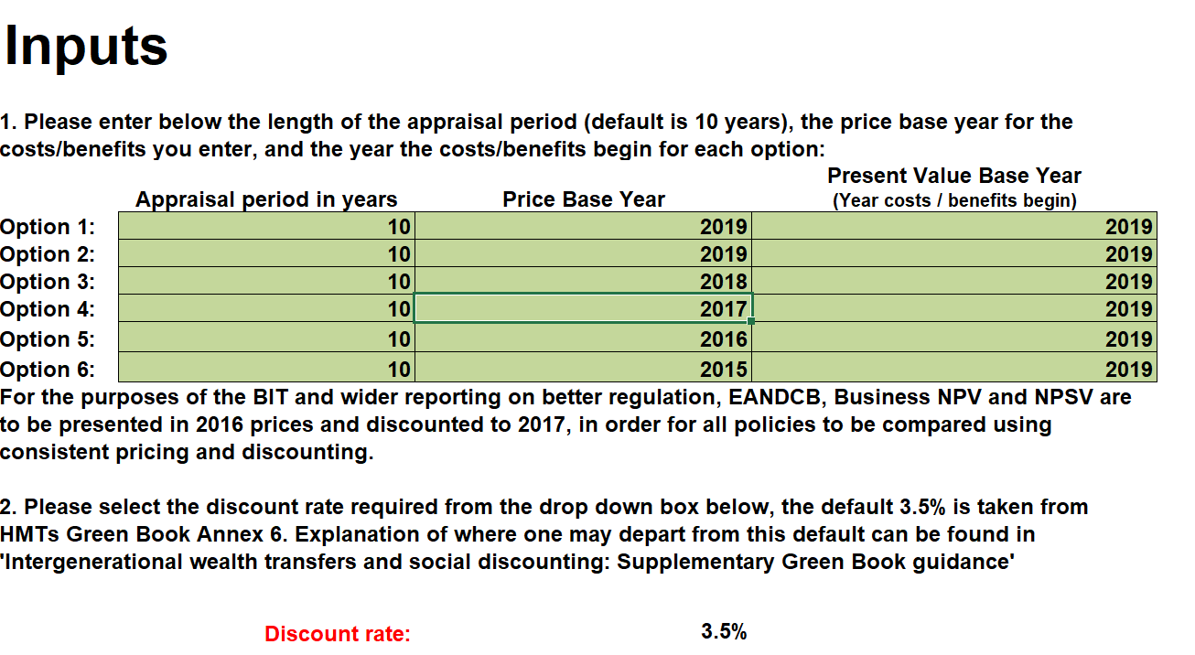
- For each option tab costs and benefits should be entered in millions, so £1,500,000 should be entered as 1.5.
  - Each year should be the 12-month period from when the policy starts, so this may not fit with a calendar year. If a policy has costs and benefits starting in different years, please remember to stagger them when entering the figures into the calculator.
  - An error message will appear if the drop-down boxes for business and direct business impact are not completed, please select yes or no for both boxes for each cost or benefit you enter. Note that a direct business impact must be a business impact.
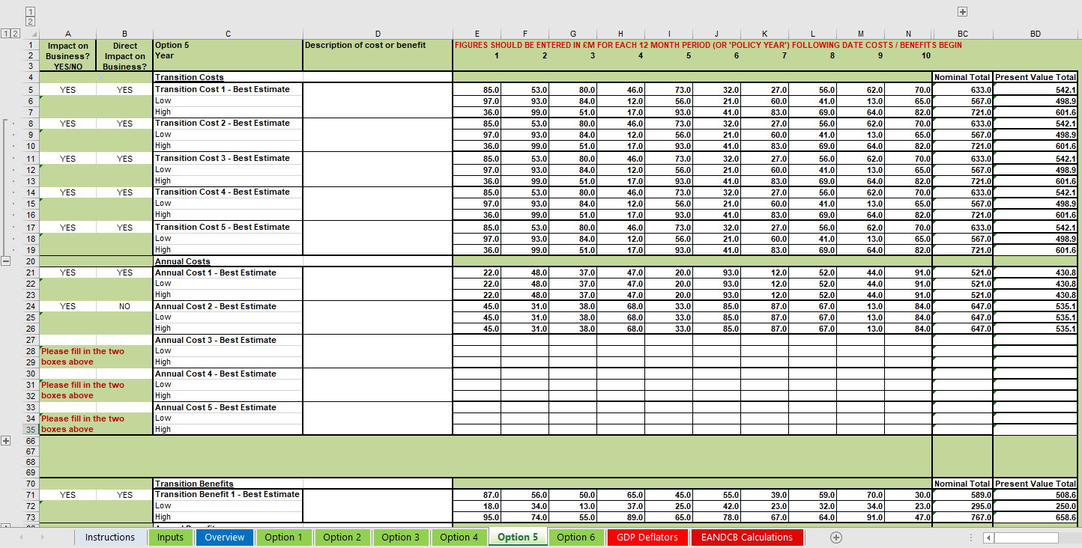
  - The + buttons in the margins can extend the number of years up to 50 and give the option for 5 different transition costs or benefits and 15 different annual costs or benefits.

- The overview sheet contains outputs relevant to the impact assessment, the grey box gives figures required for Business Impact Target reporting and these are in 2016 prices and 2017 present value as explained above.
- As a default, the figures not in the grey box are for information and are output in the price and present value base years that are specified in the instructions tab. This explains differences between the figures in the grey box. There is an option to have the figures output in 2016 Price Year and 2017 Present Value Year, simply select YES from the dropdown at the top of the overview sheet.
Concepts
- The concept of Present Value takes into account that a set sum of money is not as valuable to us at some point in the future as it would be today, reflecting in part time preference and in part an assumption that as the economy is expected to grow over time, the marginal utility of each additional pound diminishes in the future. Future costs and benefits therefore must be discounted in order to be comparable with today's costs and benefits. The Net Present Social Value of a policy is the Present Value of Benefits minus the Present Value Costs, and so demonstrates the overall current monetary value of a policy option.
- The calculator also uses all the costs/benefits that have been assigned as direct impacts on business to compute the Business NPV and Equivalent Annual Net Direct Cost to Business (EANDCB) for each option, using an EANDCB calculator which is embedded in the spreadsheet. This is required for the BIT. The EANDCB only uses the direct impacts on business, but an IA will often also include indirect costs to business. Please select "YES" only for those impacts on business that are direct, not the indirect impacts on business.
- The present value of each cost and benefit, for each option, is computed by the calculator. The results are converted into the 'Overview' tab and split into transition, average annual and total costs/benefits as is required in the Impact Assessment.
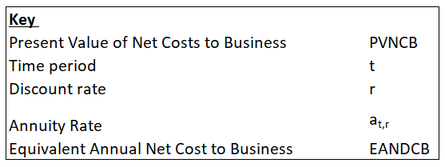
EANDCB Formulae

