MONTHLY TRADE REPORT INDIA TRADE POLICY TEAM FEBRUARY 2019
IN THIS ISSUE:
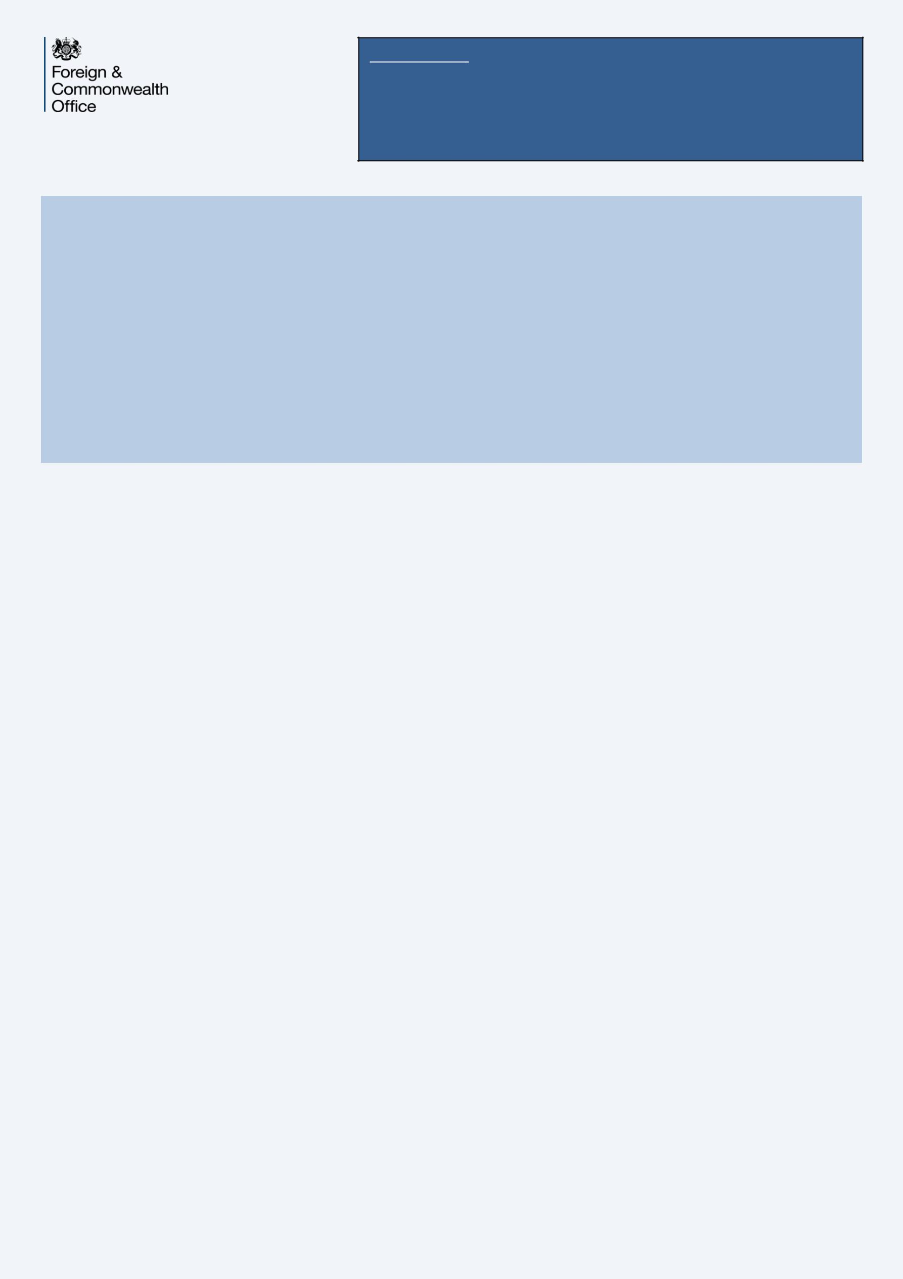

- RCEP Members meet in Cambodia

- India-US commercial dialogues held

- India and Italy hold economic cooperation talks

1. The 7th RCEP Inter-sessional Ministerial Meeting was held on 2nd March 2019 in Cambodia. The Ministers from the 16 RCEP member countries met to review developments since the 2nd RCEP Summit in November 2018 and recent related meetings in Bali. Indian Commerce Minister Suresh Prabhu also participated in the discussions where members reiterated their commitment to conclude the mega-regional deal in 2019. The RCEP negotiations, which cover trade in goods and services, investment, economic and technical cooperation, competition, as well as intellectual property rights, has entered its sixth year. To ensure conclusion in 2019, the Ministers agreed to intensify engagement. It was also noted that four member countries – India, Indonesia, Thailand and Australia – will shortly have elections. The Ministers agreed to meet next in July/August 2019 – which will be a critical milestone and an indicator of political commitment of all 16 countries to conclude the deal this year. This will be followed by the 7th RCEP Ministerial Meeting in September 2019.

- India and the United States held their bilateral Commercial Dialogue and CEO Forum in New Delhi on 14th February 2019. Minister Suresh Prabhu chaired the meeting, while his US counterpart, Wilbur Ross, Secretary of Commerce, participated through teleconference. Both sides noted that the annual bilateral trade in goods and services doubled over the last decade, from $58 billion in 2007 to $126 billion in 2017. Both sides also agreed to set up working groups on financial services, healthcare, and defence under the US-India CEO Forum. This is in addition to the existing four groups on energy, water and environment; ICT and emerging technologies; entrepreneurship; and infrastructure and manufacturing. Other outcomes of the dialogue included the U.S.’s initiative to organise a ‘Trade Winds’ event in May in India, aimed at creating a platform for SMEs to engage with each other and encourage best practices in manufacturing and services. Both sides also agreed to an MoU between their respective national accreditation bodies: National

Accreditation Board for Certification Bodies of India and the US’s ANSI National Accreditation Board for cooperation.

Subsequently, on 5th March, the US announced that it is now withdrawing its GSP scheme for India.

- India and Italy held their 20th Joint Commission for Economic Cooperation on 26 – 27 February 2019 in New Delhi. The meeting was co-chaired by Minister Suresh Prabhu and his Italian counterpart Deputy Minister of Economic Development Michele Geraci. Both sides reviewed economic developments, trade, bilateral investment and economic and industrial cooperation. The two countries agreed to enhance cooperation in sectors of mutual interest including machinery, infrastructure and engineering, ICT, agriculture and IPR. Italy is currently India's 5th largest trading partner in the European Union (UK is India’s 2nd largest EU partner) and 25th in the world. Bilateral trade with Italy grew 18.5% to $10.4 billion during 2017-18. Exports to Italy were valued at $5.7 billion (a 16.4% growth) while imports from Italy also grew at 20.8% to $4.7 billion. Italy ranks 17th in terms of FDI inflow in India ($2.7 billion cumulatively from April 2000 to December 2018). Geraci stated that Italy is keen to partner in areas like financial services, renewable energy, infrastructure, transport development in railways, construction and the automotive sector. Both ministers agreed to hold the 21th Meeting of the Joint Commission in Italy in 2021.
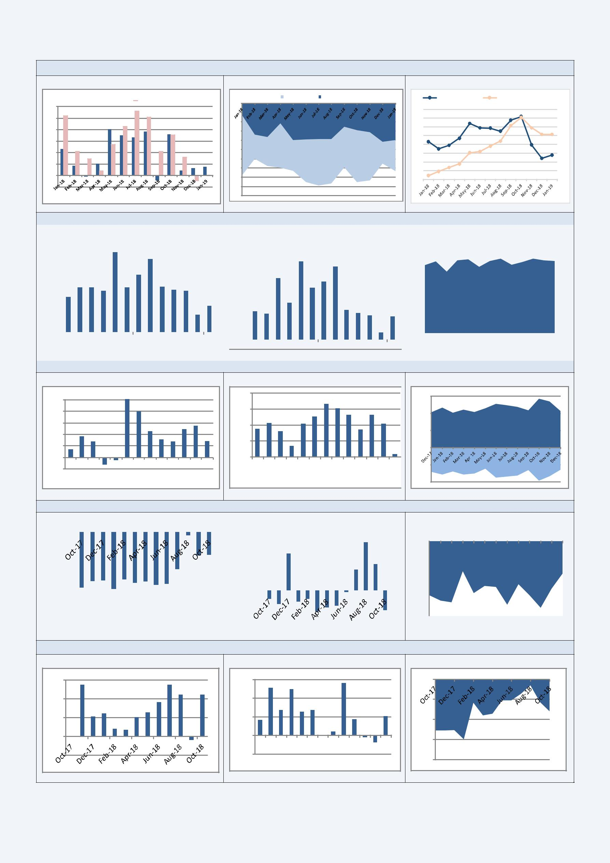
Merchandise trade: exports/imports / trade balance

Export/Imports growth (% y/y)

Exports Y/Y % Imports Y/Y %

30

25

20

15

10

5

0

-5

Trade balance ($bn)

Trade Balance | Non-oil Trade Balance

0

-2

-4

-6

-8

-10

-12

-14

-16

-18

-20

Global Oil Price vs. Rupee Depreciation ($)

Brent Crude Oil Prices | Rupees per US dollar (Right Axis)
85 | 75
80 | 73
75
70 | 71
65 | 69
60 | 67
55
50 | 65
45 | 63

Services trade: exports / imports / trade balance
Export growth (% y/y) |  |  |  |  |  |  |  | Imports (% y/y) |  |  |  |  |  |  |  |  | Trade balance ($bn)
 | 40 |  |  |  |  |  |  |  | 60 |  |  |  |  |  |  |  | 8
 | 30 |  |  |  |  |  |  |  | 50 |  |  |  |  |  |  |  | 6
 | 30 |  |  |  |  |  |  |  | 40 |  |  |  |  |  |  |  | 6
 | 20 |  |  |  |  |  |  |  | 40 |  |  |  |  |  |  |  | 4
 | 20 |  |  |  |  |  |  |  | 30 |  |  |  |  |  |  |  | 4
 | 10 |  |  |  |  |  |  |  | 20 |  |  |  |  |  |  |  | 2
 | 0 |  |  |  |  |  |  |  | 10 |  |  |  |  |  |  |  | 0
 | 0 |  |  |  |  |  |  |  | 0 |  |  |  |  |  |  |  | 0
 | Dec-17 |  |  | Jun-18 | Dec-18 |  |  |  | 0 |  |  |  |  |  |  |  | Dec-17 |  |  | Jun-18 |  |  | Dec-18
 |  |  |  |  |  |  |  |  | Dec-17 |  |  | Jun-18 | Dec-18

Petroleum Oil Lubricant (POL) trade Export growth (% y/y)

100
80
60
40
20
0 | Jan-18 | Feb-18 | Mar-18 | Apr-18 | May-18 | Jun-18 | Jul-18 | Aug-18 | Sep-18 | Oct-18 | Nov-18 | Dec-18
Dec-17
-20

Imports (% y/y)

80

60

40

20

0

Dec-17 | Jan-18 | Feb-18 | Mar-18 | Apr-18 | May-18 | Jun-18 | Jul-18 | Aug-18 | Sep-18 | Oct-18 | Nov-18 | Dec-18

Trade balance ($bn)

15,000

10,000

5,000

0

-5,000

-10,000

Gold trade

Export growth (% y/y) |  |  |  |  |  |  |  |  |  |  |  |  |  |  |  |  | Imports (% y/y)
0.00 |  |  |  |  |  |  |  |  |  |  |  |  |  |  |  |  |  | 100.00
-50.00 |  |  |  |  |  |  |  |  |  |  |  |  |  |  |  |  |  | 100.00
-50.00 |  |  |  |  |  |  |  |  |  |  |  |  |  |  |  |  |  | 50.00
-100.00 |  |  |  |  |  |  |  |  |  |  |  |  |  |  |  |  |  | 0.00
-150.00 |  |  |  |  |  |  |  |  |  |  |  |  |  |  |  |  |  | -50.00

Trade balance ($bn)

0
0 | Oct-17 |  | Nov-17 | Dec-17 | Jan-18 | Feb-18 | Mar-18 | Apr-18 | May-18 | Jun-18 | Jul-18 | Aug-18 | Sep-18 | Oct-18
-1
-2
-3
-4
Non-oil/Non gold trade Export growth (% y/y)

30

20

10

0

-10

Imports (% y/y)

30
20
10
0 | Oct-17 | Nov-17 | Dec-17Jan-18Feb-18Mar-18Apr-18May-18Jun-18Jul-18Aug-18Sep-18Oct-18
-10 | Oct-17 | Nov-17

Trade balance ($bn)

0

-2

-4

-6

-8

Data Sources : Government of India and Reserve Bank of India official statistics

For further information, please contact – Sakshi.jain@fco.gov.uk

Read our analysis on the India Economic Share Point

