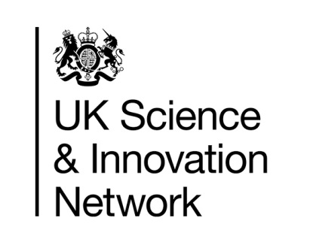


UK Science & Innovation Network Country snapshot:
Colombia
Colombia Science and Innovation
For 2018-2022, the Colombian government has committed a 1.5% investment of the GDP to Science, Technology and Innovation activities. They will also transform Colciencias, the current Science, Technology and Innovation National Administrative Department into a new Ministry of Science, Technology and Innovation to capture more resources to promote research projects. In 2018, Colombia invested in 0,67% of the GDP in Science, Technology and Innovation (STI) activities.
Value of UK export to Colombia:
£464M
Value of UK imports from Colombia:
£405M
UN Comtrade 2017

In addition, Colombia has recently joined the OECD and will face key priorities such as increasing investment in research and development, which will create new opportunities for use of natural resources, raw material valorisation knowledge and productive sector enhancement. The focus will be in SMEs where the OECD recommends developing, implementing and evaluating effective policies that allow the increase of the sustainable and inclusive growth.
To achieve these goals, Colombia will foster innovation, digital technologies, digital security, among others.
Other priorities are the developing infrastructure for research and technological development, promote digital infrastructure for researchers, and enhance open science.
For 2018-2022 Colombia seeks to foster STI by strengthening their funds to ensure research and high quality education, focusing in priority programmes such as Colombia BIO. Colombia Bio is one of our biggest programmes and was formalised between Colciencias and BEIS in 2016, funded by Newton Fund in the framework of the Colombian State Visit. The programme has a total allocation between UK and Colombia of £20M and it aims to strengthen partnerships focused on the Colombian biodiversity studies. The initiative is a strategic programme of National interest that seeks to foster knowledge, conservation, management and sustainable use of Colombian biodiversity, as second country with the highest biodiversity per square meter in the world. Delivery partners include NERC (Natural Environmental Research Council), the British Council, the Arts & Humanities Research Council among others.
Newton Fund
Newton-Caldas Fund has been in Colombia since 2014 and will have allocated £30M in 2021. These funds represent the half of the investment of each co-fund project with Colombian partners, for a total allocation of £60M between both countries. The fund represents the largest cooperation programme in science and innovation signed between Colombia and the international community.
Some of their programmes include: Research and Development projects under Colombia Bio, Institutional Links, Research Links, researchers and innovators mobility schemes, such as Leaders in Innovation Fellowship, Industry Academia Partnership Programme, among others.
Useful Information
Two Colombian universities are ranked in the top 10 in Latin America according to QS ranking 2018 (University of Andes and the National University).
https://www.bbc.com/mundo/noticias-46079530

The UK fluctuates between the first and the second preferred option for Colombians to undertake Masters Degrees abroad

Colombia Científica – Ministry of Education, MinCIT and Colciencias: Governmental programme that aims to improve quality in High Education institutions, in research, teaching and internationalisation as well as support the research and innovation system of scientific excellence articulated with the productive sector. http://colombiacientifica.gov.co/colombia/
Contacts
Luis Calzadilla – Director Science and Innovation (based in Bogota)
Telephone: +57 1 3268287
luis.calzadilla@fco.gov.uk

Natalia Ramirez – Science and Innovation Co-ordinator (Newton Fund) (based in Bogota)
Telephone: +57 1 3268272
natalia.ramirez@fco.gov.uk

Carolina Tamayo – Economic Diplomacy Officer (based in Medellin)
Mobile: +57 3174282880
carolina.tamayo@fco.gov.uk

Angela Estrada – Economic Diplomacy Adviser (based in Bogota)
Telephone: +57 1 3268368
angela.estrada@fco.gov.uk

References
https://www.elespectador.com/noticias/ciencia/aumentar-la-inversion-para-ciencia-una-promesa-incumplida-articulo-804617
https://www.portafolio.co/economia/los-retos-en-ciencia-y-tecnologia-para-colombia-despues-del-ingreso-a-la-ocde-518437
https://www.bbc.com/mundo/noticias-46079530
https://www.colciencias.gov.co/convocatorias/colombiabio
http://colombiacientifica.gov.co/colombia/

