Contents
1. OVERALL CONTEXT 2
1.1 Objectives 2
FCO spend by strategic objective: 2
FCO funding 3
1.2 Spending controls 4
1.3 Main areas of spending 4
Sections of the estimate 4
Breakdown of Resource DEL spending 5
Administration costs 5
Programme expenditure 5
1.4 Efficiency 6
1.5 Key drivers of funding changes since last year 6
Resource DEL 6
Capital DEL 7
Annually Managed Expenditure (AME) 7
2 EXPLANATION OF CHANGES IN THE SUPPLEMENTARY ESTIMATE 7
2.1 Drawdown of additional funding 7
2.2 Returns of funding to the Treasury 8
2.3 Budget transfers 9
3. PRIORITIES AND PERFORMANCE 9
3.1 How spending relates to objectives 9
3.2 Measures of performance against each priority 9
3.3 Major projects 9

1. OVERALL CONTEXT
This memorandum gives background to the FCO Supplementary Estimate 2018-19. The format of this memorandum follows revised guidance from the Parliamentary Scrutiny Unit, to provide wider context about departments’ objectives and finances.

1.1 Objectives
The 2018-19 Supplementary Estimate supports the FCO’s Strategic Objectives as set out in our Single Departmental Plan:
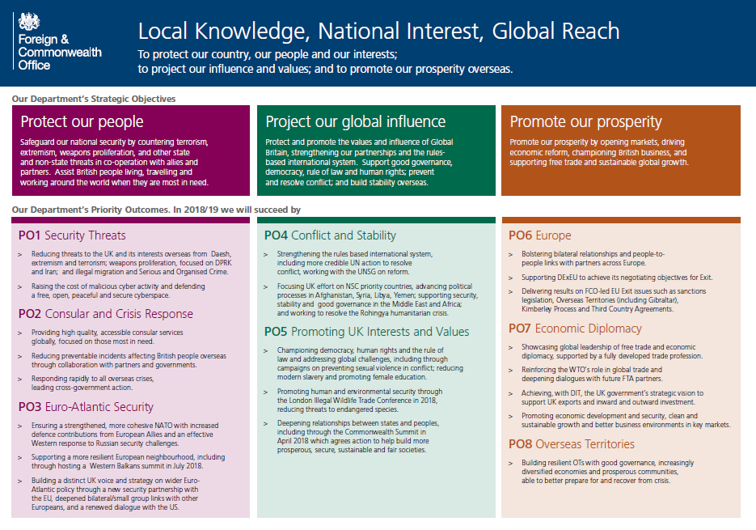

FCO spend by strategic objective:
The chart below gives a breakdown of FCO’s spending by our three strategic objectives. The costs of running FCO’s network are apportioned based on activity recording by staff. The methodology means that most of the operating cost of the network is shown under “Project our Global Influence”. A fuller explanation is given in Note 2 to the annual accounts (the statement of costs by operating segments).
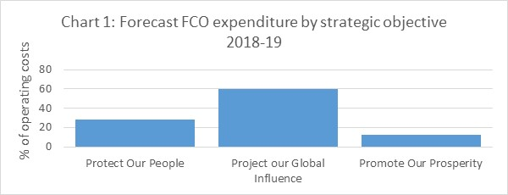

FCO funding
The chart shows the FCO’s funding since 2008-09 in real terms (2018-19 prices):
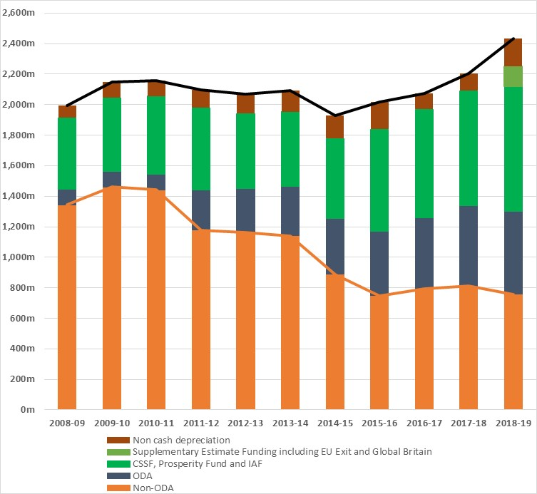
Notes:
- Figures show FCO Resource DEL in 2018-19 prices.
- For comparability with the Supplementary Estimate, this chart shows Parliamentary funding, not end-year outturn. It excludes FCO’s income from other sources, such as the charges paid by other government departments whose staff are hosted on FCO’s overseas platform.
- Funding for UK Trade and Investment has been removed from the series (£75.7m a year from 2008-09 to 2010-11; £114m from 2011-12 to 2013-14).
- Annual budget adjustments under the FCO’s foreign currency mechanism and differential inflation agreement have been removed, to reduce the impact of exchange rate movements.
- The CSSF and Prosperity Fund category also includes funding this year for the Gulf Strategy Integrated Activity Fund,
- The non-ODA budget consists of the core Spending Review settlement (£682m this year) adjusted for Supplementary Estimate changes such as the Consular Premium and HM Treasury contributions for International Subscriptions.

1.2 Spending controls
The table below shows the FCO’s key budgetary controls.
Control totals (£m) | 2017-18 | 2018-19 | Change (£m) | Change (%)
Resource DEL | 2,217.4 | 2,429.7 | 212.3 | 9.6%
Capital DEL | 137.6 | 156.6 | 19.0 | 13.8%
Resource AME | 205.0 | 200.0 | - 5.0 | -2.4%
Minus
Non-cash DEL | 139.0 | 181.5 | 42.5 | 30.6%
Non-cash AME | 165.0 | 160.0 | - 5.0 | -3.0%
Change in working capital |  | 30.0
= Net cash requirement | 2,256.0 | 2,474.8 | 218.8 | 9.7%

1.3 Main areas of spending

Sections of the estimate
The table below shows the lines of the FCO’s Estimate. Section E (Prosperity Fund) is a new addition this year to provide more transparency. Previously expenditure on the Prosperity Fund was shown within sections A and B.
Section | Description
A | Expenditure by the FCO on its administration, strategic and bilateral programmes, FCO Services, Wilton Park Executive Agency, hospitality and facilities; scholarships, information services and sponsored visits; special payments and assistance programmes to support foreign policy objectives including human rights, good governance, international security and the fight against the illicit drug trade; and on associated non-cash items;
B | Grants to international organisations and other bodies supporting FCO objectives and programmes;
C | Resource grant to the British Council;
D | The net expenditure of FCO sponsored Arm’s Length Bodies (ALBs) in particular the Westminster Foundation for Democracy, the Marshall Aid Commemoration Commission and the Great Britain China Centre;
E | Expenditure by the Foreign Office on the Prosperity Fund to remove barriers to economic growth in order to reduce poverty;
F | Expenditure by the Foreign and Commonwealth Office on conflict prevention, early warning, crisis management, conflict resolution/peacekeeping;
G | Expenditure on peacekeeping and peace building activity and on associated strengthening of international and regional systems;
H | AME non-cash expenditure on impairments, provisions, foreign exchange;
I | AME grants to refund certain taxes and duties paid by certain Foreign and Commonwealth governments.

Breakdown of Resource DEL spending
The chart shows a more detailed breakdown of FCO’s spending.
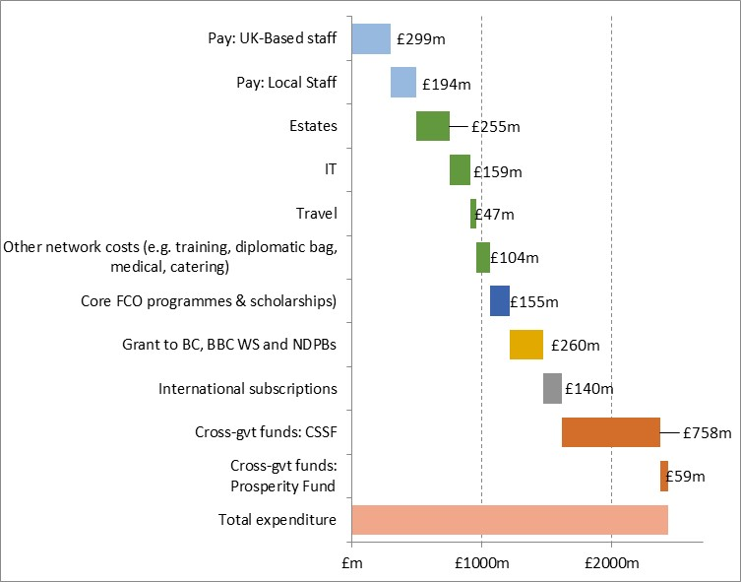
Note: This table reconciles to the figures in Annex A. The breakdown of administration and network costs is based on latest in-year forecasts.

Administration costs
The FCO’s administration cost limit is £193.0 million. This compares to £183.6 million in 2017-18. The increase is largely due to a switch from capital into administration costs (£7.5m) to cover the costs of cloud-based IT services. There have also been a number of other smaller transfers as set out at Annex B.

Programme expenditure
The FCO’s own programmes are split between sections A and B depending on which delivery method offers the best value for money. Where FCO programmes are grant-funded they score in section B of the Estimate. Other methods of programme delivery such as the use of commercial contracts score in section A.
Cross-Whitehall programmes have separate sections, with section E covering the Prosperity Fund, section F covering conflict prevention and section G covering Peacekeeping. Sections F and G together make up the Conflict, Stability and Security Fund (CSSF). Sections E to G are ring-fenced, and funding cannot be transferred into other parts of the core FCO budget without approval.
In addition to the programmatic expenditure set out above, many of the operational costs of running the FCO network are classified as programme rather than administration, because they support front-line diplomatic work.

1.4 Efficiency
As shown in Chart 2 above, the FCO’s funding has remained broadly flat over the last decade, but an increasing proportion of the budget has come through the cross-Whitehall Prosperity Fund and Conflict Stability and Security Fund, which are ring-fenced, and in funding classified as Official Development Assistance (ODA). FCO’s core budget – in particular the amount that is non-ODA – has reduced. In response, FCO has driven a large number of efficiencies, including:
- A shift over time towards greater use of locally-employed staff, to reduce the cost of posting UK-based staff overseas and increase local expertise. Around half of FCO’s posts have two or fewer UK-based staff;
- Centralising corporate functions, through creating global transaction processing centres, central banking systems, and regional hubs for finance, procurement and HR;
- Consolidating overseas government properties under FCO management following the One HMG principle, to create a single platform across government;
- Increased digital delivery – for example through the current Technology Overhaul programme – to enable staff to work more flexibly and efficiently; and
- Tight financial management generating savings from budgets across the organisation.
The FCO’s Diplomacy 20:20 programme includes further measures that will improve our efficiency and effectiveness. For example, a review of the structure, size and shape of London policy directorates made savings to recycle into strengthening our Europe network after the 2016 referendum. The Corporate Capability Programme is reviewing our corporate services operating model in order to drive efficiencies and improvements across a breadth of operational services such as estate maintenance. The Atlas programme will modernise our finance and HR information systems in order to streamline processes, improve the user experience and create better management information.

1.5 Key drivers of funding changes since last year

Resource DEL
Overall Resource DEL funding increased in 2018-19 due to additional funding for specific activity agreed by the Treasury during 2018, and some technical budget adjustments. The major increases in funding are:
- £45m to support the government’s Global Britain ambitions and support the opening of 14 new posts;
- £35m for the FCO’s EU Exit preparations;
- £20m drawdown against the sale of the Bangkok compound to address a historic backlog of maintenance and seismic works on the overseas estate.
There is also a £70m increase in the FCO’s ring-fenced non-cash allocation to reflect a rise in the expected depreciation charge this year and allow for foreign exchange volatility.

Capital DEL
On capital, the FCO strives to maintain a UK and overseas platform – for the whole of government – which is modern, flexible, environmentally sustainable, compliant with health and safety standards, and secure for our staff and visitors. We have a core capital budget of £98m a year, largely spent on security and technology, but depend on asset sales (in particular the sale of the Bangkok embassy compound) to fund investment in our estate. We have flexibility from HM Treasury to draw down sale proceeds to reinvest in later years.
This year in the Supplementary Estimate we are drawing down £34m of the Bangkok sale receipt to spend as capital, in addition to the £20m mentioned above for maintenance works that score as Resource DEL.
The funding will support a number of projects under the FCO’s Global Asset Management Plan (GLAMP). These include the acquisition of the New York Consul General’s residence and a new Bangkok residence; and, with a transfer of funding from DFID, major works on the Kathmandu embassy compound following the 2015 Nepal earthquake.

Annually Managed Expenditure (AME)
FCO has a non-cash AME budget mainly to cover some depreciation/impairments of assets and unrealised foreign exchange gains/losses. As in 2017-18, we are increasing this budget in the Supplementary Estimate to provide cover against exchange rate volatility.

2 EXPLANATION OF CHANGES IN THE SUPPLEMENTARY ESTIMATE

2.1 Drawdown of additional funding
Most of the major budget changes, including those listed in section 1.5 above, are technically classed as claims on the Treasury’s Reserve that we are taking up in the Supplementary Estimate:
- Take up of £51.2m for the Consular Premium, which is a non-discretionary levy charged as part of the passport application fee. It is classified as a tax and therefore paid directly by the Home Office into the Treasury-run Consolidated Fund. The Premium is transferred from the Consolidated Fund to the Consular Service of the FCO each year through a claim on the Reserve;
- Take up of Treasury’s 60% contribution, which amounts to £41.4m this year, for payments for International Subscriptions above an £82m baseline;
- Take up of £34m of banked asset sales receipts (largely from the 2018 sale of FCO’s embassy compound in Bangkok) for capital investment in our estate. In addition, we have agreed with Treasury to switch £7.5m of our core capital budget to Resource DEL, to reflect a shift away from FCO-owned assets (which count as capital) towards purchasing cloud-based services (a resource cost);
- Take up of £20m Resource DEL In line with the Chancellor’s agreement in 2017 to switch a proportion of the Bangkok sale proceeds into Resource DEL for additional seismic and maintenance work;
- Take up of £35.2m funding for EU exit preparations;
- Take up of £9m for local initiatives to counter disinformation and encourage civil society engagement delivered through the BBC World Service for global strategic communications, as agreed in Spending Review 2015;
- Take up of £0.784m funding raised through LIBOR fines from which Treasury has agreed to cover the costs of erecting in the UK a memorial to the victims of the 2015 Tunisian terror attack; and
- A £70m increase in FCO’s non-cash budget for depreciation. The main reason is to provide headroom against foreign exchange volatility. A fall in the value of sterling would increase the value of FCO’s overseas assets, and therefore increase the non-cash depreciation charge in our accounts.

2.2 Returns of funding to the Treasury
We have returned £34m of peacekeeping funding in relation to the Common Foreign and Security Policy as this is paid directly by Treasury as part of the UK’s net EU contribution.
We have also returned £30m non-ODA funding to Treasury, as agreed in our Global Britain funding uplift.
There is a return to Treasury in respect of the Foreign Currency Mechanism (FCM) and differential inflation agreement, which help protect FCO against exchange rate movements and overseas inflation. This year, because of very high currency depreciation or inflation in some emerging markets, we have switched to paying in dollars in a few countries (e.g. Argentina, Iran and Venezuela). The FCM rules did not properly account for this change, so we have negotiated a slight correction. We have made a net transfer to Treasury of £1.7m for the FCM and differential inflation; that transfer would have been larger without the correction.
We have used Budget Exchange to move £3m of the FCO’s Resource DEL (a contribution to the costs of the Dubai Expo) and £6.5m of CSSF peacekeeping funding from 2018-19 into 2019-20.

2.3 Budget transfers
There have also been a number of routine transfers to and from the FCO, in particular those arising from the CSSF, as set out in annex B.

3. PRIORITIES AND PERFORMANCE

3.1 How spending relates to objectives
Section 1.1 above outlines the FCO’s priority outcomes and spend by strategic objective. Priority outcomes 1,2,3,6, and 8 are covered by sections A, B and H of the Estimate. Priority outcome 4 is covered by sections F and G. Priority outcomes 5 and 7 are shared between sections A,B,C,D and E. Non-Cash AME in section I supports all of objectives.

3.2 Measures of performance against each priority
Data on performance against the FCO’s Single Departmental Plan Key Performance Indicators is given on pages 7 and 8 of the FCO 2017-18 Annual Report and Accounts (HHC1216). This can be found at the link below.
https://assets.publishing.service.gov.uk/government/uploads/system/uploads/attachment_data/file/722730/FCO1119_FCO_Annual_Report_2018_-_ONLINE.PDF

3.3 Major projects
The FCO has five major projects as defined by the Infrastructure and Projects Authority (IPA):
- Technology Overhaul – a programme to upgrade FCO’s IT;
- Echo 2: a joint project with the British Council and the Department for International Development to provide new network, telephony and video-conferencing services;
- Atlas: a programme to replace the FCO’s finance and HR information system;
- Desktop Infrastructure: to design and deliver the future operational support for FCO’s desktop computing system;
- A major refurbishment of the embassy and ambassador’s residence in Washington DC.
Progress on major projects is recorded at: https://www.gov.uk/government/publications/fco-government-major-projects-portfolio-data-2018

